sldemo_househeat_doc

Software Design Description



Firstname Lastname

sldemo_househeat_doc: Software Design Description

by Firstname Lastname

Published 31-Jul-2018

Copyright © 2018

Abstract

N/A

Table of Contents

Chapter 1. Introduction 0

1.1. Document Purpose. 0

1.2. Scope. 0

Chapter 2. Preliminaries and Notation 1

2.1. Acronyms. 1

2.2. Definitions. 1

2.3. Notation. 1

Chapter 3. Design Description of sldemo_househeat_doc 2

3.2. Interface. 2

3.2.1. Inputs. 2

3.2.2. Outputs. 2

3.2.3. Updates. 3

3.3.Calibrations 3

3.4.4. Local Declarations. 4

3.4.8. Design Description of House. 5

3.4.8.2. Interface. 6

3.4.8.2.1. Inputs. 6

3.4.8.2.2. Outputs. 6

3.4.8.2.3. Updates. 7

3.4.8.3.4. Local Declarations. 8

Chapter 1. Introduction

1.1. Document Purpose.

The purpose of this document is to provide a detailed design description for sldemo_househeat_doc. To provide this detailed description, the model will be described in a hierarchical fashion starting with the top-level and progressively working toward lower level descriptions of the most significant subsystems within the model.

1.2. Scope.

This document aims to explain in detail how a given system works. It will explain system interfaces, how it works, why it was designed the way it was, and it may provide traceability to both the system and the requirements for the system.

Chapter 2. Preliminaries and Notation

2.1. Acronyms.

General Acronyms.

-AC: Alternating Current

System Specific Acronyms.

N/A

2.2. Definitions.

General Definitions.

-State of Charge (SOC): The percentage of usable charge (Ampere-hours) contained in a battery relative to its usable capacity when fully charged. While 0% and 100% are not absolute limits, they are the recommended extremes for cell state. From the user's perspective, it is the equivalent of a fuel gauge for (hybrid) electric vehicles. The inverse of the SOC is Depth of Discharge (DoD, also a percentage). If the battery is fully charged, the SOC is 100%, and the DoD is 0%.

System Specific Definitions.

N/A

2.3. Notation.

General Notation.

N/A

System Specific Notation.

N/A

Chapter 3. Design Description of sldemo_househeat_doc

**Full path: sldemo_househeat_doc**

This section will provide the purpose, interface, and internal design of sldemo_househeat_doc.

3.1. Purpose.

The purpose of this system is to model the outdoor environment, the thermal characteristics of the house, and the house heating system. See[*The MathWorks*](https://www.mathworks.com/help/simulink/examples/thermal-model-of-a-house.html?s_tid=gn_loc_drop)page on this model for further details from those provided in this example.

3.2. Interface.

3.2.1. Inputs.

Inports.

N/A

Data Store Reads.

N/A

Global Froms.

N/A

Scoped Froms.

N/A

3.2.2. Outputs.

Outports.

N/A

Data Store Writes.

N/A

Global Gotos.

N/A

Scoped Gotos.

N/A

3.2.3. Updates.

N/A

3.3.Calibrations

Calibrations.

N/A

3.4. Internal Design.

This section will provide the rationale and anticipated changes of sldemo_househeat_doc.

3.4.1. System Snapshot.

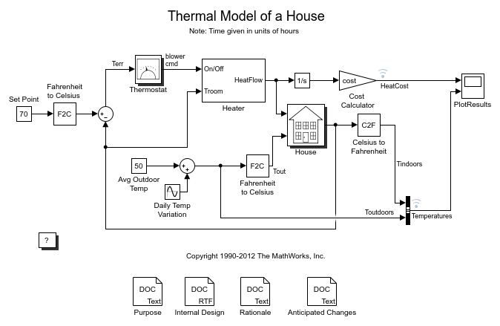

3.4.2. Subsystems and Functions.

|  |  |
| --- | --- |
| Block | Description |
| Heater |  |
| House |  |
| More Info |  |
| Thermostat |  |

3.4.4. Local Declarations.

Data Store Declarations.

N/A

Goto Tag Declarations.

N/A

3.4.5. Description.

The system uses a simulated thermostat, heater, and house along with desired temperature and environment temperature data to provide a thermal model of a house which shows temperature and cost over time.

3.4.6. Rationale.

This design was made with separate subsystems for the thermostat, heater, and house in order to increase readability of the model and to modularize the different parts.

3.4.7. Anticipated Changes.

This particular model is designed to calculate the heating costs only. If the temperature of the outside air is higher than the room temperature, the room temperature will exceed the desired "Set Point".

You can modify this model to include an air conditioner. You can implement the air conditioner as a modified heater. To do this, add parameters like the following to sldemo_househeat_data.m.

-Cold air output

-Temperature of the stream from the air conditioner

-Air conditioner efficiency

You would also need to modify the thermostat to control both the air conditioner and the heater.

3.4.8. Design Description of House.

**Full path: sldemo_househeat_doc/House**

This section will provide the purpose, interface, and internal design of House.

3.4.8.1. Purpose.

The House subsystem calculates room temperature variations. It takes into consideration the heat flow from the heater and heat losses to the environment. Heat losses and the temperature time derivative are expressed by the equations in the following figure:

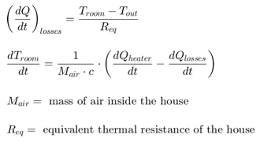

3.4.8.2. Interface.

3.4.8.2.1. Inputs.

Table 3.1. Inports

|  |  |  |
| --- | --- | --- |
| **Name** | **Unit** | **Description** |
| Heater QDot In | N/A | N/A |
| Outdoor Temp Tout | N/A | N/A |

Data Store Reads.

N/A

Global Froms.

N/A

Scoped Froms.

N/A

3.4.8.2.2. Outputs.

Table 3.2. Outports

|  |  |  |
| --- | --- | --- |
| **Name** | **Unit** | **Description** |
| Room Temp Troom | N/A | N/A |

Data Store Writes.

N/A

Global Gotos.

N/A

Scoped Gotos.

N/A

3.4.8.2.3. Updates.

N/A

3.4.8.3. Internal Design.

This section will provide the rationale and anticipated changes of House.

3.4.8.3.1. System Snapshot.

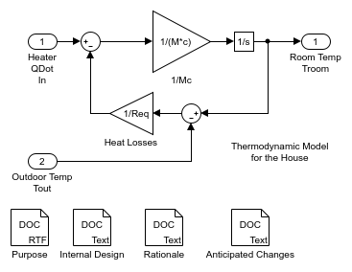

3.4.8.3.2. Subsystems and Functions.

Subsystems in House.

N/A

3.4.8.3.4. Local Declarations.

Data Store Declarations.

N/A

Goto Tag Declarations.

N/A

3.4.8.3.5. Description.

The environment is modelled as a heat sink with infinite heat capacity and time varying temperature Tout.   
The constant block "Avg Outdoor Temp" specifies the average air temperature outdoors.   
The "Daily Temp Variation" Sine Wave block generates daily temperature fluctuations of outdoor temperature.

3.4.8.3.6. Rationale.

A feedback loop is used to model the house since its change in temperature depends on the the previous state.

3.4.8.3.7. Anticipated Changes.

None.