sldemo_househeat

Software Design Description



Firstname Lastname

sldemo_househeat: Software Design Description

by Firstname Lastname

Published 26-May-2017

Copyright © 2017

Abstract

N/A

Table of Contents

Chapter 1. Introduction 0

1.1. Document Purpose. 0

1.2. Scope. 0

Chapter 2. Design Description of sldemo_househeat 1

2.1. Purpose. 1

2.2. Interface. 1

2.2.1. Inputs. 1

2.2.2. Outputs. 1

2.2.3. Declarations. 2

2.2.4. Updates. 2

2.3. Internal Design. 2

2.3.1. Internal Design Supplement. 3

2.3.1.1. Rationale. 3

2.3.1.2. Anticipated Changes. 4

2.3.1.3. Design Description of House. 4

2.3.1.3.1. Purpose. 4

2.3.1.3.2. Interface. 4

2.3.1.3.2.1. Inputs. 4

2.3.1.3.2.2. Outputs. 5

2.3.1.3.2.3. Declarations. 5

2.3.1.3.2.4. Updates. 6

2.3.1.3.3. Internal Design. 6

2.3.1.3.3.1. Internal Design Supplement. 6

2.3.1.3.3.1.1. Rationale. 6

2.3.1.3.3.1.2. Anticipated Changes. 7

Chapter 3. Glossary 8

3.1. Acronyms. 8

3.2. Definitions. 8

3.3. Notation. 8

Chapter 1. Introduction

1.1. Document Purpose.

The purpose of this document is to provide a detailed design description for this model. To provide this detailed description the model will be described in a hierarchical fashion starting with the top-level and progressively working toward lower level descriptions of the most significant subsystems within the model.

1.2. Scope.

This document aims to explain in detail how a given system works. It will explain system interfaces, how it works, why it was designed the way it was, and it may provide traceability to both the system and the requirements for the system.

Chapter 2. Design Description of sldemo_househeat

**Full path: sldemo_househeat**

This section will provide the purpose, interface, and internal design of sldemo_househeat.

2.1. Purpose.

The purpose of this system is to model the outdoor environment, the thermal characteristics of the house, and the house heating system. See[*The MathWorks*](https://www.mathworks.com/help/simulink/examples/thermal-model-of-a-house.html?s_tid=gn_loc_drop)page on this model for further details from those provided in this example.

2.2. Interface.

2.2.1. Inputs.

Inports.

N/A

Data Store Reads.

N/A

Global Froms.

N/A

Scoped Froms.

N/A

2.2.2. Outputs.

Outports.

N/A

Data Store Writes.

N/A

Global Gotos.

N/A

Scoped Gotos.

N/A

2.2.3. Declarations.

Data Store Declarations.

N/A

Goto Tag Declarations.

N/A

2.2.4. Updates.

N/A

2.3. Internal Design.

This section will provide the rationale and anticipated changes of sldemo_househeat.

Figure 2.1. Snapshot of sldemo_househeat

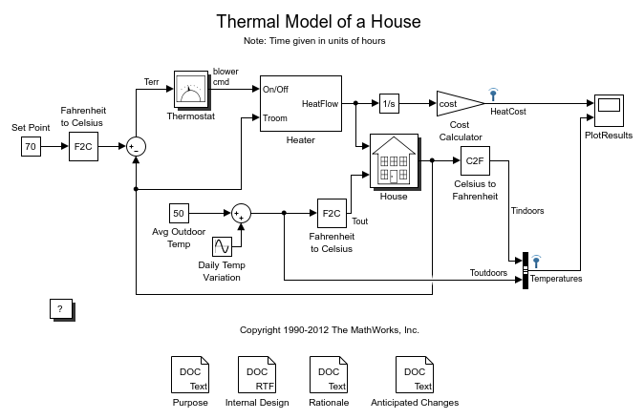

The system uses a simulated thermostat, heater, and house along with temperature data to provide a thermal model of a house.

2.3.1. Internal Design Supplement.

Table 2.1. Subsystems in sldemo_househeat

|  |  |
| --- | --- |
| **Block** | **Description** |
| Heater |  |
| House |  |
| More Info |  |
| Thermostat |  |

2.3.1.1. Rationale.

Rationale not available.

2.3.1.2. Anticipated Changes.

This particular model is designed to calculate the heating costs only. If the temperature of the outside air is higher than the room temperature, the room temperature will exceed the desired "Set Point".

You can modify this model to include an air conditioner. You can implement the air conditioner as a modified heater. To do this, add parameters like the following to sldemo_househeat_data.m.

-Cold air output

-Temperature of the stream from the air conditioner

-Air conditioner efficiency

You would also need to modify the thermostat to control both the air conditioner and the heater.

2.3.1.3. Design Description of House.

**Full path: sldemo_househeat/House**

This section will provide the purpose, interface, and internal design of House.

2.3.1.3.1. Purpose.

The House subsystem calculates room temperature variations. It takes into consideration the heat flow from the heater and heat losses to the environment. Heat losses and the temperature time derivative are expressed by the equations in the following figure:

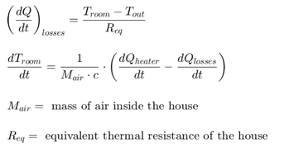

2.3.1.3.2. Interface.

2.3.1.3.2.1. Inputs.

Table 2.2. Inports

|  |  |  |
| --- | --- | --- |
| **Name** | **Data Type** | **Description** |
| Heater QDot In | Inherit: auto | N/A |
| Outdoor Temp Tout | N/A | N/A |

Data Store Reads.

N/A

Global Froms.

N/A

Scoped Froms.

N/A

2.3.1.3.2.2. Outputs.

Table 2.3. Outports

|  |  |  |
| --- | --- | --- |
| **Name** | **Data Type** | **Description** |
| Room Temp Troom | Inherit: auto | N/A |

Data Store Writes.

N/A

Global Gotos.

N/A

Scoped Gotos.

N/A

2.3.1.3.2.3. Declarations.

Data Store Declarations.

N/A

Goto Tag Declarations.

N/A

2.3.1.3.2.4. Updates.

N/A

2.3.1.3.3. Internal Design.

This section will provide the rationale and anticipated changes of House.

Figure 2.2. Snapshot of House

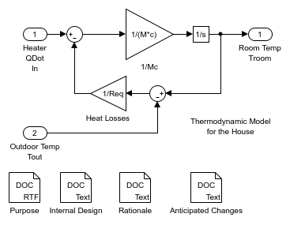

The environment is modelled as a heat sink with infinite heat capacity and time varying temperature Tout.   
The constant block "Avg Outdoor Temp" specifies the average air temperature outdoors.   
The "Daily Temp Variation" Sine Wave block generates daily temperature fluctuations of outdoor temperature.

2.3.1.3.3.1. Internal Design Supplement.

Subsystems in House.

N/A

2.3.1.3.3.1.1. Rationale.

Rationale not available.

2.3.1.3.3.1.2. Anticipated Changes.

None.

Chapter 3. Glossary

3.1. Acronyms.

General Acronyms.

N/A

System Specific Acronyms.

N/A

3.2. Definitions.

General Definitions.

N/A

System Specific Definitions.

N/A

3.3. Notation.

General Notation.

N/A

System Specific Notation.

N/A