FIN-220 Hands-On Machine Learning
HW 6
Due on December 01, 2025
- Let K : R² ×R² → R, be defined by K(a,b) = (a^{T}b)³. Find φ : R² → R⁴ such that < φ(a),φ(b) >= K(a,b)
(a^{T}b)³
${\left(a_{1}b_{1}\right)}^{3}+{3\left(a_{1}b_{1}\right)}^{2} a_{2}b_{2}+ 3\left(a_{1}b_{1}\right){\left(a_{2}b_{2}\right)}^{2}+{\left(a_{2}b_{2} \right)}^{3}$
$${a_{1}}^{3}{b_{1}}^{3}+{{3a}_{1}}^{2}a_{2}{b_{1}}^{2}b_{2}+{3a}_{1}{a_{2}}^{2}b_{1}{b_{2}}^{2}+{a_{2}}^{3}{b_{2}}^{3}$$
$$\left({a_{1}}^{3}\right)\left({b_{1}}^{3}\right)+\left({{\sqrt{3}a}_{1}}^{2}a_{2}\right)\left({{\sqrt{3}b}_{1}}^{2}b_{2}\right)+\left({\sqrt{3}a}_{1}{a_{2}}^{2}\right)\left({\sqrt{3}b}_{1}{b_{2}}^{2}\right)+\left({a_{2}}^{3}\right)\left({b_{2}}^{3}\right)$$
So:
$$φ\left(a\right)= \left[{a_{1}}^{3},{{\sqrt{3}a}_{1}}^{2}a_{2},{\sqrt{3}a}_{1}{a_{2}}^{2},{a_{2}}^{3}\right]$$
$$φ\left(b\right)= \left[{b_{1}}^{3},{{\sqrt{3}b}_{1}}^{2}b_{2},{\sqrt{3}b}_{1}{b_{2}}^{2},{b_{2}}^{3}\right]$$

- Consider the following dataset with one feature x and binary label y ∈{0,1}:
Sample | x | y
1 | 2 | 0
2 | 3 | 0
3 | 10 | 1
4 | 12 | 1
The possible split thresholds (midpoints between sorted feature values) are:
t ∈{2.5, 6.5, 11}.

Compute the Gini impurity for each split! Which one should you choose to split the root node?
Split 2.5
Left x <= 2.5, n = 1, Sample 1 -> y = [0]
1 – (1/1)² – (0/1)²
Right x > 2.5: n= 3, Samples 2,3,4 -> y = [0,1,1]
1 – (1/3)² – (2/3)² = 4/9 = 0.444
Split ¼ *0 + ¾ * 4/9 = 3/9 = 0.333

Split 6.5

Left x <= 6.5, n = 2, Samples 1,2 -> y = [0,0]

1 – (2/2)² – (0/2)² = 1 – 1 = 0

Right x > 6.5, n = 2, Samples 3, 5 -> y = [1,1]

1 – (0/2)² – (2/2)² = 1 – 1 = 0

Split 2/4 * 0 + 2/4 * 0 = 0

Split 11

Left x <= 11, n = 3, Samples 1,2,3 -> y = [0,0,1]

1 – (2/3)² – (1/3)² = 4/9 = 0.444

Right x > 11, n = 1, Sample 4 -> y = [1]

1 – (0/1)² – (1/1)² = 0

Split ¾ * 4/9 + ¼ * 0 = 0.333

Minimum Gini for 6.5

- Train and fine-tune a decision tree for the moons dataset by following these steps:
  - Use make moons(n samples=10000, noise=0.4) to generate a moons dataset.
  - Use train test split() to split the dataset into a training set and a test set.
Code is in:
https://github.com/McSavage/FIN220/blob/main/lectures/HandsOn_Chapter6/06_scribbles.ipynb

import numpy as np
from sklearn.pipeline import make_pipeline
from sklearn.preprocessing import StandardScaler
from sklearn.datasets import make_moons
from sklearn.preprocessing import PolynomialFeatures
from sklearn.svm import LinearSVC
from sklearn.model_selection import train_test_split
from sklearn.tree import DecisionTreeClassifier

# Generate moons dataset
X, y = make_moons(n_samples=10000, noise=0.4, random_state=42)

# Split the dataset into training and test sets
X_train, X_test, y_train, y_test = train_test_split(X, y, test_size=0.2, random_state=42)

print(f"Training set size: {len(X_train)}")
print(f"Test set size: {len(X_test)}")

Training set size: 8000
Test set size: 2000

  - Use grid search with cross-validation (with the help of the GridSearchCV class) to find good hyperparameter values for a DecisionTreeClassifier. Hint: try various values for max leaf nodes.
  - Train it on the full training set using these hyperparameters, and measure your model’s performance on the test set. You should get roughly 85% to 87% accuracy.

from sklearn.model_selection import GridSearchCV

# Define the parameter grid for hyperparameter tuning
param_grid = {
'max_leaf_nodes': [2, 5, 10, 20, 50, 100, 200, 500, 1000],
'max_depth': [None, 5, 10, 15, 20],
'min_samples_split': [2, 5, 10, 20]
}

# Create a DecisionTreeClassifier
tree_clf = DecisionTreeClassifier(random_state=42)

# Perform grid search with cross-validation
# Note: n_jobs=1 to avoid output duplication in Jupyter
grid_search = GridSearchCV(tree_clf, param_grid, cv=5,
scoring='accuracy', verbose=1, n_jobs=1)

# Fit the grid search to the training data
grid_search.fit(X_train, y_train)

# Display the best parameters and best score in a single print
results = f"""
Best parameters: {grid_search.best_params_}
Best cross-validation score: {grid_search.best_score_:.4f}
Test set score: {grid_search.best_estimator_.score(X_test, y_test):.4f}
"""
print(results)

Fitting 5 folds for each of 180 candidates, totalling 900 fits

Best parameters: {'max_depth': None, 'max_leaf_nodes': 20, 'min_samples_split': 2}
Best cross-validation score: 0.8586
Test set score: 0.8700
import matplotlib.pyplot as plt
from matplotlib.colors import ListedColormap

# Get the best model from grid search
best_tree = grid_search.best_estimator_

# Create a mesh to plot decision boundaries
x_min, x_max = X_train[:, 0].min() - 0.5, X_train[:, 0].max() + 0.5
y_min, y_max = X_train[:, 1].min() - 0.5, X_train[:, 1].max() + 0.5
xx, yy = np.meshgrid(np.linspace(x_min, x_max, 200),
np.linspace(y_min, y_max, 200))

# Predict on the mesh
Z = best_tree.predict(np.c_[xx.ravel(), yy.ravel()])
Z = Z.reshape(xx.shape)

# Create the plot
plt.figure(figsize=(12, 5))

# Plot 1: Training data with decision boundaries
plt.subplot(1, 2, 1)
plt.contourf(xx, yy, Z, alpha=0.3, cmap=ListedColormap(['#FFAAAA', '#AAAAFF']))
plt.scatter(X_train[:, 0], X_train[:, 1], c=y_train, cmap=ListedColormap(['#FF0000', '#0000FF']),
edgecolors='k', s=20, alpha=0.6)
plt.xlabel('Feature 1')
plt.ylabel('Feature 2')
plt.title('Training Data with Decision Boundaries')

# Plot 2: Test data with decision boundaries
plt.subplot(1, 2, 2)
plt.contourf(xx, yy, Z, alpha=0.3, cmap=ListedColormap(['#FFAAAA', '#AAAAFF']))
plt.scatter(X_test[:, 0], X_test[:, 1], c=y_test, cmap=ListedColormap(['#FF0000', '#0000FF']),
edgecolors='k', s=20, alpha=0.6)
plt.xlabel('Feature 1')
plt.ylabel('Feature 2')
plt.title('Test Data with Decision Boundaries')

plt.tight_layout()
plt.show()

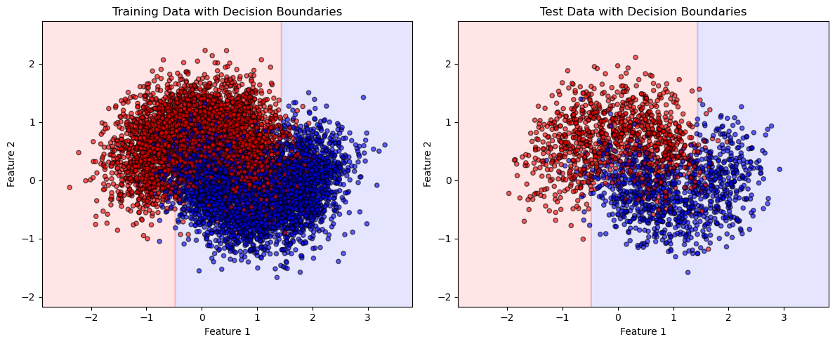
# Check the actual properties of the best tree
print("Actual tree properties:")
print(f"Max depth reached: {best_tree.get_depth()}")
print(f"Number of leaves: {best_tree.get_n_leaves()}")
print(f"Total number of nodes: {best_tree.tree_.node_count}")

Actual tree properties:
Max depth reached: 7
Number of leaves: 20
Total number of nodes: 39

