OroConnect: Integrated Barangay Services App for Oro Site

A Project Study Presented to
the Faculty of the Computer Studies at Computer Arts and Technological College, Inc.

In Partial Fulfillment of the Requirements for the Degree
BACHELOR OF SCIENCE IN INFORMATION TECHNOLOGY

by ABORDO, NOEL JR. S
APINADO, JOSH S VILLANUEVA, IAN JAMES A.

MARCH 2026

ADVISER’S RECOMMENDATION SHEET

This Capstone Project entitled

PROJECT STUDY TITLE TO BE TYPED USING ALL CAPITAL

LETTERS IN AN INVERTED PYRAMIDAL FORM

Developed by: NOEL SERRANO ABORDO JR.
JOSH SOLIS APINADO IAN JAMES ABAD VILLANUEVA

Submitted in partial fulfillment of the requirements of the Bachelor of Science in Information Technology degree has been examined and is recommended for acceptance and approval.

IAN CLINT EDIZA OFFEMARIA, MIT
Capstone Project Adviser MARCH 2026

PANEL’S APPROVAL SHEET

This Capstone Project, TYPE PROJECT STUDY TITLE IN CAPITAL LETTERS having been presented is hereby approved by the members of the panel.

ALLAN REY M. BELLEZA

Lead Panelist

MARY GRACE A. BUBAN, MIT

Panel Member

PETER PAUL A. SAN DIEGO, MIT

Panel Member

MARCH 2026

TABLE OF CONTENTS
Page TITLE PAGE 1
RECOMMENDATION SHEET. 2
APPROVAL SHEET 3
TABLE OF CONTENTS 4
CHAPTER
- PROJECT OVERVIEW
Background of the Study 6
Company Profile 28
Importance of the Study 34
Statement of the Problem. 36
Objectives of the Study 37
Definition of Terms 38
- METHODOLOGY
Software Development Methodology. 39
Scope and Delimitation of the Study 50
Data Gathering Techniques 54
Sources of Data 56
REFERENCES. 58
APPENDICES

A | Title | 1 | . . . . . . . . . . . . . . . . . . . . | 71
B | Title | 2 | . . . . . . . . . . . . . . . . . . . . | 72
C | Title | 3 | . . . . . . . . . . . . . . . . . . . . | 73
D | Title | 4 | . . . . . . . . . . . . . . . . . . . . | 78
E | Title | 5 | . . . . . . . . . . . . . . . . . . . . | 80

Chapter 1

PROJECT OVERVIEW

Background of the Study

The broader field of e-governance encompasses the use of information technology to modernize public administration, particularly in local units like barangays in the Philippines, which are the smallest administrative divisions responsible for essential services such as appointment scheduling for consultations, document issuance, and complaint resolution. Historically, barangay operations relied on manual, paper-based systems prone to inefficiencies, but the digital transformation era, beginning in the early 2000s, introduced web-based platforms that integrate multiple functions. Key concepts include appointment scheduling, which employs algorithms to optimize resource allocation and reduce wait times; document management, ensuring secure digital storage, retrieval, and compliance; and complaints management, facilitating real- time submission, tracking, and resolution of grievances to enhance accountability. Current trends emphasize user- friendly interfaces, real-time updates, and mobile accessibility to serve diverse stakeholders, including

residents, officials, and external agencies, aligning with global shifts toward inclusive digital infrastructures.
Efficient appointment, document, and complaints management systems are essential for barangay governance, especially in areas like Barangay 34 Oro Site Legazpi City, Province of Albay, Region V Bicol. This urban barangay, situated in a lowland area along Poblacion, Tabing-ilog, spans 9.8 hectares and has a total population of 3,373, with commercial activities as its major economic source. Manual processes in such settings result in long queues, lost documents, unresolved grievances, and administrative bottlenecks. These inefficiencies weaken service delivery, erode public trust, and sustain disparities in access to resources and justice. To mitigate these adverse effects, the adoption of a digital governance framework is imperative. Such a system facilitates the seamless exchange of information, reducing the dependency on physical presence and manual process. By establishing a centralized digital infrastructure, the barangay can ensure that administrative processes are transparent, efficient, and accessible to all residents. This technological intervention serves as a catalyst for modernizing local

administration and restoring confidence in public institutions. Stakeholders benefit from 24/7 access, realtime tracking, and equitable grievance handling, addressing gaps in Oro Site. Practically, systems support appointment scheduling, documents, and complaints management, promoting community development and digital transformation. This initiative contributes to Sustainable Development Goals the Industry, Innovation, and Infrastructure by building resilient digital infrastructures and fostering innovation to enable sustainable development in urban communities. It also advances Peace, Justice, and Strong Institutions through improved transparency and enhanced access to justice via accountable, inclusive public services that strengthen social cohesion and institutional integrity.
Research on web-based and mobile systems for public service management highlights their effectiveness in streamlining operations across various sectors. Appointment scheduling studies, such as those by Diantara et al. (2022), explore web-based booking service system applications using the Software Development Life Cycle method, providing methodological frameworks adaptable to barangay

consultations. Building on scheduling optimization, Esberto et al. (2023) developed and evaluated AppSys, an online appointment system, demonstrating the efficacy of digital platforms in reducing administrative burdens. Similarly, Mahmod et al. (2024) emphasize the need to innovate and automate business processes, noting that web-based solutions significantly enhance efficiency in appointment systems.
Furthermore, Hui and Teo (2024) implemented digital platforms specifically to enhance appointment scheduling, offering insights into improving attendance rates and resource utilization for scheduled services.
Extending beyond scheduling, document management research demonstrates the versatility of integrated solutions in government operations. Syauqi and Suendri (2022) detail secure web-based document archives management for provincial offices, demonstrating scalable approaches for government archiving needs. Similarly, Alade (2023) presents compliant designs for web-based document management systems, emphasizing security and accessibility in public record keeping. Directly applicable to local government contexts, Taruc et al. (2023) present Docu-Go, a barangay-

specific system for document requests with automated workflows. Complementing these efforts, Lim
(2022) designed a Barangay Integrated Management System with Mobile Support, highlighting the critical need for mobile accessibility in local governance to ensure that residents can access services regardless of their location.
Complaints management is emphasized in works like Sinlae et al. (2022), who developed electronic public complaints systems to improve public services, and Alenezy and Akhlaq (2023), who presented Fix-it, a public complaint management system design and implementation. Expanding the scope of complaint handling, Jenifa et al. (2023) developed an Android application for a complaint management system, proving that mobile-first approaches can facilitate realtime grievance resolution. Ningrum et al. (2025) further argue that a web-based citizen complaint system increases citizen participation in the village development process, linking feedback mechanisms to community growth.
Despite progress, gaps remain in integrated systems for barangays, particularly those incorporating complaints management with mobile support. Many studies, such as Mahmod et al. (2024) and Qiao et al. (2023), enhance clinic and

hospital appointment systems through web-based solutions, demonstrating sector-specific adaptations that inform but do not fully address barangay requirements. Similarly, while Esberto et al. (2023) contribute methodological insights for appointment optimization, their system lacks integration with document management and complaints handling functions essential for local governance. Although Lim (2022) addresses mobile support in barangay systems, there is a continued need for a unified platform that seamlessly combines scheduling, digital documents, and grievance resolution in a single accessible application. This project uniquely addresses these gaps by developing a comprehensive system that embeds appointment scheduling, documents, and complaints management, enabling online scheduling, real-time submission, tracking, and resolution to promote accountability and citizen engagement.
Building on this foundation, the capstone project aims to design and develop OroConnect: Integrated Barangay Services App for Oro Site. This initiative seeks to address identified inefficiencies by creating a user-friendly platform that combines scheduling, digital documents, and complaints resolution. By leveraging mobile and web

technologies, OroConnect ensures that residents of Barangay Oro Site have equitable access to local government services. This project contributes to sustainable local governance by fostering Industry, Innovation, and Infrastructure; and strengthening Peace, Justice, and Strong Institutions.

Review of Related Literature

The rapid advancement of information and communication technology has significantly transformed how organizations deliver services and manage information. In both public and private sectors, digital systems are increasingly used to automate administrative processes, improve operational efficiency, and enhance user accessibility. In particular, mobile and web-based applications have become essential tools for providing convenient and efficient services to users. These technologies enable organizations to streamline workflows, reduce manual processing, and provide real-time access to services and information.
In local government settings, particularly at the

barangay level, the adoption of digital systems can greatly improve the delivery of community services. Barangay offices are responsible for handling various administrative tasks such as scheduling appointments, receiving citizen

complaints, issuing official documents, and maintaining records. However, many barangays still rely on manual processes or fragmented systems, which can lead to inefficiencies, delays, and limited accessibility for residents. The integration of these services into a centralized digital platform can significantly improve service delivery, transparency, and communication between citizens and local government officials.
Several studies have explored the development and implementation of digital systems designed to improve service management and information processing. These include appointment scheduling systems that optimize service allocation and reduce waiting times, complaint management systems that facilitate citizen feedback and issue resolution, and document management systems that enhance the storage and retrieval of digital records. In addition, integrated information systems have been developed to combine multiple administrative functions within a single platform to improve efficiency and accessibility.
The purpose of this is to examine existing studies and technological developments related to appointment scheduling systems, complaint management systems, document management

systems, and integrated government service platforms. The reviewed literature provides insights into the design, implementation, and benefits of these systems across various sectors. By analyzing these related studies, this chapter establishes the theoretical and technological foundation for the development of the OroConnect: Integrated Barangay Services App for Oro Site, which aims to provide a unified mobile application that improves barangay service accessibility and efficiency for residents.
Appointment Scheduling Systems. Appointment scheduling systems have become essential tools in modern service oriented environments because they help reduce waiting times, improve resource allocation, and enhance service efficiency. According to Ala and Chen (2022), appointment scheduling in complex service environments requires systematic optimization to balance service capacity and customer demand. Their review highlights how scheduling algorithms can improve operational efficiency in service systems such as healthcare facilities. Similarly, Ala et al. (2022) explored fairness-based scheduling policies using a fuzzy ant lion optimizer, demonstrating that intelligent algorithms can enhance appointment allocation while ensuring

fairness among users. These studies emphasize that well- designed appointment systems can significantly improve service delivery, which is particularly relevant for public service environments such as barangays where demand for services can fluctuate.
Several studies have focused on the development of practical appointment systems in different service sectors. Doshi et al. (2022) proposed an electronic appointment and scheduling system designed to streamline service access and reduce manual booking processes. Similarly, Diantara et al. (2022) developed a web-based online booking system using the Software Development Life Cycle (SDLC) method to manage reservations effectively. Niu et al. (2023) further examined optimization techniques in scheduling systems, emphasizing the importance of computational models in improving appointment management performance. These findings indicate that digital scheduling platforms can significantly enhance efficiency by automating appointment allocation and reducing human error.
Research has also explored appointment systems within healthcare and other service-oriented industries. Woodcock et al. (2022) analyzed automated patient self-scheduling

systems and found that allowing users to book appointments independently increases operational efficiency and patient satisfaction. Likewise, Lu et al. (2022) investigated appointment window scheduling in healthcare environments and demonstrated that optimized time-slot allocation can reduce patient abandonment due to long waiting times. Jouini et al. (2022) also examined queueing systems in appointment-driven environments, highlighting how customer punctuality and scheduling policies influence service flow.
Other scholars have proposed the implementation of digital platforms to enhance appointment management. Hui and Teo (2024) emphasized that digital platforms improve service coordination by providing centralized scheduling and real- time updates. Hua et al. (2024) also addressed the issue of customer no-shows in appointment systems and suggested predictive methods to reduce missed appointments. Fall et al. (2025) further analyzed resource utilization in appointment scheduling systems, showing that effective scheduling improves operational productivity and reduces service bottlenecks.
Various practical implementations of appointment systems have been developed in different contexts. Esberto

et al. (2023) developed AppSys, an online appointment platform designed to improve scheduling efficiency and user accessibility. Similarly, Qiao et al. (2023) designed an online hospital registration and appointment management system that simplified patient registration and improved service coordination. Reguyal et al. (2023) implemented an online scheduling system for an obstetrics and gynecology clinic to streamline appointment management and reduce administrative workload. Additional implementations include systems for clinics and healthcare services (Srinivasan et al., 2024; Saavedra et al., 2024; Mahmod et al., 2024; Masano & Alapo, 2024), which demonstrate how appointment systems can improve service delivery through digital automation.
Additional studies have explored appointment management systems in other service-oriented environments. Brunner (2024) developed the Assistive Musician Management and Schedule Alignment Service, a scheduling system designed to help musicians manage performance schedules and coordinate appointments efficiently. Although designed for the music industry, the system demonstrates how digital scheduling tools can streamline appointment coordination in service-

based environments. Similarly, Huamaní (2024) designed a responsive web-based booking management system aimed at improving healthcare service quality by reducing waiting times and enhancing appointment coordination. Subhi et al. (2023) also proposed a doctor appointment system that simplifies patient booking and improves communication between patients and healthcare providers through an automated scheduling platform.
Beyond healthcare, appointment scheduling systems have also been implemented in other industries. Avuçlu and Taptal (2024) developed an online appointment system for barbershops to improve communication between service providers and customers. Similarly, Khoo and Omar (2024) created an online salon appointment system that enhances customer experience by providing real-time booking functionality. Tran (2026) and Khin et al. (2025) also proposed appointment management systems for beauty salons.
In the academic and organizational context, Lungu and Mwashi (2025) developed an online staff appointment system for educational institutions. Arunkiri and Rodjam (2023) provided guidelines for developing appointment systems for IT support services. These studies highlight the versatility

of appointment scheduling technologies across various sectors.
More advanced scheduling models have also been proposed to improve appointment system performance. Carlini et al. (2025) evaluated adaptive appointment booking systems that dynamically adjust schedules based on user demand. Yu et al. (2025) proposed real-time scheduling models that accommodate walk-in customers while maintaining scheduled appointments. Lakhani et al. (2023) also examined scheduling strategies for resource-constrained environments, demonstrating how optimized scheduling improves efficiency when service resources are limited. Patel et al. (2025) explored appointment management systems with real-time availability features, further highlighting the importance of dynamic scheduling systems.
These studies collectively demonstrate that appointment scheduling systems improve service efficiency, reduce waiting times, and enhance user satisfaction. The integration of such systems into a mobile application like OroConnect can significantly improve barangay service accessibility by enabling residents to schedule appointments digitally.

Complaint Management Systems. Complaint management systems play a crucial role in improving organizational responsiveness and maintaining service quality. Al-Waeli and Hassan (2022) developed a student complaint management system that automates complaint submission and tracking, enabling administrators to respond more effectively to user concerns. Similarly, Alifat et al. (2022) introduced a webbased campus complaint management system that improves communication between users and service providers through digital complaint handling processes.
Other researchers have also explored automated complaint management systems in institutional environments. Alex (2023) developed an automated web-based complaint management system for tertiary institutions, demonstrating that digital complaint platforms can streamline issue reporting and resolution processes. Likewise, Hamed et al. (2024) designed a student complaint management system that enhances transparency and accountability within educational institutions.
Public service environments have also adopted digital complaint management platforms. Alenezy and Akhlaq (2023) introduced Fix-it, a public complaint management system

designed to facilitate citizen engagement and streamline issue resolution in public services. Similarly, Ningrum et al. (2025) designed a web-based citizen complaint system aimed at increasing public participation in local governance. These studies emphasize the importance of providing digital platforms that allow citizens to report issues and receive timely responses from authorities.
Other researchers have also explored digital complaint platforms designed to improve public service responsiveness. Sinlae et al. (2022) developed an electronic public complaints system that enables citizens to submit concerns through a digital platform, allowing government agencies to respond more efficiently while improving transparency in the complaint resolution process. Similarly, Pratama and Widiono (2025) designed a web-based student complaint system equipped with an activity dashboard that allows administrators to monitor complaints, track resolution progress, and manage cases more effectively.
Mobile technologies have also been integrated into complaint management systems. Jenifa et al. (2023) developed an Android-based complaint management application that allows users to submit complaints directly from their mobile

devices. Similarly, Saputra and Sutopo (2025) implemented a web-based e-complaint system with WebSocket integration to enable real-time communication between users and administrators.
Several studies have also explored complaint management systems in organizational contexts. Merang et al. (2022) developed a complaint management system for water supply services to improve communication between service providers and consumers. Mutiawani et al. (2024) created a web-based complaint system for university laboratories to enhance service monitoring and issue tracking. Muzones and Pomperada (2025) developed a complaint management system for West Visayas State University, emphasizing improved service efficiency and complaint resolution.
Research has also examined the broader impact of complaint management systems on service quality. Jacobs and Liebrecht (2023) studied how public organizations respond to online complaints and found that timely responses improve organizational reputation and user trust. Jesiah (2025) analyzed e-grievance systems through the SERVQUAL framework, highlighting their role in enhancing service quality. Shuja et al. (2023) also examined the transformation of

traditional complaint handling into a robust e-complaint management system.
These studies demonstrate that digital complaint management systems improve transparency, accountability, and responsiveness in service organizations. Integrating such features into OroConnect will enable residents to submit complaints efficiently and ensure that barangay officials can respond to community concerns more effectively.
Document Management Systems. Document management systems are essential for organizing, storing, and retrieving digital records efficiently. Alade (2023) emphasized that web-based document management systems improve information accessibility and reduce administrative workload by automating document storage and retrieval processes. Similarly, Avazbek and Tohirbek (2025) discussed the automation of electronic document management systems to streamline organizational workflows.
Several studies have also explored digital record management systems in institutional environments. Bizi et al. (2025) conducted a systematic review of electronic records management systems and highlighted their importance in improving information governance and data management

practices. Bhambri et al. (2024) further discussed the role of intelligent automation in document management systems, emphasizing the shift toward paperless record-keeping.
Document archiving systems have also been developed for educational and government institutions. Daluyon (2024) designed an electronic document archiving system to improve record storage and retrieval efficiency. Hasibuan et al. (2026) developed a web-based document archive system for an education quality assurance agency. Similarly, Nagrama et al. (2024) implemented a web-based document management system that improves document organization and accessibility.
In government contexts, digital document management systems have also been implemented to support administrative operations. Gani et al. (2024) explored electronic document management systems within e-government environments, demonstrating their ability to improve service delivery and information transparency. Rodriguez et al. (2024) also examined document management digitalization in government agencies to improve administrative monitoring.
Other studies have explored the integration of advanced technologies in document management systems. Ferro et al.

(2023) discussed the use of artificial intelligence in digitizing historical documents, while Vayadande et al. (2024) proposed an AI-powered legal documentation assistant designed to improve document processing efficiency.
Researchers have also investigated document management systems in various institutional settings. Triyana and Fianty (2023) developed a web-based document management system for educational institutions to improve administrative efficiency. Orioque et al. (2024) highlighted the contextualized implementation of online document management systems to support organizational needs.
Similarly, Syauqi and Suendri (2022) designed a webbased document archive system for government planning agencies.
In the Philippine context, Taruc et al. (2023) developed Docu-Go, a web-based barangay document requesting system designed to simplify document requests and reduce administrative processing time. Barbieri et al. (2023) also discussed the integration of electronic health records into clinical management systems, highlighting the importance of centralized document management in service systems. Katuu (2023) further emphasized the need for proper training and infrastructure to manage digital records effectively.

These studies highlight the importance of digital document management systems in improving information organization and service efficiency. Integrating document request and management features in OroConnect can help barangay offices manage records more effectively while providing residents with convenient access to essential documents.
Integrated Government Service and Information Systems.

Integrated service systems are increasingly being adopted by governments to improve public service delivery. Lim
(2022) developed a barangay integrated management system with mobile support that enables local government units to manage administrative tasks more efficiently. Such systems demonstrate the potential of digital platforms in improving local governance and community engagement.
Adebayo (2025) proposed a sustainable framework for web-based appointment and evaluation management in healthcare delivery, highlighting how integrated digital systems can improve service coordination and evaluation. Similarly, Adil et al. (2022) examined online service failures and their impact on user satisfaction, emphasizing the importance of reliable digital service platforms.

These studies highlight the growing adoption of digital systems in public service environments. Integrated systems allow organizations to combine multiple service functions within a single platform, improving operational efficiency and user accessibility. For local governments, such systems can facilitate better communication between citizens and authorities while streamlining administrative processes.
The reviewed literature demonstrates the growing importance of digital information systems in improving service delivery across various sectors. Studies on appointment scheduling systems highlight the effectiveness of automated booking platforms in reducing waiting times, improving resource utilization, and enhancing service efficiency. Research on complaint management systems emphasizes the role of digital platforms in improving transparency, accountability, and citizen engagement.
Meanwhile, document management and records systems have been shown to enhance administrative efficiency by enabling organizations to store, manage, and retrieve digital records effectively.
Furthermore, studies on integrated information systems demonstrate how combining multiple service functions within

a single platform can significantly improve service coordination and accessibility. Despite the advancements in digital service systems, many local government units still rely on fragmented or manual processes for handling appointments, complaints, and document requests.
Based on these findings, there is a clear need for an integrated mobile-based platform that consolidates multiple barangay services into a single application. The proposed OroConnect system aims to address this need by providing a unified mobile application that integrates appointment scheduling, complaint management, and document request functionalities. By leveraging insights from existing studies, OroConnect seeks to enhance service efficiency, improve citizen engagement, and support digital transformation within barangay-level governance.

Company Profile

Barangay 34 Oro Site is an urban barangay located in Legazpi City, Province of Albay, Region V Bicol. Situated in a lowland area along Poblacion, Tabing-ilog, this barangay spans a total land area of 9.8 hectares and serves as a commercial hub within the city. According to recent data, the barangay has a total population of 3,373 residents,

comprising 691 households and 1,016 families. The primary economic activity in the area is commercial trading, which serves as the major source of livelihood for the community residents.
Barangay Oro Site provides various essential services to its residents, including the issuance of certificates and permits, facilitation of community programs, and other administrative functions handled by the barangay officials. Among these services, the Certificate of Indigency is the most frequently requested document by the residents.
Currently, the barangay operates using a completely manual process for scheduling appointments and requesting documents, wherein residents need to visit the barangay hall in person to submit their requests. This manual approach involves filling out paper-based forms, recording information in logbooks, and physically retrieving documents upon approval. On average, it takes approximately
5 to 10 minutes to process a typical request, from the time of submission until the document is issued.
The reliance on manual processes for appointment scheduling, document requests and complaints management presents significant inefficiencies and challenges for both

the barangay staff and the residents. Residents often need to queue for extended periods, especially during peak hours, which leads to inconvenience and wasted time. The absence of a digital platform makes it difficult to track the status of requests, manage appointment schedules efficiently, and maintain organized records of all transactions. These limitations highlight the urgent need for the development of an integrated mobilebased appointment, document, and complaints management system that can streamline operations, reduce waiting times, and improve overall service delivery in Barangay Oro
Site.
Regarding grievances and complaints handling, Barangay
Oro Site has established a formal system for managing complaints, which involves the manual recording of all incoming complaints in a dedicated logbook. Residents can file their complaints through two primary channels: inperson walk-ins at the barangay hall and via telephone calls. All complaints are recorded in a manual logbook, and the Barangay Captain is primarily responsible for resolving these issues. The average response time to acknowledge a complaint is approximately 5 hours, while the average

resolution time ranges from 5 to 7 days. Common types of complaints received include neighborhood disputes, noise disturbances, property line issues, waste management concerns, physical injuries, and verbal abuse. The biggest challenge faced in handling complaints effectively is managing angry emotions from complainants, which can be difficult to address without a structured and systematic approach.
Residents are currently notified of their complaint status through written notices and phone calls, which can be time-consuming and may not provide real-time updates. The barangay has expressed strong interest in including a digital Complaints Management module in the new proposed system, which would enable residents to track the status of their complaints via the mobile app, receive automatic system notifications, and allow for more efficient resolution of issues. This aligns perfectly with the capstone project's goal of developing an integrated mobile platform that encompasses not only appointments and documents management but also a complaints handling mechanism.

The current operations of Barangay 34 Oro Site heavily rely on manual processes for document management and scheduling. No digital tools, software, or spreadsheets are currently being used for these purposes. All transactions are conducted through paper-based methods, including handwritten forms and logbooks. The barangay does not use any specific software for managing complaints, further emphasizing the need for a complete digital transformation.
Several challenges have been identified in the current system, including time-consuming paper handling, difficulty in tracking the status of requests, limited transparency for residents regarding their document or complaint status.
These inefficiencies not only affect the daily operations of the barangay but also impact the satisfaction of the residents who rely on these services.
Barangay Oro Site demonstrates a positive and open attitude toward adopting new technology for improving public service delivery. The barangay officials have expressed willingness to embrace a mobile application for managing appointments, document requests, and complaints, which forms the foundation of the capstone project titled

"OroConnect: Integrated Barangay Services App for Oro Site."
Currently, they have no specific concerns regarding cost, digital literacy, or security issues related to implementing a new digital system. This openness to change provides a favorable environment for the development and implementation of the proposed system. The long-term vision of the barangay is to establish Barangay 34 Oro Site as a community of responsible people that upholds commitment, values, unity, and discipline.
The officials believe that technology can significantly contribute to the progress of the community by streamlining processes, enhancing transparency, and improving overall service delivery to the residents. The integration of a mobile-based application will not only address the current pain points in appointment scheduling and document management but also provide a platform for efficient complaints handling, which is essential for maintaining peace and order in the community.
The proposed system, OroConnect is designed to address the challenges and limitations currently experienced in the barangay's operations. The project aims to develop a

comprehensive mobile application that will replace the manual processes with digital solutions, enabling residents to schedule appointments, request documents, and file complaints through a single accessible mobile platform.

Importance of the Study

The OroConnect: Integrated Barangay Services App for Oro Site represents a significant advancement in local governance, combining appointment scheduling, documents and complaints handling into a unified mobile-based platform.
This integration streamlines administrative processes, enhances accuracy, and boosts accessibility, ultimately improving service delivery and community engagement within the barangay framework. By modernizing traditional manual methods, the system addresses inefficiencies in scheduling, documents, and complaints, fostering a more efficient, transparent, and user-friendly environment that aligns with national digital transformation goals.
To the Barangay. Barangay Oro Site improves efficiency, transparency, and community trust through a mobile-based platform that supports online services and administrative management aligned with national policies.

To the Barangay Officials. The platform reduces manual tasks by automating appointment scheduling and enabling real-time tracking of documents and complaints.
To the Barangay Residents. Barangay Oro Site residents can easy access to services through online appointment scheduling, documents and complaints management.
To the Researchers. The study enhances researchers' skills in e-governance, stakeholder engagement, and community-focused research, preparing them for future careers in public service and technology.
To Future Researchers. This study offers a model for digital tools in barangay governance, with potential for future research on scalability, emerging technologies, and long-term socio-economic impacts.
The proposed platform, by fulfilling the requirements of these key stakeholders, demonstrates innovation in local administration, record systems, and community services. It not only modernizes operations at Barangay Oro Site but also sets a replicable model for other barangays, promoting efficiency, transparency, and inclusivity in Philippine local governance. This contributes to overall societal progress by empowering communities and aligning with

national efforts toward digital equity and sustainable development.

Statement of the Problems

Barangay Oro Site, a local government unit in the Philippines, currently relies on manual processes for managing appointments, documents and complaints, leading to several operational inefficiencies. Residents often face long waiting times, scheduling conflicts, and errors in document processing due to the lack of a centralized mobile platform. These challenges highlight the need for a digital solution to streamline operations, enhance transparency, and improve service quality in Barangay Oro Site.
Specifically, this study seeks to answer the following problems:
1. What are the information, hardware, and software requirements are needed to design and develop the proposed OroConnect: Integrated Barangay Services App for Oro Site? 2. What are the features of the proposed OroConnect:
Integrated Barangay Services App for Oro Site?
3. What is the extent of usability and accuracy of the proposed OroConnect: Integrated Barangay Services App for Oro Site?

Objectives of the Study

The general objective of this study is to design and develop OroConnect: Integrated Barangay Services App for Oro Site to streamline administrative processes, enhance service delivery, and improve resident satisfaction through digital integration.
Specifically, this study aims to:

- determine the information, hardware, and software requirements that are needed to design and develop the proposed OroConnect: Integrated Barangay Services App for Oro Site;
- identify and develop the features of the proposed OroConnect: Integrated Barangay Services App for Oro Site; and
- assess the extent of usability of the proposed OroConnect: Integrated Barangay Services App for Oro Site.

Definition of Terms

The following terms are defined for clarity in the study.
OroConnect. The proposed integrated mobile application combining appointments, documents, and complaints managemennt.

Appointment Scheduling. Digital booking of time slots for barangay consultations to optimize resources and reduce physical wait times.
Documents Management. A sub-system for the secure storage, retrieval, and issuance of digital records.
Complaints Management. A sub-system for submitting, tracking, and resolving barangay grievances efficiently.
Digital Transformation. The shift from manual, paperbased processes to integrated digital systems.
E-governance. Utilization of IT to modernize public administration and enhance service delivery.
Mobile Accessibility. The capability to access services through mobile devices for 24/7 availability.
Real-time Updates. Instant notifications from application regarding the status of requests, appointments, or complaints.
Stakeholders. Barangay officials and residents who interact with or benefit from the system.
Accuracy. The correctness and reliability of data processing and transaction record.

Chapter 2 METHODOLOGY
This chapter describes the research design and development process of the Integrated Appointment and Documents Management System in Barangay Oro Site based on descriptive-developmental approach to analyze the current manual processes and as well develop, test and review web-based system using Agile methodology in iterative processes involving Requirements, Design, Development, Testing, Deployment, and Review.

Software Development Methodology

The research will use Agile approach to enable flexibility, constant enhancement and stakeholder joint work during the development cycle. Agile will be chosen since it allows developing the system in small steps and making changes according to the feedback of the barangay officials and people living

in the area.The Agile process that will be used in this study will consist of six major phases:
Requirements, Design, Development, Testing, Deployment, and Review. Each phase will contribute to the systematic creation of the integrated system.
The Agile methodology was selected for this study because the development of the proposed system requires continuous evaluation and improvement of features based on the needs of the barangay officials and residents. Through iterative development, the researchers were able to gradually design, develop, and refine the system components such as appointment scheduling, document requests, and complaint submission. This approach helps ensure that the system remains aligned with the operational needs of Barangay 34 Oro Site while allowing adjustments during the development process.

Figure 1: Agile Methodology
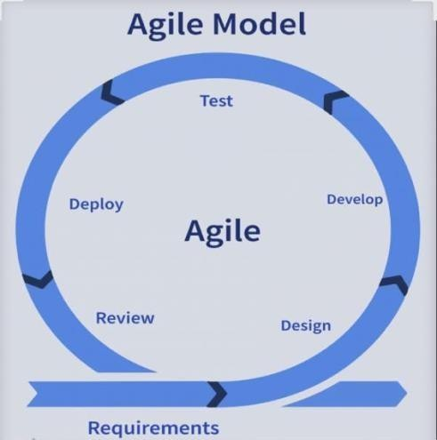
Requirement Phase. The Requirements Phase focuses on identifying and analyzing the needs of Barangay Oro Site in effectively managing appointments, documents, and complaints. During this phase, the researchers will gather essential information to understand the current processes and challenges experienced by barangay officials and residents. The primary objective is to determine both the functional requirements, which define the specific features and capabilities of the system, and the non-functional requirements, which include aspects such as system performance, usability, security, and reliability.

Data collection methods such as interviews, observations, and document reviews may be conducted to obtain accurate and relevant information about the existing workflow. The results of this phase will serve as the foundation for designing and developing the proposed system. By clearly identifying the system requirements, the researchers can ensure that the developed solution will effectively address the needs of Barangay Oro Site and improve the efficiency of its service delivery.
During this stage, interviews and observations will be conducted to understand the existing workflows and operational challenges within the barangay. These activities will help the researchers identify the key processes involved in managing appointments, documents, and complaints. Based on the gathered information, the proponents will determine essential system features such as user registration and authentication, appointment scheduling, document

request processing, complaint submission and tracking, report generation, and an administrative dashboard. In addition, the hardware and software requirements necessary to support the system will also be identified. This stage ensures that the proposed system is aligned with the actual needs and operations of the barangay.
Design Phase. The Design Phase focuses on planning how the system will function and how users will interact with it. During this phase, the gathered requirements are translated into structured system models and interface layouts to provide a clear blueprint for development. This includes designing workflows, data structures, and user interfaces to ensure efficiency and usability. The phase also defines the system architecture and specifications needed for implementation. Overall, it ensures that the system is well-organized,

functional, and ready for the next stage of development.
The proponents will develop system flowcharts, use case diagrams, database structures, and user interface prototypesto provide a detailed blueprint of the proposed system. The system architecture will be designed to ensure secure data handling and proper integration of the appointment, document, and complaint modules. Additionally, the principles of user-centered design will be applied to make the system simple, intuitive, and easy to access for all users. This approach ensures that both the mobile platform for residents and the web-based platform for administrators are efficient, functional, and userfriendly. Overall, these design strategies provide a solid foundation for the successful development and implementation of the system.
Development Phase. The Development Phase will involve the actual coding and construction of the

system based on the approved design. During this phase, the system’s functionalities, workflows, and interfaces will be implemented according to the specifications outlined in the design phase. This will include developing both the mobile platform for residents and the web-based platform for administrators, ensuring that all modules for appointments, document management, and complaints will be properly integrated. The phase will also involve testing individual components to ensure they will function correctly before full system integration. Overall, the Development
Phase will transform the planned designs into a fully functional and operational system.
The system modules will be developed using incremental development. First, the proponents will introduce the user management capabilities, followed by the implementation of the appointment scheduling module. Next, the document management module will be

developed to support the digital submission and processing of requests. Finally, the complaint management module will be addedto enable real-time submission and tracking of complaints. Additionally, database connectivity and back-end functionalities will be established to ensure efficient storage and retrieval of data throughout the system.
Testing Phase. The Testing Phase will ensure that the developed system meets the specified requirements and performs accurately. During this phase, each module of the system, including user management, appointment scheduling, document management, and complaint handling, will be thoroughly tested to verify functionality, reliability, and security. The proponents will conduct both unit testing of individual components and integration testing to ensure that all modules work together seamlessly. Any errors or issues identified during testing will be correctedto maintain system quality and performance.

Overall, this phase will confirm that the system is fully functional, user-friendly, and ready for deployment.
Functional testing will be conducted to ensure that each module of the system is working as intended, while integration testing will verify that all modules operate together seamlessly. To assess usability, a System Usability Scale (SUS) questionnaire will be administered to evaluate ease of use, learnability, and overall user satisfaction. Any errors or bugs identified during these tests will be corrected to ensure the system functions reliably. This comprehensive testing process will ensure that the system is fully operational, user-friendly, and ready for deployment.
Deployment Phase. The Deployment Phase will involve implementing the system within Barangay Oro Site for actual use. During this phase, the developed system will be installed and configured to ensure

that it operates properly in the barangay’s working environment. The mobile application for residents and the web-based system for administrators will be deployed to allow users to access the system’s features. Barangay staff will also be oriented on how to use and manage the system effectively. This phase will ensure that the system is fully operational and ready to support the barangay’s services.
The system will be introduced and installed in the identified environment of Barangay Oro Site. Both the web-based system for administrators and the mobile application for residents will be deployed to ensure that all users can access the system’s features. Barangay officials will be trained on using the system, including appointment approvals, document processing, and complaint monitoring. Appropriate adjustments will be made to ensure compatibility with the existing hardware and internet infrastructure.
These activities will ensure that the system is fully

operational, accessible, and ready to support the efficient delivery of barangay services.
Review Phase. The Review Phase will focus on evaluating the system’s overall performance to determine how effectively it meets the intended objectives. This phase will involve assessing the system’s functionality, reliability, and usability, as well as identifying any areas that may require improvement. Feedback from users and administrators will be gathered to inform necessary updates and enhancements. By conducting this evaluation, the system can be refined to ensure it operates efficiently and continues to meet the needs of
Barangay Oro Site.
Feedback will be collected from barangay officials and selected residents following the initial use of the system. Observations and usability results will be analyzed to assess the system’s effectiveness, accuracy, and overall performance.

Based on these findings, necessary refinements will be incorporated to continuously improve the system and ensure it meets the needs of both administrators and residents. This process will help maintain a reliable, efficient, and user-friendly system for Barangay Oro Site.

Scope and Delimitation of the Study

This study focuses on the design and development of a Barangay Service Management System intended to improve the efficiency, accessibility, and organization of selected administrative services in Barangay 34 Oro Site, Legazpi City. The system aims to provide residents with a more convenient way to interact with the barangay office by allowing them to access services through a digital platform.
The system includes several core features that support common barangay transactions. These features include appointment scheduling, which allows residents to set appointments with the barangay office for specific services in order to reduce waiting time and manage the flow of visitors. The system also provides a document request module

where residents can submit requests for barangay documents such as certificates and clearances. Through the system, barangay personnel can review, manage, and process these requests more efficiently.
Another feature included in the system is the complaint submission function, which allows residents to report concerns, issues, or community-related problems directly through the application. This feature aims to improve communication between residents and barangay officials by providing a structured and accessible way to submit complaints. In addition, the system provides service notifications that inform users about the status of their requests, scheduled appointments, or important announcements from the barangay office.
The system consists of a mobile application for residents and an administrative management interface for barangay personnel. The mobile application enables residents to access barangay services, submit requests, schedule appointments, and receive notifications. On the other hand, barangay administrators can monitor requests, manage appointments, review complaints, and update service information through the system’s management interface.

The study also covers the development, implementation, and testing of the system to evaluate its functionality, usability, and effectiveness in supporting barangay administrative services. The evaluation involves assessing whether the system can help streamline processes, improve service accessibility, and enhance communication between the barangay office and its residents.
Overall, the scope of the study is limited to the development and evaluation of a digital platform that supports selected administrative services of Barangay 34 Oro Site. The system is intended to assist both barangay personnel and residents by providing a more organized and accessible way of managing service requests and communication within the community.
This study focuses on the development of a Barangay Service Management System designed to improve the efficiency of service delivery in Barangay 34 Oro Site, Legazpi City.
However, several limitations are established to define the boundaries of the system and the research.
First, the system is specifically designed for Barangay
34 Oro Site, Legazpi City, and the implementation of the system is limited to the services and administrative

processes available within this barangay. The system design and results of the study may not necessarily apply to other barangays or local government units that may have different administrative procedures and service structures.
Second, the system only includes selected barangay services such as appointment scheduling, complaint submission, document requests, and service notifications. Other barangay functions and programs, including health services, disaster response management, and community development programs, are not included in the system.
Third, the system does not support online payment integration. Payments for barangay services, particularly those related to document requests and other service fees, are conducted personally at the barangay office using traditional payment methods. The system only facilitates the request and scheduling processes, while the actual payment transactions are handled directly at the barangay office.
Fourth, the mobile application developed for the system is limited to Android devices only. The system is designed and optimized for Android smartphones, and it does not currently support other mobile operating systems such as iOS. Users who do not have Android devices may access the

system through alternative methods if available, but the mobile application itself is specifically built for the Android platform.
Fifth, the system requires internet connectivity in order to access its features and services. Residents must have access to an internet-enabled device and a stable internet connection to use the system effectively.
Individuals without internet access may still rely on traditional manual transactions at the barangay office.
Lastly, the study focuses primarily on the design, development, and evaluation of the system's functionality and usability. Long-term maintenance, large-scale government deployment, and integration with other government information systems are beyond the scope of this research.

Data Gathering Techniques
This section presents the data gathering techniques used by the researchers to obtain the necessary information for the development and evaluation of the proposed OroConnect: Integrated Barangay Services App for Oro Site. The techniques help the researchers identify the system requirements, understand the existing barangay processes, and evaluate the usability of the developed application. The data gathering

techniques used in this study include interviews, observation, and survey questionnaires.
Technique 1: Interviews. The interview technique will be conducted with selected barangay officials, staff and residents to determine the information, hardware, and software requirements needed for the design and development of the proposed OroConnect system. This technique supports Objective 1, which aims to identify the necessary requirements for the development of the system.
Technique 2: Observation. Observation will be conducted within the barangay office to examine the current procedures used in managing services such as appointment scheduling, document requests, and complaint handling. This technique supports Objective 2, which focuses on identifying and developing the appropriate features of the proposed OroConnect: Integrated Barangay Services App for
Oro Site.
Technique 3: Survey Questionnaire. The survey questionnaire will be administered to selected residents and barangay personnel who will use the developed system. This technique supports Objective 3, which aims to assess the

usability of the proposed OroConnect system in terms of its functionality and overall performance.

Sources of Data

This section presents the sources of data used in the study. These sources provide the necessary information to support the development and evaluation of the proposed OroConnect: Integrated Barangay Services App for Oro Site. The data gathered from these sources are aligned with the data collection techniques such as interviews, observation, and survey questionnaires.
Source 1: Barangay Officials and Staff of Barangay 34
Oro Site. Barangay officials and administrative staff serve as the primary source of information for determining the information, hardware, and software requirements needed for the development of the proposed system. Through interviews and observation, the researchers will gather insights regarding the current procedures in managing appointments, document requests, and complaint handling within the barangay office. This source supports Objective 1, which aims to determine the requirements necessary to design and develop the proposed system.

Source 2: Current Barangay Administrative Processes and Office Operations. The existing administrative operations and workflow processes within the barangay office serve as another important source of data. Through observation, the researchers will examine how services such as appointment scheduling, document processing, and complaint management are currently performed. This source helps the researchers identify operational procedures and system features that need to be integrated into the proposed application. This source supports Objective 2, which focuses on identifying and developing the features of the proposed OroConnect system.
Source 3: Selected Residents and Barangay Personnel.

Selected residents and barangay personnel who will use and evaluate the developed application will serve as respondents for the survey questionnaire. Their responses will be used to assess the usability, functionality, and overall performance of the proposed system. This source supports Objective 3, which aims to evaluate the usability of the proposed OroConnect: Integrated Barangay Services
App for Oro Site.

REFERENCES

A. Published Materials

Adil, M., Sadiq, M., Jebarajakirthy, C., Maseeh, H. I., Sangroya, D., & Bharti, K. (2022). Online service failure: antecedents, moderators and consequences. Journal of Service Theory and Practice, 32(6), 797– 842.
Adebayo, T. O. (2025). A sustainable ERA framework for webbased medical appointment and evaluation management in healthcare delivery. Computer Engineering and Intelligent System Journal, 13(4), 1–18.
Alade, S. (2023). Design and implementation of a web-based document management system. International Journal of Information Technology and Computer Science, 15(2), 35– 53.
Ala, A., & Chen, F. (2022). Appointment scheduling problem in complexity systems of the healthcare services: A comprehensive review. Journal of Healthcare Engineering, 2022(1), 5819813.
Ala, A., Simic, V., Pamucar, D., & Tirkolaee, E. B. (2022).

Appointment scheduling problem under fairness policy

in healthcare services: Fuzzy ant lion optimizer.
Expert Systems with Applications, 207, 117949.

Al-Waeli, W. S. N., & Hassan, N. B. (2022). Student complaint management system. Applied Information Technology and Computer Science, 3(1), 748–759.
Alenezy, F. A., & Akhlaq, M. (2023). Fix-it: Design and implementation of a public complaint management system. In 2023 International Conference on Computer
Science, Information Technology and Engineering (ICCoSITE) (pp. 858–862). IEEE.
Alex, A. O. I. (2023). An automated and robust tertiary institution web-based student complaint management system. International Research Journal of Innovations in Engineering and Technology (IRJIET), 7(12), 110– 124.
Alifat, F. A., Biodun, O. A., Oluwatobi, O. A., & Jennifer,
U. (2022). Web-based campus complaint management system (WCCMS). International Journal of Computer
Trends and Technology, 70(10), 28–36.

Arunkiri, M., & Rodjam, C. (2023). Guidelines for developing an appointment system for IT support teams.
International Conference on Management, Innovation,

Economics and Social Sciences.

Avuçlu, E., & Taptal, K. (2024). An advanced online appointment system for hairdressers and barbers to communicate seamlessly with their customers. Selcuk University Journal of Engineering Sciences, 23(2), 42– 47.
Avazbek o’g’li, A. X., & Tohirbek O‘ktamjon o‘g, S. (2025). Automation of electronic document management. Spanish Journal of Innovation and Integrity, 41, 404–407.
Barbieri, C., Neri, L., Stuard, S., Mari, F., & MartínGuerrero, J. D. (2023). From electronic health records to clinical management systems. Clinical Kidney Journal, 16(11), 1878–1884.
Bhambri, P., Rani, S., & Pareek, P. K. (2024). Paperless paradigm: Intelligent automation in document and record management. In Hyperautomation in Business and
Society (pp. 164–183). IGI Global.

Bizi, M. K., Ghazali, A. M., & Yunus, M. N. (2025). Adoption of electronic records management systems: A systematic review. Journal of Information and Knowledge Management, 15(SI2), 280–292.

Brunner, S. A. (2024). Appointment management for musicians: Assistive Musician Management and Schedule Alignment Service (Doctoral dissertation, FH CAMPUS 02).
Carlini, M., Anatriello, G., & Cicchiello, E. (2025).

Evaluation study of an adaptive appointment booking system. International Congress on Information and Communication Technology.
Daluyon, M. A. (2024). Design and development of electronic document archiving system. Journal of Innovative Technology Convergence, 6(4), 35–44.
Diantara, R., Siswanto, S., & Yupianti, Y. (2022). Webbased online booking service system application design using software development life cycle method. Jurnal Media Computer Science, 1(1), 19–24.
Doshi, S. H., More, R. A., Nikam, N. S., & Onkare, R. P. (2022). E-appointment and scheduling system.
International Journal of Recent Scientific Research,
13(07), 1889–1891.

Esberto, E. M., Malaborbor, R. A. C., & Ablan, A. M. (2023).
Development and evaluation of AppSys: An online

appointment system. In 2023 7th International
Conference on E-Society, E-Education and E-Technology (ESET) (pp. 18–23). IEEE.
Fall, M., Slama, I., & Ouazene, Y. (2025). Managing noshows and resource utilisation for outpatient appointment scheduling. IFAC-PapersOnLine, 59(10), 745–750.
Ferro, S., Pelillo, M., & Traviglia, A. (2023). AI-assisted digitalisation of historical documents. The International Archives of the Photogrammetry, Remote Sensing and Spatial Information Sciences, 48, 557–562.
Gani, D. H. A., Abd Kadir, I. K., Rahman, A. A., & Yunus, A.

M. (2024). Electronic document management system in electronic government environment. European Proceedings of Social and Behavioural Sciences.
Hamed, M., Al-Harbi, O., Al-Mukhalf, A., & El-Boghdadi, H.
M. (2024). Design of students complaints management system. International Journal of Computer Science & Network Security, 24(12), 205–212.
Hasibuan, N. N., Harahap, T. B., & Furqan, M. (2026). Design and implementation of a web-based document archive application at the North Sumatra Education
Quality Assurance Agency. International Journal of

Education, Social Studies, and Management, 6(1), 1–11.

Hua, Y., Che, T., Yang, C., & Hu, M. (2024). Customer noshow reduction in web-based appointment services. The Service Industries Journal, 44(7–8), 538–562.
Huamaní, E. L. (2024). Design of a booking management system with responsive design web appointments to reduce time and improve the quality of health care services.
Journal of Electrical Systems, 20(3), 457– 468.

Hui, L. Y., & Teo, P. C. (2024). An implementation of digital platform to enhance the appointment scheduling system. International Journal of Academic Research in Business & Social Sciences, 14(2).
Jacobs, S., & Liebrecht, C. (2023). Responding to online complaints in webcare by public organizations: The impact on continuance intention and reputation.
Journal of Communication Management, 27(1), 1–20.

Jenifa, D. R., Savitha, Y., & Theebika, K. (2023). Android application for complaint management system.
International Journal of Scientific Research in Science, Engineering and Technology, 10(3), 104–111.
Jesiah, S. (2025). Webportal in e-grievance management system assessing its functionality through the lens of

SERVQUAL dimensions. Electronic Government, an International Journal, 21(4), 391–404.
Jouini, O., Benjaafar, S., Lu, B., Li, S., & Legros, B. (2022). Appointment-driven queueing systems with nonpunctual customers. Queueing Systems, 101(1), 1–56.
Katuu, S. (2023). Tapestry of the education and training landscape for archives and records management in Africa. In Managing Digital Records in Africa. Taylor & Francis.
Khoo, K. Z. X., & Omar, N. A. (2024). Online salon appointment and management system of FOREVER18 Hair Salon. Applied Information Technology and Computer Science, 5(2), 331–350.
Khin, S. W., Yee, H. H., & Nwe, D. K. T. (2025). Beauty salon appointment system.
Lakhani, S., Mahajan, A., Baheti, A. D., & Kulkarni, S. (2023). Online appointment scheduling in resourceconstrained facilities. EUROSIM Congress.
Lim, J. P. (2022). Barangay integrated management system with mobile support. International Journal of Computer Science and Mobile Computing, 11(7), 119–127.

Lu, Y., Jiang, Z., Geng, N., Jiang, S., & Xie, X. (2022).

Appointment window scheduling with wait-dependent abandonment for elective inpatient admission.
International Journal of Production Research, 60(19), 5977–5993.
Lungu, J. N., & Mwashi, M. (2025). Design and development of an online school staff appointment system.
Mahmod, M. N., Mokhtar, R., & Mohamed, H. (2024). Web-based solutions for clinic appointment system enhancement.
Applied Information Technology and Computer Science,
5(1), 1341–1349.

Masano, L., & Alapo, R. S. (2024). An automated patient’s appointment scheduling system for the dental unit at School of Dentistry Makerere University. Doctoral dissertation, Makerere University.
Merang, E. K., Ibrahim, A. F., & Jamaluddin, M. N. F. (2022). Development of a web-based water supply complaint management system. Journal of Computing Research and Innovation, 7(2), 211–222.
Mutiawani, V., Al Hafist, P., & Dawood, R. (2024). Design and development of a web-based complaints management system at Syiah Kuala University Integrated

Laboratory. International Journal Software Engineering and Computer Science, 4(2), 396–408.
Muzones, E. Z., & Pomperada, J. R. (2025). A complaint management system for enhanced efficiency at West Visayas State University Himamaylan City Campus. Philippine Social Science Journal, 8(2), 71–71.
Nagrama, N. D. C., Lingating, M. L. D., Calleno, J. T., Rato, R. K. A., Catungal, M. L. P., & Encarnacion, P.
C. (2024). Web-based document management system.
International Journal, 13(3).

Ningrum, D. A. C., Riadi, A. A., & Susanto, A. (2025). Design of a web-based citizen complaint system in increasing citizen participation in the village development process. Journal La Multiapp, 6(2), 312– 324.
Niu, T., Lei, B., Guo, L., Fang, S., Li, Q., Gao, B., & Gao,

K. (2023). A review of optimization studies for system appointment scheduling. Axioms, 13(1), 16.
Orioque, J., Pajaron, S., & Cabardo, J. (2024).
Contextualized online document management systems.
Journal of Innovative Technology Convergence, 6(1).

Patel, R., Pawar, A., & Deshpande, K. (2025). Appointment management, real-time availability, and precise disease. In Proceedings of Sixth Doctoral Symposium on Computational Intelligence (DoSCI 2025) (p. 471).
Springer.
Pratama, W. D., & Widiono, S. (2025). Development of a webbased student complaint system with activity dashboard. Journal of Scientific Research, Education, and Technology (JSRET), 4(4), 2699–2710.
Qiao, C. J., Keong, L. K., & Jegatheswaran, R. (2023). Online hospital registration and appointment management system (OHRAMS). Journal of Applied Technology and Innovation, 7(1).
Reguyal, J. M. T., Agno, A. M. S., Martinez, M. C., Castro,
J. T., Cariazo, B. V., Olipas, C. N. P., & Alegado, R.
T. (2023). Ob-Gyn clinic online scheduling system.
Formosa Journal of Computer and Information Science, 2(1), 25–36.
Rodriguez, B. A., Aquiatan, V. T., Verallo, C. J. A., Agpad, S. B., De Loyola, R. C., & Bibangco, E. J. P. (2024). Digitalization of document management and monitoring in the Department of the Interior and Local

Government Negros Occidental. In 2024 15th International Conference on Computing Communication and Networking Technologies (ICCCNT) (pp. 1–8). IEEE.
Saavedra, C., Honores, C., & Ticona, W. (2024).
Implementation of a web-based system to improve the appointment process in a clinic. In 2024 14th International Conference on Cloud Computing, Data Science & Engineering (Confluence) (pp. 116–123).
IEEE.
Saputra, J. A., & Sutopo, J. (2025). Development of a webbased e-complaint platform with WebSocket integration using the prototyping method. JUKI: Jurnal Komputer dan Informatika, 7(2), 197–208.
Shuja, A., Awan, M. I., & Saleem, I. (2023). Cotton Web Limited: A journey from disintegrated complaint handling to an efficient and robust e-complaint management system. Emerald Emerging Markets Case Studies, 1–19.
Sinlae, A. A. J., Daniarti, Y., Alamsyah, D., & Damuri, A. (2022). Development of an electronic public complaints system to improve public services. Jurnal Pilar Nusa Mandiri, 18(1), 81–86.

Srinivasan, S., Duraimutharasan, N., Ganesh, D., Nagaraj, S., & Balaji, R. L. (2024). A web-based doctor appointment system.
Subhi, A., Jalal, D., & Samal, M. (2023). Doctor appointment system. PhD dissertation.
Syauqi, S., & Suendri, S. (2022). Information system design of web-based document archives management in the Office Bappeda of North Sumatra Province. Journal of Information Systems and Technology Research, 1(1),
7–17.
Taruc, F. S., Martin, T. A. S., Olipas, C. N. P., & Alegado,

R. T. (2023). Docu-Go: The development and assessment of a web-based barangay document requesting system. International Journal of Information
Technology and Computer Engineering, 34, 40–49.
Tran, A. (2026). Nail salon appointment management system.

Triyana, M. H., & Fianty, M. I. (2023). Optimizing educational institutions: Web-based document management. International Journal of Science, Technology & Management, 4(6), 1653–1659.

Vayadande, K., Bhat, A., Bachhav, P., Bhoyar, A., Charoliya, Z., & Chavan, A. (2024). AI-powered legal documentation assistant. In 2024 4th International
Conference on Pervasive Computing and Social Networking (ICPCSN) (pp. 84–91). IEEE.
Woodcock, E., Sen, A., & Weiner, J. (2022). Automated patient self-scheduling: Case study. Journal of the American Medical Informatics Association, 29(9), 1637–
1641.

Yu, L., Luo, L., & Wu, P. (2025). Appointment scheduling and real-time scheduling for multiple service processes with walk-ins. In Proceedings of the 2025 6th International Symposium on Artificial Intelligence for Medical Sciences (pp. 768–773).

APPENDICES

Appendix A

5 Why’s Analysis of Proposed Capstone

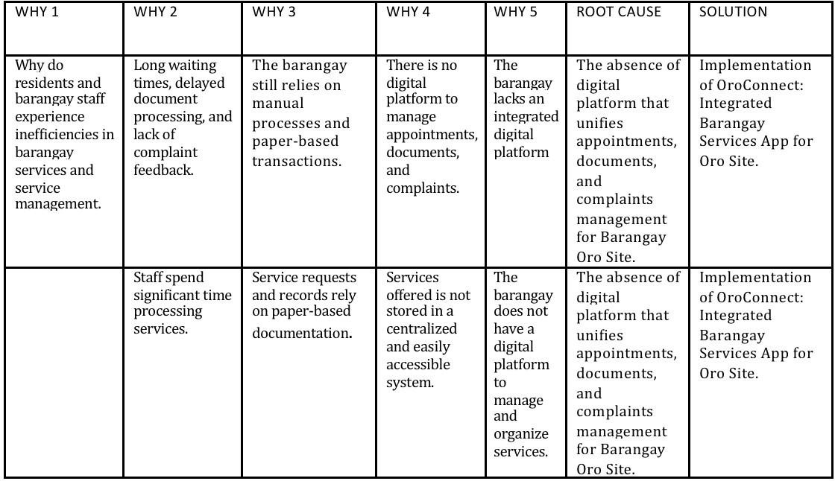
Content Here

Letter of Approval to develop the proposed capstone
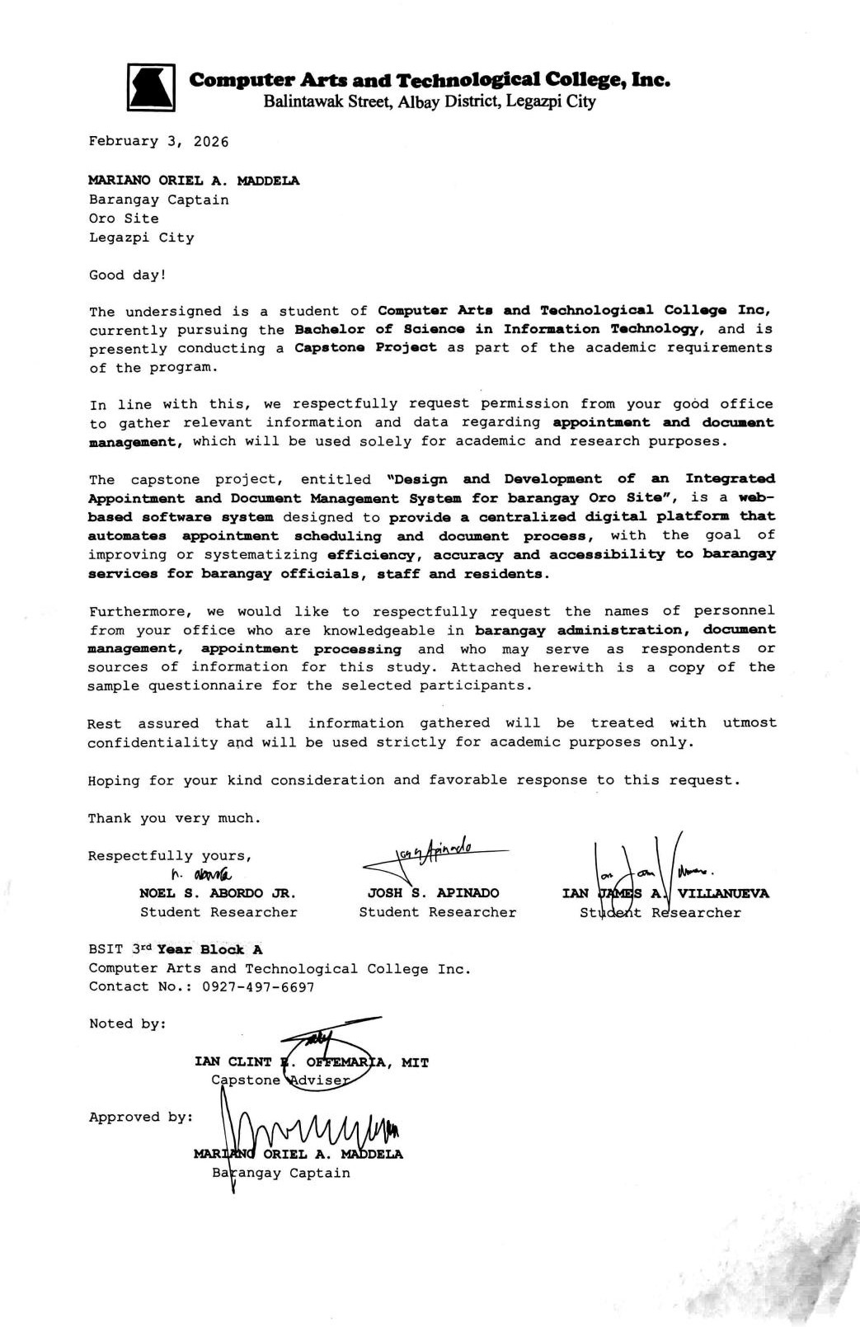

Barangay Oro Site Profile
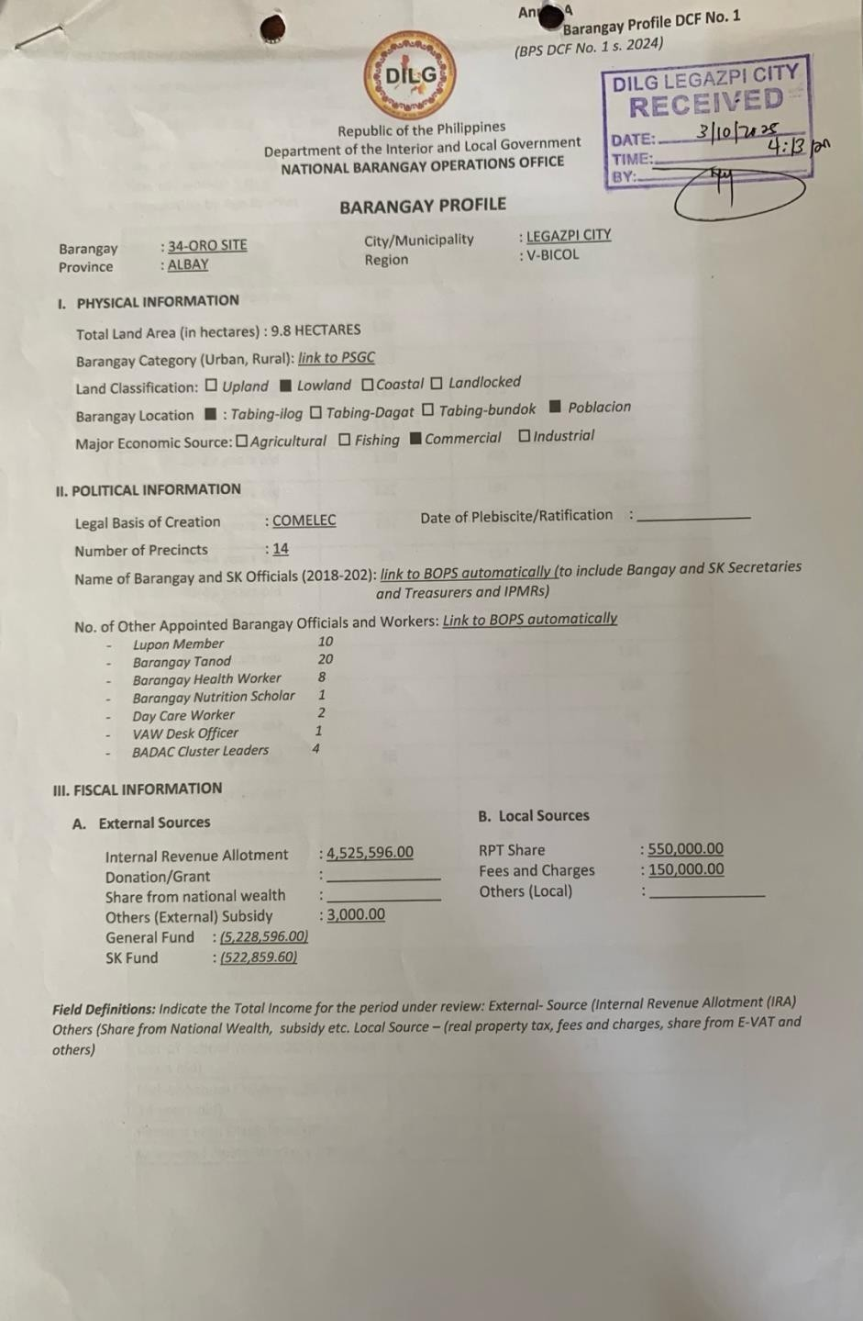

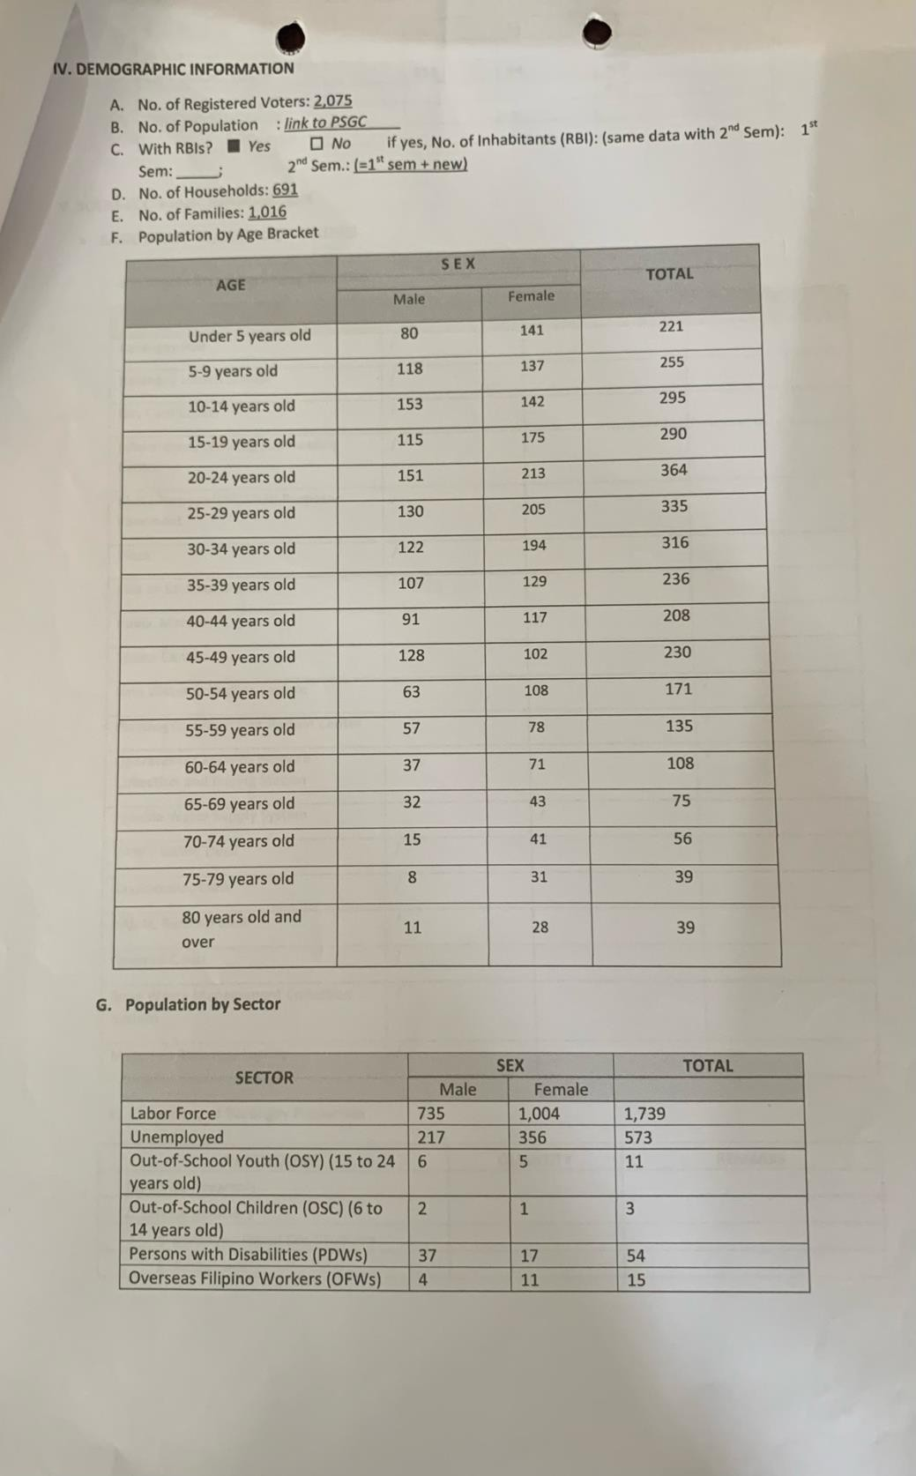

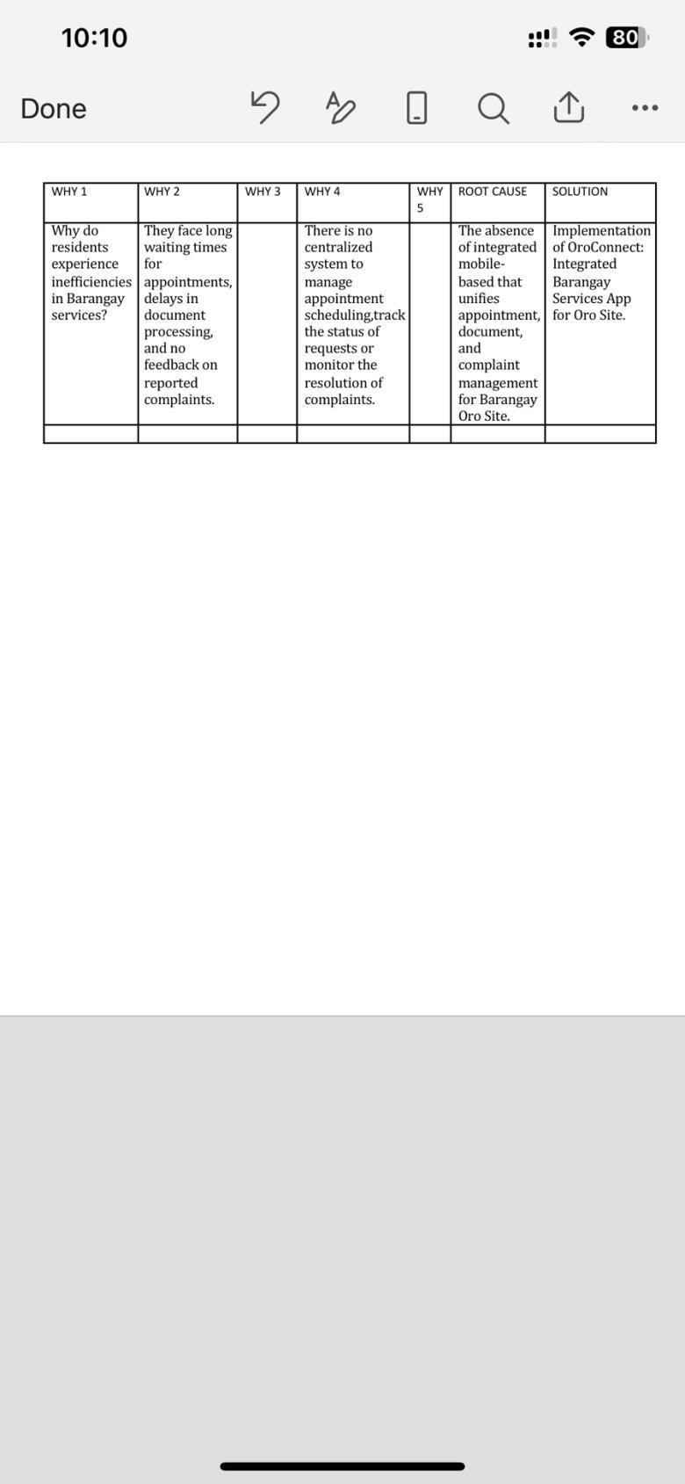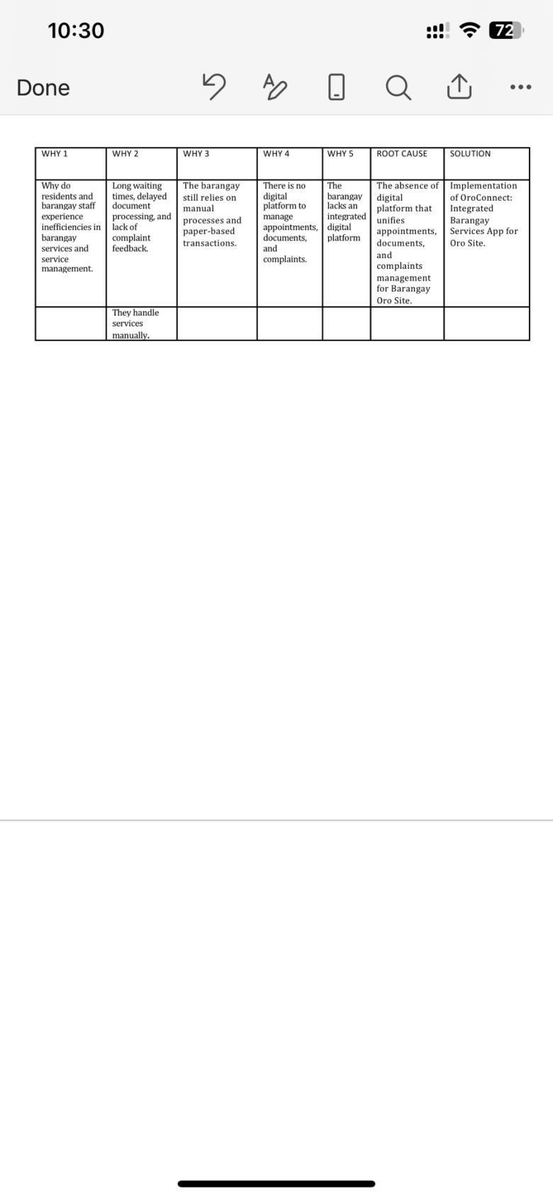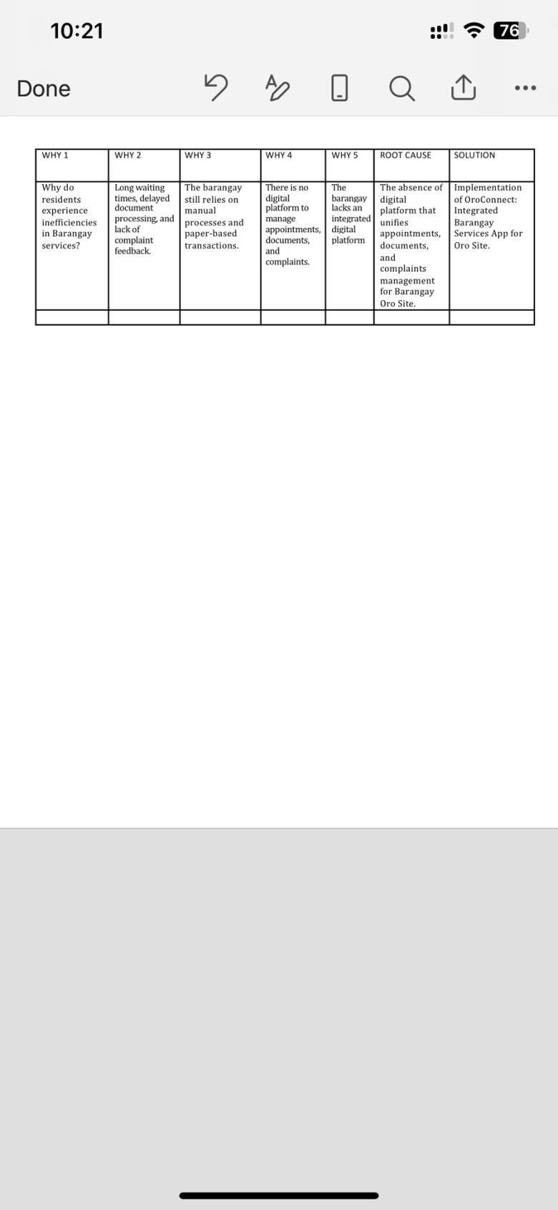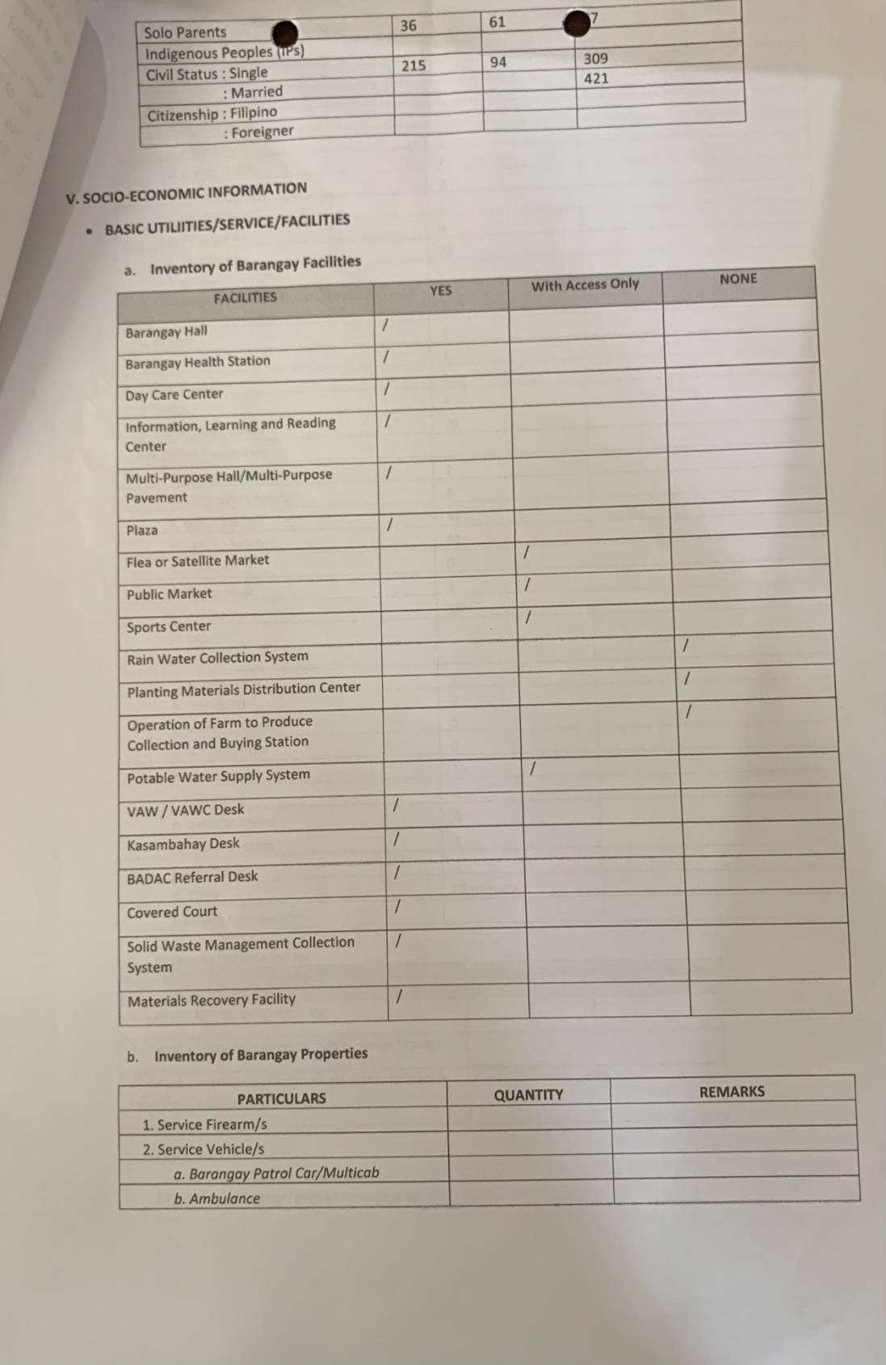

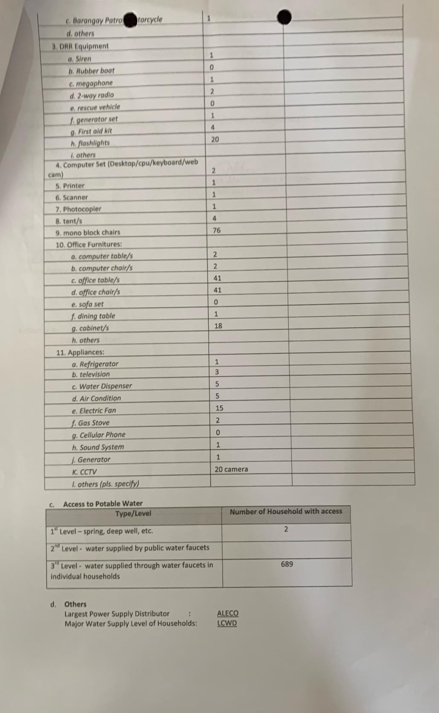

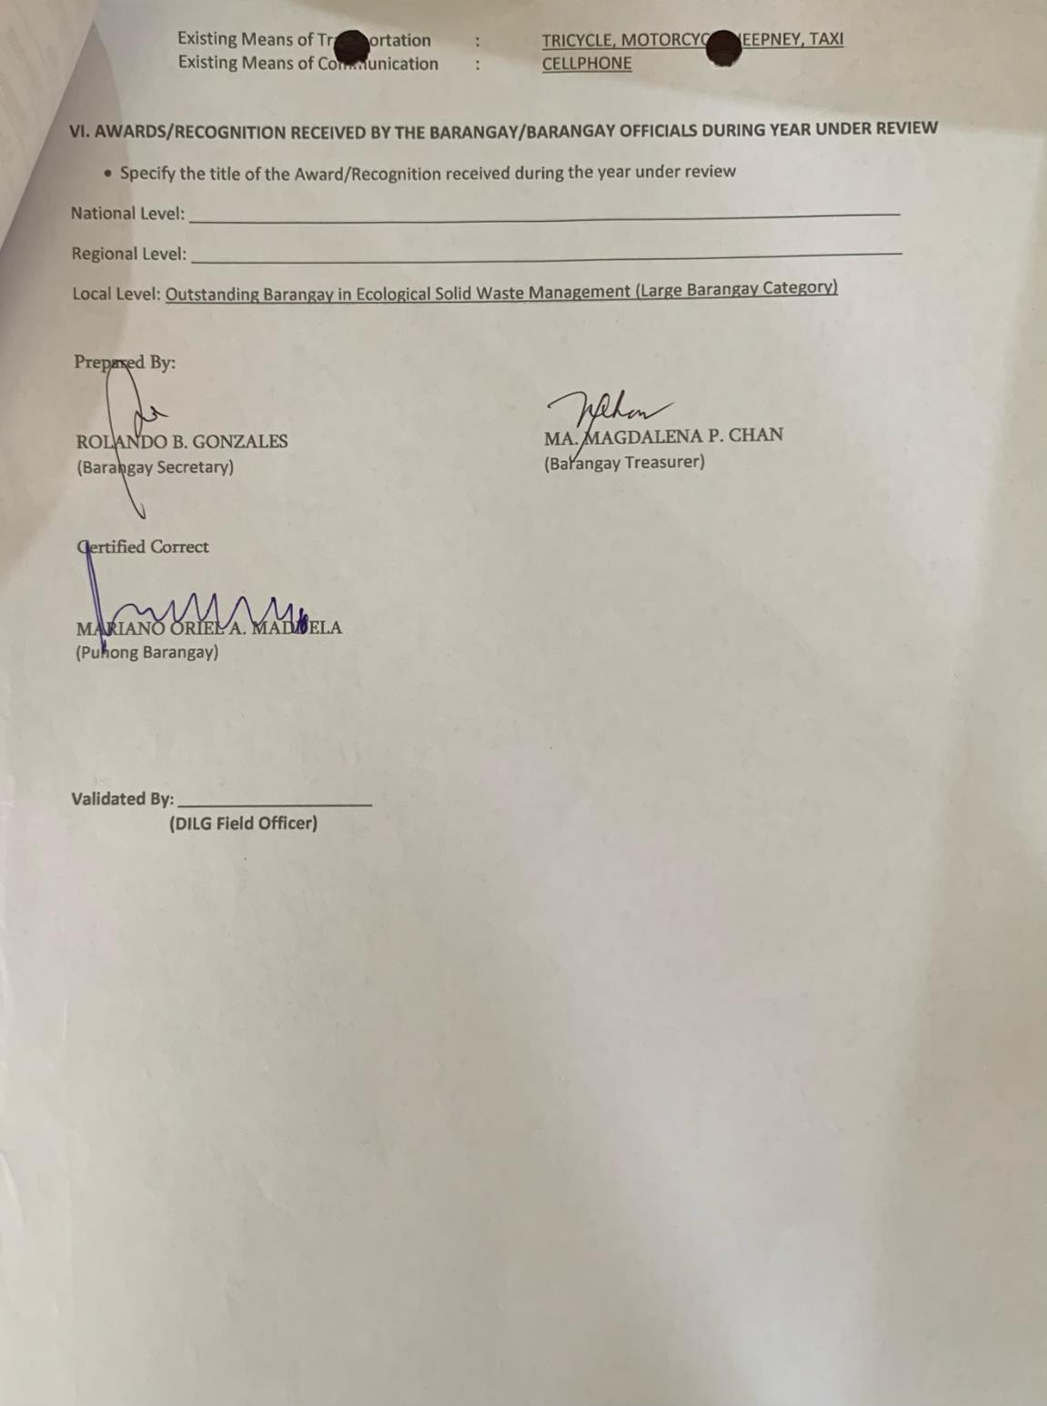

Appendix D Questionnaire for Barangay Profile
Design and Development of an Integrated Appointment and Documents Management System for Barangay Oro Site
Part I: General Information (Barangay Identity)
- Official Name of Barangay:
- Date of Establishment:
- Physical OfficeAddress:
- Current Barangay Captain: Part II: Services and Operations
- What services does the barangay provide to residents?

- Which services are most frequently requested?

- Describe the current process for appointments scheduling and documents requesting:
- On average, how long does it take to process a typical request?

Part III: Complaints Management
To evaluate how grievances are handled and integrated.
- Does the barangay have a formal system for managing complaints?
  - [ ] Yes (Briefly describe: )
  - [ ] No
- Channels available for filing a complaint (Check all that apply):
  - [ ] In-person (Walk-in)
  - [ ] Telephone
  - [ ] Email
  - [ ] Suggestion Box
  - [ ] Online Portal
  - [ ] Social Media
  - [ ] Other:
- How are complaints recorded? (e.g., paper log, spreadsheet, database)

- Who is responsible for resolving complaints? (Position/Department)

- Average Response Times:
  - To Acknowledge: days/hours
  - To Resolve: days
- Common types of complaints: (e.g., noise, waste, safety, etc.)

- What are the biggest challenges in handling complaints effectively?

- How are residents notified of their complaint status? (e.g., SMS, call, notice)

- Would you like the new digital system to include a Complaints Management module?
  - [ ] Yes
  - [ ] No
Part IV: Current Systems, Tools, and Challenges
To identify the technical "pain points."
- What tools are currently used for document management and scheduling?
- Are these processes:
[ ] Manual [ ]Digital
[ ] Both (Hybrid)
- What challenges or bottlenecks do you experience with the current system?

- Do you currently use any specific software for complaints?
  - [ ] Yes (Please specify: )
  - [ ] No
Part V: Vision and Readiness for Digital Transformation
To gauge the willingness to adopt new technology.
- Are you open to adopting a web-based system for appointments and documents?

- What concerns (e.g., cost, digital literacy, security) do you have about new technology?

- What is the barangay’s long-term vision for improving public service?

- How do you believe technology can help achieve this vision?

Apendix E
Interview of Proposed Capstone to Oro Site Barangay Captain
