**PROGRAM-1**

**Aim:** Implement concurrent day-time client-server application.

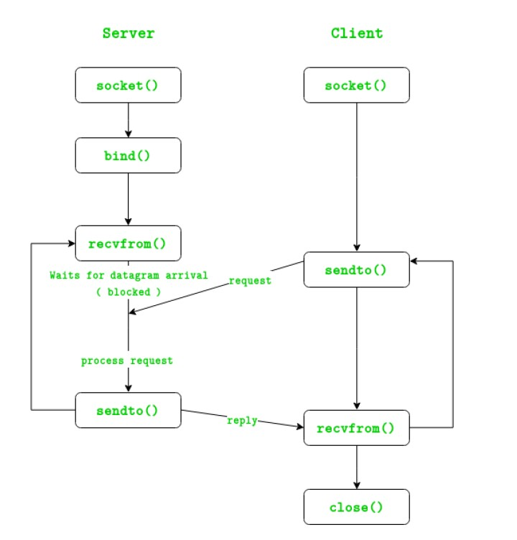**Introduction:** There are two major transport layer protocols to communicate between hosts: TCP and UDP. In UDP, the client does not form a connection with the server like in TCP and instead just sends a datagram. Similarly, the server need not accept a connection and just waits for datagrams to arrive. Datagrams upon arrival contain the address of sender which the server uses to send data to the correct client.

**Socket**

A socket is a combination of IP address and port on one system. On each system a socket exists for a process interacting with the socket on other system over the network. A combination of local socket and the socket at the remote system is also known a ‘Four tuple’ or ‘4-tuple’. Each connection between two processes running at different systems can be uniquely identified through their 4-tuple. **Function Descriptions socket()**

Creates an UN-named socket inside the kernel and returns an integer known as socket descriptor. This function takes domain/family as its first argument. For Internet family of ipv4 addresses we use AF_INET. The second argument ‘SOCK_STREAM’ specifies that the transport layer protocol that we want should be reliable i.e. It should have acknowledgement techniques. The third argument is generally left zero to let the kernel decide the default protocol to use for this connection. For connection oriented reliable connections, the default protocol used is TCP.

**bind()**

Assigns the details specified in the structure ‘serv_addr’ to the socket created in the step above. The details include, the family/domain, the interface to listen on(in case the system has multiple interfaces to network) and the port on which the server will wait for the client requests to come. **listen()**

With second argument as ’10’ specifies maximum number of client connections that server will queue for this listening socket. After the call to listen(), this socket becomes a fully functional listening socket.

**accept()**

The server is put to sleep and when for an incoming client request, the three-way TCP handshake is complete, the function accept () wakes up and returns the socket descriptor representing the client socket. Accept() is run in an infinite loop so that the server is always running and the delay or sleep of 1 sec ensures that this server does not eat up all your CPU processing. As soon as server gets a request from client, it prepares the date and time and writes on the client socket through the descriptor returned by accept().

**Algorithm / Explanation:**

Server:

1. create UDP socket
2. Bind socket to address
3. wait for datagram from client
4. process and reply to client request
5. repeat while server is active

Client:

1. create UDP socket
2. send request to server
3. wait for datagram from server
4. process and reply from server
5. close socket and exit

**Code:**

Server:

#include <sys/socket.h>

#include <sys/types.h>

#include <netinet/in.h>

#include <netdb.h>

#include <stdio.h>

#include <string.h>

#include <stdlib.h>

#include <unistd.h>

#include <errno.h>

#include <arpa/inet.h>

int main()

{

struct sockaddr_in sa; // Socket address data structure

int n, sockfd; // read and source

char buff[1025]; // buffer to store the readstream

sockfd = socket(PF_INET, SOCK_STREAM, 0); // New socket created

// Checking for valid socket

if (sockfd < 0)

{

printf("Error in creation\n");

exit(0);

}

else

{

printf("Socket created\n");

}

// Clearing and assigning type and address to the socket

bzero(&sa, sizeof(sa));

sa.sin_family = AF_INET;

sa.sin_port = htons(5600);

// establishing and verifying the connection

if (connect(sockfd, (struct sockaddr *)&sa, sizeof(sa)) < 0)

{

printf("Connection failed\n");

exit(0);

}

else

printf("Connection made\n"); // Reading and priting data from the server after verification

if (n = read(sockfd, buff, sizeof(buff)) < 0)

{

printf("Read Error\n");

exit(0);

}

else

{

printf("Read message: %s\n", buff);

printf("%s\n", buff);

printf("Done with connection, exiting\n");

}

close(sockfd); // Closing the socket

return 0;

}

Client:

#include <sys/socket.h>

#include <netinet/in.h>

#include <arpa/inet.h>

#include <stdio.h>

#include <stdlib.h>

#include <unistd.h>

#include <errno.h>

#include <string.h>

#include <sys/types.h>

#include <time.h>

int main()

{

struct sockaddr_in sa; // Socket address data structure

int sockfd, coontfd; // Source and destination addresses

char str[1025]; // Buffer to hold the out-going stream

time_t tick; // System time data structure

sockfd = socket(AF_INET, SOCK_STREAM, 0); // New socket created

// Checking for valid socket

if (sockfd < 0)

{

printf("Error in creating socket\n");

exit(0);

}

else

{

printf("Socket Created\n");

}

// Clearing and assigning type and address to the socket

printf("Socket created\n");

bzero(&sa, sizeof(sa));

memset(str, '0', sizeof(str)); // clearing the buffer

sa.sin_family = AF_INET;

sa.sin_port = htons(5600);

sa.sin_addr.s_addr = htonl(INADDR_ANY); // binding and verifying the socket to address

if (bind(sockfd, (struct sockaddr *)&sa, sizeof(sa)) < 0)

{

printf("Bind Error\n");

}

else

printf("Binded\n");

// starts the server with a max client queue size set as 10

listen(sockfd, 10); // server run

while (1)

{

coontfd = accept(sockfd, (struct sockaddr *)NULL, NULL); // Accept a request from client

printf("Accepted\n");

tick = time(NULL);

snprintf(str, sizeof(str), "%.24s\r\n", ctime(&tick)); //read sys time and write to buffer

printf("sent\n");

printf("%s\n", str);

write(coontfd, str, strlen(str)); // send buffer to client

}

close(sockfd); // close the socket return 0;

}

**Output:**

Server:

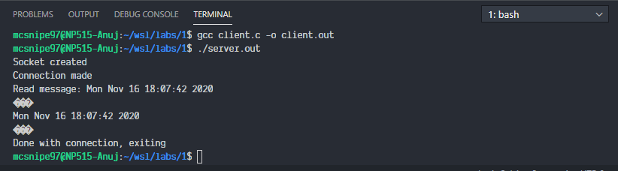

Client:

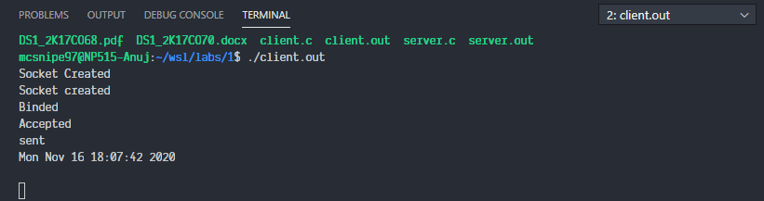

**Conclusion:**

1. We successfully implemented a date-time client-server.
2. UDP is a connectionless protocol where the server waits for a request from a client to become active. Each connection is treated as a new one.
3. On a local system i.e. within the same computer, the loop back address should be used as the argument to the client.
4. The connect procedure follows the Three-way handshake process to establish the connection.