**PROGRAM - 2**

**Aim**: To implement Berkeley clock synchronization algorithm.

**Theory**: Berkeley’s Algorithm is a clock synchronization technique used in distributed systems. The algorithm assumes that each machine node in the network either doesn’t have an accurate time source or doesn’t possess an UTC server.

Steps involved in Berkeley’s Algorithm:

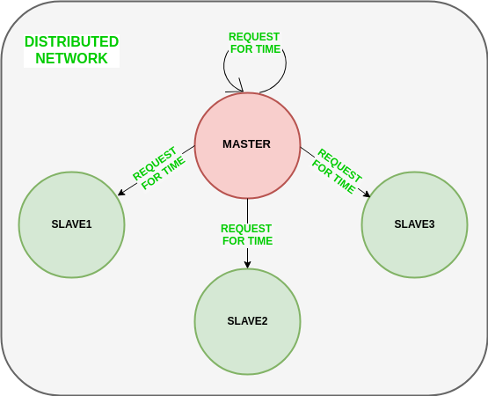

1.

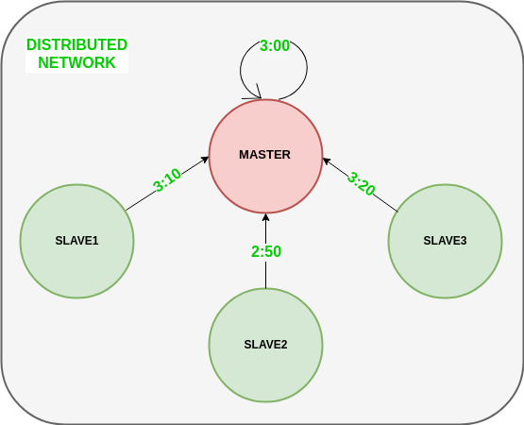2.

3**.**

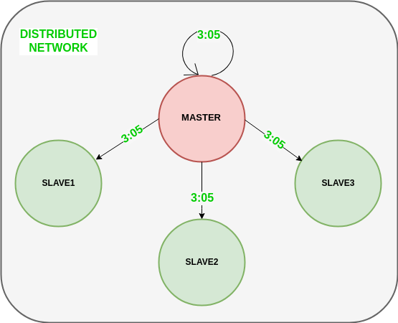

**Code**:

Server:

from functools import reduce

from dateutil import parser

import threading

import datetime

import socket

import time

# datastructure used to store client address and clock data

client_data = {}

''' nested thread function used to receive

clock time from a connected client '''

def startRecieveingClockTime(connector, address):

while True:

# recieve clock time

clock_time_string = connector.recv(1024).decode()

clock_time = parser.parse(clock_time_string)

clock_time_diff = datetime.datetime.now() - \

clock_time

client_data[address] = {

"clock_time": clock_time,

"time_difference": clock_time_diff,

"connector": connector

}

print("Client Data updated with: " + str(address),

end="\n\n")

time.sleep(5)

''' master thread function used to open portal for

accepting clients over given port '''

def startConnecting(master_server):

# fetch clock time at slaves / clients

while True:

# accepting a client / slave clock client

master_slave_connector, addr = master_server.accept()

slave_address = str(addr[0]) + ":" + str(addr[1])

print(slave_address + " got connected successfully")

current_thread = threading.Thread(

target=startRecieveingClockTime,

args=(master_slave_connector,

slave_address, ))

current_thread.start()

# subroutine function used to fetch average clock difference

def getAverageClockDiff():

current_client_data = client_data.copy()

time_difference_list = list(client['time_difference']

for client_addr, client

in client_data.items())

sum_of_clock_difference = sum(time_difference_list,

datetime.timedelta(0, 0))

average_clock_difference = sum_of_clock_difference \

/ len(client_data)

return average_clock_difference

''' master sync thread function used to generate

cycles of clock synchronization in the network '''

def synchronizeAllClocks():

while True:

print("New synchroniztion cycle started.")

print("Number of clients to be synchronized: " +

str(len(client_data)))

if len(client_data) > 0:

average_clock_difference = getAverageClockDiff()

for client_addr, client in client_data.items():

try:

synchronized_time = \

datetime.datetime.now() + \

average_clock_difference

client['connector'].send(str(

synchronized_time).encode())

except Exception as e:

print("Something went wrong while " +

"sending synchronized time " +

"through " + str(client_addr))

else:

print("No client data." +

" Synchronization not applicable.")

print("\n\n")

time.sleep(5)

# function used to initiate the Clock Server / Master Node

def initiateClockServer(port=8080):

master_server = socket.socket()

master_server.setsockopt(socket.SOL_SOCKET,

socket.SO_REUSEADDR, 1)

print("Socket at master node created successfully\n")

master_server.bind(('', port))

# Start listening to requests

master_server.listen(10)

print("Clock server started...\n")

# start making connections

print("Starting to make connections...\n")

master_thread = threading.Thread(

target=startConnecting,

args=(master_server, ))

master_thread.start()

# start synchroniztion

print("Starting synchronization parallely...\n")

sync_thread = threading.Thread(

target=synchronizeAllClocks,

args=())

sync_thread.start()

# Driver function

if __name__ == '__main__':

# Trigger the Clock Server

initiateClockServer(port=8080)

Client:

from timeit import default_timer as timer

from dateutil import parser

import threading

import datetime

import socket

import time

# client thread function used to send time at client side

def startSendingTime(slave_client):

while True:

# provide server with clock time at the client

slave_client.send(str(

datetime.datetime.now()).encode())

print("Recent time sent successfully",

end="\n\n")

time.sleep(5)

# client thread function used to receive synchronized time

def startReceivingTime(slave_client):

while True:

# receive data from the server

Synchronized_time = parser.parse(

slave_client.recv(1024).decode())

print("Synchronized time at the client is: " +

str(Synchronized_time),

end="\n\n")

# function used to Synchronize client process time

def initiateSlaveClient(port=8080):

slave_client = socket.socket()

# connect to the clock server on local computer

slave_client.connect(('127.0.0.1', port))

# start sending time to server

print("Starting to receive time from server\n")

send_time_thread = threading.Thread(

target=startSendingTime,

args=(slave_client, ))

send_time_thread.start()

# start recieving synchronized from server

print("Starting to recieving " +

"synchronized time from server\n")

receive_time_thread = threading.Thread(

target=startReceivingTime,

args=(slave_client, ))

receive_time_thread.start()

# Driver function

if __name__ == '__main__':

# initialize the Slave / Client

initiateSlaveClient(port=8080)

**Output:**

Server:

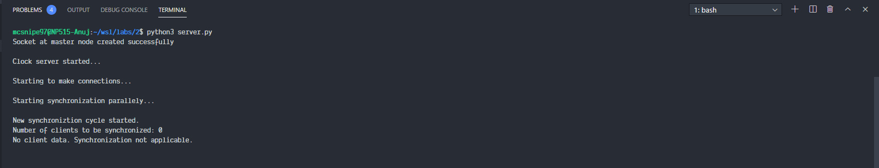

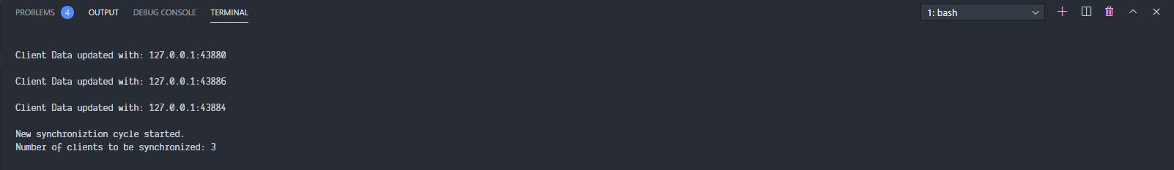

Client:

1:

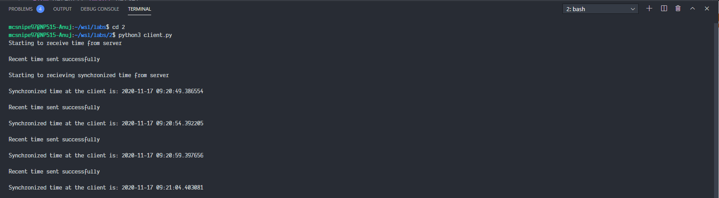

2:

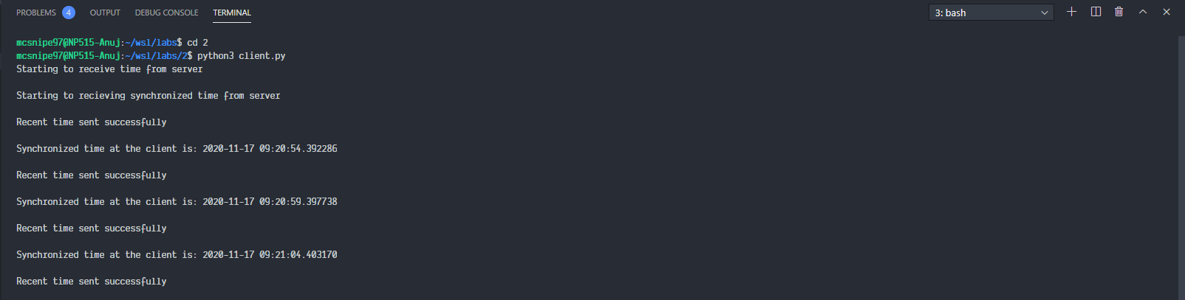

3:

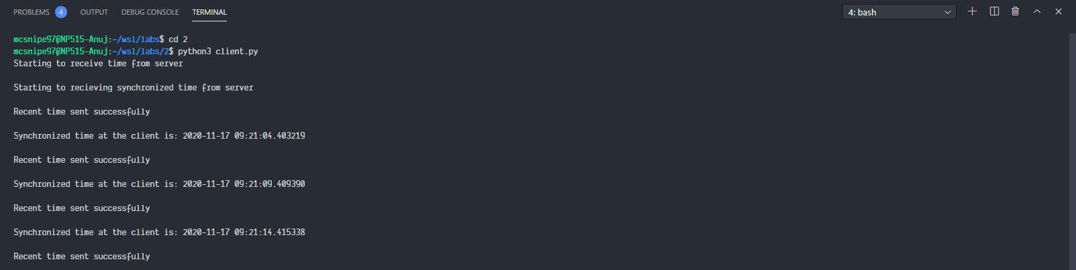

**Conclusion**:

Berkeley clock synchronization algorithm is implemented.