1. What are three conclusions we can make about Kickstarter campaigns given the provided data?

**Conclusion 1-**

We saw the highest number of campaigns in theatre category (1393 projects) followed by music (700 projects). While 53% of all the campaigns were successful, the success rate was highest for Music category (77%) followed by theatre category (60%). *See chart below-*

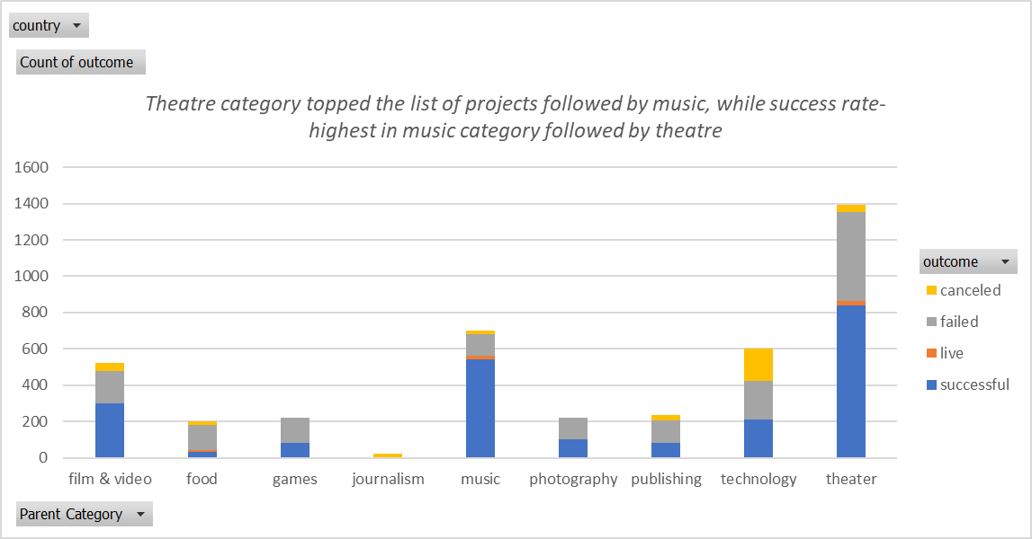

**Conclusion 2-**

The highest number of projects were successful in “plays” sub-category. All projects under rock, documentary, hardware, tabletop games, non-fiction, shorts, television, classical music, electronic music, pop, metal and radio/podcast sub-categories were successful. *See chart below-*

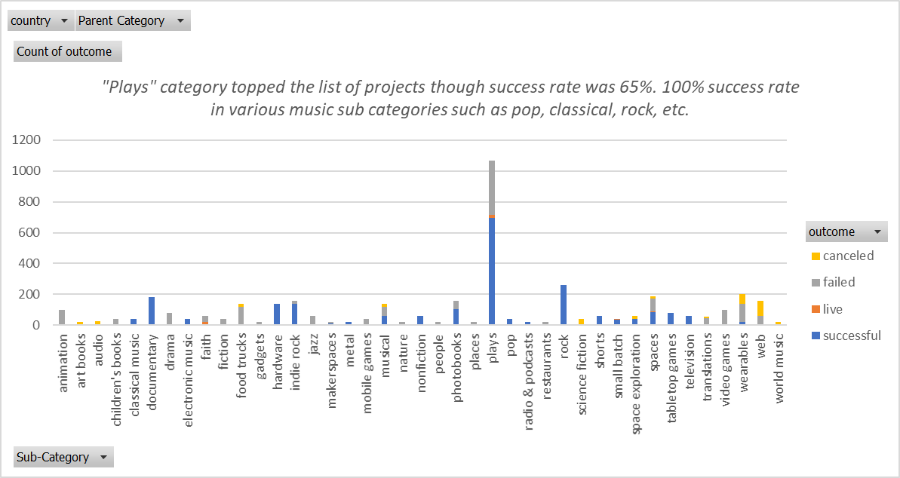

**Conclusion 3-**

Max projects started in May and dipped in December. *See chart below-*

What are some of the limitations of this dataset?

1. Defining true success- Is exceeding goals successful or exceeding returns for backers? There is no info about the returns for backers.
2. It will be nice to understand backer demographics and individual contribution.
3. I understand that Kickstarter takes 5% of the backed amount. Is the pledged amount inclusive of Kickstarter fees?
4. What happened in 2017?

What are some other possible tables/graphs that we could create?

1. Funding time- The difference between the date of campaign creation to the deadline provides us the funding time/# days it takes for a project to be successful/canceled/fail.
2. Staff picked projects- It will be nice to understand if staff picked projects actually help expedite the funding goal or time.

# successful campaigns peaked in 2015 and the average funding time reduced from 60 to 32 days. Also note that staff picked projects didn’t really affect the funding time.

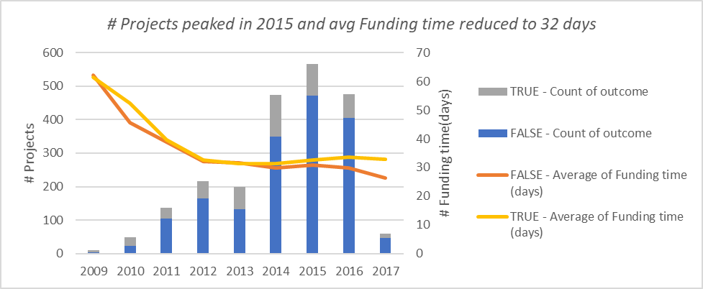

1. Successful projects statistics- In USA, out of all the successful projects, technology projects received highest funding up to $14.6mio and exceeded their goals by 192%.

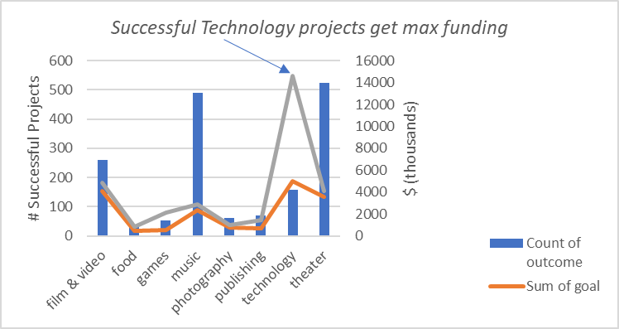

1. Other tables/graphs can be as follows-

Parent successful campaigns over success-rate over time

#backers Vs countries and their success rate

#backers, Goal amount, pledged amount over the last 6 years