### Space Shooter

Contents

Summary 1

Controls 1

Start 1

Gameplay 2

Game Over (End) 2

Enemies 3

Scoring 3

Sound 3

Images 4

### Summary

The game starts by dropping the player right into the game. The player controls a ship and tries to collect pickups. The player can also fire projectiles (controlled by a cooldown timer) which will destroy an enemy it comes into contact with. The player has 3 lives and can increase their score by grabbing green/grey cargo crates to increase it. If the player hits an enemy 1 life is deducted. Once the player reaches 0 lives, the game is over and a screen displaying the current high score as well as a button to reset the screen are displayed.

### Controls

W or Up Arrow Key – Move up

A or Left Arrow Key – Move left

S or Down Arrow Key – Move down

D or Right Arrow Key – Move right

Spacebar – Shoot

## 

## Start

Starting screen as soon as the player enters the game

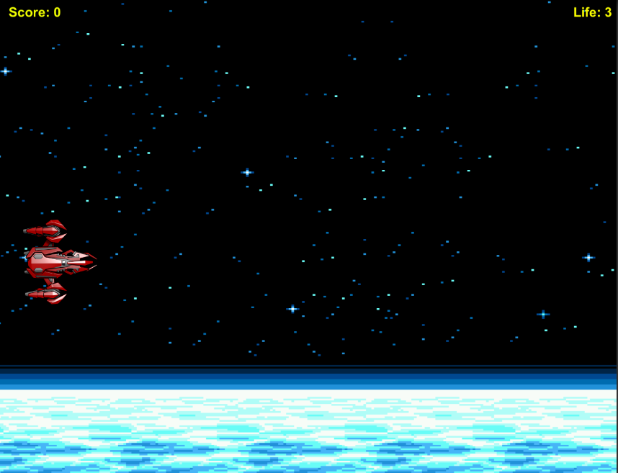

## Gameplay

Player destroying an enemy with various enemies and a pickup on the screen.

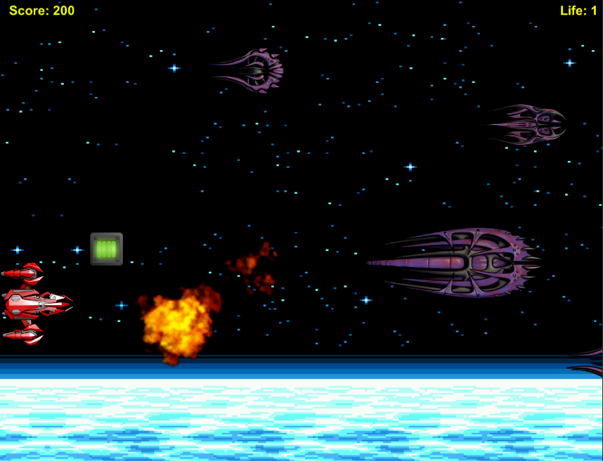

### 

### Game Over (End)

The player has run out of lives and lost the game. This game over screen is then displayed.

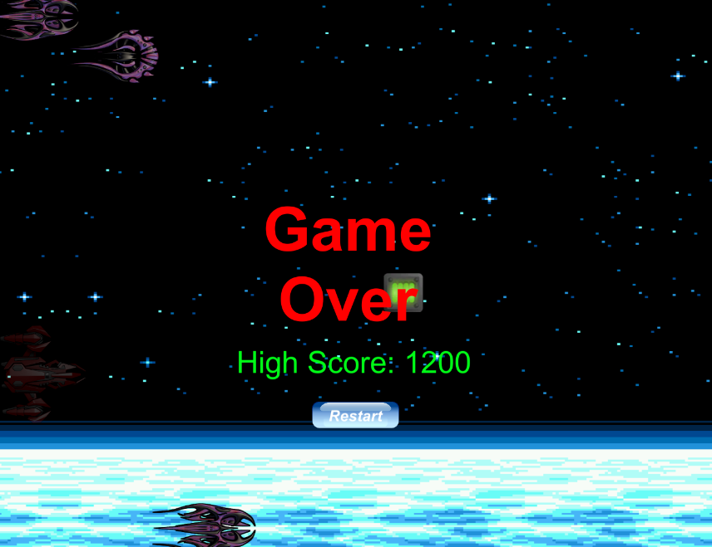

### Enemies

The enemies are controlled by moving across the scene horizontally and at a slower speed vertically. There are 3 types of enemies which have different speed properties for both their x and y values. When an enemy hits the player, they lose a life.

### Scoring

The player starts out with 0 points and can gain points by grabbing green/grey cargo crates for 100 points each. If the player gets the highest score, it is saved for display on the game over screen.

### 

### Sound

*explosion01-04*

Sounds played when player is hit and when enemies are destroyed

*pickupItem*

Played when the player picks up an item

*shoot*

Plays when player hits the spacebar and shoots

*Music*

Background music played

### Images

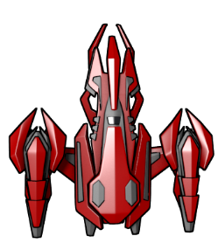

Player avatar

D:\TheVaults\Documents\Coding\Unity\Space Shooter\Assets\Sprites\playerBullet.png

Player projectile

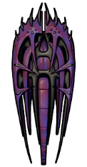

Enemy01

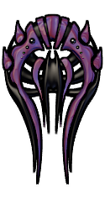

Enemy02

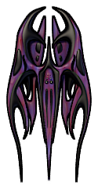

Enemy03

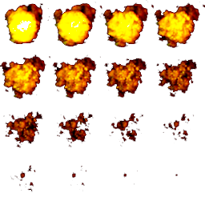

Explosion sprite sheet



Pickup item



Button image