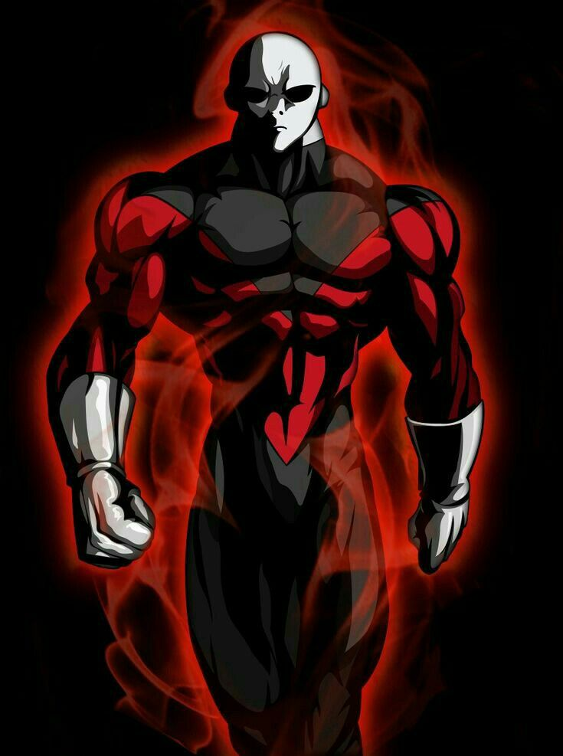12 basic principles

Animation

**Tiancheng MCCREAN 60019307**

Principles of Animation

動漫の理論

of animation

Principle of Animation

SQUASH AND STRETCH1

键入章标题(第 2 级)2

键入章标题(第 3 级)3

键入章标题(第 1 级)4

键入章标题(第 2 级)5

键入章标题(第 3 级)6