

Muun Macdonald

40536364  
40536364@live.napier.ac.uk

**XL001600_2021-2_TR1_001 - Scripting for Cybersecurity and Networks (CSN08114/CSN08414)**

Documentation

**Packet capture plot**

**Dependency Diagram**

Last minute fail

**PEP8 Evidence**

**Pylint**

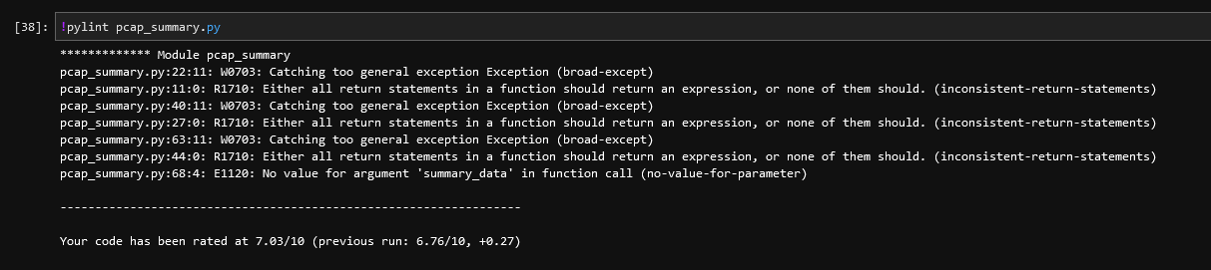

**Pycodestyle**

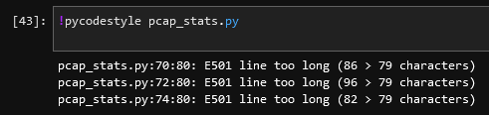

**KML**

