PENETRATION TESTING REPORT
Footprinting & Network Scanning Phases

Pentester Name | Atanda Oluwagbenga
Program / Batch | B082-Week2
Date | 24 August 2026
Target / Scope | networkwalks.com and local network evidence supplied for the practical
Operating Environment | Kali Linux; Zenmap/Nmap topology evidence
Phases Covered | Phase 1: Reconnaissance & Footprinting; Phase 2: Scanning & Network Discovery

EDUCATIONAL / AUTHORIZED TESTING NOTICE
The activities documented in this report are presented as cybersecurity training and assessment work. Reconnaissance and scanning should only be performed against systems and networks for which appropriate authorization exists.

1. Liability Disclaimer
I performed the documented activities for cybersecurity education and practical training. Testing and scanning must be limited to systems, domains and networks where the tester has appropriate authorization. The information in this report describes observations from reconnaissance and network-discovery exercises; it does not constitute proof that any identified technology, service or host is vulnerable. No exploitation is documented in this report.

2. Introduction
This Week 2 report documents reconnaissance and network-scanning activities performed using Kali Linux tools against the networkwalks.com domain, together with Zenmap topology evidence from a local network exercise. The purpose was to understand how a security professional can collect publicly observable information, identify web technologies, resolve DNS information, inspect HTTP response headers, enumerate DNS records, and visualize discovered network hosts.
The report follows the organization of the supplied penetration-testing sample while using the actual outputs provided for this submission. Where the supplied evidence does not show a result, the report does not invent one.

3. Tools Used
Tool | Purpose
Kali Linux | Operating environment for the reconnaissance commands.
WHOIS | Collected domain registration, registrar, dates and name-server information.
WhatWeb | Fingerprinting of web technologies and application components.
nslookup | DNS resolution of networkwalks.com to an IP address.
curl -I | Inspection of HTTP response headers.
DNSRecon | Enumeration of DNS records including NS, MX, A, TXT and SRV information.
Zenmap / Nmap | Network discovery and topology visualization for the supplied local-network evidence.

4. Activities Performed

4.1 Footprinting & Reconnaissance
The footprinting activity used WHOIS, WhatWeb, nslookup, curl and DNSRecon. Each tool provided a different type of information about networkwalks.com.

4.1.1 WHOIS
The WHOIS output identified the queried domain as NETWORKWALKS.COM. The observed record showed GoDaddy.com, LLC as the registrar, a creation date of 6 November 2019, an updated date of 12 November 2025, and a registry expiry date of 6 November 2027. The name servers shown were NS6135.HOSTGATOR.COM and NS6136.HOSTGATOR.COM. The output also showed several client status codes and indicated that DNSSEC was unsigned.
Security relevance: registration and name-server information can help build a basic profile of the target's domain and hosting infrastructure.
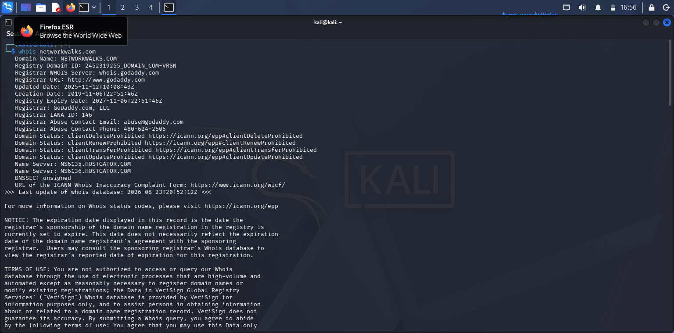
Figure 1: WHOIS output for networkwalks.com

4.1.2 WhatWeb
WhatWeb identified the web server and application technologies exposed by the site. The supplied output shows Apache, WordPress 7.1, WP Download Manager 3.3.58, Bootstrap 7.1, HTML5, Google-Tag-Manager, jQuery 3.7.1, and the IP address 192.232.216.135. The page title was shown as 'Networkwalks Academy'.
Security relevance: technology fingerprinting can help a security professional identify components that should be checked for current versions, secure configuration and known security advisories.
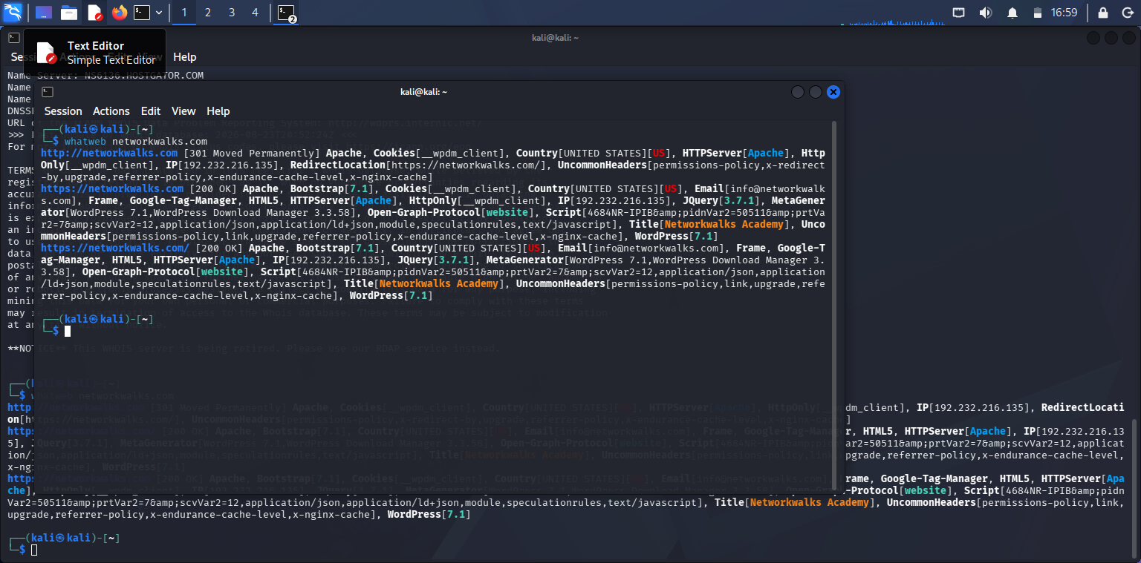
Figure 2: WhatWeb technology-fingerprinting output

4.1.3 nslookup
The nslookup output resolved networkwalks.com to 192.232.216.135. The DNS server used for the lookup was 8.8.8.8, and the result was marked as a non-authoritative answer.
Security relevance: DNS resolution provides an IP address that can be used to understand where the web service is reachable and to correlate results from other reconnaissance tools.
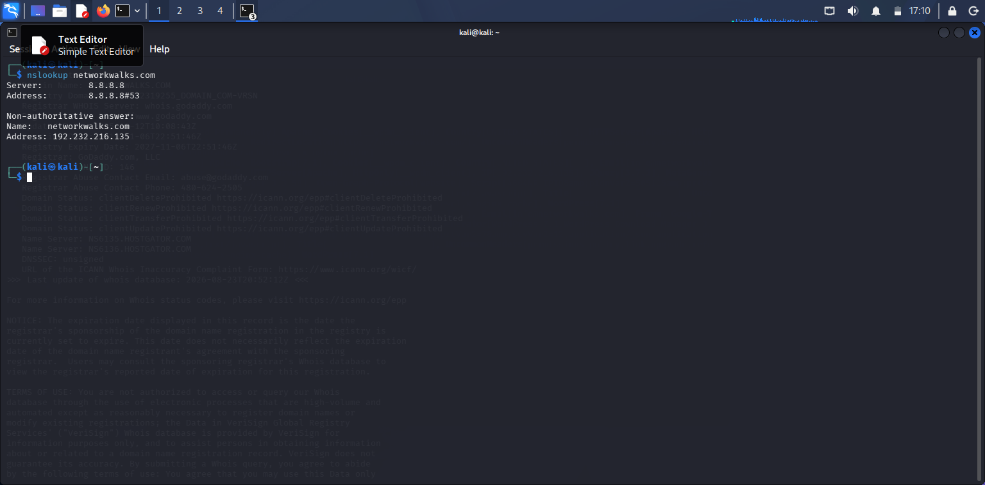
Figure 3: nslookup result for networkwalks.com

4.1.4 curl -I
The curl -I output returned HTTP/2 200. The headers exposed information including Apache as the server, WordPress through the x-nginx-cache-style/related headers shown in the output, a WordPress REST API link, a set-cookie value, permissions-policy and referrer-policy headers, and the page content type. The Link header exposed a WordPress REST API endpoint containing /wp-json/.
Security relevance: HTTP headers can reveal implementation details and application endpoints. This information is useful for defensive review of unnecessary technical exposure.
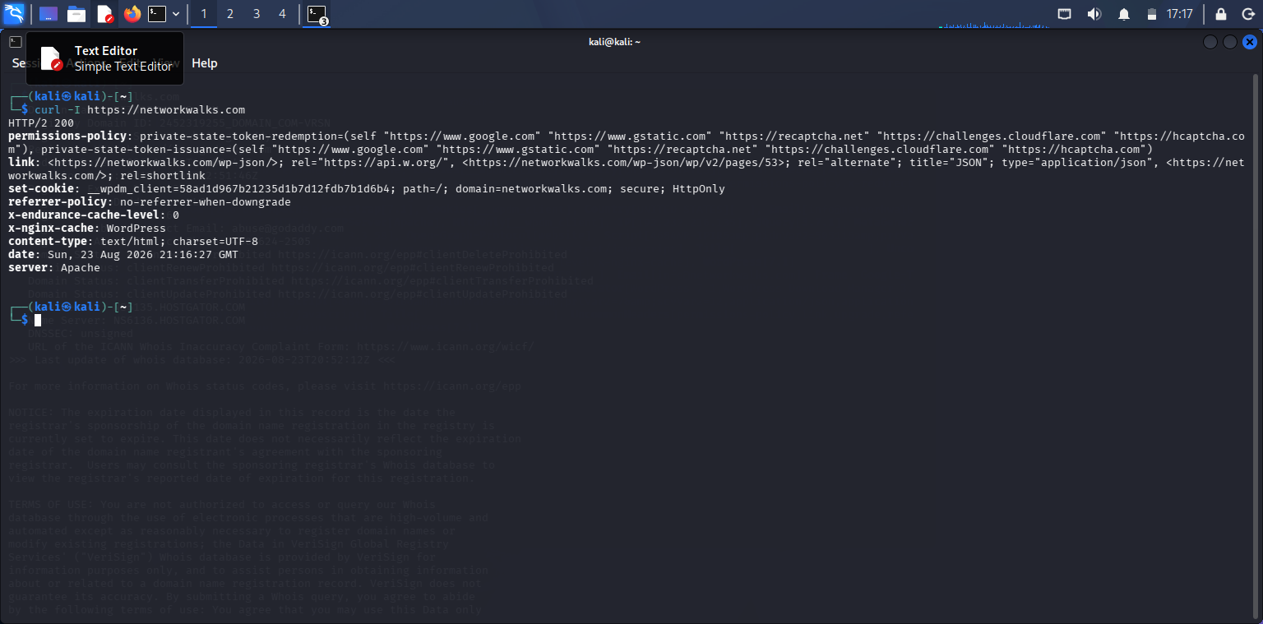
Figure 4: curl -I HTTP response-header output

4.1.5 DNSRecon
DNSRecon enumerated DNS information for networkwalks.com. The output showed two name servers, an MX record for mail.networkwalks.com pointing to 192.232.216.135, an A record for networkwalks.com pointing to 192.232.216.135, TXT/SPF information, and several SRV records associated with cpanel email discovery. The output reported 8 records found and completed the enumeration.
Security relevance: DNS records can reveal relationships between web, mail and supporting services, helping a defender understand the externally visible infrastructure.
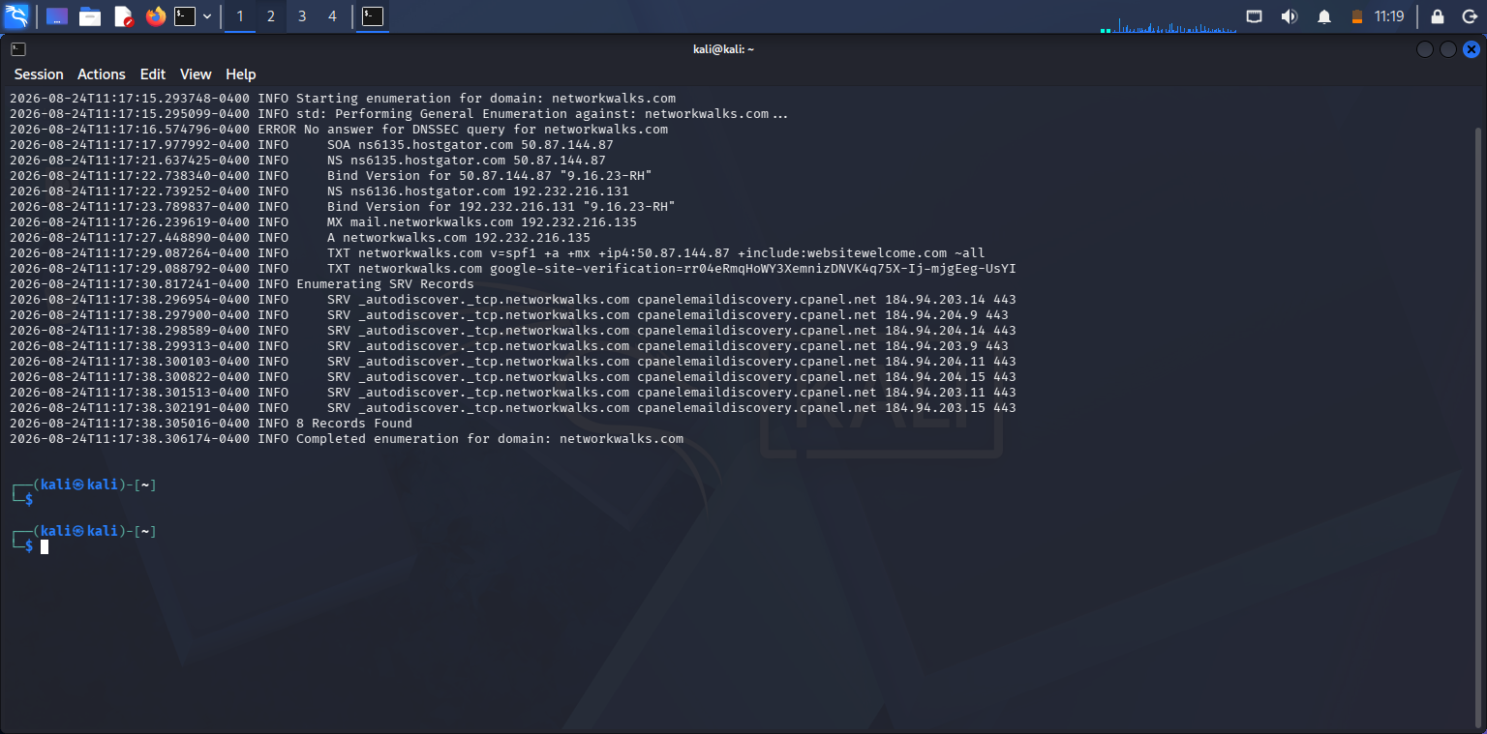
Figure 5: DNSRecon enumeration output
Note: No Wafw00f output was supplied in the evidence set used for this report, so no WAF identification is reported here.

4.2 Network Scanning with Zenmap
The supplied Zenmap/Nmap topology evidence shows three labeled nodes: 192.168.16.1, localhost, and 192.168.16.254. The topology visualization places localhost between the two 192.168.16.x addresses.
The evidence provided does not contain enough information to state MAC addresses, operating systems, open ports, or a complete host inventory. Therefore, those values are not added to this report.
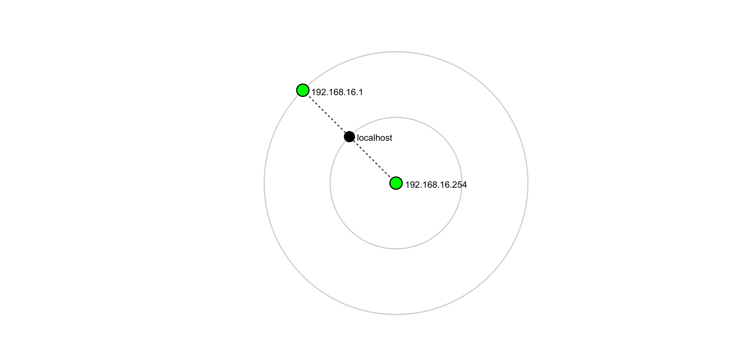
Figure 6: Supplied Zenmap/Nmap topology evidence (see the attached Nmap - Zenmap GUI PDF)
Zenmap evidence note: the supplied PDF contains the topology labels 192.168.16.1, localhost and 192.168.16.254. This is the basis for the network-discovery observations in this section.

5. Risk Analysis / Impact
The findings below are observations from footprinting and network discovery. They are not confirmed vulnerabilities.
# | Risk / Finding | Evidence / Observation | Potential Impact | Risk Level
1 | Web technology information exposed | WhatWeb identified Apache, WordPress 7.1, WP Download Manager 3.3.58 and other components. | May assist technology fingerprinting and identification of software requiring security review. | Medium
2 | Public IP address identifiable | nslookup and WhatWeb identified 192.232.216.135. | Provides information about the network location of the web service. | Low
3 | HTTP technical information exposed | curl -I returned HTTP headers and a WordPress REST API link containing /wp-json/. | May assist further enumeration and technology fingerprinting. | Low
4 | DNS infrastructure information exposed | DNSRecon identified NS, MX, A, TXT/SPF and SRV records. | Can help build a broader picture of externally visible infrastructure. | Medium
5 | Multiple network nodes visible in topology | Zenmap evidence shows 192.168.16.1, localhost and 192.168.16.254. | Unexpected or unauthorized devices on a local network should be investigated. | Medium
Risk key: Critical = immediate/high consequence concern; Medium = should be reviewed and addressed according to the organization's risk priorities; Low = limited direct impact but useful for reducing information exposure.

6. Recommendations
- Review publicly exposed technology information and minimize unnecessary version or implementation details.
- Keep WordPress, plugins and supporting web components updated and review them against current security advisories.
- Review HTTP response headers and remove unnecessary technical information where practical.
- Review DNS records regularly and ensure that only required services and records are publicly exposed.
- Monitor DNS and web infrastructure for unexpected changes.
- Perform regular authorized internal network discovery to identify active devices.
- Investigate unknown or unexpected hosts discovered during internal network scans.
- Maintain current network documentation and topology records.
- Repeat reconnaissance and scanning periodically so that changes in the attack surface are detected.
- Perform any further vulnerability validation or exploitation only within a clearly authorized scope.

7. Conclusion
During Week 2, I completed practical exercises covering footprinting, reconnaissance and network discovery. The footprinting activity demonstrated how WHOIS can provide domain-registration information, WhatWeb can fingerprint web technologies, nslookup can resolve DNS names, curl can inspect HTTP response headers, and DNSRecon can enumerate DNS records.
The Zenmap evidence demonstrated how network-discovery information can be represented visually. The supplied topology showed 192.168.16.1, localhost and 192.168.16.254. The exercise reinforced the importance of documenting the exact observations obtained from tools rather than assuming that an observation is automatically a vulnerability.
Overall, the practical showed that reconnaissance is an important early stage of a security assessment because it helps a tester understand the externally visible technologies, DNS infrastructure and network environment before any deeper security testing is considered.

8. Evidence Collected
- Figure 1 – WHOIS output
- Figure 2 – WhatWeb output
- Figure 3 – nslookup output
- Figure 4 – curl -I output
- Figure 5 – DNSRecon output
- Figure 6 – Zenmap/Nmap topology evidence supplied as a PDF
-End-

