BB2920-C17 Genetics

Exam 1

Professor Farny

Name:

**Instructions:**

**Do not open this exam until instructed to do so.**

**You will have 1 hour to complete the exam.**

**You may not leave the examination room during the exam.**

**Phones, tablets, computers, and any other electronic device are strictly prohibited. They must be completely out of sight for the entirety of the exam. You will not need a calculator.**

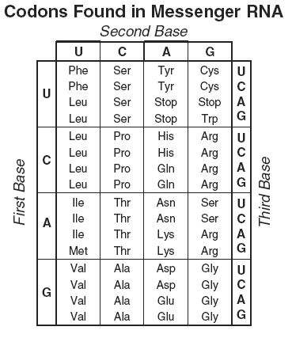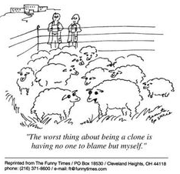

**Amino Acid Groups:**

**Nonpolar: Gly, Ala, Val, Leu, Met, Ile**

**Polar: Ser, Thr, Cys, Pro, Asn, Gln**

**Aromatic: Phe, Tyr, Trp**

**Positive charge: Lys, Arg, His**

**Negative charge: Asp, Glu**

|  |  |  |
| --- | --- | --- |
| **Question:** | **possible points** | **points received** |
| **1** | **9** |  |
| **2** | **12** |  |
| **3** | **9** |  |
| **4** | **14** |  |
| **5** | **16** |  |
| **6** | **16** |  |
| **7** | **8** |  |
| **8** | **16** |  |
| **maximum**  **total:** | **100** | **your score:** |
| **Extra credit** | **+3** | **Adjusted total:** |

**Question 1**  (9 points) Examine the three nucleotide structures below:

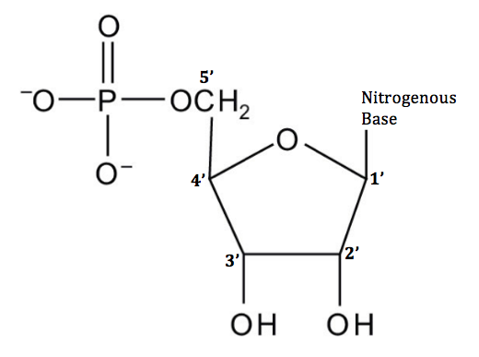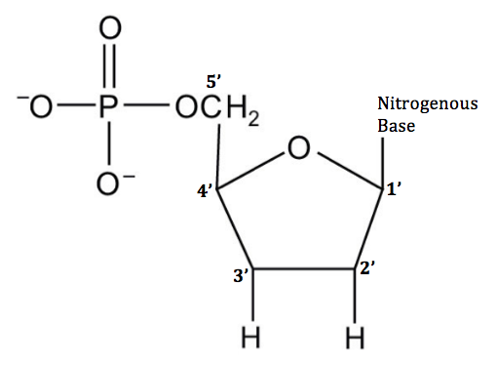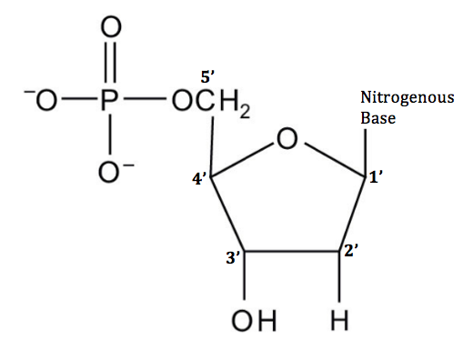

**A B C**

For each statement below, write the letter(s) of the nucleotide(s) that applies to that statement on the line to the left of the statement. If there is no nucleotide that can accurately be associated with the statement, place an X on the line. (Yes, you may write multiple letters next to a single statement if appropriate)

_____A, B_______ Necessary for Sanger sequencing

______X______ Contained in the products of translation

______C______ Contained in the products of transcription

______B______ Contained in a promoter sequence

______A,B,C or X__(all or none, depending on your interpretation)____ Capable of forming 5’ phosphodiester linkages

_____B,C_______ Capable of forming 3’ phosphodiester linkages

_____B_______ Used in a PCR reaction

______X______ Present in the samples run on a Western blot

______C______ Present in the samples run on a Northern blot

**Question 2** (12 points): PCR is a method of replicating DNA outside of a cell, and as such the two processes (PCR and DNA replication) have many similarities.

a) Describe two things that are similar about the processes of PCR and DNA replication.

multiple correct responses, but both processes require:

primers

template

nucleotides

polymerase

**Note that PCR does NOT have an origin of replication, does NOT use RNA primers, and neither process has anything to do with translation, promoters, or amino acids.

b) One very important difference between PCR and DNA replication is the way that the two DNA strands are separated from one another. How are the strands separated for PCR? How are the strands separated for DNA replication?

PCR: heat

Replication: Helicase

**Question 3**: (9 points)

The Genetic Code is **1)unambiguous, 2)degenerate, 3)non-overlapping** and **4)universal**. Which one of these four characteristics accounts for the following features of the genetic code (circle ONE for each statement)

a) The mRNA sequence of a mouse gene could be translated into protein by bacteria at a deep sea vent.

**unambiguous degenerate non-overlapping**  **universal**

b) The amino acid Serine is encoded by 6 different codons (UCU, UCC, UCG, UCA, AGU, AGC).

**unambiguous degenerate non-overlapping**  **universal**

c) The codon GGG always encodes the amino acid Glycine.

**unambiguous degenerate non-overlapping**  **universal**

**Question 4**: (14 points) A purified DNA plasmid sample is digested with *Xba*1 restriction endonuclease. In separate reactions, samples of the same plasmid were digested with *Kpn*1 and with a mixture of *Xba*I and *Kpn*1. The diagram below shows the digestion products in the three digestion mixtures, after separation by electrophoresis in an agarose gel.

Lane M—linear DNA markers of the indicated length in kb

Lane 1—sample of the plasmid after *Xba*1 digestion

Lane 2—sample of the plasmid after *Kpn*1 digestion

Lane 3—sample of the plasmid after *Xba*1 and *Kpn*1 digestion

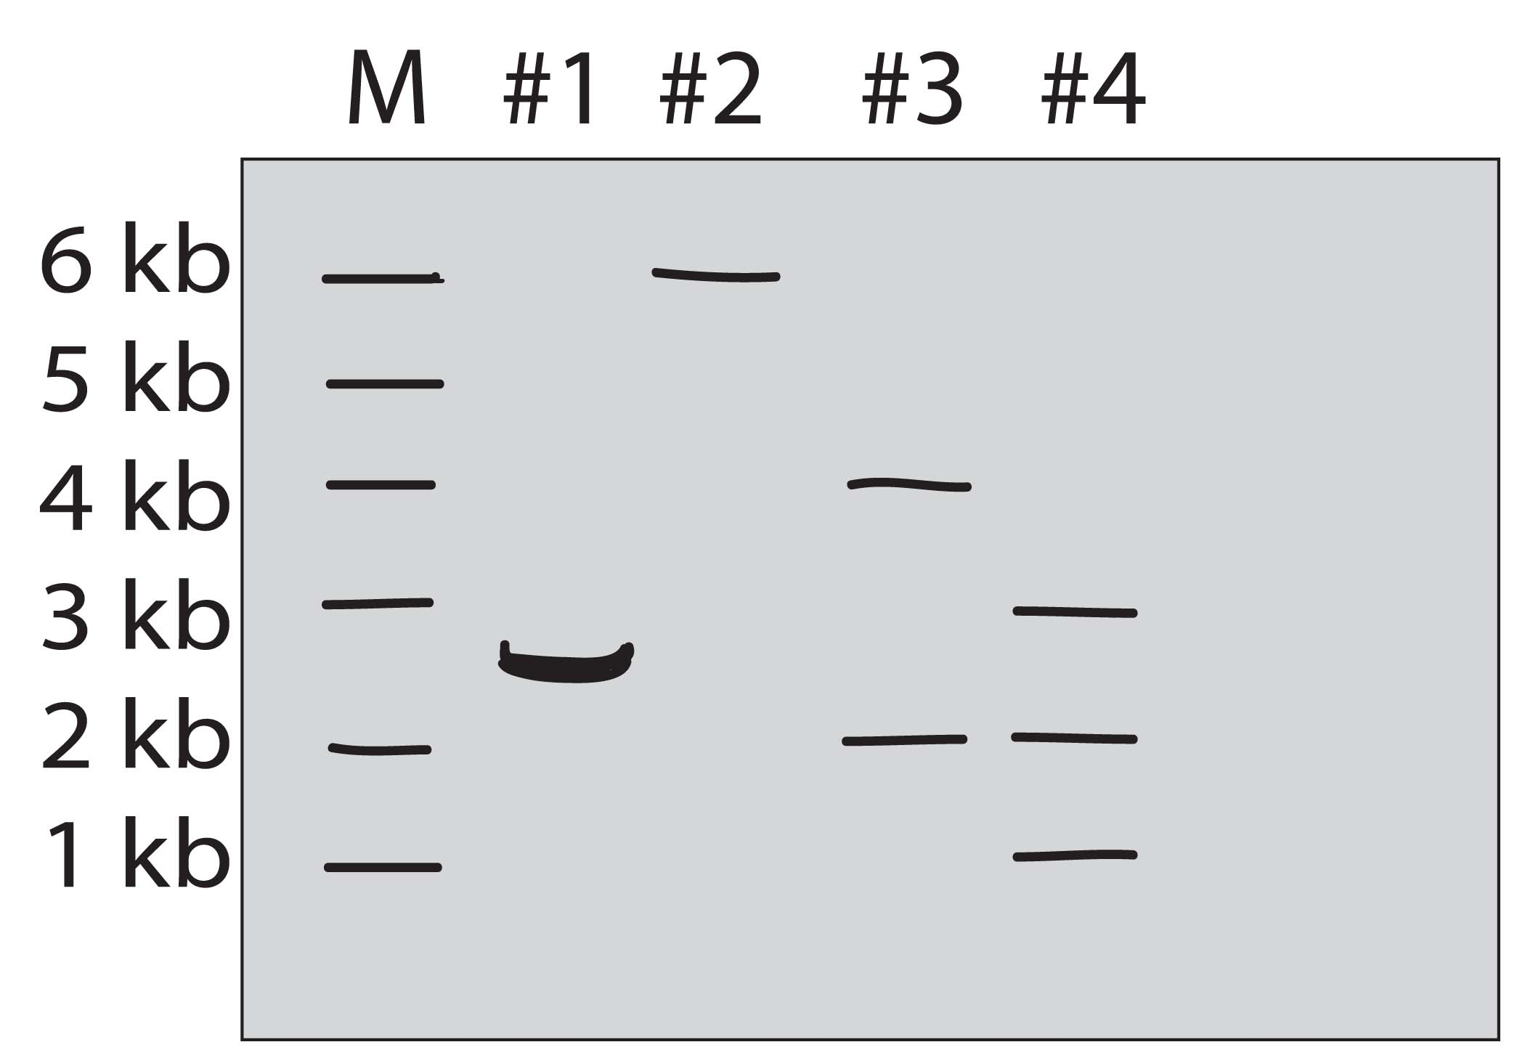 M 1 2 3

KpnI

1kb

XbaI

2.5kb

1.5kb

XbaI

a) What was the original DNA plasmid’s length? ________5kb________

b) How many restriction sites for *Xba*I and *Kpn*1 did the original plasmid have?

XbaI________2__________ KpnI__________1__________

c) Draw the original plasmid above in the space beside the gel. Label the restriction sites and indicate the distance between each site in kilobases (Kb).

**Question 5**: (16 points)

Examine the replication fork below:

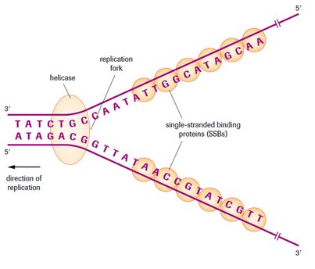

a) Clearly label the leading and lagging strands on the diagram. (leading bottom, lagging top)

b) Write the sequence of the 8 nucleotide primer that would be used to replicate the lagging strand (Begin with the first nucleotide not overlapped by the helicase).

5’____________GUUAUAAC_____________________________________3’

c) A mutation in the gyrase (topoisomerase) enzyme causes the gyrase to add supercoils to the unwound DNA rather than relieve supercoiling. Which functional mutation best describes the activity of this mutant gyrase? Give a ONE SENTENCE explanation of your answer.

antimorph - does the opposite of the original function

d) A mutation in DNA polymerase III causes its rate of synthesis to decrease by 50%. Which functional mutation best describes the activity of this mutant polymerase? Give a ONE SENTENCE explanation of your answer.

hypomorph – still same function, just less efficient

Question 6: (16 points) The pygmy peoples of Africa and Oceania are known for their particularly short stature. A recent genome sequencing study of pygmy individuals from several tribes in Cameroon (Africa) and Papua New Guinea (Oceania) identified several mutations within genes that contribute to growth.

One gene identified by these researchers as contributing to short stature in Pygmies is the human growth hormone enhancing factor (GHEF). This protein increases the activity of human growth hormone, enhancing bone growth. The blots below show the analysis of GHEF expression in samples from a pygmy from Cameroon, a pygmy from Papua New Guinea, and a Bantu person of average height as a control.

Papua New

Guinea

Papua New

Guinea

Bantu

Cameroon

Bantu

Cameroon

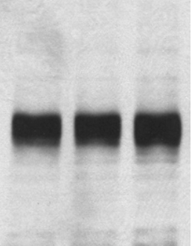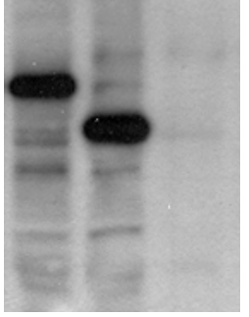

**Western blot using an antibody to GHEF**

**Northern blot using a probe to GHEF**

Notes: Assume each pygmy person has a ***single point mutation*** of some kind. There may be more than one plausible answer for each person. Credit will be awarded for answers that are consistent with the data presented in the blots. **Explanations should refer to the data on both blots!**

a) What is the most likely (physical) mutation affecting GHEF in the pygmy from Cameroon? Provide a justification for your response.

most likely a nonsense mutation, as the mRNA is present at the correct size but the protein is smaller than normal.

A single nucleotide insertion or deletion that results in a frameshift is also possible.

b) What is the most likely (physical) mutation affecting GHEF in the pygmy from Papua New Guinea? Provide a justification for your response.

missense or nonsense mutation affecting the start codon (AUG) – the mRNA is present, but no protein is made, thus the mutation likely affects the translation start site. Translation must start at a methionine (AUG), so even a missense here would completely prevent translation initiation.

also acceptable: a nonsense mutation very close to the start site that makes an extremely small protein not recognized by the antibody (antibodies need 9-12 amino acids for recognition)

Or, a frameshift (insertion/deletion) that occurred early in the sequence, such that most of the protein is different and is no longer identified by the antibody.

Question 6 Continued:

c)  Is this study of height-related genes in pygmy populations an example of forward genetics or reverse genetics? Briefly explain (no more than 2 sentences).

Forward - started with height phenotype and then performed genome sequencing to identify potential mutations (phenotype to genotype)

b)  Is height in humans considered an example of continuous or discontinuous variation? Briefly explain (no more than two sentences).

continuous - there are infinite categories of heights that are possible (not a few categories) Also its controlled by many genes

Question 7: (8 points) For each of the statements below, indicate whether the statement applies to prokaryotes, eukaryotes, both or neither by placing an X in the corresponding box (and X indicates that the statement applies, a blank box indicates that the statement does not apply.

|  |  |  |
| --- | --- | --- |
| prokaryote | eukaryote |  |
| x | x | DNA replication begins at an origin of replication. |
|  |  | Transcription can occur without a promoter. |
| x |  | The promoter contains -10 and -35 consensus sequence elements. |
|  | x | The promoter is bound by a transcription factor known as TBP. |
| x |  | Transcription and translation of the same mRNA can occur simultaneously. |
|  | x | Chromosomes are linear. |
| x | x | AUG encodes for Methionine. |
|  | x | mRNAs are spliced. |

Question 8

The following sequence of nucleotides is found within a single-stranded DNA template. Assume that the RNA polymerase if transcribing this template from left to right.

_3’__TACGCCAGATCATCCCAATAG __5’_

_5’__AUGCGGUCUAGUAGGGUUAUC 3’

M R S S R V I

a) Label the 5’ and 3’ ends of the DNA template above in the blank spaces provided.

b) Write the sequence of the mRNA transcribed from this template, and label its 5’ and 3’ ends clearly (you may write immediately below the DNA template)

c) Translate your mRNA using the codon chart on the front of this exam. (you may write your translation immediately below the mRNA sequence)

d) Assume a transition mutation occurs at the position in the DNA template indicated with the arrow.

Write the new **codon** created by this mutation: _______UCC_________note! Serine is NOT a CODON!_____

e) How would this transition mutation be classified? (What type of physical mutation occurs in the protein sequence?)

silent mutation – still a mutation but encodes the same amino acid