Problem set 2 BB2920 – Genetics - C term 2017 due **in class** Fri 1/27/17

Question 1, 30 points

Phenylketonuria (PKU) is a metabolic disorder in which patients lack expression of an enzyme called phenylalanine hydroxylase (PAH), which breaks down phenylalanine from the foods we eat into tyrosine. In the absence of PAH function, phenylalanine builds up to extremely high concentrations and causes brain damage and mental retardation. The six people below were tested for PKU. Person A is an unaffected control. Person B is not affected, but has affected children. Persons C, D, E and F all have PKU. DNA (digested with HindIII), mRNA and protein samples were collected from each person and were analyzed. The results are below.

1. With reference to the Southern, Northern, and Western blots below, explain what the likely mutation is that affects persons C, D, E and F. (Remember, C, D, E and F are all AFFECTED by the disease, which means they ALL have a hypomorphic or amorphic mutation in the PKU gene. I am looking for insights about the type of molecular mutation - insertion, deletion, base change, missense, nonsense, etc). Note: you must mention the results on *each* blot for *each* person to get full credit.
2. Why is person B unaffected? Note the differences on the Northern and Western blots between person A and person B in your response.
3. One of the affected patients (C, D, E, or F) is the child of person B. Which one? Explain how you can make this decision based on the blots.

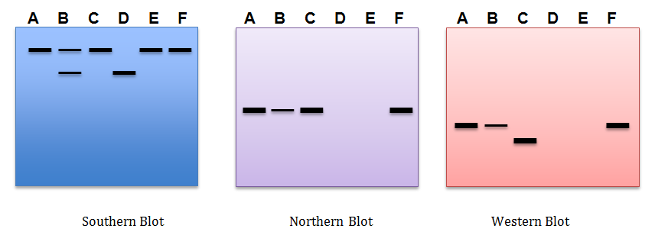

Question 2, 20 points

EcoRI is a restriction enzyme that recognizes the sequence GAATTC. Briefly define each type of mutation listed below, and describe what would happen to the function of EcoRI if it obtained each mutation. Make reference to the specific function of EcoRI (eg, it binds to GAATTC and cuts it) in your response.

1. hypermorph –
2. amorph –
3. neomorph –
4. hypomorph –
5. antimorph –

Question 3, 20 points

You have a plasmid vector that contains this restriction site: 5’A/GATCT3’ (slash indicates the cut site). You are attempting to clone an ~1kb DNA fragment containing the following restriction site on both ends: 5’G/GATCC3’.

(a) If you cut each of these sequences with the appropriate enzymes, can you ligate the DNA fragment into this plasmid? Why or why not?

(b) Draw a schematic of the plasmid and the insert *before* and *after* cloning to illustrate your answer to

(c) Can the resulting plasmid be re-cut with either enzyme in the future? Why or why not?

Question 4, 30 points

You are a molecular geneticist working for a major drug company. This drug company has discovered a strain of yeast that produces a new and highly potent inhibitor of cholesterol absorption from the intestinal tract. The drug company sees this as an important (and potentially very lucrative) therapy for hypercholesterolemia, or high cholesterol, which affects millions of people. The company has named the inhibitor molecule CholeBlock.

The yeast turns a precursor metabolite into CholeBlock using an enzyme called Yfe1 (a protein product of the YFE1 gene). The simplified reaction mechanism is shown below:

Yfe1

Precursor CholeBlock

You have been given the task of improving the efficiency of Yfe1 in an attempt to optimize yield of the drug. You make a number of point mutations in the gene, and then test the enzymatic function of the resulting yfe1 mutants by seeing how efficiently the mutant enzyme can convert the precursor to CholeBlock.

a) [12 points] Below are four mRNA sequences from a section of the coding region of the YFE1 mRNA, one wild type as well as three mutations you created. Translate each mRNA, and identify the type of mutation (frameshift insertion/deletion, missense conservative/non-conservative, nonsense, etc) that resulted in each case.

Wild type YFE1: 5’-AUGUACCGGCCUACCCAUCGAUACUCCGAAUUU-3’

yfe1 mutant 1: 5’- AUGUACCGGCCUACCCAUGGAUACUCCGAAUUU -3’

yfe1 mutant 2: 5’- AUGUACGGCCUACCCAUCGAUACUCCGAAUUU-3’

yfe1 mutant 3: 5’- AUGUACCGGCCUACCCGUCGAUACUCCGAAUUU -3’

b) [15 points] Next, you test the wild type and the three mutants in an assay to detect the efficiency of the Yfe1 enzyme. You add the purified Yfe1 enzyme and the precursor metabolite to a test tube, and you monitor the formation of CholeBlock over time. The result of your experiment is shown below:

Describe the functional effect of each mutation (hint, I’m looking for the “-morph” description here). Based on the mutation types identified in part a, write a sentence or two about what you think happened to each enzyme (you will need to hypothesize a bit here. What I am really asking you to do is relate the physical mutation from part a to the functional mutation in part b).

c) [3 points] Did you succeed in your task? Which enzyme will you present to the CEO of the drug company as your “new and improved” Yfe1 at your next meeting?