BB2920 Problem Set 3

**Problem 1 (30 points)**

*C. elegans*, a microscopic roundworm, is often used as a model organism by geneticists. Imagine you are studying a mutation in the (fictional) nco-1 gene (named “no crossing over”) in *C. elegans*, that prevents crossing over between homologous chromosomes, but otherwise the chromosomes pair normally. Assume that, other than the inability to cross over, meiosis proceeds normally.

a) The diploid chromosome number in C. elegans is 10. How many possible gametes could be formed by an individual with the nco-1 mutation? (looking for an exact number here)

b) Imagine that a similar gene to your nco-1 gene exists in humans, and that the gametes of individuals with a human nco-1 mutation are viable (the individuals are fertile). How many possible gametes could a person with this mutation produce? (looking for an exact number here)

(c) What is the likelihood that a man and a woman that both have the nco-1 mutation could produce two genetically identical offspring from different pregnancies? (calculate a number and describe your reasoning).

(d) A different mutation, in the gene hec-1 (a critical component of the kinetochore complex) affects the kinetochore such that microtubules can no longer connect to opposing sides of both sister chromatid kinetochores, but can only attach to one side or the other. Would this mutation cause a problem in meiosis I? What about meiosis II? Explain what would happen to the developing gametes in each case.

**Problem 2 (30 points)**

Zebras are part of the equine family, but zebras, horses, donkeys and other equines all have vastly different chromosome numbers.

In horses, 2n=64. In some zebras, 2n=44. Crosses between a zebra and another equine species are known as zebroids. Typically a zebroid looks like a striped version of the horse parent.

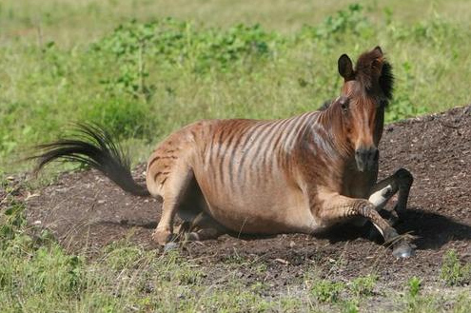Kumana @ Wild Equines - <http://farm4.static.flickr.com/3645/3322859004_4224a726b8.jpg?v=0>

a) Assume the horse and zebra with chromosome numbers listed above are crossed. How many chromosomes are in a somatic cell in the resulting zebroid? How did you arrive at this number? Explain using your knowledge of meiosis, NOT the internet!

b) Would you expect there to be a problem with a zebroid’s cells during mitosis? Why or why not?

c) Most zebroids are sterile because their gametes are not viable. Why? What specifically is the problem?

**Problem 3 (20 points)**

You have a fruit fly with shiny wings, which you believe is a dominant phenotype, because you have noticed more shiny winged flies (W) than dull winged flies (w). How would you determine if a given shiny winged fly is homozygous or heterozygous for the W allele?

a) Describe the genetic cross you would perform, and the possible outcomes of progeny for each case (homozygous and heterozygous).

b) draw out the Punnett squares to illustrate your answer to part a.

**Problem 4 (20 points)**

You have two laboratory mice, a male and a female, that are both black. You are told by a labmate that these are pure-breeding strains, which means they are homozygous all possible alleles. You breed the animals continuously for a year, and while most of the offspring are black, you do see a few with grey fur. Of the 64 total offspring generated over the year, 15 were grey. What’s going on? Did your lab mate make a mistake? Explain, and draw a Punnett square to illustrate your explanation.