Conference 1 practice problems - Solutions

From the textbook (this is a problem on basic DNA composition)

Ch7: 21 (answers in back) A=T= 15%, each G=C=35% each

Follow-up question to ask the class (not in the book):

What percentage of this DNA molecule is pyrimidines?

Answer: pyrimidines are C and T, so 35% + 15% = 50%.

Problem on DNA replication (not in the book):

Below is a very small segment of the human genome: (draw this up on the board)

5′ CTGAATCGGGTTGGG 3′

3′ GACTTAGCCCAACCC 5′

In order for the top DNA strand to be replicated, what primer sequence is needed?

**5**′ **CCCAAC 3’**

In order for the bottom DNA strand to be replicated, what primer sequence is needed?

**5’ CTGAAT** 3’

For a replication fork moving to the RIGHT of this page, which strand would be the leading strand, and which would be lagging? bottom = leading, top = lagging, engourage students to draw it out.

For a replication fork moving to the LEFT of this page, which strand would be the leading strand, and which would be lagging? top = leading, bottom = lagging, encourage students to draw it out.

**Remind the students that DNA pol III can only add to the 3’ end of the primer or growing strand, therefore a 5’to 3’ primer is needed, so that there will be an open 3’ end. To determine leading and lagging, the same principle applies.**

**Also remind them that sequences are always written 5’ to 3’, so they will have to transpose if needed!**

Two follow-up questions:

a) What is the first protein at the replication fork, and what is its function? helicase, its creating the replication fork by disrupting the hydrogen bonds betweenthe strands

b) By itself, DNA polymerase III can only synthesize a few nucleotides before it dissociates from (falls off) the strand. Yet in reality DNA pol III can synthesize a thousand nucleotides a second! Which protein of the replisome allows DNA pol III to remain on the DNA? beta clamp

Problem on transcription:

Ch 8, #14

Solutions (these are not in the book):

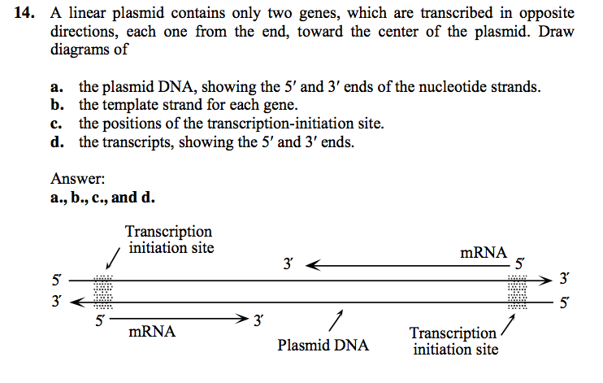

Ch8: 17 (answer in back) - if you are running out of time, suggest that the students try this problem on their own, and tell them the answer is in the back.

In Chapter 9, the following are helpful problems: #13, 39, 41 and 43.

39 and 43 solutions are not in the book, solutions are included below:

I suggest you try 13 and 41 in class as time permits. I will post the solutions to 39 and 43 after conference.

#39:

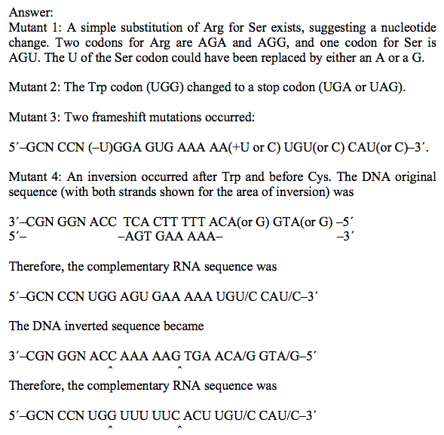

#43:

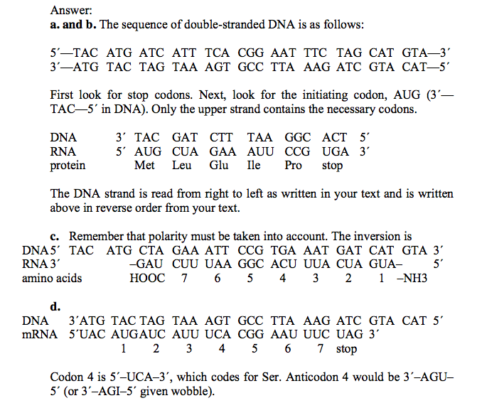

In chapter 16, the following problems are good (you probably won’t have time, so just suggest these for the students to try) #8, 9, and 10 and 31. (solution to 8 is in the book, 9, 10 and 31 below)

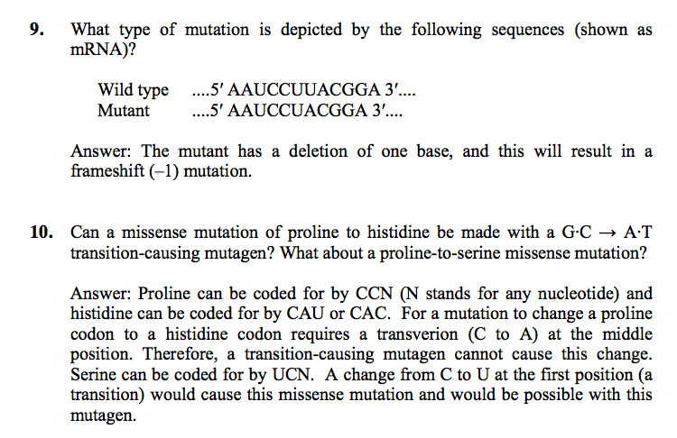

#31:

