Consider this region of a typical prokaryotic gene:

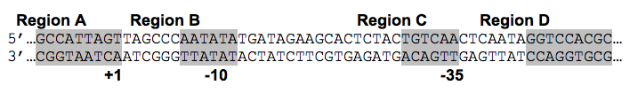

1. Which strand (top or bottom) is the template strand?
2. Which region of this DNA sequence will be transcribed?
3. Give the sequence of the first 8 bases of the transcribed RNA.
4. Which region is considered to be “*upstream”* of the promoter?

Consider this region of a typical prokaryotic gene:



1. Which strand (top or bottom) is the template strand?
2. Which region of this DNA sequence will be transcribed?
3. Give the sequence of the first 8 bases of the transcribed RNA.
4. Which region is considered to be “*upstream”* of the promoter?