Daniel McDonough

HW-4 CS4516

4/6/19

5.6) *[20] <5.2> Many snooping coherence protocols have additional states, state transitions, or bus transactions to reduce the overhead of maintaining cache coherency. In Implementation 1 of Exercise 5.2, misses are incurring fewer stall cycles when they are supplied by cache than when they are supplied by memory. The MOESI protocol extension (see Section 5.2) addresses this need.*

*Draw new protocol diagrams with the additional state and transitions.*

Below is a copy of Figure 5.7, a Cache coherence state diagram. State transitions induced by the local processor shown in black and by the bus activities shown in gray and the activities on a transition are shown in bold. This diagram is used as a basis for the MOESI protocol extension.

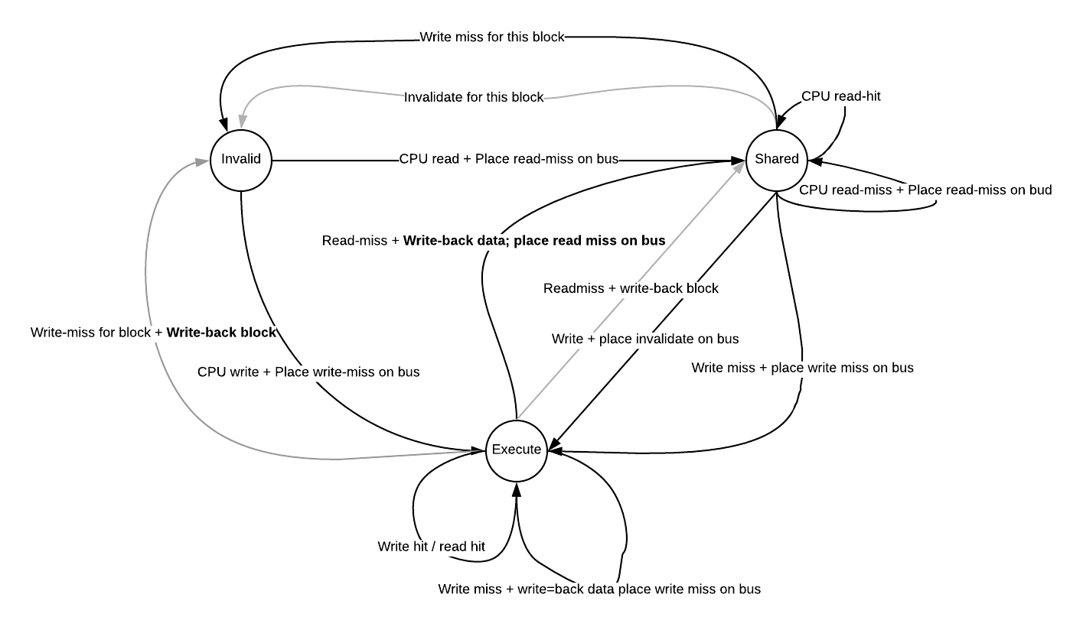

Below is the MOESI protocol extension.

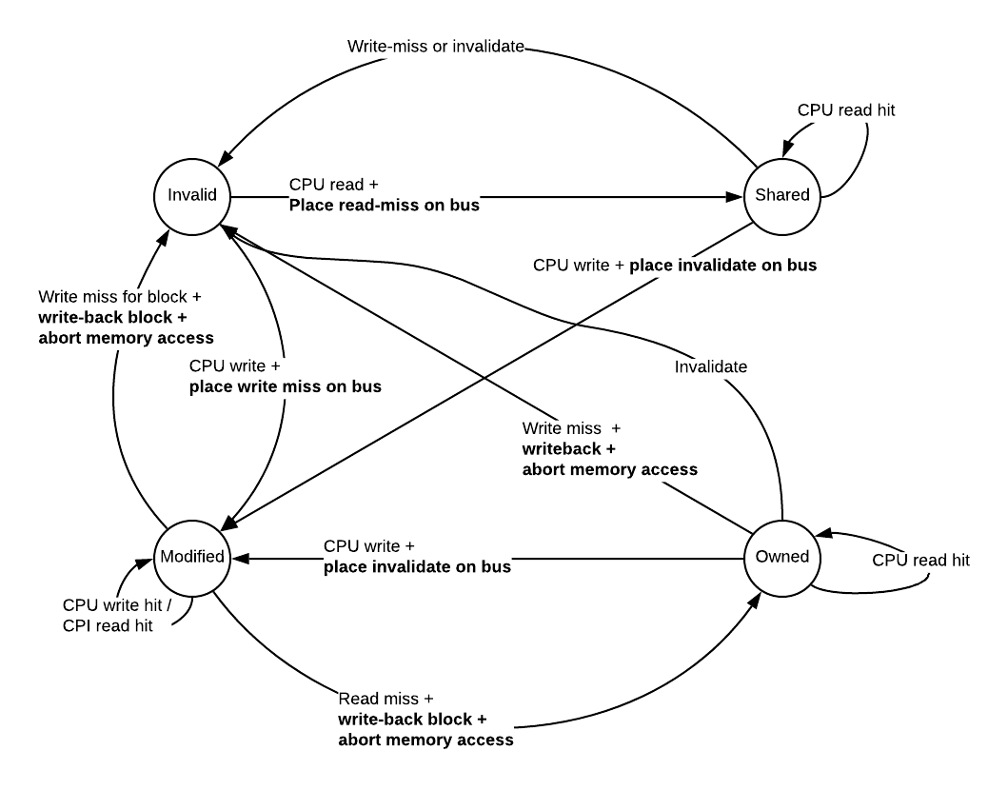

“MOESI adds the state Owned to the MESI protocol to indicate that the associated block is owned by that cache and out-of-date in memory. In MSI and MESI protocols, when there is an attempt to share a block in the Modified state, the state is changed to Shared (in both the original and newly sharing cache), and the block must be written back to memory. In a MOESI protocol, the block can be changed from the Modified to Owned state in the original cache without writing it to memory. Other caches, which are newly sharing the block, keep the block in the Shared state; the O state, which only the original cache holds, indicates that the main memory copy is out of date and that the designated cache is the owner. The owner of the block must supply it on a miss, since memory is not up to date and must write the block back to memory if it is replaced.” - p388 of Hennessy & Patterson, 6 th edition.