Daniel McDonough
CS534
9/28/19
HW 5

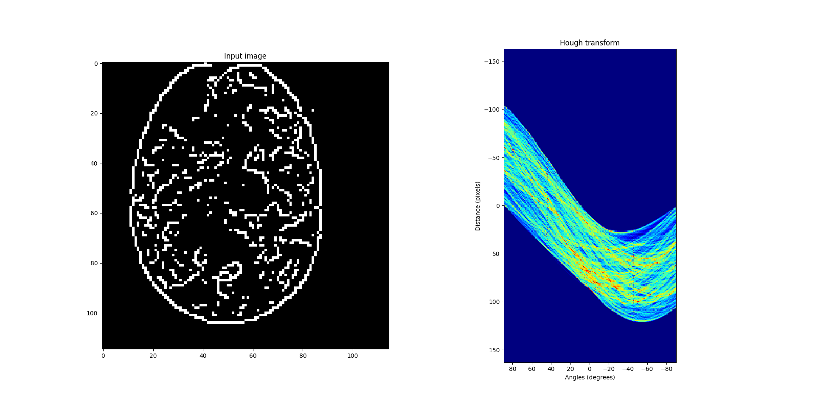

Here the Line Hough transform is densist around the line gap at the top of the image.

  - L1 corresponds to (0,2) and L2 corresponds to (-3,3)
  - y = -1/3x + 2
  - P3 = (0,6)
  - P4 = (1/3,0) → y= 3x+0: intersection = (0.5,1.5)

  - MAX(|x-a|,|y-b|) = r/2
(This makes it such that only squares aligned with the x,y axes are considered)
Where in SH space the axis are x position, y position and side length = (a,b,r)

  - Image Space
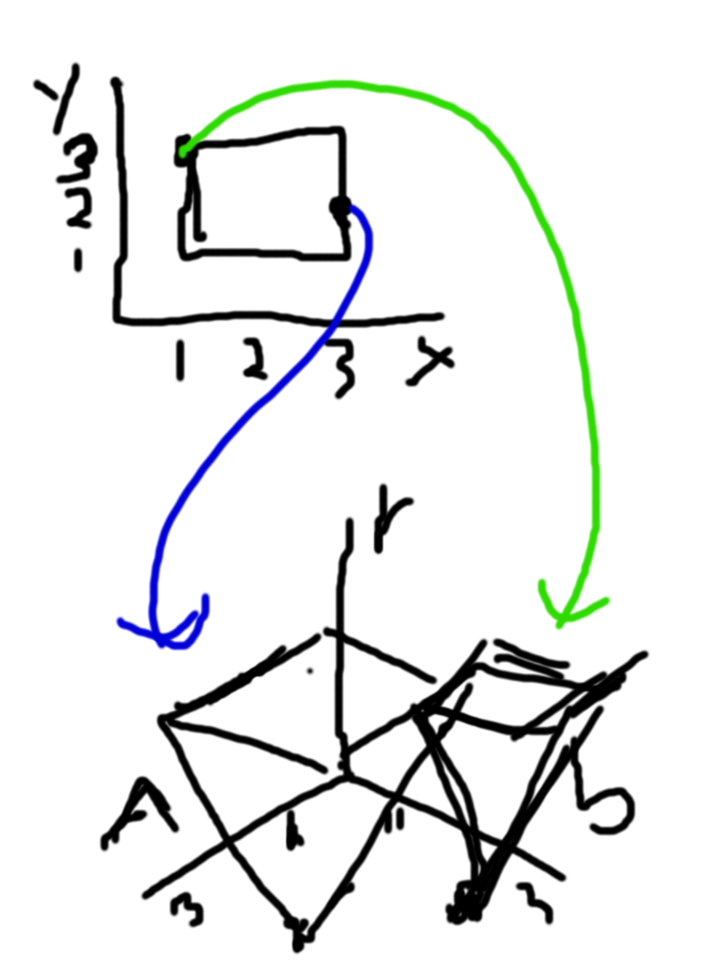

Square Hough (SH) Space

3. These two points currently describe the perfect square at center (2,2) and all increasing squares from any point along x=y. In SH space, the intersecting volume of the two points represent all possible side lengths as r increases.

- The histogram shows the magnitude (occurrence) and orientation (bins) for all pixels around a point. This is then used to label a pixel with a gradient as a key point / feature.

  - The original image can be summed by Integral Image from the region (x0,y0)→ (x1,y1) as (x1,y0)+(x0,y1)-(x0,y0)-(x1,y1)
  - The box filters for SURF can be calculated as the second integral image in respect to y. As given in the determinant of the Hessian.

