Reed Bunnell - Assignment 1.4

Flowchart:

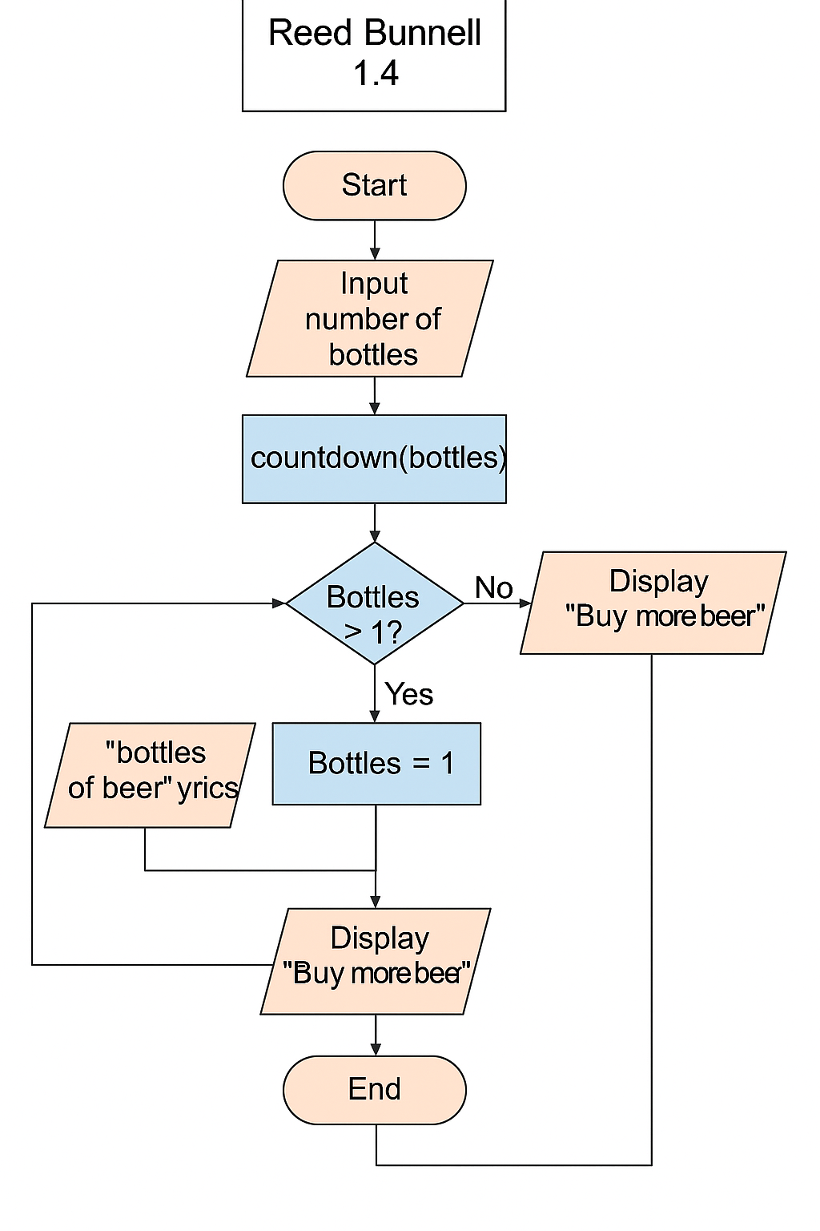

This flowchart models the logic of the 'Bottles of Beer on the Wall' program. It begins by asking the user how many bottles are on the wall, then uses a countdown function to display song lyrics accordingly. The flowchart handles the special case when only one bottle remains, and ends by reminding the user to buy more beer.

# Python Code

"""

Author: Reed Bunnell

Assignment: Module 1 - 100 Bottles of Beer Countdown

Description: This program asks the user how many bottles of beer are on the wall, then

uses a function to count down to 1, updating the lyrics along the way. Once finished,

the user is reminded to buy more beer.

"""

def countdown_beer(bottles):

while bottles > 0:

if bottles == 1:

print(f"{bottles} bottle of beer on the wall, {bottles} bottle of beer.")

print("Take one down and pass it around, no more bottles of beer on the wall.\n")

else:

next_bottles = bottles - 1

bottle_word = "bottles" if next_bottles != 1 else "bottle"

print(f"{bottles} bottles of beer on the wall, {bottles} bottles of beer.")

print(f"Take one down and pass it around, {next_bottles} {bottle_word} of beer on the wall.\n")

bottles -= 1

def main():

try:

user_input = int(input("Enter number of bottles: "))

if user_input < 1:

print("Please enter a number greater than 0.")

else:

countdown_beer(user_input)

print("Time to buy more beer!")

except ValueError:

print("Invalid input. Please enter a whole number.")

if __name__ == "__main__":

main()