CSD-430 Module 1 – Installation & JSP Verification
Name: Reed Bunnell
Date: January 19, 2026
Assignment: Module 1 – Java / Tomcat / IDE Setup + JSP

1) Java Installed & Configured
Example: Command prompt showing `java -version`, `javac -version`, and/or JAVA_HOME set.
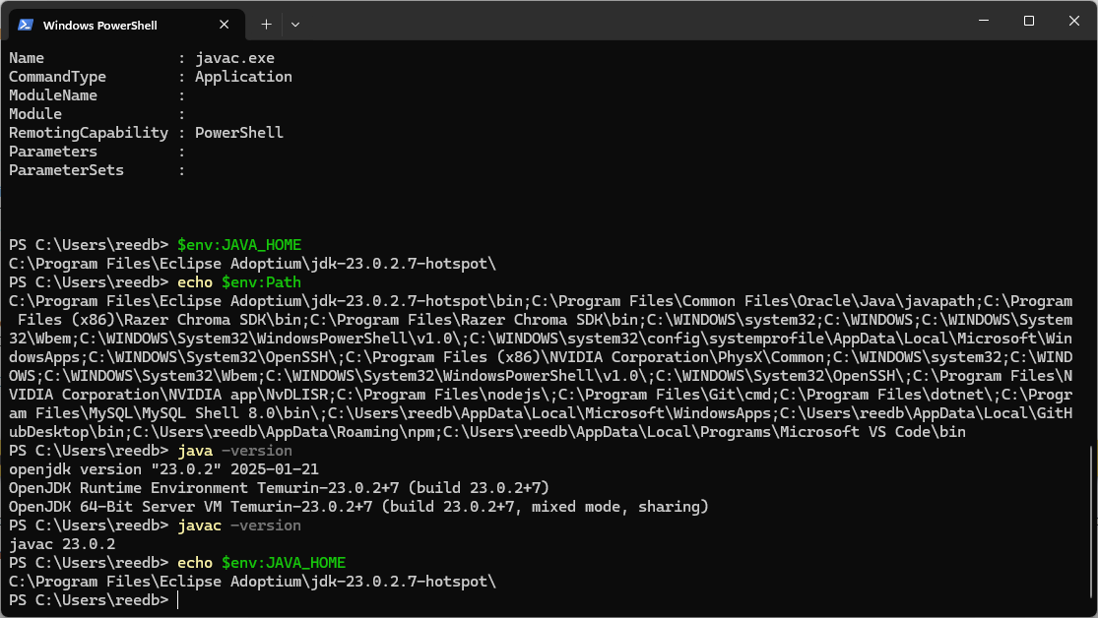

2) Jakarta Tomcat Installed & Configured
Example: Eclipse Servers view with Tomcat configured, or Tomcat manager/status page.
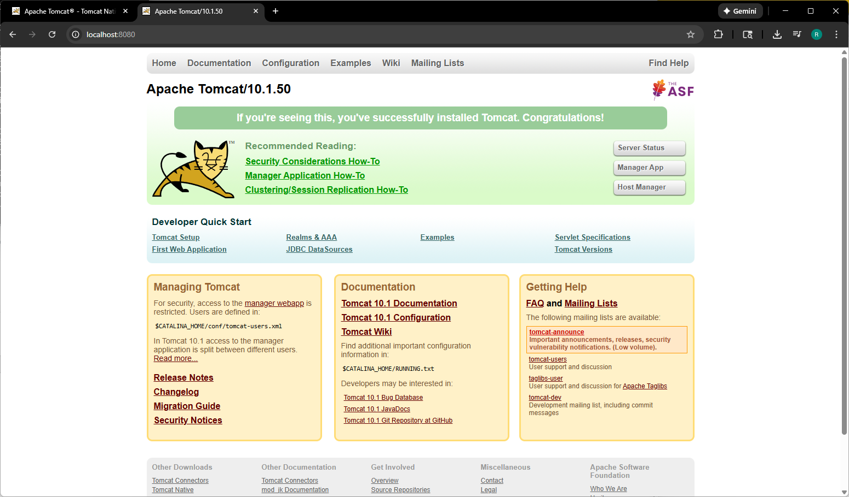

3) IDE Installed & Configured (Eclipse)
Example: Eclipse ‘About’ dialog, workspace, and project/server configuration.
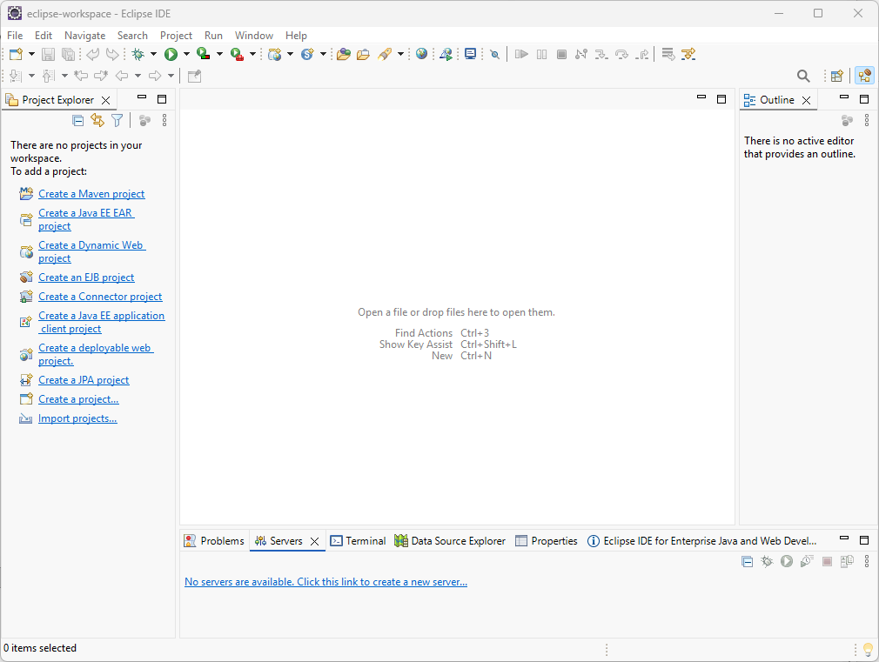
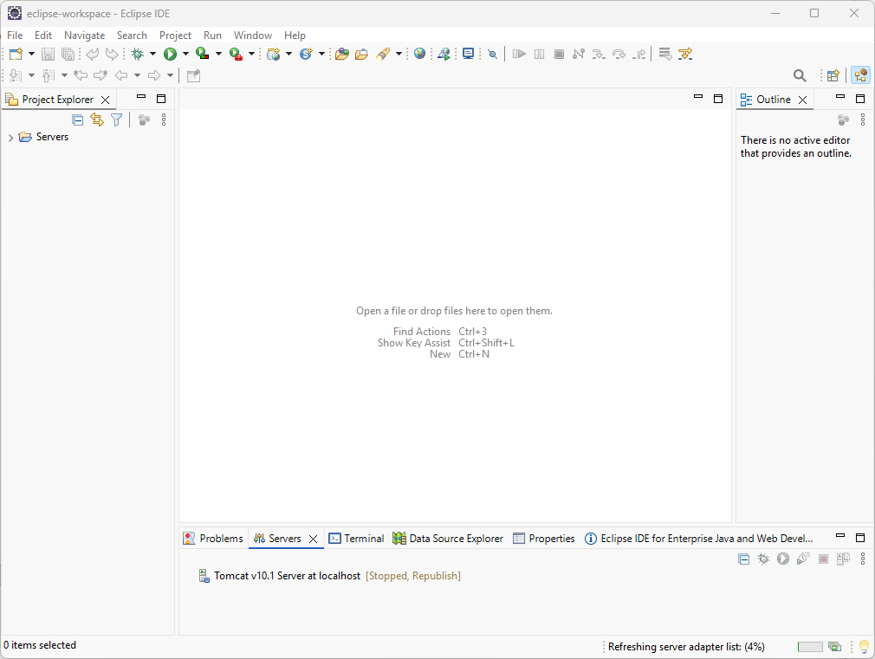

4) JSP File Running Successfully
Example: Browser showing the rendered `index.jsp` page with ‘JSP is working ✅’ and server time.
