# Reed Bunnell Module 2.3 Assignment – Relational vs Non-Relational

Entity Relationship Diagram:

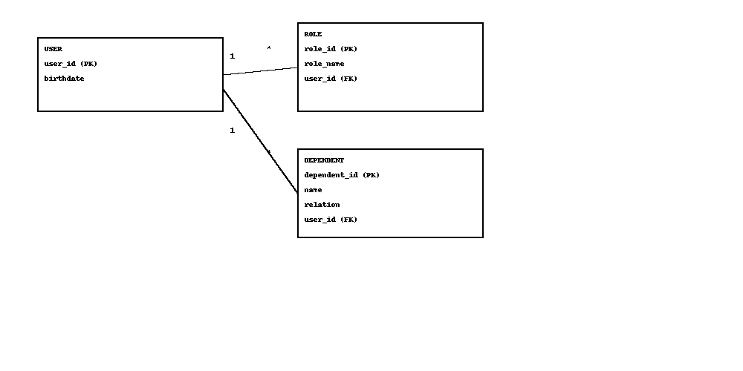

NoSQL Data Structure:

