CHAPTER FOUR: SYSTEM ANALYSIS AND DESIGN

4.0 Introduction
Chapter Three explained how the study was carried out and how the models were tested. This chapter shows how the system was planned before and during coding. It moves from what the system must do to how it is built. Functional models show the flow of data through the pharmacy. System models show how users and components interact over time. Data models show how records are stored. The chapter then presents the user interface and the security design. Every design choice is linked back to the objectives in Chapter One.

4.0.1 Requirements Summary
The requirements came from three sources. These were the study objectives and the literature in Chapter Two. The third was the planned consultation with PGH pharmacy staff. Table 4.1 lists the functional requirements.
ID | The system shall | Objective
FR1 | Let users log in with an email and password and give each user a role. | 6
FR2 | Show stock, reorder points and expiry dates for every medicine. | 1, 6
FR3 | Record dispensing, taking stock from the earliest-expiring batch first. | 6
FR4 | Forecast daily demand for each medicine for 1 to 90 days ahead. | 2
FR5 | Estimate the chance of a stockout before the next delivery. | 3
FR6 | Score and tier suppliers from their delivery records. | 4
FR7 | Flag batches likely to expire before they are used. | 5
FR8 | Combine the four models into reorder recommendations with reasons. | 6
FR9 | Let a pharmacist approve or reject each recommendation. | 6
FR10 | Create a purchase order when a recommendation is approved. | 6
FR11 | Let users test each model with their own inputs. | 7
FR12 | Produce reports in CSV and PDF format. | 6
FR13 | Let the administrator manage users and import datasets. | 6
Table 4.1: Functional requirements
Table 4.2 lists the non-functional requirements. These describe how well the system must work.
Quality | Requirement
Performance | A full decision run for all medicines finishes in under five seconds. Pages load in under three seconds.
Usability | A pharmacist can run and approve a reorder without training beyond one short session.
Security | Only logged-in users can see data. Each action is checked against the user's role.
Reliability | The system runs on the hospital network and keeps working when the internet is down.
Auditability | Every decision, approval and dispense is recorded with the user and the time.
Transparency | Every model result shows the main reasons behind it.
Maintainability | Models are stored as versioned files and can be replaced without changing code.
Portability | Users need only a modern web browser.
Table 4.2: Non-functional requirements

4.1 Functional Modeling
Functional modeling shows what the system does with data. It uses data flow diagrams in the style of Gane and Sarson (1979). Rounded boxes are processes, square boxes are external entities and open boxes are data stores.

4.1.1 Context Diagram
Figure 4.1 shows the system as a single process. It also shows the six external entities that exchange data with it. Pharmacists send receipts, dispensing records and approvals. In return, they receive forecasts, risk alerts and reorder recommendations. The pharmacy manager sets policy and reviews dashboards and reports. Stores staff look up stock and receive stock and expiry lists. The administrator manages users and roles. Approved orders go to suppliers as purchase orders. Finally, trained model files come from Google Colab, where the models were built.
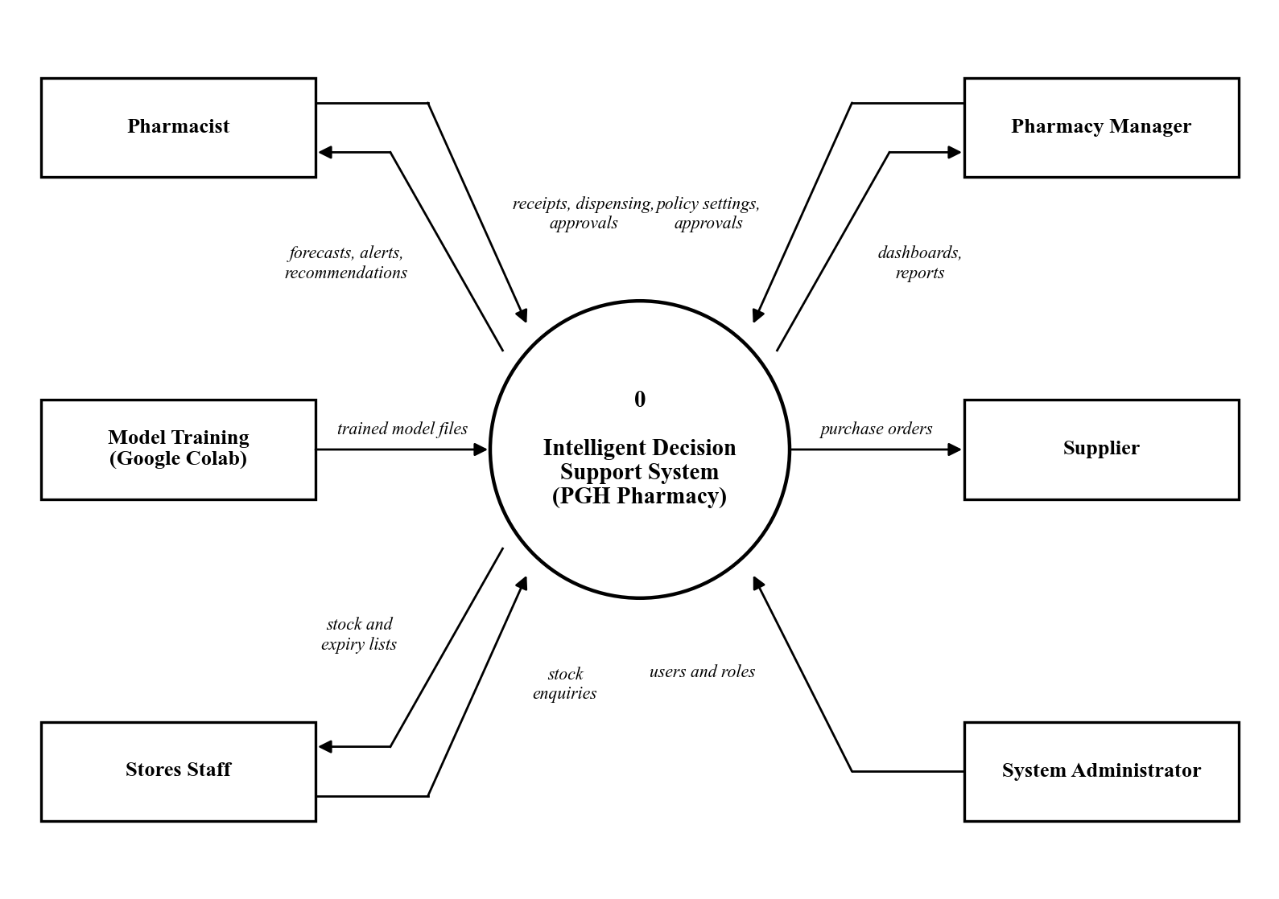
Figure 4.1: Context diagram of the proposed system

4.1.2 Data Flow Diagram (Level 1)
Figure 4.2 breaks the system into seven main processes and seven data stores. Process 1.0 checks each user against the users store (D1). Process 2.0 records receipts and dispensing and updates medicines and batches (D2). Process 3.0 reads the demand history (D3) and forecasts demand with Model 1. Process 4.0 reads delivery records (D4) and scores suppliers with Model 3. Process 5.0 uses stock, the forecast and the model files (D6) to assess risk. It applies Model 2 for stockouts and Model 4 for expiry. Process 6.0 combines all results into recommendations and saves them in D5. It writes each action to the audit log (D7). It also sends purchase orders to suppliers. Process 7.0 turns stored decisions into reports and dashboards for pharmacy staff.
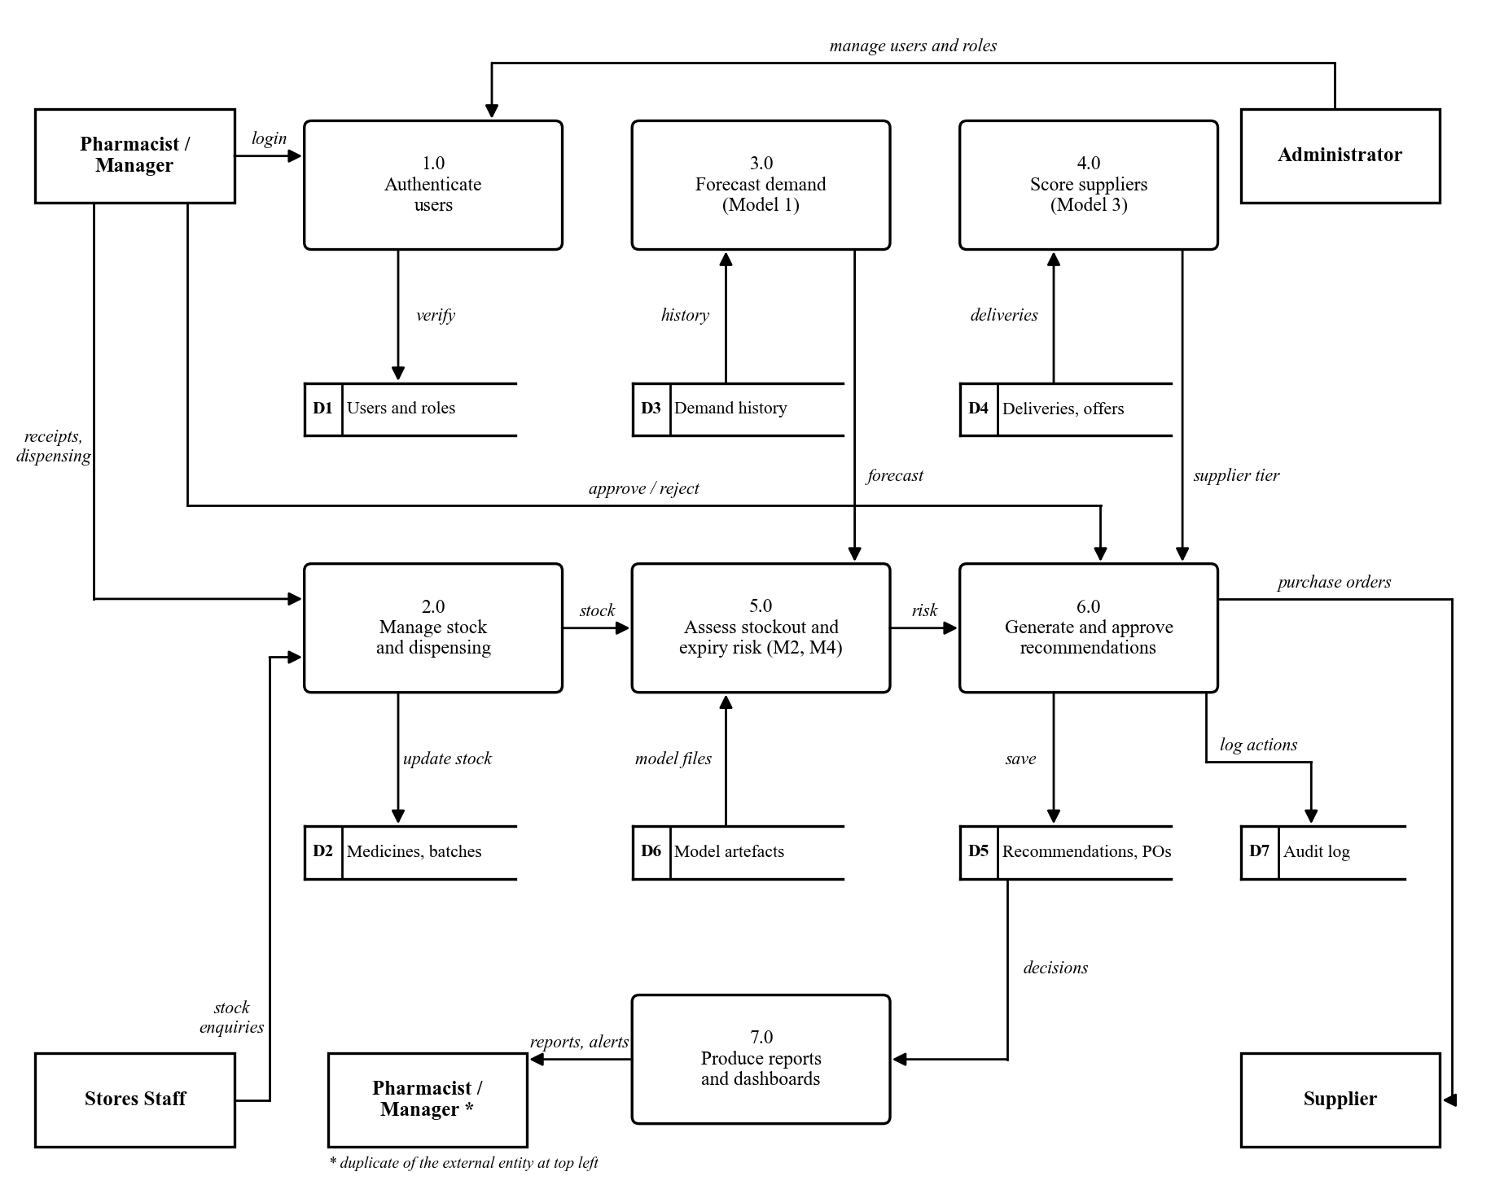
Figure 4.2: Level 1 data flow diagram

4.2 System Modeling
System modeling describes the behaviour of the system. The Unified Modeling Language (UML) was used for these diagrams (Fowler, 2004).

4.2.1 Use Case Diagram
Figure 4.3 shows the four user roles and the services each one uses. The roles form a chain. Each role can do everything the role above it can do, plus more. Stores staff can log in and view stock and expiry lists. Pharmacists add forecasting, the Model Lab, the decision engine and approvals. Pharmacy managers can also update supplier details. The administrator can also manage users and import datasets.
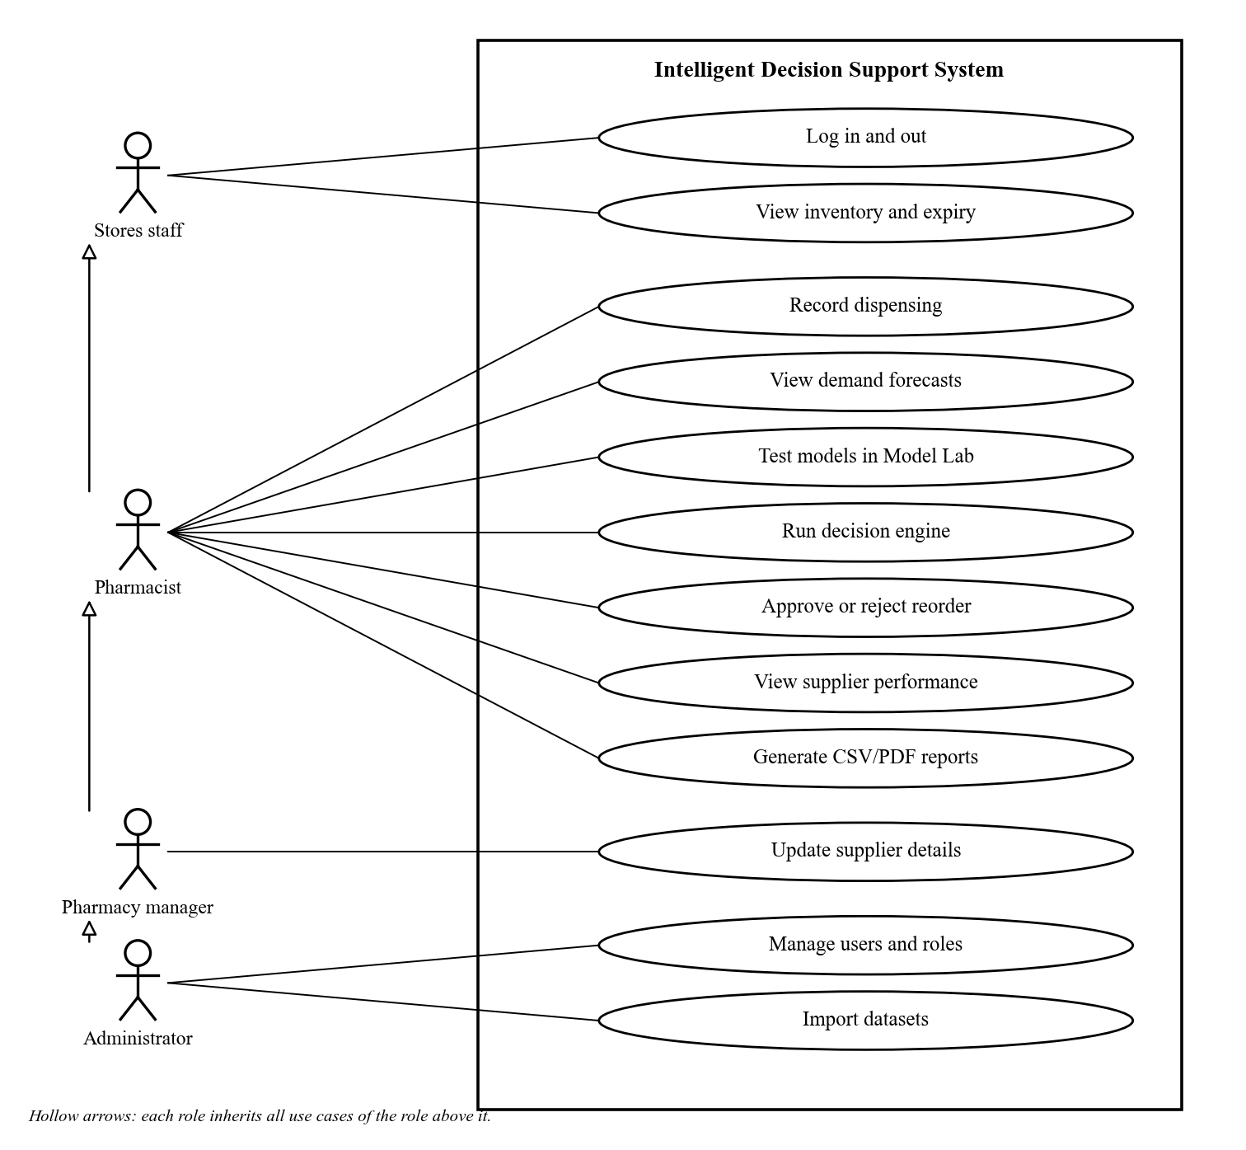
Figure 4.3: Use case diagram
Table 4.3 describes the most important use case in detail.
Item | Description
Use case | Run decision engine and approve a reorder
Actor | Pharmacist (also manager and administrator)
Precondition | The user is logged in. Stock, demand and supplier data are loaded.
Main flow | 1. The user clicks Run decision engine. 2. The system checks every medicine with the four models. 3. The system lists orders, expedite advice and medicines needing no action. 4. The user opens a recommendation and reads its reasons. 5. The user approves it, with or without changing the quantity. 6. The system creates a purchase order and records the approval.
Alternative flow | At step 5 the user rejects the recommendation. The system marks it rejected and records who did so.
Postcondition | A purchase order exists, or the recommendation is rejected. The audit log holds the decision.
Table 4.3: Use case description for running the decision engine

4.2.2 Sequence Diagrams
Figure 4.4 shows the login sequence. The React interface sends the email and password to the Django authentication API. The API first checks that the user has not made too many attempts. It then compares the password with the stored hash. If they match, it returns a short-lived access token and a refresh token. The interface uses the access token to fetch the user's name and role. It then shows only the menus that the role allows.
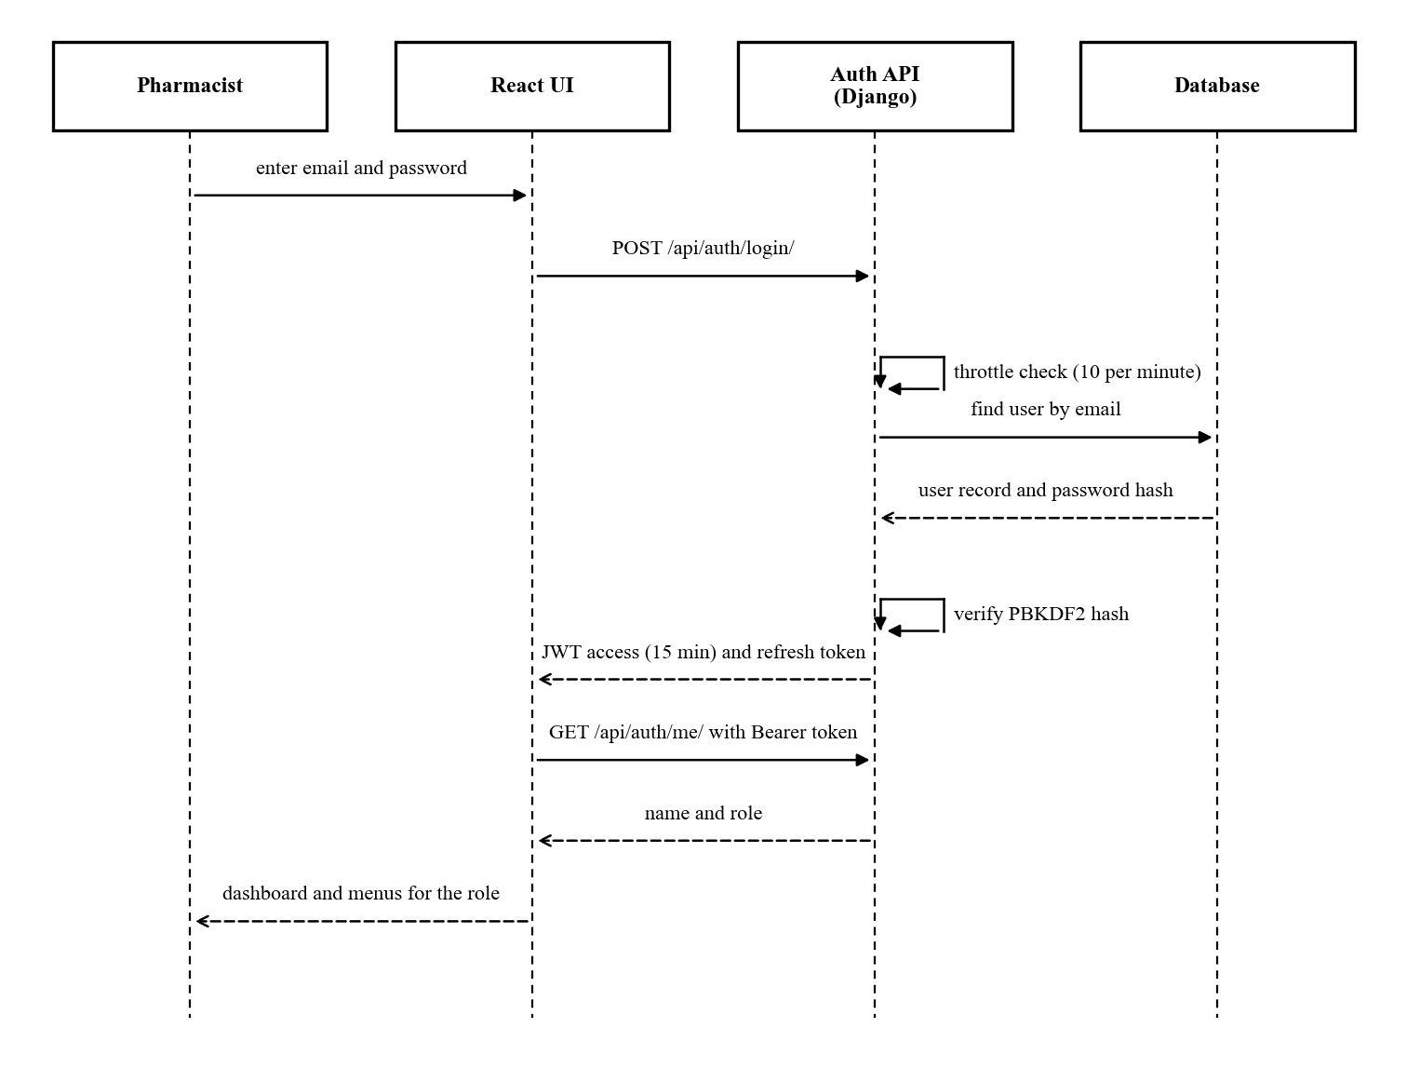
Figure 4.4: Sequence diagram for user login
Figure 4.5 shows the core sequence of the system. The pharmacist starts a decision run from the Reorder Decisions page. The decision engine reads stock, demand and delivery data from the database. It then calls the four models in turn. The results are saved as recommendations, and an audit event is written. When the pharmacist approves one, the API creates a purchase order. The order's due date is set from the supplier's lead time.
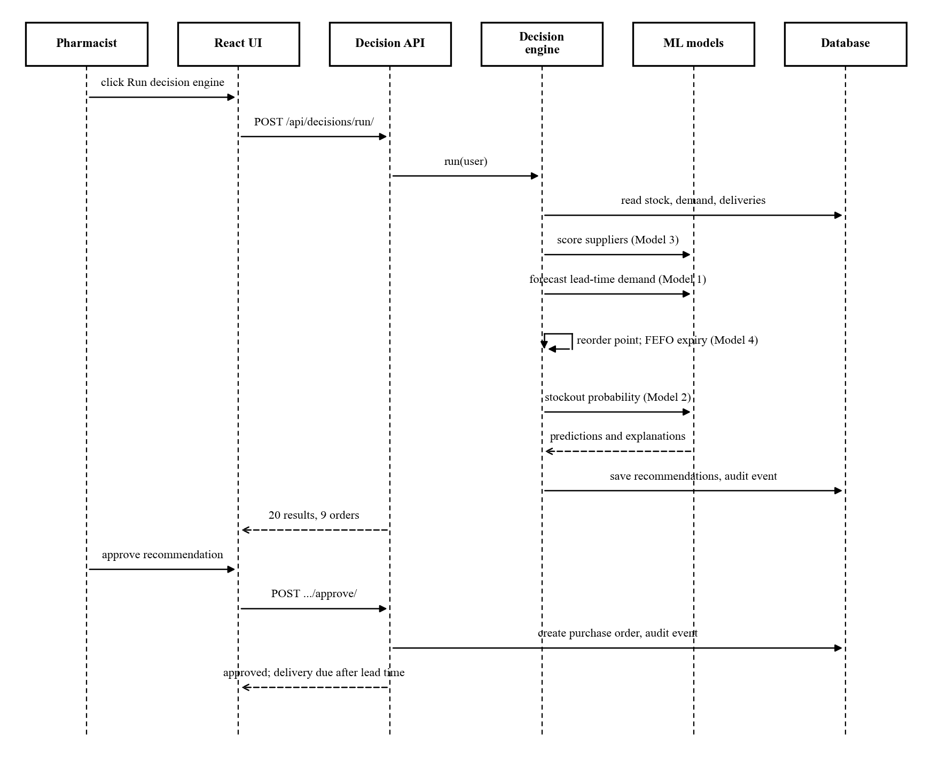
Figure 4.5: Sequence diagram for running the decision engine and approving a reorder

4.2.3 State Diagrams
Figure 4.6 shows the life of a recommendation and of a purchase order. A recommendation starts as pending when the engine creates it. It then becomes approved, rejected or superseded. It is superseded when a newer engine run replaces it. This prevents two open recommendations for the same medicine. An approved recommendation creates a purchase order. The order starts as pending and becomes partial, delivered or cancelled.
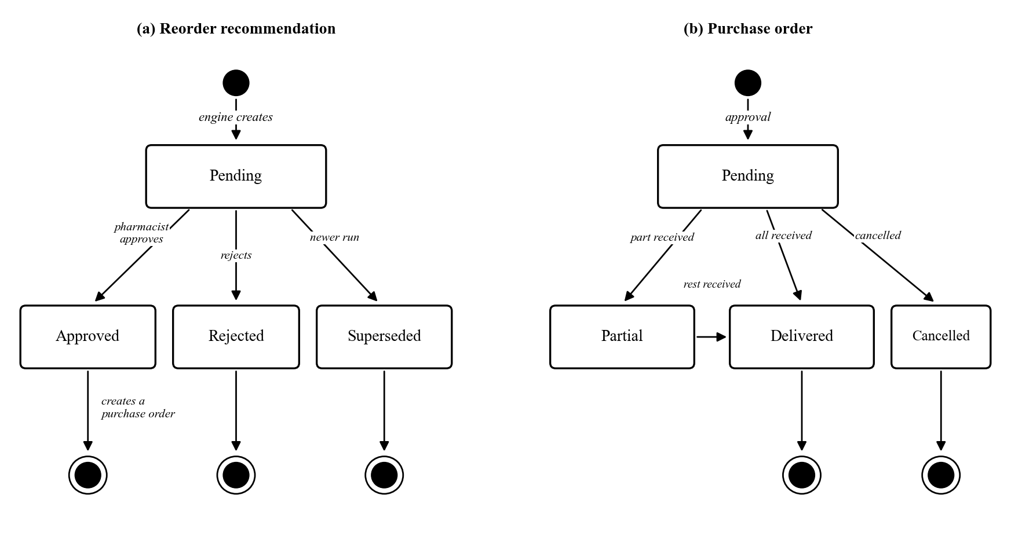
Figure 4.6: State diagrams for (a) a recommendation and (b) a purchase order

4.2.4 Activity Diagram
Figure 4.7 shows the reorder decision logic for one medicine. The engine first gathers data and chooses a supplier. It forecasts demand and sets the reorder point. It then removes stock that will expire unused and estimates the stockout risk. If usable stock is at or below the reorder point, an order is proposed. Stock may sit above that point while the risk is still high. In that case, the engine checks for open orders. With no open order, it proposes a new one. With an open order, it advises the pharmacist to expedite that order instead. Ordering again would not help, because a new order would arrive just as late.
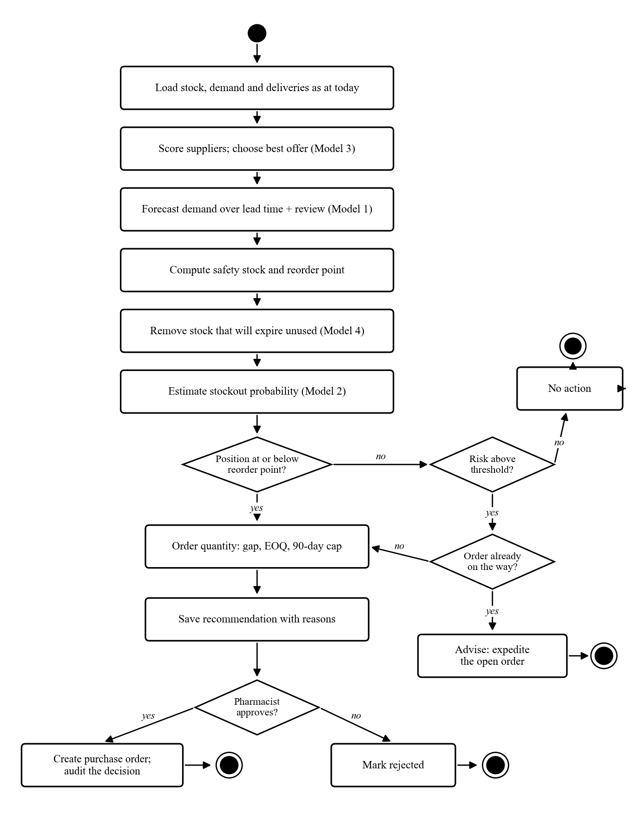
Figure 4.7: Activity diagram for the reorder decision

4.2.5 Architectural Design
Figure 4.8 shows the architecture of the system. It follows a three-tier design with a separate service layer (Sommerville, 2016). The presentation tier is a React web application. It runs in any modern browser on the pharmacy's computers. The application tier is a Django REST API. It checks every request for a valid token and the right role. The service layer holds the decision engine, the Model Lab and the reporting logic. The data tier is a PostgreSQL database. SQLite is used during development.
The machine learning models are trained offline in Google Colab. Only the finished model files are copied to the server. The server loads them read-only and never accepts model files from users. This keeps heavy training work away from the hospital server. It also means the whole system can run on the hospital network without internet access. This matters in Zimbabwe, where internet outages and load shedding are common.
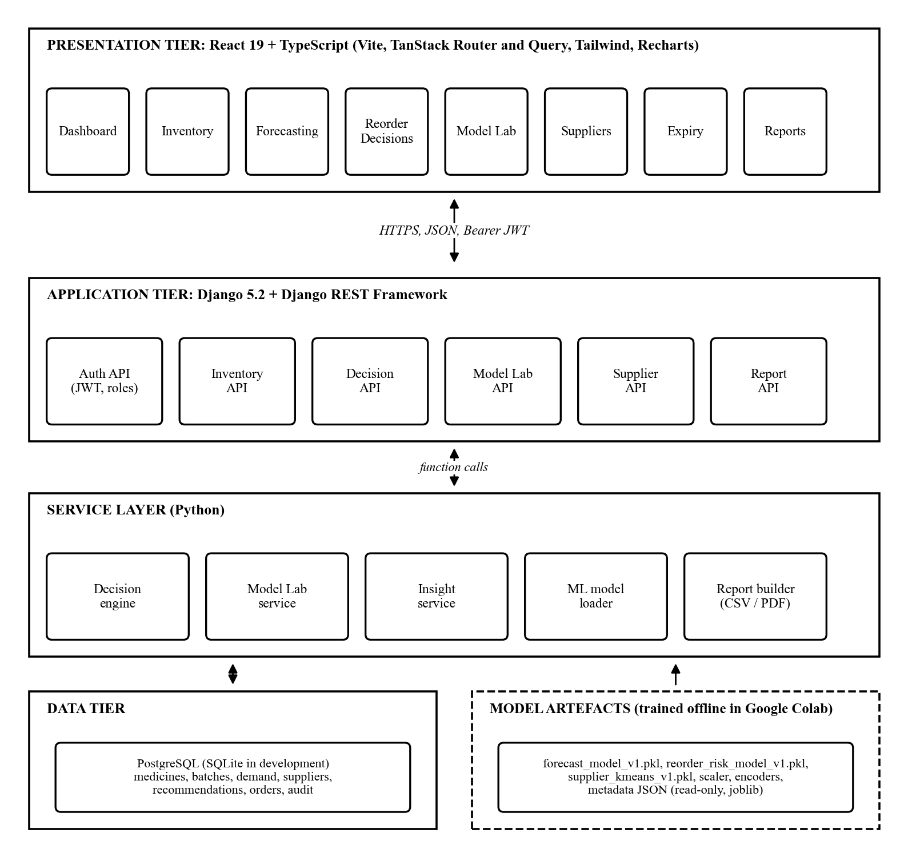
Figure 4.8: System architecture

4.2.6 Component and Module Design
Figure 4.9 shows the main software components and how they depend on each other. Table 4.4 describes the role of each module.
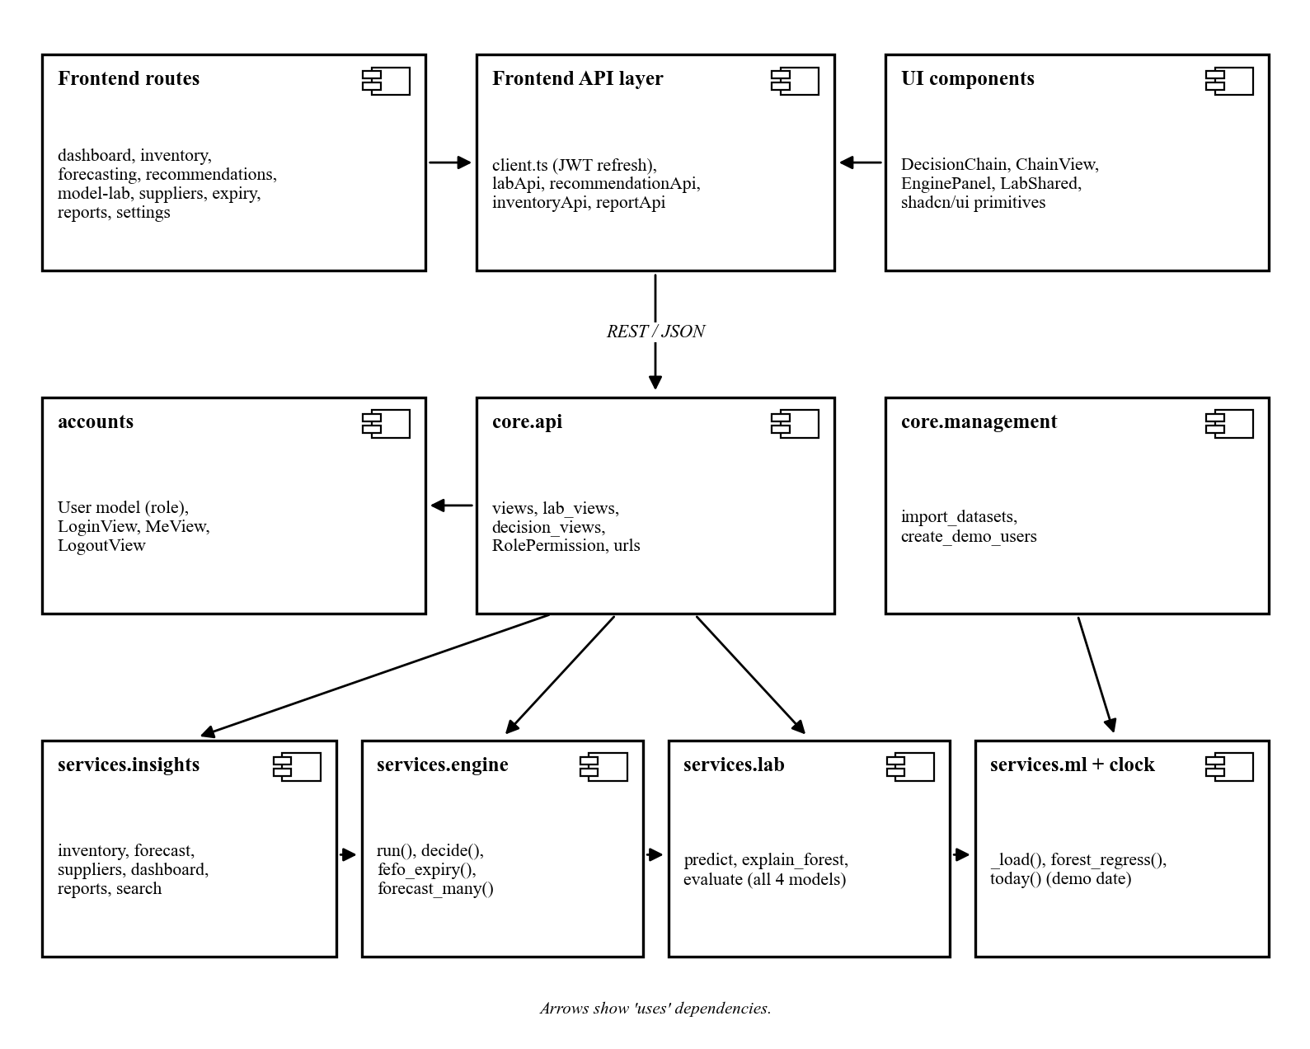
Figure 4.9: Component diagram
Module | Responsibility
Frontend routes | One page per task. Pages cover the dashboard, inventory, forecasts, reorders, Model Lab, suppliers, expiry, reports and settings.
Frontend API layer | Sends all requests to the backend. Adds the access token and renews it when it expires.
accounts | Stores users and roles. Handles login, logout and the current user's profile.
core.api | Exposes the REST endpoints. Checks the role permission for every request.
services.engine | Runs the four models together and produces reorder decisions.
services.lab | Runs any single model on custom inputs, explains the result and re-tests the model.
services.insights | Builds the figures shown on every page and produces CSV and PDF reports.
services.ml and clock | Loads model files once and keeps them in memory. Supplies today's date, or the demo date.
core.management | Command-line tools to import the datasets and create demo users.
Table 4.4: Module responsibilities

4.3 Data Modeling

4.3.1 Entity Relationship Diagram
Figure 4.10 shows the entities stored by the system and how they relate. MEDICINE sits at the centre. Each medicine has many daily demand records, batches, supplier offers and recommendations. Each supplier has many offers and many delivery records. A supplier offer links one medicine to one supplier with a price and lead time. A recommendation points to the chosen offer. An approved recommendation leads to at most one purchase order. Users record stock movements, decide on recommendations and create purchase orders. Every important action is written to the audit log.
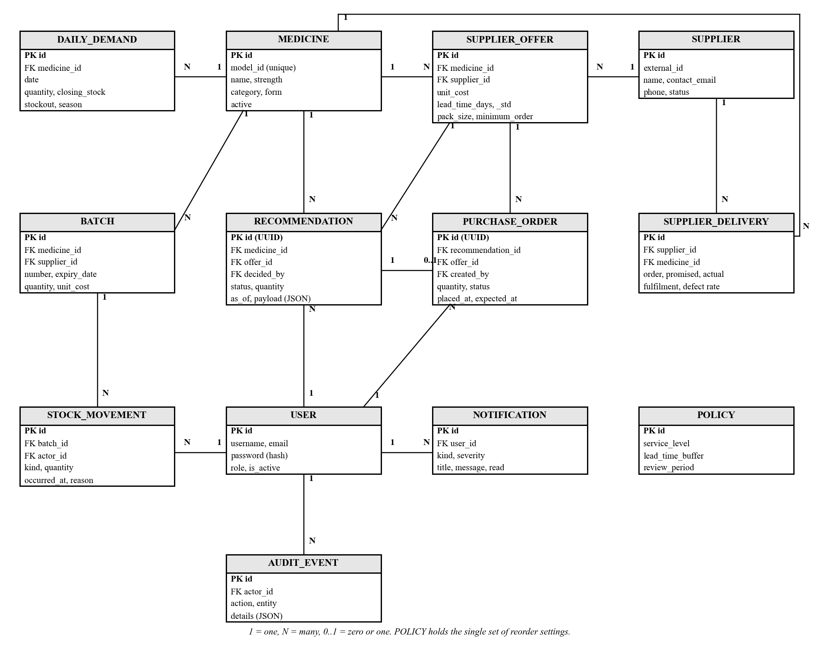
Figure 4.10: Entity relationship diagram

4.3.2 Class Diagram
Figure 4.11 shows the main classes. The upper classes are data classes that map to database tables. The lower classes are service classes that hold the decision logic. The DecisionEngine reads batches, uses the ModelLab's explanation method and creates recommendations. The InsightService calls the engine without saving, to build the figures on each page. It caches the results and recomputes them only when stock or orders change.
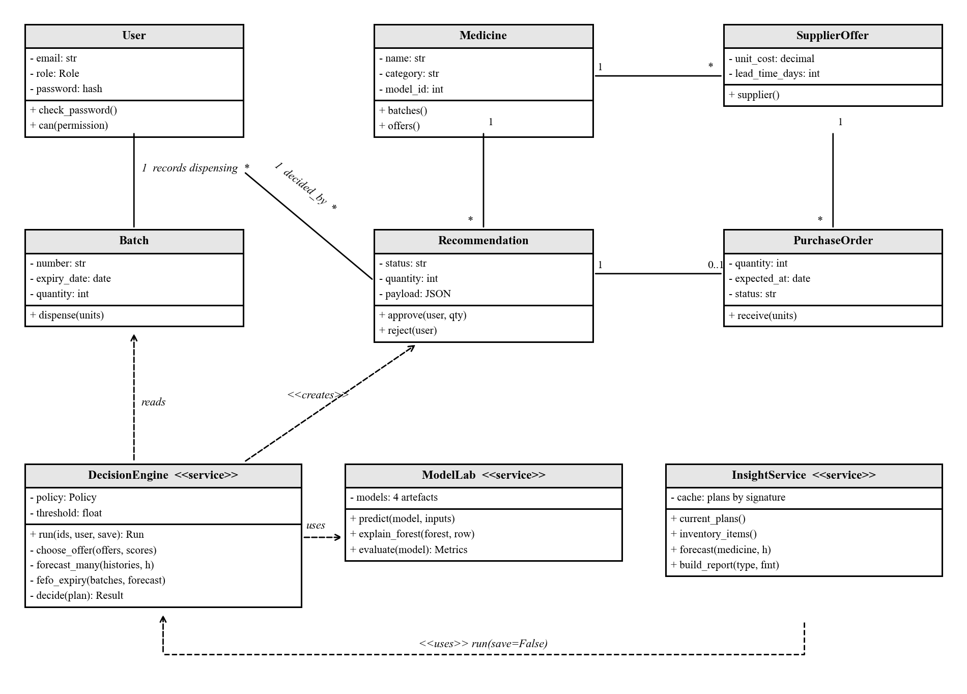
Figure 4.11: Class diagram

4.3.3 Database Design
The database has 18 application tables. Tables 4.5 to 4.9 show the five most important ones. PK marks a primary key and FK marks a foreign key.
Field | Type | Key or rule
id | Integer | PK
model_id | Integer | Unique; links the medicine to the model's encoding
name | Text (200) | Required
strength | Text (80) | Optional
category | Text (100) | Required
form | Text (80) | Optional
active | Boolean | Default true
Table 4.5: MEDICINE table
Field | Type | Key or rule
id | Integer | PK
medicine_id | Integer | FK to MEDICINE
supplier_id | Integer | FK to SUPPLIER; optional
number | Text (100) | Unique for each medicine
received_at | Date | Required
expiry_date | Date | Must not be before received_at
unit_cost | Decimal (12,4) | Zero or more
quantity | Integer | Zero or more
quarantined | Boolean | Excluded from stock when true
Table 4.6: BATCH table
Field | Type | Key or rule
id | Integer | PK
medicine_id | Integer | FK to MEDICINE
date | Date | Unique with medicine_id
quantity | Integer | Units dispensed that day
closing_stock | Integer | Stock at the end of the day
stockout | Boolean | True when stock ran out that day
holiday | Boolean | Public holiday flag
season | Text (50) | Rainy, dry/cold or transition
Table 4.7: DAILY_DEMAND table
Field | Type | Key or rule
id | UUID | PK
medicine_id | Integer | FK to MEDICINE
offer_id | Integer | FK to SUPPLIER_OFFER
status | Text (15) | Pending, approved, rejected or superseded
quantity | Integer | Suggested units
unit_cost | Decimal (12,4) | Price at the time of the decision
as_of | Date | Date of the decision
payload | JSON | Full reasoning from all four models
decided_by | Integer | FK to USER; set on approval or rejection
decided_at | Date and time | Set on approval or rejection
Table 4.8: RECOMMENDATION table
Field | Type | Key or rule
id | UUID | PK
recommendation_id | UUID | FK to RECOMMENDATION; one order at most
offer_id | Integer | FK to SUPPLIER_OFFER
quantity | Integer | More than zero
received_units | Integer | Cannot exceed quantity
placed_at | Date | Date of approval
expected_at | Date | placed_at plus supplier lead time
status | Text (20) | Pending, partial, delivered or cancelled
created_by | Integer | FK to USER
Table 4.9: PURCHASE_ORDER table
The tables were normalised to the third normal form (Codd, 1970; Elmasri & Navathe, 2016). Each field holds a single value, which satisfies the first normal form. Every non-key field depends on the whole primary key, which satisfies the second normal form. No non-key field depends on another non-key field, which satisfies the third normal form. For example, supplier names live only in the SUPPLIER table. Offers refer to suppliers by key instead of repeating their details.
Two fields break this rule on purpose. First, the recommendation keeps its full reasoning in a JSON payload. This freezes the evidence exactly as it was when the decision was made. An auditor can later see why an order was placed, even after stock has changed. Second, purchase orders copy the unit cost at the time of approval. This keeps the order value correct even if the supplier's price changes later.

4.4 Interface Design

4.4.1 Design Principles
The interface was designed for busy pharmacy staff. It follows recognised usability principles (Nielsen, 1993). Pages use plain words, consistent layouts and clear colour-coded status labels. Every model result shows the reasons behind it. A decision chain at the top of each page shows where the page sits. The chain runs from raw data to analytics, forecast, decision and action. Figures 4.12 to 4.16 show the main screens of the working system. They are shown in greyscale to follow the project guide.
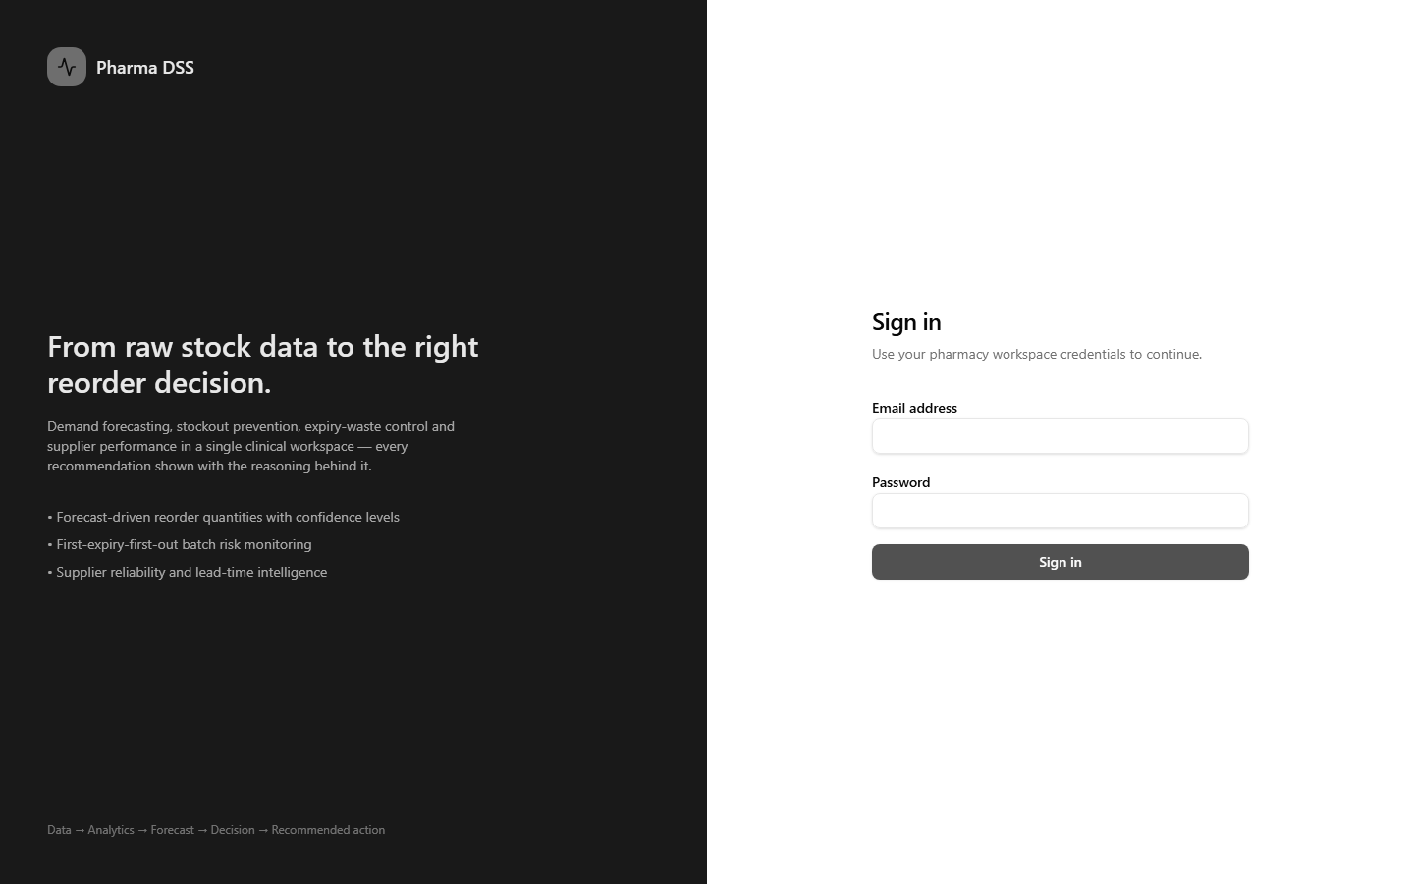
Figure 4.12: Login screen
Figure 4.12 shows the login screen. The left panel explains what the system does. The right panel accepts the user's email and password.
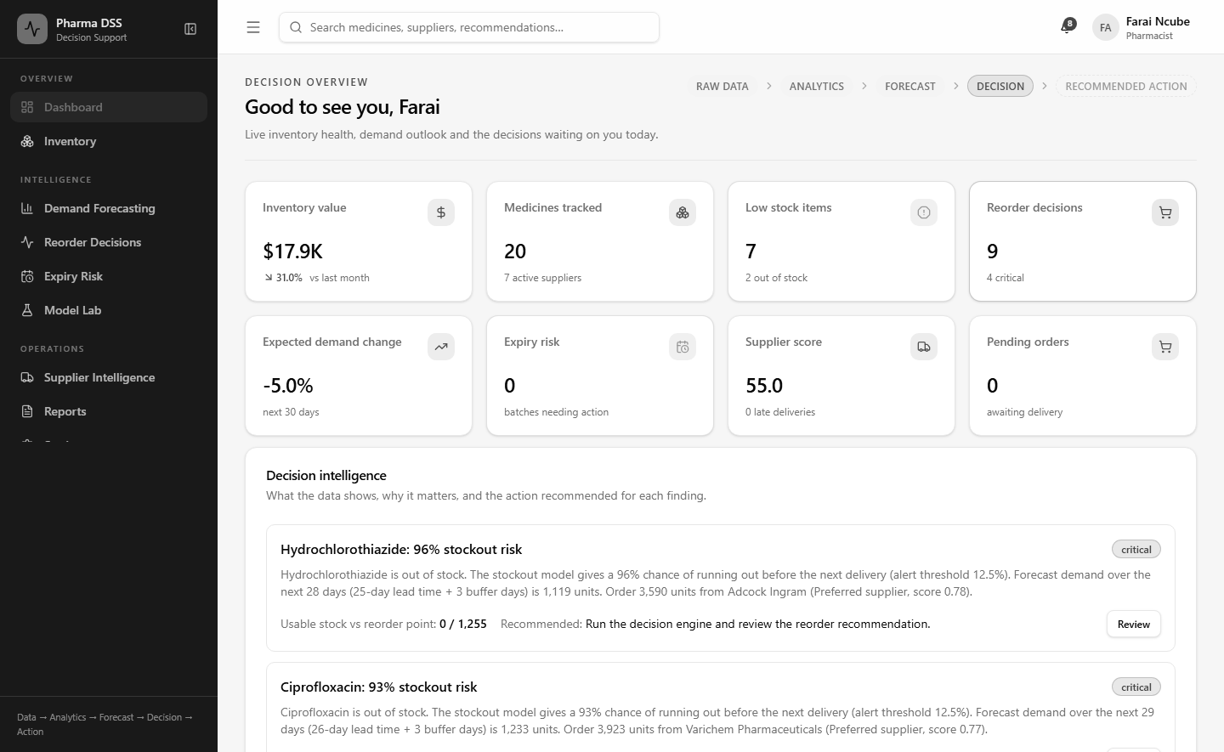
Figure 4.13: Dashboard showing key indicators and decision intelligence
Figure 4.13 shows the dashboard as at 31 December 2024. It shows stock value, low stock items, pending reorder decisions and expected demand change. Below these, the decision intelligence panel lists the most urgent findings in plain language. For example, it warns that Hydrochlorothiazide is out of stock with a 96% stockout risk.
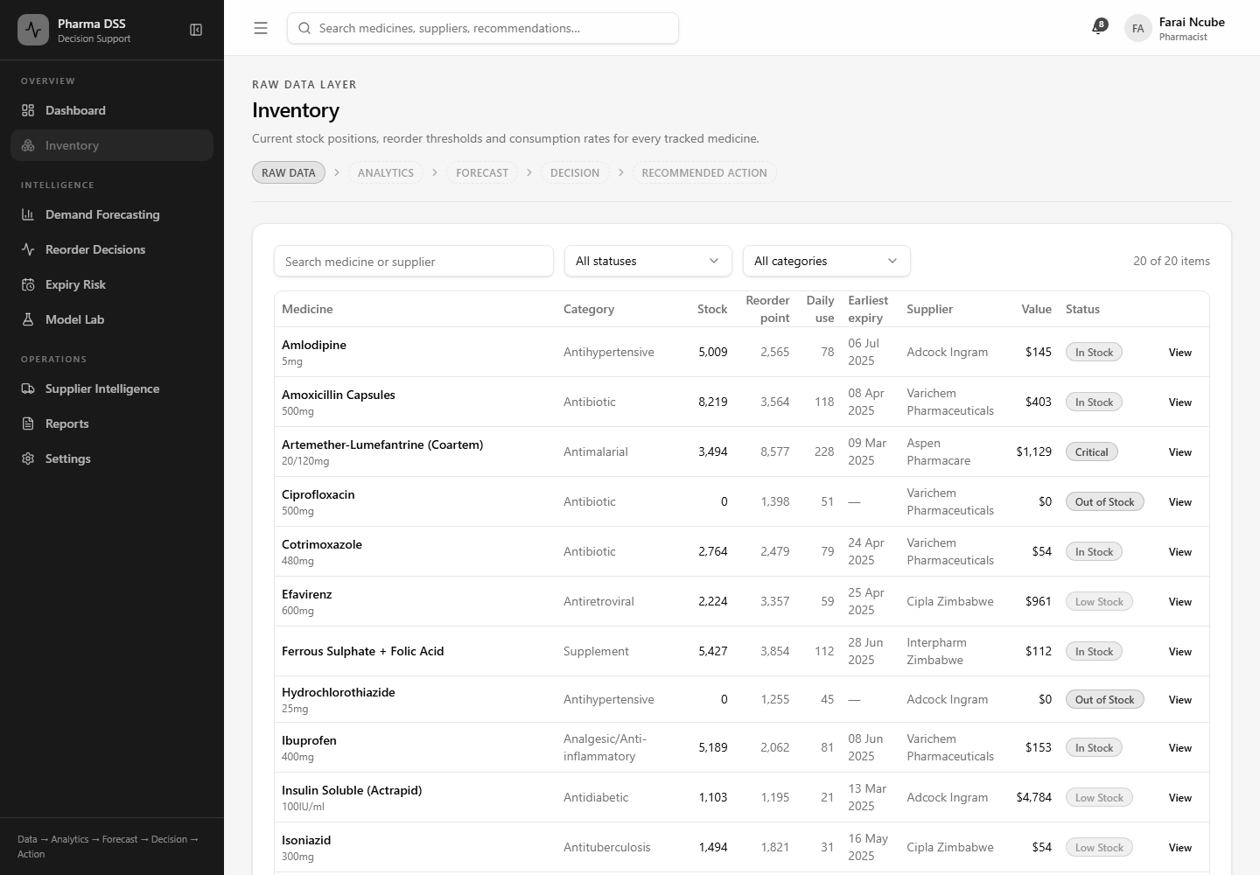
Figure 4.14: Inventory screen with model-based reorder points
Figure 4.14 shows the inventory screen. Each medicine has its own reorder point and daily use, both computed by the system. Status labels show which medicines are critical, low or out of stock.
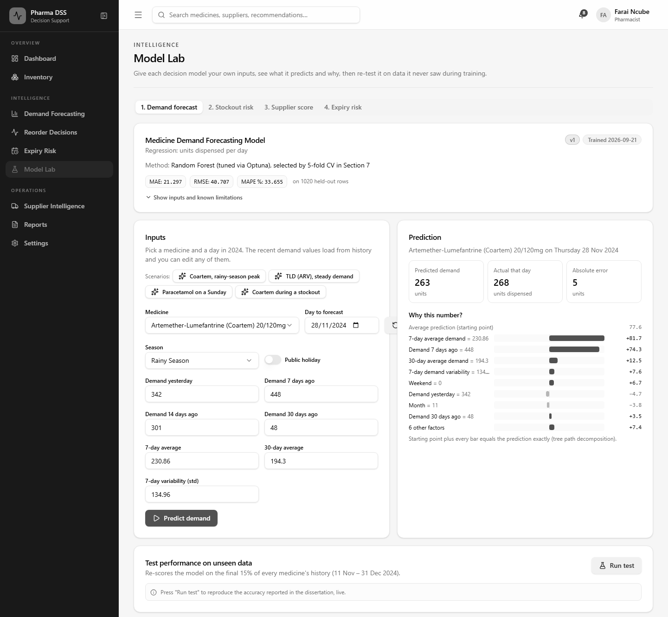
Figure 4.15: Model Lab screen for the demand forecasting model
Figure 4.15 shows the Model Lab. Here a user can test any of the four models with their own inputs. In this example, the demand model predicts 263 units of Coartem for 28 November 2024. The actual figure that day was 268. The bars on the right explain how each input moved the prediction up or down. A test button re-scores the model on data it never saw during training.
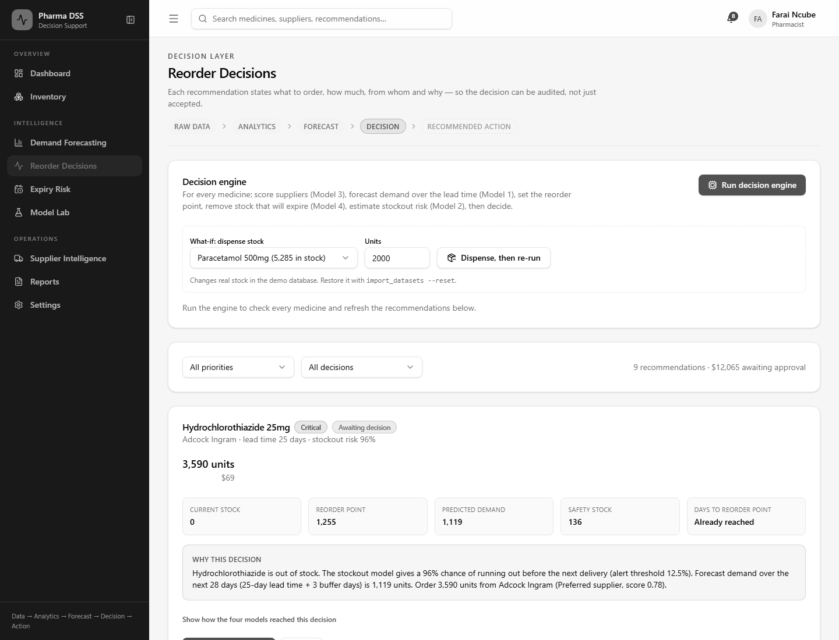
Figure 4.16: Reorder Decisions screen with the decision engine
Figure 4.16 shows the Reorder Decisions screen. The pharmacist can run the decision engine and try a what-if dispense. Each recommendation shows the quantity, cost, reorder point and the reason in plain words. A link expands the full chain of reasoning from all four models.

4.4.2 Pseudocode for Core Components
The following pseudocode describes the core logic without showing raw source code.
FUNCTION Login(email, password)
IF more than 10 attempts in the last minute THEN
RETURN "Too many attempts. Try again shortly."
user <- find user WHERE email matches
IF user not found THEN RETURN error "Email is not valid."
IF hash(password) does not match user.password_hash THEN
RETURN error "Wrong password."
IF user is disabled THEN RETURN error "Account is disabled."
access <- signed token valid for 15 minutes
refresh <- signed token valid for 1 day
RETURN access, refresh, user.name, user.role
END FUNCTION
Pseudocode 4.1: User login
FUNCTION Decide(medicine, today)
offers <- supplier offers for medicine
supplier <- offer with best tier, then highest score, then shortest lead time // Model 3
L <- supplier.lead_time + buffer days
forecast <- predict daily demand for next (L + review period) days // Model 1
mean, sd <- average and spread of recent demand, ignoring stockout days
safety <- z * sd * SQRT(L)
reorder_point <- SUM(forecast over L days) + safety
expiring <- units that will expire before use (FEFO check) // Model 4
usable <- stock on hand - expiring + units already on order
risk <- probability of stockout before next delivery // Model 2
IF usable <= reorder_point OR (risk >= threshold AND nothing on order) THEN
quantity <- MAX(order-up-to gap, MIN(EOQ, 90 days of demand))
RETURN "Order", quantity, supplier, reasons
ELSE IF risk >= threshold AND an order is already on the way THEN
RETURN "Expedite the open order", reasons
ELSE
RETURN "No action", reasons
END FUNCTION
Pseudocode 4.2: Decision engine for one medicine
FUNCTION ExpiringUnits(batches, forecast)
sort batches by expiry date, earliest first
day <- 0 ; expiring <- 0
FOR EACH batch IN batches
demand_before_expiry <- forecast demand from day until batch expires
used <- MIN(batch.quantity, demand_before_expiry)
expiring <- expiring + (batch.quantity - used)
day <- day + days needed to use 'used' units
END FOR
RETURN expiring
END FUNCTION
Pseudocode 4.3: First-expiry-first-out expiry check
FUNCTION PredictAndExplain(model, inputs)
VALIDATE every input is present, numeric and in range
row <- build feature row exactly as in the training notebook
prediction <- model.predict(row)
baseline <- 0 ; contributions <- zeros
FOR EACH tree IN model
follow the path of row from root to leaf
add each change in node value to the feature used at that split
END FOR
average baseline and contributions over all trees // baseline + SUM = prediction
RETURN prediction, baseline, top contributions
END FUNCTION
Pseudocode 4.4: Model Lab prediction with explanation
The explanation method in Pseudocode 4.4 follows the tree path decomposition of Saabas (2014). It splits each prediction exactly into a starting value plus one contribution per input. This lets a pharmacist see why the model gave a particular answer.
FUNCTION Approve(recommendation, user, quantity)
IF user role lacks "recommendations.approve" THEN RETURN "Access denied"
LOCK recommendation
IF recommendation.status is not "pending" THEN RETURN "Already decided"
IF quantity < 1 THEN RETURN error
order <- new purchase order(quantity, unit cost now,
placed today, due today + supplier lead time)
recommendation.status <- "approved" ; record user and time
write audit event "approve_recommendation"
RETURN updated recommendation
END FUNCTION
Pseudocode 4.5: Approve a recommendation

4.5 Security Design
The system holds stock, supplier and user data for a public hospital. Its security design follows the threats listed in Chapter Two. It also respects the Cyber and Data Protection Act (Government of Zimbabwe, 2021).

4.5.1 Password Hashing
Passwords are never stored as plain text. Django stores them as salted PBKDF2-SHA256 hashes. Each password is run through the hash function many thousands of times. This makes stolen hashes very slow to crack. Passwords must also pass Django's built-in strength checks.

4.5.2 Data Encryption
In production, all traffic between the browser and the server uses HTTPS. The server also sends HSTS headers, so browsers refuse plain HTTP. Session and CSRF cookies are marked secure. Secret keys and database passwords are kept in an environment file outside the code. For data at rest, the server disk should be encrypted, for example with BitLocker.

4.5.3 Authentication and Authorisation Logic
Users log in with an email and password. The server then issues JSON Web Tokens (Jones et al., 2015). The access token lasts 15 minutes and the refresh token lasts one day. Refresh tokens are rotated, and old ones are blacklisted. A stolen token therefore has a short useful life. Login attempts are limited to ten per minute to slow down password guessing.
Authorisation is checked on the server for every request. Each endpoint names the permission it needs. The server compares this with the permissions of the user's role. The frontend also hides menus a role cannot use. However, hiding a menu is only a convenience. The server check is what actually protects the data.

4.5.4 User Access Roles
Table 4.10 shows the permissions of each role.
Permission | Staff | Pharmacist | Manager | Admin
View inventory and expiry | Yes | Yes | Yes | Yes
Record dispensing | No | Yes | Yes | Yes
View forecasts and use the Model Lab | No | Yes | Yes | Yes
Run the decision engine | No | Yes | Yes | Yes
Approve or reject reorders | No | Yes | Yes | Yes
View supplier performance | No | Yes | Yes | Yes
Edit supplier details | No | No | Yes | Yes
Generate reports | No | Yes | Yes | Yes
Manage users and settings | No | No | No | Yes
Table 4.10: Role permission matrix

4.5.5 Secure Storage and Integrity
Several further controls protect the stored data. Model files are loaded read-only from a fixed folder. They are never uploaded through the web. Stock changes run inside database transactions, so a failed update leaves no half-written records. Each stock movement carries a unique key, so a repeated request is rejected. The audit log records who did what and when. Imported datasets are stored with a SHA-256 fingerprint to detect changes. Finally, the database should be backed up daily. A UPS should protect the server from power cuts.

4.6 Hardware Design
This project is a software system, so no custom hardware was designed. No circuits, sensors or printed circuit boards are needed. The system runs on one ordinary server on the hospital network. Staff use the pharmacy's existing computers and a web browser. The hardware needed was listed in the technical feasibility study in Chapter Two.

4.7 Summary
This chapter presented the analysis and design of the system. It began with 13 functional and eight non-functional requirements. The context and data flow diagrams showed how data moves through the pharmacy. UML diagrams showed the users, the main sequences, the states and the decision logic. The architecture separates the interface, the API, the services and the data. The ERD, class diagram and tables showed how records are stored in third normal form. The interface design showed the main screens and the pseudocode for the core logic. The security design covered hashing, encryption, tokens and role-based access. The next chapter presents the coding and testing of the system.

References
Codd, E. F. (1970). A relational model of data for large shared data banks. Communications of the ACM, 13(6), 377–387. https://doi.org/10.1145/362384.362685
Elmasri, R., & Navathe, S. B. (2016). Fundamentals of database systems (7th ed.). Pearson.
Fowler, M. (2004). UML distilled: A brief guide to the standard object modeling language (3rd ed.). Addison-Wesley.
Gane, C., & Sarson, T. (1979). Structured systems analysis: Tools and techniques. Prentice Hall.
Government of Zimbabwe. (2021). Cyber and Data Protection Act [Chapter 12:07] (Act No. 5 of 2021). Government Printer.
Jones, M., Bradley, J., & Sakimura, N. (2015). JSON Web Token (JWT) (RFC 7519). Internet Engineering Task Force. https://doi.org/10.17487/RFC7519
Nielsen, J. (1993). Usability engineering. Academic Press.
Saabas, A. (2014, October 19). Interpreting random forests. Diving into Data. https://blog.datadive.net/interpreting-random-forests/
Sommerville, I. (2016). Software engineering (10th ed.). Pearson.

