CHAPTER ONE: INTRODUCTION

1.0 Introduction
Medicines save lives only when they are on the shelf at the right time. A hospital pharmacy must therefore plan its stock with great care. It must order enough to meet patient demand. Yet it must not buy so much that stock expires before use. Getting this balance right is hard in Zimbabwe's public hospitals. Budgets are tight, lead times are long and demand shifts with the seasons.
This study is based at Parirenyatwa Group of Hospitals (PGH) in Harare. It focuses on the hospital's Pharmacy Department. The department keeps computer records of its stock. However, these records mostly describe what has already happened. They do not tell managers what is likely to happen next. Choices on what to order, how much, and from whom still rest on experience. This study proposes an Intelligent Decision Support System (IDSS) to close this gap. The system uses machine learning to forecast demand and flag stockout risk. It also scores suppliers and points out batches likely to expire unused.
This chapter opens with the background of the organisation. It then explains the current system and the problem it creates. The aim, objectives and research questions follow. Key terms, significance, theory, assumptions and ethics are then covered. The chapter closes with the methodology, scope, timeline and justification.

1.1 Background of the Organisation
Parirenyatwa Group of Hospitals is the largest referral hospital in Zimbabwe. It is a public institution located in Harare. The hospital falls under the Ministry of Health and Child Care (MoHCC). A Hospital Management Board oversees its day-to-day running. The group is named after Dr Tichafa Samuel Parirenyatwa. He is remembered as the first Black Zimbabwean to qualify as a medical doctor.

1.1.1 Structure and Services
PGH is not one building but a group of units. These include the main hospital and Mbuya Nehanda Maternity Hospital. Sekuru Kaguvi Eye Unit, a psychiatric unit and a radiotherapy centre are also included. The group is the main teaching hospital for the University of Zimbabwe medical school. Clinics and district hospitals across the country refer patients to it. As a result, PGH treats a very wide range of conditions. These run from malaria and tuberculosis to HIV, diabetes and hypertension.

1.1.2 Goals of the Organisation
Like other central hospitals, PGH has three broad goals. First, it provides specialist care that lower-level facilities cannot offer. Second, it trains doctors, nurses, pharmacists and other health workers. Third, it supports medical research that informs national health policy. Each of these goals depends on a steady supply of safe and affordable medicines.

1.1.3 The Pharmacy Department
The Pharmacy Department is the focus of this study. It supplies medicines to wards, specialist clinics and outpatient services. Its core tasks are procurement, receiving, storage, stock control and dispensing. It also advises clinicians on the safe and rational use of medicines. Senior pharmacists lead the department. They work with pharmacy technicians, stores clerks and procurement officers. Every week, staff must decide which items to reorder and in what quantity.

1.1.4 Operational Environment
Most medicines reach PGH through the National Pharmaceutical Company of Zimbabwe (NatPharm). NatPharm is the state body that buys, stores and distributes medicines to public facilities. When NatPharm is out of stock, the hospital turns to other registered suppliers. These include local manufacturers such as CAPS, Varichem and Datlabs. Some products come from regional importers in South Africa and India. All products must be registered by the Medicines Control Authority of Zimbabwe (MCAZ).
The operating environment is far from easy. Foreign currency shortages often delay imports and push up prices. Supplier lead times can stretch to several weeks. Demand for antimalarials climbs sharply during the rainy season. Programme medicines such as antiretrovirals (ARVs) must never run out. A missed dose can harm the patient and weaken long-term treatment. At the same time, power cuts and network outages disrupt computer work. Any new system must therefore be light, reliable and simple to use.

1.2 Background to the Proposed System

1.2.1 The Current System
At present, the pharmacy tracks stock with stock cards, ledgers and spreadsheets. Summary reports also feed into the national electronic Logistics Management Information System (eLMIS). In addition, public hospitals are adopting Impilo, the national electronic health record (EHR). These tools are a clear step up from paper alone. Staff can now see balances, receipts and issues much faster.
Even so, the current tools are transactional in nature. They store what has already taken place. They do not study past consumption to estimate future demand. Reorders are decided during periodic stock reviews. A pharmacist checks recent issues and then settles on an order quantity. This depends heavily on personal judgement. It also takes many hours when hundreds of items need review. When an experienced officer is away, the quality of decisions can drop.

1.2.2 Gaps in the Current System
A review of the current process reveals five main gaps.
- No demand forecasting. Seasonal peaks, such as malaria cases, are noticed late.
- No early stockout warning. Risk is seen only when shelves are nearly empty.
- No objective supplier rating. Late or short deliveries are not turned into scores.
- Weak expiry tracking. Slow-moving batches are often found just before they expire.
- No link from data to action. Reports exist, but they do not recommend anything.

1.2.3 The Opportunity
Artificial intelligence (AI) offers a practical way to fill these gaps. Machine learning models can learn patterns from past stock transactions. They can then estimate future demand and the chance of a stockout. Scoring models can rank suppliers on reliability, quality and price. A web dashboard can bring these results together for pharmacists. The pharmacist still makes the final call. The system simply backs that call with evidence. This approach fits Education 5.0 and the Fourth Industrial Revolution (4IR) agenda. It also supports Vision 2030 (Government of Zimbabwe, 2018) and NDS1 (Government of Zimbabwe, 2020).

1.3 Statement of the Problem
The PGH Pharmacy Department suffers repeated stockouts of key medicines. At the same time, other medicines expire on the shelves before they are used. Both problems waste scarce public funds and put patients at risk. The current records do not forecast demand or warn of coming shortages. They also fail to rate suppliers or flag batches at risk of expiry. Pharmacists therefore make ordering decisions by hand, using experience and old reports. This is slow and hard to apply across hundreds of medicines. It also copes poorly with seasonal demand and uncertain supplier lead times. There is a need for a system that turns pharmacy data into timely recommendations.

1.4 Aim and Objectives of the Proposed System

1.4.1 Aim
The aim of this study is to develop an Intelligent Decision Support System. The system will improve medicine supply chain decisions at the PGH Pharmacy Department.

1.4.2 Objectives
The specific objectives of the study are:
- To analyse current inventory and procurement practices at the PGH Pharmacy Department.
- To develop a machine learning model that forecasts daily demand for each medicine.
- To develop a classification model that predicts stockout risk before the next delivery.
- To design a supplier performance scoring model using weighted scoring and clustering.
- To develop an expiry risk module that flags batches likely to expire unused.
- To integrate the models into a secure web-based system with role-based dashboards.
- To evaluate the system using model accuracy metrics and user acceptance testing.

1.4.3 Research Questions
The study seeks to answer the following questions:
- How does the PGH pharmacy currently plan and order its medicines?
- How accurately can machine learning forecast daily medicine demand?
- Can a classifier detect stockout risk early enough for staff to act?
- How can suppliers be ranked fairly on delivery, quality and cost?
- How can these models be combined into one system that pharmacists accept?

1.5 Definitions of Key Terms and Concepts
Table 1.1 explains the main terms used in this document.
Term | Meaning in this study
Decision Support System (DSS) | A computer system that helps managers make better choices. It does not replace them.
Intelligent DSS (IDSS) | A DSS that adds AI or machine learning to analyse data and suggest actions.
Pharmaceutical supply chain | All steps that move a medicine from maker to patient.
Machine learning (ML) | A branch of AI where computers learn patterns from data.
Demand forecasting | Estimating how much of a medicine will be used in a future period.
Stockout | A situation where a medicine is needed but none is in stock.
Lead time | The number of days between placing an order and receiving it.
Safety stock | Extra stock kept to cover sudden demand or late deliveries.
Reorder point (ROP) | The stock level at which a new order should be placed.
Economic Order Quantity (EOQ) | The order size that keeps ordering and holding costs lowest.
Expiry risk | The chance that a batch will pass its expiry date before it is used.
Random Forest | An ML method that combines many decision trees to give one prediction.
K-Means clustering | An ML method that sorts similar items into a set number of groups.
Mean Absolute Error (MAE) | The average size of forecast errors, in units of medicine.
PR-AUC | A score from 0 to 1 showing how well a model finds rare events.
Electronic Health Record (EHR) | A digital version of a patient's health record. Impilo is Zimbabwe's national EHR.
REST API | A standard way for the web screens to request data from the server.
JSON Web Token (JWT) | A signed digital pass that proves a user has logged in.
Table 1.1: Definitions of key terms and concepts

1.6 Significance of the Study

1.6.1 To the PGH Pharmacy Department
The system gives pharmacists a clear, daily view of stock risk. It shows which medicines to reorder, how much to order and from whom. Stock reviews that take hours could be done in minutes. Fewer stockouts mean fewer emergency purchases at high prices. Fewer expiries mean less money lost to destroyed stock.

1.6.2 To Patients
Patients are the final beneficiaries. Better stock planning means medicines are there when prescribed. Patients on ARVs and TB treatment can keep to their regimens without breaks. Families also spend less buying medicines from private pharmacies.

1.6.3 To MoHCC and NatPharm
Forecasts from central hospitals can improve national quantification. NatPharm could plan its own purchases with better demand signals. The ministry could also use supplier scores to guide tender decisions.

1.6.4 To the Academic Community
The study adds local evidence on machine learning in health supply chains. Most published work comes from high-income countries. This project shows how such tools can work under Zimbabwean conditions. Future students can build on its models, datasets and methods.

1.6.5 To the Researcher
The project lets the researcher apply skills gained during the degree. These include software engineering, databases, web development and machine learning. It also builds research and writing skills needed in industry.

1.6.6 Alignment with National and Global Frameworks
The study supports Vision 2030 and NDS1, which both prioritise health and digital growth. It contributes to Sustainable Development Goal 3 on good health (United Nations, 2015). It also supports SDG 9 on industry, innovation and infrastructure. Finally, it links to Aspiration 1 of Agenda 2063 (African Union Commission, 2015). That aspiration calls for healthy and well-nourished citizens.

1.7 Theoretical Framework and Conceptual Model
Three bodies of theory guide the design of the system. These are decision-making theory, inventory control theory and machine learning theory.

1.7.1 Simon's Model of Decision Making
Simon (1960) describes decision making in three phases. The first is intelligence, where the decision maker spots a problem. The second is design, where possible solutions are developed. The third is choice, where one option is selected. Power (2002) shows that a DSS can support each of these phases. In this study, the ML engine supports the intelligence phase. It detects rising demand, stockout risk and expiry risk early. The decision models support the design phase by proposing order options. The pharmacist then makes the choice by approving or rejecting each recommendation.

1.7.2 Inventory Control Theory
Classic inventory theory tells a store when to order and how much. The reorder point is the stock level that triggers an order (Silver et al., 2017). It is found with the formula below.
ROP = (d × L) + SS
Here d is the average daily demand and L is the lead time in days. SS is the safety stock, which covers uncertainty in demand. Safety stock is found as follows.
SS = z × σd × √L
In this formula, z is the service level factor. The symbol σd is the standard deviation of daily demand. The order size comes from the Economic Order Quantity model (Harris, 1913).
EOQ = √(2DS / H)
D is the annual demand and S is the cost of placing one order. H is the cost of holding one unit for a year. Traditional systems use simple averages for d. This study replaces the average with an ML forecast. This allows the reorder point to rise and fall with seasons and trends.

1.7.3 Machine Learning Theory
The study uses both supervised and unsupervised learning. In supervised learning, a model learns from examples with known answers. Demand forecasting is a regression task because the answer is a number. Stockout risk is a classification task because the answer is yes or no. Both tasks use Random Forest, which combines many decision trees (Breiman, 2001). In unsupervised learning, there is no known answer to learn from. Supplier tiers are therefore found with K-Means clustering. SHAP values are used to explain which inputs drive each prediction (Lundberg & Lee, 2017).

1.7.4 Conceptual Model
Figure 1.1 brings these theories together. Pharmacy data flows into the data layer and then into the ML engine. The engine feeds the decision models, which produce recommendations. The pharmacist reviews each one before any order is placed. New data from each cycle is used to retrain the models.
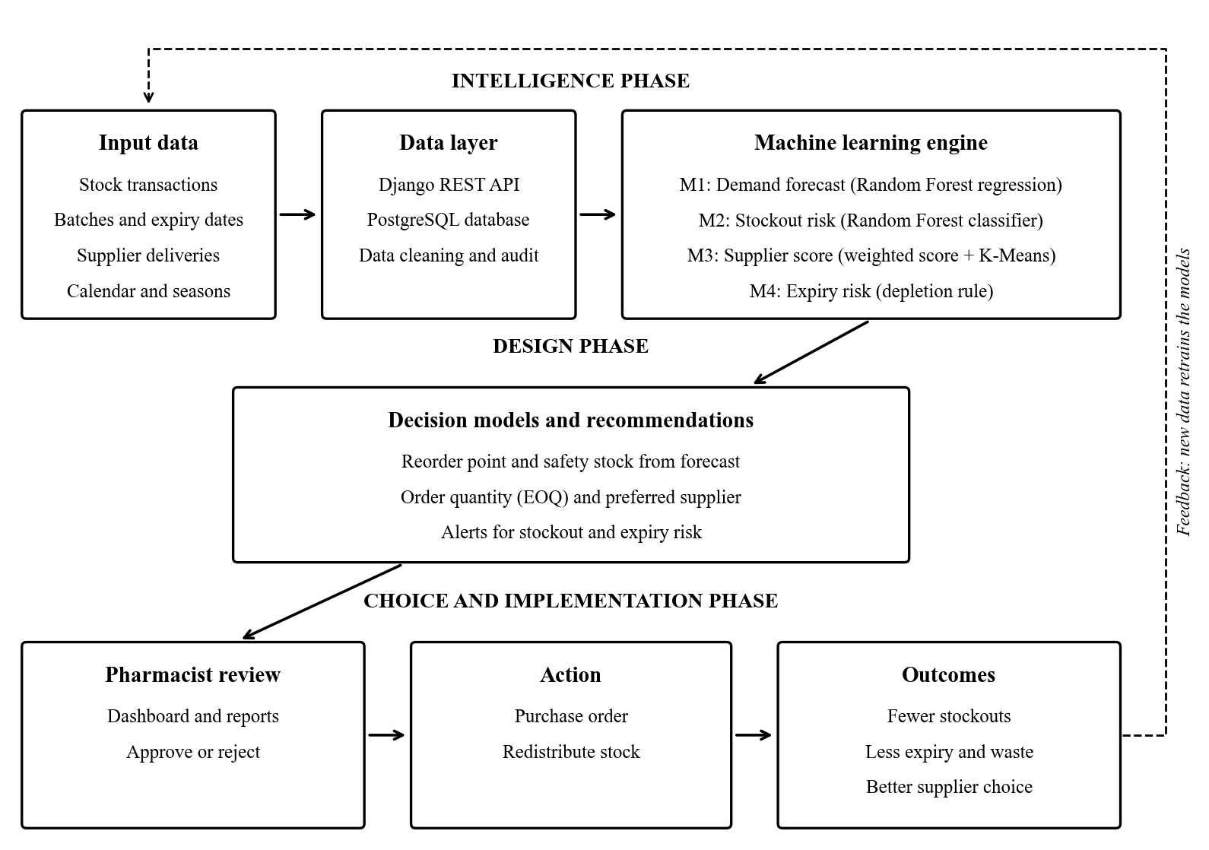
Figure 1.1: Conceptual model of the proposed IDSS (adapted from Simon, 1960)

1.8 Assumptions
The study is based on the following assumptions:
- Past consumption patterns are a fair guide to demand in the near future.
- Stock records captured by pharmacy staff are accurate and up to date.
- Suppliers will behave in future much as they have in the past.
- The hospital will provide computers and a stable local network.
- Pharmacists will review each recommendation before placing an order.
- Users have basic computer skills and can use a web browser.
- The simulated training data captures the main demand patterns found at PGH.

1.9 Ethical Considerations
Health data is sensitive, so the study follows clear ethical rules.
- Permission. Written approval will be sought from PGH management and the university first.
- Informed consent. Each participant will read a consent note before the questionnaire. Taking part is voluntary, and anyone may withdraw.
- Anonymity. No names or staff numbers will be recorded in the questionnaire.
- Confidentiality. The system stores medicine data only. It holds no patient names or diagnoses.
- Data protection. The study follows the Cyber and Data Protection Act (Government of Zimbabwe, 2021). Passwords are hashed and access is controlled by user role.
- Honest use of data. The models were trained on simulated data. Supplier scores are illustrations, not real judgements of any company.
- Fairness. Model accuracy is checked for each medicine category. Weak spots are reported openly.
- Human oversight. The system never places an order on its own. A pharmacist must approve every action.
- Use of AI tools. Any AI writing or coding aid will be declared, as the project guide requires.
- Originality. All sources are cited in APA style, and the work is checked with Turnitin.

1.10 Methodology
This section explains how the research was carried out. It also covers how the software was built and which tools were used.

1.10.1 Research Methodology
The study follows the Design Science Research (DSR) approach. DSR builds and tests an artefact that solves a real problem (Hevner et al., 2004). Here, the artefact is the IDSS. The six DSR steps of Peffers et al. (2007) were followed. Table 1.2 shows how each step was applied.
DSR step | Activity in this study
1. Identify the problem | Study stockouts, expiries and manual ordering at PGH pharmacy.
2. Define objectives | Set the seven objectives listed in Section 1.4.2.
3. Design and develop | Train four models in Colab. Build the Django and React system.
4. Demonstrate | Run the system with pharmacy data and sample reorder scenarios.
5. Evaluate | Measure model accuracy. Run user acceptance tests with pharmacy staff.
6. Communicate | Present the results in this dissertation and at the viva.
Table 1.2: Design Science Research steps applied to this study
Within DSR, a mixed methods design was used. The qualitative part explores how staff plan and order medicines. It answers research question one. The quantitative part is experimental. It tests how well each model performs on held-out data. It answers research questions two to four. The final question is answered through system testing and user feedback.
The machine learning work followed the CRISP-DM process (Wirth & Hipp, 2000). Its six stages are business understanding, data understanding and data preparation. These are followed by modelling, evaluation and deployment. Each dataset was first audited for missing values, duplicates and impossible values. Data was then split by date into training, validation and test sets. A 70, 15 and 15 percent split was used. The split was never shuffled, so no future data leaked into training. Five-fold time-series cross-validation then confirmed the ranking of models.
Several candidate models were compared for each task. For demand, these were a naive baseline, SARIMA and Linear Regression. Random Forest was also tested. So were XGBoost (Chen & Guestrin, 2016) and LightGBM (Ke et al., 2017). Forecasts were judged by MAE, RMSE and MAPE. For stockout risk, Logistic Regression, Random Forest, XGBoost and LightGBM were compared. Only about one check in ten was a stockout. Accuracy alone would therefore mislead. Precision, recall, F1 score and PR-AUC were used instead (Saito & Rehmsmeier, 2015). The best model was tuned with Optuna (Akiba et al., 2019). It was kept only if it beat the untuned version on the test set.

1.10.2 Software Development Methodology
The system was built using the Agile Scrum method (Schwaber & Sutherland, 2020). Work was split into two-week sprints. Each sprint delivered a working part of the system. The supervisor acted as the product owner and reviewed each sprint. Pharmacy staff gave feedback on screens as they were built.
The life cycle phases were applied within each sprint as follows.
- Requirements gathering. Needs were collected through questionnaires, interviews and observation. They were written as user stories in a product backlog.
- Design. Each sprint began with design of the screens, database tables and API endpoints involved.
- Implementation. Models were coded in Google Colab. The backend used Django and the frontend used React.
- Testing. Unit and integration tests ran at the end of each sprint. User acceptance testing followed the final sprint.
- Deployment. The system runs as a web application on the hospital network.
- Maintenance. Models are versioned, so a better model can replace an old one safely.
Agile suits this project for four reasons. First, ML work is experimental, and results often change the plan. Second, user needs became clearer only after staff saw early screens. Third, a working version was always ready to show the supervisor. Fourth, the Waterfall model was rejected because it handles change poorly. In Waterfall, a late change to requirements is slow and costly.

1.10.3 Data Collection Tools and Techniques
Data for this study came from people and from records. Table 1.3 lists the tools used.
Tool | How it is used | Type of data
Questionnaire (Google Forms) | Sent online to pharmacists, technicians and stores staff. | Quantitative and qualitative
Semi-structured interviews | Face-to-face talks with senior pharmacists and procurement officers. | Qualitative, unstructured
Observation | Watching stock reviews, receiving and dispensing in the pharmacy. | Qualitative
Document review | Studying stock cards, delivery notes, requisitions and expiry records. | Quantitative, structured
Transaction datasets | Daily demand, reorder checks, supplier orders and batch records. | Quantitative, structured
System logs | Usage and error logs captured during testing. | Quantitative, structured
Table 1.3: Data collection tools and techniques
Purposive sampling was used to select respondents. Only staff who handle medicine stock were included. Their knowledge is directly relevant to the problem.
Real dispensing records could not be released because of confidentiality rules. A structured, simulated dataset was therefore built for model training. It was shaped around 20 essential medicines on the hospital's list. It also reflects Zimbabwe's rainy, cold and transition seasons. The demand file holds 7,320 daily records for the year 2024. The reorder file holds 6,000 risk checks. The supplier file holds 6,000 orders from 12 suppliers. A further 6,000 batch records support the expiry module.
Several steps were taken to keep the data reliable and valid.
- The questionnaire was pilot tested with three people before release.
- The same interview guide was used with every respondent.
- Results from questionnaires, interviews and records were compared to confirm findings.
- Each dataset was audited for gaps, duplicates and impossible values before modelling.
- Models were tested only on data they had never seen during training.

1.10.4 Development Tools and Technologies
Table 1.4 lists the tools used to build the system.
Category | Tool or technology | Purpose
ML environment | Google Colab, Python 3 | Free cloud notebooks for training models.
Data handling | pandas, NumPy | Loading, cleaning and shaping data.
ML libraries | scikit-learn, XGBoost, LightGBM, statsmodels | Training and comparing models.
Tuning and explanation | Optuna, SHAP | Tuning settings and explaining predictions.
Visualisation | Matplotlib, Seaborn, Recharts | Charts in notebooks and on dashboards.
Model storage | joblib, JSON metadata | Saving versioned model files for the backend.
Backend | Django 5.2, Django REST Framework | Business logic and REST API.
Security | Simple JWT, role-based permissions | Login, tokens and access control.
Database | PostgreSQL (SQLite in development) | Storing medicines, stock, suppliers and results.
Reports | ReportLab | Producing PDF reports.
Frontend | React 19, TypeScript, Vite | Building the user interface.
UI and data fetching | TanStack Router and Query, Tailwind CSS, shadcn/ui | Pages, styling and server data.
Version control | Git, GitHub, Lovable | Tracking code changes and backups.
Editor and diagrams | Visual Studio Code, draw.io | Writing code and drawing UML diagrams.
Table 1.4: Development tools and technologies

1.11 Scope and Limitations

1.11.1 Scope
The system covers the main stores and dispensary of the PGH Pharmacy Department. It includes the following modules:
- User login with four roles: administrator, manager, pharmacist and staff.
- Medicine and inventory records, including batches and stock movements.
- Demand forecasting for each medicine.
- Stockout risk alerts and reorder recommendations with suggested quantities.
- Supplier performance scores and tiers.
- Expiry risk monitoring for batches.
- Dashboards, notifications, PDF and CSV reports, and an audit trail.
Some areas fall outside the scope. The system does not handle patient records or prescriptions. It does not make payments or send orders to suppliers automatically. Direct links to eLMIS, Impilo and NatPharm are left for future work. A mobile app and IoT sensors are also not included.

1.11.2 Limitations
- Data access. Real records were confidential, so models were trained on simulated data. Results must be confirmed with live hospital data.
- Short history. One year of demand data limits how well yearly seasons are learned.
- Hidden demand. On stockout days, true demand is unknown because nothing could be issued.
- Few suppliers. Only 12 suppliers were scored, which limits the clustering results.
- Time. The project had to fit within one academic year.
- Resources. Training used the free tier of Google Colab, which limits computing power.
- User availability. Busy pharmacy staff had limited time for interviews and testing.
- Power and network. Load shedding and slow internet affected some development work.

1.12 Project Timeline
The project runs for 34 weeks, from 3 August 2026 to 26 March 2027. Table 1.5 lists each task, its length and the tasks it depends on. Slack is the number of weeks a task can slip without delaying the project.
ID | Task | Weeks | Depends on | Start | End | Slack (wks)
A | Proposal and topic approval | 3 | - | 03 Aug 2026 | 21 Aug 2026 | 0
B | Requirements gathering at PGH | 2 | A | 24 Aug 2026 | 04 Sep 2026 | 4
C | Literature review | 6 | A | 24 Aug 2026 | 02 Oct 2026 | 0
D | Data preparation and audit | 2 | B | 07 Sep 2026 | 18 Sep 2026 | 8
E | ML model training and evaluation | 5 | D | 21 Sep 2026 | 23 Oct 2026 | 8
F | System analysis and design | 4 | B,C | 05 Oct 2026 | 30 Oct 2026 | 0
G | Backend development (Django) | 7 | F | 02 Nov 2026 | 18 Dec 2026 | 0
H | Frontend development (React) | 7 | F | 02 Nov 2026 | 18 Dec 2026 | 3
I | Model integration | 3 | E,G | 21 Dec 2026 | 08 Jan 2027 | 0
J | Testing and user acceptance | 4 | I,H | 11 Jan 2027 | 05 Feb 2027 | 0
K | Final documentation | 4 | J | 08 Feb 2027 | 05 Mar 2027 | 0
L | Submission and viva preparation | 3 | K | 08 Mar 2027 | 26 Mar 2027 | 0
Table 1.5: Project tasks, durations, dependencies and slack
Figure 1.2 shows the same plan as a Gantt chart. Black bars mark critical tasks. Hatched bars mark tasks that have some slack.
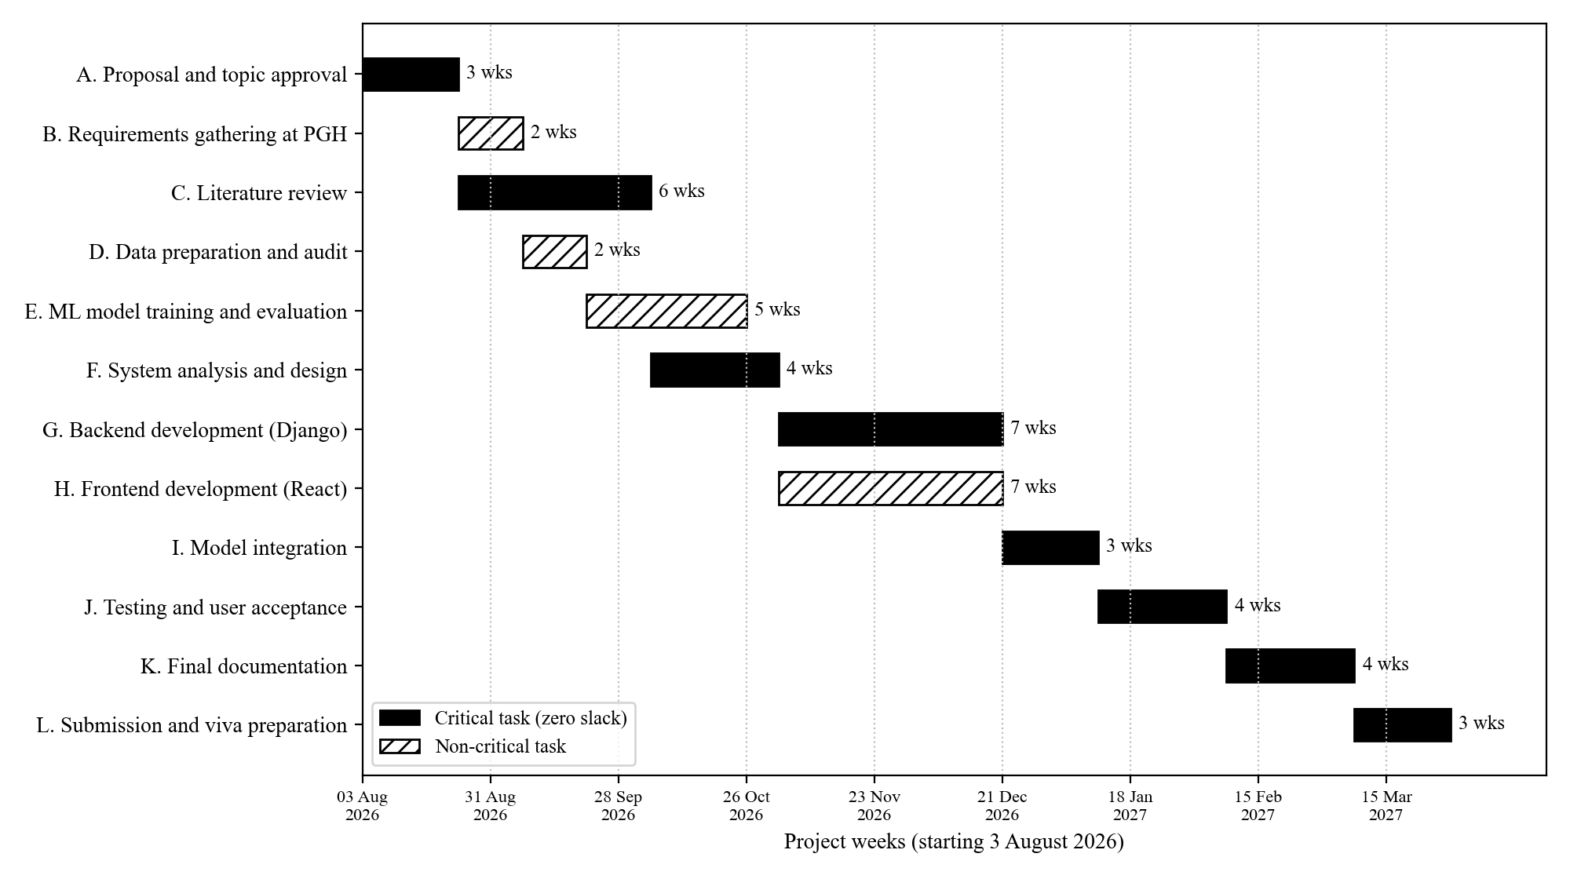
Figure 1.2: Gantt chart showing the critical path of the project
The critical path is A, C, F, G, I, J, K and L. These tasks have zero slack and add up to 34 weeks. A delay in any one of them delays the whole project. Requirements gathering has four weeks of slack. Data preparation and model training share eight weeks of slack. Frontend work has three weeks of slack, as it runs alongside the backend. Close attention was therefore given to the literature review, design and backend work.

1.13 Justification of the Project
Stockouts and expiries both drain the limited budget of a public hospital. A stockout forces emergency buying at higher prices. Worse still, it can interrupt life-saving treatment. An expired batch is money lost and must also be safely destroyed. Manual ordering cannot keep up with hundreds of medicines and shifting seasons. A data-driven system is therefore needed.
Early experiments show that the approach is promising. The Random Forest forecaster cut the average error by about 46 percent. This was compared with simply using the previous day's demand. The stockout classifier was tuned to catch at least 80 percent of real stockout cases. These results come from simulated data and still need confirming with live data. Even so, they show what the system could achieve.
The project is also affordable. It is built with free, open-source tools. It runs in a web browser on computers the hospital already owns. Pharmacists keep full control, since every recommendation needs their approval. For these reasons, the project is both needed and practical.

1.14 Summary
This chapter introduced Parirenyatwa Group of Hospitals and its Pharmacy Department. It showed that current stock systems record data but do not support decisions. This leads to stockouts, expired stock and slow manual ordering. The chapter set out the aim, seven objectives and five research questions. It also presented the theoretical framework and a conceptual model. Design Science Research, CRISP-DM and Agile Scrum were chosen as methods. The scope, limitations and a 34-week timeline were also given. The next chapter reviews related literature and assesses the feasibility of the system.

References
African Union Commission. (2015). Agenda 2063: The Africa we want. African Union Commission.
Akiba, T., Sano, S., Yanase, T., Ohta, T., & Koyama, M. (2019). Optuna: A next-generation hyperparameter optimization framework. In Proceedings of the 25th ACM SIGKDD International Conference on Knowledge Discovery & Data Mining (pp. 2623–2631). ACM. https://doi.org/10.1145/3292500.3330701
Breiman, L. (2001). Random forests. Machine Learning, 45(1), 5–32. https://doi.org/10.1023/A:1010933404324
Chen, T., & Guestrin, C. (2016). XGBoost: A scalable tree boosting system. In Proceedings of the 22nd ACM SIGKDD International Conference on Knowledge Discovery and Data Mining (pp. 785–794). ACM. https://doi.org/10.1145/2939672.2939785
Government of Zimbabwe. (2018). Vision 2030: Towards a prosperous and empowered upper middle income society by 2030. Government of Zimbabwe.
Government of Zimbabwe. (2020). National Development Strategy 1: January 2021 – December 2025. Government of Zimbabwe.
Government of Zimbabwe. (2021). Cyber and Data Protection Act [Chapter 12:07] (Act No. 5 of 2021). Government Printer.
Harris, F. W. (1913). How many parts to make at once. Factory, The Magazine of Management, 10(2), 135–136.
Hevner, A. R., March, S. T., Park, J., & Ram, S. (2004). Design science in information systems research. MIS Quarterly, 28(1), 75–105. https://doi.org/10.2307/25148625
Ke, G., Meng, Q., Finley, T., Wang, T., Chen, W., Ma, W., Ye, Q., & Liu, T.-Y. (2017). LightGBM: A highly efficient gradient boosting decision tree. In Advances in Neural Information Processing Systems 30 (pp. 3146–3154).
Lundberg, S. M., & Lee, S.-I. (2017). A unified approach to interpreting model predictions. In Advances in Neural Information Processing Systems 30 (pp. 4765–4774).
Peffers, K., Tuunanen, T., Rothenberger, M. A., & Chatterjee, S. (2007). A design science research methodology for information systems research. Journal of Management Information Systems, 24(3), 45–77. https://doi.org/10.2753/MIS0742-1222240302
Power, D. J. (2002). Decision support systems: Concepts and resources for managers. Quorum Books.
Saito, T., & Rehmsmeier, M. (2015). The precision-recall plot is more informative than the ROC plot when evaluating binary classifiers on imbalanced datasets. PLoS ONE, 10(3), e0118432. https://doi.org/10.1371/journal.pone.0118432
Schwaber, K., & Sutherland, J. (2020). The Scrum guide: The definitive guide to Scrum. Scrum.org.
Silver, E. A., Pyke, D. F., & Thomas, D. J. (2017). Inventory and production management in supply chains (4th ed.). CRC Press.
Simon, H. A. (1960). The new science of management decision. Harper & Row.
United Nations. (2015). Transforming our world: The 2030 Agenda for Sustainable Development (A/RES/70/1). United Nations.
Wirth, R., & Hipp, J. (2000). CRISP-DM: Towards a standard process model for data mining. In Proceedings of the 4th International Conference on the Practical Applications of Knowledge Discovery and Data Mining (pp. 29–39).

