CHAPTER FIVE: CODING AND TESTING

5.0 Introduction
Chapter Four presented the design of the system. This chapter shows how that design was built and tested. Section 5.1 describes the coding of the models, the backend and the frontend. In line with the project guide, pseudocode is used instead of raw source code. Section 5.2 presents the testing evidence. It covers automated tests, model tests, system tests, performance tests and the defects found. Every result reported here was produced by running the finished system. Screenshots were captured during the tests and annotated with numbered markers.

5.1 Coding

5.1.1 Development Environment
The system was built with the tools listed in Chapter One. The models were trained in Google Colab using Python and scikit-learn. The backend was written in Python with Django 5.2 and Django REST Framework. The frontend was written in TypeScript with React 19. Development took place on a Windows 11 laptop using Visual Studio Code. Git was used for version control, with each completed stage saved as a commit. SQLite was used during development, and the same code runs on PostgreSQL.

5.1.2 Building the Machine Learning Models
Each model was built in its own Colab notebook. Every notebook followed the same ten stages. These were setup, data audit, exploration, charts and feature building. They were followed by training, validation, stress testing, tuning and export. The data was always split by date, never at random. This stopped future data from leaking into training. Pseudocode 5.1 summarises the training of the demand model.
LOAD daily demand records for 20 medicines (2024)
CHECK for missing values, duplicates and negative quantities
FOR EACH medicine
ADD calendar features: weekday, month, weekend, public holiday, season
ADD lag features: demand 1, 7, 14 and 30 days earlier (shifted, no leakage)
ADD 7-day and 30-day averages and the 7-day spread
END FOR
SPLIT each medicine's history by date: first 70% train, next 15% validate, last 15% test
TRAIN naive, Linear Regression, Random Forest, XGBoost and LightGBM
RANK models by mean error in 5-fold time-series cross-validation
TUNE the best model with Optuna (40 trials)
KEEP the tuned model only if it beats the untuned one on the test set
SAVE model, encoders and metadata (features, metrics, limitations) as version v1
Pseudocode 5.1: Training the demand forecasting model
The stockout model followed the same pattern. Stockouts made up only about 10% of the records. Class weighting was therefore used during training. The alert threshold was then lowered to 0.125. This catches at least 80% of stockouts. The supplier model is unsupervised. It combines a weighted score with K-Means clustering into three tiers.

5.1.3 Training and Testing the Expiry Model
Chapter Three reported that the expiry classifier was still in training. It was completed during this phase. Only batches whose outcome was already known on each split date were used for training. This left 1,254 training batches, 122 validation batches and 560 test batches. Logistic Regression and Random Forest were compared on the validation set. Random Forest scored higher and was tuned to catch at least 85% of at-risk batches. Table 5.1 compares it with the simple depletion rule on the 560 unseen test batches.
Method | Precision | Recall | F1 | At-risk batches missed
Random Forest classifier | 96.5% | 92.7% | 0.946 | 15 of 206
Depletion rule (stock exceeds use before expiry) | 95.6% | 94.7% | 0.951 | 11 of 206
Table 5.1: Expiry classifier compared with the depletion rule on 560 test batches
The trained classifier did not beat the rule. It missed four more at-risk batches. The rule is also simpler to explain to pharmacists. The system therefore keeps the depletion rule as its expiry model. This is an honest result rather than a failure. A learned model should replace a rule only when it clearly performs better.

5.1.4 Backend Implementation
The backend was built as two Django apps. The accounts app holds users and roles. The core app holds medicines, stock, suppliers, recommendations and orders. Business logic lives in four service modules rather than in the web views. This keeps the API layer thin and easy to test.
A management command loads the project datasets into the database. It turns the four CSV files into a working pharmacy as at 31 December 2024. Pseudocode 5.2 shows the main steps.
READ demand, supplier and batch CSV files
VALIDATE required columns, empty cells and negative quantities
CREATE 20 medicines and 7,320 daily demand records (with closing stock and stockout flags)
CREATE 12 suppliers and their delivery records
SKIP any delivery that arrives after the snapshot date (no future data)
CREATE one offer per medicine and supplier: average price and lead time from past orders
FOR EACH medicine
total <- closing stock on the snapshot date
SPLIT total across three real batches (older batches hold less stock)
END FOR
RECORD a fingerprint of each file and an audit event
Pseudocode 5.2: Importing the datasets as a demonstration pharmacy
Testing showed that recent demand was understated after stockouts. On a stockout day nothing can be dispensed, so the record shows zero. This hides the true demand. The engine was therefore changed to ignore stockout days when it measures demand. Pseudocode 5.3 shows this step.
INPUT last 60 days of (quantity, stockout flag)
clean <- quantities in the last 30 days where stockout flag is false
IF fewer than 10 clean days THEN
clean <- quantities in the last 60 days where stockout flag is false
IF fewer than 5 clean days THEN
clean <- all quantities in the last 30 days
RETURN mean(clean), standard deviation(clean), number of stockout days
Pseudocode 5.3: Measuring demand without stockout days
For Ibuprofen, this changed the recent daily average from 27 to 81 units. The medicine had been out of stock for 20 days in December. The corrected figure now matches the forecast and the medicine's yearly average.

5.1.5 Integrating the Models
The trained models were copied from Colab into the project as read-only files. The server loads each model once and keeps it in memory. Models are preloaded when the server starts, so the first request is fast. Forecasts beyond one day feed each prediction back in as the next day's input. For speed, the engine forecasts one day for all 20 medicines in a single step. Pseudocode 5.4 shows this step.
INPUT for each medicine: category and last 30 days of demand
FOR day = 1 TO horizon
rows <- one feature row per medicine for this day
(season from the month, holiday from the calendar, lags from history)
predictions <- model.predict(rows) // one call for all medicines
APPEND each prediction to that medicine's history and forecast
END FOR
RETURN forecasts
Pseudocode 5.4: Forecasting many medicines in one pass
Early runs were slow. A full decision run for 20 medicines took about 21 seconds. Profiling found the cause. The library re-checked the model before each of its 750 trees. The trees were then called directly. This gave identical predictions about twelve times faster. Through the API, a full run now takes about 1.5 seconds.

5.1.6 Frontend Implementation
The frontend has one page for each task in the use case diagram. All server calls go through a single API layer. This layer adds the user's access token to every request. When the access token expires, it renews it silently, as shown in Pseudocode 5.5.
FUNCTION Request(path, options)
response <- send request with the current access token
IF response is 401 (expired token) THEN
new_token <- send refresh token to /token/refresh/
IF new_token received THEN
save new_token ; response <- send request again with new_token
ELSE
clear tokens ; RETURN "Session expired" (user goes to login)
IF response is an error THEN
RETURN a plain-language message for its status (400, 403, 409, 422, 429, 503 ...)
RETURN response data
END FUNCTION
Pseudocode 5.5: Sending a request with automatic token renewal
The Model Lab and the decision engine panel were added for the viva demonstration. In the Model Lab, examiners can test each model with their own inputs. They can also see why it answered. The decision panel runs all four models together and supports a what-if dispense.

5.2 Testing

5.2.1 Testing Approach
Testing followed the plan in Chapter Three. It was carried out at five levels. Automated tests checked the backend code and the reproduced model results. Model tests checked accuracy on data the models had never seen. System tests checked each feature through the real interface. Performance tests measured response times. User acceptance testing with PGH pharmacy staff is the final level. System tests were run with an automated browser driven by Playwright. This made each test repeatable and produced a screenshot at every step.

5.2.2 Automated Unit and Integration Tests
The backend has 35 automated tests written with the Django test framework. Table 5.2 groups them by purpose. All 35 tests passed in the final run.
Group | Tests | What they check | Result
Authentication | 4 | Clear login messages, and blocking after ten attempts in a minute | All passed
Administration | 2 | All data tables are registered in the admin site | All passed
Model reproduction | 4 | Live re-tests match the Colab results for all four models | All passed
Explanations | 3 | Explanation bars add up exactly to each prediction | All passed
Model Lab access | 6 | Role checks, input validation and safe handling of missing model files | All passed
Decision engine | 8 | Orders for out-of-stock items, no duplicates, approval, expedite and FEFO dispensing | All passed
Page data | 8 | No placeholder values, real reports, search, demo date and stockout-day handling | All passed
Table 5.2: Automated backend tests

5.2.3 Model Testing
Table 5.3 shows the results of the model test cases planned in Table 3.7. Each model was re-tested live inside the finished system. The results matched the Colab notebooks to two decimal places.
ID | Test | Expected | Actual | Result
MT-01 | Audit each dataset | No gaps or duplicates | All four files: no missing cells, no duplicate rows | Pass
MT-02 | Leakage check | All correlations below 0.98 | Highest 0.76 (demand) and 0.42 (stockout) | Pass
MT-03 | Demand model vs naive baseline | Lower MAE | MAE 21.30 vs 39.36, an error cut of 45.9% | Pass
MT-04 | Ranking under cross-validation | Same leader across folds | Random Forest led both supervised tasks | Pass
MT-05 | Errors by category | Weak areas found | Antimalarials weakest (MAE 64.97); stockout days harder | Pass
MT-06 | Stockout alert threshold | Recall of at least 0.80 | Recall 0.802 at threshold 0.125 | Pass
MT-07 | Keep tuned model only if better | Better model deployed | Demand: tuned kept. Stockout: untuned kept | Pass
MT-08 | K-Means vs hierarchical | ARI above 0.80 | ARI 1.000 | Pass
MT-09 | Weights changed by 30% (500 runs) | Spearman above 0.90 | Mean 0.994, lowest 0.972 | Pass
MT-10 | Resample orders 200 times | Most suppliers keep their tier | Each kept its main tier in at least 73% of runs | Pass
Table 5.3: Machine learning test results
Figure 5.1 shows one of these re-tests running in the Model Lab. The stockout model's live test reproduced a recall of 80.2% and a PR-AUC of 0.81. It caught 65 of 81 real stockouts and raised 49 false alarms.
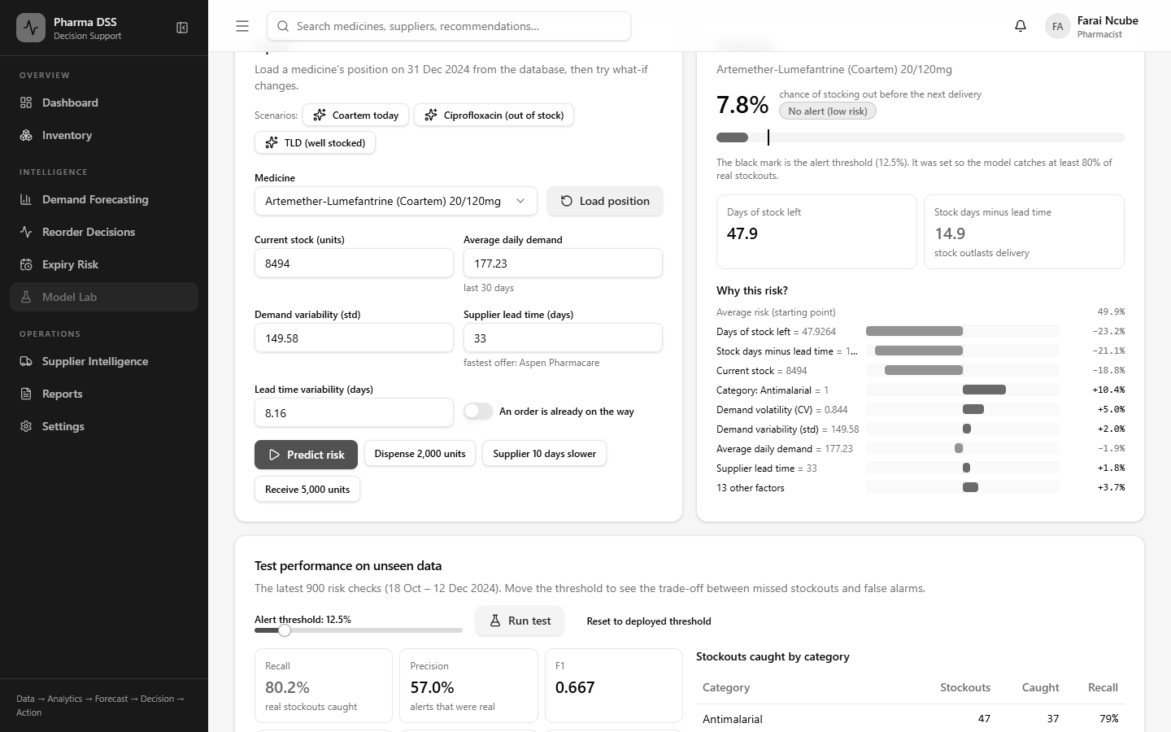
Figure 5.1: Live re-test of the stockout model in the Model Lab

5.2.4 System Functional Testing
Table 5.4 summarises the system test cases planned in Table 3.8. The actual results were recorded automatically during the test run.
ID | Test scenario | Expected | Actual | Result
ST-01 | Log in with a valid email and password | Dashboard opens for the user's role | Dashboard opened for Farai Ncube (Pharmacist) with live indicators. | Pass
ST-02 | Log in with a wrong password | Clear error message, no access | The page showed 'Wrong password'. The user stayed on the login page. | Pass
ST-03 | Try more than 10 logins in one minute | Further attempts are blocked | Of eleven quick attempts, attempts 9 to 11 got HTTP 429. Earlier test logins used part of the limit. The page then showed 'Too many attempts'. | Pass
ST-04 | Use the system after the access token expires | Token refreshes or the user is asked to log in | The invalid access token was rejected and silently replaced using the refresh token. The inventory page loaded without asking the user to log in again. | Pass
ST-05 | Staff user tries to approve or change stock | Action refused for this role | The staff menu had no reorder pages. Server calls for recommendations, engine runs and dispensing all got HTTP 403. | Pass
ST-06 | Open the demand forecast for a medicine | Forecast chart and model version shown | The chart showed an 80% prediction interval and total demand. Model version v1 and MAE 21.30 were listed. | Pass
ST-07 | Medicine's stock falls into the risk zone | Reorder recommendation appears with quantity and supplier | Paracetamol had 5,285 units and needed no action. After 4,000 units were dispensed, it showed an order of 13,633 units at 64% risk. | Pass
ST-08 | Pharmacist approves a recommendation | Status changes to approved and an audit entry is saved | Status changed to Approved with 'decided by Farai Ncube'. A purchase order was created. | Pass
ST-09 | Open the supplier page | Scores, tiers and low-confidence flags shown | All 12 suppliers listed with score, on-time rate, lead time, defect rate and review status. | Pass
ST-10 | Open the expiry risk page | Batches at risk listed by expiry date | 54 batches listed by expiry date with daily use, projected unused units and advice. No batch was projected to expire unused in the demo data. | Pass
ST-11 | Generate a stock report | PDF or CSV file downloads | File inventory-2024-11-30-to-2024-12-31.csv downloaded with 20 data rows. Header: medicineId,medicineName,strength,category,currentStock,reorderPoint,sa | Pass
ST-12 | Medicine with no demand history | No crash. Forecast shown as unavailable | No crash. The page showed 'Not enough data'. It said at least 30 days of history are needed. | Pass
ST-13 | Enter a negative stock quantity | Input rejected with a message | Rejected with the message 'Invalid request Quantity must be at least 1.'. Stock was not changed. | Pass
ST-14 | Model file is missing or fails to load | System shows that predictions are unavailable | Forecast, Model Lab and engine requests returned HTTP 503 'Model artifact is missing'. No crash. | Pass
Table 5.4: System test results
All fourteen system tests passed. The following figures give annotated evidence for the main tests. Numbered markers point to the part of the screen being tested.

ST-01 and ST-02: Login
Figure 5.2 shows a login attempt with a wrong password. Marker 1 shows the clear error message. The user stays on the login page and gains no access.
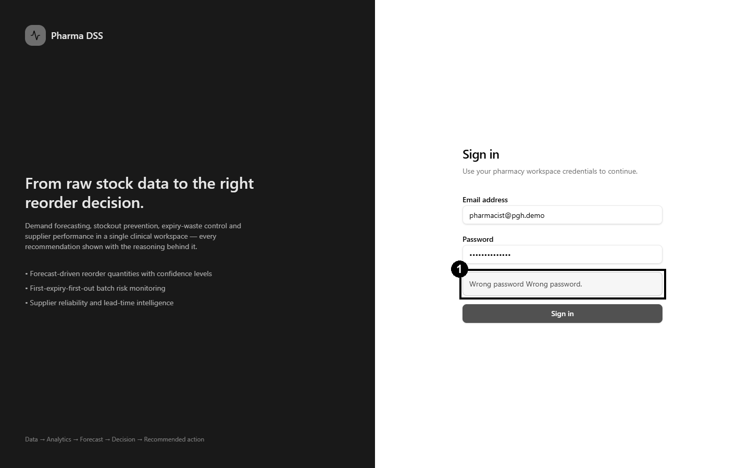
Figure 5.2: ST-02, login rejected with a wrong password
Figure 5.3 shows a successful login. Marker 1 shows the logged-in pharmacist, Farai Ncube. Marker 2 shows the pending reorder decisions waiting for this user.
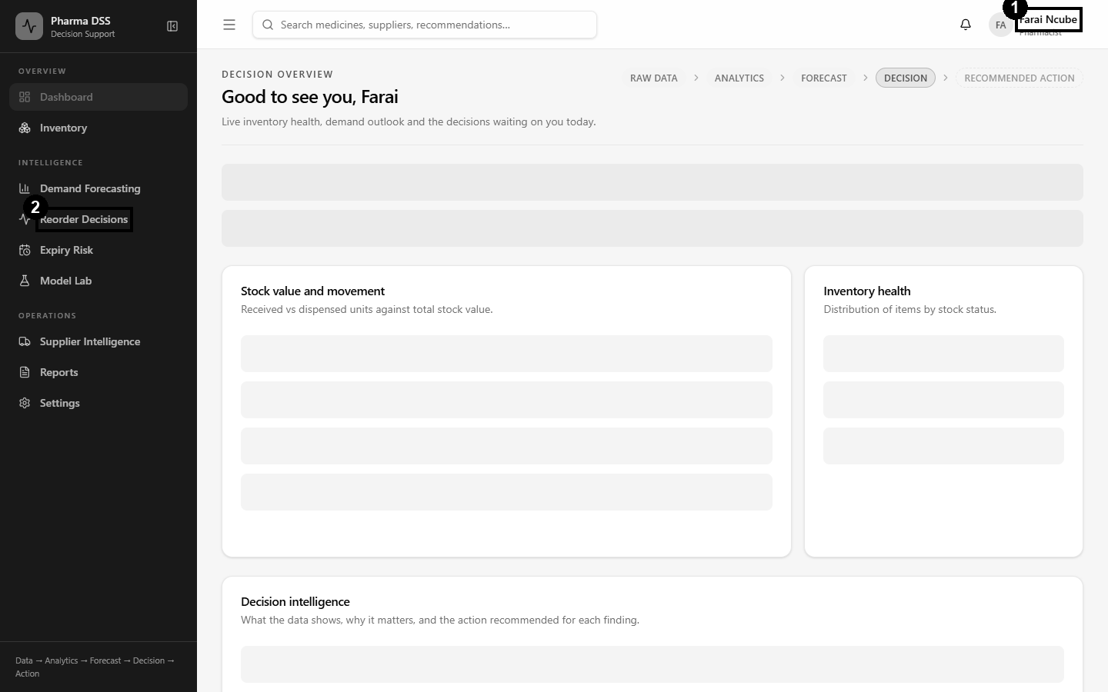
Figure 5.3: ST-01, dashboard after a successful login

ST-03 and ST-05: Security Controls
Eleven wrong passwords were sent in quick succession. The first ten were rejected as wrong passwords. The eleventh was blocked with HTTP 429. Figure 5.4 shows the message that the login page then displayed.
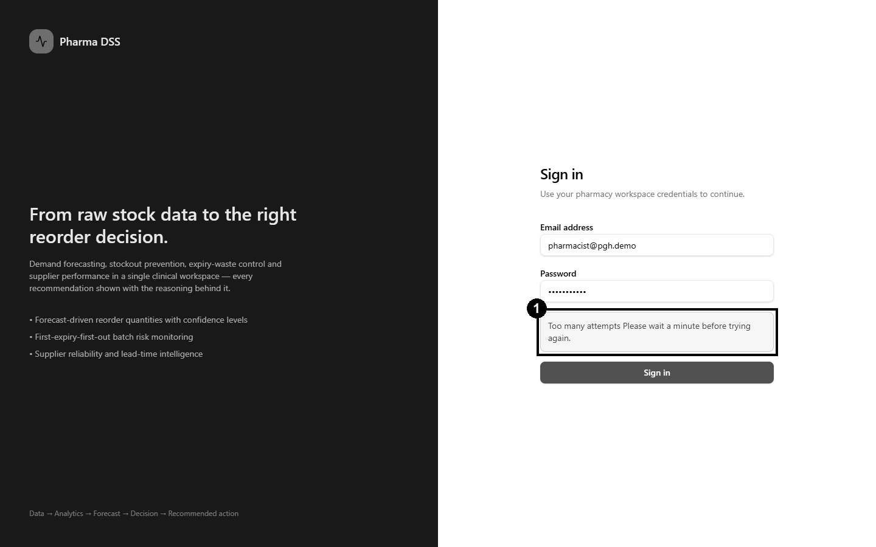
Figure 5.4: ST-03, repeated login attempts blocked
Figure 5.5 shows the system for a stores staff account. Marker 1 shows that the menu offers no forecasting, reorder or supplier pages. Direct requests to those services were also refused by the server.
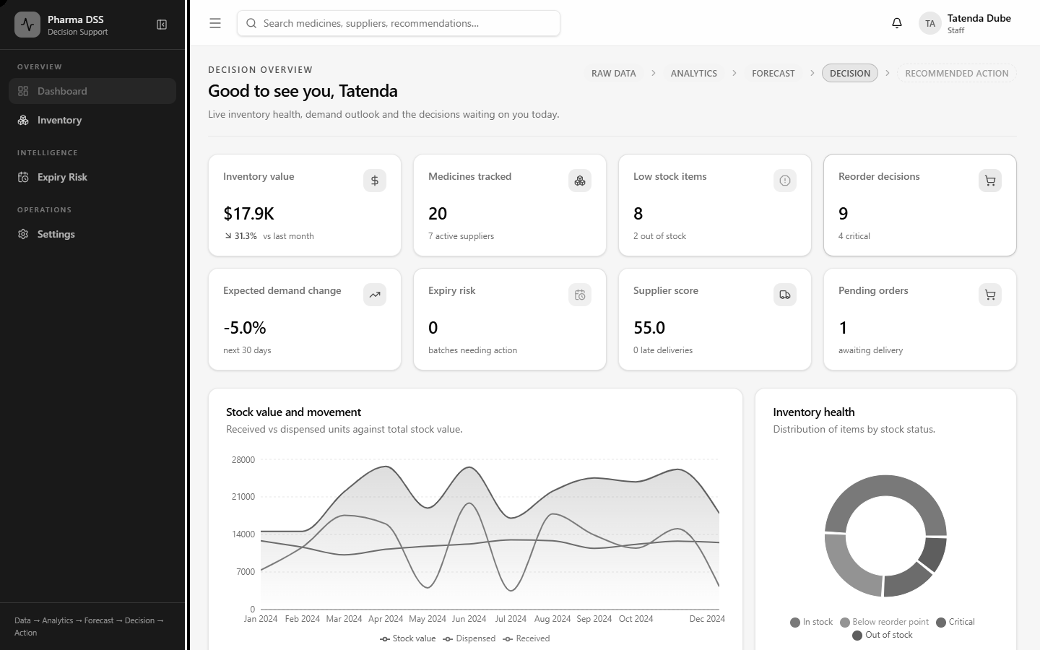
Figure 5.5: ST-05, reduced menu for the stores staff role

ST-06 and ST-12: Demand Forecasting
Figure 5.6 shows the forecast page. Marker 1 shows the model version. Marker 2 shows the 80% prediction interval around the forecast.
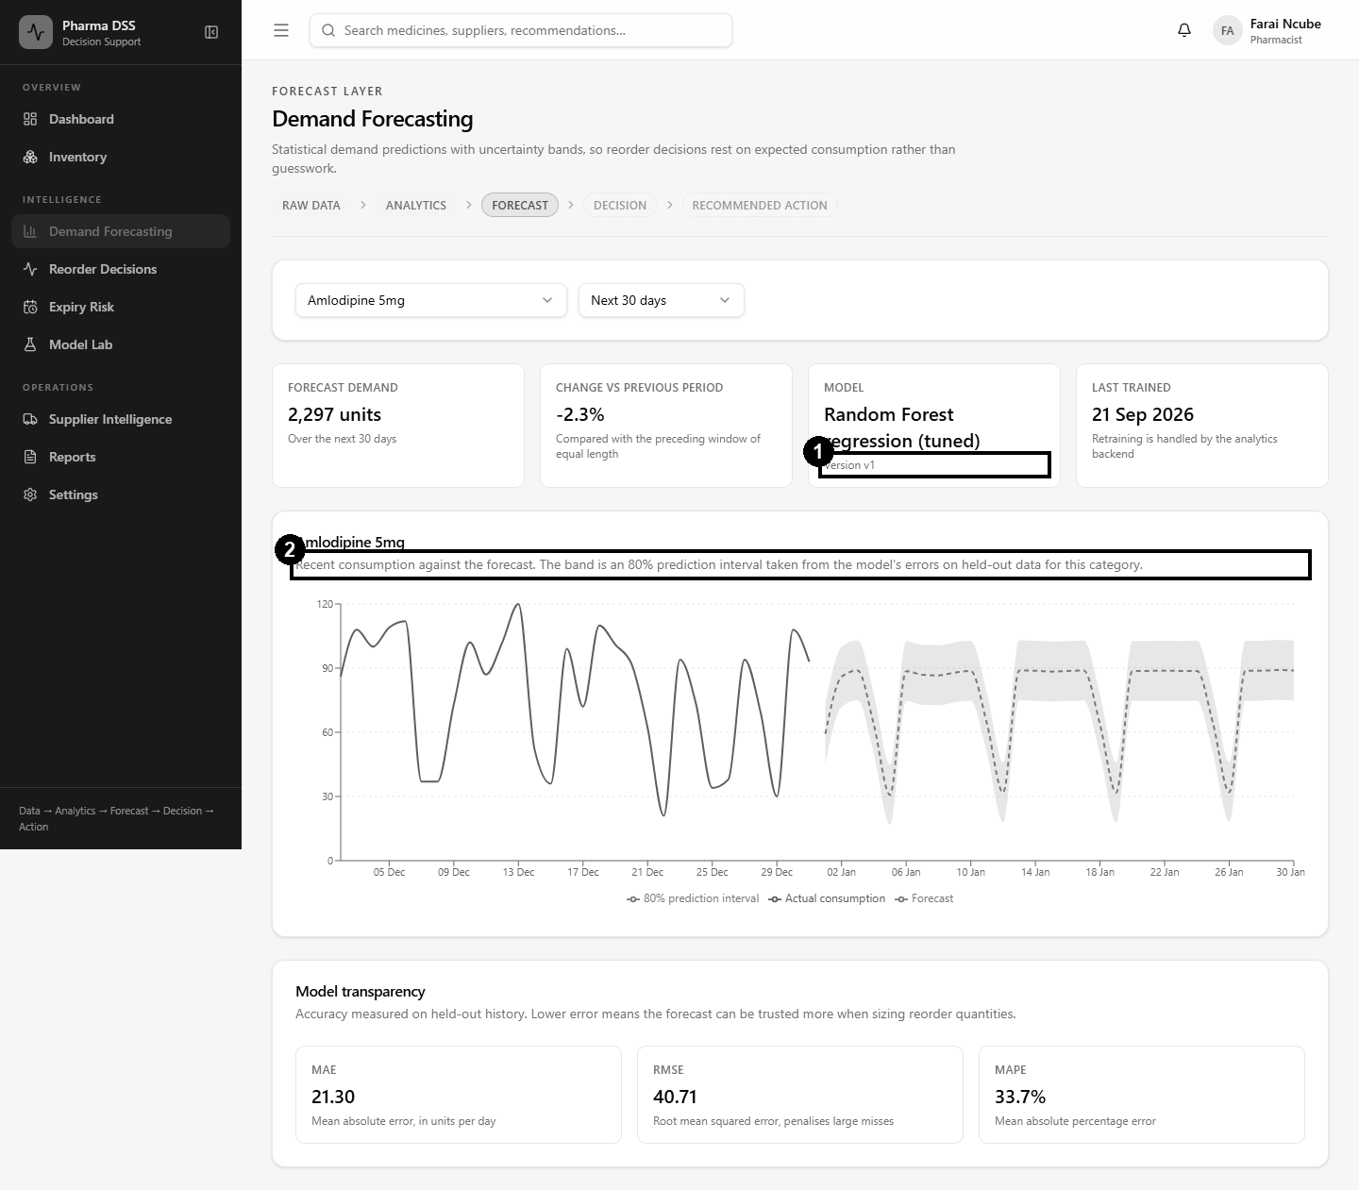
Figure 5.6: ST-06, demand forecast with model details
Figure 5.7 shows a medicine with no demand history. Marker 1 shows that the page explains the problem instead of crashing.
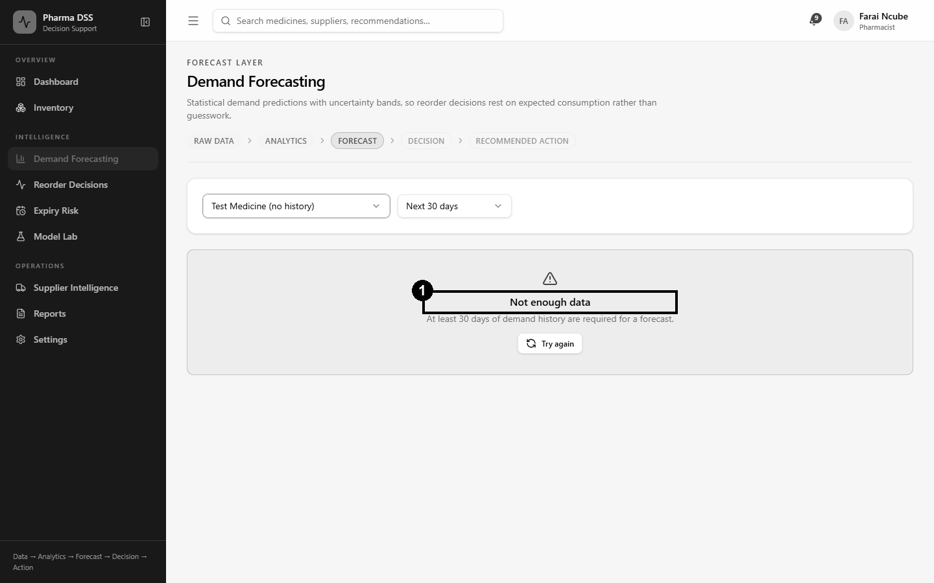
Figure 5.7: ST-12, a medicine with no history

ST-07, ST-08 and ST-13: The Decision Engine
Figure 5.8 shows the decision engine before the what-if test. Paracetamol had 5,285 units in stock and needed no action.
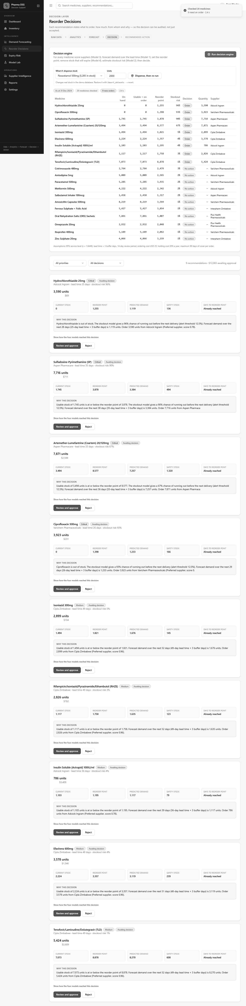
Figure 5.8: Decision engine results before the what-if dispense
Next, 4,000 units of Paracetamol were dispensed, and the engine ran again. Figure 5.9 shows the result. Marker 1 shows that Paracetamol now needs an order with a 64% stockout risk.
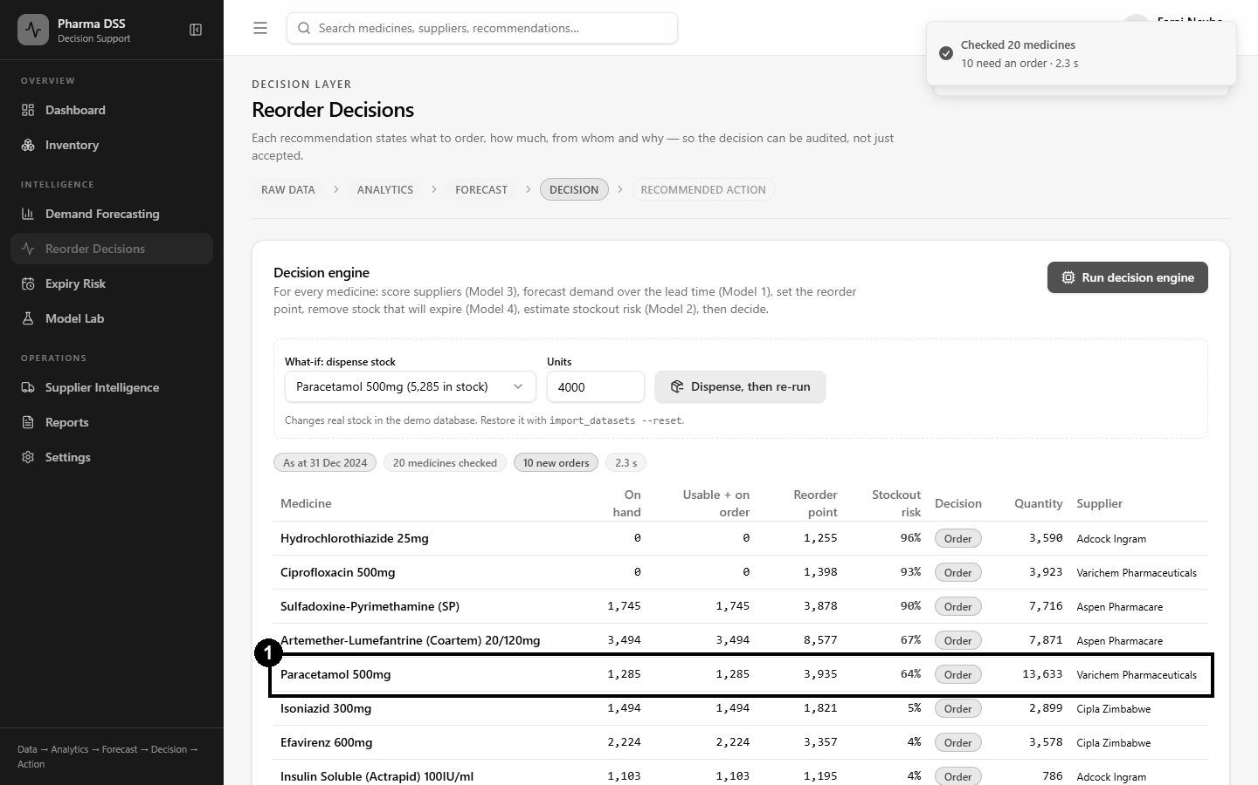
Figure 5.9: ST-07, Paracetamol moves into the risk zone after dispensing
Figure 5.10 shows a dispense of minus five units. Marker 1 shows that the system rejected it with a clear message.
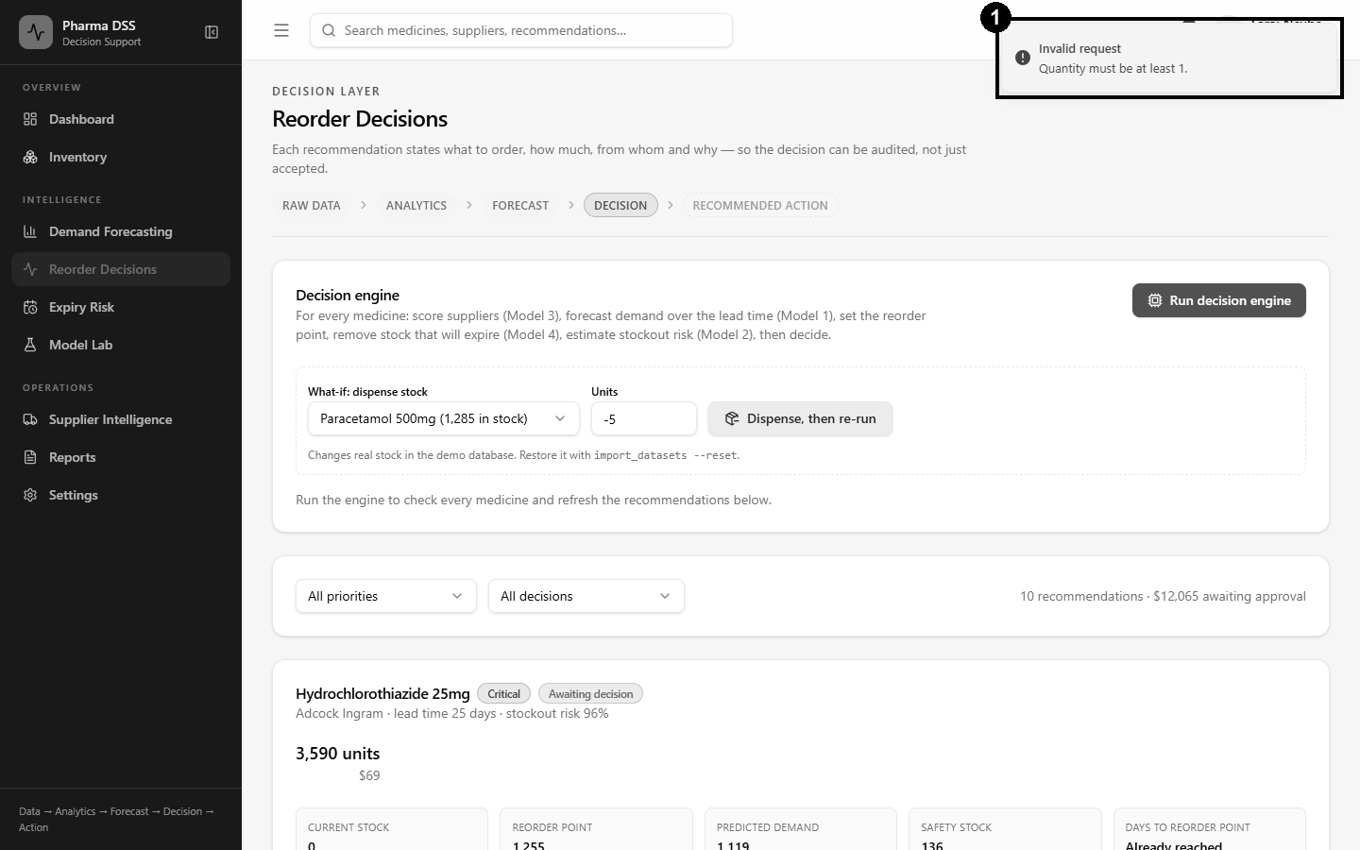
Figure 5.10: ST-13, a negative quantity is rejected
Figure 5.11 shows the full chain of reasoning for the Paracetamol recommendation. It lists the supplier choice, forecast, reorder point, expiry check, stockout risk and quantity.
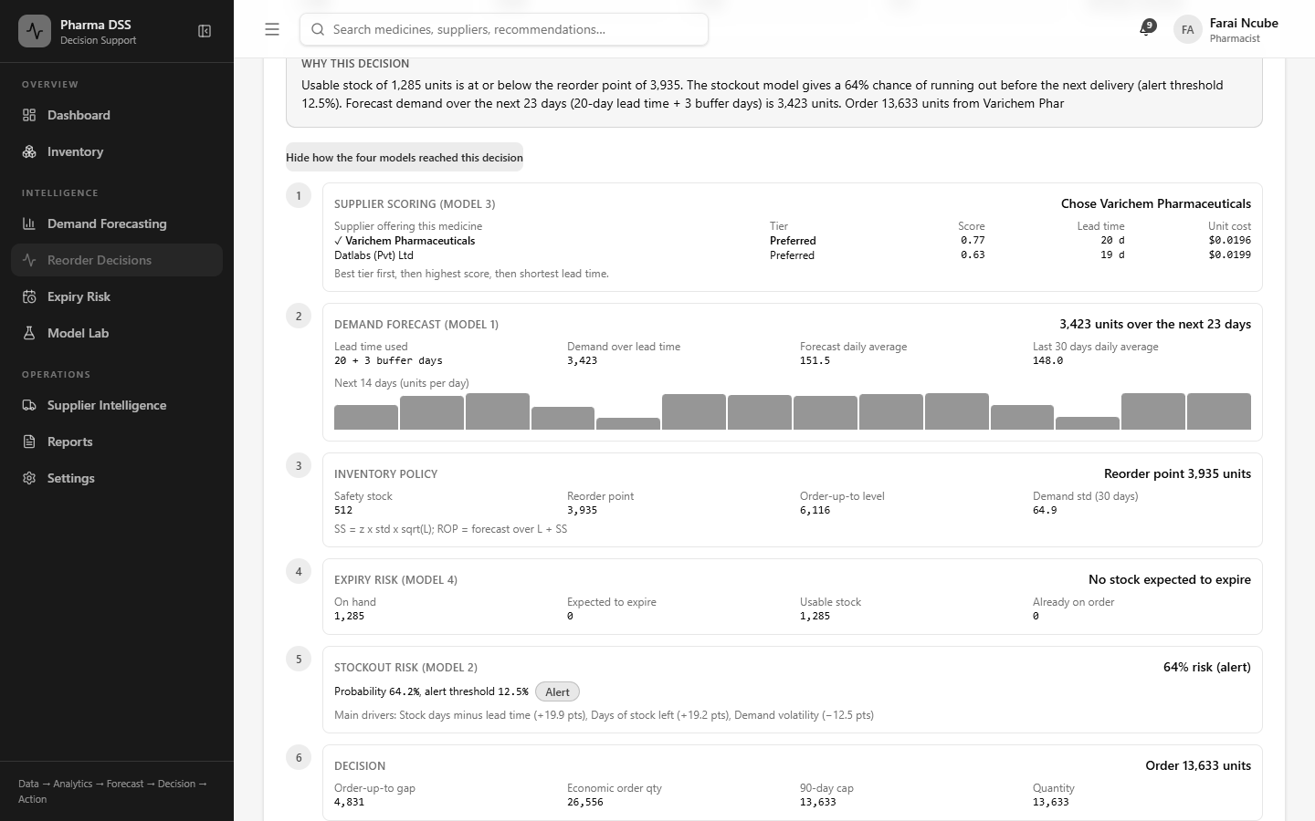
Figure 5.11: The four-model decision chain for a recommendation
The pharmacist then approved the recommendation. Figure 5.12 shows the result. Marker 1 shows the approved status. Marker 2 records who made the decision.
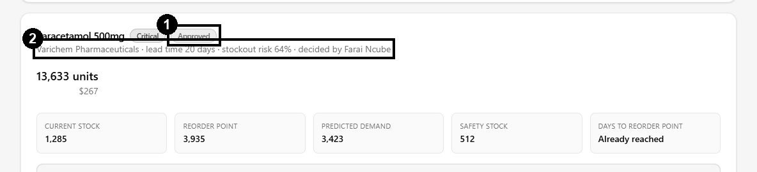
Figure 5.12: ST-08, recommendation approved and recorded

ST-09, ST-10 and ST-11: Suppliers, Expiry and Reports
Figure 5.13 shows the supplier page with scores and tiers. Marker 1 shows a supplier flagged for review because of its low tier.
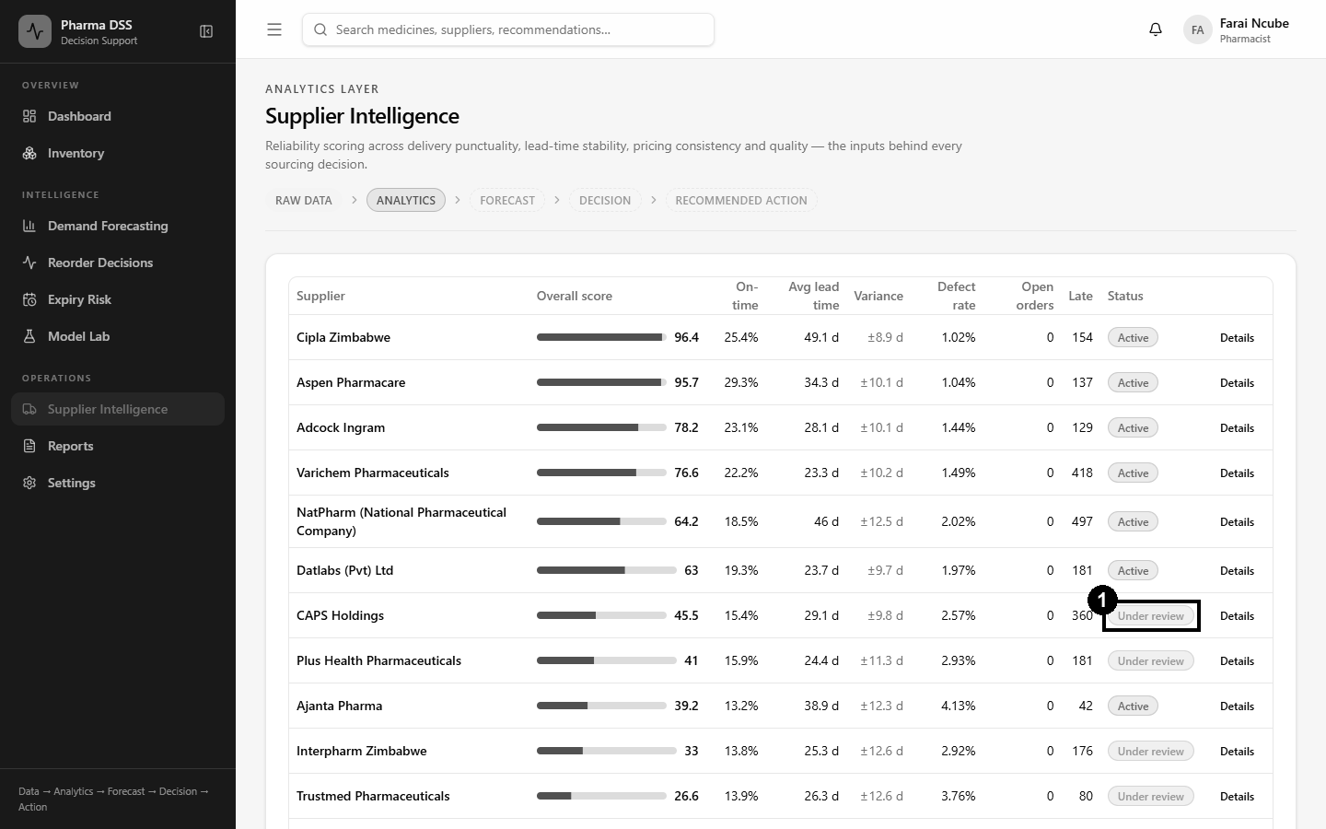
Figure 5.13: ST-09, supplier performance page
Figure 5.14 shows the expiry page, with batches in first-expiry-first-out order.
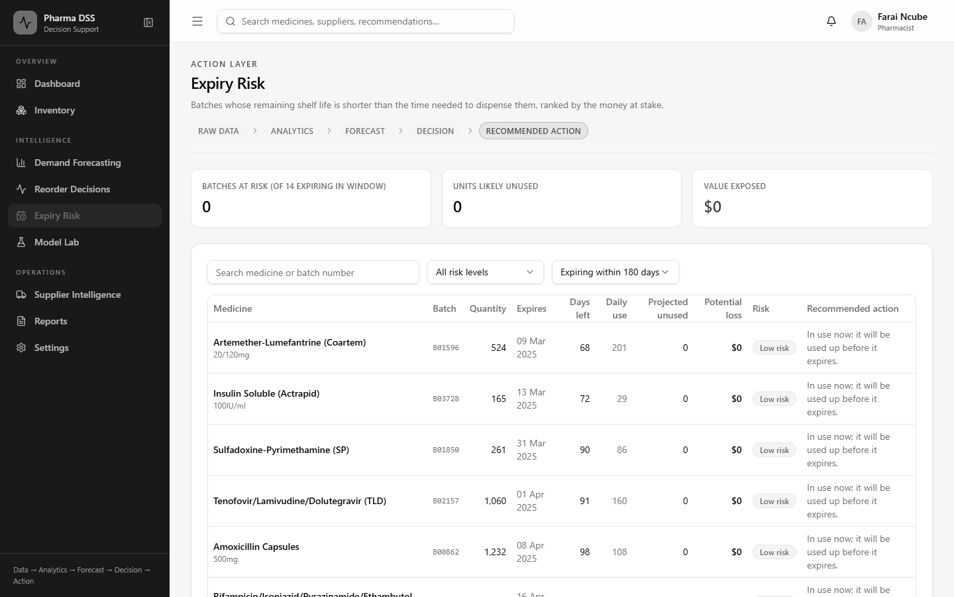
Figure 5.14: ST-10, expiry risk page
Figure 5.15 shows a generated inventory report. Marker 1 shows the row count. The downloaded CSV file was opened and checked. It held 20 data rows, one for each medicine.
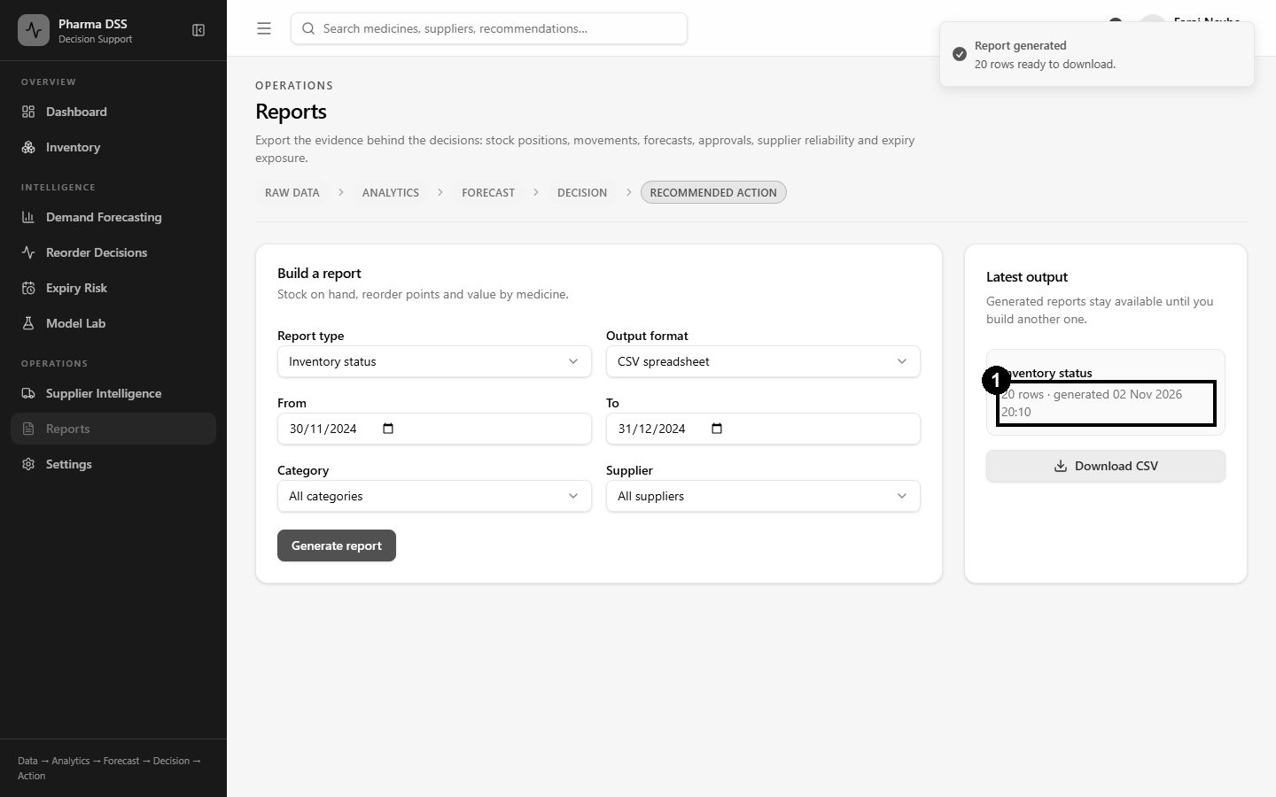
Figure 5.15: ST-11, inventory report generated and downloaded

The Model Lab What-If Test
Figures 5.16 and 5.17 show a what-if test in the Model Lab. Coartem first showed a stockout risk of 67.5%, which raised an alert. After 5,000 units were added, the risk fell to 7.8% and the alert cleared.
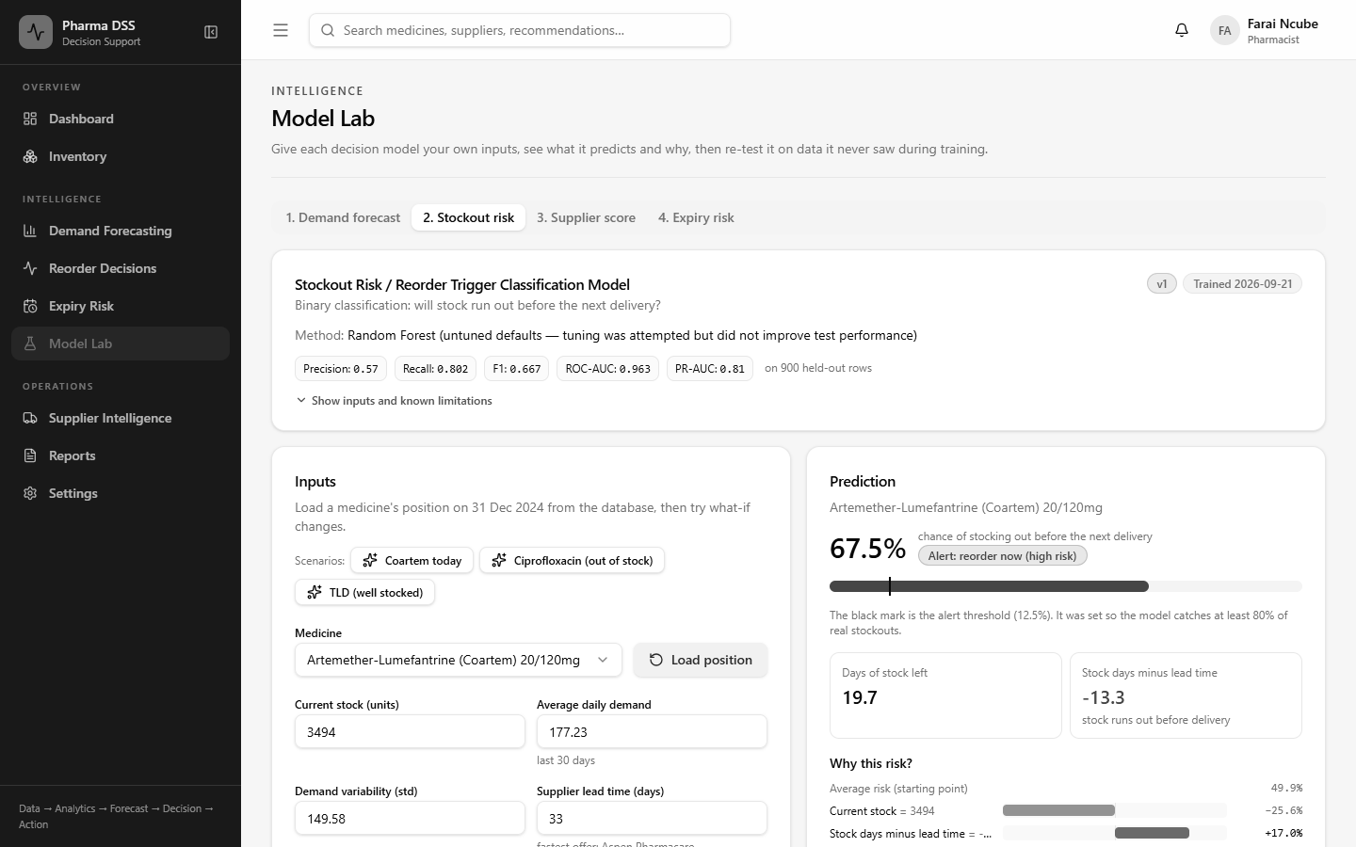
Figure 5.16: Stockout risk for Coartem before the what-if change
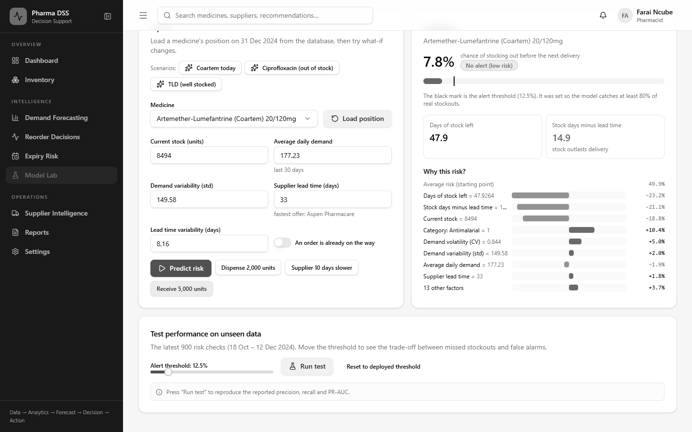
Figure 5.17: Stockout risk for Coartem after adding 5,000 units

5.2.5 Performance Testing
Response times were measured on the development laptop with the server running locally. Table 5.5 shows the median of five runs for each operation.
Operation | Target | Measured (median) | Result
Run decision engine for 20 medicines | under 5 s | 1.51 s | Pass
30-day demand forecast for one medicine | under 3 s | 0.18 s | Pass
90-day demand forecast for one medicine | under 3 s | 0.50 s | Pass
Model Lab: one demand prediction with explanation | under 3 s | 0.10 s | Pass
Model Lab: re-test demand model (repeat run, cached) | under 3 s | 0.02 s | Pass
Inventory list (20 medicines) | under 3 s | 0.01 s | Pass
Dashboard indicators | under 3 s | 0.17 s | Pass
Generate PDF inventory report | under 3 s | 0.11 s | Pass
Dashboard page fully loaded in the browser | under 3 s | 1.05 s | Pass
Table 5.5: Performance test results
All operations met their targets. The slowest step is the very first page load after the development server starts. This happens because the development server compiles each page on first use. A production build is compiled in advance, so users do not see this delay.

5.2.6 Defects Found and Fixed
Testing found several defects. Each one was fixed and then re-tested. Table 5.6 lists the most important ones.
ID | Defect found | Severity | Fix
D-01 | Approving a recommendation crashed because the order date was never set. | High | Order date set; delivery date now uses the supplier lead time.
D-02 | Several screens showed fixed sample numbers instead of calculated ones. | High | Every figure now comes from the data and the decision engine.
D-03 | The interface and the API used different data formats on four pages. | High | Formats aligned and checked by automated tests.
D-04 | Stockout days lowered demand averages, e.g. a false 202% rise for Ibuprofen. | High | Stockout days are excluded from demand statistics.
D-05 | After approval, the engine proposed a second, duplicate order. | Medium | It now advises expediting the open order instead.
D-06 | A full decision run took about 21 seconds. | Medium | Trees called directly; a run now takes about 1.5 seconds.
D-07 | Pharmacists could not approve orders, unlike the design. | Medium | Role permissions updated to match Chapter Four.
D-08 | Reports were saved as JSON files with the wrong extension. | Medium | Real CSV and PDF files are now produced.
D-09 | A missing model file revealed the server's folder path. | Medium | Messages now name the file only.
D-10 | The model list crashed (HTTP 500) when a model file was missing. | Medium | It now returns a clear 'model unavailable' message.
D-11 | Some errors showed only 'Something went wrong'. | Low | Plain messages added for too many attempts, conflicts, missing data and unavailable models.
D-12 | Every medicine looked close to expiry because of how demo batches were chosen. | Low | Batches now reflect a realistic mix of expiry dates.
D-13 | The 10-per-minute login limit was configured but never enforced. | High | Rate limiting switched on and covered by a new automated test.
Table 5.6: Defect log

5.2.7 User Acceptance Testing
User acceptance testing checks whether real users find the system useful. It will be carried out with pharmacists and technicians at the PGH Pharmacy Department. Each participant will complete five tasks without help. They will log in, check a medicine's stock and forecast, and run the decision engine. They will then approve one recommendation and download a report. They will then rate it on a five-point scale using the form in Appendix C. The system passes if at least 70% rate it useful or very useful. Table 5.7 shows the tasks and acceptance criteria.
Task | Acceptance criterion
Log in with your own account | Completed without help
Find the stock, reorder point and forecast for Coartem | Completed in under two minutes
Run the decision engine and explain one recommendation | Participant can state the main reason
Approve or reject a recommendation | Completed without help
Download the inventory report | File opens correctly
Overall rating | At least 70% rate the system useful or very useful
Table 5.7: User acceptance test plan
The results of this testing will be reported in Chapter Six.

5.3 Summary
All planned parts of the system were implemented. These include the four models, the decision engine, the Model Lab and every designed page. All 35 automated tests, all 10 model tests and all 14 system tests passed. Performance targets were met, with a full decision run taking about 1.5 seconds.
Several challenges arose during coding and testing. The datasets were simulated, so results must still be confirmed with real PGH records. Stockout days hid true demand until the engine was changed to ignore them. The expiry classifier did not beat a simple rule, so the rule was kept. The development server was slow to start on the test laptop. Testing also found thirteen defects, and all were fixed and re-tested.
Some areas need further work. User acceptance testing with PGH staff must be completed. The models should be retrained on real hospital data. Multi-factor login should be added for administrators. Links to eLMIS and Impilo would remove the need for manual data loading. The next chapter discusses the results against the objectives of the study.

