CHAPTER SIX: RESULTS AND DISCUSSIONS

6.0 Introduction
Chapter Five showed that the system was built and that it passed its tests. This chapter asks a different question. Did the system achieve what the study set out to do? Each objective from Chapter One is linked to the features that meet it. Screen dumps of the working system show each objective in action. The results are then compared with the studies reviewed in Chapter Two. The chapter ends with the limitations, recommendations for further research and a conclusion.

6.1 Achievement of Objectives
Table 6.1 gives a summary before each objective is discussed.
Objective | Feature that meets it | Key evidence | Status
1. Analyse current practices at PGH | Background study and gap analysis | Five gaps identified (Section 1.2.2) | Partly achieved
2. Forecast daily demand | Model 1: Random Forest regression | MAE 21.30 vs 39.36 naive | Achieved
3. Predict stockout risk | Model 2: Random Forest classifier | Recall 80.2%, PR-AUC 0.81 | Achieved
4. Score suppliers | Model 3: weighted score and K-Means | ARI 1.000; rank stability 0.994 | Achieved
5. Flag expiry risk | Model 4: depletion rule with FEFO | 95.53% agreement; F1 0.951 | Achieved
6. Integrate into a secure web system | Decision engine, Model Lab, role-based pages | All four models run in 1.5 seconds | Achieved
7. Evaluate the system | Automated, model, system and performance tests | 59 of 59 tests passed | Partly achieved
Table 6.1: Summary of objectives and their achievement

6.1.1 Objective 1: Analyse Current Inventory and Procurement Practices
The first objective was to understand how the PGH pharmacy plans and orders medicines. Chapter One described the current tools: stock cards, ledgers, spreadsheets, eLMIS reports and Impilo. It found five gaps. There was no demand forecasting, no early stockout warning and no objective supplier rating. Expiry tracking was weak, and reports did not lead to clear actions. Each gap shaped one part of the system, as Table 6.2 shows.
Gap found | Feature that addresses it
No demand forecasting | Daily forecasts for every medicine, with an 80% prediction interval
No early stockout warning | Stockout probability before the next delivery, with alerts
No objective supplier rating | Supplier scores and tiers from delivery records
Weak expiry tracking | First-expiry-first-out check of every batch against the forecast
No link from data to action | Decision engine that recommends what, how much and from whom
Table 6.2: Gaps in the current system and the features that address them
This objective is marked as partly achieved. The gaps came from the literature, national reports and the design of the current tools. They still need to be confirmed with PGH staff through the planned questionnaire and interviews.

6.1.2 Objective 2: Forecast Daily Medicine Demand
The second objective was a machine learning model that forecasts daily demand for each medicine. A single Random Forest model was trained across all 20 medicines. On 1,020 unseen test days, its mean absolute error was 21.30 units a day. A naive forecast, which repeats yesterday's demand, had an error of 39.36. The model therefore cut the error by 45.9%. Figure 6.1 shows this result being reproduced live in the Model Lab.
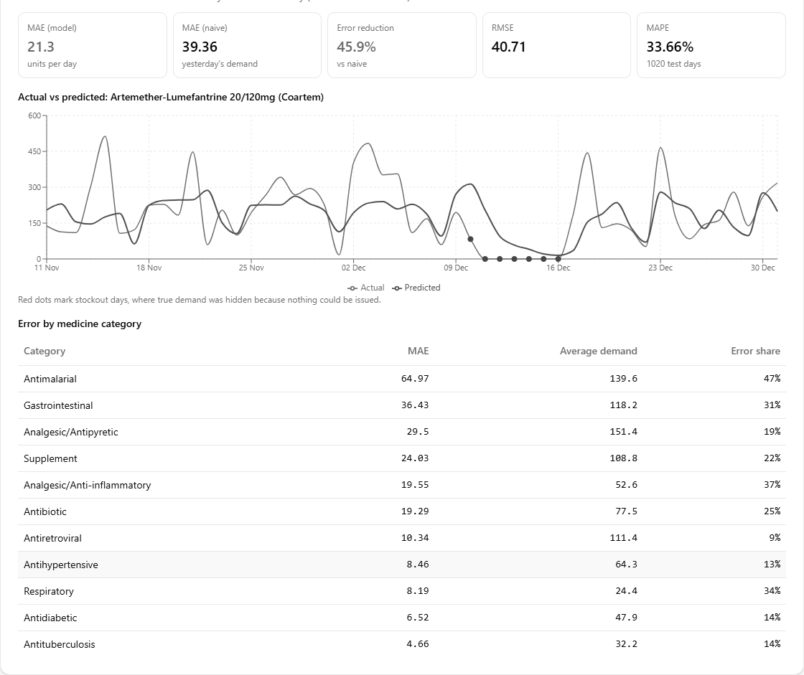
Figure 6.1: Demand model re-tested on unseen data in the Model Lab
The model forecasts steady medicines best. Errors were lowest for TB medicines and antiretrovirals. They were 9% to 14% of average demand. Errors were highest for antimalarials, at about 47% of average demand. Malaria demand rises and falls sharply in the rainy season. This makes it hard to predict. The black dots in Figure 6.1 mark stockout days, when true demand was hidden.
These results agree with Mbonyinshuti et al. (2022). They also found Random Forest a reliable forecaster of essential medicines in Rwanda. One shared model for all medicines also won the M5 competition (Makridakis et al., 2022). One finding was unexpected. The season feature contributed only 0.1% to the model's decisions. The 7-day average and the demand a week earlier contributed 65%. Recent demand already reflects the season, so the model learns the season from it indirectly.

6.1.3 Objective 3: Predict Stockout Risk
The third objective was a classifier that predicts stockout risk before the next delivery. Only about one check in ten was a stockout, so accuracy would have been misleading. The model was judged instead by recall and PR-AUC (Saito & Rehmsmeier, 2015). At an alert threshold of 0.125, it caught 80.2% of real stockouts. Its PR-AUC was 0.81, against 0.09 for a model that never raises an alert. Figure 6.2 shows the model scoring Coartem as at 31 December 2024.
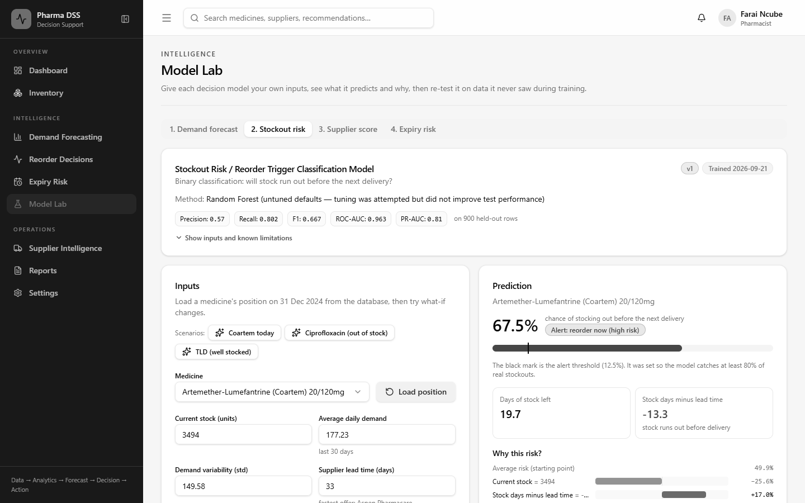
Figure 6.2: Stockout risk for Coartem, with the reasons behind it
The model gave Coartem a 67.5% risk. Its stock would last about 20 days. The supplier needs about 33 days to deliver. The explanation bars show that this gap drove the alert. Three inputs mattered most. They were days of stock left, stock days minus lead time and current stock. Together they made up 75% of its decisions. This matches inventory theory, where stock must outlast the lead time (Silver et al., 2017).
The threshold choice has a cost. About four in ten alerts are false. This was accepted on purpose. A false alarm costs a pharmacist a minute to check. A missed stockout can interrupt treatment for patients on ARVs or TB medicines.

6.1.4 Objective 4: Score and Tier Suppliers
The fourth objective was a supplier scoring model. Each supplier was scored on on-time delivery, order fulfilment, price and defects. K-Means then grouped suppliers into Preferred, Acceptable and At-Risk tiers. Figure 6.3 shows a new supplier being scored and ranked against the existing twelve.
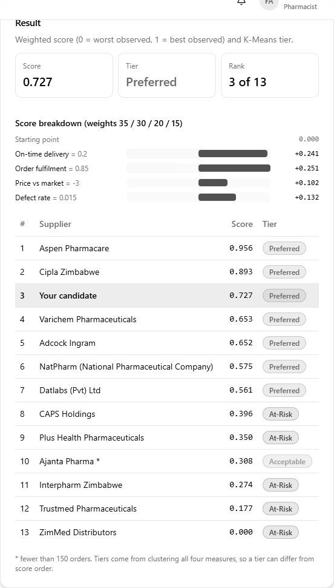
Figure 6.3: Scoring a candidate supplier in the Model Lab
There is no correct ranking to test a supplier score against. The model was therefore tested for consistency instead. An independent clustering method produced identical tiers, with an adjusted Rand index of 1.000. Changing the weights by up to 30% hardly moved the ranking. The mean correlation was 0.994. Figure 6.4 shows that the live system reproduces all twelve exported scores exactly.

Figure 6.4: Supplier scores recomputed live from 6,000 orders
Ho et al. (2010) noted that most supplier models rely on expert weights that are rarely tested. This study tested its weights and showed that the ranking does not depend on them. The results also raise a practical concern for PGH. Four medicines, including oral rehydration salts, are offered only by At-Risk suppliers. The pharmacy may need to qualify new suppliers for these items.

6.1.5 Objective 5: Flag Batches at Risk of Expiry
The fifth objective was an expiry risk module. The module compares how long a batch will last with its time to expiry. Batches are used earliest-expiry-first, in line with good pharmacy practice. Figure 6.5 shows a slow-moving batch being checked.
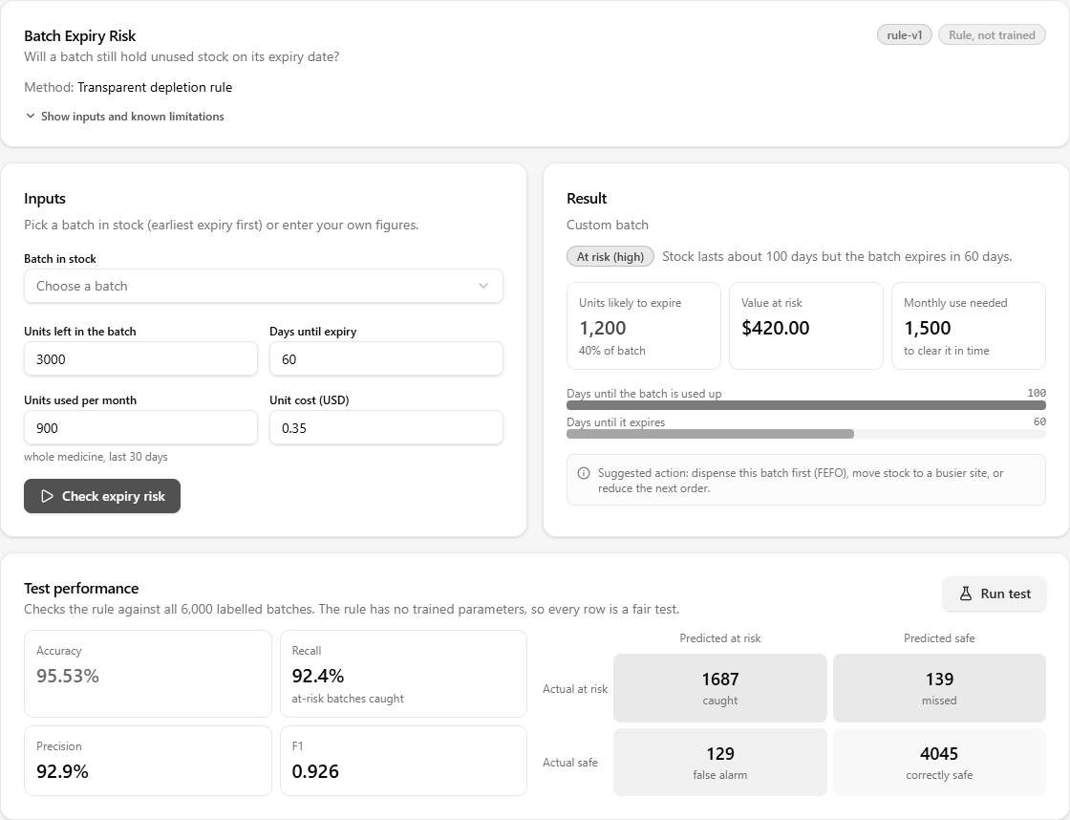
Figure 6.5: Expiry risk check and its test results
The batch in Figure 6.5 has 3,000 units and 60 days to expiry. At 900 units a month, it would take 100 days to use. About 1,200 units, worth USD 420, would therefore expire. Across 6,000 labelled batches, the rule agreed with 95.53% of the outcomes.
A Random Forest classifier was also trained for this task. On 560 unseen batches it scored an F1 of 0.946, against 0.951 for the rule. It also missed more at-risk batches. The rule was therefore kept. Machine learning should not replace a clear rule that works as well.

6.1.6 Objective 6: Integrate the Models into a Secure Web System
The sixth objective was to combine the models into one secure web system. The decision engine runs all four models for every medicine in about 1.5 seconds. It chooses a supplier, forecasts demand and sets the reorder point. It also removes stock that will expire. It then estimates the stockout risk and recommends an action. Figure 6.6 shows the full chain of reasoning for one recommendation.
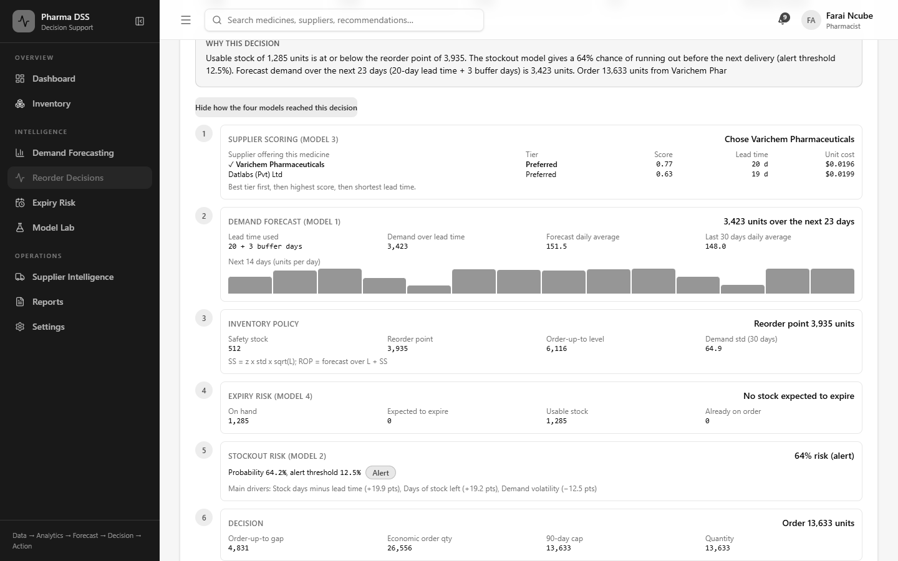
Figure 6.6: How the four models reached one reorder decision
This design follows Simon's (1960) model of decision making. The models carry out the intelligence and design phases. The pharmacist keeps the choice phase by approving or rejecting each order. Security is enforced on the server for every request. Figure 6.7 shows the reduced menu that a stores staff account receives.
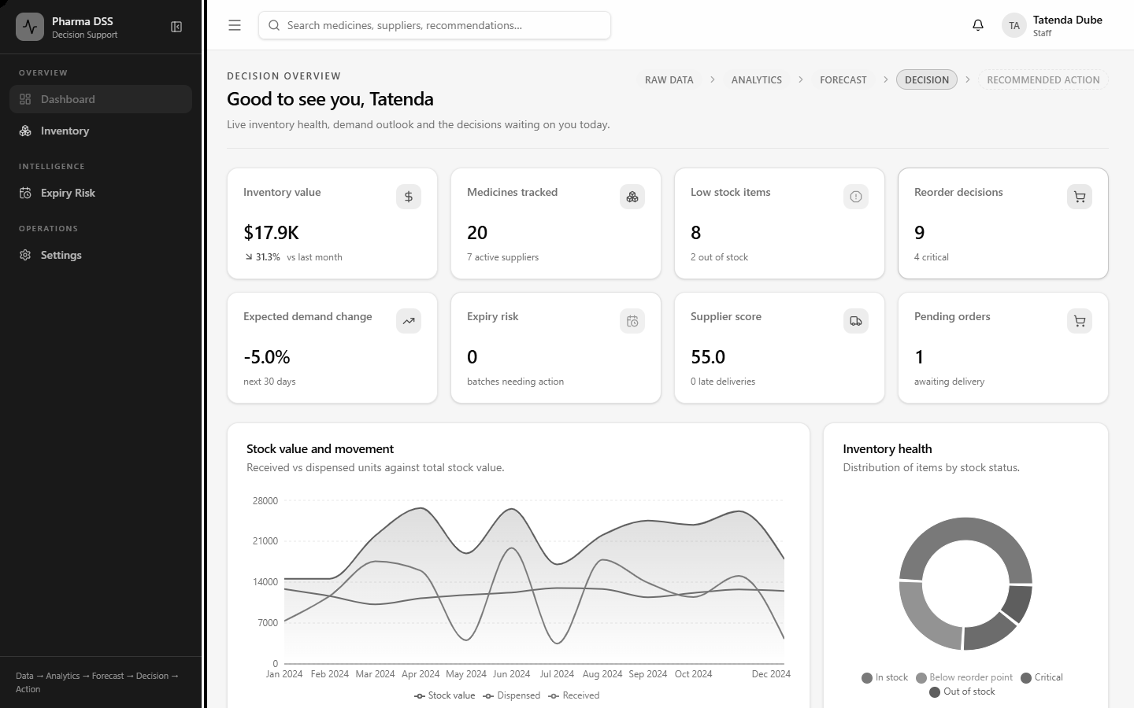
Figure 6.7: Role-based access for a stores staff account
The system also runs on the hospital network without internet access. Mugauri and Chimsimbe (2025) found that poor connectivity and power cuts limited Impilo in Zimbabwe. Designing for offline use addresses this local constraint directly.

6.1.7 Objective 7: Evaluate the System
The final objective was to evaluate the system with accuracy metrics and user acceptance testing. Table 6.3 summarises the technical evaluation reported in Chapter Five.
Test level | Tests | Passed
Automated backend tests | 35 | 35
Machine learning tests | 10 | 10
System functional tests | 14 | 14
Performance tests | 9 | 9
Table 6.3: Summary of the technical evaluation
Testing also found and fixed thirteen defects. The most serious was that login throttling had been configured but never switched on. Finding this before deployment shows the value of testing each claim against the running system.
User acceptance testing with PGH pharmacy staff is the remaining step. Its plan is set out in Section 5.2.7. Table 6.4 will record its results.
Measure | Result
Number of participants | [to be completed]
Tasks completed without help | [to be completed]
Participants rating the system useful or very useful | [to be completed]
Main suggestions from participants | [to be completed]
Table 6.4: User acceptance test results (to be completed after testing at PGH)
Until this testing is done, objective seven is only partly achieved.

6.1.8 Answers to the Research Questions
Research question | Answer from this study
RQ1: How does the pharmacy plan and order medicines? | Through periodic manual reviews of stock records. Five gaps were identified, pending staff confirmation.
RQ2: How accurately can ML forecast daily demand? | To within 21.3 units a day on average, 45.9% better than a naive forecast.
RQ3: Can a classifier detect stockout risk early enough to act? | Yes. It caught 80.2% of stockouts before the next delivery was due.
RQ4: How can suppliers be ranked fairly? | With a weighted score and clustering. The ranking was stable when weights changed.
RQ5: Can the models form one usable system? | Yes, technically. Acceptance by PGH staff is still to be tested.
Table 6.5: Answers to the research questions

6.2 Limitations and Constraints
Several limitations affect how far these results can be applied.
- Simulated data. Real PGH records were confidential, so the models were trained on simulated data. The results show what the system can do. They do not yet prove how it will perform at PGH.
- Short history. Only one year of demand data was available. The models could not learn how demand changes from year to year.
- Hidden demand. On stockout days, true demand was not recorded. The engine now ignores those days, but the true demand on them is still unknown.
- Forecast horizon. Accuracy was measured one day ahead. Longer forecasts feed predictions back in and are less certain.
- Few suppliers. Only twelve suppliers were scored, which limits the strength of the clustering results.
- Assumed costs. The ordering cost, holding cost and buffer days were assumptions. Real PGH figures may change the order sizes.
- User testing. Acceptance testing with PGH staff has not yet been carried out.
- Time and resources. The project had one academic year, a single developer and free cloud tools.
- Local conditions. Power cuts and slow internet affected development. The test laptop was also slow to start the server.
These limits do not undo the findings. They mean the results should be read as a tested proof of concept. A pilot on real PGH data must come before the system guides real orders.

6.3 Recommendations for Further Research
The following recommendations come directly from the experience of this project.
- Pilot the system on real PGH data. Retrain each model on two or more years of records. Then compare the results with this study.
- Record unmet demand. Staff could note how many patients were turned away during a stockout. This would reveal the demand that the current data hides.
- Add disease data. Malaria case reports from the national health information system could give earlier warning.
- Link to national systems. Links to eLMIS, Impilo and NatPharm would remove manual data loading. They would also support stock sharing.
- Retrain regularly. Models should be retrained monthly, or when live error rises 20% above the test error.
- Strengthen security. Multi-factor login for administrators and encrypted server disks should be added before full use.
- Send alerts by SMS. Critical alerts could reach pharmacists by text message. SMS for Life did this in Tanzania (Barrington et al., 2010).
- Train users continuously. Mbonane et al. (2023) found that training alone did not ensure good use of stock tools. Regular refresher sessions are needed.
- Confirm the cost-benefit estimates. Real PGH expiry and purchase records should test the savings estimated in Chapter Two.

6.4 Conclusion
This study aimed to help the PGH pharmacy make evidence-based stock decisions. It developed and tested an Intelligent Decision Support System with four decision models. The demand model cut forecast error by almost half. The stockout model catches four in five stockouts before the next delivery. The supplier model ranks suppliers in a stable and explainable way. The expiry rule flags batches that will not be used in time.
The study's main contribution is how these models work together. One decision engine turns their outputs into a clear action for each medicine. Every recommendation shows its reasons, and a pharmacist must approve it. The system runs on ordinary computers and works without internet access. These features suit the conditions in Zimbabwean public hospitals.
The study also showed the value of honest evaluation. A rule was kept where machine learning did not improve on it. Hidden demand on stockout days was found and corrected. A security weakness was found in testing and fixed before deployment.
Much remains to be done before the system can guide real orders at PGH. It must be tested with pharmacy staff and retrained on real hospital data. Even so, the results show that machine learning can help Zimbabwe's public pharmacies. It can reduce stockouts, cut waste and support better use of scarce funds. In this way, it supports Vision 2030 and reliable access to essential medicines.

References
Barrington, J., Wereko-Brobby, O., Ward, P., Mwafongo, W., & Kungulwe, S. (2010). SMS for Life: A pilot project to improve anti-malarial drug supply management in rural Tanzania using standard technology. Malaria Journal, 9, 298. https://doi.org/10.1186/1475-2875-9-298
Ho, W., Xu, X., & Dey, P. K. (2010). Multi-criteria decision making approaches for supplier evaluation and selection: A literature review. European Journal of Operational Research, 202(1), 16–24. https://doi.org/10.1016/j.ejor.2009.05.009
Makridakis, S., Spiliotis, E., & Assimakopoulos, V. (2022). M5 accuracy competition: Results, findings, and conclusions. International Journal of Forecasting, 38(4), 1346–1364. https://doi.org/10.1016/j.ijforecast.2021.11.013
Mbonane, H., Sibanda, M., Godman, B., Meyer, J. C., & Matlala, M. (2023). Knowledge, attitudes and practices of healthcare professionals on the use of an electronic stock visibility and management tool in a middle-income country: Implications for the future. Exploratory Research in Clinical and Social Pharmacy, 9, 100233.
Mbonyinshuti, F., Nkurunziza, J., Niyobuhungiro, J., & Kayitare, E. (2022). The prediction of essential medicines demand: A machine learning approach using consumption data in Rwanda. Processes, 10(1), 26. https://doi.org/10.3390/pr10010026
Mugauri, H. D., & Chimsimbe, M. (2025). Electronic health record systems in limited resource settings: A comprehensive evaluation of the Impilo platform. Acta Informatica Pragensia, 14(3), 393–407. https://doi.org/10.18267/j.aip.265
Saito, T., & Rehmsmeier, M. (2015). The precision-recall plot is more informative than the ROC plot when evaluating binary classifiers on imbalanced datasets. PLoS ONE, 10(3), e0118432. https://doi.org/10.1371/journal.pone.0118432
Silver, E. A., Pyke, D. F., & Thomas, D. J. (2017). Inventory and production management in supply chains (4th ed.). CRC Press.
Simon, H. A. (1960). The new science of management decision. Harper & Row.

