GREAT ZIMBABWE UNIVERSITY
FACULTY OF NATURAL SCIENCES
DEPARTMENT OF MATHEMATICS AND COMPUTER SCIENCE

NAME: MACDONALD K GUDO (M215524)
LEVEL: 4.2
PROGRAMME: BACHELOR OF SCIENCE HONOURS COMPUTER SCIENCE
COURSE CODE: HCS460
PROJECT TITLE: AN INTELLIGENT DECISION SUPPORT SYSTEM FOR PHARMACEUTICAL SUPPLY CHAIN OPTIMISATION: A CASE OF PARIRENYATWA GROUP OF HOSPITALS
SUPERVISOR: [SUPERVISOR'S NAME]
A dissertation submitted in partial fulfilment of the requirements for the Bachelor of Science Honours Degree in Computer Science.
[MONTH YEAR]

DECLARATION
I, Macdonald K. Gudo (M215524), declare that this dissertation is my own work. It was carried out under the guidance of my supervisor. It has not been submitted for any other degree at this or any other university. All sources of information have been acknowledged and cited in APA style.

Declaration on the use of AI tools
Section 3.1.2 of the project guidelines requires students to declare the use of AI tools. I declare that AI tools were used during this project. They helped with drafting and editing parts of this document. They also helped with parts of the software. I reviewed, tested and edited all such output. I take full responsibility for the content, the code and the results reported here.
Student: Macdonald K. Gudo Signature: ......................... Date: ..................
Supervisor: [Supervisor's name] Signature: ......................... Date: ..................

ACKNOWLEDGEMENT
First, I thank God Almighty for the strength and wisdom to finish this work. Without His grace, this work would not have been possible.
I am deeply grateful to my supervisor, [Supervisor's name], for patient guidance throughout the year. Your questions and corrections shaped this work at every stage.
I also thank the lecturers of the Department of Mathematics and Computer Science. The knowledge they shared over four years is the foundation of this project.
My thanks go to the staff of the Pharmacy Department at Parirenyatwa Group of Hospitals. Their daily work in difficult conditions inspired this study.
Finally, I thank my family for their prayers, sacrifice and constant support. I am also grateful to my classmates, whose ideas and encouragement kept me going.

ABSTRACT
Zimbabwe's public hospitals often run out of essential medicines. At the same time, other stock expires on the shelves. This study developed an Intelligent Decision Support System for this problem. The case study was the Pharmacy Department of Parirenyatwa Group of Hospitals. The study followed Design Science Research. CRISP-DM guided the models and Agile Scrum guided the software. Four decision models were trained in Google Colab on simulated data for 20 essential medicines. A Random Forest model forecasts daily demand. It cut forecast error by 45.9% compared with a naive method. A second Random Forest model predicts stockouts before the next delivery. It caught 80.2% of real stockouts, with a PR-AUC of 0.81. A weighted score with K-Means clustering places twelve suppliers into three stable tiers. A first-expiry-first-out rule flags batches likely to expire unused. It agreed with 95.5% of labelled outcomes and outperformed a trained classifier. A decision engine combines the four models into one reorder recommendation per medicine. Each recommendation explains its reasons and needs a pharmacist's approval. The system was built with Django, React and PostgreSQL. It runs on the hospital network without internet access. It passed 35 automated tests, 10 model tests and 14 system tests. Testing also found and fixed thirteen defects. User acceptance testing with hospital staff remains to be done. The study shows that machine learning can help Zimbabwean public pharmacies reduce stockouts and waste.
Keywords: decision support system, machine learning, demand forecasting, pharmaceutical supply chain, Zimbabwe

TABLE OF CONTENTS
DECLARATION i
ACKNOWLEDGEMENT ii
ABSTRACT iii
LIST OF ABBREVIATIONS xv
CHAPTER ONE: INTRODUCTION 1
1.0 Introduction 1
1.1 Background of the Organisation 1
1.1.1 Structure and Services 1
1.1.2 Goals of the Organisation 2
1.1.3 The Pharmacy Department 2
1.1.4 Operational Environment 2
1.2 Background to the Proposed System 3
1.2.1 The Current System 3
1.2.2 Gaps in the Current System 3
1.2.3 The Opportunity 3
1.3 Statement of the Problem 4
1.4 Aim and Objectives of the Proposed System 4
1.4.1 Aim 4
1.4.2 Objectives 4
1.4.3 Research Questions 5
1.5 Definitions of Key Terms and Concepts 5
1.6 Significance of the Study 6
1.6.1 To the PGH Pharmacy Department 6
1.6.2 To Patients 6
1.6.3 To MoHCC and NatPharm 6
1.6.4 To the Academic Community 6
1.6.5 To the Researcher 6
1.6.6 Alignment with National and Global Frameworks 6
1.7 Theoretical Framework and Conceptual Model 7
1.7.1 Simon's Model of Decision Making 7
1.7.2 Inventory Control Theory 7
1.7.3 Machine Learning Theory 8
1.7.4 Conceptual Model 8
1.8 Assumptions 9
1.9 Ethical Considerations 9
1.10 Methodology 10
1.10.1 Research Methodology 10
1.10.2 Software Development Methodology 11
1.10.3 Data Collection Tools and Techniques 12
1.10.4 Development Tools and Technologies 12
1.11 Scope and Limitations 13
1.11.1 Scope 13
1.11.2 Limitations 14
1.12 Project Timeline 14
1.13 Justification of the Project 16
1.14 Summary 16
CHAPTER TWO: LITERATURE REVIEW AND FEASIBILITY STUDY 17
2.0 Introduction 17
2.1 What Has Been Done Locally 17
2.1.1 The State of Zimbabwe's Medicine Supply Chain 17
2.1.2 From Push Systems to the Zimbabwe Assisted Pull System 18
2.1.3 Digital Health Systems in Zimbabwe 18
2.1.4 Regional Advances 18
2.1.5 Successes, Failures and Limitations of Local Efforts 19
2.1.6 Government Policies and Initiatives 20
2.2 What Has Been Done Globally 20
2.2.1 Optimising the Pharmaceutical Supply Chain 20
2.2.2 Machine Learning for Demand Forecasting 21
2.2.3 Predicting Stockouts and Backorders 21
2.2.4 Supplier Evaluation and Selection 21
2.2.5 Commercial and Hospital Systems 22
2.2.6 Challenges and Lessons Learned 22
2.2.7 Summary of Related Studies 22
2.3 What New Idea Is This Project Bringing? 23
2.3.1 Comparison with Existing Systems 23
2.3.2 Originality and Novelty 23
2.3.3 Potential Contributions 24
2.4 Feasibility Study of the Proposed System 24
2.4.1 Technical Feasibility 24
2.4.2 Operational Feasibility 25
2.4.3 Schedule Feasibility 26
2.4.4 Economic Feasibility 27
2.4.5 Threats to Security and Controls 29
2.5 Summary 30
CHAPTER THREE: METHODOLOGY 32
3.0 Introduction 32
3.1 Research Methodology 32
3.1.1 Research Philosophy and Design 32
3.1.2 Design Science Approach 32
3.1.3 Experimental-Based Approach 33
3.1.4 Quantitative Approach 34
3.1.5 Qualitative Approach 34
3.1.6 Population and Sampling 34
3.1.7 Data Collection Instruments 34
3.1.8 Datasets for Model Development 35
3.1.9 Data Preparation and Feature Engineering 35
3.1.10 Model Development 36
3.1.11 Data Analysis 37
3.2 Test Plan for the Proposed Model 37
3.2.1 Test Objectives 37
3.2.2 Test Environment 37
3.2.3 Test Data 38
3.2.4 Performance Metrics 38
3.2.5 Test Cases 39
3.2.6 Test Results 40
3.2.7 Bug and Issue Reporting 41
3.3 Ethical Considerations 42
3.3.1 Originality and Referencing 42
3.3.2 Use of AI Tools 42
3.3.3 Consent and Data Privacy 42
3.3.4 Bias and Fairness in AI Models 43
3.3.5 Environmental and Social Responsibility 43
3.4 Summary 43
CHAPTER FOUR: SYSTEM ANALYSIS AND DESIGN 44
4.0 Introduction 44
4.0.1 Requirements Summary 44
4.1 Functional Modeling 45
4.1.1 Context Diagram 45
4.1.2 Data Flow Diagram (Level 1) 46
4.2 System Modeling 47
4.2.1 Use Case Diagram 47
4.2.2 Sequence Diagrams 49
4.2.3 State Diagrams 50
4.2.4 Activity Diagram 51
4.2.5 Architectural Design 52
4.2.6 Component and Module Design 54
4.3 Data Modeling 55
4.3.1 Entity Relationship Diagram 55
4.3.2 Class Diagram 56
4.3.3 Database Design 57
4.4 Interface Design 59
4.4.1 Design Principles 59
4.4.2 Pseudocode for Core Components 64
4.5 Security Design 66
4.5.1 Password Hashing 66
4.5.2 Data Encryption 66
4.5.3 Authentication and Authorisation Logic 66
4.5.4 User Access Roles 67
4.5.5 Secure Storage and Integrity 67
4.6 Hardware Design 67
4.7 Summary 68
CHAPTER FIVE: CODING AND TESTING 69
5.0 Introduction 69
5.1 Coding 69
5.1.1 Development Environment 69
5.1.2 Building the Machine Learning Models 69
5.1.3 Training and Testing the Expiry Model 70
5.1.4 Backend Implementation 70
5.1.5 Integrating the Models 71
5.1.6 Frontend Implementation 72
5.2 Testing 73
5.2.1 Testing Approach 73
5.2.2 Automated Unit and Integration Tests 73
5.2.3 Model Testing 73
5.2.4 System Functional Testing 75
5.2.5 Performance Testing 91
5.2.6 Defects Found and Fixed 91
5.2.7 User Acceptance Testing 92
5.3 Summary 93
CHAPTER SIX: RESULTS AND DISCUSSIONS 94
6.0 Introduction 94
6.1 Achievement of Objectives 94
6.1.1 Objective 1: Analyse Current Inventory and Procurement Practices 94
6.1.2 Objective 2: Forecast Daily Medicine Demand 95
6.1.3 Objective 3: Predict Stockout Risk 97
6.1.4 Objective 4: Score and Tier Suppliers 98
6.1.5 Objective 5: Flag Batches at Risk of Expiry 100
6.1.6 Objective 6: Integrate the Models into a Secure Web System 101
6.1.7 Objective 7: Evaluate the System 103
6.1.8 Answers to the Research Questions 104
6.2 Limitations and Constraints 104
6.3 Recommendations for Further Research 105
6.4 Conclusion 106
REFERENCES 107

LIST OF FIGURES
Figure 1.1: Conceptual model of the proposed IDSS (adapted from Simon, 1960) 8
Figure 1.2: Gantt chart showing the critical path of the project 15
Figure 2.1: Project Gantt chart showing concurrency and sequencing of tasks 27
Figure 4.1: Context diagram of the proposed system 46
Figure 4.2: Level 1 data flow diagram 47
Figure 4.3: Use case diagram 48
Figure 4.4: Sequence diagram for user login 49
Figure 4.5: Sequence diagram for running the decision engine and approving a reorder 50
Figure 4.6: State diagrams for (a) a recommendation and (b) a purchase order 51
Figure 4.7: Activity diagram for the reorder decision 52
Figure 4.8: System architecture 53
Figure 4.9: Component diagram 54
Figure 4.10: Entity relationship diagram 56
Figure 4.11: Class diagram 57
Figure 4.12: Login screen 60
Figure 4.13: Dashboard showing key indicators and decision intelligence 61
Figure 4.14: Inventory screen with model-based reorder points 62
Figure 4.15: Model Lab screen for the demand forecasting model 63
Figure 4.16: Reorder Decisions screen with the decision engine 64
Figure 5.1: Live re-test of the stockout model in the Model Lab 75
Figure 5.2: ST-02, login rejected with a wrong password 77
Figure 5.3: ST-01, dashboard after a successful login 78
Figure 5.4: ST-03, repeated login attempts blocked 79
Figure 5.5: ST-05, reduced menu for the stores staff role 80
Figure 5.6: ST-06, demand forecast with model details 81
Figure 5.7: ST-12, a medicine with no history 82
Figure 5.8: Decision engine results before the what-if dispense 84
Figure 5.9: ST-07, Paracetamol moves into the risk zone after dispensing 84
Figure 5.10: ST-13, a negative quantity is rejected 85
Figure 5.11: The four-model decision chain for a recommendation 86
Figure 5.12: ST-08, recommendation approved and recorded 86
Figure 5.13: ST-09, supplier performance page 87
Figure 5.14: ST-10, expiry risk page 88
Figure 5.15: ST-11, inventory report generated and downloaded 89
Figure 5.16: Stockout risk for Coartem before the what-if change 90
Figure 5.17: Stockout risk for Coartem after adding 5,000 units 90
Figure 6.1: Demand model re-tested on unseen data in the Model Lab 96
Figure 6.2: Stockout risk for Coartem, with the reasons behind it 97
Figure 6.3: Scoring a candidate supplier in the Model Lab 100
Figure 6.4: Supplier scores recomputed live from 6,000 orders 100
Figure 6.5: Expiry risk check and its test results 101
Figure 6.6: How the four models reached one reorder decision 102
Figure 6.7: Role-based access for a stores staff account 103

LIST OF TABLES
Table 0.1: List of abbreviations xv
Table 1.1: Definitions of key terms and concepts 5
Table 1.2: Design Science Research steps applied to this study 10
Table 1.3: Data collection tools and techniques 12
Table 1.4: Development tools and technologies 13
Table 1.5: Project tasks, durations, dependencies and slack 15
Table 2.1: Summary of related studies 23
Table 2.2: Comparison of existing systems with the proposed IDSS 23
Table 2.3: Technical resources required 25
Table 2.4: Estimated costs of the proposed system 28
Table 2.5: Estimated yearly benefits of the proposed system 28
Table 2.6: Three-year cash flow and NPV at a 12% discount rate 29
Table 2.7: Security threats and controls 30
Table 3.1: Research approaches mapped to research questions 32
Table 3.2: Data collection instruments 35
Table 3.3: Datasets used for model development 35
Table 3.4: Candidate models for each decision task 36
Table 3.5: Test environment 38
Table 3.6: Performance metrics 38
Table 3.7: Machine learning test cases 39
Table 3.8: System test cases 39
Table 3.9: Model 1 results on the held-out test set 40
Table 3.10: Model 2 results on the held-out test set 40
Table 3.11: Issue log from model development 42
Table 4.1: Functional requirements 44
Table 4.2: Non-functional requirements 45
Table 4.3: Use case description for running the decision engine 49
Table 4.4: Module responsibilities 55
Table 4.5: MEDICINE table 57
Table 4.6: BATCH table 58
Table 4.7: DAILY_DEMAND table 58
Table 4.8: RECOMMENDATION table 58
Table 4.9: PURCHASE_ORDER table 59
Table 4.10: Role permission matrix 67
Table 5.1: Expiry classifier compared with the depletion rule on 560 test batches 70
Table 5.2: Automated backend tests 73
Table 5.3: Machine learning test results 74
Table 5.4: System test results 76
Table 5.5: Performance test results 91
Table 5.6: Defect log 92
Table 5.7: User acceptance test plan 92
Table 6.1: Summary of objectives and their achievement 94
Table 6.2: Gaps in the current system and the features that address them 95
Table 6.3: Summary of the technical evaluation 103
Table 6.4: User acceptance test results (to be completed after testing at PGH) 104
Table 6.5: Answers to the research questions 104

LIST OF ABBREVIATIONS
Abbreviation | Meaning
AI | Artificial Intelligence
API | Application Programming Interface
ARI | Adjusted Rand Index
ARV | Antiretroviral
CRISP-DM | Cross-Industry Standard Process for Data Mining
CSV | Comma-Separated Values
DFD | Data Flow Diagram
DSR | Design Science Research
DSS | Decision Support System
EHR | Electronic Health Record
eLMIS | Electronic Logistics Management Information System
EOQ | Economic Order Quantity
ERD | Entity Relationship Diagram
FEFO | First Expiry, First Out
IDSS | Intelligent Decision Support System
JWT | JSON Web Token
MAE | Mean Absolute Error
MAPE | Mean Absolute Percentage Error
MCAZ | Medicines Control Authority of Zimbabwe
ML | Machine Learning
MoHCC | Ministry of Health and Child Care
NatPharm | National Pharmaceutical Company of Zimbabwe
NDS1 | National Development Strategy 1
NPV | Net Present Value
PGH | Parirenyatwa Group of Hospitals
PR-AUC | Area Under the Precision-Recall Curve
REST | Representational State Transfer
RMSE | Root Mean Squared Error
ROC-AUC | Area Under the Receiver Operating Characteristic Curve
ROI | Return on Investment
ROP | Reorder Point
SDG | Sustainable Development Goal
SHAP | SHapley Additive exPlanations
TB | Tuberculosis
UAT | User Acceptance Testing
UML | Unified Modeling Language
ZAPS | Zimbabwe Assisted Pull System
Table 0.1: List of abbreviations

CHAPTER ONE: INTRODUCTION

1.0 Introduction
Medicines save lives only when they are on the shelf at the right time. A hospital pharmacy must therefore plan its stock with great care. It must order enough to meet patient demand. Yet it must not buy so much that stock expires before use. Getting this balance right is hard in Zimbabwe's public hospitals. Budgets are tight, lead times are long and demand shifts with the seasons.
This study is based at Parirenyatwa Group of Hospitals (PGH) in Harare. It focuses on the hospital's Pharmacy Department. The department keeps computer records of its stock. However, these records mostly describe what has already happened. They do not tell managers what is likely to happen next. Choices on what to order, how much, and from whom still rest on experience. This study proposes an Intelligent Decision Support System (IDSS) to close this gap. The system uses machine learning to forecast demand and flag stockout risk. It also scores suppliers and points out batches likely to expire unused.
This chapter opens with the background of the organisation. It then explains the current system and the problem it creates. The aim, objectives and research questions follow. Key terms, significance, theory, assumptions and ethics are then covered. The chapter closes with the methodology, scope, timeline and justification.

1.1 Background of the Organisation
Parirenyatwa Group of Hospitals is the largest referral hospital in Zimbabwe. It is a public institution located in Harare. The hospital falls under the Ministry of Health and Child Care (MoHCC). A Hospital Management Board oversees its day-to-day running. The group is named after Dr Tichafa Samuel Parirenyatwa. He is remembered as the first Black Zimbabwean to qualify as a medical doctor.

1.1.1 Structure and Services
PGH is not one building but a group of units. These include the main hospital and Mbuya Nehanda Maternity Hospital. Sekuru Kaguvi Eye Unit, a psychiatric unit and a radiotherapy centre are also included. The group is the main teaching hospital for the University of Zimbabwe medical school. Clinics and district hospitals across the country refer patients to it. As a result, PGH treats a very wide range of conditions. These run from malaria and tuberculosis to HIV, diabetes and hypertension.

1.1.2 Goals of the Organisation
Like other central hospitals, PGH has three broad goals. First, it provides specialist care that lower-level facilities cannot offer. Second, it trains doctors, nurses, pharmacists and other health workers. Third, it supports medical research that informs national health policy. Each of these goals depends on a steady supply of safe and affordable medicines.

1.1.3 The Pharmacy Department
The Pharmacy Department is the focus of this study. It supplies medicines to wards, specialist clinics and outpatient services. Its core tasks are procurement, receiving, storage, stock control and dispensing. It also advises clinicians on the safe and rational use of medicines. Senior pharmacists lead the department. They work with pharmacy technicians, stores clerks and procurement officers. Every week, staff must decide which items to reorder and in what quantity.

1.1.4 Operational Environment
Most medicines reach PGH through the National Pharmaceutical Company of Zimbabwe (NatPharm). NatPharm is the state body that buys, stores and distributes medicines to public facilities. When NatPharm is out of stock, the hospital turns to other registered suppliers. These include local manufacturers such as CAPS, Varichem and Datlabs. Some products come from regional importers in South Africa and India. All products must be registered by the Medicines Control Authority of Zimbabwe (MCAZ).
The operating environment is far from easy. Foreign currency shortages often delay imports and push up prices. Supplier lead times can stretch to several weeks. Demand for antimalarials climbs sharply during the rainy season. Programme medicines such as antiretrovirals (ARVs) must never run out. A missed dose can harm the patient and weaken long-term treatment. At the same time, power cuts and network outages disrupt computer work. Any new system must therefore be light, reliable and simple to use.

1.2 Background to the Proposed System

1.2.1 The Current System
At present, the pharmacy tracks stock with stock cards, ledgers and spreadsheets. Summary reports also feed into the national electronic Logistics Management Information System (eLMIS). In addition, public hospitals are adopting Impilo, the national electronic health record (EHR). These tools are a clear step up from paper alone. Staff can now see balances, receipts and issues much faster.
Even so, the current tools are transactional in nature. They store what has already taken place. They do not study past consumption to estimate future demand. Reorders are decided during periodic stock reviews. A pharmacist checks recent issues and then settles on an order quantity. This depends heavily on personal judgement. It also takes many hours when hundreds of items need review. When an experienced officer is away, the quality of decisions can drop.

1.2.2 Gaps in the Current System
A review of the current process reveals five main gaps.
- No demand forecasting. Seasonal peaks, such as malaria cases, are noticed late.
- No early stockout warning. Risk is seen only when shelves are nearly empty.
- No objective supplier rating. Late or short deliveries are not turned into scores.
- Weak expiry tracking. Slow-moving batches are often found just before they expire.
- No link from data to action. Reports exist, but they do not recommend anything.

1.2.3 The Opportunity
Artificial intelligence (AI) offers a practical way to fill these gaps. Machine learning models can learn patterns from past stock transactions. They can then estimate future demand and the chance of a stockout. Scoring models can rank suppliers on reliability, quality and price. A web dashboard can bring these results together for pharmacists. The pharmacist still makes the final call. The system simply backs that call with evidence. This approach fits Education 5.0 and the Fourth Industrial Revolution (4IR) agenda. It also supports Vision 2030 (Government of Zimbabwe, 2018) and NDS1 (Government of Zimbabwe, 2020).

1.3 Statement of the Problem
The PGH Pharmacy Department suffers repeated stockouts of key medicines. At the same time, other medicines expire on the shelves before they are used. Both problems waste scarce public funds and put patients at risk. The current records do not forecast demand or warn of coming shortages. They also fail to rate suppliers or flag batches at risk of expiry. Pharmacists therefore make ordering decisions by hand, using experience and old reports. This is slow and hard to apply across hundreds of medicines. It also copes poorly with seasonal demand and uncertain supplier lead times. There is a need for a system that turns pharmacy data into timely recommendations.

1.4 Aim and Objectives of the Proposed System

1.4.1 Aim
The aim of this study is to develop an Intelligent Decision Support System. The system will improve medicine supply chain decisions at the PGH Pharmacy Department.

1.4.2 Objectives
The specific objectives of the study are:
1. To analyse current inventory and procurement practices at the PGH Pharmacy Department.
2. To develop a machine learning model that forecasts daily demand for each medicine.
3. To develop a classification model that predicts stockout risk before the next delivery.
4. To design a supplier performance scoring model using weighted scoring and clustering.
5. To develop an expiry risk module that flags batches likely to expire unused.
6. To integrate the models into a secure web-based system with role-based dashboards.
7. To evaluate the system using model accuracy metrics and user acceptance testing.

1.4.3 Research Questions
The study seeks to answer the following questions:
1. How does the PGH pharmacy currently plan and order its medicines?
2. How accurately can machine learning forecast daily medicine demand?
3. Can a classifier detect stockout risk early enough for staff to act?
4. How can suppliers be ranked fairly on delivery, quality and cost?
5. How can these models be combined into one system that pharmacists accept?

1.5 Definitions of Key Terms and Concepts
Table 1.1 explains the main terms used in this document.
Term | Meaning in this study
Decision Support System (DSS) | A computer system that helps managers make better choices. It does not replace them.
Intelligent DSS (IDSS) | A DSS that adds AI or machine learning to analyse data and suggest actions.
Pharmaceutical supply chain | All steps that move a medicine from maker to patient.
Machine learning (ML) | A branch of AI where computers learn patterns from data.
Demand forecasting | Estimating how much of a medicine will be used in a future period.
Stockout | A situation where a medicine is needed but none is in stock.
Lead time | The number of days between placing an order and receiving it.
Safety stock | Extra stock kept to cover sudden demand or late deliveries.
Reorder point (ROP) | The stock level at which a new order should be placed.
Economic Order Quantity (EOQ) | The order size that keeps ordering and holding costs lowest.
Expiry risk | The chance that a batch will pass its expiry date before it is used.
Random Forest | An ML method that combines many decision trees to give one prediction.
K-Means clustering | An ML method that sorts similar items into a set number of groups.
Mean Absolute Error (MAE) | The average size of forecast errors, in units of medicine.
PR-AUC | A score from 0 to 1 showing how well a model finds rare events.
Electronic Health Record (EHR) | A digital version of a patient's health record. Impilo is Zimbabwe's national EHR.
REST API | A standard way for the web screens to request data from the server.
JSON Web Token (JWT) | A signed digital pass that proves a user has logged in.
Table 1.1: Definitions of key terms and concepts

1.6 Significance of the Study

1.6.1 To the PGH Pharmacy Department
The system gives pharmacists a clear, daily view of stock risk. It shows which medicines to reorder, how much to order and from whom. Stock reviews that take hours could be done in minutes. Fewer stockouts mean fewer emergency purchases at high prices. Fewer expiries mean less money lost to destroyed stock.

1.6.2 To Patients
Patients are the final beneficiaries. Better stock planning means medicines are there when prescribed. Patients on ARVs and TB treatment can keep to their regimens without breaks. Families also spend less buying medicines from private pharmacies.

1.6.3 To MoHCC and NatPharm
Forecasts from central hospitals can improve national quantification. NatPharm could plan its own purchases with better demand signals. The ministry could also use supplier scores to guide tender decisions.

1.6.4 To the Academic Community
The study adds local evidence on machine learning in health supply chains. Most published work comes from high-income countries. This project shows how such tools can work under Zimbabwean conditions. Future students can build on its models, datasets and methods.

1.6.5 To the Researcher
The project lets the researcher apply skills gained during the degree. These include software engineering, databases, web development and machine learning. It also builds research and writing skills needed in industry.

1.6.6 Alignment with National and Global Frameworks
The study supports Vision 2030 and NDS1, which both prioritise health and digital growth. It contributes to Sustainable Development Goal 3 on good health (United Nations, 2015). It also supports SDG 9 on industry, innovation and infrastructure. Finally, it links to Aspiration 1 of Agenda 2063 (African Union Commission, 2015). That aspiration calls for healthy and well-nourished citizens.

1.7 Theoretical Framework and Conceptual Model
Three bodies of theory guide the design of the system. These are decision-making theory, inventory control theory and machine learning theory.

1.7.1 Simon's Model of Decision Making
Simon (1960) describes decision making in three phases. The first is intelligence, where the decision maker spots a problem. The second is design, where possible solutions are developed. The third is choice, where one option is selected. Power (2002) shows that a DSS can support each of these phases. In this study, the ML engine supports the intelligence phase. It detects rising demand, stockout risk and expiry risk early. The decision models support the design phase by proposing order options. The pharmacist then makes the choice by approving or rejecting each recommendation.

1.7.2 Inventory Control Theory
Classic inventory theory tells a store when to order and how much. The reorder point is the stock level that triggers an order (Silver et al., 2017). It is found with the formula below.
ROP = (d × L) + SS
Here d is the average daily demand and L is the lead time in days. SS is the safety stock, which covers uncertainty in demand. Safety stock is found as follows.
SS = z × σd × √L
In this formula, z is the service level factor. The symbol σd is the standard deviation of daily demand. The order size comes from the Economic Order Quantity model (Harris, 1913).
EOQ = √(2DS / H)
D is the annual demand and S is the cost of placing one order. H is the cost of holding one unit for a year. Traditional systems use simple averages for d. This study replaces the average with an ML forecast. This allows the reorder point to rise and fall with seasons and trends.

1.7.3 Machine Learning Theory
The study uses both supervised and unsupervised learning. In supervised learning, a model learns from examples with known answers. Demand forecasting is a regression task because the answer is a number. Stockout risk is a classification task because the answer is yes or no. Both tasks use Random Forest, which combines many decision trees (Breiman, 2001). In unsupervised learning, there is no known answer to learn from. Supplier tiers are therefore found with K-Means clustering. SHAP values are used to explain which inputs drive each prediction (Lundberg & Lee, 2017).

1.7.4 Conceptual Model
Figure 1.1 brings these theories together. Pharmacy data flows into the data layer and then into the ML engine. The engine feeds the decision models, which produce recommendations. The pharmacist reviews each one before any order is placed. New data from each cycle is used to retrain the models.
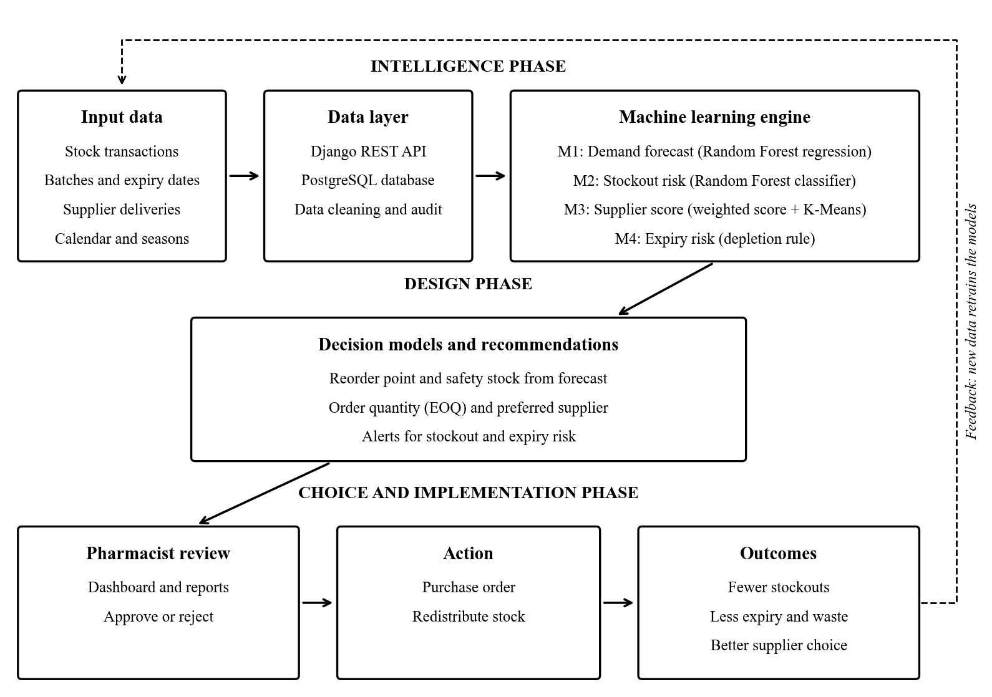
Figure 1.1: Conceptual model of the proposed IDSS (adapted from Simon, 1960)

1.8 Assumptions
The study is based on the following assumptions:
- Past consumption patterns are a fair guide to demand in the near future.
- Stock records captured by pharmacy staff are accurate and up to date.
- Suppliers will behave in future much as they have in the past.
- The hospital will provide computers and a stable local network.
- Pharmacists will review each recommendation before placing an order.
- Users have basic computer skills and can use a web browser.
- The simulated training data captures the main demand patterns found at PGH.

1.9 Ethical Considerations
Health data is sensitive, so the study follows clear ethical rules.
- Permission. Written approval will be sought from PGH management and the university first.
- Informed consent. Each participant will read a consent note before the questionnaire. Taking part is voluntary, and anyone may withdraw.
- Anonymity. No names or staff numbers will be recorded in the questionnaire.
- Confidentiality. The system stores medicine data only. It holds no patient names or diagnoses.
- Data protection. The study follows the Cyber and Data Protection Act (Government of Zimbabwe, 2021). Passwords are hashed and access is controlled by user role.
- Honest use of data. The models were trained on simulated data. Supplier scores are illustrations, not real judgements of any company.
- Fairness. Model accuracy is checked for each medicine category. Weak spots are reported openly.
- Human oversight. The system never places an order on its own. A pharmacist must approve every action.
- Use of AI tools. Any AI writing or coding aid will be declared, as the project guide requires.
- Originality. All sources are cited in APA style, and the work is checked with Turnitin.

1.10 Methodology
This section explains how the research was carried out. It also covers how the software was built and which tools were used.

1.10.1 Research Methodology
The study follows the Design Science Research (DSR) approach. DSR builds and tests an artefact that solves a real problem (Hevner et al., 2004). Here, the artefact is the IDSS. The six DSR steps of Peffers et al. (2007) were followed. Table 1.2 shows how each step was applied.
DSR step | Activity in this study
1. Identify the problem | Study stockouts, expiries and manual ordering at PGH pharmacy.
2. Define objectives | Set the seven objectives listed in Section 1.4.2.
3. Design and develop | Train four models in Colab. Build the Django and React system.
4. Demonstrate | Run the system with pharmacy data and sample reorder scenarios.
5. Evaluate | Measure model accuracy. Run user acceptance tests with pharmacy staff.
6. Communicate | Present the results in this dissertation and at the viva.
Table 1.2: Design Science Research steps applied to this study
Within DSR, a mixed methods design was used. The qualitative part explores how staff plan and order medicines. It answers research question one. The quantitative part is experimental. It tests how well each model performs on held-out data. It answers research questions two to four. The final question is answered through system testing and user feedback.
The machine learning work followed the CRISP-DM process (Wirth & Hipp, 2000). Its six stages are business understanding, data understanding and data preparation. These are followed by modelling, evaluation and deployment. Each dataset was first audited for missing values, duplicates and impossible values. Data was then split by date into training, validation and test sets. A 70, 15 and 15 percent split was used. The split was never shuffled, so no future data leaked into training. Five-fold time-series cross-validation then confirmed the ranking of models.
Several candidate models were compared for each task. For demand, these were a naive baseline, SARIMA and Linear Regression. Random Forest was also tested. So were XGBoost (Chen & Guestrin, 2016) and LightGBM (Ke et al., 2017). Forecasts were judged by MAE, RMSE and MAPE. For stockout risk, Logistic Regression, Random Forest, XGBoost and LightGBM were compared. Only about one check in ten was a stockout. Accuracy alone would therefore mislead. Precision, recall, F1 score and PR-AUC were used instead (Saito & Rehmsmeier, 2015). The best model was tuned with Optuna (Akiba et al., 2019). It was kept only if it beat the untuned version on the test set.

1.10.2 Software Development Methodology
The system was built using the Agile Scrum method (Schwaber & Sutherland, 2020). Work was split into two-week sprints. Each sprint delivered a working part of the system. The supervisor acted as the product owner and reviewed each sprint. Pharmacy staff gave feedback on screens as they were built.
The life cycle phases were applied within each sprint as follows.
- Requirements gathering. Needs were collected through questionnaires, interviews and observation. They were written as user stories in a product backlog.
- Design. Each sprint began with design of the screens, database tables and API endpoints involved.
- Implementation. Models were coded in Google Colab. The backend used Django and the frontend used React.
- Testing. Unit and integration tests ran at the end of each sprint. User acceptance testing followed the final sprint.
- Deployment. The system runs as a web application on the hospital network.
- Maintenance. Models are versioned, so a better model can replace an old one safely.
Agile suits this project for four reasons. First, ML work is experimental, and results often change the plan. Second, user needs became clearer only after staff saw early screens. Third, a working version was always ready to show the supervisor. Fourth, the Waterfall model was rejected because it handles change poorly. In Waterfall, a late change to requirements is slow and costly.

1.10.3 Data Collection Tools and Techniques
Data for this study came from people and from records. Table 1.3 lists the tools used.
Tool | How it is used | Type of data
Questionnaire (Google Forms) | Sent online to pharmacists, technicians and stores staff. | Quantitative and qualitative
Semi-structured interviews | Face-to-face talks with senior pharmacists and procurement officers. | Qualitative, unstructured
Observation | Watching stock reviews, receiving and dispensing in the pharmacy. | Qualitative
Document review | Studying stock cards, delivery notes, requisitions and expiry records. | Quantitative, structured
Transaction datasets | Daily demand, reorder checks, supplier orders and batch records. | Quantitative, structured
System logs | Usage and error logs captured during testing. | Quantitative, structured
Table 1.3: Data collection tools and techniques
Purposive sampling was used to select respondents. Only staff who handle medicine stock were included. Their knowledge is directly relevant to the problem.
Real dispensing records could not be released because of confidentiality rules. A structured, simulated dataset was therefore built for model training. It was shaped around 20 essential medicines on the hospital's list. It also reflects Zimbabwe's rainy, cold and transition seasons. The demand file holds 7,320 daily records for the year 2024. The reorder file holds 6,000 risk checks. The supplier file holds 6,000 orders from 12 suppliers. A further 6,000 batch records support the expiry module.
Several steps were taken to keep the data reliable and valid.
- The questionnaire was pilot tested with three people before release.
- The same interview guide was used with every respondent.
- Results from questionnaires, interviews and records were compared to confirm findings.
- Each dataset was audited for gaps, duplicates and impossible values before modelling.
- Models were tested only on data they had never seen during training.

1.10.4 Development Tools and Technologies
Table 1.4 lists the tools used to build the system.
Category | Tool or technology | Purpose
ML environment | Google Colab, Python 3 | Free cloud notebooks for training models.
Data handling | pandas, NumPy | Loading, cleaning and shaping data.
ML libraries | scikit-learn, XGBoost, LightGBM, statsmodels | Training and comparing models.
Tuning and explanation | Optuna, SHAP | Tuning settings and explaining predictions.
Visualisation | Matplotlib, Seaborn, Recharts | Charts in notebooks and on dashboards.
Model storage | joblib, JSON metadata | Saving versioned model files for the backend.
Backend | Django 5.2, Django REST Framework | Business logic and REST API.
Security | Simple JWT, role-based permissions | Login, tokens and access control.
Database | PostgreSQL (SQLite in development) | Storing medicines, stock, suppliers and results.
Reports | ReportLab | Producing PDF reports.
Frontend | React 19, TypeScript, Vite | Building the user interface.
UI and data fetching | TanStack Router and Query, Tailwind CSS, shadcn/ui | Pages, styling and server data.
Version control | Git, GitHub, Lovable | Tracking code changes and backups.
Editor and diagrams | Visual Studio Code, draw.io | Writing code and drawing UML diagrams.
Table 1.4: Development tools and technologies

1.11 Scope and Limitations

1.11.1 Scope
The system covers the main stores and dispensary of the PGH Pharmacy Department. It includes the following modules:
- User login with four roles: administrator, manager, pharmacist and staff.
- Medicine and inventory records, including batches and stock movements.
- Demand forecasting for each medicine.
- Stockout risk alerts and reorder recommendations with suggested quantities.
- Supplier performance scores and tiers.
- Expiry risk monitoring for batches.
- Dashboards, notifications, PDF and CSV reports, and an audit trail.
Some areas fall outside the scope. The system does not handle patient records or prescriptions. It does not make payments or send orders to suppliers automatically. Direct links to eLMIS, Impilo and NatPharm are left for future work. A mobile app and IoT sensors are also not included.

1.11.2 Limitations
- Data access. Real records were confidential, so models were trained on simulated data. Results must be confirmed with live hospital data.
- Short history. One year of demand data limits how well yearly seasons are learned.
- Hidden demand. On stockout days, true demand is unknown because nothing could be issued.
- Few suppliers. Only 12 suppliers were scored, which limits the clustering results.
- Time. The project had to fit within one academic year.
- Resources. Training used the free tier of Google Colab, which limits computing power.
- User availability. Busy pharmacy staff had limited time for interviews and testing.
- Power and network. Load shedding and slow internet affected some development work.

1.12 Project Timeline
The project runs for 34 weeks, from 3 August 2026 to 26 March 2027. Table 1.5 lists each task, its length and the tasks it depends on. Slack is the number of weeks a task can slip without delaying the project.
ID | Task | Weeks | Depends on | Start | End | Slack (wks)
A | Proposal and topic approval | 3 | - | 03 Aug 2026 | 21 Aug 2026 | 0
B | Requirements gathering at PGH | 2 | A | 24 Aug 2026 | 04 Sep 2026 | 4
C | Literature review | 6 | A | 24 Aug 2026 | 02 Oct 2026 | 0
D | Data preparation and audit | 2 | B | 07 Sep 2026 | 18 Sep 2026 | 8
E | ML model training and evaluation | 5 | D | 21 Sep 2026 | 23 Oct 2026 | 8
F | System analysis and design | 4 | B,C | 05 Oct 2026 | 30 Oct 2026 | 0
G | Backend development (Django) | 7 | F | 02 Nov 2026 | 18 Dec 2026 | 0
H | Frontend development (React) | 7 | F | 02 Nov 2026 | 18 Dec 2026 | 3
I | Model integration | 3 | E,G | 21 Dec 2026 | 08 Jan 2027 | 0
J | Testing and user acceptance | 4 | I,H | 11 Jan 2027 | 05 Feb 2027 | 0
K | Final documentation | 4 | J | 08 Feb 2027 | 05 Mar 2027 | 0
L | Submission and viva preparation | 3 | K | 08 Mar 2027 | 26 Mar 2027 | 0
Table 1.5: Project tasks, durations, dependencies and slack
Figure 1.2 shows the same plan as a Gantt chart. Black bars mark critical tasks. Hatched bars mark tasks that have some slack.
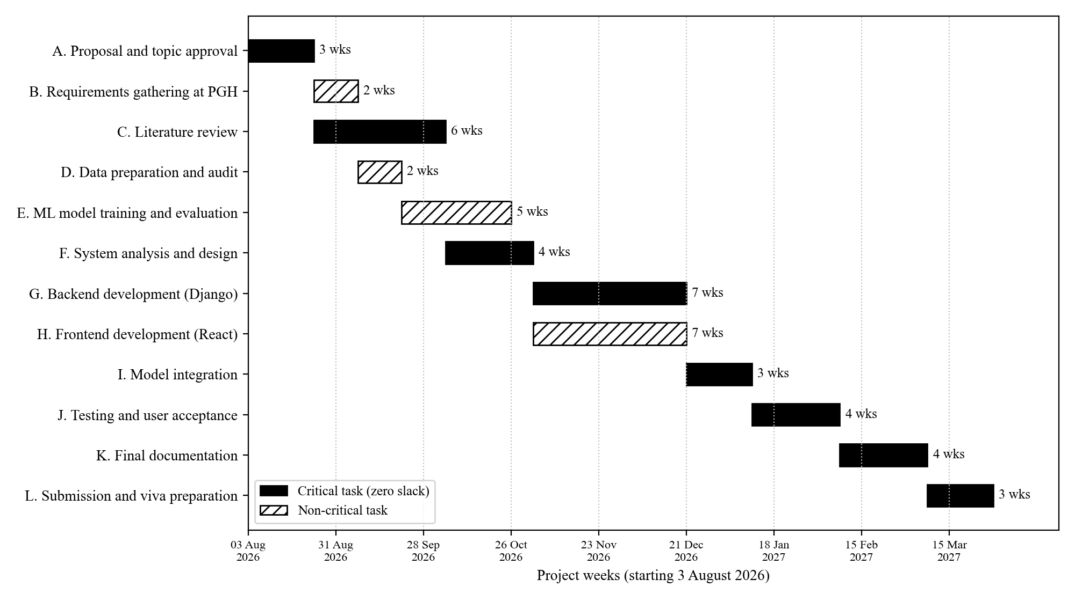
Figure 1.2: Gantt chart showing the critical path of the project
The critical path is A, C, F, G, I, J, K and L. These tasks have zero slack and add up to 34 weeks. A delay in any one of them delays the whole project. Requirements gathering has four weeks of slack. Data preparation and model training share eight weeks of slack. Frontend work has three weeks of slack, as it runs alongside the backend. Close attention was therefore given to the literature review, design and backend work.

1.13 Justification of the Project
Stockouts and expiries both drain the limited budget of a public hospital. A stockout forces emergency buying at higher prices. Worse still, it can interrupt life-saving treatment. An expired batch is money lost and must also be safely destroyed. Manual ordering cannot keep up with hundreds of medicines and shifting seasons. A data-driven system is therefore needed.
Early experiments show that the approach is promising. The Random Forest forecaster cut the average error by about 46 percent. This was compared with simply using the previous day's demand. The stockout classifier was tuned to catch at least 80 percent of real stockout cases. These results come from simulated data and still need confirming with live data. Even so, they show what the system could achieve.
The project is also affordable. It is built with free, open-source tools. It runs in a web browser on computers the hospital already owns. Pharmacists keep full control, since every recommendation needs their approval. For these reasons, the project is both needed and practical.

1.14 Summary
This chapter introduced Parirenyatwa Group of Hospitals and its Pharmacy Department. It showed that current stock systems record data but do not support decisions. This leads to stockouts, expired stock and slow manual ordering. The chapter set out the aim, seven objectives and five research questions. It also presented the theoretical framework and a conceptual model. Design Science Research, CRISP-DM and Agile Scrum were chosen as methods. The scope, limitations and a 34-week timeline were also given. The next chapter reviews related literature and assesses the feasibility of the system.

CHAPTER TWO: LITERATURE REVIEW AND FEASIBILITY STUDY

2.0 Introduction
Chapter One showed that the PGH Pharmacy Department records stock but lacks decision support. This chapter looks at what others have already done to solve similar problems. It starts with work done in Zimbabwe and the wider region. It then reviews global research and systems. From this review, the gap that this project fills becomes clear. The second half of the chapter tests whether the proposed system is feasible. Technical, operational, schedule, economic and security aspects are all assessed.

2.1 What Has Been Done Locally
This section reviews work done in Zimbabwe and in nearby African countries. It covers local systems, studies of how well they work, and government policy.

2.1.1 The State of Zimbabwe's Medicine Supply Chain
Zimbabwe's public health sector relies on NatPharm as its central medicine supplier. NatPharm buys medicines, stores them in regional warehouses and delivers them to facilities. Central hospitals such as PGH also buy directly from private suppliers when needed. This mixed system has struggled for many years. Foreign currency shortages make it hard to pay foreign suppliers on time. Local manufacturers also depend on imported raw materials. As a result, orders arrive late or only partly filled.
Recent audit work points to weaknesses inside hospitals themselves. Reports by the Auditor-General on public hospitals have noted weak stock control. They also cite inaccurate inventory records and poor forecasting (Office of the Auditor-General, 2025). Some hospitals were found holding expired medicines alongside usable stock. The Auditor-General called for better inventory systems through digitalisation. These findings match the problems described at PGH in Chapter One. They show that the gap is not only about funding. It is also about how stock data is used to make decisions.

2.1.2 From Push Systems to the Zimbabwe Assisted Pull System
Zimbabwe has tried several ways to distribute medicines to facilities. Early programmes used push systems, where central stores decided what each facility received. The Delivery Team Topping Up (DTTU) system was one such approach. Trucks visited clinics and topped up stock to set levels. Over time, separate systems grew for different disease programmes. This created duplication and extra cost.
In response, the MoHCC piloted the Zimbabwe Assisted Pull System (ZAPS) in Manicaland. ZAPS merged several distribution systems into one. Facilities reported their stock, and orders were calculated from that data. ZAPS kept supply performance steady at a lower cost. This was the finding of an official evaluation (USAID | DELIVER PROJECT, 2015). However, ZAPS still relied on simple reorder formulas based on past averages. It did not forecast seasonal changes or score suppliers. At hospital level, some older systems also continued to run alongside it.

2.1.3 Digital Health Systems in Zimbabwe
Zimbabwe has also invested in electronic systems for health data. The national electronic Logistics Management Information System (eLMIS) collects stock reports from facilities. It gives central managers better visibility of stock across the country. Its main role, however, is reporting rather than prediction.
Impilo is Zimbabwe's national electronic health record. It was developed locally under the MoHCC and piloted from 2016. It supports patient registration, tracking, stock monitoring and data analysis. Mugauri and Chimsimbe (2025) evaluated Impilo at ten facilities in Harare and Bulawayo. They interviewed 45 health workers about their experience. Poor connectivity, weak power backup and staff shortages limited its use. Interoperability problems and restricted editing rights were also reported. The study shows that local digital systems can work. Yet it also shows they must cope with power and network failures.

2.1.4 Regional Advances
Several African countries have tried technology to improve medicine availability. Four examples are most relevant to this study.
In Tanzania, the SMS for Life pilot used basic mobile phones to report stock levels. Health workers sent weekly antimalarial stock counts by text message. District managers could then move stock before facilities ran out. Over 21 weeks, facilities without antimalarials fell from 78% to 26% (Barrington et al., 2010). The project proved that simple, timely data can cut stockouts. However, it only showed current stock and did not predict future need.
South Africa introduced the Stock Visibility System (SVS) in primary health care clinics. Staff scan medicine barcodes with a smartphone to record stock. Managers can then see stock levels of ARVs, TB medicines and vaccines. Mbonane et al. (2023) studied 206 health workers using SVS in KwaZulu-Natal. Most had been trained and held positive views of the system. Yet only 17% showed good practice in using it. The authors called for continuous training. This lesson is important for any new system at PGH.
Zambia rolled out an eLMIS from 2014, starting with a six-month pilot. An endline evaluation found that facilities using the computerised edition had fewer stockouts. They experienced 15.5% fewer stockouts than similar facilities without it (AIDSFree Project, 2019). This shows the value of digital stock records in a setting like Zimbabwe's.
Rwanda has gone a step further by applying machine learning to medicine demand. Mbonyinshuti et al. (2022) used consumption data from Rwanda's eLMIS. They compared linear regression, artificial neural networks and Random Forest. Random Forest gave the most reliable forecasts for the medicines studied. This is the closest regional study to the present project. However, it focused on forecasting alone. It did not link forecasts to reorder decisions, supplier choice or expiry risk.

2.1.5 Successes, Failures and Limitations of Local Efforts
The local and regional work shows clear successes. Digital stock reporting improves visibility and reduces stockouts. Simple tools such as SMS can work even in rural areas. Machine learning has been shown to forecast medicine demand in an African setting.
Yet there are also clear limitations. Most local systems only record and report stock. Few turn data into a clear recommendation. Power cuts, poor networks and staff shortages often limit use. Training does not always lead to good daily practice. No local study was found that combines forecasting, stockout risk, supplier scoring and expiry risk. This gap is the starting point for the proposed system.

2.1.6 Government Policies and Initiatives
Several Zimbabwean policies support the use of AI in health supply chains. Vision 2030 aims to turn Zimbabwe into an upper middle-income economy (Government of Zimbabwe, 2018). It names health and digital technology as key enablers. NDS1 calls for better health services and wider use of ICT (Government of Zimbabwe, 2020). The National Health Strategy 2021 to 2025 also aims to widen access to medicines. This is set out by the Ministry of Health and Child Care (2021). Education 5.0 also pushes universities to produce innovation and industrial solutions.
Some policies set limits that the system must respect. The Cyber and Data Protection Act governs personal data (Government of Zimbabwe, 2021). It names POTRAZ as the data protection authority. The Medicines and Allied Substances Control Act gives MCAZ control over medicine registration. The system must therefore only recommend suppliers and products that MCAZ has approved. Procurement by public hospitals must also follow public procurement law. For this reason, the system recommends orders but never places them by itself.

2.2 What Has Been Done Globally
This section reviews international research and systems. It focuses on supply chain optimisation, machine learning forecasting, stockout prediction and supplier evaluation.

2.2.1 Optimising the Pharmaceutical Supply Chain
Researchers have long used mathematical models to manage hospital medicine stock. Uthayakumar and Priyan (2013) built an inventory model for a pharmaceutical company and a hospital. Their model reduced total cost while keeping service levels high. Settanni et al. (2017) reviewed many operations research models for pharmaceutical supply chains. They found that most models treat demand as known or follow a simple pattern. In real hospitals, demand changes with disease seasons and outbreaks. This weakness opened the door for data-driven forecasting.

2.2.2 Machine Learning for Demand Forecasting
Carbonneau et al. (2008) were among the first to test machine learning for supply chain demand. They compared neural networks and support vector machines with traditional methods. The machine learning models gave better forecasts when demand was noisy. Since then, tree-based models have become popular for this task.
The M5 forecasting competition is one of the largest tests of forecasting methods. It used daily sales data for over 30,000 retail products (Makridakis et al., 2022). Gradient-boosted tree models such as LightGBM won most top places. Many winners trained one global model across all products. This lets slow-moving items learn from patterns in faster-moving ones. The present project uses the same global approach across 20 medicines.
Fourkiotis and Tsadiras (2024) applied similar methods to pharmacy sales data. XGBoost performed strongly among the machine learning models they tested. However, other studies warn that simple statistical models can still win on small datasets. For this reason, the present project compares several models fairly. A naive baseline, SARIMA and Linear Regression are included alongside tree-based models.

2.2.3 Predicting Stockouts and Backorders
Some studies predict stockouts directly instead of forecasting demand. de Santis et al. (2017) used machine learning to predict material backorders. Tree-based models performed well, but the data was highly imbalanced. Only a small share of items ever went on backorder. Saito and Rehmsmeier (2015) showed that accuracy is misleading on such data. They recommend the precision-recall curve instead. The present project follows this advice for its stockout model. It also sets the alert threshold to catch at least 80% of real stockouts.

2.2.4 Supplier Evaluation and Selection
Supplier evaluation has a long history in purchasing research. Dickson (1966) listed 23 criteria that buyers use to choose suppliers. Quality, on-time delivery and price were ranked among the most important. Ho et al. (2010) reviewed later multi-criteria methods for supplier selection. They found weighted scoring, the Analytic Hierarchy Process and data envelopment analysis widely used. Most of these methods depend on expert judgement for weights. Few studies combine a weighted score with clustering to group suppliers into tiers. Fewer still check whether the ranking stays stable when weights change.

2.2.5 Commercial and Hospital Systems
In high-income countries, large hospitals use enterprise resource planning (ERP) systems. These systems link procurement, inventory and finance in one platform. Many include demand planning modules and automated reorder points. Automated dispensing cabinets also track each item as it leaves the shelf. These tools are powerful but costly. They need licences, reliable power and a strong network. They also need trained IT staff to maintain them. Such conditions are rare in Zimbabwe's public hospitals.

2.2.6 Challenges and Lessons Learned
Global experience also shows the limits of these tools. The COVID-19 pandemic disrupted supply chains around the world. Ivanov (2020) showed that sudden shocks break normal demand and supply patterns. Forecasting models trained on normal years then perform poorly. This means human judgement must stay in the loop. A second lesson concerns trust. Users are slow to act on predictions they cannot understand. SHAP helps by showing why a model made each prediction (Lundberg & Lee, 2017). A third lesson concerns data quality. Models are only as good as the stock records they learn from.

2.2.7 Summary of Related Studies
Table 2.1 summarises the most relevant studies reviewed in this chapter.
Study | Setting | Approach | Key finding | Gap for this project
USAID | DELIVER PROJECT (2015) | Zimbabwe | ZAPS pull system | Same performance at lower cost. | No forecasting or supplier scoring.
Mugauri & Chimsimbe (2025) | Zimbabwe | Impilo EHR evaluation | Power and network limit use. | Records data but gives no stock advice.
Barrington et al. (2010) | Tanzania | SMS stock reporting | Stockouts fell from 78% to 26%. | Shows current stock only.
Mbonane et al. (2023) | South Africa | SVS mobile app | Good attitudes, weak practice. | Visibility only, no prediction.
AIDSFree Project (2019) | Zambia | eLMIS | 15.5% fewer stockouts. | Reporting tool, not decision support.
Mbonyinshuti et al. (2022) | Rwanda | ML demand forecasting | Random Forest forecast well. | Forecast not linked to reorder decisions.
Makridakis et al. (2022) | Global retail | M5 competition | Global boosted trees did best. | Retail data, not medicines.
de Santis et al. (2017) | Global industry | ML backorder prediction | Trees handle rare events well. | Not applied to medicines.
Ho et al. (2010) | Global | Supplier selection review | Weighted scoring widely used. | Weights rarely stress-tested.
Table 2.1: Summary of related studies

2.3 What New Idea Is This Project Bringing?

2.3.1 Comparison with Existing Systems
Table 2.2 compares the proposed system with the main existing approaches.
Feature | Stock cards and spreadsheets | eLMIS / ZAPS | Impilo EHR | SVS (South Africa) | Commercial ERP | Proposed IDSS
Records stock movements | Yes | Yes | Partly | Yes | Yes | Yes
Forecasts demand with ML | No | No | No | No | Some | Yes
Predicts stockout risk | No | No | No | No | Some | Yes
Scores and tiers suppliers | No | No | No | No | Some | Yes
Flags expiry risk early | No | Partly | No | No | Yes | Yes
Explains its advice | No | No | No | No | Rarely | Yes
Pharmacist approval step | Manual | Manual | No | No | Optional | Built in
Low cost, open source | Yes | Donor funded | Yes | Donor funded | No | Yes
Table 2.2: Comparison of existing systems with the proposed IDSS

2.3.2 Originality and Novelty
The proposed system differs from existing work in six ways.
1. It combines four decision models in one system. These are demand forecasting, stockout risk, supplier scoring and expiry risk.
2. It feeds the forecast into the reorder point. Reorder levels therefore rise and fall with the seasons.
3. Its demand model includes Zimbabwe's rainy, cold and transition seasons, plus public holidays.
4. Its stockout alert is tuned to catch at least 80% of real stockouts. This puts patient safety ahead of raw accuracy.
5. Its supplier scores carry a confidence flag. Suppliers with few orders are marked as uncertain.
6. Every recommendation shows its reasons and needs a pharmacist's approval. The system supports people rather than replacing them.

2.3.3 Potential Contributions
The project adds value in several ways. For PGH, it offers a working tool that turns stock data into daily advice. For research, it gives local evidence on machine learning in a Zimbabwean hospital. It also shows how to test models honestly on time-based data. For practice, it offers a low-cost design that other public hospitals could adopt. Finally, its open design allows future links to eLMIS and Impilo.

2.4 Feasibility Study of the Proposed System
A feasibility study checks whether a system can and should be built. This section assesses the proposed IDSS from five angles.

2.4.1 Technical Feasibility
Technical feasibility asks whether the needed technology is available and suitable. Three questions guided this assessment.

Is the required technology available locally?
Yes. All the software used is free and open source. Python, Django, React and PostgreSQL can be downloaded anywhere. Google Colab is reachable from Zimbabwe through any internet connection. The hardware needed is ordinary office equipment sold in Harare. No special sensors or imported devices are required.

Can existing technologies be used effectively?
Yes. Early experiments confirm that the chosen methods work on the project data. The Random Forest forecaster beat the naive baseline by a wide margin. The stockout classifier reached a PR-AUC of about 0.81 on unseen data. The supplier rankings stayed stable when the scoring weights were changed by 30%. The trained models are small files that load quickly on a normal computer. The system runs in any modern web browser. It can also run on the hospital's local network if the internet goes down.

What resources are needed?
Table 2.3 lists the hardware, software and skills needed to build and run the system.
Resource | Requirement | Availability
Server computer | Core i5 or better, 16 GB RAM, 512 GB SSD | Can be bought locally
Client computers | Any PC with a modern web browser | Already in the pharmacy
Power backup | UPS and inverter battery | Can be bought locally
Network | Hospital local area network | Already in place
Operating system | Windows or Linux | Available
Software stack | Python, Django, React, PostgreSQL | Free and open source
Model training | Google Colab | Free tier available
Skills | Python, web development, machine learning | Held by the researcher
Support | IT officer for backups and updates | Hospital IT department
Table 2.3: Technical resources required
The technical assessment shows that the system is technically feasible.

2.4.2 Operational Feasibility
Operational feasibility asks whether the system will work in daily practice. Three questions guided this assessment.

Can the people involved handle the new technology?
Pharmacy staff already use computers for spreadsheets, eLMIS reports and email. The new system uses familiar web pages, tables and charts. Each user sees only the screens that match their role. Colour-coded alerts show at a glance which medicines need attention. This keeps the learning curve short.

Will the system fit with existing operations?
The system follows the pharmacy's current workflow rather than replacing it. Staff still review stock and approve orders as they do today. The difference is that the system prepares the evidence for them. Stock data can be imported from existing spreadsheets. The system does not replace eLMIS or Impilo. It sits alongside them and adds decision support.

What training is needed?
Lessons from South Africa show that training must continue after launch (Mbonane et al., 2023). Two short hands-on sessions will be held for pharmacists and technicians. A simple user guide will be left in the pharmacy. One IT officer will be trained to manage users, backups and model updates. Refresher sessions are planned every six months.
Pharmacy staff showed interest in a tool that reduces manual stock reviews. Management also supports any tool that cuts waste. The system is therefore operationally feasible.

2.4.3 Schedule Feasibility
Schedule feasibility asks whether the project can be finished on time. The project runs over 34 weeks in four stages.
1. Planning and design: proposal, requirements gathering, literature review and system design.
2. Development and implementation: data preparation, model training, backend and frontend coding, and integration.
3. Testing and evaluation: unit, integration, model and user acceptance testing.
4. Deployment and maintenance: installation, training, documentation and the viva.
Figure 2.1 shows the timeline as a Gantt chart. Some tasks run at the same time. For example, the literature review runs alongside requirements gathering. Model training also runs alongside system design. Backend and frontend development run in parallel too. Other tasks must follow a strict order. Integration cannot start until the models and backend are ready. Testing must wait for integration to finish.
Figure 2.1: Project Gantt chart showing concurrency and sequencing of tasks
The critical path takes 34 weeks and ends on 26 March 2027. This is before the expected submission date. Non-critical tasks have between three and eight weeks of slack. The schedule is therefore feasible.

2.4.4 Economic Feasibility
Economic feasibility asks whether the benefits of the system outweigh its costs. All amounts are in United States dollars (USD), the main trading currency in Zimbabwe. Prices are estimates based on local market prices in 2026. Benefit figures are planning estimates. They should be updated with real PGH expiry and purchase records once available.

Costs
Table 2.4 shows the one-off development costs and yearly running costs.
Cost item | Type | Amount (USD)
Server computer (Core i5, 16 GB RAM, SSD) | Once-off | 850
UPS and inverter battery for load shedding | Once-off | 350
Network switch and cabling | Once-off | 120
Internet data during development (6 months) | Once-off | 240
Data collection, printing and stationery | Once-off | 90
User training (two sessions) | Once-off | 250
Developer labour (400 hours at USD 4 per hour, in kind) | Once-off | 1,600
Total development cost |  | 3,500
System maintenance and support | Yearly | 600
Internet connectivity | Yearly | 480
Electricity and battery upkeep | Yearly | 150
Cloud notebook subscription for retraining | Yearly | 120
Total yearly running cost |  | 1,350
Table 2.4: Estimated costs of the proposed system

Benefits
Table 2.5 shows the expected yearly benefits once the system is fully in use. Only 60% of these benefits are assumed in the first year while staff adapt.
Benefit | How it arises | Amount (USD)
Less expired stock | Slow-moving batches are flagged early and used or moved. | 2,600
Fewer emergency purchases | Stockouts are seen early, so costly urgent buying drops. | 2,200
Staff time saved | About five hours a week saved on stock reviews. | 1,300
Total yearly benefit |  | 6,100
Table 2.5: Estimated yearly benefits of the proposed system
The system also brings benefits that are hard to price. Patients face fewer treatment breaks. Decisions become consistent and easy to audit. The hospital also gains better data for budgeting and tenders.

Net Present Value (NPV)
NPV converts future cash flows into today's value. A discount rate of 12% was used to reflect borrowing costs in Zimbabwe. The formula is shown below.
NPV = Σ [ Net benefit in year t ÷ (1 + r)^t ] − Initial cost
Year | Benefits (USD) | Running costs (USD) | Net benefit (USD) | Discount factor | Present value (USD)
0 | - | 3,500 | -3,500 | 1.0000 | -3,500
1 | 3,660 | 1,350 | 2,310 | 0.8929 | 2,062
2 | 6,100 | 1,350 | 4,750 | 0.7972 | 3,787
3 | 6,100 | 1,350 | 4,750 | 0.7118 | 3,381
Total | 15,860 | 7,550 | 8,310 |  | NPV = 5,730
Table 2.6: Three-year cash flow and NPV at a 12% discount rate
The NPV is about USD 5,730. A positive NPV means the project creates more value than it costs.

Return on Investment (ROI)
ROI measures the gain from the project compared with its total cost.
ROI = (Total benefits − Total costs) ÷ Total costs × 100
ROI = (15,860 − 7,550) ÷ 7,550 × 100 = 110.1%
Over three years, every dollar spent returns about two dollars and ten cents.

Payback Period
The payback period is the time needed to recover the initial cost. By the end of year one, USD 2,310 of the USD 3,500 has been recovered. The remaining USD 1,190 is recovered in about three months of year two. The payback period is therefore about 1.25 years, or 15 months.

Recommendation
The project has a positive NPV and an ROI above 100%. Its payback period is also under two years. It is therefore economically feasible. It is recommended that the project proceeds. To keep costs low, the system should run on the hospital's own network. Real expiry and purchase data should be used to confirm the benefits after six months.

2.4.5 Threats to Security and Controls
The system holds stock, supplier and user data. A breach could disrupt medicine supply or expose sensitive records. Table 2.7 lists the main threats and the controls built into the system.
Threat | Possible impact | Control in the system
Unauthorised access | Outsiders view or change stock data. | Login with JSON Web Tokens. Access tokens expire after 15 minutes.
Password guessing | Attackers break into user accounts. | Login limited to 10 attempts per minute. Passwords are hashed by Django.
Stolen session token | An attacker reuses a valid login. | Refresh tokens rotate and old ones are blacklisted.
Misuse by insiders | Staff approve orders beyond their role. | Role-based permissions for admin, manager, pharmacist and staff.
Data interception | Data is read while moving over the network. | HTTPS with HSTS and secure cookies in production.
Cross-site attacks | Malicious sites send requests as the user. | CSRF protection and an allow-list of trusted origins.
Tampering with models | A false model gives harmful advice. | Versioned model files with metadata. Only admins can replace them.
Data poisoning | Bad records skew predictions. | Data audit before retraining. Pharmacist approval for every order.
Undetected changes | Actions cannot be traced. | Audit trail records who did what and when.
Data loss | Power cuts or disk failure destroy records. | UPS power backup and daily database backups.
Table 2.7: Security threats and controls
Two further controls are recommended before full deployment. First, multi-factor authentication should be added for administrator accounts. Second, continuous monitoring of login failures should alert the IT officer. A clear incident response plan will also guide staff if a breach occurs. These controls follow the ISO/IEC 27001 standard for information security (International Organization for Standardization, 2022). With these controls in place, the security risks are manageable.

2.5 Summary
This chapter reviewed what has been done locally and globally. Zimbabwe has made progress with ZAPS, eLMIS and Impilo. Regional projects in Tanzania, South Africa, Zambia and Rwanda show that digital tools reduce stockouts. Global research shows that tree-based machine learning forecasts demand well. However, no reviewed system combines forecasting, stockout risk, supplier scoring and expiry risk. Few systems also explain their advice or keep the pharmacist in control. The proposed IDSS fills this gap. The feasibility study found the system technically, operationally and economically feasible. It can be finished on schedule, and its security risks can be controlled. The next chapter describes the research methodology in detail.

CHAPTER THREE: METHODOLOGY

3.0 Introduction
Chapter Two found no local system that joins all four decision tasks. This chapter explains how the study set out to fill that gap. It describes the research approach and the steps taken to build and test the system. It also presents the test plan for the machine learning models and the software. The chapter ends with the ethical rules that guided the work.

3.1 Research Methodology

3.1.1 Research Philosophy and Design
This study takes a pragmatic view. Pragmatism judges research by whether it solves a real problem (Creswell & Creswell, 2018). It allows the researcher to use whatever methods best answer each question. For this reason, the study combines four approaches. Design Science Research is the main approach, since the goal is a working system. An experimental approach is used to test the machine learning models. Quantitative and qualitative methods are used to gather and analyse data. Table 3.1 shows how each approach links to the research questions from Chapter One.
Research question | Approach | Data source
RQ1: How does the pharmacy plan and order medicines? | Qualitative and quantitative | Questionnaire, interviews, observation
RQ2: How accurately can ML forecast daily demand? | Experimental | Demand transactions dataset
RQ3: Can a classifier detect stockout risk early? | Experimental | Reorder risk dataset
RQ4: How can suppliers be ranked fairly? | Experimental and quantitative | Supplier orders dataset
RQ5: Can the models form one usable system? | Design Science | System tests and user feedback
Table 3.1: Research approaches mapped to research questions

3.1.2 Design Science Approach
Design Science Research builds and tests a solution to a problem (Hevner et al., 2004). In this study, the artefact is the Intelligent Decision Support System. The five steps in the project guide were followed.
1. Problem identification. Stockouts, expiries and manual ordering at PGH were studied through questionnaires and interviews.
2. Designing the artefact. Four decision models and a web system were designed. Chapter Four presents the full design.
3. Implementation. Models were trained in Google Colab. The backend was built in Django and the frontend in React.
4. Evaluation. Each model was tested on unseen data. The full system is tested against the test plan in Section 3.2.
5. Reflection. Results were compared with the objectives. Weak areas were recorded for future work.
This approach suits the project because the main output is a working prototype. Each design choice is tested rather than assumed.

3.1.3 Experimental-Based Approach
An experimental approach was used to test the machine learning models. It follows five steps: hypothesis, experiment design, data collection, analysis and conclusion.

Hypotheses
Three hypotheses were set before training began.
- H1. A machine learning model forecasts daily medicine demand with lower error than a naive baseline.
- H2. A classifier detects stockout risk far better than a model that always predicts no stockout.
- H3. Supplier rankings stay stable when the scoring weights are changed by up to 30%.

Experiment Design
Each experiment compared several candidate models on the same data. A simple baseline was always included as the bar to beat. The independent variable was the type of model. The dependent variables were the error and detection scores in Section 3.2.4. Data was split by date, never at random. The first 70% of each series was used for training. The next 15% was used for validation and the final 15% for testing. This mirrors real use, where a model learns from the past and predicts the future. Five-fold time-series cross-validation was then used to confirm each ranking (Hyndman & Athanasopoulos, 2021). The best model was tuned with Optuna over 40 trials (Akiba et al., 2019). A tuned model was kept only if it beat the untuned one on test data.

3.1.4 Quantitative Approach
The quantitative approach measures numerical variables and analyses them statistically. Two kinds of numbers were collected. The first came from the questionnaire, such as how often stockouts occur. The second came from the stock and supplier datasets. Model performance was measured with error metrics, detection metrics and clustering scores. Descriptive statistics, regression and classification were used to analyse these figures.

3.1.5 Qualitative Approach
The qualitative approach explores how staff work and what they need. Semi-structured interviews and observation were used. Interview notes were analysed with thematic analysis (Braun & Clarke, 2006). Notes were first read several times. Key ideas were then coded and grouped into themes. Expected themes included ordering practice, causes of stockouts and trust in computer advice. These themes shaped the system requirements in Chapter Four.

3.1.6 Population and Sampling
The target population is staff who handle medicine stock at the PGH Pharmacy Department. This includes pharmacists, pharmacy technicians, stores clerks and procurement officers. Purposive sampling was used to select respondents (Etikan et al., 2016). Only people with direct knowledge of stock control were chosen. A sample of 20 questionnaire respondents was targeted. Five key informants were chosen for in-depth interviews. These included senior pharmacists and a procurement officer.

3.1.7 Data Collection Instruments
Table 3.2 describes each data collection instrument.
Instrument | Content | Administration
Questionnaire | Section A: role and experience. Section B: current ordering practice. Section C: stockouts and expiries. Section D: views on a decision support tool. | Google Forms link sent to staff. Paper copies for those without data.
Interview guide | Ordering steps, data used, supplier problems, and features wanted in a new system. | Face-to-face, about 30 minutes each. Notes taken with consent.
Observation checklist | Stock review steps, records used, time taken and problems seen. | Two observation visits to the pharmacy stores.
Document review form | Stock cards, delivery notes, requisitions and expiry records. | Reviewed on site. No copies of patient data taken.
Table 3.2: Data collection instruments
The questionnaire was pilot tested with three people before release. Unclear questions were reworded after the pilot. The consent form and questionnaire appear in Appendix A and Appendix B.

3.1.8 Datasets for Model Development
Real dispensing records could not be released because of confidentiality rules. Four structured datasets were therefore simulated for model development. They were shaped around 20 essential medicines used at PGH. They also reflect Zimbabwe's rainy, cold and transition seasons and public holidays. Supplier names reflect firms active in Zimbabwe, but their scores are simulated. Table 3.3 summarises the four datasets.
Dataset | Size | Period | Target | Used by
Demand transactions | 7,320 rows, 11 columns | 1 Jan to 31 Dec 2024 | Quantity dispensed per day | Model 1
Reorder risk checks | 6,000 rows, 13 columns | 15 Feb to 12 Dec 2024 | Stockout occurred (9.78% yes) | Model 2
Supplier orders | 6,000 rows, 19 columns | 2023 to early 2025 | None (unsupervised) | Model 3
Batch expiry records | 6,000 rows, 14 columns | 2022 to 2027 | Expired unused (30.43% yes) | Model 4
Table 3.3: Datasets used for model development

3.1.9 Data Preparation and Feature Engineering
Every dataset was audited before modelling. The audit checked for missing values, duplicate rows and impossible values. All four files had no missing cells and no exact duplicate rows.
For Model 1, calendar features were added for weekday, month and weekend. Lag features recorded demand 1, 7, 14 and 30 days earlier. Rolling means and standard deviations over 7 and 30 days were also added. Each lag was shifted before averaging. This stops a row from seeing its own answer. The first 30 days of each medicine were dropped because they lacked full history. This left 6,720 rows for modelling.
For Model 2, three features were built from inventory logic. Demand variability is the standard deviation of demand divided by its mean. Lead time margin is days of stock left minus the supplier lead time. A negative margin means stock will run out before the order arrives. Lead time variability was also scaled by the lead time. Medicine category was one-hot encoded, giving 21 features in total.
For Model 3, 6,000 orders were grouped into 12 supplier records. Four measures were computed for each supplier. These were on-time rate, fulfilment rate, price variance and defect rate. Each was scaled to a range of 0 to 1. Measures where lower is better were reversed before scoring.
For Model 4, days to depletion was computed from current stock and monthly use. The coverage gap is days to depletion minus days to expiry. A positive gap means some stock will expire before it is used.

3.1.10 Model Development
Table 3.4 lists the candidate models compared for each task.
Model | Task type | Candidates compared | Selection rule
M1: Demand forecast | Regression | Naive lag-1, SARIMA, Linear Regression, Random Forest, XGBoost, LightGBM | Lowest mean MAE in cross-validation
M2: Stockout risk | Binary classification | Majority-class baseline, Logistic Regression, Random Forest, XGBoost, LightGBM | Highest mean PR-AUC in cross-validation
M3: Supplier score | Unsupervised scoring | Weighted score with K-Means and hierarchical clustering | Stability and agreement checks
M4: Expiry risk | Rule and classification | Depletion rule, Logistic Regression, Random Forest | Must beat the transparent rule
Table 3.4: Candidate models for each decision task
Random Forest combines many decision trees and averages their votes (Breiman, 2001). It handles non-linear patterns and needs little tuning. Class weighting was used in Model 2 because stockouts were rare. In Model 3, the weights were 0.35 for on-time delivery and 0.30 for fulfilment. Price variance was weighted 0.20 and defect rate 0.15. Late and short deliveries were weighted highest because they cause stockouts. K-Means then grouped suppliers into Preferred, Acceptable and At-Risk tiers.
Each final model was saved with joblib alongside a JSON metadata file. The metadata records the version, feature list, metrics and decision threshold. The Django backend loads these files to make predictions.

3.1.11 Data Analysis
Questionnaire data was exported from Google Forms and analysed with Python and Excel. Frequencies, percentages and charts were used to summarise answers. Interview data was analysed with thematic analysis, as described in Section 3.1.5. Model results were analysed with the metrics in Section 3.2.4. SHAP values were used to explain which features drove each prediction (Lundberg & Lee, 2017).

3.2 Test Plan for the Proposed Model
The test plan sets out how the models and the full system are checked. It covers objectives, environment, data, metrics, test cases, results and issue reporting.

3.2.1 Test Objectives
- To confirm each model beats a simple baseline on data it has never seen.
- To confirm no future information leaks into model training.
- To find where each model is weak, by medicine category and season.
- To confirm every system feature works as the requirements state.
- To confirm the system blocks unauthorised users and actions.
- To confirm pharmacy staff find the system useful and easy to use.

3.2.2 Test Environment
Component | Specification
Model training | Google Colab, Python 3, scikit-learn, XGBoost, LightGBM, Optuna, SHAP
Development machine | Laptop running Windows 11 with Python 3.10 and Node.js
Backend | Django 5.2, Django REST Framework, scikit-learn 1.6.1
Database | SQLite for development, PostgreSQL for deployment
Frontend | React 19 with TypeScript, built with Vite
Browsers | Google Chrome and Microsoft Edge
Unit testing | Django test runner
User testing | Pharmacy computers on the hospital network
Table 3.5: Test environment

3.2.3 Test Data
Model tests used the held-out final 15% of each dataset. For demand, this covered 11 November to 31 December 2024. For stockout risk, it covered checks from 18 October to 12 December 2024. For expiry risk, 560 batches were kept for testing. System tests used sample medicines, batches, suppliers and four user accounts. One account was created for each role. Edge cases included zero demand, zero stock, missing values and expired tokens.

3.2.4 Performance Metrics
Metric | What it measures | Target
MAE | Average forecast error in units per day | Lower than the naive baseline
RMSE | Forecast error that punishes large misses | Lower than the naive baseline
MAPE | Average forecast error as a percentage | Lower than the naive baseline
Precision | Share of stockout alerts that are real | At least 0.50
Recall | Share of real stockouts that are caught | At least 0.80
PR-AUC | Overall skill at finding rare stockouts | Well above the 0.09 baseline
Silhouette score | How well suppliers fit their tier (Rousseeuw, 1987) | Near the best value for any k
Adjusted Rand Index | Agreement between two clustering methods (Hubert & Arabie, 1985) | Above 0.80
Spearman correlation | Ranking stability when weights change | Above 0.90
Response time | Time for a page or prediction to load | Under 3 seconds
User acceptance | Share of staff rating the system useful | At least 70%
Table 3.6: Performance metrics

3.2.5 Test Cases
Table 3.7 lists the test cases for the machine learning models.
ID | Test | Expected result
MT-01 | Audit each dataset for gaps, duplicates and impossible values | No missing cells or duplicates
MT-02 | Check no feature is almost identical to the target | All correlations below 0.98
MT-03 | Compare Model 1 with the naive baseline | Lower MAE than the baseline
MT-04 | Confirm model ranking with time-series cross-validation | Same leading model across folds
MT-05 | Measure Model 1 error by category and on stockout days | Weak areas identified
MT-06 | Tune Model 2 threshold for recall | Recall of at least 0.80
MT-07 | Keep a tuned model only if it beats the untuned one | Better model deployed
MT-08 | Compare K-Means with hierarchical clustering | ARI above 0.80
MT-09 | Change supplier weights by up to 30% over 500 runs | Spearman above 0.90
MT-10 | Resample supplier orders 200 times | Most suppliers keep the same tier
Table 3.7: Machine learning test cases
Table 3.8 lists the functional and edge case tests for the system.
ID | Test scenario | Expected result
ST-01 | Log in with a valid email and password | Dashboard opens for the user's role
ST-02 | Log in with a wrong password | Clear error message, no access
ST-03 | Try more than 10 logins in one minute | Further attempts are blocked
ST-04 | Use the system after the token expires | Token refreshes or user is asked to log in
ST-05 | Staff user tries to approve a reorder | Action refused for this role
ST-06 | Open the demand forecast for a medicine | Forecast chart and model version shown
ST-07 | Medicine's stock falls into the risk zone | Reorder recommendation appears with quantity and supplier
ST-08 | Pharmacist approves a recommendation | Status changes to approved and an audit entry is saved
ST-09 | Open the supplier page | Scores, tiers and low-confidence flags shown
ST-10 | Open the expiry risk page | Batches at risk listed by expiry date
ST-11 | Generate a stock report | PDF or CSV file downloads
ST-12 | Medicine with no demand history | No crash. Forecast shown as unavailable
ST-13 | Enter a negative stock quantity | Input rejected with a message
ST-14 | Model file is missing or fails to load | System shows that predictions are unavailable
Table 3.8: System test cases

3.2.6 Test Results
The model tests have been run. Their results are reported here. The system test results are presented with screenshots in Chapter Five.

Model 1: Demand Forecasting
Model | MAE | RMSE | MAPE (%) | Mean CV MAE
Naive (lag-1) | 39.36 | 66.01 | 67.20 | -
Linear Regression | 25.53 | 44.58 | 47.78 | 21.86
Random Forest | 21.16 | 41.07 | 32.85 | 18.36
XGBoost | 21.70 | 41.00 | 30.22 | 18.77
LightGBM | 21.33 | 40.94 | 30.25 | 18.49
Random Forest (tuned, deployed) | 21.30 | 40.71 | 33.66 | -
Table 3.9: Model 1 results on the held-out test set
Random Forest had the lowest mean error in cross-validation, so it was tuned. The tuned version scored a test MAE of 21.30. This beat the untuned version retrained on the same data, which scored 21.67. The tuned model was therefore deployed. It cut the average error by about 46% compared with the naive baseline. Hypothesis H1 is supported. SARIMA was fitted to paracetamol alone as a reference and scored an MAE of 37.28.
Stress tests showed where the model is weaker. In the notebook test, antimalarials had the highest error (MAE 65.55 units). This reflects sharp malaria peaks in the rainy season. TB medicines had the lowest error, at 4.49 units. Error was also higher on stockout days, at 32.54 against 20.64. On those days, true demand was hidden because no stock was available.

Model 2: Stockout Risk
Model | Precision | Recall | F1 | ROC-AUC | PR-AUC | Mean CV PR-AUC
Majority-class baseline | 0.000 | 0.000 | 0.000 | 0.500 | 0.090 | -
Logistic Regression | 0.800 | 0.691 | 0.742 | 0.946 | 0.817 | 0.802
Random Forest | 0.943 | 0.617 | 0.746 | 0.964 | 0.819 | 0.865
XGBoost | 0.900 | 0.556 | 0.687 | 0.954 | 0.803 | 0.858
LightGBM | 0.925 | 0.605 | 0.731 | 0.944 | 0.777 | 0.850
Random Forest (deployed, threshold 0.125) | 0.570 | 0.802 | 0.667 | 0.963 | 0.810 | -
Table 3.10: Model 2 results on the held-out test set
Random Forest had the highest mean PR-AUC in cross-validation. Tuning lowered its test PR-AUC from 0.810 to 0.783. The untuned version was therefore deployed. At the default threshold of 0.5, it caught only 61.7% of stockouts. The threshold was lowered to 0.125 to raise recall to 80.2%. Precision fell to 0.570 as a result. This means about four in ten alerts will be false. A pharmacist can quickly dismiss a false alert. A missed stockout, however, can harm a patient. A PR-AUC of 0.810 is far above the 0.090 baseline, so H2 is supported.

Model 3: Supplier Performance
Three tiers were chosen for the supplier clusters. Their silhouette score of 0.455 was close to the best value of 0.459. Three tiers also match how pharmacy managers think about suppliers. K-Means and hierarchical clustering agreed perfectly, with an ARI of 1.000. Changing the weights by up to 30% gave a mean Spearman correlation of 0.994. The lowest value over 500 runs was 0.972. Hypothesis H3 is supported. Six suppliers were rated Preferred, one Acceptable and five At-Risk. Three suppliers had fewer than 150 orders and were flagged as low confidence.

Model 4: Expiry Risk
A simple depletion rule was tested first as the benchmark. It agreed with 95.53% of the expiry labels, or 5,732 of 6,000 batches. Any learned model must beat this rule to be worth using. The batches were split by date into 1,254 training, 122 validation and 560 test records. Classifier training for Model 4 is still in progress. Its results will be reported in Chapter Five.

3.2.7 Bug and Issue Reporting
Every issue found during testing is logged with an ID, description, cause and action taken. Issues are ranked as high, medium or low severity. High severity issues must be fixed before deployment. Table 3.11 shows the issues recorded during model development.
ID | Issue | Severity | Action taken
I-01 | Demand on stockout days is understated because stock ran out. | Medium | Rows kept but flagged. Reported as a limitation.
I-02 | Reorder data has 1,789 repeated medicine and date checks. | Medium | Kept in the same data split to avoid leakage.
I-03 | Default 0.5 threshold caught only 61.7% of stockouts. | High | Threshold lowered to 0.125 for 80.2% recall.
I-04 | Tuned Model 2 did worse on the test set. | Medium | Untuned model deployed instead.
I-05 | At the default threshold, Model 2 caught none of the 8 supplement stockouts. | High | Threshold lowered; 2 of 8 are now caught. Logged for retraining.
I-06 | Three suppliers had very few orders. | Medium | Low-confidence flag shown with their scores.
I-07 | SARIMA warned that no date frequency was set. | Low | Daily frequency inferred. Used as reference only.
I-08 | Features could be built in a different order in Django. | High | Feature list stored in metadata. Library versions pinned.
Table 3.11: Issue log from model development

3.3 Ethical Considerations
Ethical rules protect participants, the hospital and the integrity of the research. This study follows the five areas set out in the project guide.

3.3.1 Originality and Referencing
This document is the researcher's own work. All ideas, data and figures from other sources are cited in APA style. The document has been checked with Turnitin to keep similarity below 15%.

3.3.2 Use of AI Tools
AI tools were used during this project, and their use is declared here. An AI assistant helped with drafting and editing parts of this document. AI coding assistants were also used during software development. All AI output was reviewed, tested and edited by the researcher. The researcher takes full responsibility for the final content and code.

3.3.3 Consent and Data Privacy
Written permission was sought from PGH management before any data collection. Each participant read a consent form before taking part. The form explained the purpose of the study and the right to withdraw. Signed consent forms are kept as proof and appear in Appendix A. The questionnaire did not ask for names or staff numbers. No patient data was collected at any point. Research data is stored on a password-protected computer. The study follows the Cyber and Data Protection Act (Government of Zimbabwe, 2021).

3.3.4 Bias and Fairness in AI Models
A model can be accurate overall yet unfair to certain groups (Mehrabi et al., 2021). In this system, the groups are medicine categories and suppliers. Each model was therefore tested by category, not just overall. These tests revealed weaker forecasts for antimalarials. They also revealed that most supplement stockouts were missed. These weak spots are reported openly rather than hidden in an average. Suppliers with few orders carry a low-confidence flag. This stops them being judged unfairly on thin evidence. Supplier scores in this study are simulated. They are not real judgements of any named company.

3.3.5 Environmental and Social Responsibility
Large AI models can use a great deal of energy (Strubell et al., 2019). This project chose light models that train in minutes on free cloud notebooks. The final system runs on one ordinary server in the hospital. It also reduces paper by replacing printed stock reviews with on-screen dashboards. Socially, the system aims to reduce medicine shortages for patients. It keeps pharmacists in control rather than replacing their jobs.

3.4 Summary
This chapter explained how the study was carried out. Design Science Research guided the building of the system. An experimental approach tested the models against clear hypotheses. Questionnaires, interviews and observation gathered staff views and practices. Four datasets supported the development of four decision models. The test plan set out objectives, metrics and test cases. Model tests support all three hypotheses, though some weak spots remain. Ethical issues such as consent, bias and AI use were also addressed. The next chapter presents the analysis and design of the system.

CHAPTER FOUR: SYSTEM ANALYSIS AND DESIGN

4.0 Introduction
Chapter Three explained how the study was carried out and how the models were tested. This chapter shows how the system was planned before and during coding. It moves from what the system must do to how it is built. Functional models show the flow of data through the pharmacy. System models show how users and components interact over time. Data models show how records are stored. The chapter then presents the user interface and the security design. Every design choice is linked back to the objectives in Chapter One.

4.0.1 Requirements Summary
The requirements came from three sources. These were the study objectives and the literature in Chapter Two. The third was the planned consultation with PGH pharmacy staff. Table 4.1 lists the functional requirements.
ID | The system shall | Objective
FR1 | Let users log in with an email and password and give each user a role. | 6
FR2 | Show stock, reorder points and expiry dates for every medicine. | 1, 6
FR3 | Record dispensing, taking stock from the earliest-expiring batch first. | 6
FR4 | Forecast daily demand for each medicine for 1 to 90 days ahead. | 2
FR5 | Estimate the chance of a stockout before the next delivery. | 3
FR6 | Score and tier suppliers from their delivery records. | 4
FR7 | Flag batches likely to expire before they are used. | 5
FR8 | Combine the four models into reorder recommendations with reasons. | 6
FR9 | Let a pharmacist approve or reject each recommendation. | 6
FR10 | Create a purchase order when a recommendation is approved. | 6
FR11 | Let users test each model with their own inputs. | 7
FR12 | Produce reports in CSV and PDF format. | 6
FR13 | Let the administrator manage users and import datasets. | 6
Table 4.1: Functional requirements
Table 4.2 lists the non-functional requirements. These describe how well the system must work.
Quality | Requirement
Performance | A full decision run for all medicines finishes in under five seconds. Pages load in under three seconds.
Usability | A pharmacist can run and approve a reorder without training beyond one short session.
Security | Only logged-in users can see data. Each action is checked against the user's role.
Reliability | The system runs on the hospital network and keeps working when the internet is down.
Auditability | Every decision, approval and dispense is recorded with the user and the time.
Transparency | Every model result shows the main reasons behind it.
Maintainability | Models are stored as versioned files and can be replaced without changing code.
Portability | Users need only a modern web browser.
Table 4.2: Non-functional requirements

4.1 Functional Modeling
Functional modeling shows what the system does with data. It uses data flow diagrams in the style of Gane and Sarson (1979). Rounded boxes are processes, square boxes are external entities and open boxes are data stores.

4.1.1 Context Diagram
Figure 4.1 shows the system as a single process. It also shows the six external entities that exchange data with it. Pharmacists send receipts, dispensing records and approvals. In return, they receive forecasts, risk alerts and reorder recommendations. The pharmacy manager sets policy and reviews dashboards and reports. Stores staff look up stock and receive stock and expiry lists. The administrator manages users and roles. Approved orders go to suppliers as purchase orders. Finally, trained model files come from Google Colab, where the models were built.
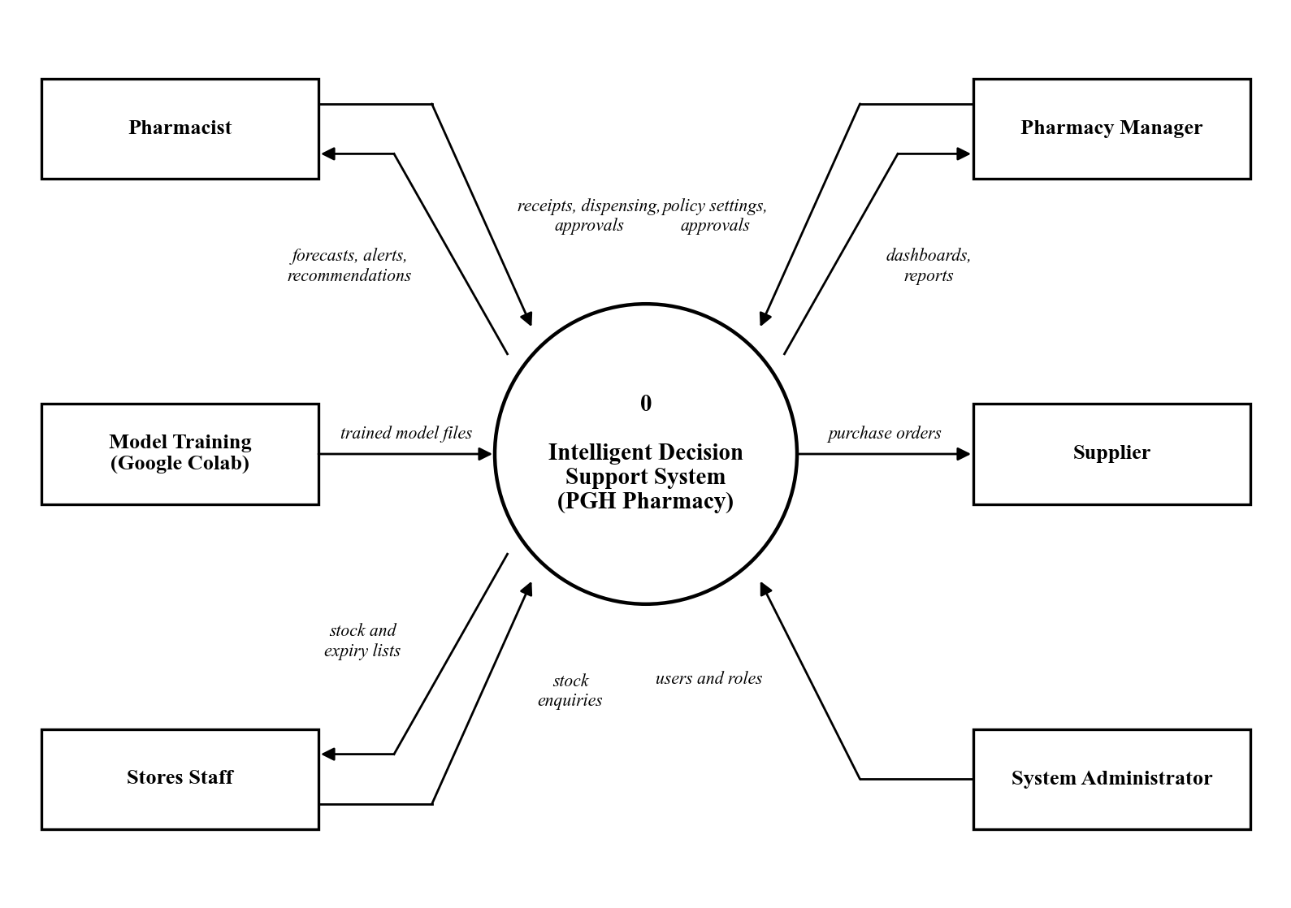
Figure 4.1: Context diagram of the proposed system

4.1.2 Data Flow Diagram (Level 1)
Figure 4.2 breaks the system into seven main processes and seven data stores. Process 1.0 checks each user against the users store (D1). Process 2.0 records receipts and dispensing and updates medicines and batches (D2). Process 3.0 reads the demand history (D3) and forecasts demand with Model 1. Process 4.0 reads delivery records (D4) and scores suppliers with Model 3. Process 5.0 uses stock, the forecast and the model files (D6) to assess risk. It applies Model 2 for stockouts and Model 4 for expiry. Process 6.0 combines all results into recommendations and saves them in D5. It writes each action to the audit log (D7). It also sends purchase orders to suppliers. Process 7.0 turns stored decisions into reports and dashboards for pharmacy staff.
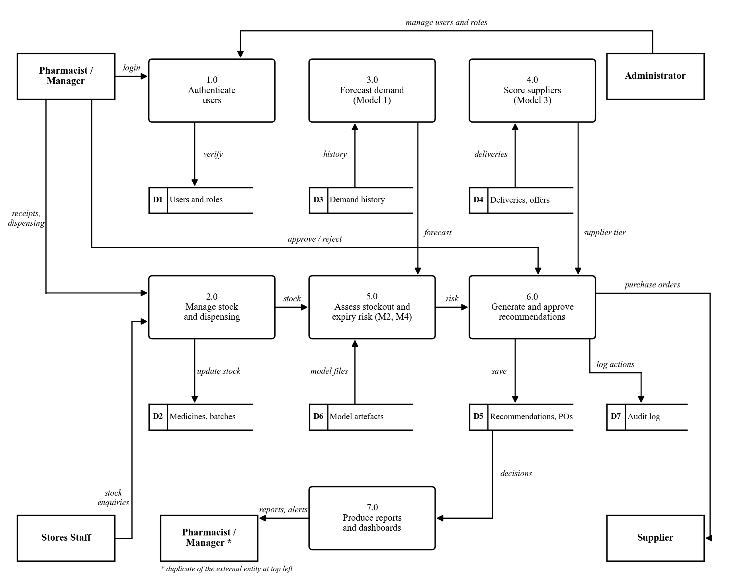
Figure 4.2: Level 1 data flow diagram

4.2 System Modeling
System modeling describes the behaviour of the system. The Unified Modeling Language (UML) was used for these diagrams (Fowler, 2004).

4.2.1 Use Case Diagram
Figure 4.3 shows the four user roles and the services each one uses. The roles form a chain. Each role can do everything the role above it can do, plus more. Stores staff can log in and view stock and expiry lists. Pharmacists add forecasting, the Model Lab, the decision engine and approvals. Pharmacy managers can also update supplier details. The administrator can also manage users and import datasets.
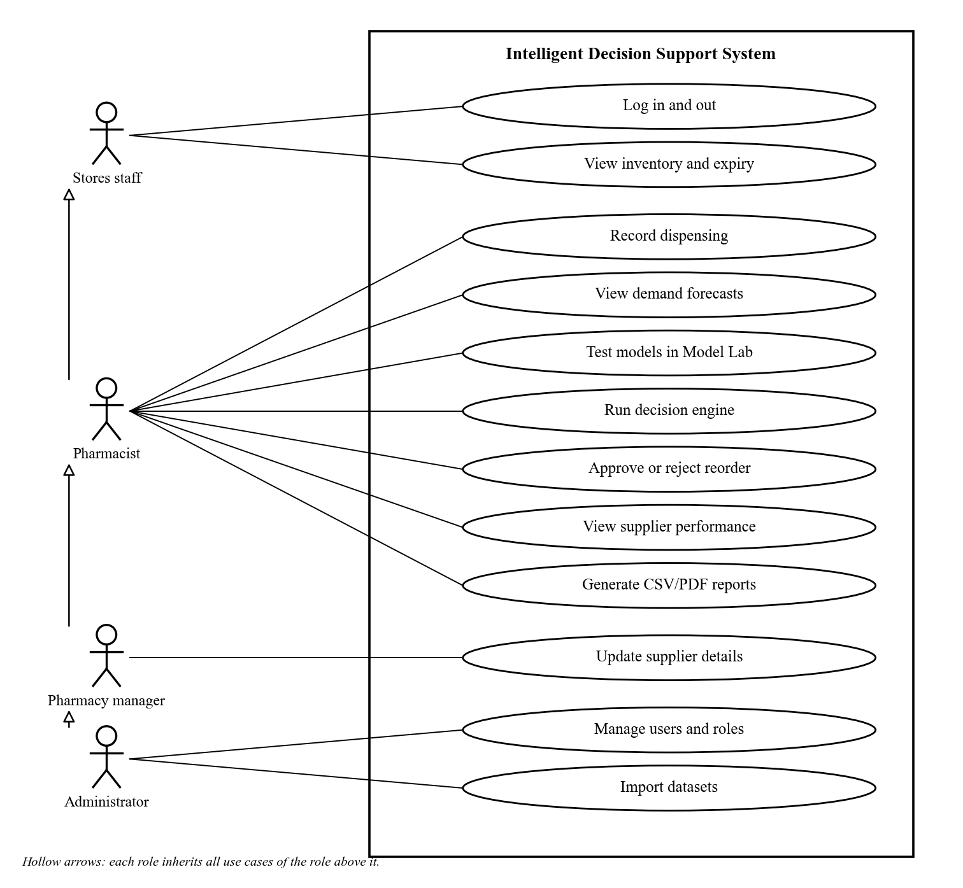
Figure 4.3: Use case diagram
Table 4.3 describes the most important use case in detail.
Item | Description
Use case | Run decision engine and approve a reorder
Actor | Pharmacist (also manager and administrator)
Precondition | The user is logged in. Stock, demand and supplier data are loaded.
Main flow | 1. The user clicks Run decision engine. 2. The system checks every medicine with the four models. 3. The system lists orders, expedite advice and medicines needing no action. 4. The user opens a recommendation and reads its reasons. 5. The user approves it, with or without changing the quantity. 6. The system creates a purchase order and records the approval.
Alternative flow | At step 5 the user rejects the recommendation. The system marks it rejected and records who did so.
Postcondition | A purchase order exists, or the recommendation is rejected. The audit log holds the decision.
Table 4.3: Use case description for running the decision engine

4.2.2 Sequence Diagrams
Figure 4.4 shows the login sequence. The React interface sends the email and password to the Django authentication API. The API first checks that the user has not made too many attempts. It then compares the password with the stored hash. If they match, it returns a short-lived access token and a refresh token. The interface uses the access token to fetch the user's name and role. It then shows only the menus that the role allows.
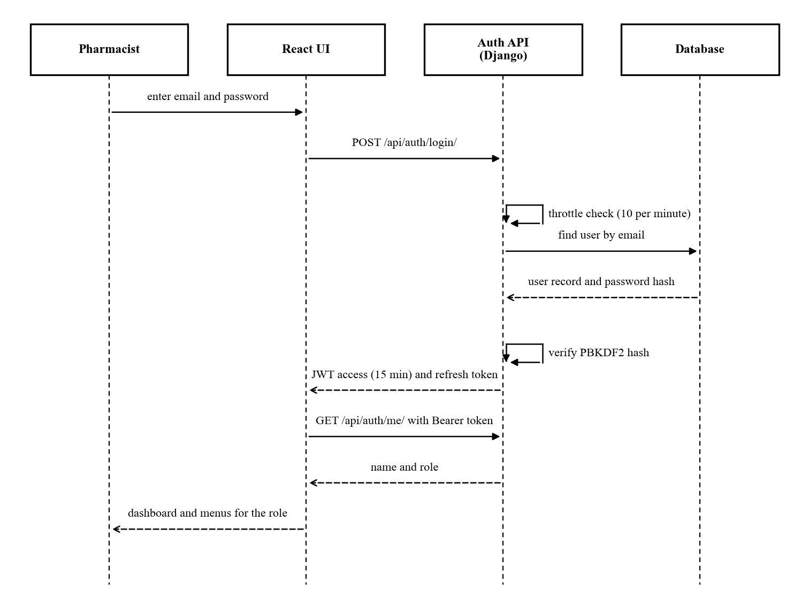
Figure 4.4: Sequence diagram for user login
Figure 4.5 shows the core sequence of the system. The pharmacist starts a decision run from the Reorder Decisions page. The decision engine reads stock, demand and delivery data from the database. It then calls the four models in turn. The results are saved as recommendations, and an audit event is written. When the pharmacist approves one, the API creates a purchase order. The order's due date is set from the supplier's lead time.
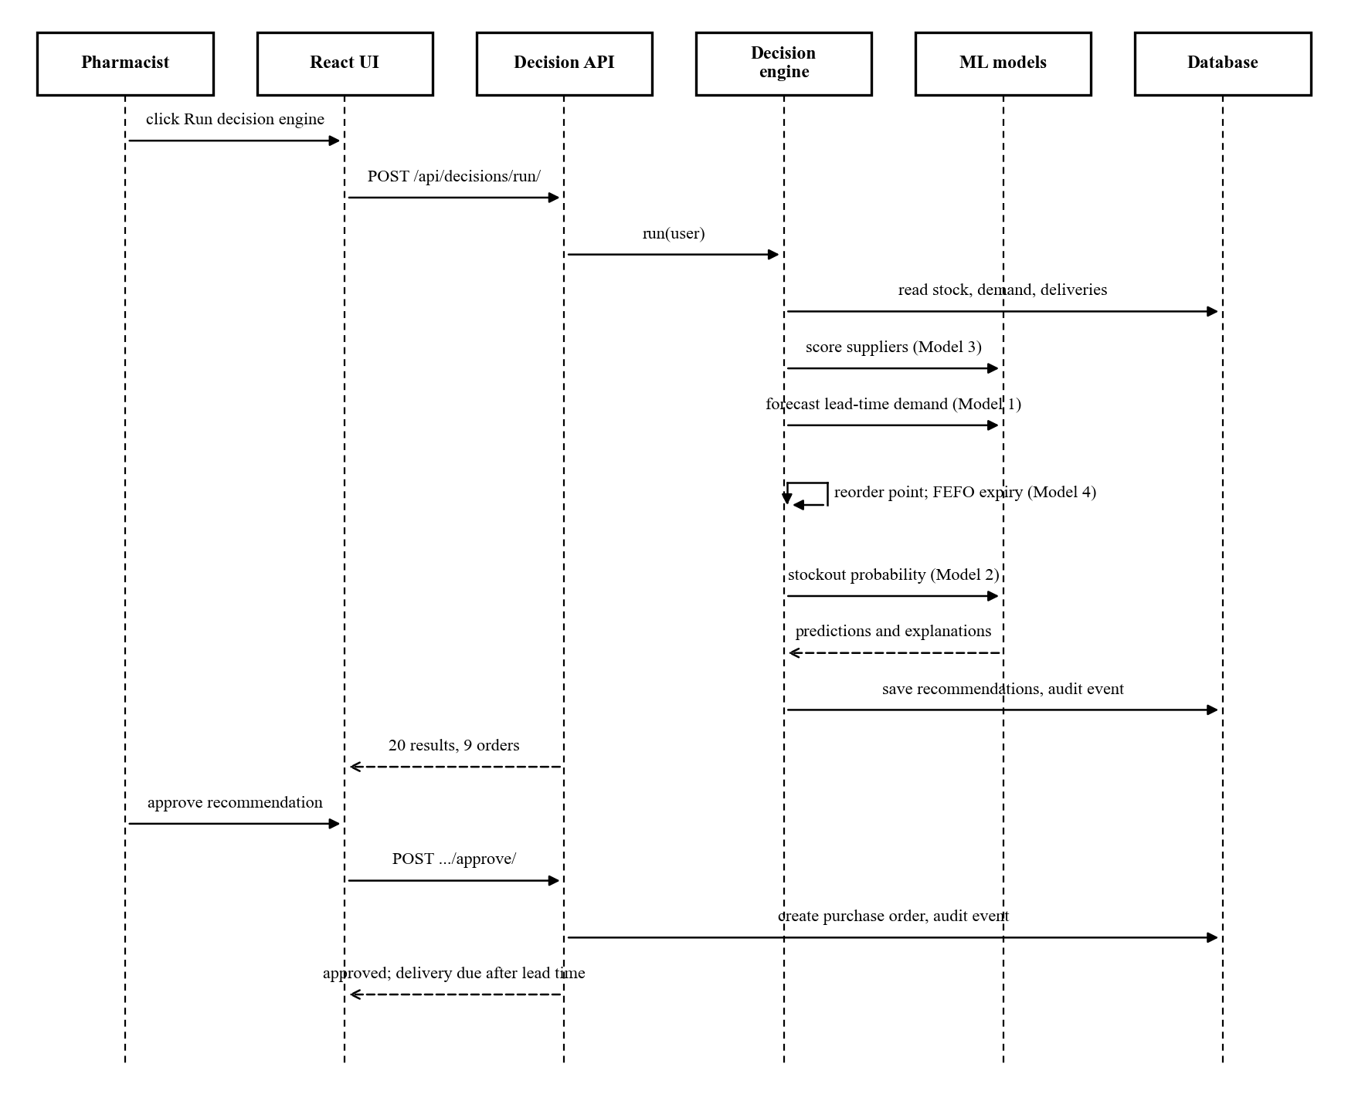
Figure 4.5: Sequence diagram for running the decision engine and approving a reorder

4.2.3 State Diagrams
Figure 4.6 shows the life of a recommendation and of a purchase order. A recommendation starts as pending when the engine creates it. It then becomes approved, rejected or superseded. It is superseded when a newer engine run replaces it. This prevents two open recommendations for the same medicine. An approved recommendation creates a purchase order. The order starts as pending and becomes partial, delivered or cancelled.
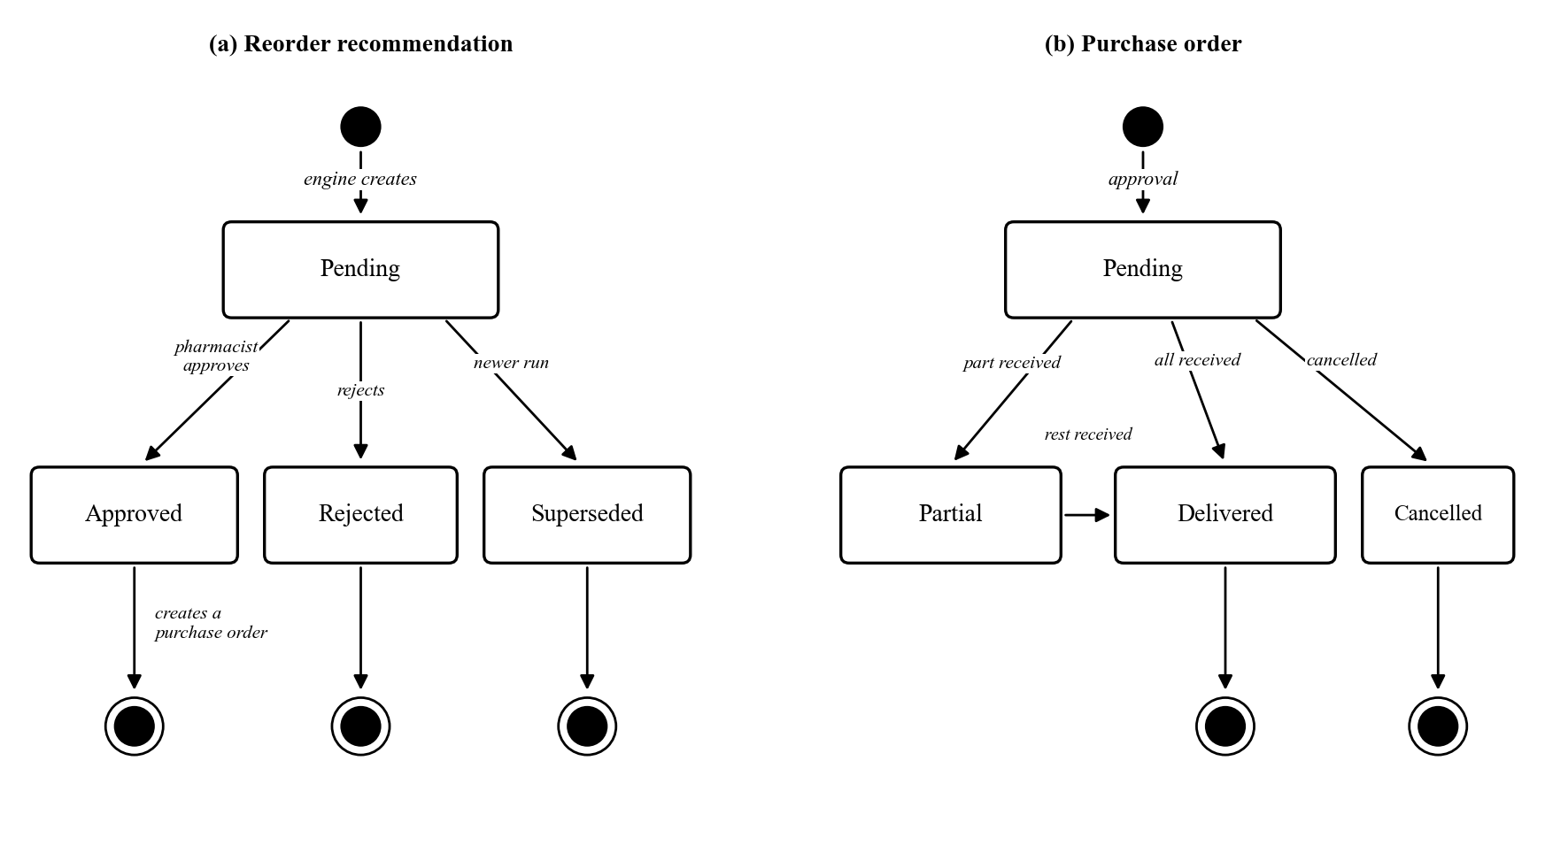
Figure 4.6: State diagrams for (a) a recommendation and (b) a purchase order

4.2.4 Activity Diagram
Figure 4.7 shows the reorder decision logic for one medicine. The engine first gathers data and chooses a supplier. It forecasts demand and sets the reorder point. It then removes stock that will expire unused and estimates the stockout risk. If usable stock is at or below the reorder point, an order is proposed. Stock may sit above that point while the risk is still high. In that case, the engine checks for open orders. With no open order, it proposes a new one. With an open order, it advises the pharmacist to expedite that order instead. Ordering again would not help, because a new order would arrive just as late.
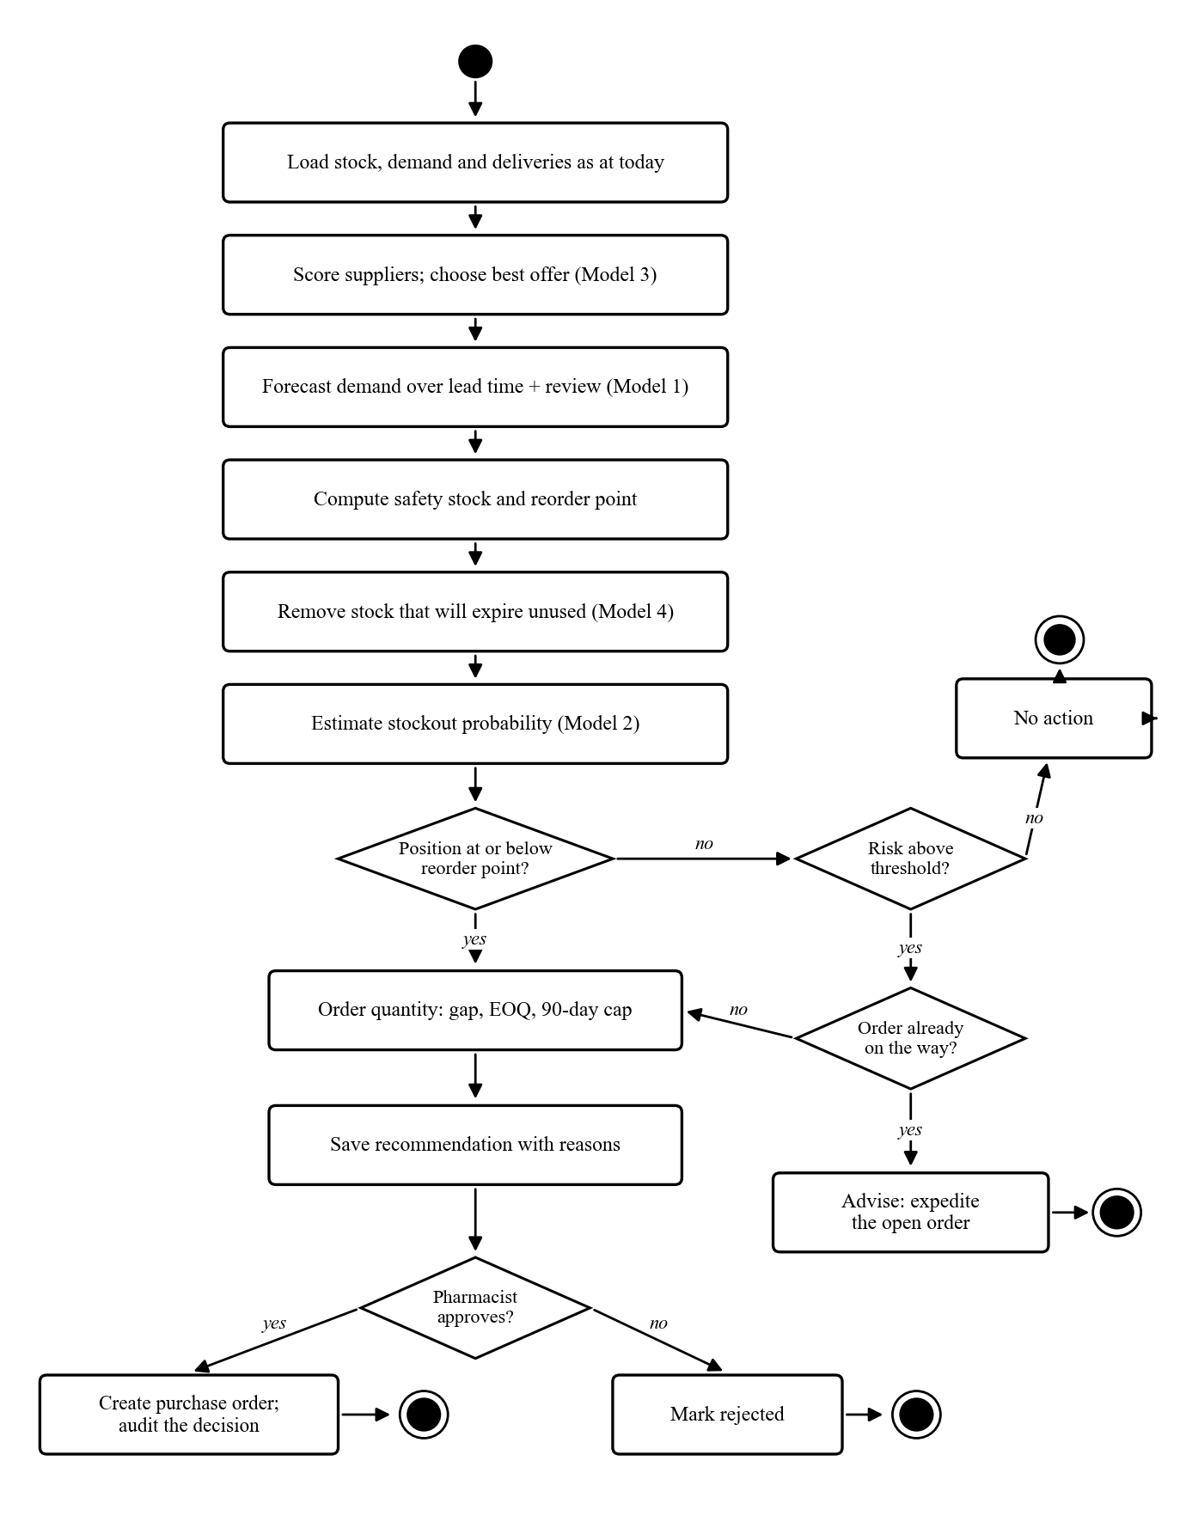
Figure 4.7: Activity diagram for the reorder decision

4.2.5 Architectural Design
Figure 4.8 shows the architecture of the system. It follows a three-tier design with a separate service layer (Sommerville, 2016). The presentation tier is a React web application. It runs in any modern browser on the pharmacy's computers. The application tier is a Django REST API. It checks every request for a valid token and the right role. The service layer holds the decision engine, the Model Lab and the reporting logic. The data tier is a PostgreSQL database. SQLite is used during development.
The machine learning models are trained offline in Google Colab. Only the finished model files are copied to the server. The server loads them read-only and never accepts model files from users. This keeps heavy training work away from the hospital server. It also means the whole system can run on the hospital network without internet access. This matters in Zimbabwe, where internet outages and load shedding are common.
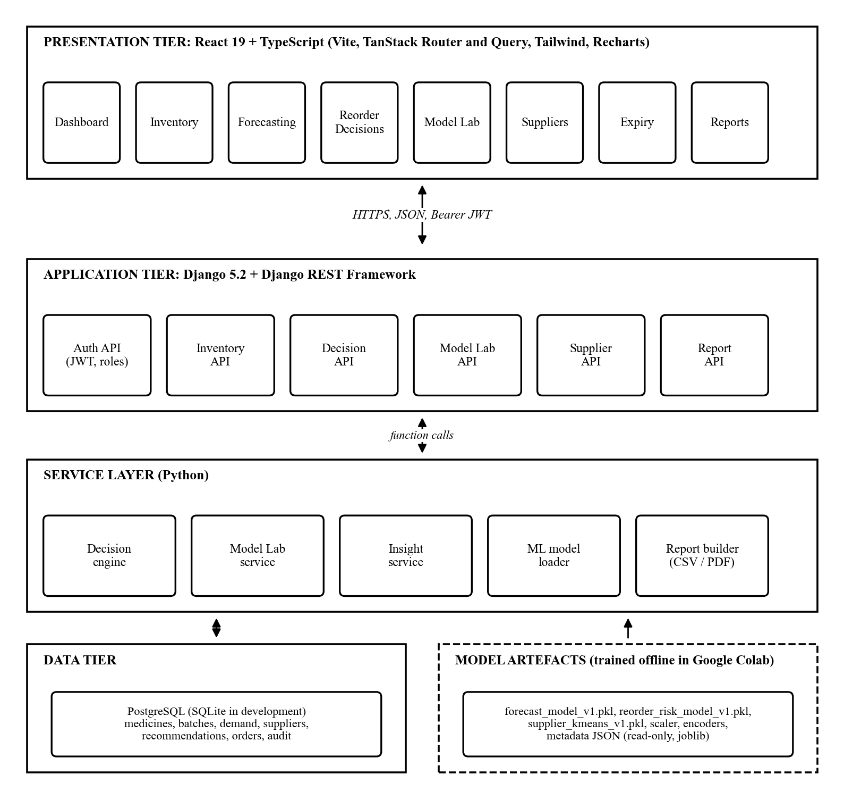
Figure 4.8: System architecture

4.2.6 Component and Module Design
Figure 4.9 shows the main software components and how they depend on each other. Table 4.4 describes the role of each module.
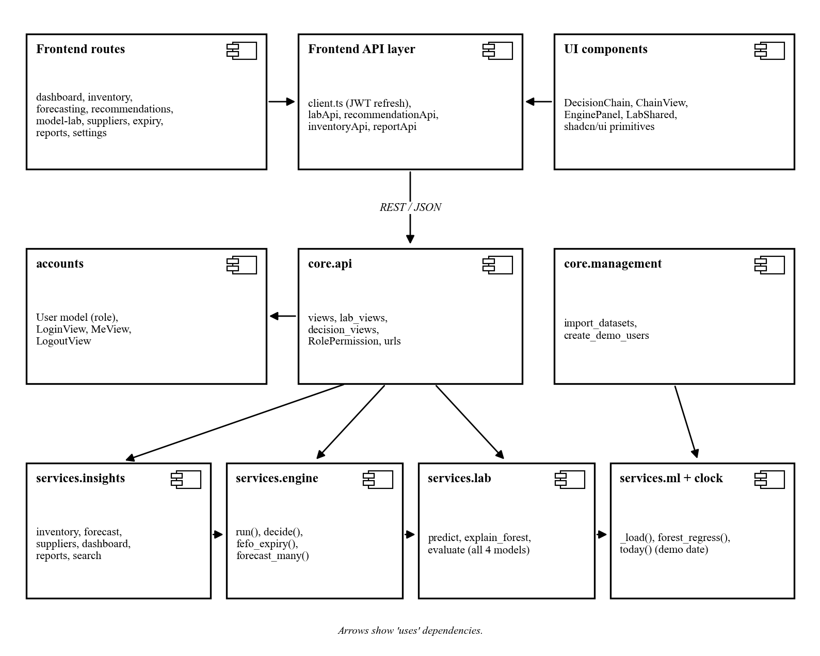
Figure 4.9: Component diagram
Module | Responsibility
Frontend routes | One page per task. Pages cover the dashboard, inventory, forecasts, reorders, Model Lab, suppliers, expiry, reports and settings.
Frontend API layer | Sends all requests to the backend. Adds the access token and renews it when it expires.
accounts | Stores users and roles. Handles login, logout and the current user's profile.
core.api | Exposes the REST endpoints. Checks the role permission for every request.
services.engine | Runs the four models together and produces reorder decisions.
services.lab | Runs any single model on custom inputs, explains the result and re-tests the model.
services.insights | Builds the figures shown on every page and produces CSV and PDF reports.
services.ml and clock | Loads model files once and keeps them in memory. Supplies today's date, or the demo date.
core.management | Command-line tools to import the datasets and create demo users.
Table 4.4: Module responsibilities

4.3 Data Modeling

4.3.1 Entity Relationship Diagram
Figure 4.10 shows the entities stored by the system and how they relate. MEDICINE sits at the centre. Each medicine has many daily demand records, batches, supplier offers and recommendations. Each supplier has many offers and many delivery records. A supplier offer links one medicine to one supplier with a price and lead time. A recommendation points to the chosen offer. An approved recommendation leads to at most one purchase order. Users record stock movements, decide on recommendations and create purchase orders. Every important action is written to the audit log.
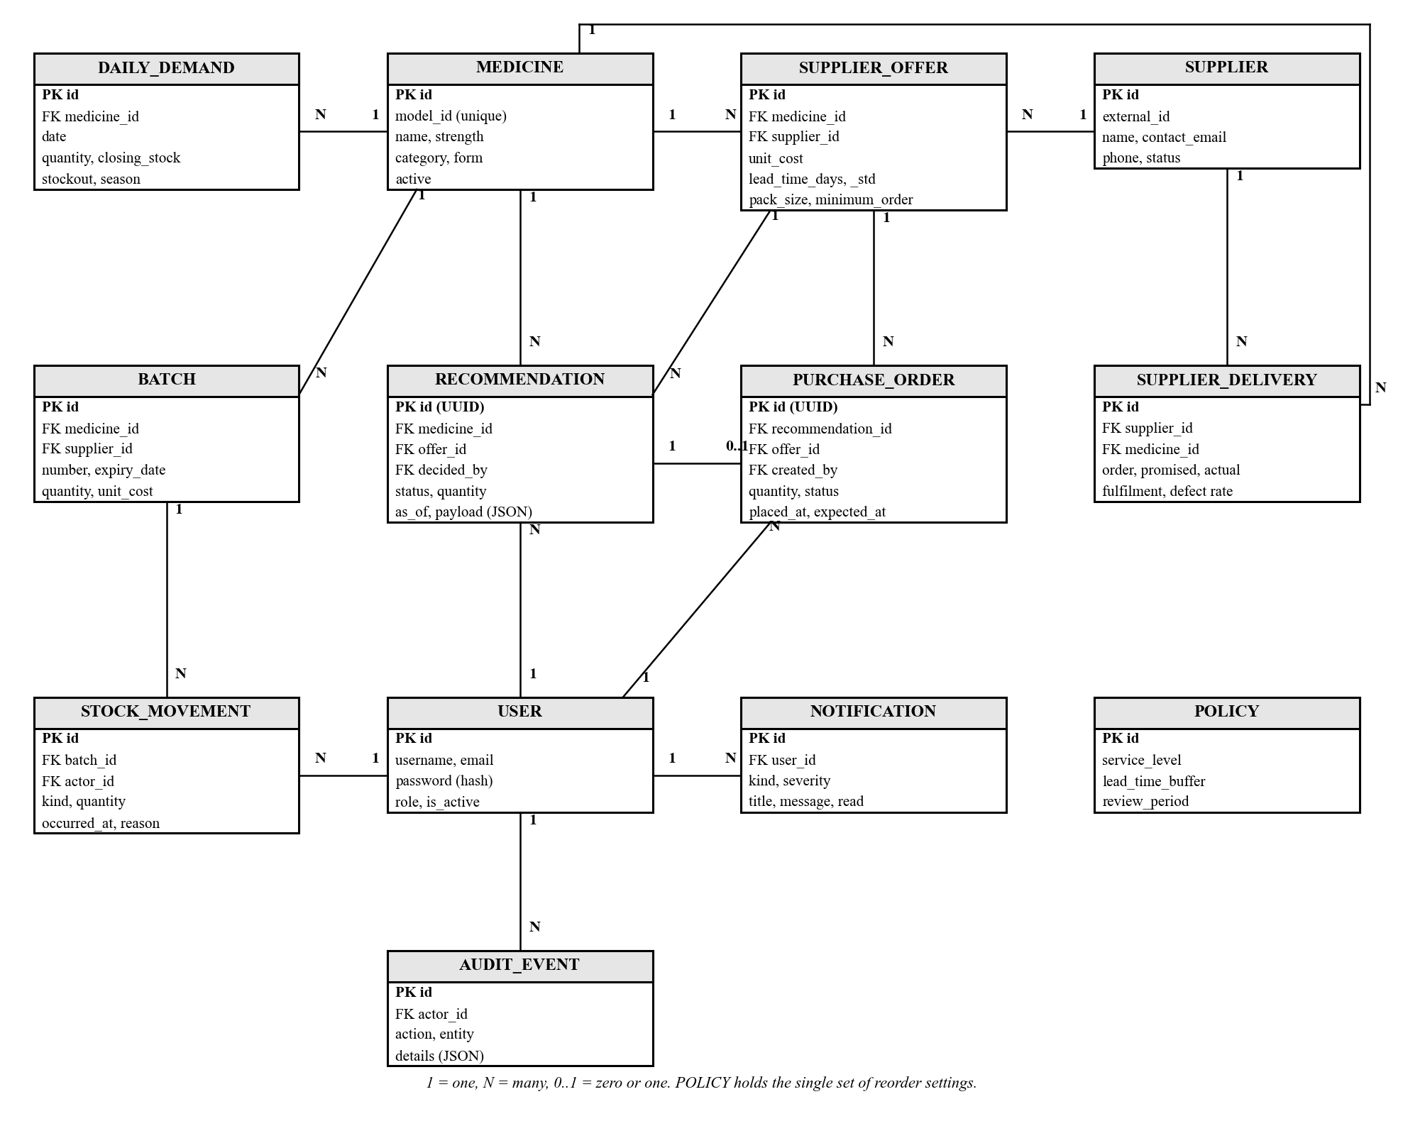
Figure 4.10: Entity relationship diagram

4.3.2 Class Diagram
Figure 4.11 shows the main classes. The upper classes are data classes that map to database tables. The lower classes are service classes that hold the decision logic. The DecisionEngine reads batches, uses the ModelLab's explanation method and creates recommendations. The InsightService calls the engine without saving, to build the figures on each page. It caches the results and recomputes them only when stock or orders change.
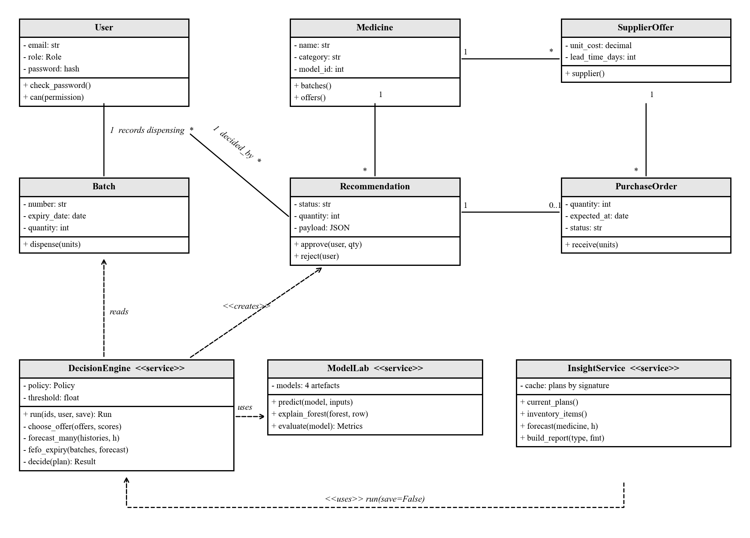
Figure 4.11: Class diagram

4.3.3 Database Design
The database has 18 application tables. Tables 4.5 to 4.9 show the five most important ones. PK marks a primary key and FK marks a foreign key.
Field | Type | Key or rule
id | Integer | PK
model_id | Integer | Unique; links the medicine to the model's encoding
name | Text (200) | Required
strength | Text (80) | Optional
category | Text (100) | Required
form | Text (80) | Optional
active | Boolean | Default true
Table 4.5: MEDICINE table
Field | Type | Key or rule
id | Integer | PK
medicine_id | Integer | FK to MEDICINE
supplier_id | Integer | FK to SUPPLIER; optional
number | Text (100) | Unique for each medicine
received_at | Date | Required
expiry_date | Date | Must not be before received_at
unit_cost | Decimal (12,4) | Zero or more
quantity | Integer | Zero or more
quarantined | Boolean | Excluded from stock when true
Table 4.6: BATCH table
Field | Type | Key or rule
id | Integer | PK
medicine_id | Integer | FK to MEDICINE
date | Date | Unique with medicine_id
quantity | Integer | Units dispensed that day
closing_stock | Integer | Stock at the end of the day
stockout | Boolean | True when stock ran out that day
holiday | Boolean | Public holiday flag
season | Text (50) | Rainy, dry/cold or transition
Table 4.7: DAILY_DEMAND table
Field | Type | Key or rule
id | UUID | PK
medicine_id | Integer | FK to MEDICINE
offer_id | Integer | FK to SUPPLIER_OFFER
status | Text (15) | Pending, approved, rejected or superseded
quantity | Integer | Suggested units
unit_cost | Decimal (12,4) | Price at the time of the decision
as_of | Date | Date of the decision
payload | JSON | Full reasoning from all four models
decided_by | Integer | FK to USER; set on approval or rejection
decided_at | Date and time | Set on approval or rejection
Table 4.8: RECOMMENDATION table
Field | Type | Key or rule
id | UUID | PK
recommendation_id | UUID | FK to RECOMMENDATION; one order at most
offer_id | Integer | FK to SUPPLIER_OFFER
quantity | Integer | More than zero
received_units | Integer | Cannot exceed quantity
placed_at | Date | Date of approval
expected_at | Date | placed_at plus supplier lead time
status | Text (20) | Pending, partial, delivered or cancelled
created_by | Integer | FK to USER
Table 4.9: PURCHASE_ORDER table
The tables were normalised to the third normal form (Codd, 1970; Elmasri & Navathe, 2016). Each field holds a single value, which satisfies the first normal form. Every non-key field depends on the whole primary key, which satisfies the second normal form. No non-key field depends on another non-key field, which satisfies the third normal form. For example, supplier names live only in the SUPPLIER table. Offers refer to suppliers by key instead of repeating their details.
Two fields break this rule on purpose. First, the recommendation keeps its full reasoning in a JSON payload. This freezes the evidence exactly as it was when the decision was made. An auditor can later see why an order was placed, even after stock has changed. Second, purchase orders copy the unit cost at the time of approval. This keeps the order value correct even if the supplier's price changes later.

4.4 Interface Design

4.4.1 Design Principles
The interface was designed for busy pharmacy staff. It follows recognised usability principles (Nielsen, 1993). Pages use plain words, consistent layouts and clear colour-coded status labels. Every model result shows the reasons behind it. A decision chain at the top of each page shows where the page sits. The chain runs from raw data to analytics, forecast, decision and action. Figures 4.12 to 4.16 show the main screens of the working system. They are shown in greyscale to follow the project guide.
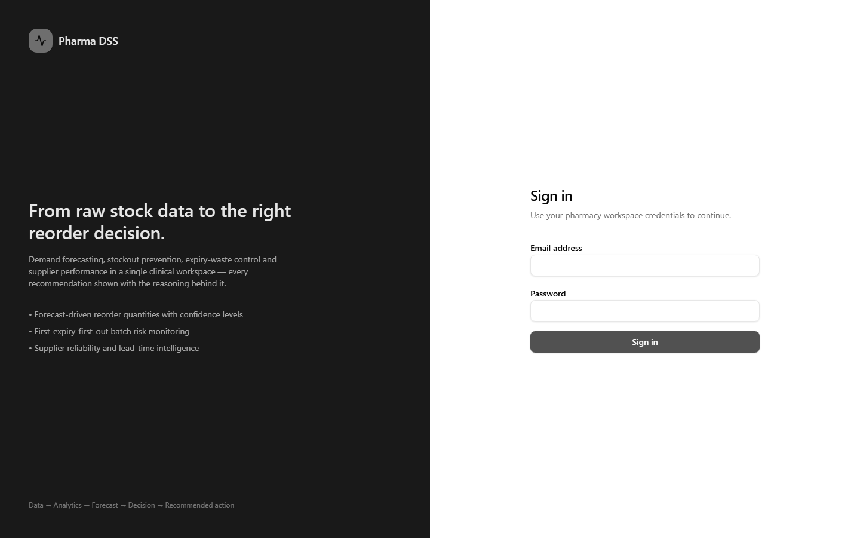
Figure 4.12: Login screen
Figure 4.12 shows the login screen. The left panel explains what the system does. The right panel accepts the user's email and password.
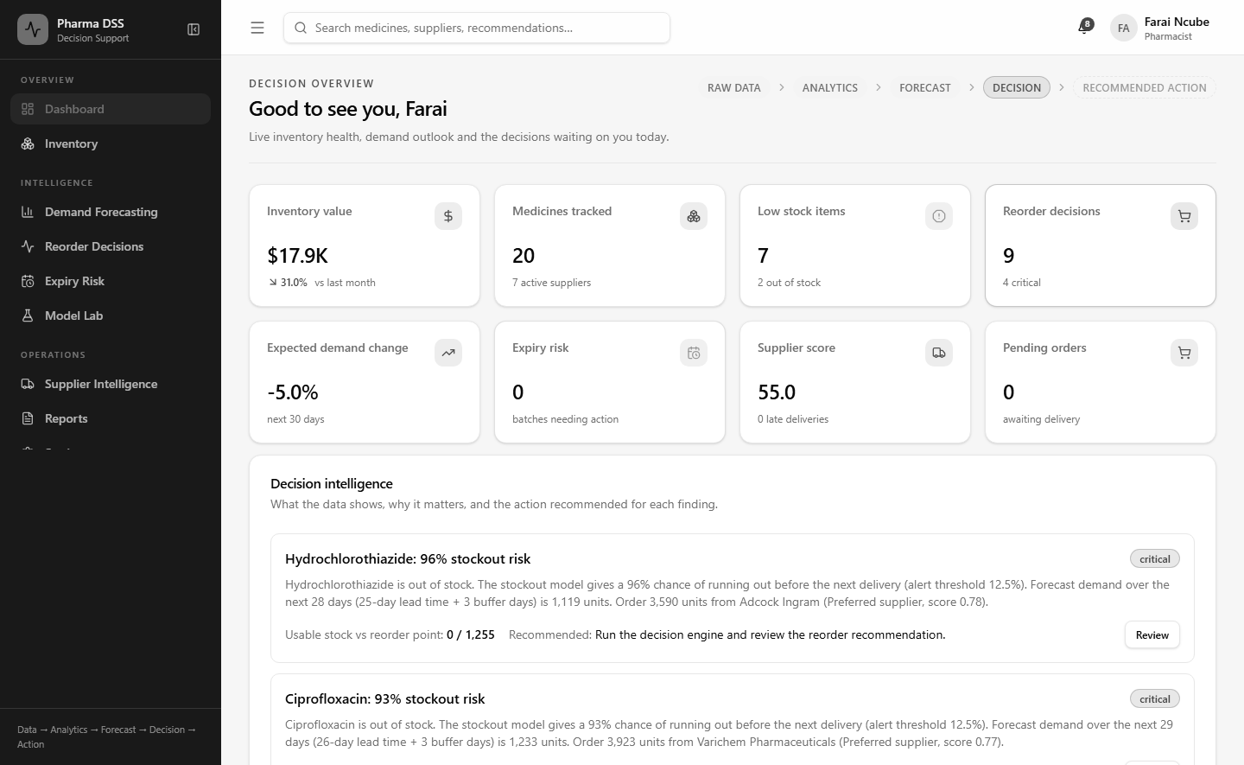
Figure 4.13: Dashboard showing key indicators and decision intelligence
Figure 4.13 shows the dashboard as at 31 December 2024. It shows stock value, low stock items, pending reorder decisions and expected demand change. Below these, the decision intelligence panel lists the most urgent findings in plain language. For example, it warns that Hydrochlorothiazide is out of stock with a 96% stockout risk.
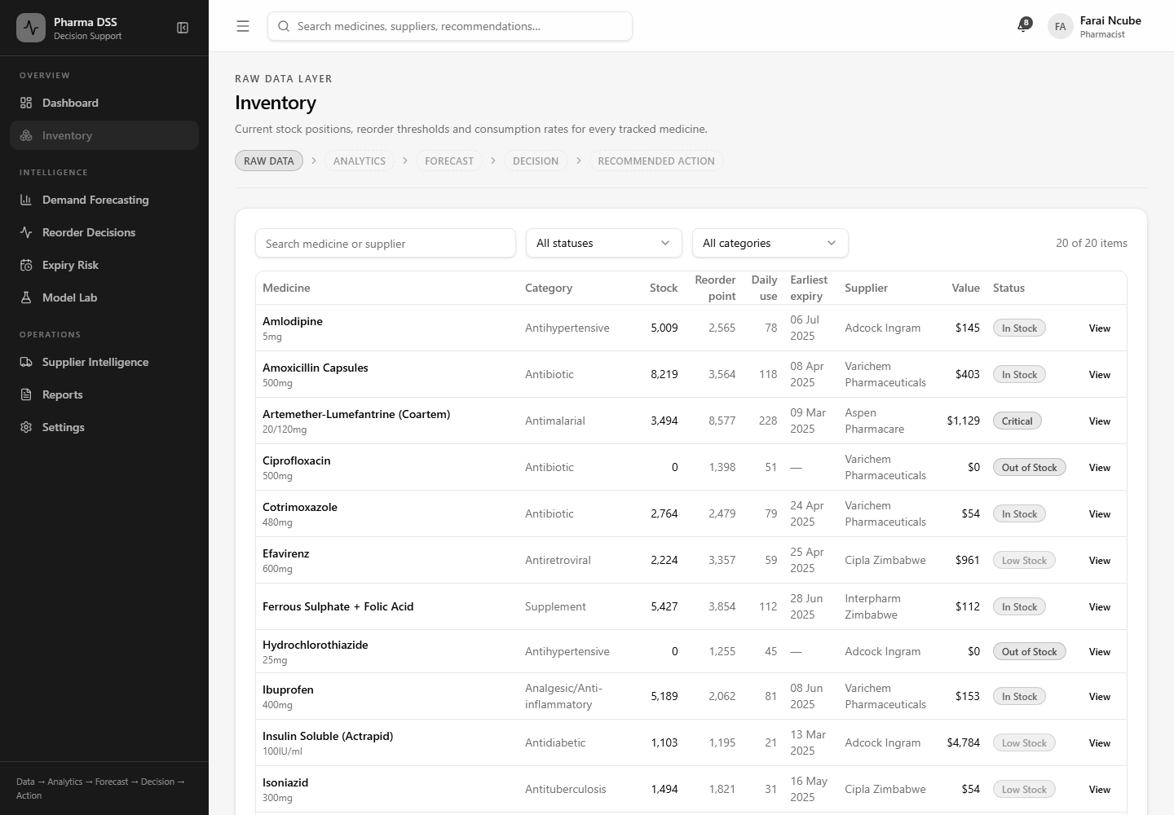
Figure 4.14: Inventory screen with model-based reorder points
Figure 4.14 shows the inventory screen. Each medicine has its own reorder point and daily use, both computed by the system. Status labels show which medicines are critical, low or out of stock.
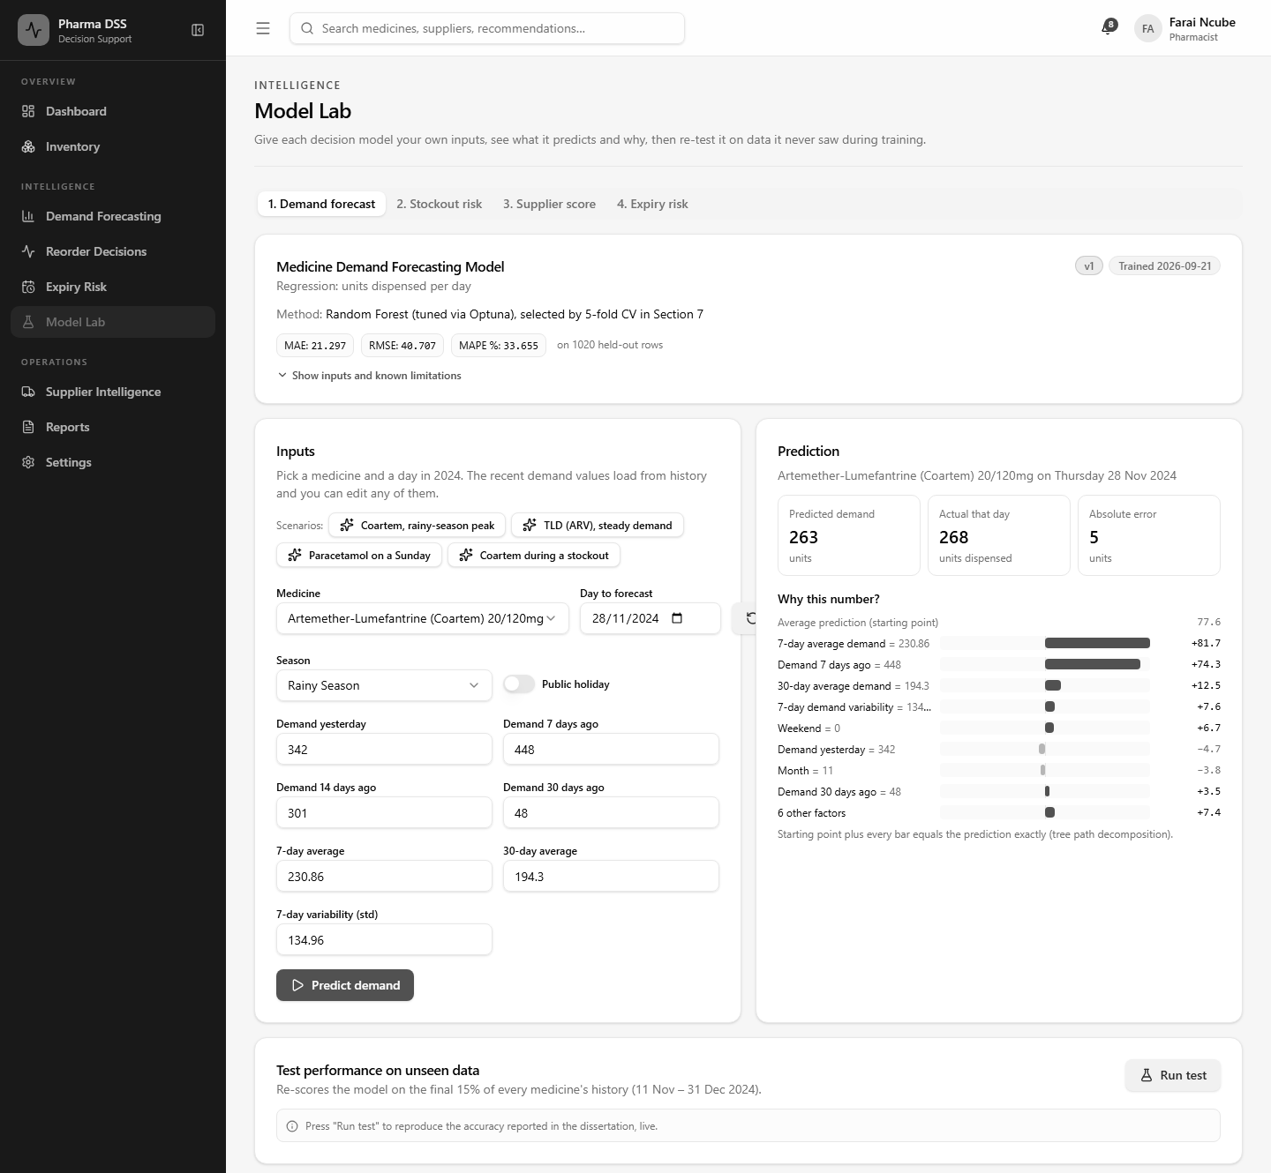
Figure 4.15: Model Lab screen for the demand forecasting model
Figure 4.15 shows the Model Lab. Here a user can test any of the four models with their own inputs. In this example, the demand model predicts 263 units of Coartem for 28 November 2024. The actual figure that day was 268. The bars on the right explain how each input moved the prediction up or down. A test button re-scores the model on data it never saw during training.
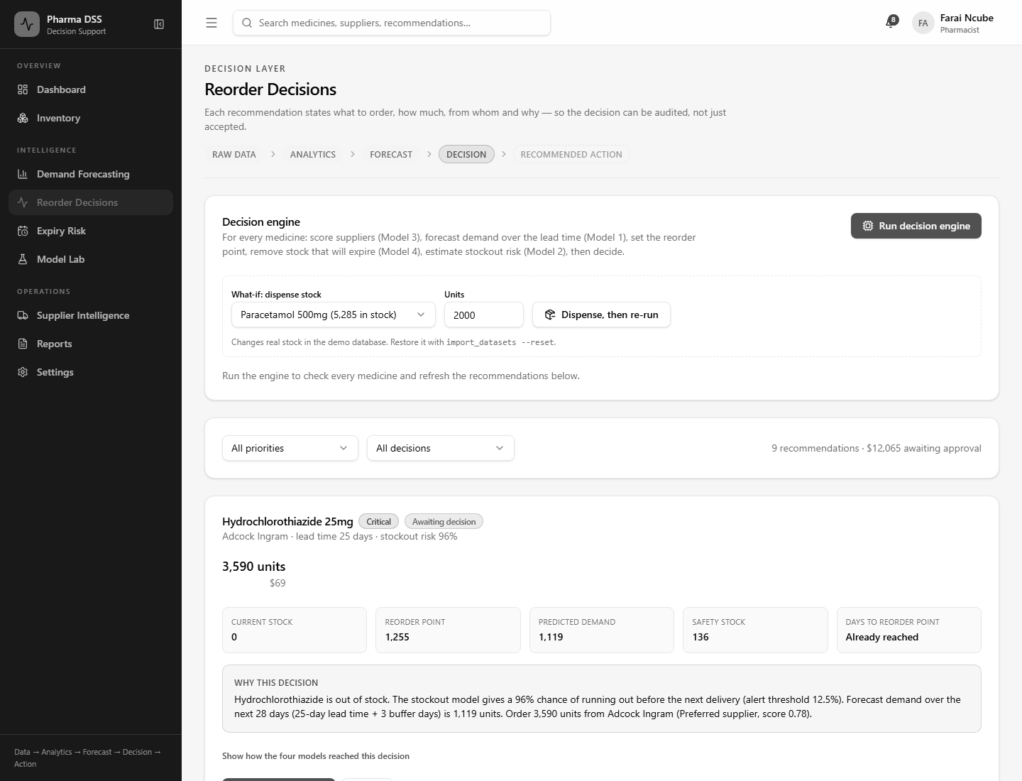
Figure 4.16: Reorder Decisions screen with the decision engine
Figure 4.16 shows the Reorder Decisions screen. The pharmacist can run the decision engine and try a what-if dispense. Each recommendation shows the quantity, cost, reorder point and the reason in plain words. A link expands the full chain of reasoning from all four models.

4.4.2 Pseudocode for Core Components
The following pseudocode describes the core logic without showing raw source code.
FUNCTION Login(email, password)
IF more than 10 attempts in the last minute THEN
RETURN "Too many attempts. Try again shortly."
user <- find user WHERE email matches
IF user not found THEN RETURN error "Email is not valid."
IF hash(password) does not match user.password_hash THEN
RETURN error "Wrong password."
IF user is disabled THEN RETURN error "Account is disabled."
access <- signed token valid for 15 minutes
refresh <- signed token valid for 1 day
RETURN access, refresh, user.name, user.role
END FUNCTION
Pseudocode 4.1: User login
FUNCTION Decide(medicine, today)
offers <- supplier offers for medicine
supplier <- offer with best tier, then highest score, then shortest lead time // Model 3
L <- supplier.lead_time + buffer days
forecast <- predict daily demand for next (L + review period) days // Model 1
mean, sd <- average and spread of recent demand, ignoring stockout days
safety <- z * sd * SQRT(L)
reorder_point <- SUM(forecast over L days) + safety
expiring <- units that will expire before use (FEFO check) // Model 4
usable <- stock on hand - expiring + units already on order
risk <- probability of stockout before next delivery // Model 2
IF usable <= reorder_point OR (risk >= threshold AND nothing on order) THEN
quantity <- MAX(order-up-to gap, MIN(EOQ, 90 days of demand))
RETURN "Order", quantity, supplier, reasons
ELSE IF risk >= threshold AND an order is already on the way THEN
RETURN "Expedite the open order", reasons
ELSE
RETURN "No action", reasons
END FUNCTION
Pseudocode 4.2: Decision engine for one medicine
FUNCTION ExpiringUnits(batches, forecast)
sort batches by expiry date, earliest first
day <- 0 ; expiring <- 0
FOR EACH batch IN batches
demand_before_expiry <- forecast demand from day until batch expires
used <- MIN(batch.quantity, demand_before_expiry)
expiring <- expiring + (batch.quantity - used)
day <- day + days needed to use 'used' units
END FOR
RETURN expiring
END FUNCTION
Pseudocode 4.3: First-expiry-first-out expiry check
FUNCTION PredictAndExplain(model, inputs)
VALIDATE every input is present, numeric and in range
row <- build feature row exactly as in the training notebook
prediction <- model.predict(row)
baseline <- 0 ; contributions <- zeros
FOR EACH tree IN model
follow the path of row from root to leaf
add each change in node value to the feature used at that split
END FOR
average baseline and contributions over all trees // baseline + SUM = prediction
RETURN prediction, baseline, top contributions
END FUNCTION
Pseudocode 4.4: Model Lab prediction with explanation
The explanation method in Pseudocode 4.4 follows the tree path decomposition of Saabas (2014). It splits each prediction exactly into a starting value plus one contribution per input. This lets a pharmacist see why the model gave a particular answer.
FUNCTION Approve(recommendation, user, quantity)
IF user role lacks "recommendations.approve" THEN RETURN "Access denied"
LOCK recommendation
IF recommendation.status is not "pending" THEN RETURN "Already decided"
IF quantity < 1 THEN RETURN error
order <- new purchase order(quantity, unit cost now,
placed today, due today + supplier lead time)
recommendation.status <- "approved" ; record user and time
write audit event "approve_recommendation"
RETURN updated recommendation
END FUNCTION
Pseudocode 4.5: Approve a recommendation

4.5 Security Design
The system holds stock, supplier and user data for a public hospital. Its security design follows the threats listed in Chapter Two. It also respects the Cyber and Data Protection Act (Government of Zimbabwe, 2021).

4.5.1 Password Hashing
Passwords are never stored as plain text. Django stores them as salted PBKDF2-SHA256 hashes. Each password is run through the hash function many thousands of times. This makes stolen hashes very slow to crack. Passwords must also pass Django's built-in strength checks.

4.5.2 Data Encryption
In production, all traffic between the browser and the server uses HTTPS. The server also sends HSTS headers, so browsers refuse plain HTTP. Session and CSRF cookies are marked secure. Secret keys and database passwords are kept in an environment file outside the code. For data at rest, the server disk should be encrypted, for example with BitLocker.

4.5.3 Authentication and Authorisation Logic
Users log in with an email and password. The server then issues JSON Web Tokens (Jones et al., 2015). The access token lasts 15 minutes and the refresh token lasts one day. Refresh tokens are rotated, and old ones are blacklisted. A stolen token therefore has a short useful life. Login attempts are limited to ten per minute to slow down password guessing.
Authorisation is checked on the server for every request. Each endpoint names the permission it needs. The server compares this with the permissions of the user's role. The frontend also hides menus a role cannot use. However, hiding a menu is only a convenience. The server check is what actually protects the data.

4.5.4 User Access Roles
Table 4.10 shows the permissions of each role.
Permission | Staff | Pharmacist | Manager | Admin
View inventory and expiry | Yes | Yes | Yes | Yes
Record dispensing | No | Yes | Yes | Yes
View forecasts and use the Model Lab | No | Yes | Yes | Yes
Run the decision engine | No | Yes | Yes | Yes
Approve or reject reorders | No | Yes | Yes | Yes
View supplier performance | No | Yes | Yes | Yes
Edit supplier details | No | No | Yes | Yes
Generate reports | No | Yes | Yes | Yes
Manage users and settings | No | No | No | Yes
Table 4.10: Role permission matrix

4.5.5 Secure Storage and Integrity
Several further controls protect the stored data. Model files are loaded read-only from a fixed folder. They are never uploaded through the web. Stock changes run inside database transactions, so a failed update leaves no half-written records. Each stock movement carries a unique key, so a repeated request is rejected. The audit log records who did what and when. Imported datasets are stored with a SHA-256 fingerprint to detect changes. Finally, the database should be backed up daily. A UPS should protect the server from power cuts.

4.6 Hardware Design
This project is a software system, so no custom hardware was designed. No circuits, sensors or printed circuit boards are needed. The system runs on one ordinary server on the hospital network. Staff use the pharmacy's existing computers and a web browser. The hardware needed was listed in the technical feasibility study in Chapter Two.

4.7 Summary
This chapter presented the analysis and design of the system. It began with 13 functional and eight non-functional requirements. The context and data flow diagrams showed how data moves through the pharmacy. UML diagrams showed the users, the main sequences, the states and the decision logic. The architecture separates the interface, the API, the services and the data. The ERD, class diagram and tables showed how records are stored in third normal form. The interface design showed the main screens and the pseudocode for the core logic. The security design covered hashing, encryption, tokens and role-based access. The next chapter presents the coding and testing of the system.

CHAPTER FIVE: CODING AND TESTING

5.0 Introduction
Chapter Four presented the design of the system. This chapter shows how that design was built and tested. Section 5.1 describes the coding of the models, the backend and the frontend. In line with the project guide, pseudocode is used instead of raw source code. Section 5.2 presents the testing evidence. It covers automated tests, model tests, system tests, performance tests and the defects found. Every result reported here was produced by running the finished system. Screenshots were captured during the tests and annotated with numbered markers.

5.1 Coding

5.1.1 Development Environment
The system was built with the tools listed in Chapter One. The models were trained in Google Colab using Python and scikit-learn. The backend was written in Python with Django 5.2 and Django REST Framework. The frontend was written in TypeScript with React 19. Development took place on a Windows 11 laptop using Visual Studio Code. Git was used for version control, with each completed stage saved as a commit. SQLite was used during development, and the same code runs on PostgreSQL.

5.1.2 Building the Machine Learning Models
Each model was built in its own Colab notebook. Every notebook followed the same ten stages. These were setup, data audit, exploration, charts and feature building. They were followed by training, validation, stress testing, tuning and export. The data was always split by date, never at random. This stopped future data from leaking into training. Pseudocode 5.1 summarises the training of the demand model.
LOAD daily demand records for 20 medicines (2024)
CHECK for missing values, duplicates and negative quantities
FOR EACH medicine
ADD calendar features: weekday, month, weekend, public holiday, season
ADD lag features: demand 1, 7, 14 and 30 days earlier (shifted, no leakage)
ADD 7-day and 30-day averages and the 7-day spread
END FOR
SPLIT each medicine's history by date: first 70% train, next 15% validate, last 15% test
TRAIN naive, Linear Regression, Random Forest, XGBoost and LightGBM
RANK models by mean error in 5-fold time-series cross-validation
TUNE the best model with Optuna (40 trials)
KEEP the tuned model only if it beats the untuned one on the test set
SAVE model, encoders and metadata (features, metrics, limitations) as version v1
Pseudocode 5.1: Training the demand forecasting model
The stockout model followed the same pattern. Stockouts made up only about 10% of the records. Class weighting was therefore used during training. The alert threshold was then lowered to 0.125. This catches at least 80% of stockouts. The supplier model is unsupervised. It combines a weighted score with K-Means clustering into three tiers.

5.1.3 Training and Testing the Expiry Model
Chapter Three reported that the expiry classifier was still in training. It was completed during this phase. Only batches whose outcome was already known on each split date were used for training. This left 1,254 training batches, 122 validation batches and 560 test batches. Logistic Regression and Random Forest were compared on the validation set. Random Forest scored higher and was tuned to catch at least 85% of at-risk batches. Table 5.1 compares it with the simple depletion rule on the 560 unseen test batches.
Method | Precision | Recall | F1 | At-risk batches missed
Random Forest classifier | 96.5% | 92.7% | 0.946 | 15 of 206
Depletion rule (stock exceeds use before expiry) | 95.6% | 94.7% | 0.951 | 11 of 206
Table 5.1: Expiry classifier compared with the depletion rule on 560 test batches
The trained classifier did not beat the rule. It missed four more at-risk batches. The rule is also simpler to explain to pharmacists. The system therefore keeps the depletion rule as its expiry model. This is an honest result rather than a failure. A learned model should replace a rule only when it clearly performs better.

5.1.4 Backend Implementation
The backend was built as two Django apps. The accounts app holds users and roles. The core app holds medicines, stock, suppliers, recommendations and orders. Business logic lives in four service modules rather than in the web views. This keeps the API layer thin and easy to test.
A management command loads the project datasets into the database. It turns the four CSV files into a working pharmacy as at 31 December 2024. Pseudocode 5.2 shows the main steps.
READ demand, supplier and batch CSV files
VALIDATE required columns, empty cells and negative quantities
CREATE 20 medicines and 7,320 daily demand records (with closing stock and stockout flags)
CREATE 12 suppliers and their delivery records
SKIP any delivery that arrives after the snapshot date (no future data)
CREATE one offer per medicine and supplier: average price and lead time from past orders
FOR EACH medicine
total <- closing stock on the snapshot date
SPLIT total across three real batches (older batches hold less stock)
END FOR
RECORD a fingerprint of each file and an audit event
Pseudocode 5.2: Importing the datasets as a demonstration pharmacy
Testing showed that recent demand was understated after stockouts. On a stockout day nothing can be dispensed, so the record shows zero. This hides the true demand. The engine was therefore changed to ignore stockout days when it measures demand. Pseudocode 5.3 shows this step.
INPUT last 60 days of (quantity, stockout flag)
clean <- quantities in the last 30 days where stockout flag is false
IF fewer than 10 clean days THEN
clean <- quantities in the last 60 days where stockout flag is false
IF fewer than 5 clean days THEN
clean <- all quantities in the last 30 days
RETURN mean(clean), standard deviation(clean), number of stockout days
Pseudocode 5.3: Measuring demand without stockout days
For Ibuprofen, this changed the recent daily average from 27 to 81 units. The medicine had been out of stock for 20 days in December. The corrected figure now matches the forecast and the medicine's yearly average.

5.1.5 Integrating the Models
The trained models were copied from Colab into the project as read-only files. The server loads each model once and keeps it in memory. Models are preloaded when the server starts, so the first request is fast. Forecasts beyond one day feed each prediction back in as the next day's input. For speed, the engine forecasts one day for all 20 medicines in a single step. Pseudocode 5.4 shows this step.
INPUT for each medicine: category and last 30 days of demand
FOR day = 1 TO horizon
rows <- one feature row per medicine for this day
(season from the month, holiday from the calendar, lags from history)
predictions <- model.predict(rows) // one call for all medicines
APPEND each prediction to that medicine's history and forecast
END FOR
RETURN forecasts
Pseudocode 5.4: Forecasting many medicines in one pass
Early runs were slow. A full decision run for 20 medicines took about 21 seconds. Profiling found the cause. The library re-checked the model before each of its 750 trees. The trees were then called directly. This gave identical predictions about twelve times faster. Through the API, a full run now takes about 1.5 seconds.

5.1.6 Frontend Implementation
The frontend has one page for each task in the use case diagram. All server calls go through a single API layer. This layer adds the user's access token to every request. When the access token expires, it renews it silently, as shown in Pseudocode 5.5.
FUNCTION Request(path, options)
response <- send request with the current access token
IF response is 401 (expired token) THEN
new_token <- send refresh token to /token/refresh/
IF new_token received THEN
save new_token ; response <- send request again with new_token
ELSE
clear tokens ; RETURN "Session expired" (user goes to login)
IF response is an error THEN
RETURN a plain-language message for its status (400, 403, 409, 422, 429, 503 ...)
RETURN response data
END FUNCTION
Pseudocode 5.5: Sending a request with automatic token renewal
The Model Lab and the decision engine panel were added for the viva demonstration. In the Model Lab, examiners can test each model with their own inputs. They can also see why it answered. The decision panel runs all four models together and supports a what-if dispense.

5.2 Testing

5.2.1 Testing Approach
Testing followed the plan in Chapter Three. It was carried out at five levels. Automated tests checked the backend code and the reproduced model results. Model tests checked accuracy on data the models had never seen. System tests checked each feature through the real interface. Performance tests measured response times. User acceptance testing with PGH pharmacy staff is the final level. System tests were run with an automated browser driven by Playwright. This made each test repeatable and produced a screenshot at every step.

5.2.2 Automated Unit and Integration Tests
The backend has 35 automated tests written with the Django test framework. Table 5.2 groups them by purpose. All 35 tests passed in the final run.
Group | Tests | What they check | Result
Authentication | 4 | Clear login messages, and blocking after ten attempts in a minute | All passed
Administration | 2 | All data tables are registered in the admin site | All passed
Model reproduction | 4 | Live re-tests match the Colab results for all four models | All passed
Explanations | 3 | Explanation bars add up exactly to each prediction | All passed
Model Lab access | 6 | Role checks, input validation and safe handling of missing model files | All passed
Decision engine | 8 | Orders for out-of-stock items, no duplicates, approval, expedite and FEFO dispensing | All passed
Page data | 8 | No placeholder values, real reports, search, demo date and stockout-day handling | All passed
Table 5.2: Automated backend tests

5.2.3 Model Testing
Table 5.3 shows the results of the model test cases planned in Table 3.7. Each model was re-tested live inside the finished system. The results matched the Colab notebooks to two decimal places.
ID | Test | Expected | Actual | Result
MT-01 | Audit each dataset | No gaps or duplicates | All four files: no missing cells, no duplicate rows | Pass
MT-02 | Leakage check | All correlations below 0.98 | Highest 0.76 (demand) and 0.42 (stockout) | Pass
MT-03 | Demand model vs naive baseline | Lower MAE | MAE 21.30 vs 39.36, an error cut of 45.9% | Pass
MT-04 | Ranking under cross-validation | Same leader across folds | Random Forest led both supervised tasks | Pass
MT-05 | Errors by category | Weak areas found | Antimalarials weakest (MAE 64.97); stockout days harder | Pass
MT-06 | Stockout alert threshold | Recall of at least 0.80 | Recall 0.802 at threshold 0.125 | Pass
MT-07 | Keep tuned model only if better | Better model deployed | Demand: tuned kept. Stockout: untuned kept | Pass
MT-08 | K-Means vs hierarchical | ARI above 0.80 | ARI 1.000 | Pass
MT-09 | Weights changed by 30% (500 runs) | Spearman above 0.90 | Mean 0.994, lowest 0.972 | Pass
MT-10 | Resample orders 200 times | Most suppliers keep their tier | Each kept its main tier in at least 73% of runs | Pass
Table 5.3: Machine learning test results
Figure 5.1 shows one of these re-tests running in the Model Lab. The stockout model's live test reproduced a recall of 80.2% and a PR-AUC of 0.81. It caught 65 of 81 real stockouts and raised 49 false alarms.
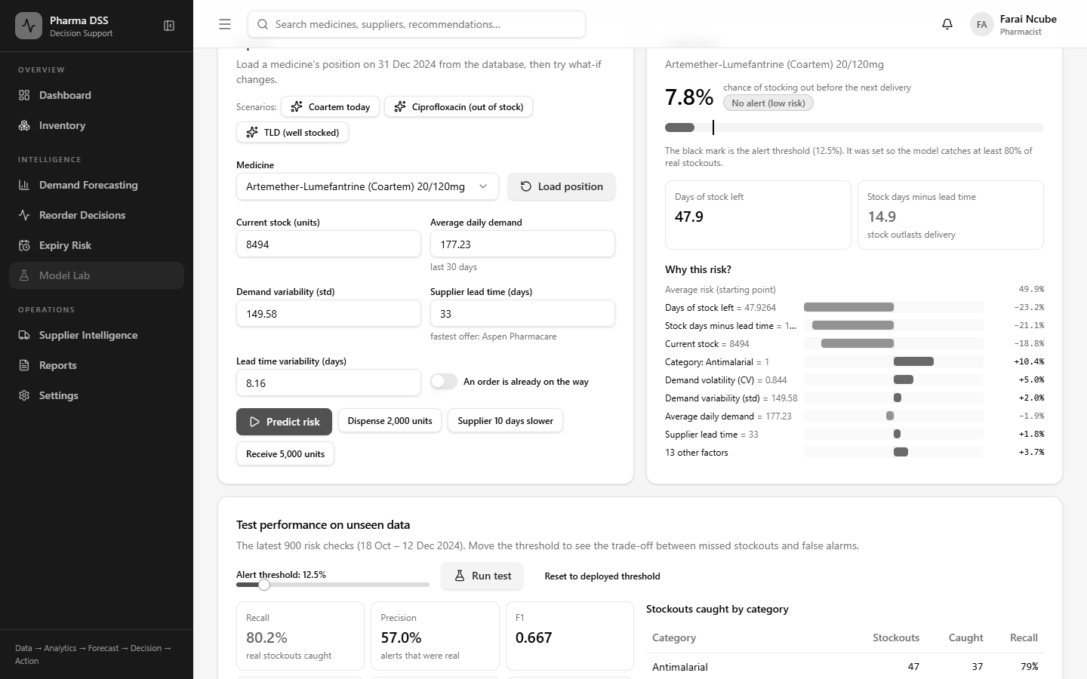
Figure 5.1: Live re-test of the stockout model in the Model Lab

5.2.4 System Functional Testing
Table 5.4 summarises the system test cases planned in Table 3.8. The actual results were recorded automatically during the test run.
ID | Test scenario | Expected | Actual | Result
ST-01 | Log in with a valid email and password | Dashboard opens for the user's role | Dashboard opened for Farai Ncube (Pharmacist) with live indicators. | Pass
ST-02 | Log in with a wrong password | Clear error message, no access | The page showed 'Wrong password'. The user stayed on the login page. | Pass
ST-03 | Try more than 10 logins in one minute | Further attempts are blocked | Of eleven quick attempts, attempts 9 to 11 got HTTP 429. Earlier test logins used part of the limit. The page then showed 'Too many attempts'. | Pass
ST-04 | Use the system after the access token expires | Token refreshes or the user is asked to log in | The invalid access token was rejected and silently replaced using the refresh token. The inventory page loaded without asking the user to log in again. | Pass
ST-05 | Staff user tries to approve or change stock | Action refused for this role | The staff menu had no reorder pages. Server calls for recommendations, engine runs and dispensing all got HTTP 403. | Pass
ST-06 | Open the demand forecast for a medicine | Forecast chart and model version shown | The chart showed an 80% prediction interval and total demand. Model version v1 and MAE 21.30 were listed. | Pass
ST-07 | Medicine's stock falls into the risk zone | Reorder recommendation appears with quantity and supplier | Paracetamol had 5,285 units and needed no action. After 4,000 units were dispensed, it showed an order of 13,633 units at 64% risk. | Pass
ST-08 | Pharmacist approves a recommendation | Status changes to approved and an audit entry is saved | Status changed to Approved with 'decided by Farai Ncube'. A purchase order was created. | Pass
ST-09 | Open the supplier page | Scores, tiers and low-confidence flags shown | All 12 suppliers listed with score, on-time rate, lead time, defect rate and review status. | Pass
ST-10 | Open the expiry risk page | Batches at risk listed by expiry date | 54 batches listed by expiry date with daily use, projected unused units and advice. No batch was projected to expire unused in the demo data. | Pass
ST-11 | Generate a stock report | PDF or CSV file downloads | File inventory-2024-11-30-to-2024-12-31.csv downloaded with 20 data rows. Header: medicineId,medicineName,strength,category,currentStock,reorderPoint,sa | Pass
ST-12 | Medicine with no demand history | No crash. Forecast shown as unavailable | No crash. The page showed 'Not enough data'. It said at least 30 days of history are needed. | Pass
ST-13 | Enter a negative stock quantity | Input rejected with a message | Rejected with the message 'Invalid request Quantity must be at least 1.'. Stock was not changed. | Pass
ST-14 | Model file is missing or fails to load | System shows that predictions are unavailable | Forecast, Model Lab and engine requests returned HTTP 503 'Model artifact is missing'. No crash. | Pass
Table 5.4: System test results
All fourteen system tests passed. The following figures give annotated evidence for the main tests. Numbered markers point to the part of the screen being tested.

ST-01 and ST-02: Login
Figure 5.2 shows a login attempt with a wrong password. Marker 1 shows the clear error message. The user stays on the login page and gains no access.
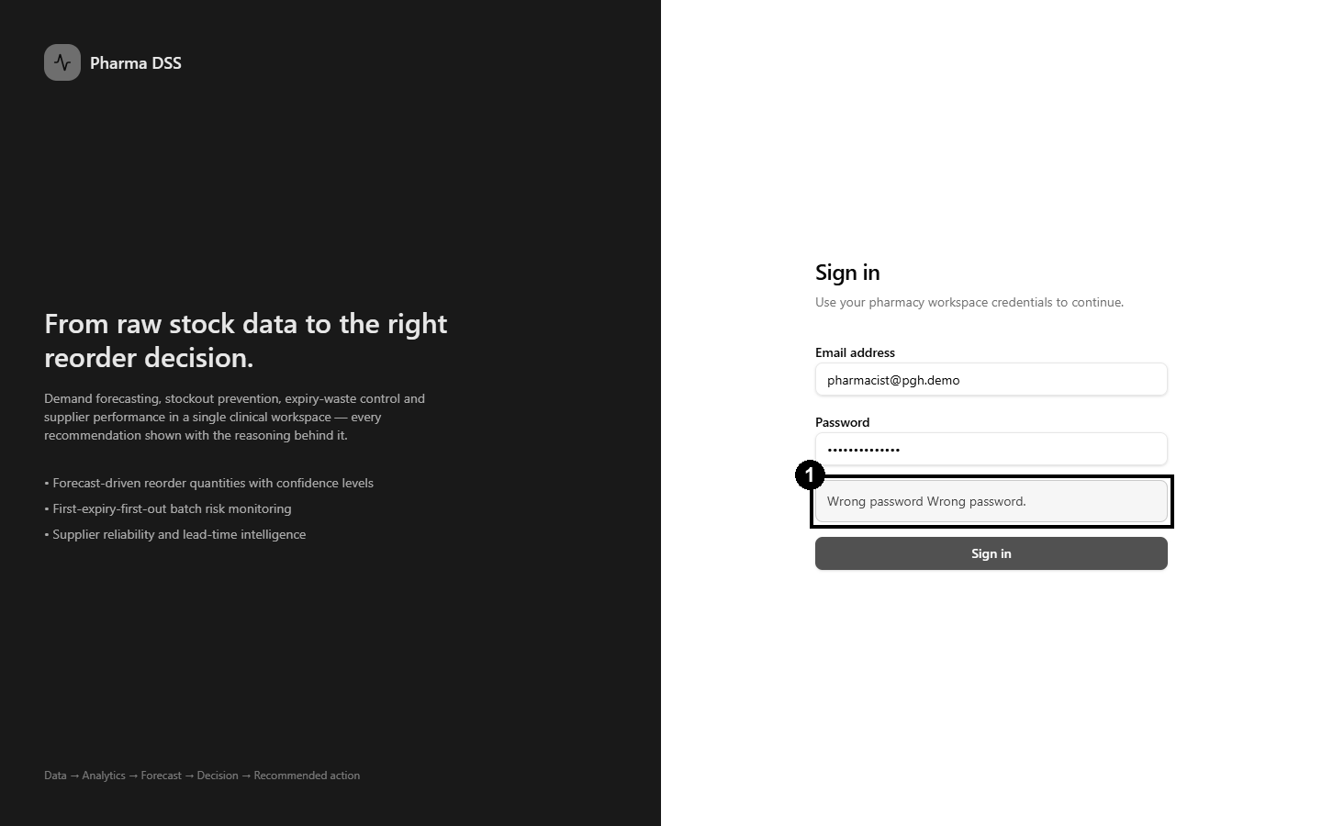
Figure 5.2: ST-02, login rejected with a wrong password
Figure 5.3 shows a successful login. Marker 1 shows the logged-in pharmacist, Farai Ncube. Marker 2 shows the pending reorder decisions waiting for this user.
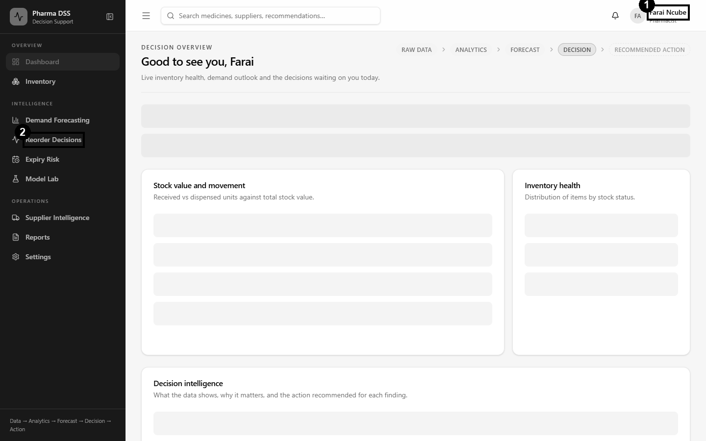
Figure 5.3: ST-01, dashboard after a successful login

ST-03 and ST-05: Security Controls
Eleven wrong passwords were sent in quick succession. The first ten were rejected as wrong passwords. The eleventh was blocked with HTTP 429. Figure 5.4 shows the message that the login page then displayed.
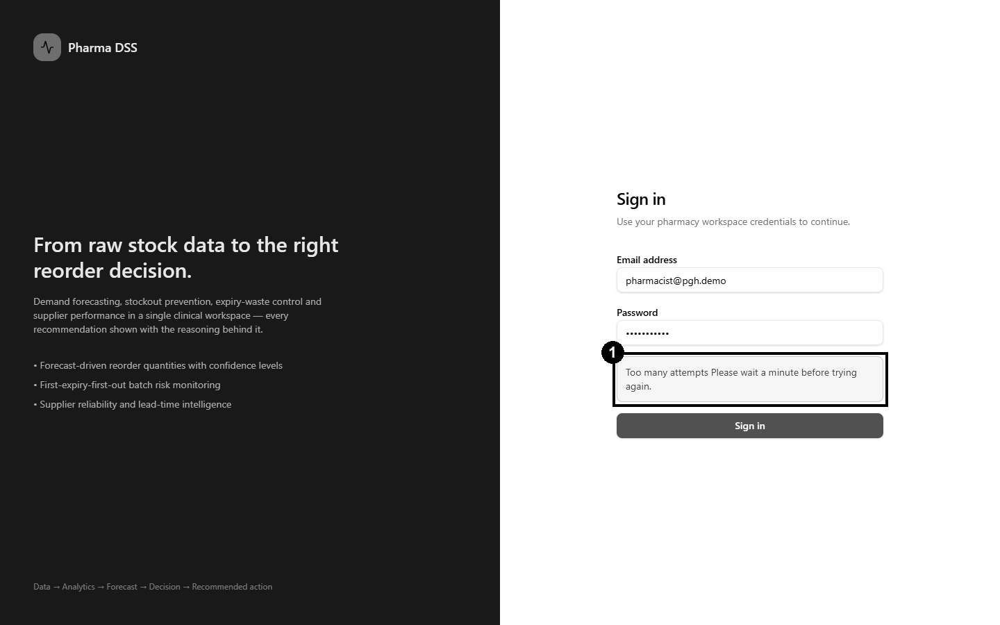
Figure 5.4: ST-03, repeated login attempts blocked
Figure 5.5 shows the system for a stores staff account. Marker 1 shows that the menu offers no forecasting, reorder or supplier pages. Direct requests to those services were also refused by the server.
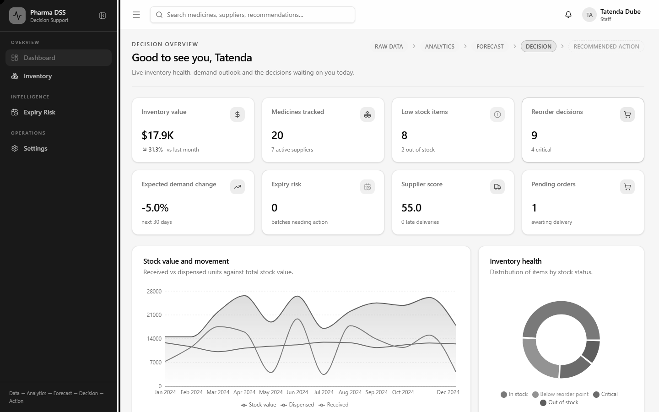
Figure 5.5: ST-05, reduced menu for the stores staff role

ST-06 and ST-12: Demand Forecasting
Figure 5.6 shows the forecast page. Marker 1 shows the model version. Marker 2 shows the 80% prediction interval around the forecast.
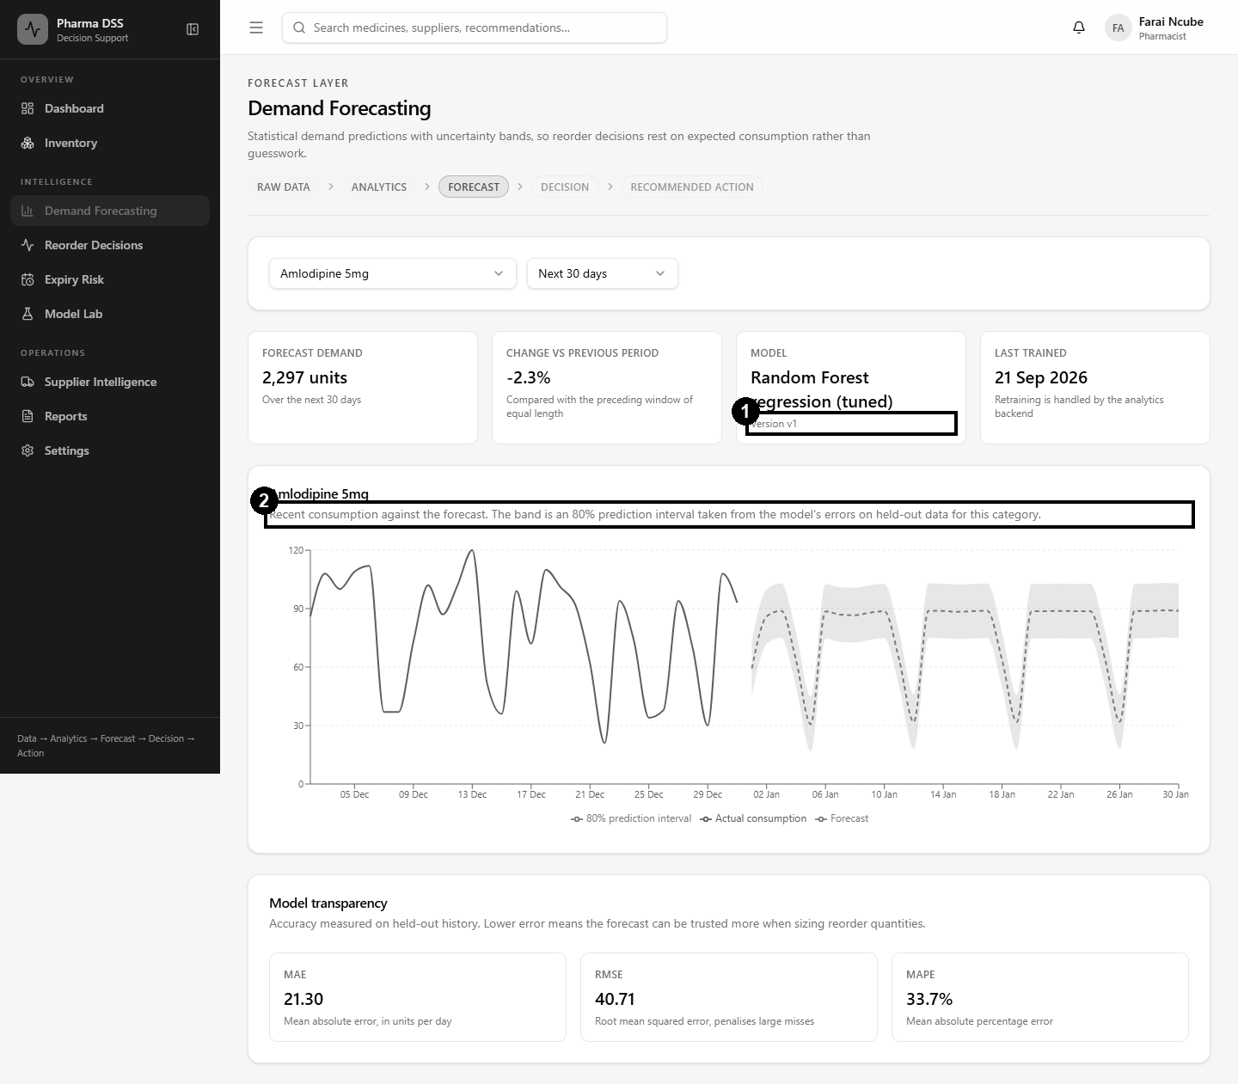
Figure 5.6: ST-06, demand forecast with model details
Figure 5.7 shows a medicine with no demand history. Marker 1 shows that the page explains the problem instead of crashing.
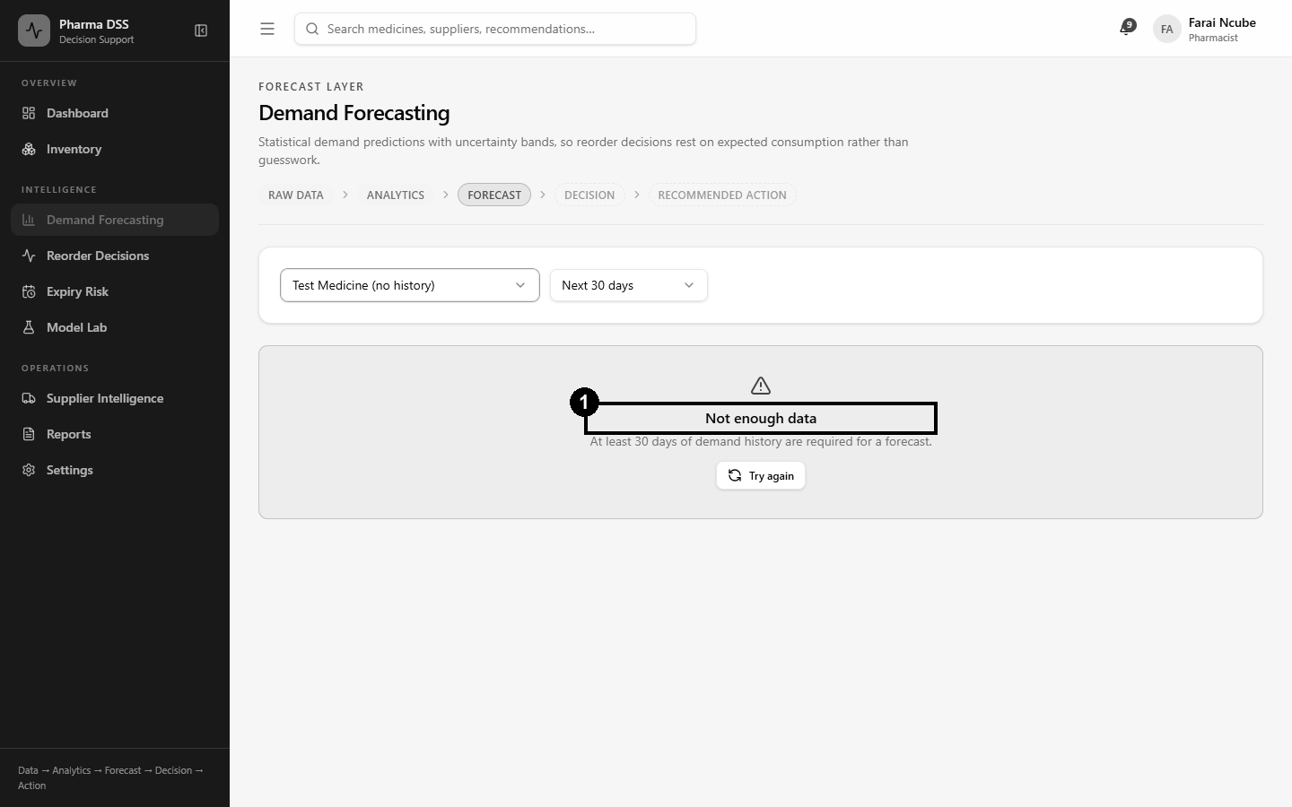
Figure 5.7: ST-12, a medicine with no history

ST-07, ST-08 and ST-13: The Decision Engine
Figure 5.8 shows the decision engine before the what-if test. Paracetamol had 5,285 units in stock and needed no action.
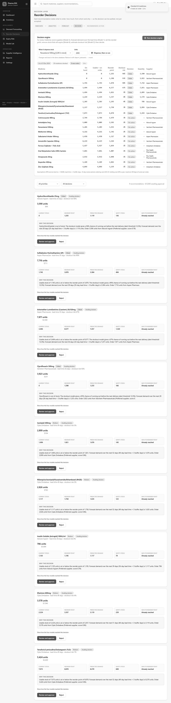
Figure 5.8: Decision engine results before the what-if dispense
Next, 4,000 units of Paracetamol were dispensed, and the engine ran again. Figure 5.9 shows the result. Marker 1 shows that Paracetamol now needs an order with a 64% stockout risk.
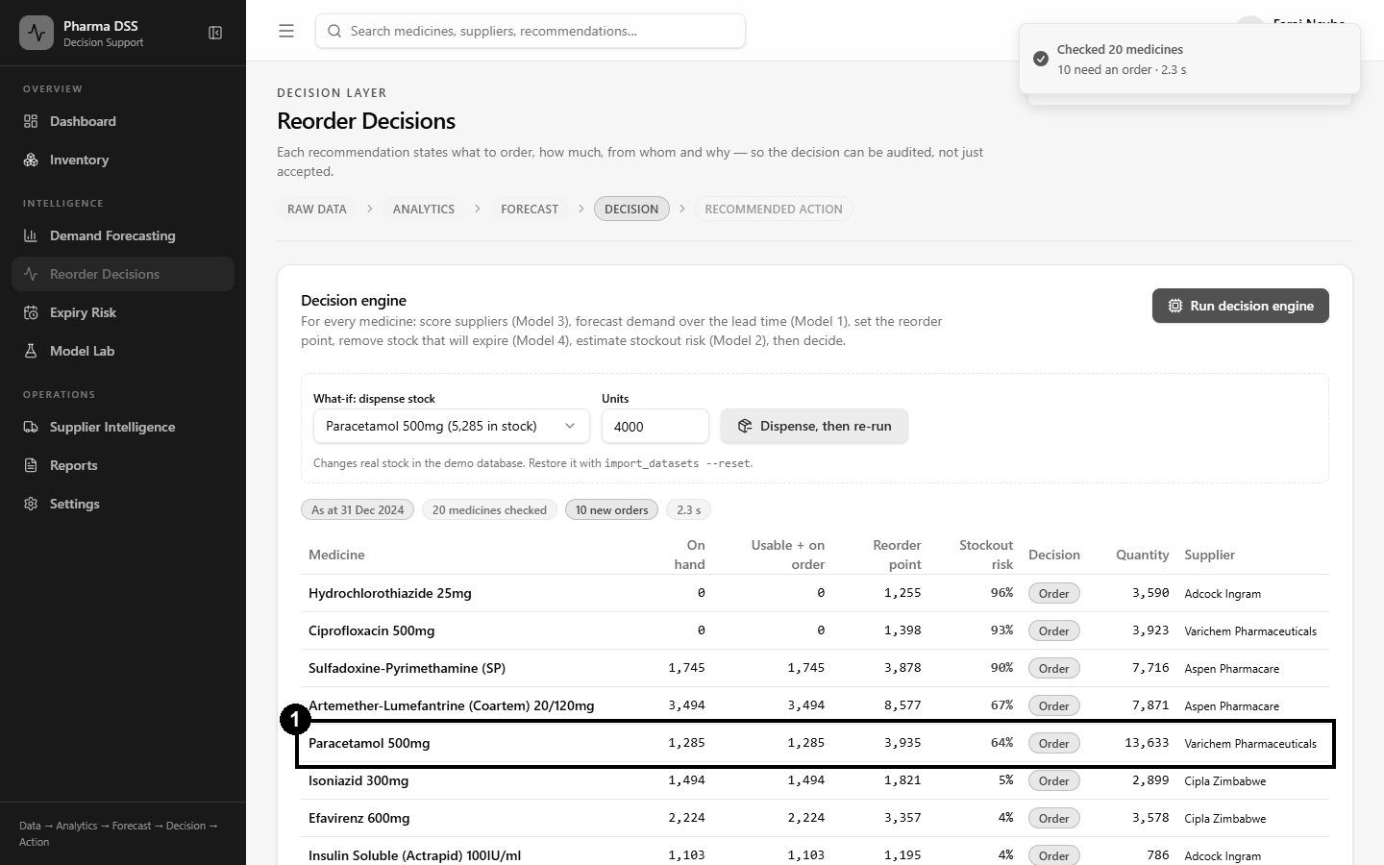
Figure 5.9: ST-07, Paracetamol moves into the risk zone after dispensing
Figure 5.10 shows a dispense of minus five units. Marker 1 shows that the system rejected it with a clear message.
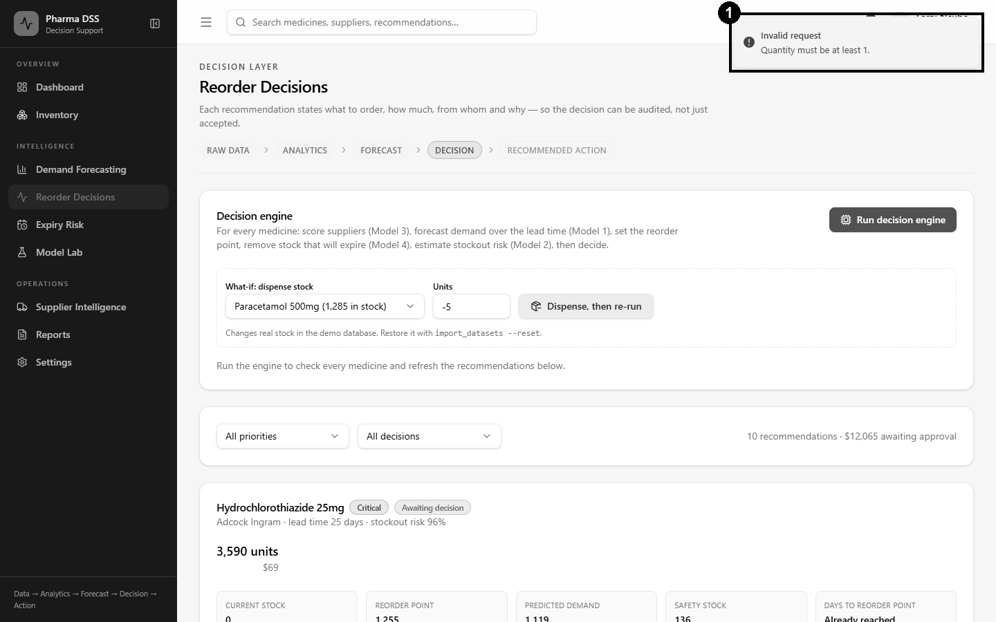
Figure 5.10: ST-13, a negative quantity is rejected
Figure 5.11 shows the full chain of reasoning for the Paracetamol recommendation. It lists the supplier choice, forecast, reorder point, expiry check, stockout risk and quantity.
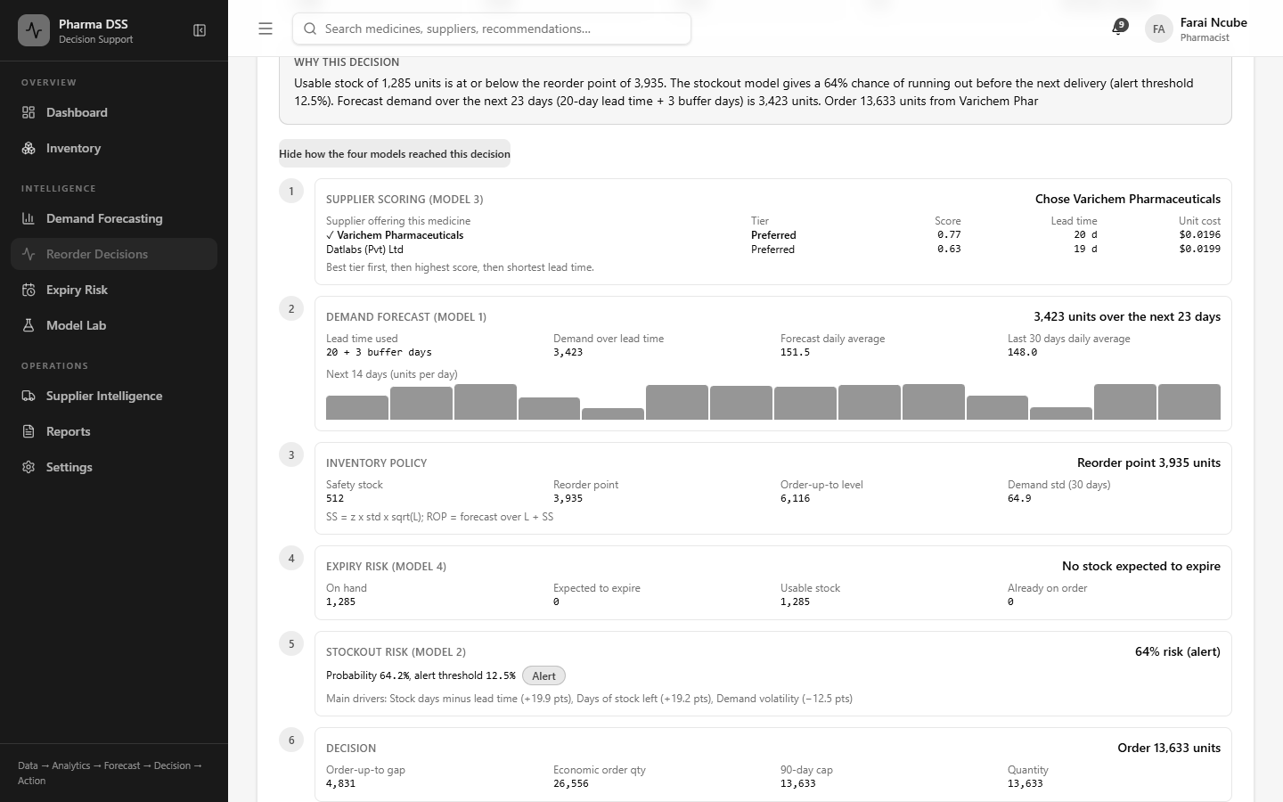
Figure 5.11: The four-model decision chain for a recommendation
The pharmacist then approved the recommendation. Figure 5.12 shows the result. Marker 1 shows the approved status. Marker 2 records who made the decision.
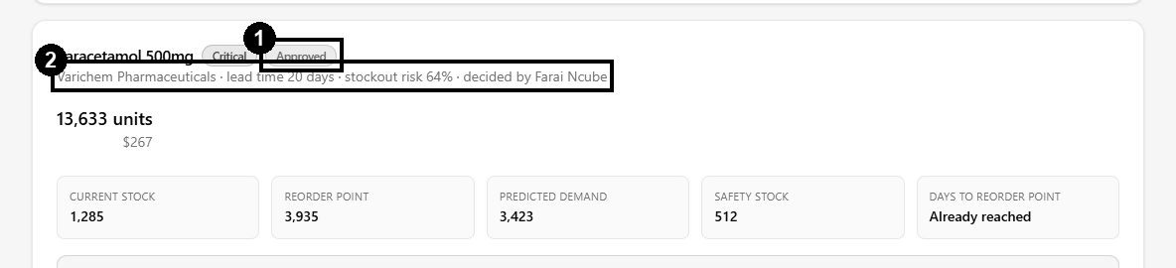
Figure 5.12: ST-08, recommendation approved and recorded

ST-09, ST-10 and ST-11: Suppliers, Expiry and Reports
Figure 5.13 shows the supplier page with scores and tiers. Marker 1 shows a supplier flagged for review because of its low tier.
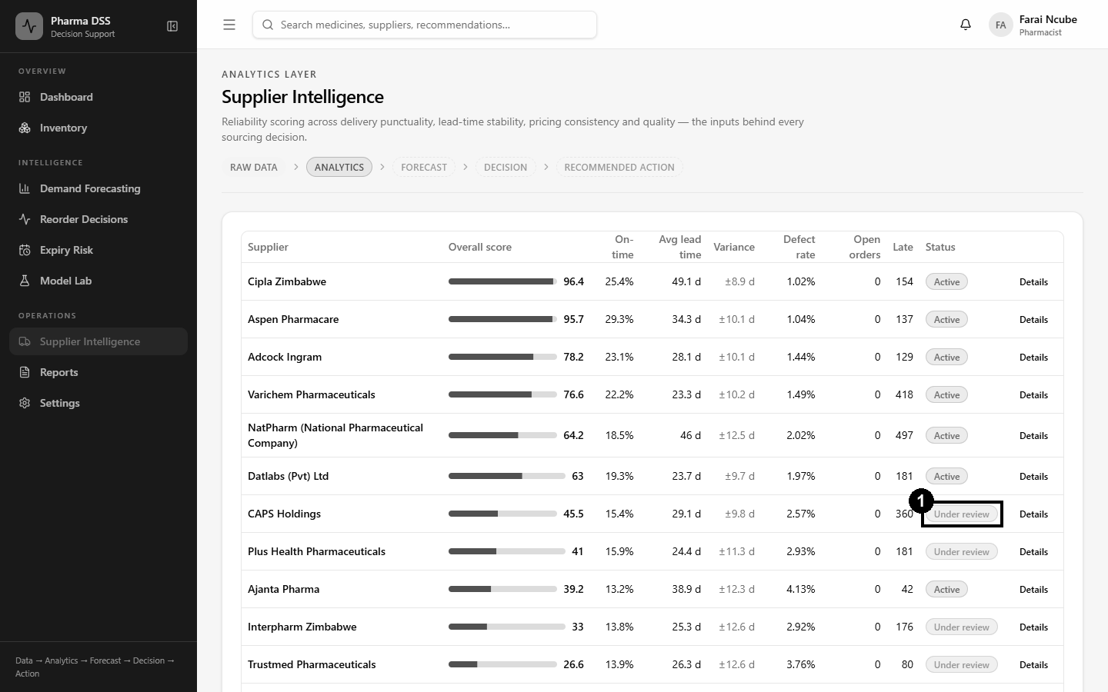
Figure 5.13: ST-09, supplier performance page
Figure 5.14 shows the expiry page, with batches in first-expiry-first-out order.
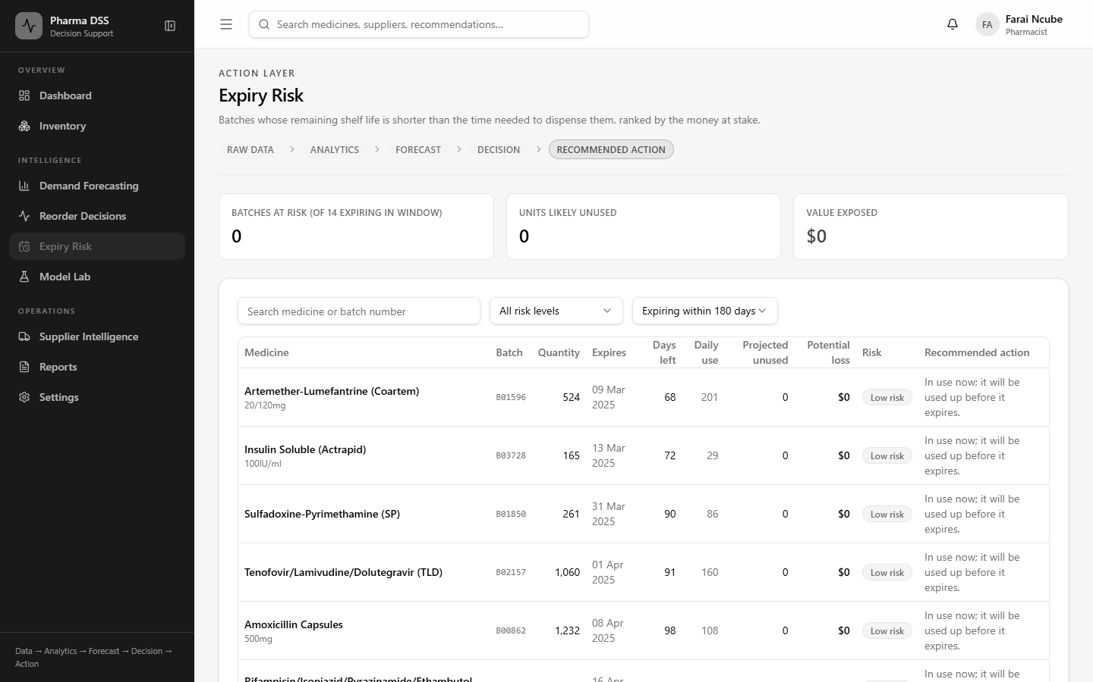
Figure 5.14: ST-10, expiry risk page
Figure 5.15 shows a generated inventory report. Marker 1 shows the row count. The downloaded CSV file was opened and checked. It held 20 data rows, one for each medicine.
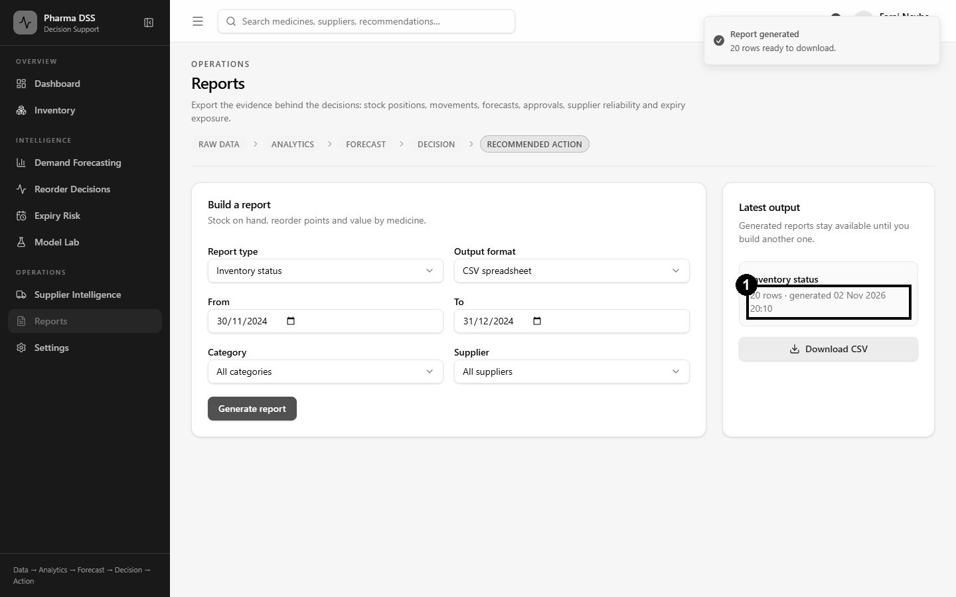
Figure 5.15: ST-11, inventory report generated and downloaded

The Model Lab What-If Test
Figures 5.16 and 5.17 show a what-if test in the Model Lab. Coartem first showed a stockout risk of 67.5%, which raised an alert. After 5,000 units were added, the risk fell to 7.8% and the alert cleared.
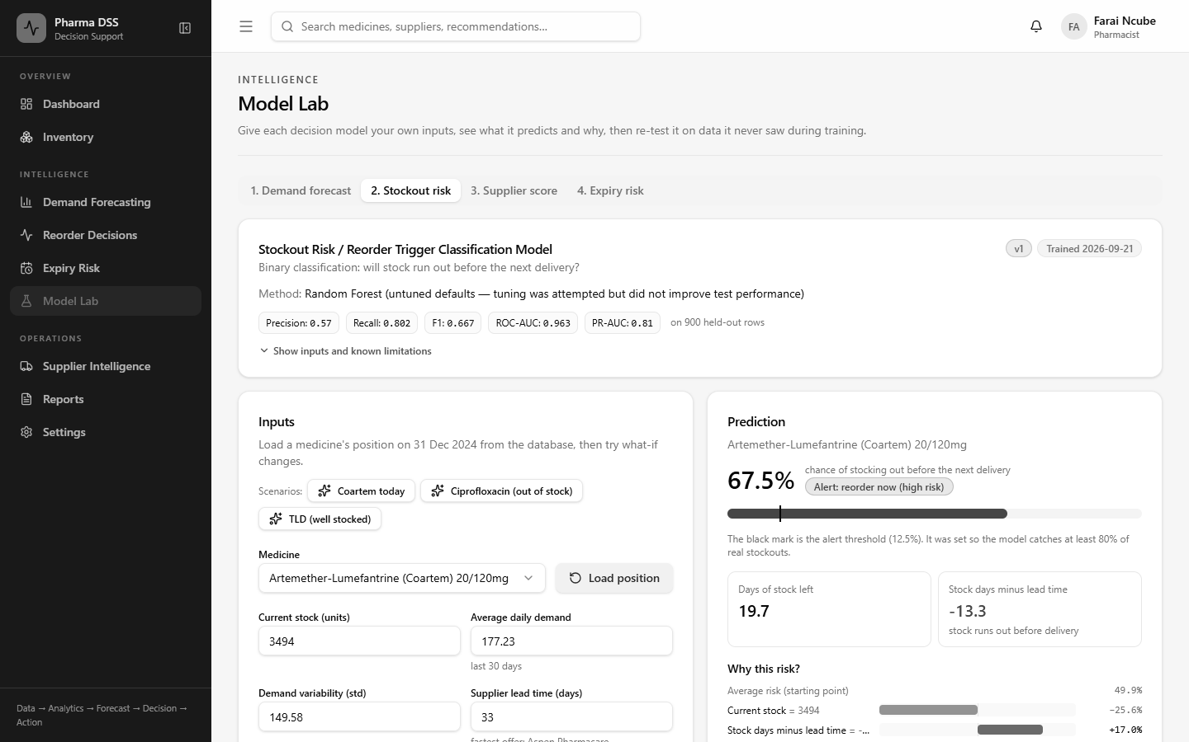
Figure 5.16: Stockout risk for Coartem before the what-if change
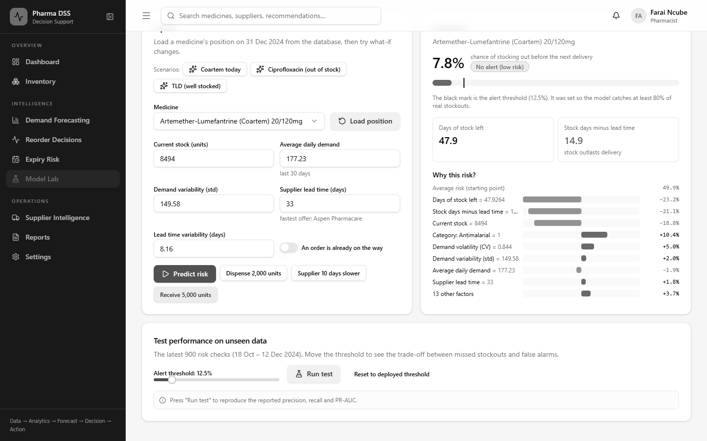
Figure 5.17: Stockout risk for Coartem after adding 5,000 units

5.2.5 Performance Testing
Response times were measured on the development laptop with the server running locally. Table 5.5 shows the median of five runs for each operation.
Operation | Target | Measured (median) | Result
Run decision engine for 20 medicines | under 5 s | 1.51 s | Pass
30-day demand forecast for one medicine | under 3 s | 0.18 s | Pass
90-day demand forecast for one medicine | under 3 s | 0.50 s | Pass
Model Lab: one demand prediction with explanation | under 3 s | 0.10 s | Pass
Model Lab: re-test demand model (repeat run, cached) | under 3 s | 0.02 s | Pass
Inventory list (20 medicines) | under 3 s | 0.01 s | Pass
Dashboard indicators | under 3 s | 0.17 s | Pass
Generate PDF inventory report | under 3 s | 0.11 s | Pass
Dashboard page fully loaded in the browser | under 3 s | 1.05 s | Pass
Table 5.5: Performance test results
All operations met their targets. The slowest step is the very first page load after the development server starts. This happens because the development server compiles each page on first use. A production build is compiled in advance, so users do not see this delay.

5.2.6 Defects Found and Fixed
Testing found several defects. Each one was fixed and then re-tested. Table 5.6 lists the most important ones.
ID | Defect found | Severity | Fix
D-01 | Approving a recommendation crashed because the order date was never set. | High | Order date set; delivery date now uses the supplier lead time.
D-02 | Several screens showed fixed sample numbers instead of calculated ones. | High | Every figure now comes from the data and the decision engine.
D-03 | The interface and the API used different data formats on four pages. | High | Formats aligned and checked by automated tests.
D-04 | Stockout days lowered demand averages, e.g. a false 202% rise for Ibuprofen. | High | Stockout days are excluded from demand statistics.
D-05 | After approval, the engine proposed a second, duplicate order. | Medium | It now advises expediting the open order instead.
D-06 | A full decision run took about 21 seconds. | Medium | Trees called directly; a run now takes about 1.5 seconds.
D-07 | Pharmacists could not approve orders, unlike the design. | Medium | Role permissions updated to match Chapter Four.
D-08 | Reports were saved as JSON files with the wrong extension. | Medium | Real CSV and PDF files are now produced.
D-09 | A missing model file revealed the server's folder path. | Medium | Messages now name the file only.
D-10 | The model list crashed (HTTP 500) when a model file was missing. | Medium | It now returns a clear 'model unavailable' message.
D-11 | Some errors showed only 'Something went wrong'. | Low | Plain messages added for too many attempts, conflicts, missing data and unavailable models.
D-12 | Every medicine looked close to expiry because of how demo batches were chosen. | Low | Batches now reflect a realistic mix of expiry dates.
D-13 | The 10-per-minute login limit was configured but never enforced. | High | Rate limiting switched on and covered by a new automated test.
Table 5.6: Defect log

5.2.7 User Acceptance Testing
User acceptance testing checks whether real users find the system useful. It will be carried out with pharmacists and technicians at the PGH Pharmacy Department. Each participant will complete five tasks without help. They will log in, check a medicine's stock and forecast, and run the decision engine. They will then approve one recommendation and download a report. They will then rate it on a five-point scale using the form in Appendix C. The system passes if at least 70% rate it useful or very useful. Table 5.7 shows the tasks and acceptance criteria.
Task | Acceptance criterion
Log in with your own account | Completed without help
Find the stock, reorder point and forecast for Coartem | Completed in under two minutes
Run the decision engine and explain one recommendation | Participant can state the main reason
Approve or reject a recommendation | Completed without help
Download the inventory report | File opens correctly
Overall rating | At least 70% rate the system useful or very useful
Table 5.7: User acceptance test plan
The results of this testing will be reported in Chapter Six.

5.3 Summary
All planned parts of the system were implemented. These include the four models, the decision engine, the Model Lab and every designed page. All 35 automated tests, all 10 model tests and all 14 system tests passed. Performance targets were met, with a full decision run taking about 1.5 seconds.
Several challenges arose during coding and testing. The datasets were simulated, so results must still be confirmed with real PGH records. Stockout days hid true demand until the engine was changed to ignore them. The expiry classifier did not beat a simple rule, so the rule was kept. The development server was slow to start on the test laptop. Testing also found thirteen defects, and all were fixed and re-tested.
Some areas need further work. User acceptance testing with PGH staff must be completed. The models should be retrained on real hospital data. Multi-factor login should be added for administrators. Links to eLMIS and Impilo would remove the need for manual data loading. The next chapter discusses the results against the objectives of the study.

CHAPTER SIX: RESULTS AND DISCUSSIONS

6.0 Introduction
Chapter Five showed that the system was built and that it passed its tests. This chapter asks a different question. Did the system achieve what the study set out to do? Each objective from Chapter One is linked to the features that meet it. Screen dumps of the working system show each objective in action. The results are then compared with the studies reviewed in Chapter Two. The chapter ends with the limitations, recommendations for further research and a conclusion.

6.1 Achievement of Objectives
Table 6.1 gives a summary before each objective is discussed.
Objective | Feature that meets it | Key evidence | Status
1. Analyse current practices at PGH | Background study and gap analysis | Five gaps identified (Section 1.2.2) | Partly achieved
2. Forecast daily demand | Model 1: Random Forest regression | MAE 21.30 vs 39.36 naive | Achieved
3. Predict stockout risk | Model 2: Random Forest classifier | Recall 80.2%, PR-AUC 0.81 | Achieved
4. Score suppliers | Model 3: weighted score and K-Means | ARI 1.000; rank stability 0.994 | Achieved
5. Flag expiry risk | Model 4: depletion rule with FEFO | 95.53% agreement; F1 0.951 | Achieved
6. Integrate into a secure web system | Decision engine, Model Lab, role-based pages | All four models run in 1.5 seconds | Achieved
7. Evaluate the system | Automated, model, system and performance tests | 59 of 59 tests passed | Partly achieved
Table 6.1: Summary of objectives and their achievement

6.1.1 Objective 1: Analyse Current Inventory and Procurement Practices
The first objective was to understand how the PGH pharmacy plans and orders medicines. Chapter One described the current tools: stock cards, ledgers, spreadsheets, eLMIS reports and Impilo. It found five gaps. There was no demand forecasting, no early stockout warning and no objective supplier rating. Expiry tracking was weak, and reports did not lead to clear actions. Each gap shaped one part of the system, as Table 6.2 shows.
Gap found | Feature that addresses it
No demand forecasting | Daily forecasts for every medicine, with an 80% prediction interval
No early stockout warning | Stockout probability before the next delivery, with alerts
No objective supplier rating | Supplier scores and tiers from delivery records
Weak expiry tracking | First-expiry-first-out check of every batch against the forecast
No link from data to action | Decision engine that recommends what, how much and from whom
Table 6.2: Gaps in the current system and the features that address them
This objective is marked as partly achieved. The gaps came from the literature, national reports and the design of the current tools. They still need to be confirmed with PGH staff through the planned questionnaire and interviews.

6.1.2 Objective 2: Forecast Daily Medicine Demand
The second objective was a machine learning model that forecasts daily demand for each medicine. A single Random Forest model was trained across all 20 medicines. On 1,020 unseen test days, its mean absolute error was 21.30 units a day. A naive forecast, which repeats yesterday's demand, had an error of 39.36. The model therefore cut the error by 45.9%. Figure 6.1 shows this result being reproduced live in the Model Lab.
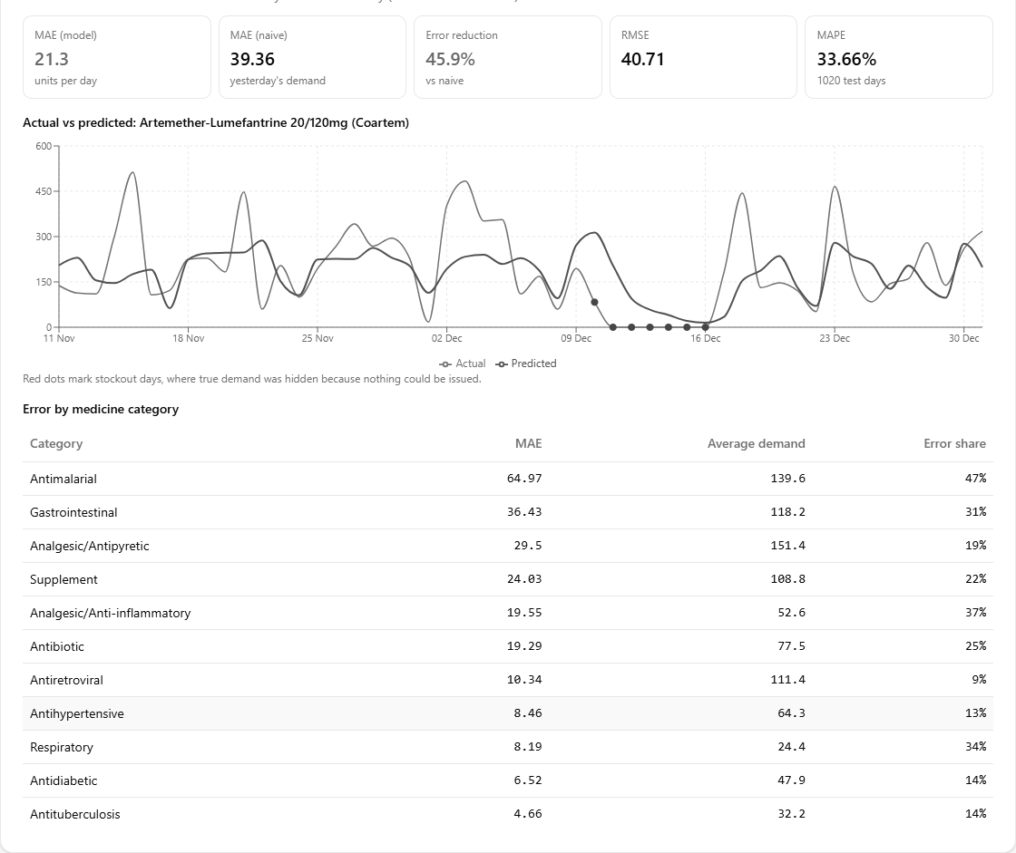
Figure 6.1: Demand model re-tested on unseen data in the Model Lab
The model forecasts steady medicines best. Errors were lowest for TB medicines and antiretrovirals. They were 9% to 14% of average demand. Errors were highest for antimalarials, at about 47% of average demand. Malaria demand rises and falls sharply in the rainy season. This makes it hard to predict. The black dots in Figure 6.1 mark stockout days, when true demand was hidden.
These results agree with Mbonyinshuti et al. (2022). They also found Random Forest a reliable forecaster of essential medicines in Rwanda. One shared model for all medicines also won the M5 competition (Makridakis et al., 2022). One finding was unexpected. The season feature contributed only 0.1% to the model's decisions. The 7-day average and the demand a week earlier contributed 65%. Recent demand already reflects the season, so the model learns the season from it indirectly.

6.1.3 Objective 3: Predict Stockout Risk
The third objective was a classifier that predicts stockout risk before the next delivery. Only about one check in ten was a stockout, so accuracy would have been misleading. The model was judged instead by recall and PR-AUC (Saito & Rehmsmeier, 2015). At an alert threshold of 0.125, it caught 80.2% of real stockouts. Its PR-AUC was 0.81, against 0.09 for a model that never raises an alert. Figure 6.2 shows the model scoring Coartem as at 31 December 2024.
Figure 6.2: Stockout risk for Coartem, with the reasons behind it
The model gave Coartem a 67.5% risk. Its stock would last about 20 days. The supplier needs about 33 days to deliver. The explanation bars show that this gap drove the alert. Three inputs mattered most. They were days of stock left, stock days minus lead time and current stock. Together they made up 75% of its decisions. This matches inventory theory, where stock must outlast the lead time (Silver et al., 2017).
The threshold choice has a cost. About four in ten alerts are false. This was accepted on purpose. A false alarm costs a pharmacist a minute to check. A missed stockout can interrupt treatment for patients on ARVs or TB medicines.

6.1.4 Objective 4: Score and Tier Suppliers
The fourth objective was a supplier scoring model. Each supplier was scored on on-time delivery, order fulfilment, price and defects. K-Means then grouped suppliers into Preferred, Acceptable and At-Risk tiers. Figure 6.3 shows a new supplier being scored and ranked against the existing twelve.
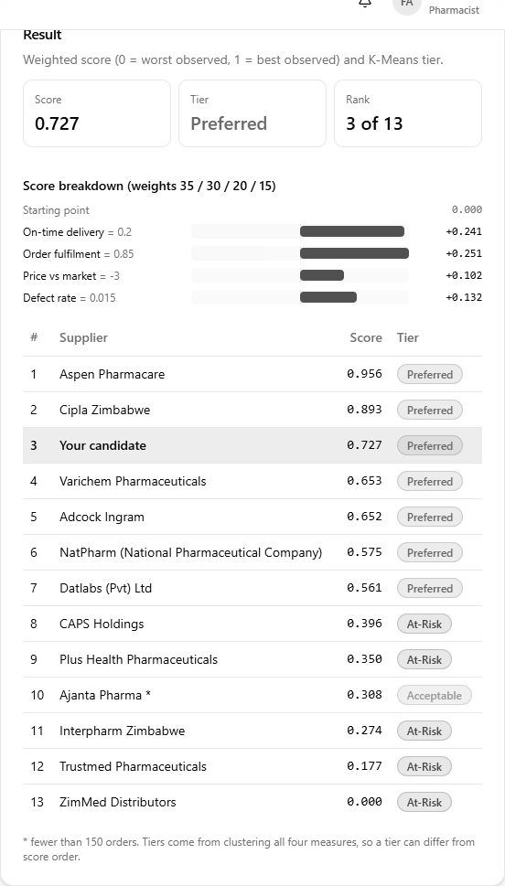
Figure 6.3: Scoring a candidate supplier in the Model Lab
There is no correct ranking to test a supplier score against. The model was therefore tested for consistency instead. An independent clustering method produced identical tiers, with an adjusted Rand index of 1.000. Changing the weights by up to 30% hardly moved the ranking. The mean correlation was 0.994. Figure 6.4 shows that the live system reproduces all twelve exported scores exactly.

Figure 6.4: Supplier scores recomputed live from 6,000 orders
Ho et al. (2010) noted that most supplier models rely on expert weights that are rarely tested. This study tested its weights and showed that the ranking does not depend on them. The results also raise a practical concern for PGH. Four medicines, including oral rehydration salts, are offered only by At-Risk suppliers. The pharmacy may need to qualify new suppliers for these items.

6.1.5 Objective 5: Flag Batches at Risk of Expiry
The fifth objective was an expiry risk module. The module compares how long a batch will last with its time to expiry. Batches are used earliest-expiry-first, in line with good pharmacy practice. Figure 6.5 shows a slow-moving batch being checked.
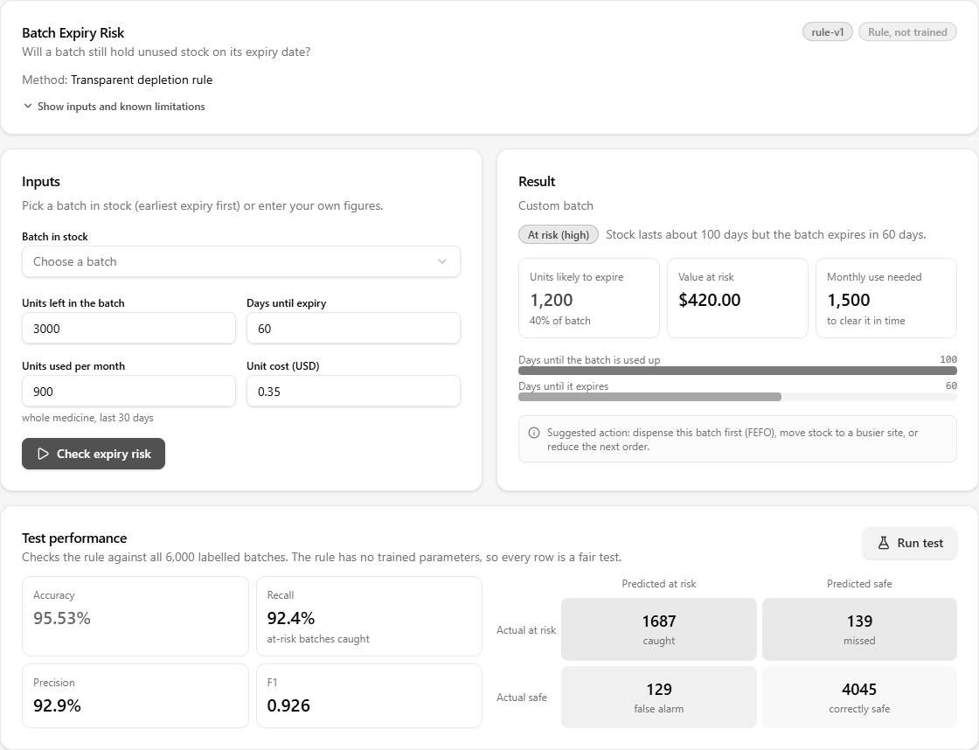
Figure 6.5: Expiry risk check and its test results
The batch in Figure 6.5 has 3,000 units and 60 days to expiry. At 900 units a month, it would take 100 days to use. About 1,200 units, worth USD 420, would therefore expire. Across 6,000 labelled batches, the rule agreed with 95.53% of the outcomes.
A Random Forest classifier was also trained for this task. On 560 unseen batches it scored an F1 of 0.946, against 0.951 for the rule. It also missed more at-risk batches. The rule was therefore kept. Machine learning should not replace a clear rule that works as well.

6.1.6 Objective 6: Integrate the Models into a Secure Web System
The sixth objective was to combine the models into one secure web system. The decision engine runs all four models for every medicine in about 1.5 seconds. It chooses a supplier, forecasts demand and sets the reorder point. It also removes stock that will expire. It then estimates the stockout risk and recommends an action. Figure 6.6 shows the full chain of reasoning for one recommendation.
Figure 6.6: How the four models reached one reorder decision
This design follows Simon's (1960) model of decision making. The models carry out the intelligence and design phases. The pharmacist keeps the choice phase by approving or rejecting each order. Security is enforced on the server for every request. Figure 6.7 shows the reduced menu that a stores staff account receives.
Figure 6.7: Role-based access for a stores staff account
The system also runs on the hospital network without internet access. Mugauri and Chimsimbe (2025) found that poor connectivity and power cuts limited Impilo in Zimbabwe. Designing for offline use addresses this local constraint directly.

6.1.7 Objective 7: Evaluate the System
The final objective was to evaluate the system with accuracy metrics and user acceptance testing. Table 6.3 summarises the technical evaluation reported in Chapter Five.
Test level | Tests | Passed
Automated backend tests | 35 | 35
Machine learning tests | 10 | 10
System functional tests | 14 | 14
Performance tests | 9 | 9
Table 6.3: Summary of the technical evaluation
Testing also found and fixed thirteen defects. The most serious was that login throttling had been configured but never switched on. Finding this before deployment shows the value of testing each claim against the running system.
User acceptance testing with PGH pharmacy staff is the remaining step. Its plan is set out in Section 5.2.7. Table 6.4 will record its results.
Measure | Result
Number of participants | [to be completed]
Tasks completed without help | [to be completed]
Participants rating the system useful or very useful | [to be completed]
Main suggestions from participants | [to be completed]
Table 6.4: User acceptance test results (to be completed after testing at PGH)
Until this testing is done, objective seven is only partly achieved.

6.1.8 Answers to the Research Questions
Research question | Answer from this study
RQ1: How does the pharmacy plan and order medicines? | Through periodic manual reviews of stock records. Five gaps were identified, pending staff confirmation.
RQ2: How accurately can ML forecast daily demand? | To within 21.3 units a day on average, 45.9% better than a naive forecast.
RQ3: Can a classifier detect stockout risk early enough to act? | Yes. It caught 80.2% of stockouts before the next delivery was due.
RQ4: How can suppliers be ranked fairly? | With a weighted score and clustering. The ranking was stable when weights changed.
RQ5: Can the models form one usable system? | Yes, technically. Acceptance by PGH staff is still to be tested.
Table 6.5: Answers to the research questions

6.2 Limitations and Constraints
Several limitations affect how far these results can be applied.
- Simulated data. Real PGH records were confidential, so the models were trained on simulated data. The results show what the system can do. They do not yet prove how it will perform at PGH.
- Short history. Only one year of demand data was available. The models could not learn how demand changes from year to year.
- Hidden demand. On stockout days, true demand was not recorded. The engine now ignores those days, but the true demand on them is still unknown.
- Forecast horizon. Accuracy was measured one day ahead. Longer forecasts feed predictions back in and are less certain.
- Few suppliers. Only twelve suppliers were scored, which limits the strength of the clustering results.
- Assumed costs. The ordering cost, holding cost and buffer days were assumptions. Real PGH figures may change the order sizes.
- User testing. Acceptance testing with PGH staff has not yet been carried out.
- Time and resources. The project had one academic year, a single developer and free cloud tools.
- Local conditions. Power cuts and slow internet affected development. The test laptop was also slow to start the server.
These limits do not undo the findings. They mean the results should be read as a tested proof of concept. A pilot on real PGH data must come before the system guides real orders.

6.3 Recommendations for Further Research
The following recommendations come directly from the experience of this project.
1. Pilot the system on real PGH data. Retrain each model on two or more years of records. Then compare the results with this study.
2. Record unmet demand. Staff could note how many patients were turned away during a stockout. This would reveal the demand that the current data hides.
3. Add disease data. Malaria case reports from the national health information system could give earlier warning.
4. Link to national systems. Links to eLMIS, Impilo and NatPharm would remove manual data loading. They would also support stock sharing.
5. Retrain regularly. Models should be retrained monthly, or when live error rises 20% above the test error.
6. Strengthen security. Multi-factor login for administrators and encrypted server disks should be added before full use.
7. Send alerts by SMS. Critical alerts could reach pharmacists by text message. SMS for Life did this in Tanzania (Barrington et al., 2010).
8. Train users continuously. Mbonane et al. (2023) found that training alone did not ensure good use of stock tools. Regular refresher sessions are needed.
9. Confirm the cost-benefit estimates. Real PGH expiry and purchase records should test the savings estimated in Chapter Two.

6.4 Conclusion
This study aimed to help the PGH pharmacy make evidence-based stock decisions. It developed and tested an Intelligent Decision Support System with four decision models. The demand model cut forecast error by almost half. The stockout model catches four in five stockouts before the next delivery. The supplier model ranks suppliers in a stable and explainable way. The expiry rule flags batches that will not be used in time.
The study's main contribution is how these models work together. One decision engine turns their outputs into a clear action for each medicine. Every recommendation shows its reasons, and a pharmacist must approve it. The system runs on ordinary computers and works without internet access. These features suit the conditions in Zimbabwean public hospitals.
The study also showed the value of honest evaluation. A rule was kept where machine learning did not improve on it. Hidden demand on stockout days was found and corrected. A security weakness was found in testing and fixed before deployment.
Much remains to be done before the system can guide real orders at PGH. It must be tested with pharmacy staff and retrained on real hospital data. Even so, the results show that machine learning can help Zimbabwe's public pharmacies. It can reduce stockouts, cut waste and support better use of scarce funds. In this way, it supports Vision 2030 and reliable access to essential medicines.

REFERENCES
African Union Commission. (2015). Agenda 2063: The Africa we want. African Union Commission.
AIDSFree Project. (2019). Zambia eLMIS endline evaluation report. JSI Research & Training Institute.
Akiba, T., Sano, S., Yanase, T., Ohta, T., & Koyama, M. (2019). Optuna: A next-generation hyperparameter optimization framework. In Proceedings of the 25th ACM SIGKDD International Conference on Knowledge Discovery & Data Mining (pp. 2623–2631). ACM. https://doi.org/10.1145/3292500.3330701
Barrington, J., Wereko-Brobby, O., Ward, P., Mwafongo, W., & Kungulwe, S. (2010). SMS for Life: A pilot project to improve anti-malarial drug supply management in rural Tanzania using standard technology. Malaria Journal, 9, 298. https://doi.org/10.1186/1475-2875-9-298
Braun, V., & Clarke, V. (2006). Using thematic analysis in psychology. Qualitative Research in Psychology, 3(2), 77–101. https://doi.org/10.1191/1478088706qp063oa
Breiman, L. (2001). Random forests. Machine Learning, 45(1), 5–32. https://doi.org/10.1023/A:1010933404324
Carbonneau, R., Laframboise, K., & Vahidov, R. (2008). Application of machine learning techniques for supply chain demand forecasting. European Journal of Operational Research, 184(3), 1140–1154. https://doi.org/10.1016/j.ejor.2006.12.004
Chen, T., & Guestrin, C. (2016). XGBoost: A scalable tree boosting system. In Proceedings of the 22nd ACM SIGKDD International Conference on Knowledge Discovery and Data Mining (pp. 785–794). ACM. https://doi.org/10.1145/2939672.2939785
Codd, E. F. (1970). A relational model of data for large shared data banks. Communications of the ACM, 13(6), 377–387. https://doi.org/10.1145/362384.362685
Creswell, J. W., & Creswell, J. D. (2018). Research design: Qualitative, quantitative, and mixed methods approaches (5th ed.). SAGE.
de Santis, R. B., de Aguiar, E. P., & Goliatt, L. (2017). Predicting material backorders in inventory management using machine learning. In 2017 IEEE Latin American Conference on Computational Intelligence (LA-CCI) (pp. 1–6). IEEE.
Dickson, G. W. (1966). An analysis of vendor selection systems and decisions. Journal of Purchasing, 2(1), 5–17.
Elmasri, R., & Navathe, S. B. (2016). Fundamentals of database systems (7th ed.). Pearson.
Etikan, I., Musa, S. A., & Alkassim, R. S. (2016). Comparison of convenience sampling and purposive sampling. American Journal of Theoretical and Applied Statistics, 5(1), 1–4. https://doi.org/10.11648/j.ajtas.20160501.11
Fourkiotis, K. P., & Tsadiras, A. (2024). Applying machine learning and statistical forecasting methods for enhancing pharmaceutical sales predictions. Forecasting, 6(1), 170–186. https://doi.org/10.3390/forecast6010010
Fowler, M. (2004). UML distilled: A brief guide to the standard object modeling language (3rd ed.). Addison-Wesley.
Gane, C., & Sarson, T. (1979). Structured systems analysis: Tools and techniques. Prentice Hall.
Government of Zimbabwe. (2018). Vision 2030: Towards a prosperous and empowered upper middle income society by 2030. Government of Zimbabwe.
Government of Zimbabwe. (2020). National Development Strategy 1: January 2021 – December 2025. Government of Zimbabwe.
Government of Zimbabwe. (2021). Cyber and Data Protection Act [Chapter 12:07] (Act No. 5 of 2021). Government Printer.
Harris, F. W. (1913). How many parts to make at once. Factory, The Magazine of Management, 10(2), 135–136.
Hevner, A. R., March, S. T., Park, J., & Ram, S. (2004). Design science in information systems research. MIS Quarterly, 28(1), 75–105. https://doi.org/10.2307/25148625
Ho, W., Xu, X., & Dey, P. K. (2010). Multi-criteria decision making approaches for supplier evaluation and selection: A literature review. European Journal of Operational Research, 202(1), 16–24. https://doi.org/10.1016/j.ejor.2009.05.009
Hubert, L., & Arabie, P. (1985). Comparing partitions. Journal of Classification, 2(1), 193–218. https://doi.org/10.1007/BF01908075
Hyndman, R. J., & Athanasopoulos, G. (2021). Forecasting: Principles and practice (3rd ed.). OTexts. https://otexts.com/fpp3/
International Organization for Standardization. (2022). ISO/IEC 27001:2022 Information security, cybersecurity and privacy protection: Information security management systems: Requirements. ISO.
Ivanov, D. (2020). Predicting the impacts of epidemic outbreaks on global supply chains: A simulation-based analysis on the coronavirus outbreak (COVID-19/SARS-CoV-2) case. Transportation Research Part E: Logistics and Transportation Review, 136, 101922. https://doi.org/10.1016/j.tre.2020.101922
Jones, M., Bradley, J., & Sakimura, N. (2015). JSON Web Token (JWT) (RFC 7519). Internet Engineering Task Force. https://doi.org/10.17487/RFC7519
Ke, G., Meng, Q., Finley, T., Wang, T., Chen, W., Ma, W., Ye, Q., & Liu, T.-Y. (2017). LightGBM: A highly efficient gradient boosting decision tree. In Advances in Neural Information Processing Systems 30 (pp. 3146–3154).
Lundberg, S. M., & Lee, S.-I. (2017). A unified approach to interpreting model predictions. In Advances in Neural Information Processing Systems 30 (pp. 4765–4774).
Makridakis, S., Spiliotis, E., & Assimakopoulos, V. (2022). M5 accuracy competition: Results, findings, and conclusions. International Journal of Forecasting, 38(4), 1346–1364. https://doi.org/10.1016/j.ijforecast.2021.11.013
Mbonane, H., Sibanda, M., Godman, B., Meyer, J. C., & Matlala, M. (2023). Knowledge, attitudes and practices of healthcare professionals on the use of an electronic stock visibility and management tool in a middle-income country: Implications for the future. Exploratory Research in Clinical and Social Pharmacy, 9, 100233.
Mbonyinshuti, F., Nkurunziza, J., Niyobuhungiro, J., & Kayitare, E. (2022). The prediction of essential medicines demand: A machine learning approach using consumption data in Rwanda. Processes, 10(1), 26. https://doi.org/10.3390/pr10010026
Mehrabi, N., Morstatter, F., Saxena, N., Lerman, K., & Galstyan, A. (2021). A survey on bias and fairness in machine learning. ACM Computing Surveys, 54(6), 1–35. https://doi.org/10.1145/3457607
Ministry of Health and Child Care. (2021). National health strategy for Zimbabwe 2021–2025. Government of Zimbabwe.
Mugauri, H. D., & Chimsimbe, M. (2025). Electronic health record systems in limited resource settings: A comprehensive evaluation of the Impilo platform. Acta Informatica Pragensia, 14(3), 393–407. https://doi.org/10.18267/j.aip.265
Nielsen, J. (1993). Usability engineering. Academic Press.
Office of the Auditor-General. (2025). Report of the Auditor-General on the management of medicines and medical supplies in public hospitals. Office of the Auditor-General of Zimbabwe.
Peffers, K., Tuunanen, T., Rothenberger, M. A., & Chatterjee, S. (2007). A design science research methodology for information systems research. Journal of Management Information Systems, 24(3), 45–77. https://doi.org/10.2753/MIS0742-1222240302
Power, D. J. (2002). Decision support systems: Concepts and resources for managers. Quorum Books.
Rousseeuw, P. J. (1987). Silhouettes: A graphical aid to the interpretation and validation of cluster analysis. Journal of Computational and Applied Mathematics, 20, 53–65. https://doi.org/10.1016/0377-0427(87)90125-7
Saabas, A. (2014, October 19). Interpreting random forests. Diving into Data. https://blog.datadive.net/interpreting-random-forests/
Saito, T., & Rehmsmeier, M. (2015). The precision-recall plot is more informative than the ROC plot when evaluating binary classifiers on imbalanced datasets. PLoS ONE, 10(3), e0118432. https://doi.org/10.1371/journal.pone.0118432
Schwaber, K., & Sutherland, J. (2020). The Scrum guide: The definitive guide to Scrum. Scrum.org.
Settanni, E., Harrington, T. S., & Srai, J. S. (2017). Pharmaceutical supply chain models: A synthesis from a systems view of operations research. Operations Research Perspectives, 4, 74–95. https://doi.org/10.1016/j.orp.2017.05.002
Silver, E. A., Pyke, D. F., & Thomas, D. J. (2017). Inventory and production management in supply chains (4th ed.). CRC Press.
Simon, H. A. (1960). The new science of management decision. Harper & Row.
Sommerville, I. (2016). Software engineering (10th ed.). Pearson.
Strubell, E., Ganesh, A., & McCallum, A. (2019). Energy and policy considerations for deep learning in NLP. In Proceedings of the 57th Annual Meeting of the Association for Computational Linguistics (pp. 3645–3650). ACL. https://doi.org/10.18653/v1/P19-1355
United Nations. (2015). Transforming our world: The 2030 Agenda for Sustainable Development (A/RES/70/1). United Nations.
USAID | DELIVER PROJECT. (2015). Evaluation of the Zimbabwe Assisted Pull System. USAID | DELIVER PROJECT, Task Order 4.
Uthayakumar, R., & Priyan, S. (2013). Pharmaceutical supply chain and inventory management strategies: Optimization for a pharmaceutical company and a hospital. Operations Research for Health Care, 2(3), 52–64. https://doi.org/10.1016/j.orhc.2013.08.001
Wirth, R., & Hipp, J. (2000). CRISP-DM: Towards a standard process model for data mining. In Proceedings of the 4th International Conference on the Practical Applications of Knowledge Discovery and Data Mining (pp. 29–39).

