**RESULTS**

|  |  |  |
| --- | --- | --- |
| **Sr. No**  **CT-IMAGE** | **RESULT** | **ACCURACY** |
| 1 | CLASS: COVID: SEVER STAGE--: | 87.5694334 |
| 2 | CLASS: COVID: SEVER STAGE--: | 97.5403666 |
| 3 | CLASS: NORMAL--: | 75.5148303 |
| 4 | CLASS: NORMAL--: | 73.6744463 |
| 5 | CLASS: NORMAL--: | 75.9560763 |
| 6 | CLASS: COVID: I STAGE--: | 85.7575285 |
| 7 | CLASS: COVID: I STAGE--: | 61.4524841 |
| 8 | CLASS: COVID: I STAGE--: | 61.3773047 |
| 9 | CLASS: COVID: SEVER STAGE--: | 75.4104971 |
| 10 | CLASS: COVID: II STAGE--: | 82.1750277 |
| 11 | CLASS: COVID: II STAGE--: | 85.3173756 |
| 12 | CLASS: COVID: II STAGE--: | 68.1913495 |
| 13 | CLASS: COVID: I STAGE--: | 81.6228806 |
| 14 | CLASS: COVID: SEVER STAGE--: | 76.7807185 |
| 15 | CLASS: COVID: II STAGE--: | 74.2959177 |
| 16 | CLASS: COVID: II STAGE--: | 82.0725309 |
| 17 | CLASS: COVID: I STAGE--: | 79.2593634 |
| 18 | CLASS: COVID: I STAGE--: | 71.1944472 |
| 19 | CLASS: COVID: II STAGE--: | 74.9860584 |
| 20 | CLASS: COVID: SEVER STAGE--: | 79.5301365 |
| 21 | CLASS: COVID: I STAGE--: | 80.2773654 |
| 22 | CLASS: COVID: II STAGE--: | 74.5178079 |
| 23 | CLASS: COVID: I STAGE--: | 80.7681912 |
| 24 | CLASS: COVID: I STAGE--: | 78.4962570 |
| 25 | CLASS: COVID: I STAGE--: | 80.6470036 |
| 26 | CLASS: NORMAL--: | 73.6744463 |
| 27 | CLASS: NORMAL--: | 85.5148303 |
| 28 | CLASS: COVID: SEVER STAGE--: | 85.3173756 |
| 29 | CLASS: COVID: SEVER STAGE--: | 82.0725309 |
| 30 | CLASS: COVID: I STAGE--: | 81.6228806 |

**Table Test Result**

|  |  |
| --- | --- |
| **SUMMARY RESULT**  **(Using pandas in python)** | |
| Count | 30.000000 |
| Mean(average accuracy) | 78.419582 |
| Std | 7.372587 |
| Min | 61.377305 |
| 25% | 74.634871 |
| 50% | 79.394750 |
| 75% | 82.072531 |
| Max | 97.540367 |

**Table Summary result**

|  |  |
| --- | --- |
| **Class Type** | **No of Class** |
| CLASS: COVID: I STAGE--: | 11 |
| CLASS: COVID: II STAGE--: | 7 |
| CLASS: COVID: SEVER STAGE--: | 7 |
| CLASS: NORMAL--: | 5 |

**Table Class type**

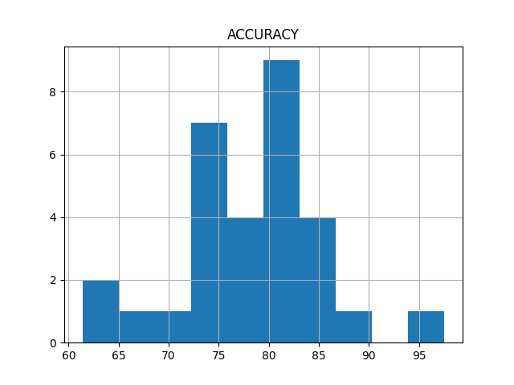

**Fig Accuracy Histogram**

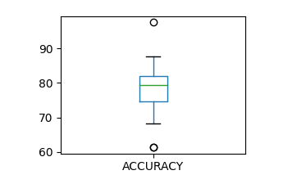

**Fig Accuracy Box Plot**