**1/Create a database called "contact"**



**2/Create a collection called "contactlist"**



**3/insert 3 persons in "contactlist" :**

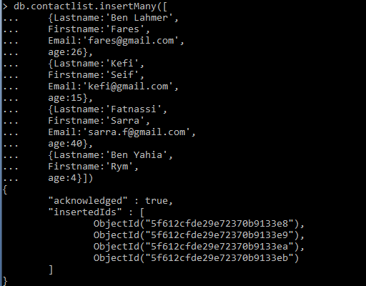

**4/Display all the contact list :**

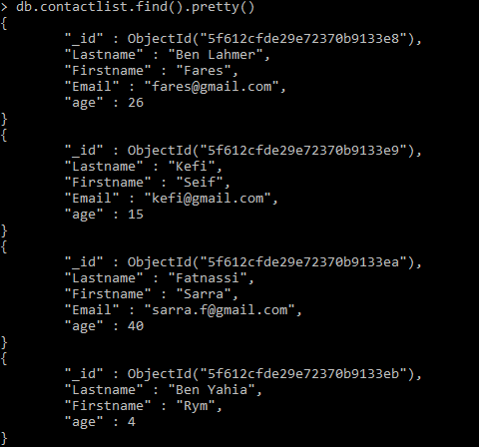

**5/Display all the information about only one person using his id :**

**6/Display all the contact list having age>18 :**

**7/Display all the contact list having age>18 and name "ah" :**

**8/Change the contact first name of "kefi Seif" by "Kefi Anis ":**

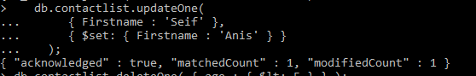

**9/Delete the the contact list having age < 5 :**



**10/Display all the contact list :**

