# Monthly Sales Data Visualization

## 1. Line Plot

import matplotlib.pyplot as plt  
  
months = ['Jan', 'Feb', 'Mar', 'Apr', 'May', 'Jun',  
 'Jul', 'Aug', 'Sep', 'Oct', 'Nov', 'Dec']  
sales = [1500, 1800, 1700, 1600, 2000, 2100,  
 2200, 1900, 2300, 2400, 2500, 2600]  
  
plt.figure(figsize=(10, 5))  
plt.plot(months, sales, marker='o', linestyle='-', color='blue', label='Sales')  
plt.title('Monthly Sales Line Plot')  
plt.xlabel('Month')  
plt.ylabel('Sales ($)')  
plt.grid(True)  
plt.legend()  
plt.tight_layout()  
plt.show()

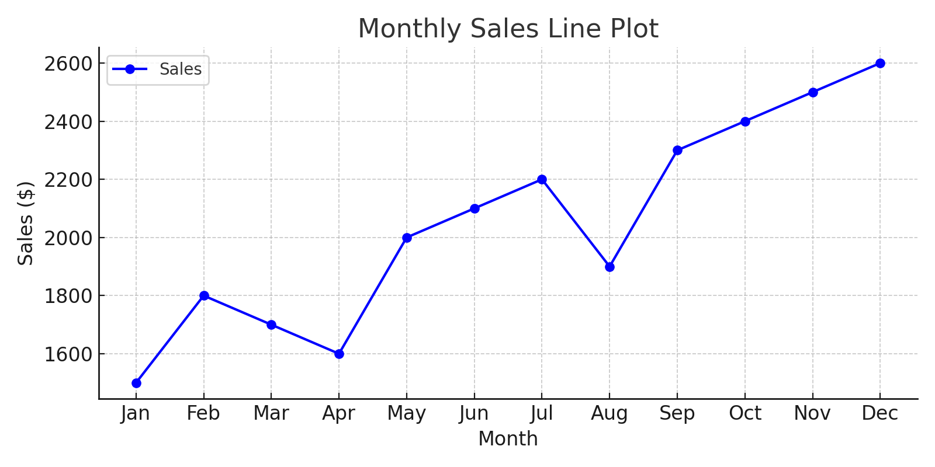

## 2. Bar Plot

import matplotlib.pyplot as plt  
  
months = ['Jan', 'Feb', 'Mar', 'Apr', 'May', 'Jun',  
 'Jul', 'Aug', 'Sep', 'Oct', 'Nov', 'Dec']  
sales = [1500, 1800, 1700, 1600, 2000, 2100,  
 2200, 1900, 2300, 2400, 2500, 2600]  
  
plt.figure(figsize=(10, 5))  
plt.bar(months, sales, color='green')  
plt.title('Monthly Sales Bar Plot')  
plt.xlabel('Month')  
plt.ylabel('Sales ($)')  
plt.tight_layout()  
plt.show()

