Monthly Weather Data Visualization

# 1. Monthly Temperature Line Plot

The following line plot shows the monthly temperature in degrees Celsius.

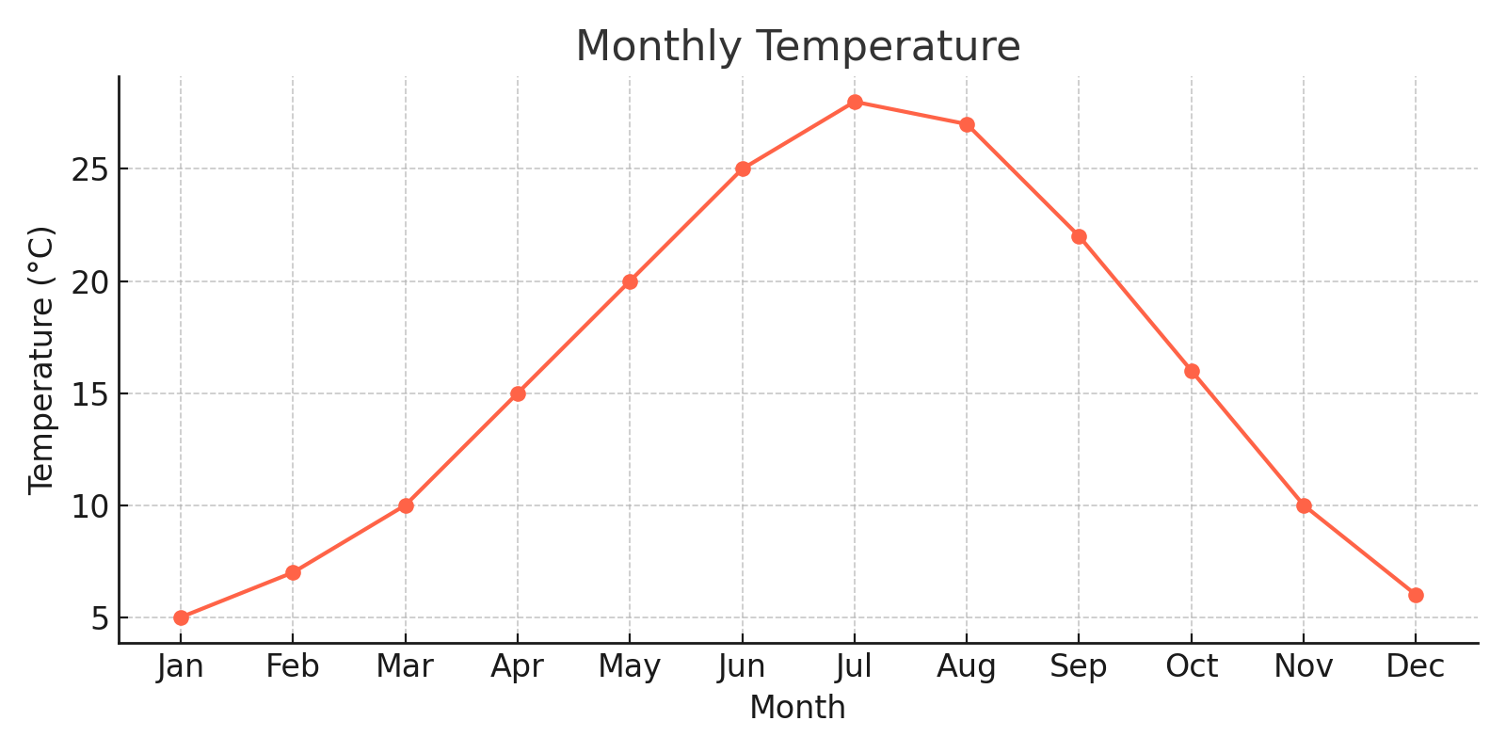

# 2. Monthly Rainfall Scatter Plot

The following scatter plot shows the monthly rainfall in millimeters.

