**Program Structures & Algorithms**

**Spring 2022**

**Assignment No. 2**

Name: Hung Chih Huang

(NUID): 001005756

* **Task: BenchMark**
* **[Part1] Timer and Benchmark**

**Pass 9 Tests, Fail Test testRepeat3**

**Pass one test, fail test testWaitPeriods**

**[Part2] Insertion Sort**

Pass five tests, fail sort2 test

The output of the failure:

**[Part3] Running times of four different array**

**Run array length of 10000 one hundred times**

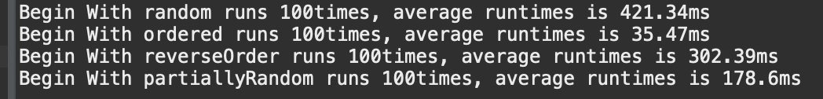

We can conclude that In the Worst Case i.e. when the array is randomly sorted and In the Best Case i.e. when the array is already sorted, Partially Random will run faster than random. And reverse order is the third slow.SÏ