IT Service Desk — Incident Resolution Report
Incident INC0012861

Ticket Summary
Ticket ID | INC0012861
Priority | Low
Subject | Legal Name Change After Marriage – Please Update My Account
Submitted By | Amanda Foster (afoster@servicedesk-simulator.com)
Request Type | Account Update – Legal Name Change
Department | Finance
Status | Resolved / Closed

Request Details
The requester reported a legal name change following marriage and asked IT to update her account to reflect her new surname. Specific items requested:
- Update display name from "Amanda Foster" to "Amanda Reyes."
- Update primary email address to areyes@servicedesk-simulator.com.
- Retain the previous email address (afoster@servicedesk-simulator.com) as an alias so existing correspondence is not missed.
- Requester noted that HR had already approved the name change and updated internal HR records.

Actions Taken
Directory profile before update:
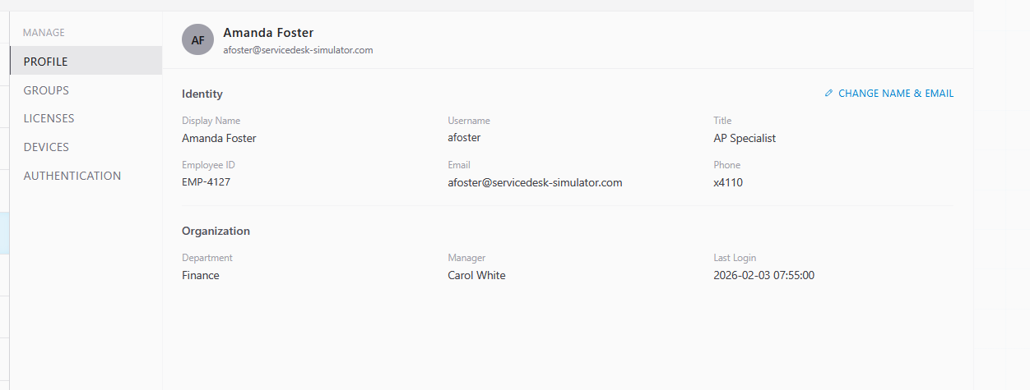
- Located the employee record for Amanda Foster (username: afoster, Employee ID: EMP-4127) in the Directory.
- Opened the "Change Name & Email" function on the user's profile.
- Updated the display name to "Amanda Reyes."
- Updated the primary email address to areyes@servicedesk-simulator.com.
- Confirmed the prior address, afoster@servicedesk-simulator.com, remained on the account as an alias so incoming mail to the old address continues to be delivered.
- Verified the updated profile: username, Employee ID, department (Finance), manager (Carol White), and phone extension (x4110) were all unchanged and correctly retained.

Resolution
Resolution notes (as entered on ticket close):
"I went into the active directory and changed the email and last name."
The account was updated to display name "Amanda Reyes," username "afoster" (unchanged), and primary email areyes@servicedesk-simulator.com, with the former address retained as an alias. The ticket was closed as resolved.
Directory profile after update:
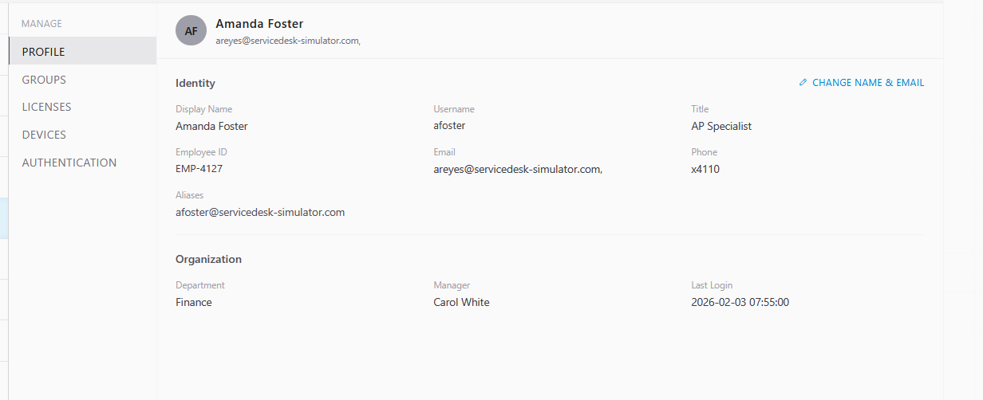

Before / After Comparison
Field | Before | After
Display Name | Amanda Foster | Amanda Reyes
Primary Email | afoster@servicedesk-simulator.com | areyes@servicedesk-simulator.com
Alias | — | afoster@servicedesk-simulator.com
Username | afoster | afoster (unchanged)

Notes
No further action required. Ticket closed as resolved with no follow-up items outstanding.
Related correspondence with requester:
