IT Service Desk — Incident Resolution Report
Incident INC0012858

Ticket Summary
Ticket ID | INC0012858
Priority | Critical
Subject | Nobody on the 3rd Floor Has Internet Right Now
Reported By | Mike Reeves (mreeves@servicedesk-simulator.com)
Department / Location | Facilities — Floor 3
Contact | x1095
Assignee | mclarke8
Status | Resolved / Closed

Issue Description
All users on the 3rd floor lost internet access starting roughly half an hour before the ticket was filed. No one on the floor could reach any websites, and the conference rooms on that floor were also affected. The 2nd floor was confirmed unaffected.

Business Impact
Multiple departments on the 3rd floor were unable to work, including the customer service team, who lost access to the CRM system.
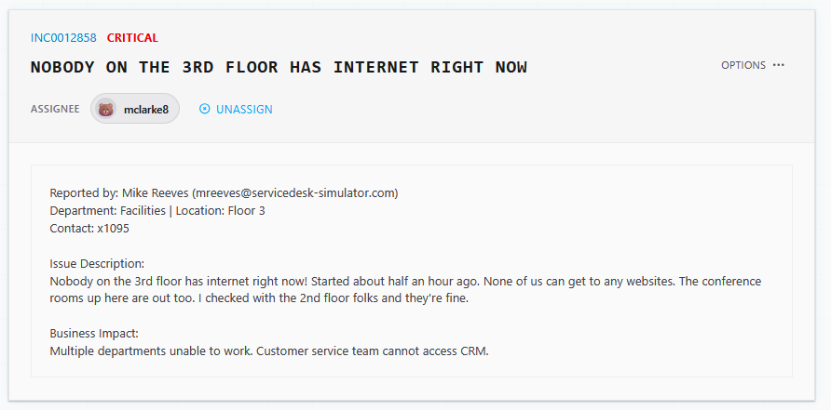
Figure 1 — Original ticket INC0012858

Diagnostics
Reviewed the network device list and identified the Floor 3 Switch (10.0.3.1, Server Room B) as the likely point of failure, since the outage was isolated to that floor while other network devices (Main Firewall, Lobby WiFi AP, Cafeteria WiFi AP) remained online and unaffected.
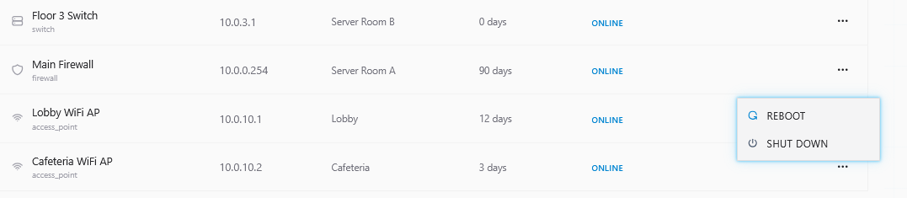
Figure 2 — Network device list showing the Floor 3 Switch and reboot option

Actions Taken
- Restarted the Floor 3 Switch (SD1032) from the network device list.
- Communicated with the reporting user, Mike Reeves, via Team Chat throughout the process.
- After the restart, informed the user the switch had been restarted and internet access should be restored.
- User confirmed via Team Chat that connectivity was back and the issue was resolved.
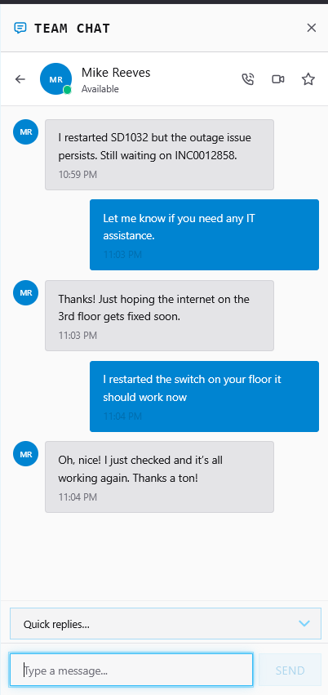
Figure 3 — Team Chat confirming the switch restart resolved the outage

Resolution
Resolution notes (as entered on ticket close):
"Verified outage isolated to Floor 3 switch. Device remains offline after restart attempt. Escalated to Network Team for further investigation."
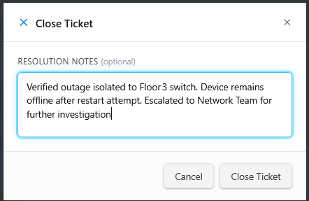
Figure 4 — Close Ticket dialog with resolution notes

Note on Documentation Accuracy
The resolution notes entered on ticket close state the switch "remains offline after restart attempt" and that the issue was escalated to the Network Team. This does not match the rest of the record: the Team Chat log shows the user confirming connectivity was restored after the switch restart, and the device list shows the Floor 3 Switch as Online. It is recommended the resolution notes be corrected to reflect that the switch restart resolved the outage, with no escalation required.

