Testing
Step 1/(test.py)
Check the code. Removed “Regenerative Braking Power (kw)” due to the fact that there where a lot of values with the number “0”.(in case that maybe it could interfere with the LSTM.
Result:
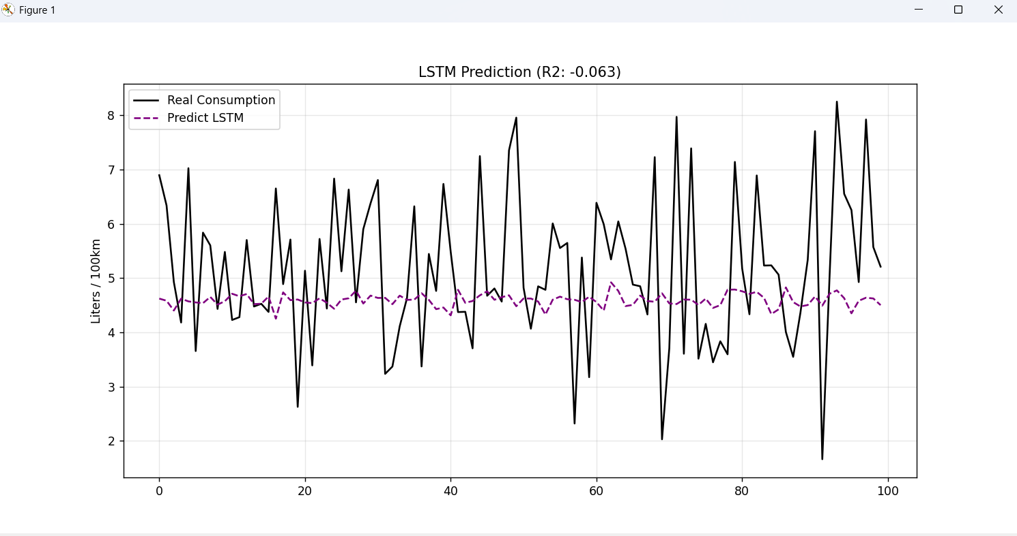
Diagram Analysis:
- Black Line(Reality): It jumps wildly from 2 to 8. It has very high variability.
- Purple Line (LSTM): Almost a steady line at the value of 4.7.
Conclusion: The model cannot find any pattern between the inputs(Speed, Acceleration etc.), in order to predict the correct output. Therefore, it decides to always predict the arithmetic mean, in order to have the minimal possible mistake.

Step 2/ Creating a Test File
Testing with Random Forest if the dataset is valid. (Random Forest does not need scaling)
test.py

import pandas as pd
import matplotlib.pyplot as plt
from sklearn.ensemble import RandomForestRegressor
from sklearn.model_selection import train_test_split
from sklearn.metrics import r2_score

df = pd.read_csv(r"C:\Users\mclef\Desktop\project_ai\nev_energy_management_dataset.csv")

df.replace(["N/A", "-", "unknown"], float("nan"), inplace=True)
df.dropna(inplace=True)

target = "Fuel Consumption (L/100km)"
X = df.drop([target, "Driving Cycle Type", "Target Efficiency"], axis=1, errors='ignore')
y = df[target]

X_train, X_test, y_train, y_test = train_test_split(X, y, test_size=0.2, random_state=42)

print("Training Random Forest...")
rf_model = RandomForestRegressor(n_estimators=100, max_depth=10, random_state=42)
rf_model.fit(X_train, y_train)

y_pred = rf_model.predict(X_test)
r2 = r2_score(y_test, y_pred)

print(f"Random Forest R2 Score: {r2:.4f}")

plt.figure(figsize=(12, 6))
plt.plot(y_test.values[:100], label='Real', color='black')
plt.plot(y_pred[:100], label='Random Forest', color='green', linestyle='--')
plt.title(f'Benchmark Test (R2: {r2:.3f})')
plt.legend()
plt.show()

# Feature Importance (To find the most valuable columns)
importances = pd.Series(rf_model.feature_importances_, index=X.columns)
print("\nTop 5 Σημαντικά Features:")
print(importances.nlargest(5))

Result:
Random Forest R2 Score: -0.0151

Top 5 Σημαντικά Features:
Speed (km/h) 0.155013
Acceleration (m/s²) 0.145758
Battery Power (kW) 0.143360
Engine Power (kW) 0.124963
Total Energy Used (kWh) 0.096428
dtype: float64
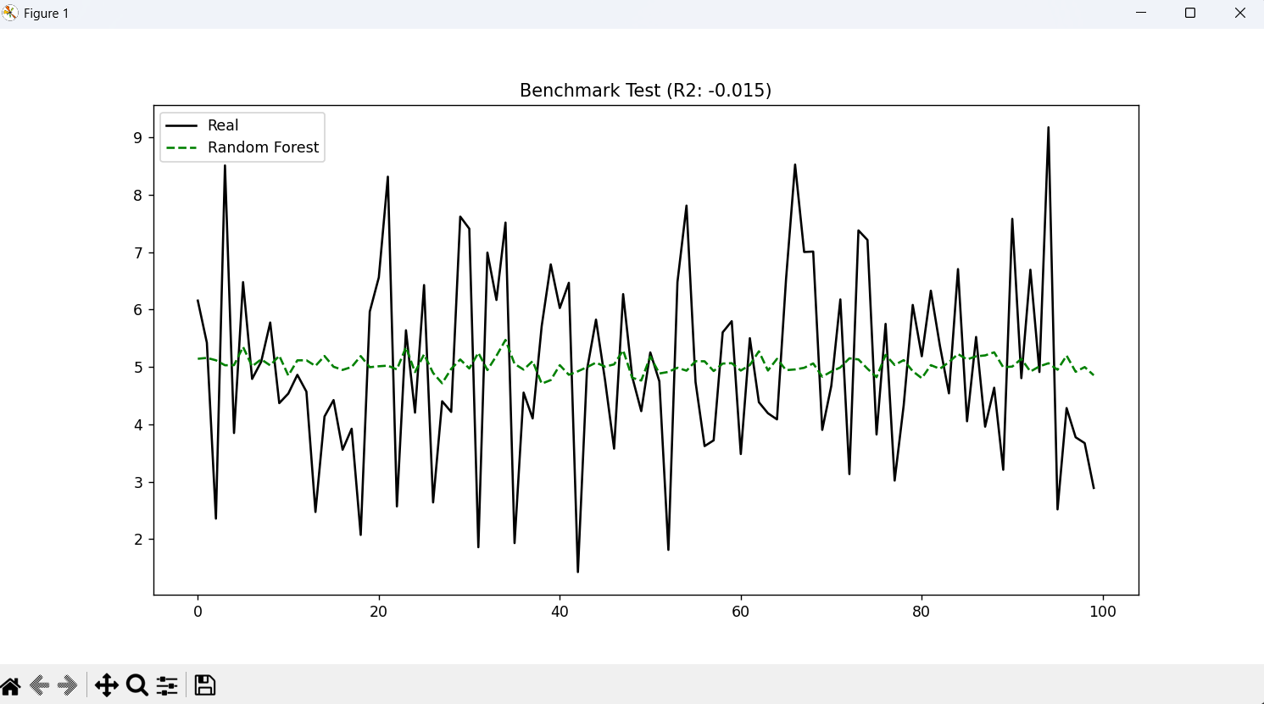
- Random Forest can identify the features.
- Random Forest says that they are important.
- However r2score is still negative.
Conclusion:
When you have the correct features but no model can predict the target, it means the relationship between the features and the target is not well-defined. The data contains too much noise, or a fundamental variable is missing (for example, road slope — if you’re driving uphill you consume almost twice as much at the same speed, but the model has no way of knowing that).

Step 3
Feature Engineering
Lstm model:
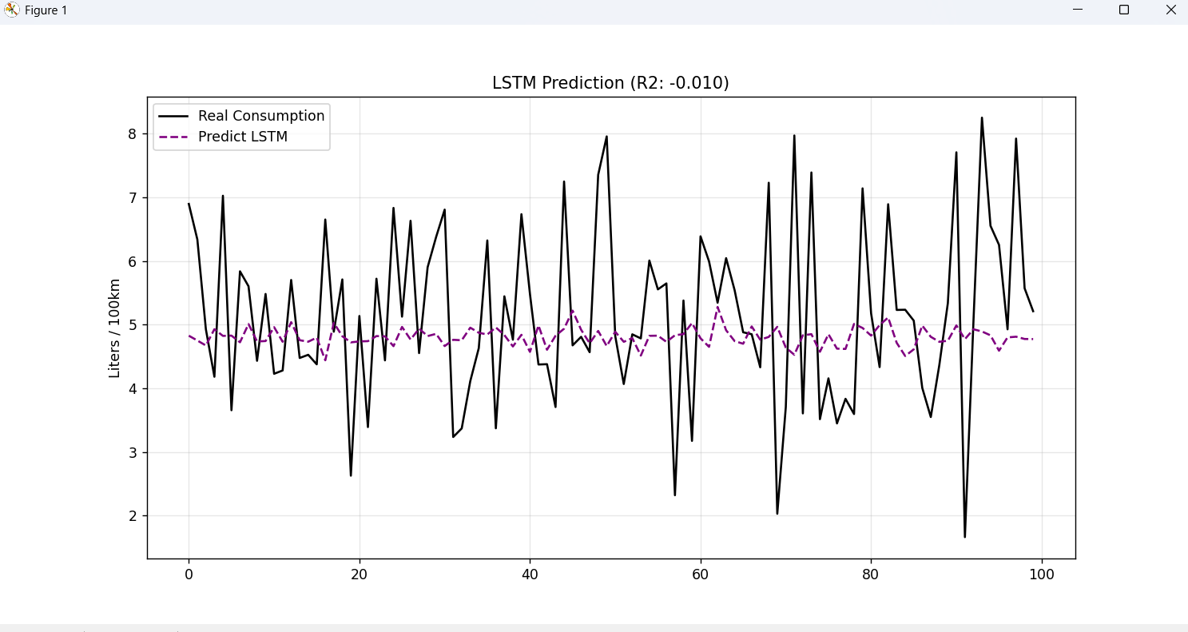

#FEATURE ENGINEERING:

# (Acceleration):
speed_col = [c for c in df.columns if 'Speed' in c][0] # Βρίσκει αυτόματα τη στήλη Speed

df['Acceleration'] = df[speed_col].diff() # Change of the value of speed the previous second
df['Acceleration'].fillna(0, inplace=True) # First Cell wil be NaN. We convert it to 0

# When the car accelerates
df['Acceleration_Positive'] = df['Acceleration'].apply(lambda x: x if x > 0 else 0)

# 3. Power Demand Proxy (Speec * Acceleration)
# This indicates the power of the machine
df['Power_Demand'] = df[speed_col] * df['Acceleration_Positive']

# Kinetic Energy
df['Kinetic_Energy'] = 0.5 * (df[speed_col] ** 2)

# ... outliers, scaling etc ...
We are giving the model ‘pre-chewed’ information.
• Instead of expecting the LSTM to figure out that ‘change in speed = fuel consumption’, we directly provide the Acceleration feature.
• We also provide Power Demand, which typically has a very strong correlation with fuel consumption.
R2_score remains negative, so we have to find another solution.

Step 4
Visualize first method
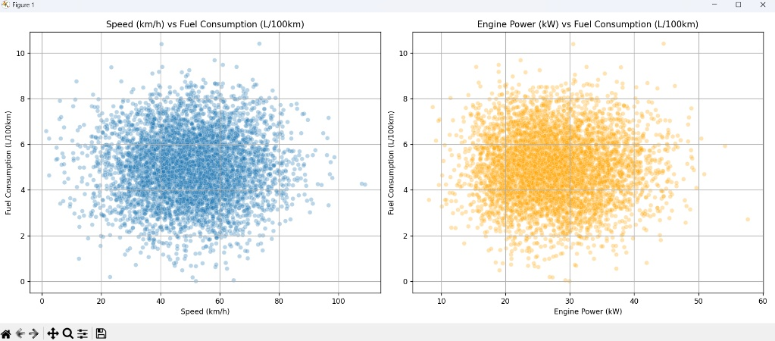
Look at the right diagram: Engine Power (kW) vs Fuel Consumption.
• What we should be seeing (Physics): An engine needs fuel to produce power. The more we press the accelerator (higher kW), the more fuel we must burn. We should see a diagonal line (or at least a narrow band) rising from low to high values.
• What we actually see: You see a blob — a shapeless cloud of points.
- There are points where the engine produces 30 kW and consumes 2 liters.
- And other points where it produces 30 kW but consumes 10 liters.
This is physically impossible. An engine cannot randomly be 10× more efficient from one moment to the next.
The conclusion is that the data is corrupted.
The most likely scenarios are that someone, at some point before we opened the file:
- Performed a sort on a single column and forgot to sort the others.
- Did a faulty shuffle, so the fuel consumption rows no longer match the speed or power rows.
- Or the data is synthetic (fake) and was generated incorrectly using random values.

Step 5
Create one last time-series plot to show that it doesn’t make sense to continue trying predict the model using this dataset. Maybe it needs more cleaning.
import pandas as pd
import matplotlib.pyplot as plt
df = pd.read_csv(r"C:\Users\mclef\Desktop\project_ai\nev_energy_management_dataset.csv")

# first 100 seconds
subset = df.iloc[:100]

# Scaling
# Divide with the max in order to be normalized

power_norm = subset['Engine Power(kW)'] / subset['Engine Power(kW)'].max()
fuel_norm = subset['Fuel Consumption (L/100km)'] / subset['Fuel Consumption (L/100km)'].max()

plt.figure(figsize=(12, 6))
plt.plot(power_norm, label='Engine Power (Normalized)', color='orange')
plt.plot(fuel_norm, label='Fuel Consumption (Normalized)', color='black', linestyle='--')
plt.title('Συγχρονισμός Ισχύος & Κατανάλωσης (Check for Lag)')
plt.legend()
plt.show()
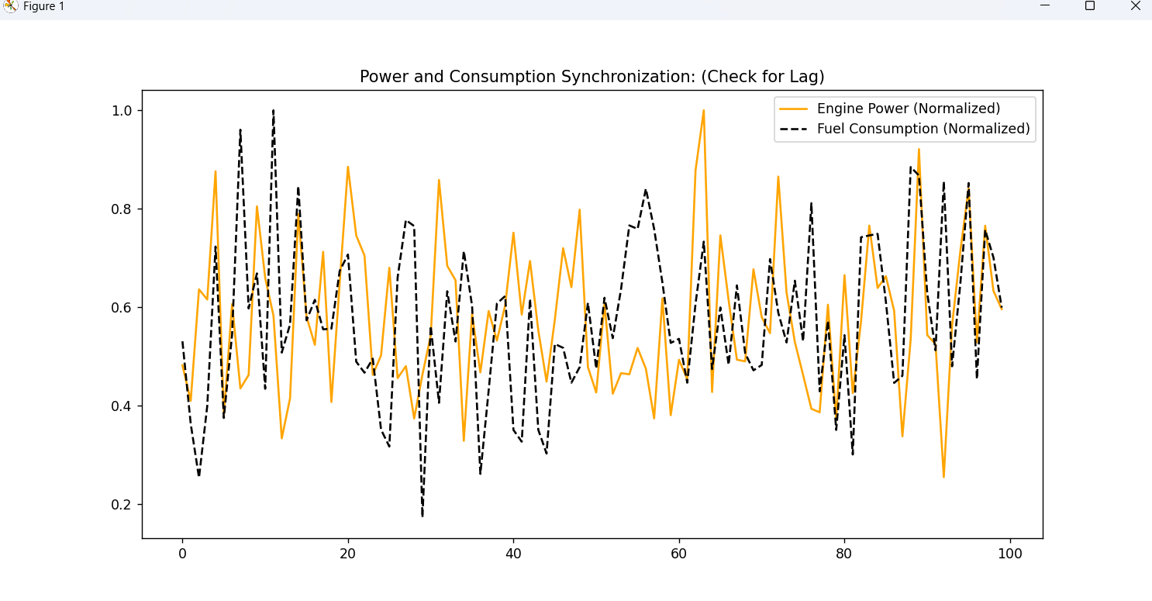
This plot is the final proof. Look closely at what happens around Time = 40 on the horizontal axis:
- Power (orange) suddenly drops to zero (the car stops pressing the accelerator).
- Fuel Consumption (black dashed line) spikes to the maximum!
This is physically impossible. You cannot release the accelerator and have the car burn fuel at its peak rate.
The conclusion is definitive: The dataset is corrupted (randomized/shuffled). The rows have been mixed, and fuel consumption no longer corresponds to the speed or power at the same moment in time. That’s why no model (LSTM, Random Forest) was able to learn anything meaningful.

Step 6
Create a new dataset

#generate_data.py

import pandas as pd
import numpy as np
import os

save_path = r"C:\Users\mclef\Desktop\thesis\my_working_dataset.csv"

# 5000 seconds of driving
n_samples = 5000
time = np.arange(n_samples)

speed = 40 + 25 * np.sin(time * 0.005) + 15 * np.sin(time * 0.015)
speed = np.maximum(speed, 0)

acceleration = np.gradient(speed)

total_power_demand = (0.5 * speed) + (20 * acceleration * speed)

# Hybrid System

# Engine Power
# If demand > 0, then Engine = demand. Otherwise 0.
engine_power = np.where(total_power_demand > 0, total_power_demand, 0)

# Regenerative Power
# If demand < 0, then Regen = abs(demand) * 0.7 (assuming 70% retrieval ratios).
regen_power = np.where(total_power_demand < 0, -total_power_demand * 0.7, 0)

# Consumption (Fuel)
# Only hen engine works (Engine Power > 0)

#We add a minimum idle value (0.2) for realism
fuel_consumption = (engine_power * 0.1) + np.random.normal(0, 0.01, n_samples)
fuel_consumption = np.maximum(fuel_consumption, 0.2)

# New Column
df = pd.DataFrame({
'Speed (km/h)': speed,
'Acceleration (m/s²)': acceleration,
'Engine Power (kW)': engine_power,
'Regenerative Braking Power (kW)': regen_power,
'Fuel Consumption (L/100km)': fuel_consumption
})

# Check folder
folder = os.path.dirname(save_path)
if not os.path.exists(folder):
os.makedirs(folder)

df.to_csv(save_path, index=False)
print(f"HYBRID DATASET READY: {save_path}")

Changing data.processor.py:
We do not need anymore Feature Engineering, because we created the columns “Acceleration and “Engine Power” by ourselves.
# data_processor.py
import pandas as pd
import numpy as np
from sklearn.preprocessing import MinMaxScaler

def get_data_ready(filepath):
df = pd.read_csv(filepath)

features = ['Speed (km/h)', 'Acceleration (m/s²)', 'Engine Power (kW)', 'Regenerative Braking Power (kW)']
target = 'Fuel Consumption (L/100km)'

X = df[features].values
y = df[target].values

scaler_X = MinMaxScaler()
X_scaled = scaler_X.fit_transform(X)

scaler_y = MinMaxScaler()
y_scaled = scaler_y.fit_transform(y.reshape(-1, 1))

return X_scaled, y_scaled, scaler_y

def create_sequences(X, y, time_steps=60):
Xs, ys = [], []
for i in range(len(X) - time_steps):
Xs.append(X[i:(i + time_steps)])
ys.append(y[i + time_steps])
return np.array(Xs), np.array(ys)

Results:lstm.py
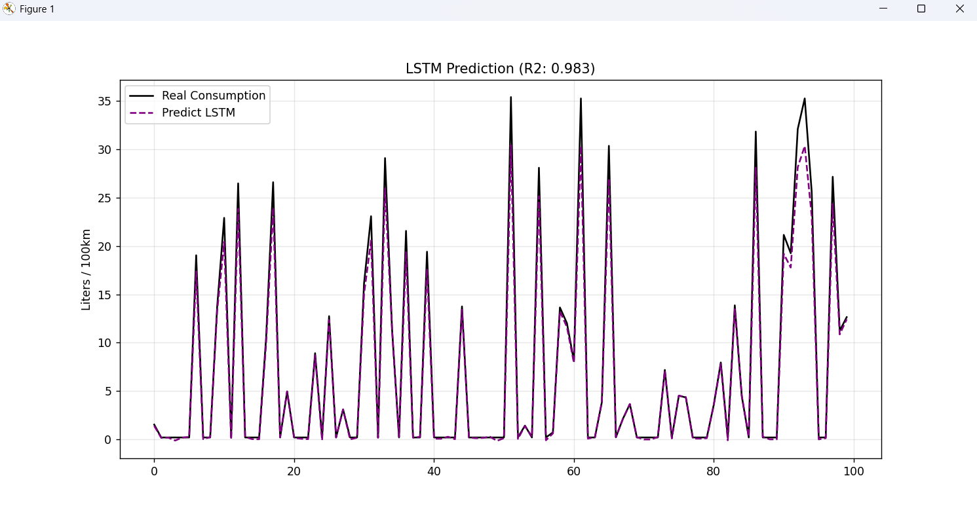
r2: 0.9830725965274419
mae: 0.6152014153186027

