

**UNIVERSITY OF EASTERN AFRICA, BARATON**

**SCHOOL OF BUSINESS**

**DEPARTMENT MANAGEMENT**

**Lecturer: Dr. Nathan Gitonga, PhD**

**ECON 210:   Principles of Microeconomics (3 Credits)**

**(Inter Semester - 2022/2023)**

**Mon - Thurs 8:00 am to 11:00 am.**

**Class Notes**

**Course Syllabus**

**__________________________________________________________________________**

**COURSE DESCRIPTION**

This course introduces students with the basic principles of microeconomic theory and their applications in decision making for the economy, household and firm thereby laying a foundation for more advanced diversified courses in economics and business. The content of the course include: scope of economics and nature of economics systems; scarcity and choice; demand, supply and determination of market price; equilibrium analysis; price elasticity of demand; elastic and inelastic demand; utility theory and consumer equilibrium; theory of the firm, theory of production, cost and supply of commodities; markets and market structures; perfect competition, monopoly, duopoly, oligopoly, general equilibrium analysis market failure and government regulations. *Prerequisite: Should have completed 1st year 32 credits.*

**COURSE PURPOSE**

This course is intended to equip the candidate with knowledge, skills and attitudes that will enable him/her to apply the fundamental principles of microeconomics in decision making

**LEARNING OUTCOME**

At the end of this course, the students will be able to:

1. Apply basic mathematical and graphical techniques to analyse microeconomic relationships and interpret the results
2. Apply the knowledge of microeconomics in decision making
3. Analyse microeconomic problems and suggest possible policy related recommendations
4. Apply knowledge of microeconomics in local production and finance
5. Apply microeconomic principles in the development and implementation of policies in agriculture and industry
6. Demonstrate an understanding of emerging microeconomic issues.

**COURSE CONTENT**

|  |  |
| --- | --- |
| **WEEK** | **TOPIC/SUBTOPIC** |
| **1** | **Registration** |
| **2** | **Introduction to Micro Economics**   * What economics is all about * Wealth definition * Welfare definition * Scarcity definition * Subject matter of economics * Positive and normative economics |
| **3** | **PROBLEMS OF AN ECONOMY**   * Central problems of an economy * Production possibility curve * Uses of production possibility curve * Opportunity cost |
| **4** | **CONSUMER BEHAVIOUR**   * Consumer’s equilibrium—utility maximization, * Utility * Total utility * Marginal utility * Law of diminishing marginal utility |
| **5** | **DEMAND ANALYSIS**   * Meaning of demand, * Market demand * Determinants of demand * Demand schedule and demand curve * Law of demand * Assumptions of the law * Why does the law of demand operate? * Exceptions to the law of demand * Movement along and shifts in demand curve   ELASTICITY OF DEMAND   * Meaning of price elasticity of demand, * Kinds of price elasticity of demand, * Measurement of price elasticity of demand—percentage, total expenditure/   outlay, arc method, geometrical method and revenue method. Income elasticity of demand,   * Cross elasticity of demand, * Determinants of price elasticity of demand |
| **6** | **SUPPLY ANALYSIS**   * Meaning of supply * Supply schedule * Supply curve * Market supply * Law of supply * Determinants of supply * Supply function * Movement along and shifts in supply curve |
| **7** | **Determination of equilibrium**   * Interaction of supply and demand, equilibrium price and quantity * Mathematical approach to equilibrium analysis * Stable versus unstable equilibrium * Effects of shifts in demand and supply on market equilibrium * Price controls * Reasons for price fluctuations in agriculture |
| **8** | **THE THEORY OF CONSUMER BEHAVIOUR**   * Approaches to the theory of the consumer- cardinal versus ordinal approach * Utility analysis, marginal utility (MU), law of diminishing marginal utility (DMU) * Limitations of cardinal approach * Indifference curve analysis * Budget line * Consumer equilibrium; effects of changes in prices and incomes on consumer equilibrium * Derivation of a demand curve * Applications of indifference curve analysis: substitution effect and income effect for a normal good, inferior good and a giffen good; derivation of the Engels curve * Consumer surplus |
| **9** | **THE THEORY THE FIRM**   * Factors influencing long term decisions of the firm * The objective of the firm * Location and localisation of firms * Survival of small scale firms alongside large scale firms |
| **10** | **THE THEORY OF PRODUCTION**   * Meaning of production, * Meaning of production function, * Returns to a factor and returns to scale, * Law of variable proportions, * Law of diminishing returns, * Assumptions of law, * Returns to scale |
| **11** | **THE THEORY OF COSTS**   * Cost of production, * Real cost and nominal cost, * Explicit and Implicit costs, * Opportunity Alternative Transfer cost, * Private, External and Social costs, * Economic costs, * Short run costs and long run costs; * Fixed and variable costs; * Total fixed cost, * Total variable cost, * Average cost, * Average fixed cost, * Average variable cost, and Marginal costs; * Relationship between average cost and marginal cost; |
| **9** | **CONCEPTS OF REVENUE**   * Meaning of revenue, * Total, Average and Marginal revenue, * Relationship between average and marginal revenue |
| **12** | **FORMS OF MARKET AND PRICE DETERMINATION**   * Meaning of market * Forms of market * Perfect competition * Price and output determination under perfect competition * Monopoly * Monopolistic competition * Oligopoly * Duopoly * Market failure * Government regulations |
| **13** | **FACTOR PRICE DETERMINATION**   * Demand for a factor * Supply of a factor * Determination of price of a factor under perfect competition * Marginal productivity theory |
| **14** | **FACTOR PRICES, COMPARATIVE ADVANTAGE AND**  **INTERNATIONAL TRADE**   * Internal and International trade, * Absolute factor price difference, * Relative factor price difference, * The classical theory of international trade—Theory of absolute advantage–Adam Smith, Theory of comparative advantage–David Ricardo, Theory of opportunity cost, * Modern theory of international trade– Heckscher and Ohlin, * Terms of trade |
| **15** | **Final Examinations** |

Course Requirements and Grade Equivalents

* Course Teaching and Learning Activities
* Class Lecture, Discussions
* Case analysis/Exercises
* Surprise Quizzes, Periodic Tests and Final Examinations
* Business Visitations and Observations

**Teaching Methodology*:***

The mode of instruction will include lectures, collaborative group discussion, individual study, class presentation, and examinations.

**Course Assessment:**

Attendance and active class participation 5%

CATs 15%

Assignments/Cases 10%

Mid-Trimester exam 10%

Final exam 60%

**Grading Scale:**

**Grade Percentage GPA**

A 85%-100% 4.00 (Superior)

A- 80%- 84% 3.67

B+ 75%- 79% 3.33

B 70% - 74% 3.00 (Above average)

B- 65%- 69% 2.67

C+ 60% - 64% 2.33

C 55%- 59% 2.00 (Average)

C- 50%- 54% 1.67

D 40%-49% 1.00 (Below Average)

F 0%-39% 0.00 (Failure)

**References**

1. Mankiw, N. Gregory. 2018. Principles of Economics. 8th ed. USA
2. Dutta, Shubhendu. 2006. *Introductory Economics*. New Dehli: New Age International (P) Limited, Publishers

Chapter 1

**INTRODUCTION TO MICROECONOMICS**

**WHAT ECONOMICS IS ALL ABOUT?**

Economics is about economizing; that is, about choice among alternative uses of scarce resources. Choices are made by millions of individuals, businesses, and government units. Economics examines how these choices add up to an economic system, and how this system operates. (L.G. Reynolds)

Scarcity is central to economic theory. Economic analysis is fundamentally about the maximization of something (leisure time, wealth, health, happiness—all commonly reduced to the concept of utility) subject to constraints. These constraints—or scarcity—inevitably define a tradeoff. For example, one can have more money by working harder, but less time (there are only so many hours in a day, so time is scarce). One can have more apples only at the expense of, say, fewer grapes (you only have so much land on which to grow food—land is scarce). Adam Smith considered, for example, the trade-off between time, or convenience, and money. He discussed how a person could live near town, and pay more for rent of his home, or live farther away and pay less, “paying the difference out of his convenience”.

Economics as a subject came into being with the publication of very popular book in 1776, “An Enquiry into the Nature and Causes of Wealth of Nations”, written by Prof. Adam Smith. At that time it was called Political economy, which remained operational at least up to the middle part of the 19th century. It is since then that the economists developed tools and principles using inductive and deductive reasoning. In fact, the ‘Wealth of Nations’ is a landmark in the history of economic thought that separated economics from other social sciences.

The word ‘Economics’ was derived from the Greek words ‘Oikos’ (a house) and ‘Nemein’ (to manage), which meant managing a household, using the limited money or resources a household has.

Let us explain a few important definitions frequently referred to in the economic theory.

|  |
| --- |
| **Adam Smith** (June 5, 1723-July 17, 1790) was a Scottish political economist and moral philosopher. His ‘Inquiry into the Nature and Causes of Wealth of Nations’ was one of the earliest attempts to study the historical development of industry and commerce in Europe. That work helped to create the modern academic discipline of Economics and provided one of the best-known intellectual rationales for free trade and capitalism.  At the age of about fifteen, Smith proceeded to the University of Glasgow, studying moral philosophy under “the never-to-be-forgotten” (as Smith called him) Francis Hutcheson. In 1740 he entered the Balliol College of the University of Oxford, but as William Robert Scott has said, “the Oxford of his time gave little if any help towards what was to be his lifework,” and he left the university in 1746. In 1748 he began delivering public lectures in Edinburgh under the patronage of Lord Kames. Some of these dealt with rhetoric and belles-lettres, but later he took up the subject of “the progress of opulence,” and it was then, in his middle or late 20s, that he first expounded the economic philosophy of “the obvious and simple system of natural liberty” which he was later to proclaim to the world in his Inquiry into the Nature and Causes of the Wealth of Nations. |

## Wealth Definition

The early economists like J.E. Cairnes, J.B.Say, and F.A.Walker have defined economics as a science of wealth. Adam Smith, who is also regarded as father of economics, stated that economics is a science concerned with the nature and causes of wealth of nations. That is, economics deal with the question as to how to acquire more and more wealth by a nation. J.S.Mill opined that it is the practical science dealing with the production and distribution of wealth. The American economist F.A.Walker says that economics is that body of knowledge, which relates to wealth. Thus, all these definitions relate to wealth.

However, the above definitions have been criticized on various grounds. As a result, economists like Marshall, Robbins and Samuelson have put forward more comprehensive and scientific definitions. Emphasis has been gradually shifted from wealth to man. As

Marshall puts, it is *“on the one side a study of wealth; and on the other, and more important side, a part of the study of man.”*

|  |
| --- |
| **Alfred Marshall** (July 26, 1842- July 13, 1924), born in Bermondsey, London, England, became one of the most influential economists of his time. His book, Principles of Political Economy (1890) brought together the theories of supply and demand, of marginal utility and of the costs of production into a coherent whole. It became the dominant economic textbook in England for a long period.  Marshall grew up in the London suburb and was educated at the Merchant Taylor’s School and St. John’s College, Cambridge, where he demonstrated an aptitude in mathematics. Although he wanted early on, at the behest of his father, to become a clergyman, his success at Cambridge University led him to take an academic career. He became a professor in 1868 specializing in political economy. He desired to improve the mathematical rigor of economics and transform it into a more scientific profession. In the 1870s he wrote a small number of tracts on international trade and the problems of protectionism. In 1879, many of these works were compiled together into a work entitled The Pure Theory of Foreign Trade: The Pure Theory  of Domestic Values. Marshall began work on his seminal work, the Principles of Economics, in 1881, and he spent much of the next decade at work on the treatise. His most important legacy was creating a respected, academic, scientifically-founded profession for economists in the future that set the tone of the field for the remainder of the twentieth century. Marshall’s influence on codifying economic thought is difficult to deny. He was the first to rigorously attach price determination to supply and demand functions; modern economists owe the linkage between price shifts and curve shifts to Marshall. Marshall was an important part of the “marginalist revolution;” the idea that consumers attempt to equal prices to their marginal utility was another contribution of his. The price elasticity of demand was presented by Marshall as an extension of these ideas. Economic welfare, divided into producer surplus and consumer surplus, was contributed by Marshall, and indeed, the two are sometimes described eponymously as ‘Marshallian surplus.’ He used this idea of surplus to rigorously analyze the effect of taxes and price shifts on market welfare. Marshall also identified quasi-rents. |

## Welfare Definition

Thus according to Marshall, economics not only analysis the aspect of how to acquire wealth but also how to utilize this wealth for obtaining material gains of human life. In fact, wealth has no meaning in itself unless it is used to purchase all those things which are required for our sustenance as well as for the comforts necessary for life. Marshall, thus, opined that wealth is a means to achieve certain ends.

In other words, economics is not a science of wealth but a science of man primarily. It may be called as the science which studies human welfare. Economics is concerned with those activities, which relates to wealth not for its own sake, but for the sake of human welfare that it promotes. According to Cannan, *“The aim of political economy is the explanation of the general causes on which the material welfare of human beings depends.”* Marshall in his book, “Principles of Economics”, published in 1890, describes economics as, *“the study of mankind in the ordinary business of life; it examines that part of the individual and social action which is most closely connected with the attainment and with the use of the material requisites of well being”.*

On examining the Marshall’s definition, we find that he has put emphasis on the following four points:

1. Economics is not only the study of wealth but also the study of human beings. Wealth is required for promoting human welfare.
2. Economics deals with ordinary men who are influenced by all natural instincts such as love, affection and fellow feelings and not merely motivated by the desire of acquiring maximum wealth for its own sake. Wealth in itself is meaningless unless it is utilized for obtaining material things of life.
3. Economics is a social science. It does not study isolated individuals but all individuals living in a society. Its aim is to contribute solutions to many social problems.
4. Economics only studies ‘material requisites of well being’. That is, it studies the causes of material gain or welfare. It ignores non-material aspects of human life.

This definition has also been criticized on the ground that it only confines its study to the material welfare. Non-material aspects of human life are not taken into consideration. Further, as Robbins said the science of economics studies several activities, that hardly promotes welfare. The activities of producing intoxicants, for instance, do not promote welfare; but it is an economic activity.

**Lionel Charles Robbins** (1898-1984) was a British economist of the 20th century who proposed one of the early contemporary definitions of economics, “Economics is a science which studies human behavior as a relationship between ends and scarce means which have alternative uses.”

Robbins’s early essays were very combative in spirit, stressing the subjectivist theory of value beyond what Anglo-Saxon economics had been used to. His famous work on costs (1930, 1934) helped bring Wieser’s “alternative cost” theorem of supply to England (which was opposed to Marshall’s “real cost” theory of supply). It was his 1932 Essay on the Nature and Significance of Economic Science where Robbins made his Continental credentials clear. Redefining the scope of economics to be “the science which studies human behavior as a relationship between scarce means which have alternative uses”.

## Scarcity Definition

Lionel Robbins challenged the traditional view of the nature of economic science. His book, “Nature and Significance of Economic Science”, published in 1932 gave a new idea of thinking about what economics is. He called all the earlier definitions as classificatory and unscientific. According to him, *“Economics is the science which studies human behaviour as a relationship between ends and scarce means which have alternative uses.”* This definition focused its attention on a particular aspect of human behaviour, that is, behaviour associated with the utilization of scarce resources to achieve unlimited ends (wants). Robbins definition, thus, laid emphasis on the following points:

1. ‘Ends’ are the wants, which every human being desires to satisfy. Want is an effective desire for a thing, which can be satisfied by making an effort for obtaining it. We have unlimited wants and as one want gets satisfied another arises. For instance, one may have the desire to buy a car or a flat. Once the car or the flat is purchased, the person wishes to buy a more spacious and designable car and the list of his wants does not stop here but goes on one after another. As human wants are unlimited, we have to make a choice between the most urgent want and less urgent wants. Thus the problem of choice arises. That is why economics is also called as a science of choice. If wants had been limited, they would have been satisfied and there would have been no economic problem.
2. ‘Means ’or resources are limited. Means are required to be used for the satisfaction of various wants. For instance, money is an important means to satisfy many of our wants. As stated, means are scarce (short in supply in relation to demand) and as such these are to be used optimally. In other words, scarce or limited means/resources are to be economized. We should not make waste of the limited resources but utilize them very judiciously to get the maximum satisfaction.
3. Robbins also said that, the scarce means have alternative uses. It means that a commodity or resource can be put to different uses. Hence, the demand in the aggregate for that commodity or resource is almost insatiable. For instance, if we have a hundred rupee note, we can use it either to purchase a book or a fashionable clothe. We may use it in other unlimited ways as we like.

Let us now turn our attention to the definitions put forward by modern economists. J.M.Keynes defined economics as the study of the management of scarce resources and of the determination of income and employment in the economy. Thus his study centered on the causes of economic fluctuations to see how economic stability could be established. According to F. Benham, economics is, *“a study of the factors affecting the size, distribution and stability of a country’s national income.”* Recently, economic growth and development has taken an important place in the study of economics. Prof. Samuelson has given a growth oriented definition of economics. According to him, economics is the study and use of scarce productive resources overtime and distribute these for present and future consumption.

In short, economics is a social science concerned with the use of scarce resources in an optimum manner and in attainment of desired level of income, output, employment and economic growth.

## SUBJECT MATTER OF ECONOMICS

The subject matter of economics is divided into two categories–microeconomics and macroeconomics. Microeconomics, which deals with individual agents, such as households and businesses, and macroeconomics, which considers the economy as a whole, in which case it considers aggregate supply and demand for money, capital and commodities. Aspects receiving particular attention in economics are resource allocation, production, distribution, trade, and competition. Economics may in principle be (and increasingly is) applied to any problem that involves choice under scarcity or determining economic value.

The term ‘Micro’ and ‘Macro’ economics have been coined by Prof. Ragnar Frisch of Oslo University during 1920’s. The word micro means a millionth part. In Greek mickros means small. Thus microeconomics deals with a small part of the whole economy. For example, if we study the price of a particular commodity instead of studying the general price level in the economy, we actually are studying microeconomics. Precisely, microeconomics studies the behaviour of individual units of an economy such as consumers, firms, and industry etc. Therefore, it is the study of a particular unit rather than all units combined together. Microeconomics is called Price theory, which explains the composition, or allocation of total production.

In short, microeconomics is the study of the economic behaviour of individual consumers, firms, and industries and the distribution of production and income among them. It considers individuals both as suppliers of labour and capital and as the ultimate consumers of the final product. On the other hand, it analyses firms both as suppliers of products and as consumers of labour and capital.

Microeconomics seeks to analyze the market form or other types of mechanisms that establish relative prices amongst goods and services and/or allocates society’s resources amongst their many alternative uses. In microeconomics, we study the following:

1. Theory of product pricing, which includes

(*a*) Theory of consumer behaviour.

(*b*) Theory of production and costs.

1. Theory of factor pricing, which constitutes

(*a*) Theory of wages.

* 1. Theory of rent.
  2. Theory of interest.
  3. Theory of profits.

1. Theory of economic welfare.

Microeconomics has occupied a very important place in the study of economic theory. In fact, it is the stepping–stone to economic theory. It has both theoretical and practical implications. Important points of its significance are mentioned as under:

1. Microeconomics is of great help in the efficient management of the limited resources available in a country.
2. Microeconomics is helpful in understanding the working of free enterprise economy where there is no central control.
3. Microeconomics is utilized to explain the gains from international trade, balance of payments disequilibrium and determination of foreign exchange rate.
4. It explains how through market mechanism goods and services produced in the community are distributed.
5. It helps in the formulation of economic policies, which are meant for promoting efficiency in production, and welfare of the people.
6. Microeconomics is the basis of welfare economics.
7. Microeconomics is used for constructing economic models for better understanding of the actual economic phenomena.

Despite the fact that it has so many benefits, it also suffers from certain defects or limitations. These are:

1. It is not capable of explaining the functioning of an economy as a whole.
2. It assumes full employment; which is rare in real life.
3. It cannot be used for solving the problem relating to public finance, monetary and fiscal policy etc.

### Positive and Normative Economics

While discussing the scope of economics, we also think of whether economics is a positive or normative science. A positive science describes ‘what is’ and normative science explains ‘what ought to be’. Thus a positive science describes a situation as it is, whereas normative science analysis the situation and suggests/comments on wrongness or rightness of a thing/state. For example, ‘population in Kenya is rising’, is a positive statement and ‘Rising population is an obstacle in the way of development’ is a normative statement.

Classical economists consider economics as a positive science. They declined any comment about wrongness or rightness of an economic situation. Robbins also supported the classical view and stated that economics is not concerned with the desirability or otherwise of ‘ends’. Therefore, the task of an economist is not to condemn or advocate but to explore and explain. However, economics should not be treated as only positive science. It should be allowed to pass moral judgments of an economic situation. It is, therefore, considered both positive and normative science. Thus, Economics is the social science that studies the allocation of scarce resources to satisfy unlimited wants. This involves analyzing the production, distribution, trade and consumption of goods and services. Economics is said to be positive when it attempts to explain the consequences of different choices given a set of assumptions or a set of observations, and normative when it prescribes that a certain action should be taken.

### Questions for Review

1. Define economics as given by L. Robbins.
2. Who is regarded as the father of economics?
3. Who coined the terms—micro and macroeconomics?
4. Name the book written by Adam Smith.
5. ‘Economics is a science of choice’—explain.
6. “Economics is a science which studies human behaviour as a relationship between ends and scarce means which have alternative uses.” Explain.
7. Give the meaning of the term opportunity cost.
8. How is the study of microeconomics significant?
9. What is the scope of microeconomics?
10. What do you mean by marginal rate of transformation?
11. What is the basic problem of an economy?
12. What do you mean by the terms ‘ends’ and ‘means’?
13. Define want.
14. What is the meaning of economizing of resources? Why is there a need for economizing resources?
15. What do you understand by Micro Economics?
16. What specific problem of an economy is studied in welfare economics?
17. Give the definition of a scarce resource.
18. What is meant by scarcity in economics?
19. Define an economy.
20. State Marshall’s definition of Economics.
21. “Economics enquires into the nature and causes of wealth of nations”. Who gave this definition of economics? What does it imply?
22. What is economics about?
23. Explain how scarcity and choice go together.
24. “Economics is about making choices in the presence of scarcity.” Explain.
25. What are the main features of Marshall’s Definition of economics?
26. “Scarce means have alternative uses.”—Explain.
27. Name the Economist who coined the terms micro and macro.
28. Write five importances of micro economics.
29. Mention three shortcomings of microeconomic theory.
30. What do you understand by positive and normative economics?
31. Is economics a positive science?

**Chapter 2**

**PROBLEMS OF AN ECONOMY**

## CENTRAL PROBLEMS OF AN ECONOMY

Scarcity is the root cause of all economic problems. We know that resources are scarce or short in supply in relation to demand; but wants or ends are unlimited. As a consequence, we face the problem of choice among so many of our wants. This is because scarce means have alternative uses. Thus, we have to choose among the most urgent and less urgent wants. In fact, the basic problem of an economy is the problem of choice. More precisely, problem before us is to take right decisions in regard to the goals or ends to be attained and the way, the scarce means to be utilized for this purpose. Every economy faces some fundamental problems called as central problems of an economy. These are the following:

1. **What goods and services are to be produced?** The first major problem faced by an economy is what types of goods and services to be produced. As resources are limited, we must choose between different alternative collection of goods and services that may be produced. It may also imply whether to produce capital/producer goods or consumer goods. Moreover, we have to decide about the quantity of the goods to be produced in the economy.
2. **How to produce these goods and services?** The next problem we have to tackle is the problem of how to produce the desired goods in the economy. Thus the question of techniques to be used in the production comes in the mind. Whether we should use labour-intensive technique or capital – intensive technique. Labour-intensive method of production implies more use of labour per unit than capital whereas; capital-intensive technique indicates more use of capital per unit than labour. The choice depends on the availability of resources. A labour surplus economy can well use the labour–intensive technology.
3. **For whom these goods and services are to be produced?** Once we have decided what goods to be produced and what techniques to be used in the production of goods, we are encountered with another problem, i.e., the problem of distribution of goods in the economy. This is the problem of sharing of national income.
4. **Are the resources efficiently used?** We have also to see that scarce resources are efficiently utilized. This is the problem of economic efficiency or welfare maximization.
5. **Are the resources fully employed?** An economy must also try to achieve full employment of all its resources.
6. **How to attain growth in the economy?** An economy is to ensure that it is attaining sufficient growth rate so that it is able to grow larger and larger and develop at faster rate. It should be able not only to make a structural change from agrarian to industrial sector but also to increase per capita and national income of the country. An economy must not remain static. Its productive capacity must increase continuously.

It is clear that the basic problem of an economy is the economizing of resources. The economizing problem arises in every type of economic society owing to the fact that resources are scarce in relation to multiple wants/ends.

## PRODUCTION POSSIBILITY CURVE

* The production possibility Curve is a graph that depicts the trade-off between any two items produced. It is also known as Transformation Curve or Production Frontier, which shows the maximum feasible quantities of two or more goods that, can be produced with the resources available. In other words, it indicates the opportunity cost of increasing one item’s production in terms of the units of the other forgone. Prof. Samuelson analyzed the economizing problem by the use of production possibility curve.
* Thus, a PPC shows the maximum obtainable amount of one commodity for any given amount of another commodity, given the availability of factors of production and the society’s technology and management skills.
* The concept is used in macroeconomics to show the production possibilities available to a nation or economy, and also in microeconomics to show the options open to an individual firm.
* All points on a production possibilities curve are points of maximum productive efficiency or minimum productive inefficiency: resources are allocated such that it is impossible to increase the output of one commodity without reducing the output of the other. That is, there must be a sacrifice—an opportunity cost—for increasing the production of any good.
* All resources are used as completely as possible (without the situation becoming unsustainable) and appropriately. The production possibility curve does not remain stationary. It moves outward overtime with growth of resources and improvement in technology. This is because we get more output from the same quantities of resources.

The table below illustrates production possibilities of a simple economy producing two commodities—cars and computers. Two production possibilities–E and F are shown. When the economy decides to put more resources for the production of computers, it must sacrifice some resources from the production of cars. Thus, when 10000 computers are decided to be produced, 5000 cars cannot be produced as the resources are now diverted to the production of computers.

|  |  |  |
| --- | --- | --- |
| *Production* | *Computers (in* | *Cars (in* |
| *possibilities* | *000’s)* | *000’s)* |
| E | 5 | 15 |
| F | 10 | 10 |

The adjacent Fig. 2.1 derived from the table above, shows the production possibility curve. If all resources in the economy are utilized in the production of cars, OA units of cars can be produced.

On the other hand, if all resources are put in the production of computers, OB units of computers would be produced in the economy. Joining points A and B, we get production possibility curve AB. In case, the economy decides to produce both the commodities by using the available resources, it can produce various combinations of cars and computers by staying on the curve AB, such as at E or F. At point E, it can produce OS units of cars and OT units of computers. Similarly, at F, ON units of cars and OM units of computers can be produced. Thus, the points E, F or any other point on curve AB show maximum feasible combinations of cars and computers which can be produced with the resources available. Point C in the figure is not attainable or feasible for the economy as it is above the production possibility curve AB, i.e., beyond the capacity of the economy. Again, it will not produce at point D which is though attainable but not desirable, because in that case the economy’s resources will not be used most effectively.

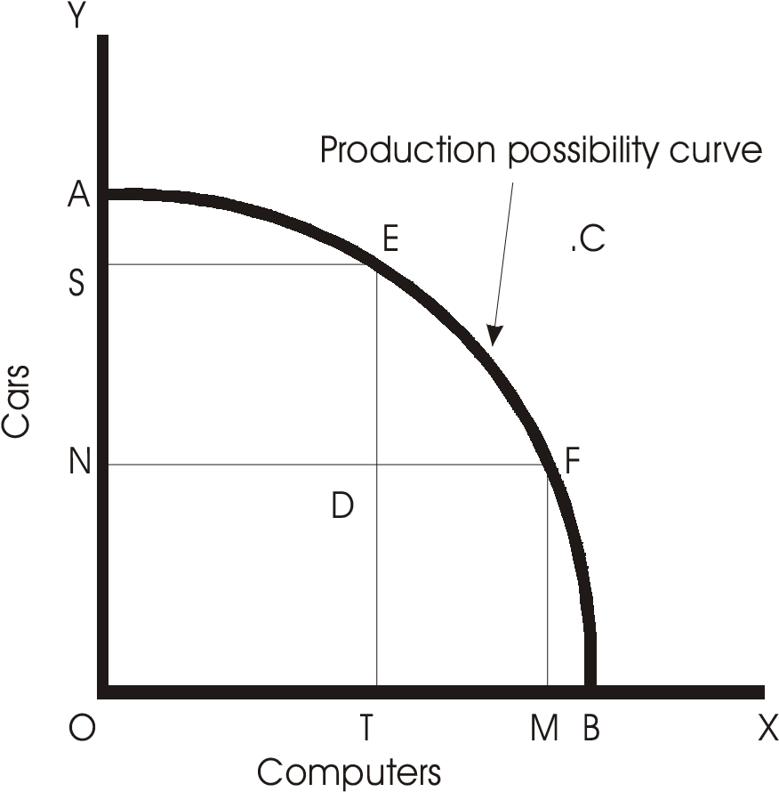

### Fig. 2.1

It is, thus, seen that to produce more computers, some units of cars are to be sacrificed, i.e., cars can be transformed to computers. The rate at which one product is transformed into another is called **marginal rate of transformation** (MRT). Thus, MRT between cars and computers is the units of cars (in our case, 5000), which has to be sacrificed for the production of computers. MRT increases, as more of one commodity is produced and less of another. This makes Production Possibility curve concave to the origin.

### Uses of Production Possibility Curve

The production possibility curve has a number of uses. It helps in finding the solution of the basic problems of production—what and how to produce and for whom to produce goods in the economy. Besides, whenever government decides to divert its resources, say, from necessaries to luxuries, it may utilize the concept of production possibility curve. It can also help in guiding the diversion of resources from current consumption goods to capital goods and increase productive capacity to attain higher levels of production.

## OPPORTUNITY COST

Opportunity cost is a term which means the cost of something in terms of an opportunity foregone (and the benefits that could be received from that opportunity), or the most valuable foregone alternative. In other words, the opportunity cost of a given commodity is the next best alternative cost or transfer costs. As we know that productive resources are scarce, therefore, the production of one commodity means not producing another commodity. The commodity that is sacrificed is the real cost of the commodity that is produced. This is the opportunity cost. Let us explain this with an example. Suppose a producer can produce a car or a computer with the money at his disposal. If the producer decides to produce car and not computer, then the real cost of the car is equal to the cost of computer, i.e., the alternative foregone. Let us take another example to explain the concept. For example, if a company decides to build hotels on vacant land that it owns, the opportunity cost is some other thing that might have been done with the land and construction funds instead. In building the hotels, the company has forgone the opportunity to build, say, a sporting center on that land, or a parking lot, or a housing complex, and so on. In simpler terms, the opportunity cost of spending a day for picnic with your friends could be the amount of money you could have earned if you had devoted that time to working overtime.

Opportunity cost need not be assessed in monetary terms, but rather, is assessed in terms of anything that is of value to the person or persons doing the assessing. The consideration of opportunity costs is one of the key differences between the concepts of economic cost and accounting cost. Assessing opportunity costs is fundamental to assessing the *true cost* of any course of action. The simplest way to estimate the opportunity cost of any single economic decision is to consider, “What is the next best alternative choice that could be made?” The opportunity cost of paying for college fee could be the ability to buy some clothes. The opportunity cost of a vacation in the Goa could be the payment for buying a motorbike.

It is to be noted that opportunity cost is not the sum of the available alternatives, but rather of benefit of the best alternative of them.

The concept of opportunity cost can be explained with a diagram that depicts opportunity cost between any two given items produced by a given economy. It is known in economics as the production possibility curve, as shown in Fig. 2.1 above. In the imaginary economy discussed above which produces only cars and computers, the economy will be operating on the PPC if all resources (inputs) are fully utilized and used most appropriately (efficiently). The exact combination of cars and computers produced depends on the mechanisms used to decide the allocation of resources (i.e., some combination of markets, government, tradition, and community democracy).

The concept of opportunity cost has become very popular in the recent years. The modern analysis of cost-benefit analysis is based on the theory of opportunity cost only. The cost-benefit analysis is a guiding tool for entrepreneurial decisions in the modern economy. Although opportunity cost can be hard to quantify, its effect is universal and very real on the individual level. The principle behind the economic concept of opportunity cost applies to all decisions, not just economic ones.

### Questions for Review

1. What do you mean by an economic problem? How does an economic problem arise?
2. What are the central problems of an economy?
3. What is a production possibility curve? Explain with the help of a diagram.
4. Give the meaning of the term opportunity cost.
5. Why is the production possibility curve concave to the origin?
6. What do you mean by marginal rate of transformation?
7. Define marginal opportunity cost along a production possibility curve.
8. Give two examples of underutilization of resources. .
9. “An economy always produces on, but not inside, a PPC.” Give reasons. .
10. Name the factors that lead to the shift of the PPC? .
11. Give two examples of growth of resources. .
12. Why do technological advances or growth of resources shift the PPC to the right? .
13. Name any two central problems facing an economy. .
14. What does increasing marginal opportunity cost along a PPC mean? .
15. What is the basic problem of an economy?
16. Distinguish between capital-intensive and labour-intensive technique of production.
17. What are the important uses of PPC?
18. Explain the concept of opportunity cost giving example.

**Chapter 13**

**CONSUMER BEHAVIOUR**

## CONSUMER’S EQUILIBRIUM–UTILITY MAXIMIZATION

The theory of demand starts with the examination of the behaviour of the consumers. In our everyday life we behave in different ways while buying and consuming a good or service. The simple calculations and human reasoning we undertake while doing any transactions have been transformed into principles which guide us to attain satisfaction or equilibrium in economic sense. When we go for shopping, we decide beforehand, what good to buy and how much to spend. It makes sense as we try to get most of what we are spending. In other words, we always want more of anything and for that purpose we negotiate and come to an agreed price which we are ready to pay happily. It is therefore, necessary to be first acquainted with the consumer behaviour, which forms the basis of the demand theory.

It is assumed that consumers are rational. Given his money income and the prices of commodities, a consumer always tries to maximize his satisfaction. That is, to get the maximum welfare (state of well-being) by spending the given money on various commodities. It is assumed that the satisfaction a consumer gets by consuming a good is measurable (measured in terms of money), though in real life it is not possible to measure satisfaction because it is psychological entity. We only feel the level of satisfaction and express the same in different ways. We show our satisfaction by our behaviour like laughing, jumping in excitement or in any other way. Thus, we cannot measure satisfaction in quantitative terms as we are capable of measuring time in seconds, weight in kilograms or length in meters. Further, each consumer is also assumed to be known of what he wants. Moreover, he has all information regarding market—the goods available, the prices of the goods at a particular point of time and so on. Every consumer uses this information in such a way as to maximize his total satisfaction.

To explain consumer’s equilibrium i.e., how a consumer attains maximum satisfaction by spending his money income on certain units of commodities, it is worthwhile to be familiar with certain important terms used in explaining various concepts and theories of demand. These are explained as under:

### Utility

Utility is defined as the power of a commodity or service to satisfy a human want. Economists have leveled the term satisfaction as utility. It is subjective concept and therefore varies from person to person. As already stated, it resides in one’s mind and therefore cannot be measured in quantitative terms. Though utility and satisfaction are used synonymously, we should note that utility is the expected satisfaction whereas satisfaction implies ‘realized satisfaction’.

### Total Utility

It is the amount of utility (satisfaction) a consumer gets by consuming all the units of a commodity. If there are *n* units of the commodity, then the total utility is the sum of the utilities of all *n* units of the commodity. Thus, if there are four units of a commodity, then total utility is,

U = U1(*n*1) + U2(*n*2) + U3(*n*3) + U4(*n*4)

Where U = total utility; U1…….U4 are the utilities of *n*1…..*n*4 units of the commodity.

Thus, if by consuming first apple, a consumer gets 12 utils of satisfaction, 10 utils from the second apple, 9 utils from the third and 7 utils from the fourth apple; then his total utility is,

U = 12 + 10 + 9 + 7 = 38

Thus utilities of various goods are additive. This means that utilities of different commodities are independent of one another. The utility derived from one commodity does not affect that of another.

### Marginal Utility

Marginal utility is defined as the change in the total utility due to a unit change in the consumption of a commodity per unit of time. It can also be defined as the addition made to the total utility by consuming an additional unit of a commodity. For example, if total utility of 3 cups of tea is 18 utils and on consuming the 4th cup it rises to 20; then marginal utility 20-18 = 2 utils. Thus, by consuming one more cup of tea, the additional utility, a consumer gets is 2 utils. Marginal utility can be expressed as,

∆TU

MU =

∆Q

Where MU = marginal utility; ∆ΤU = change in total utility; ∆Q = change in the quantity consumed. ‘Utils’ is the term used by Marshall as a measuring unit of utility. The following expression can also be used to find marginal utility:

MU = TU*n* – TU*n*-1

Where, TUn is the total utility of *n*th unit of the commodity and TU*n*-1 utility from the *n*-1th commodity. Thus, if TU from the second unit (*n*th unit) of apple is 13 and TU from the previous unit (*n*-1) is 7, then MU is 13 – 7 = 6.

The concept of total utility and marginal utility is shown in the utility schedule below:

|  |  |  |
| --- | --- | --- |
| *Units of apples* | *Total utility* | *Marginal utility* |
| 1 | 7 | 7 – 0 = 7 |
| 2 | 13 | 13 – 7 = 6 |
| 3 | 18 | 18 – 13 = 5 |
| 4 | 22 | 22 – 18 = 4 |

*Contd....*

|  |  |  |
| --- | --- | --- |
| 5 | 25 | 25 – 22 = 3 |
| 6 | 27 | 27 – 25 = 2 |
| 7 | 28 | 28 – 27 = 1 |
| 8 | 28 | 28 – 28 = 0 |

When the consumer takes 1st apple, his total utility is 7 and from the 2nd apple he gets 13 and so on. The third column shows marginal utility, which diminishes as the consumer increases units of apples. It is seen that when total utility is maximum, marginal utility is zero at 8th unit of apple. It is also seen that total utility is the sum of the marginal utilities of the 1st, 2nd, 3rd, and so on. Thus, at 8th unit of apple,

TU = MU1 + MU2 + MU3 + MU4 +…..…+ MU*n*(8)

28 = 7 + 6 + 5 + 4 +…..…+ 0

## LAW OF DIMINISHING MARGINAL UTILITY

One of the very important laws in regard to the satisfaction of human wants is known as law of diminishing marginal utility. The law explains common feeling of every consumer. Suppose a person starts consuming apples one after another. The first apple gives him the maximum satisfaction as he might be in mood of taking some food at that time for meeting his appetite. As he takes the second apple, he gets less satisfaction because by this time he has already met some level of appetite. The third and more apples yield him lesser satisfaction or utility. It means that every time the consumer increases his consumption, he gets less and less satisfaction. The satisfaction also tends to be zero when the consumer feels totally disgusted to take any more apples. If he takes more, his satisfaction turns negative or utility now becomes disutility.

Thus law of diminishing marginal utility states that additional satisfaction a person derives by consuming a commodity goes on declining as he consumes more and more of a that commodity. According to Marshall, *“The additional benefit which a person derives from a given increase of his stock of a thing diminishes with every increase in stock that he already has.”*

Two important reasons for diminishing marginal utility are the following:

1. *Each particular want is satiable (can be satisfied):* Though there are unlimited wants, a single want can be satisfied. Thus, when a consumer consumes more and more of a commodity, his want is satisfied and he does not wish to have any further increase in the commodity. As such his marginal utility falls when consumption increases.
2. *Goods are imperfect substitutes for one another i.e., one good cannot be exactly used in place of another:* Satisfaction from any two goods is not same. Different goods satisfy different wants. If a good could be perfectly substituted for another, it would have satisfied other wants. Hence, its marginal utility would not have fallen but increased.

The law can be explained with the help of a table and diagram-3.1 below:

|  |  |  |
| --- | --- | --- |
| *Units (Apples)* | *TU* | *MU* |
| 1 | 10 | 10 |
| 2 | 18 | 8 |
| 3 | 22 | 4 |
| 4 | 24 | 2 |
| 5 | 25 | 1 |
| 6 | 25 | 0 |
| 7 | 32 | –7 |
| 8 | 44 | –12 |

As the consumer goes on consuming more and more units of apples, total utility (TU) increases but marginal utility (MU) declines continuously and becomes zero at 6th unit. When consumer consumes further, utility becomes negative. It is to be noted that when TU is maximum, MU is zero. Let us now derive the MU curve from the above schedule as under. Marginal utility is measured along Y-axis while units of apples along X-axis. MU is the marginal curve falling downwards from left to right. This is diminishing MU curve. It is seen in the Fig. 3.1 below, that marginal utility is zero when the consumer buys 6th apple. As he consumes more, marginal utility becomes negative.

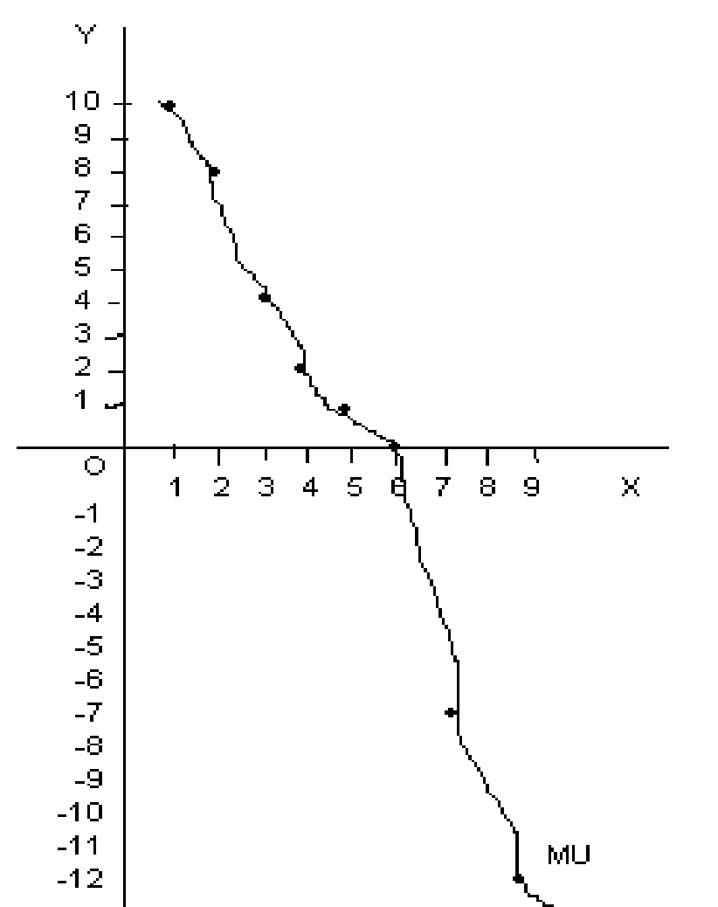

### Fig. 3.1

The law of diminishing MU has certain limitations. These are:

1. If units of a commodity consumed are not of same size and shape, the law does not

hold good. In the illustration explained above, units of apples are assumed to be of same shape and size.

1. The law does not hold good when there is enough time gap between consumption of two units. For instance, if we take second apple after a long gap of time, we may feel hungry and hence satisfaction will increase instead of falling.
2. The taste of consumer should not change for the law to hold good. It means that the person should consume all units of a good by same desire and pleasure.
3. The law does not apply to money as it is said that more money a person has, the more he wants.
4. Change in income of the consumer will falsify the law. If money income of the consumer increases or decreases during the time of consumption of a particular set of goods, the marginal utility will not fall as said above.

The law of diminishing marginal (additional) utility explains consumer’s equilibrium in case of a single commodity. A consumer will go on purchasing successive units of a commodity till the marginal utility of the commodity is equal to price. Thus, for a single commodity *x*, a consumer is in equilibrium when the marginal utility of *x* is equal to its market price (P*x*). Symbolically,

MU*x* = P*x*

In case the price goes down, he will buy more and the marginal utility will come down to the level of price. If price rises, less will be purchased and the marginal utility rises till it reaches the new level of price. Thus, equality between marginal utility and price indicates the position of consumer’s equilibrium when a single commodity is being purchased and consumed.

**Questions for Review**

1. State the law of diminishing marginal utility.
2. Define total utility.
3. Define marginal utility.
4. How is total utility derived from marginal utilities? .
5. What does rationality of consumers mean?
6. Is satisfaction measurable?
7. Define utility.
8. Show that utilities of various goods are additive.
9. Explain law of diminishing marginal utility with the help of diagram.
10. Why does marginal utility diminishes?
11. What are the assumptions of the law of diminishing marginal utility?
12. Does the law apply to money?
13. What is the condition for a consumer’s equilibrium? Explain.

**Chapter 4**

**DEMAND AND** **LAW OF DEMAND**

## MEANING OF DEMAND

In Economics, Demand means desire to have a commodity backed by enough money to pay for the good demanded. Thus, in economics we are concerned only with demand, which is effectively backed up by an adequate supply of purchasing power, i.e., with effective demand. Thus, if a person desires to buy a car, he should have enough money to buy that; then only demand becomes effective. It should also be mentioned here that demand is not complete unless the consumer has willingness to buy a good or service. A person has the desire and enough money but at a particular point of time, he may not have willingness to buy the good due to sudden change in his taste or preference. For example, when a person goes to a showroom to buy his dream car but declines to buy, just because he does not find his preferred colour. Moreover, demand for a good is always expressed in relation to a particular price and a particular time. Therefore, we may define demand for a good as the amount of it, which will be purchased per unit of time at a given price. According to F. Benham, “*The demand for anything at a given price is the amount of it which will be bought per unit of time at that price.”* Another good definition of demand, given by Bober is—“*the various quantities of a given commodity or service which consumers would buy in one market in a given period of time at various prices, or at various incomes, or at various prices of related goods.,”* constitute demand. Demand, in economics, always refers to a schedule. It is not a single quantity. The quantity which is purchased at some particular price is called the quantity demanded.

## MARKET DEMAND

Market demand is the total sum of the demands of all individual consumers, who purchase the commodity in the market. A market demand schedule is shown as under:

|  |  |  |  |  |
| --- | --- | --- | --- | --- |
| *Price* | *A’s* | *B’s* | *C’s* | *Market* |
| *(per unit)* | *demand* | *demand* | *demand* | *demand*  *(A + B + C)* |
| 1 | 8 | 9 | 10 | 27 |
| 2 | 7 | 6 | 9 | 22 |
| 4 | 6 | 4 | 8 | 18 |
| 6 | 5 | 3 | 7 | 15 |
| 8 | 4 | 2 | 6 | 12 |
| 10 | 3 | 1 | 5 | 9 |

Let us assume that there are three consumers—A, B and C. Their individual demand schedule is shown in 2nd, 3rd and 4th columns respectively. Market demand is the sum of A’s, B’s and C’s demand of, say, apples. We find that the market demand schedule also behaves in the same way as an individual’s demand for a commodity. That is, at lower price, demand is more and vice versa.

A market demand curve is the graphical representation of market demand and is derived by the lateral/horizontal summation of all individuals’ demand curve in the market as shown in the Fig. 4.1. As the individual’s demand curve slope downward from left to right, the market demand curve also slopes downward to the right.

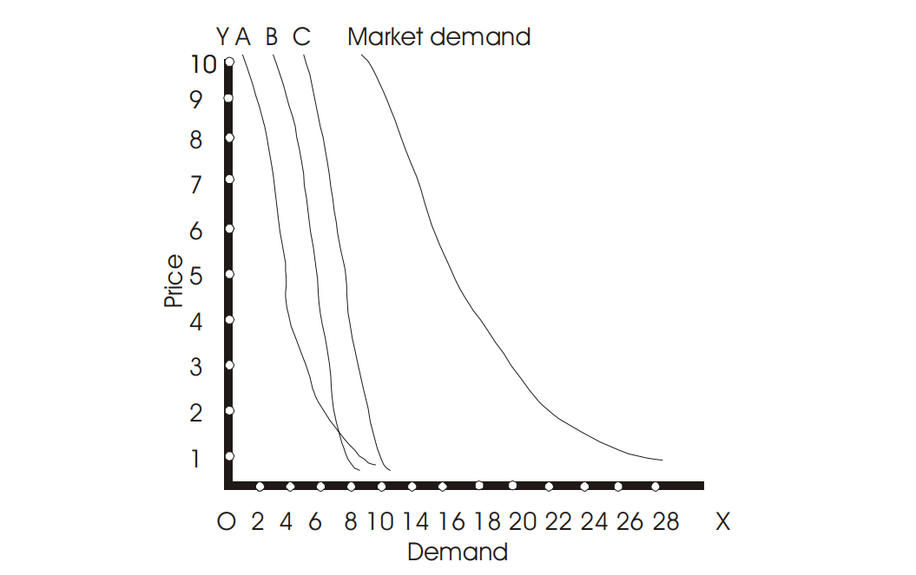

**Fig. 4.1**

## DETERMINANTS OF DEMAND

Demand for a product depends upon a number of factors. The most important of these are—the price of the product, income of the consumer, tastes and fashion and the prices of related goods. We can put it in the functional form as:

D*x* = *f* (P*x*, I, P*y*, T, F…)

Where D*x* = demand of good *x*; P*x*, = price of good *x*; I = income of the consumer; Py = prices of related goods; T = tastes and F = fashion.

Thus, demand for a commodity depends upon the following factors:

1. **Price of the commodity:** Price of a commodity is an important factor that determines demand for a commodity. When price of a commodity rises, consumers buy less and when prices fall, demand increases. Here, we assume other things (factors) to be remaining constant, i.e, *ceteris paribus.*
2. **Income of the consumer:** The demand for goods depends upon the incomes of the people. The greater the income, the greater will be the demand for a good. More income means greater purchasing power. People can afford to buy more when their incomes rise. On the other hand, if income falls, demand for a commodity also decreases.
3. **Prices of related goods:** Related goods are of two types—substitute and complements. Substitute goods can be interchangeably used. For example, tea and coffee are substitute goods. If tea is dearer, one can use coffee and vice versa. Complementary goods are demanded together as bread and butter or car and petrol.

When price of a substitute for a good falls, the demand for that good declines and when price of substitute rises, the demand for that good increases. In case of complementary goods, the change in the price of any of the two goods also affects the demand of the other. For instance, if demand for two-wheelers fall, the demand for petrol also goes down.

1. **Taste and preferences of the consumer:** These are important factors, which affects the demand for a product. If tastes and preferences are favourable, the demand for a good will be large. On the other hand, when any good goes out of fashion or people’s tastes and preferences no longer remain favourable, the demand decreases.

## DEMAND SCHEDULE AND DEMAND CURVE

A demand schedule is a tabular statement that shows the different quantities of a commodity that would be demanded at different prices. It expresses what quantities of a good will be purchased at different possible prices. A demand schedule is shown as below:

|  |  |
| --- | --- |
| *Price of apples per unit* | *Quantity demanded* |
| *(in Ksh.)* | *(in nos.)* |
| 8 | 5 |
| 6 | 7 |
| 4 | 8 |
| 2 | 10 |

It is clear from the table, that when price of an apple is Ksh. 8/- the consumer demands 5 apples and when price falls to Ksh. 2/- each, demand of apples goes up to 10 units. Thus, price and quantity demanded shows inverse relationship.

On the basis of the above demand schedule, we can derive an individual’s demand curve. A Demand curve is the graphical representation of the demand schedule. This is shown in Fig. 4.2 below. Prices of apples are measured along Y-axis and quantities demanded along X-axis. A, B, C and D are the different combinations of price and quantity demanded. Joining these points, we get the demand curve *dd* sloping downwards to the right, indicating inverse relationship between price and quantity demanded.

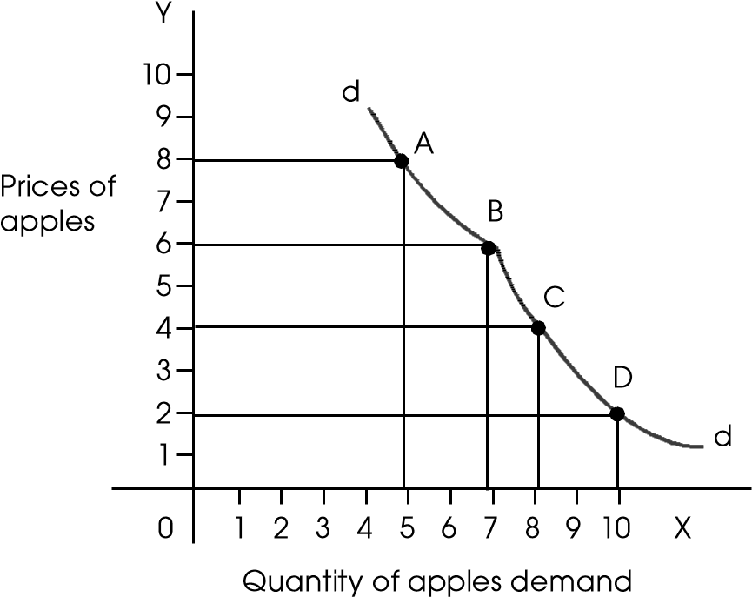

**Fig. 4.2**

## LAW OF DEMAND

The law of demand expresses the functional relationship between price and quantity demanded of a good. It is one of the most important laws of economic theory. According to this law, other things remaining constant (*ceteris paribus*), if the price of a commodity falls the quantity demanded of it will rise and if price of the good rises quantity demanded will fall. Thus, there is inverse relationship between price and quantity demanded. Thus, we buy more units of apple when its price comes down from Ksh. 4 per unit to Ksh. 2 per unit. Law of demand only applies when certain conditions are met, which have been mentioned as under.

### Assumptions of the law

The law of demand assumes the following:

1. Incomes of consumers do not change. If consumer’s income increases or decreases, the law will not hold good.
2. People’s tastes and preferences remain unchanged; and
3. Prices of substitutes and complements do not change.

The law of demand can be explained with the help of a demand schedule and through a demand curve. A demand schedule is shown as under.

|  |  |
| --- | --- |
| *Price of apples per unit* | *Quantity demanded* |
| *(in Ksh.)* | *(in nos.)* |
| 8 | 5 |
| 6 | 7 |
| 4 | 8 |
| 2 | 10 |

It is seen in the table that when the price of the commodity is Ksh. 8/- per unit, consumers buy 5 units only and at Ksh. 2/- per unit, they buy 10 units of the commodity. Thus, as price goes down, consumers buy more of a commodity and vice versa. The demand curve drawn from this schedule is shown in Fig. 4.3. Along x-axis, quantity is measured and along y-axis price of the commodity is measured. By joining various points or combinations of price and quantity demanded, we get a curve ‘*dd*’ falling downwards from left to the right. This is known as the demand curve. The demand curve clearly indicates that price is inversely related to quantity demanded. As price falls, demand rises and it shrinks when price rises. It is to be noted here that we have assumed ‘other factors’ to be constant. Thus, any changes in these factors such as tastes, fashion, income or prices of related goods etc, will falsify the law of demand. In that case, the demand curve will not behave in the manner stated above. For instance, if income of consumer rises at the time when price of goods have risen, demand will not go down. Rather, it may increase. We do not bother of rise in price of goods when our income also increases.

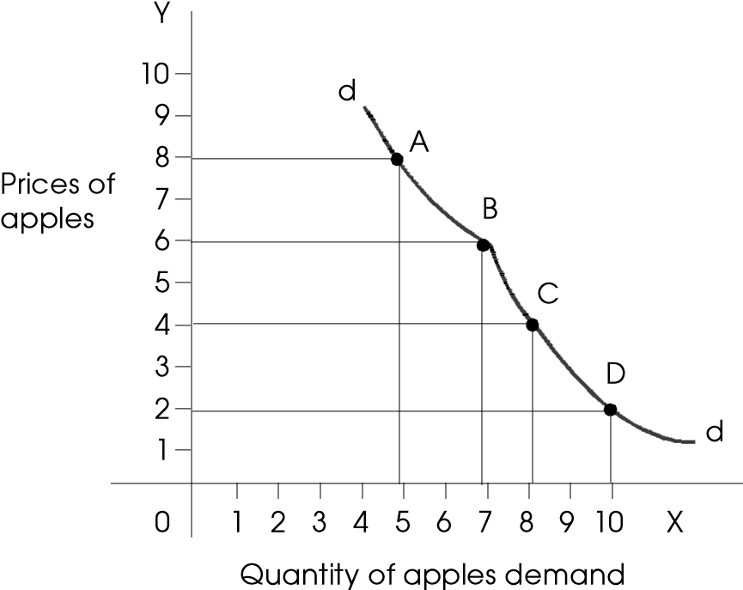

#### Fig. 4.3

**Why does the Law of Demand Operate?**

Demand curve by and large slopes downward to the right. This is because of operation of the law of diminishing marginal utility. When the price of a commodity decreases, new demand is created. Also that existing buyers buy more. As the particular commodity has become cheaper, some people will purchase it in preference to other commodities. If the law of diminishing marginal utility is true, the demand curve must slope downwards. This is because only a downward sloping demand curve represents increase in demand due to fall in the prices of a commodity. Further, when price of a commodity falls, real income of the people increases. In other words, they are able to buy more goods and services now with the same amount of money they have. This is called **income effect.**

Likewise, when the commodity is cheaper, it tends to be substituted for other commodities, which are dearer. This is called **substitution effect.** Both income effect and substitution effect together increase the capacity of the consumers to buy more of a commodity, when its price comes to low level.

Another reason for downward sloping demand curve is that when a commodity becomes cheaper, it can be put to more uses or not so urgent uses. This also makes demand to be greater when price falls.

### Exceptions to the Law of Demand

There are a few exceptions to the law of demand. It means those conditions when the law does not hold good. These are:

1. There are certain goods called as Giffen goods. In case of such goods, the law of demand does not hold good. Sir Francis Giffen observed that when Irish potato prices increased in bad years, people curtailed spending on other commodities and increased their spending on potatoes. Because with high potato prices and no increase in their money incomes, they were now too poor to afford meat and other foodstuffs. So they had to sustain themselves by eating more potatoes. That is people demanded more potatoes when their prices increased and vice versa. This is called **Giffen Paradox.** (Also see note on Giffen goods at the end of this chapter.)
2. In case of conspicuous consumption, as observed by Thorstein Veblen, the demand curve does not slope downwards. Sometimes people buy some products to show their status in the society. The possession of such commodities, they feel, may confer a higher level of social status on their holder. These goods are diamonds and other precious stones etc. Rich class buys such goods at very high price to show that they belong to a prestigious class. (Also see note on Veblen goods at the end of this chapter.)
3. The law of demand also not applies to a commodity whose quality is judged by its high price. At high prices, some people buy more of such commodity than at lower price thinking that high priced are better than those priced lower. This is out of sheer ignorance that people act in such a way.
4. Speculation (a guesswork or prediction of a future event and act accordingly) is another exception to the law of demand. If the price of commodity is increasing and people expect a further rise in the price, they will tend to buy more of the commodity at higher price than they did at the lower price. It is observed that when there is a hike in edible oil prices recently, some people purchased more of it in the expectation that future prices will be even more.

## MOVEMENT ALONG AND SHIFTS IN DEMAND CURVE

A distinction between movement along the demand curve and shifts in the demand curve is very important while studying demand theory. Movement along the demand curve takes place when there is a change in price of a good, other things remaining same. This is also termed as a change in Quantity demanded. That is changes in demand due to a change in the price of a commodity, other things being equal. In other words, when either due to increase or decrease in the price of a good, the demand increases, then it is seen that the demand curve remain the same; only the equilibrium position on the demand curve is changed. This is called extension and contraction in demand. Thus when quantity demanded of a good rises due to the decrease in price alone, it is said that extension of demand have taken place. And quantity demanded falls due to rise in price; it is called contraction in demand. The extension and contraction in demand is illustrated in the Fig. 4.4.

Y

R

Q

P

O

N

M

S

X

D

C

B

A

D

Quantity

Price

### Fig. 4.4

Assuming other factors such as tastes, income and price of related goods remain constant, demand curve DD is drawn. At OQ price, OM of the commodity is demanded so that the equilibrium point is at B. If price falls to OP, the quantity demanded increases to OS but the consumer remains on the same curve DD; only equilibrium position moves from B to C. In case of rise in price to OR, demand shrinks to ON and the equilibrium position also moves to the left from B to A. This is called contraction in demand. The extension and contraction in demand take place only due to changes in the price of a commodity, other factors remaining same.

Now let us explain shifts in the demand curve. A demand curve either shifts to the right or left, due to changes taking place in other factors and not price of the commodity. The change in the position of the demand curve due to these changes can be termed as the increase and decrease in demand. When due to changes in the factors such as tastes, fashion, price of related commodities, income etc, the demand curve shifts upwards or to the right, increase in demand is said to have taken place. Similarly, when less is demanded at the same price due to changes in other factors, it is called decrease in demand. Here, the demand curve gets shifted leftward. Thus increase in demand is due to the following factors:

1. Taste and fashion/preferences are more favourable for the good.
2. Income of the consumer increases.
3. Price of substitutes has risen.
4. Price of complementary goods has declined.
5. Propensity to consume of the people has increased.
6. Numbers of consumers have increased.

Likewise, decrease in demand may take place due to the following reasons:

1. Taste and fashion/preferences are not favourable for the good.
2. Income of the consumers has fallen.
3. Price of substitutes has fallen.
4. Price of complementary goods has risen.
5. Propensity to save of the people has increased.

Increase and decrease in demand (shifts in the demand curve) is shown in the Fig. 4.5. DD is the demand curve when price is OP. At this price, ON quantity is bought. When consumer’s income falls, price remaining same, demand curve shifts to the left as D*"* D*"*. The consumer buys less of the same commodity, i.e, ON*"* now. When income rises, price remaining same, consumer is able to buy more, i.e., ON*'*. In such case, the demand curve shifts to the right as D*'*D*'*.

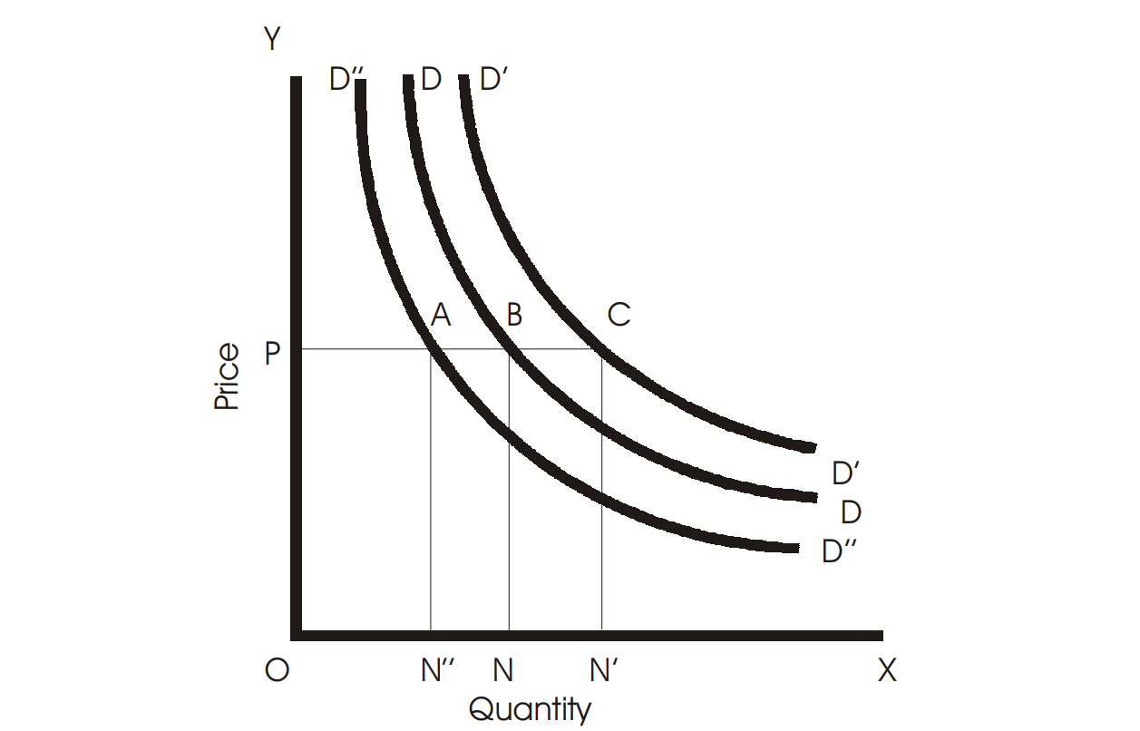

Fig. 4.5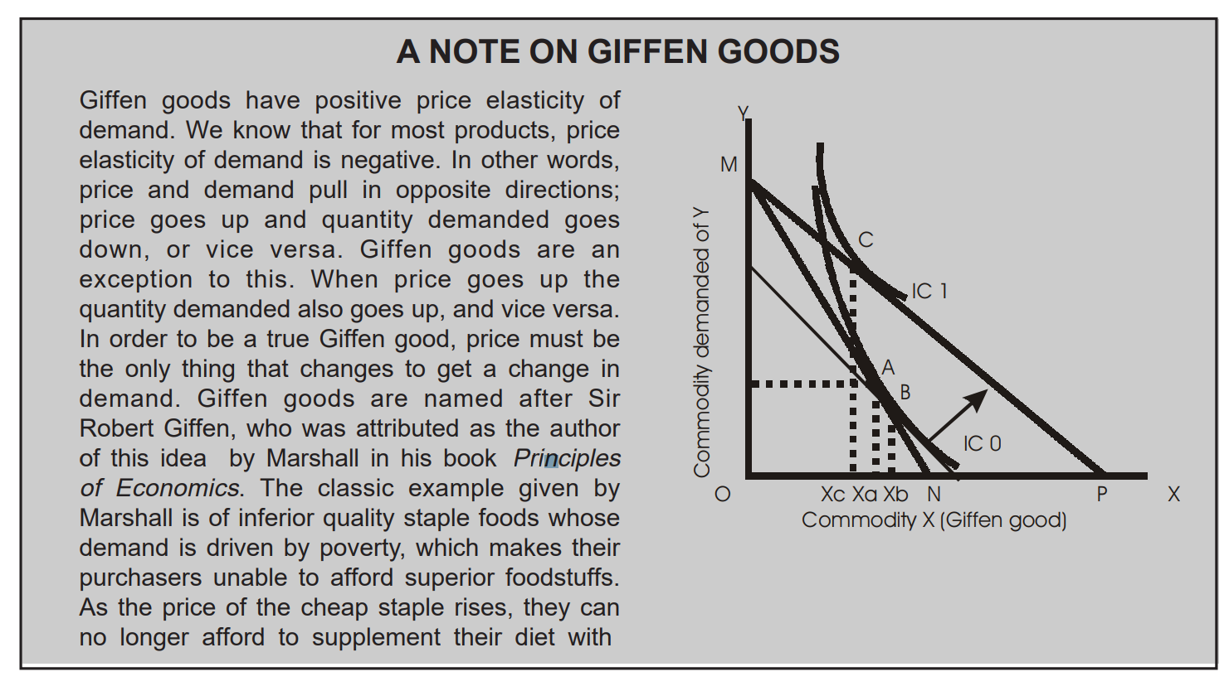

|  |
| --- |
| better foods, and must consume more of the staple food. Marshall wrote in the 1895 edition of Principles of Economics:  “As Mr. Giffen has pointed out, a rise in the price of bread makes so large a drain on the resources of the poorer labouring families and raises so much the marginal utility of money to them, that they are forced to curtail their consumption of meat and the more expensive farinaceous foods: and, bread being still the cheapest food which they can get and will take, they consume more, and not less of it.”  There are three necessary preconditions for this situation to arise:   1. The good in question must be an inferior good, 2. There must be a lack of close substitute goods, and 3. The good must comprise a substantial percentage of the buyer’s income.   If precondition no-1 is changed to “The good in question must be so inferior that the income effect is greater than the substitution effect” then this list defines necessary and sufficient conditions. This can be illustrated with a diagram above. Initially the consumer has the choice between spending their income on either commodity Y or commodity X as defined by line segment MN (where M = total available income divided by the price of commodity Y, and N = total available income divided by the price of commodity X). The line MN is known as the consumer’s budget constraint. Given the consumer’s preferences, as expressed in the indifference curve IC0, the optimum mix of purchases for this individual is point A. If there is a drop in the price of commodity X, there will be two effects. The reduced price will change relative prices in favour of commodity X, known as the substitution effect. This is illustrated by a movement down the indifference curve from point A to point B (a pivot of the budget constraint about the original indifference curve). At the same time the price reduction causes the consumers’ purchasing power to increase, known as the income effect (a outward shift of the budget constraint). This is illustrated by the shifting out of the dotted line to MP (where P = income divided by the new price of commodity X). The substitution effect (point A to point B) raises the quantity demanded of commodity X from Xa to Xb while the income effect lowers the quantity demanded from Xb to Xc. The net effect is a reduction in quantity demanded from Xa to Xc making commodity X a Giffen good by definition. Any good where the income effect more than compensates for the substitution effect is a Giffen good.  A 2002 preliminary working paper by Robert Jensen and Nolan Miller made the claim that rice and noodles are Giffen goods in parts of China. In 1991, Battalio, Kagel, and Kogut proved that quinine water is a Giffen good for lab rats. Some types of premium goods (such as expensive French wines, or celebrity endorsed perfumes) are sometimes claimed to be Giffen goods. It is claimed that lowering the price of these high status goods can decrease demand because they are no longer perceived as exclusive or high status products. However, the perceived nature of such high status goods changes significantly with a substantial price drop. This disqualifies them from being considered as Giffen goods, because the Giffen goods analysis assumes that only the consumer’s income or the relative price level changes, not the nature of the good itself. If a price change modifies consumers’ perception of the good, they should be analyzed as Veblen goods. |

## VEBLEN GOOD

A commodity is a Veblen good if people’s preference for buying it increases as a direct function of its price. The definition does not require that any Veblen goods actually exist. However, it is claimed that some types of high-status goods, such as expensive wines or perfumes are Veblen goods, in that decreasing their prices decreases people’s preference for buying them because they are no longer perceived as exclusive or high status products. The Veblen effect is named after the economist Thorstein Veblen, who invented the concepts of conspicuous consumption and status-seeking.

The Veblen effect is one of a family of theoretically possible anomalies in the general theory of demand in microeconomics. The other related effects are:

1. The snob effect: preference for good decreases as the number of people buying it increases;
2. The bandwagon effect: preference for good increases as the number of people buying it increases;
3. The **counter-Veblen** effect, in which preference for good increases as its price falls.

The concept of the counter-Veblen effect is less well known, was introduced by Lea. [(Lea, S. E. G., Tarpy, R. M., & Webley, P. (1987). The individual in the economy. Cambridge: Cambridge University Press.]

None of these effects in itself predicts what will happen to actual demand for the good (the number of units purchased) as price changes - they refer only to preferences or propensities to purchase. The actual effect on demand will depend on the range of other goods available, their prices, and their substitutability for the goods concerned. The effects are anomalies within demand theory because the theory normally assumes that preferences are independent of price or the number of units being sold. They are therefore collectively referred to as **interaction effects**.

### Questions for Review

1. What do substitute goods mean?
2. What do complementary goods mean?
3. What is increase in demand?
4. What is contraction in demand?
5. Distinguish between increase in demand and extension in demand.
6. When does a consumer buy more of a commodity at a given price?
7. Mention any one determinant of demand for a commodity other than its price.
8. Why does demand curve slope downwards from left to right?
9. Define demand.
10. What is demand schedule?
11. Explain law of demand. Illustrate your answer with appropriate diagram.
12. What factors influence the demand for a commodity?
13. What are Giffen’s goods?
14. What is the shape of a demand curve?
15. What happens to demand when there is a contraction in demand?
16. What factors determine demand?
17. What are inferior goods?
18. State the relationship between demand & price.
19. Give an example of a pair of commodities that are substitutes of each other. .
20. Give an example of a pair of commodities such that one of them is complementary in consumption to the other. .
21. If the price of good X rises and it leads to an increase in demand for good Y, how are the two goods related? .
22. If the price of good X rises and it leads to decrease in demand for good Y, how are the two goods related? .
23. What is meant by cross price effects? .
24. How will an increase in the price of coffee affect the demand for tea? .
25. How will an increase in the price of tea affect the demand for sugar? .
26. Give two examples of normal goods and two examples of inferior goods. .
27. How does an increase in income affect the demand curve for a normal good? .
28. How does an increase in income affect the demand curve for an inferior good? .
29. How the market demand curve is derived from the individual demand curves? .
30. What are the determinants of market demand curve? .
31. What is market demand?
32. Give examples of substitute goods.
33. Give examples of complimentary goods.
34. What is demand curve?
35. What is meant by the phrase—‘Ceteris paribus’?
36. What are the assumptions of law of demand?
37. Explain the terms-Income effect and Substitution effect.
38. What are the important exceptions to the law of demand?
39. What is Giffen Paradox?
40. What is conspicuous consumption?
41. Distinguish between movement along the demand curve and shifts in the demand curve.
42. What is meant by a change in quantity demanded?
43. What do you mean by extension in the demand curve?
44. Distinguish between extension and increase in demand curve.
45. Distinguish between contraction and decrease in demand curve.
46. What are the causes of increase in the demand curve?
47. What are the causes of decrease in the demand curve?
48. Show with the help of diagrams, shifts in the demand curve and movement along then demand curve.

**Chapter 5**

**ELASTICITY OF DEMAND**

### MEANING OF PRICE ELASTICITY OF DEMAND

Elasticity, roughly, means responsiveness. What response demand of a commodity shows when there is either increase or decrease in its price, is explained with the help of elasticity. Managers have great advantages by knowing elasticity of the products he is selling. Greater response means greater elasticity and small response indicates less elasticity. A manager is very interested in knowing whether sales will increase by 4 percent, 10 percent or more by cutting down price by 8 percent. Elasticity of demand, thus, measures the degree of responsiveness of demand to a change in price of the commodity. Prof. Alfred Marshall had introduced the concept of elasticity of demand in the economic theory. In his words, *“The elasticity (or responsiveness) of demand in a market is great or small according as the amount demanded increases much or little for a given fall in price and diminishes much or little for a given rise in price.”* We may thus define elasticity of demand as the ratio of the percentage change in quantity demanded to the percentage change in price.

Demand may be elastic or inelastic. When due to a small change in price, there is a great change in demand, it is said that demand is elastic. If a 5 percent cut in prices of car results in an increase in 30 percent in sales, demand is said to be highly elastic. In other words, demand has responded greatly. On the other hand, if a great change in price is followed by a small change in demand, it is inelastic demand. For example, the demand for salt is said to be inelastic because same quantity of it will be purchased even if price rises or declines. Whereas, demand for a car is elastic because a small rise/fall in price may greatly reduce/increase its demand. Price elasticity of demand is expressed as under:

Percentage change in demand

E*p* =

Percentage change in price

There are five **cases/kinds of price elasticity of demand.** These are as follows:

**1. Perfectly Inelastic Demand:** Demand for a commodity will be said to be perfectly inelastic, if the quantity demanded does not change at all in response to a given change in price. If 10 percent change in price results in zero percent change in demand, it is exactly inelastic demand. The demand curve, in this case, is vertical straight line perpendicular to Y-axis as shown in Fig. 5.1.

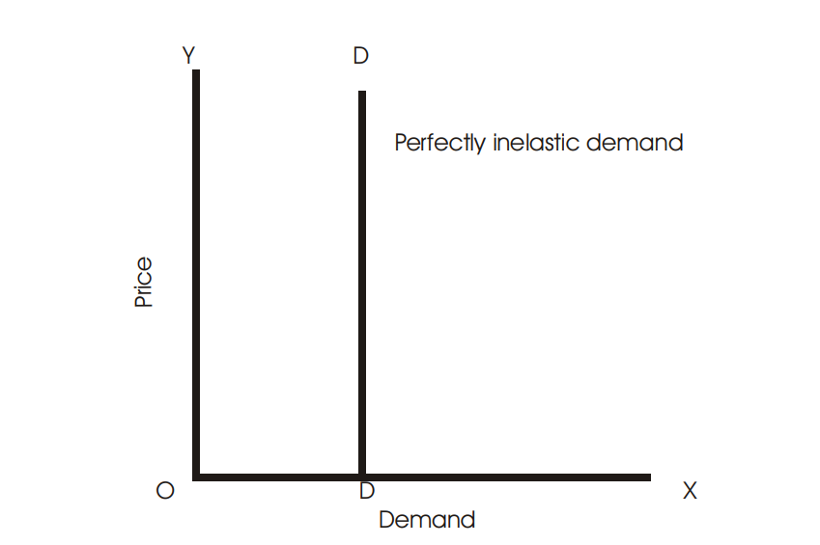

#### Fig. 5.1

**2. Inelastic or less than Unit Elastic Demand:** Demand for commodity will be said to be inelastic (or less than unit elastic) if the percentage change in quantity demanded is less than the percentage change in price. If 10 percent change in price results in 6 percent change in demand, it is inelastic demand. This is shown in Fig. 5.2.

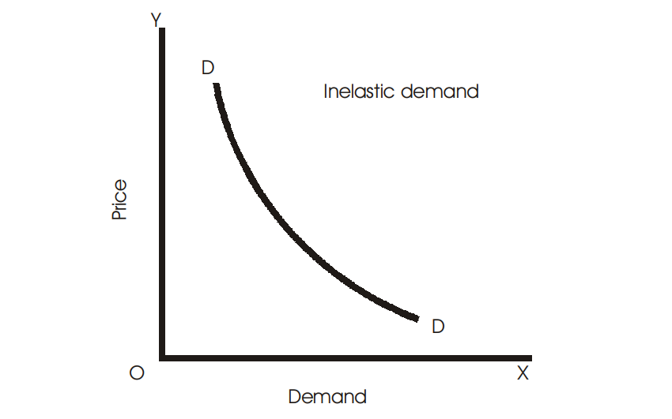

#### Fig. 5.2

**3. Unitary Elastic Demand:** Demand for a commodity will be said to be unit elastic if the percentage change in quantity demanded equals the percentage change in price. If 10 percent change in price results in 10 percent change in demand, it is unit elastic demand. The demand curve in such case is called rectangular hyperbola shown in the adjacent Fig. 5.3.

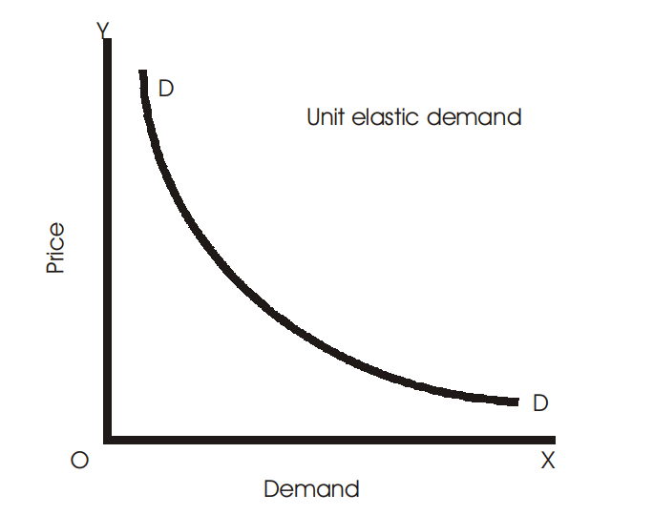

#### Fig. 5.3

**4. More than Unit Elastic:** Demand for a commodity will be said to be more than unit elastic if a change in price results in a significant change in demand for this commodity. If 10 percent change in price results in 14 percent change in demand, it is elastic demand. Figure 5.4 below shows elastic demand.

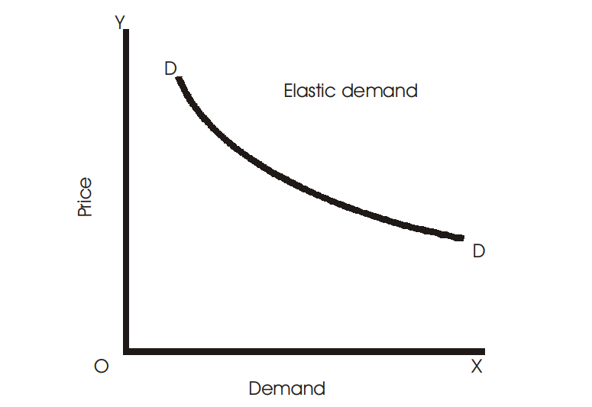

**Fig. 5.4**

**5. Perfectly Elastic Demand:** Demand for a commodity is said to be perfectly elastic, when a small change in its price results in an infinite change in its quantity demanded. If 10 percent change in price results in (α) percent change in demand, it is exactly elastic demand. In this case, demand curve is horizontal straight line parallel to X-axis as shown in Fig. 5.5. The first and the last cases are rare in real life.

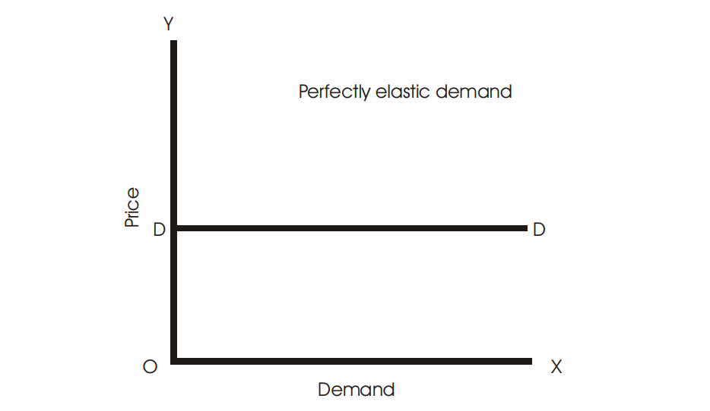

#### Fig. 5.5

Thus, we can summarize the types of elasticity in the table below:

|  |  |  |  |
| --- | --- | --- | --- |
| *Percentage change* | *Percentage change* | *Types* | *Coefficient* |
| *in price* | *in demand* |  | *of elasticity* |
| 10 | 0 | Perfectly inelastic | *e* = 0 |
| 10 | 6 | Inelastic | *e* < 1 |

*Contd....*

|  |  |  |  |
| --- | --- | --- | --- |
| 10 | 10 | Unit elastic | *e* = 1 |
| 10 | 14 | Elastic | *e* > 1 |
| 10 | α | Perfectly elastic | *e* = α |

The table shows how a 10% change in price of a good influences quantity demanded. If there is no change or zero change in quantity demanded, elasticity is perfectly inelastic. Likewise, if the change is relatively less, demand is inelastic. In case of same change and more changes in demand, elasticity is unitary and elastic demand respectively. When there is very great change, demand is perfectly elastic.

### MEASUREMENT OF PRICE ELASTICITY OF DEMAND

It is very important to know to what extent demand is responsive, that is elastic or inelastic. For this purpose measurement of elasticity is necessary. The important methods to measure elasticity are the following:

1. Percentage method.
2. Arc method.
3. Total outlay method.
4. Point/Geometrical method.
5. Revenue method.

#### Total Outlay/Expenditure Method

Elasticity of demand for a commodity can be measured with the help of the Total Outlay/ expenditure incurred by a household on the purchase of a commodity. Total outlay is (TQ = *p* × *q*) where TQ stands for total outlay, *p* and *q* for price and quantity respectively. This method provides us with three different measurements of the elasticity of demand, which are as follows:

1. Less than Unit Elastic (*e* < 1)
2. Unit Elastic (*e* = 1)
3. More than Unit Elastic (*e* > 1)

Total outlay method to measure elasticity of demand was primarily used by Prof. Marshall. According to this method, elasticity is measured by comparing the total money spent by the consumer on the goods before and after the changes in price. Elasticity can be measured for the following three situations:

1. **Unit elasticity (e = 1):** When the total money, outlay, or expenditure (TE) remains unchanged even after a change in the price of the commodity, elasticity is said to be unitary. Take for instance the following example, where TE remains the same. It is seen that when price falls to Rs 2 per unit, total expenditure does not change.

|  |  |  |
| --- | --- | --- |
| *Price (Ksh. Per unit)* | *Quantity (Q)* | *Total Expenditure (TE)* |
| 5 | 10 | 50 |
| 2 | 25 | 50 |

1. **More than unit elastic (e > 1):** When the total money expenditure rises with a fall in price and falls with a rise in price, it is the case of elasticity greater than one or elastic demand. This will be clear from the table. When price falls from Ksh. 5 to Ksh. 2 per unit, total expenditure rises from Ksh. 50 to Ksh. 60. Thus there is inverse relationship between price and total expenditure.

|  |  |  |
| --- | --- | --- |
| *Price (Ksh. Per unit)* | *Quantity (Q)* | *Total Expenditure (TE)* |
| 5 | 10 | 50 |
| 2 | 30 | 60 |

1. **Inelastic demand (e < 1):** When the total money expenditure rises with an increase in price and falls with a fall in price, it is the case of inelasticity of demand or elasticity less than one. The adjacent table shows this case. In this case, when price decreases, total expenditure also declines. Thus price and total expenditure have direct relationship.

|  |  |  |
| --- | --- | --- |
| *Price (Ksh. Per unit)* | *Quantity (Q)* | *Total Expenditure (TE)* |
| 5 | 10 | 50 |
| 2 | 15 | 30 |

The Fig. 5.6 below also depicts how price elasticity can be measured with the help of total outlay method. Demand is unit elastic over the price range R and Q; inelastic over the price range S and R and elastic over the price range P and Q.

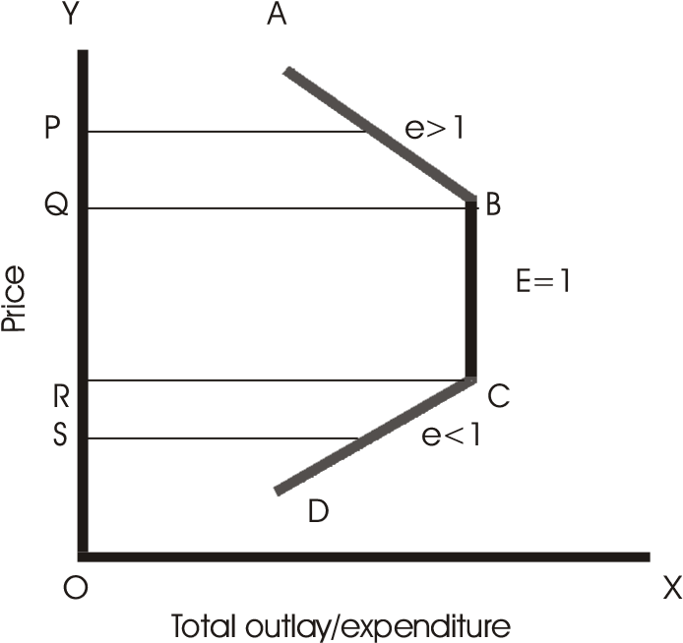

**Fig. 5.6**

#### Percentage Method

Price elasticity of demand can also be measured with the help of percentage method or proportionate method. According to this method, percentage change in price is compared with the percentage change in demand. Elasticity is the ratio of the percentage change in quantity demanded to the percentage change in price as expressed below:

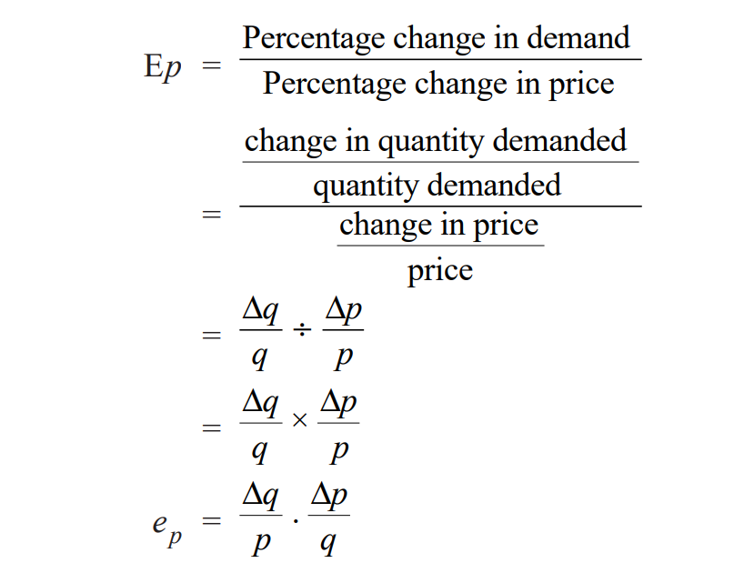

Where, *ep* = price elasticity; ∆*q* = change in quantity demanded; ∆*p* = change in price; *p* = price; *q* = quantity.

**Note:** The elasticity of demand is always negative. This is because price and quantity are inversely related. But by convention, for the sake of simplicity, the minus sign is dropped in economics.

#### Arc Method

This is another important method to measure price elasticity of demand. In this method, we take the averages of original and new prices and quantities to measure elasticity. This method is used when there is a big change in price so that an arc is formed on the demand curve. It can be measured by using the formula shown below:

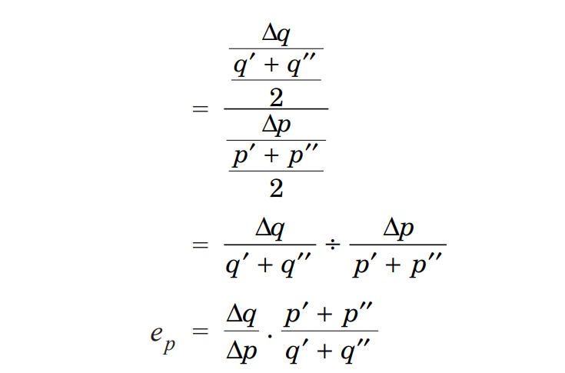

Where, *p'* = original price; *p''* = new price; *q'* = original quantity; *q''* = new quantity.

#### Point/Geometrical Method

This method measures elasticity using demand curve. It is, therefore, also called as geometrical method of measuring elasticity. The diagram below illustrates how to find different types of elasticity on a demand curve. DD is the straight line demand curve (constant slope). Elasticity is measured as under,

Lower segment of the demand curve

E =

Upper segment of the demand curve

All five cases are shown in the Fig. 5.7 below. We find that elasticity of demand falls steadily as we move from D*''* toward D.

#### C:\Users\HP\Downloads\2023-05-10 (2).png

#### Revenue Method

Revenue is the amount that a firm earns by selling its products. It is measured by multiplying price with total quantity/units of product sold. Thus, TR = Quantity × Price. Elasticity can be measured using the concepts of average and marginal revenue shown as under.

Average revenue

E = Average revenue − Marginal revenue

#### Income Elasticity of Demand

It is the ratio of the percentage change in the amount spent on the commodity to a percentage change in the consumer’s income, price remaining constant. That is,

Proportionate change in demand

I*e* =

Proportionate change in income

#### Cross Elasticity of Demand

The responsiveness of demand to a change in the prices of related commodities (substitutes and complementary) is called cross elasticity of demand. It is responsiveness of demand for commodity X to a change in price of commodity Y and is represented as follows:

Proportionate change in demand of X

C*c* =

Proportionate change in price of good Y

### DETERMINANTS OF PRICE ELASTICITY OF DEMAND

Elasticity of demand differs from commodity to commodity. The various factors upon which elasticity depends are the following:

1. **Substitute goods:** A commodity will have elastic demand if there are good substitutes for it. This is because when price of a good rises, a consumer will not buy the good but purchase its substitute.
2. **Nature of commodity:** All necessities like salt, rice etc that have no substitutes/or less substitutes will have an inelastic demand. People have to purchase such commodities for their sustenance. Therefore, there will be some demand despite the changes in price. Demand for luxury goods, on the other hand, will be elastic. If prices of such commodities rise even a little, consumers refrain to buy. At the same time a little lowering of price of such commodities attract a large number of consumers.
3. **Number of uses of commodity:** The larger the number of uses to which a commodity can be put, the higher will be its elasticity. Therefore the demand of such goods will have elastic demand. For example, milk can be used for various purposes such as for making curd, cake, sweets etc. When its price goes down, demand increases but a little rise in its price makes demand fall greatly.
4. **Possibility of postponement of consumption:** If there is a possibility of postponement of consumption of a commodity then demand will be elastic otherwise inelastic. Demand for certain goods can be postponed for sometime such as computers, printers, scanners etc. People may wait till they become cheaper. Therefore, their demand is elastic. But the demand for food or electricity cannot be postponed. As such their demand is inelastic.
5. **Percentage of income spent:** The elasticity of demand is also influenced by the percentage of income spent on the purchase of a commodity. If the percentage is very less then the demand will be inelastic. For instance, we spend a very less amount of our total money income on things like agarbatties (incense sticks), matches, pens, pencils etc. If prices of such commodities rise also, our demand is not reduced. Thus, demand of such goods is inelastic.
6. **Fashion:** Commodities, which are in fashion, will have inelastic demand. Fashion minded people do not compromise with price. Even if price is high, some people will demand more just because goods are in fashion.
7. **Change in taste:** A habitual commodity or a commodity for which consumers have developed a taste will have inelastic demand. A chain smoker always requires a cigarette, whatever the price may be. Likewise, a habitual paan (betel nut) chewer cannot leave his habit, in spite of rise in price. In such cases, therefore, demand is elastic.
8. **Price of the commodity:** Very high priced or very low priced goods have low elasticity whereas moderately priced commodities are quite high-elastic. If a good is very expensive, demand will not increase much even if there is little fall in its price. And demand will not increase even at very low prices, because people have already purchased their requirement at low prices.

#### Questions for Review

1. What is the shape of the perfectly inelastic demand curve?
2. What is the shape of the unitary elastic demand curve?
3. What is the shape of the perfectly elastic demand curve?
4. Define price elasticity of demand for a commodity and state its importance.
5. When is demand said to be inelastic?
6. How would you measure price elasticity of demand by the total outlay method? Explain.
7. Define price elasticity of demand. How can it be measured?
8. What will be the shape of demand curve when the demand is unitary elastic?

**Chapter 6**

**THEORY OF PRODUCTION**

So far we have made an analysis of how a consumer behaves and his demand for a commodity. Now we shall see concepts related to production, which are very useful for a producer in his decision making.

### MEANING OF PRODUCTION

Production in economics generally refers to the transformation of inputs into outputs. Inputs are the raw materials or other productive resources used to produce final products i.e., output. In technical terms, production means the creation of utility or creation of want-satisfying goods and services. Any good become useful for us or satisfies our want when it is worth consumption. Thus, a good can be made useful by adding utility. For instance, we cannot consume wheat flour raw when we are hungry (want), unless it is turned into bread (output). This conversion of wheat flour into bread is the process of creating utility. Utilities can be created in three ways. These are the following:

1. *By changing form or shape and size of a good.* The powdery wheat flour has been changed to slices of bread. Thus form of the good has been changed. Likewise, a carpenter giving shape of a chair to a piece of wood or a chef turning a lump of dough into delicious pizzas, are the examples of changing shape or size of a good/s and thereby creating utility.
2. Using the scarce goods and services in proper time when they are most required. Government maintains a buffer stock so that during the time of crisis, it releases food grains in the market to meet the demand.
3. By transferring a good from one place to another where its use is worthwhile. Sand transferred from river side to construction site increases its utility.

Thus, production is the process of adding utility to a good through form utility, place utility and time utility.

### MEANING OF PRODUCTION FUNCTION

Production function is defined as the functional relationship between physical inputs and physical outputs. According to Stigler, “*the production function is name given to the relationship between the rates of input of productive services and the rate of output of product. It is the economist’s summary of technological knowledge.”* Production function can be expressed as follows:

Q = *f* (*a*, *b,* *c*, *d*…)

Where, Q stands for output, *a*, *b*, *c*, *d*…. are the productive resources or inputs that help producing Q output; *f* refers to function. Thus Q is the function of *a*, *b*, *c*, *d*….., which means Q depends upon *a*, *b*, *c*, *d*…..

Thus a production function shows the maximum amount of output that can be produced from a given set of inputs in the existing state of technology.

### RETURNS TO A FACTOR AND RETURNS TO SCALE

There are generally two types of production functions mostly used in economics. First, the production function when the quantities of some inputs are kept fixed and the quantity of one or few input/s are changed. This kind of production functions are studied under law of variable proportions. These are also called short-run production function. The short-run is a period during which one or more factors of production are fixed in amount. There is no time to change plants or equipments of an enterprise.

Secondly, the production functions in which all inputs are changed. This forms the subject matter of the law of returns to scale. These are also called long-run production function. The long run is a period during which all factors become variable. A new plant can be constructed in place of an old one.

#### Law of Variable Proportions/Law of Diminishing Returns

Law of variable proportions occupies an important place in the economic theory. It examines the production function with one factor variable, keeping the quantities of other factors constant. This law tells us how the total output or marginal output is affected by a change in the proportion of the factors used. The law states that when one factor is increased keeping others fixed, the marginal and average product eventually declines. According to Stigler, *“As equal increments of one input are added; the inputs of other productive services being held constant, beyond a certain point the resulting increments of product will decrease, i.e., the marginal products will diminish.”* Thus, an increase in the quantities of a variable factor to a fixed factor results in increase in output to a point beyond which it eventually declines.

#### Assumptions of the law

The law assumes the following:

1. The state of technology is assumed to be constant.
2. There must be some inputs whose quantity is kept fixed.
3. The law is based upon the possibility of varying the proportions in which the various factors can be combined to produce a product. It cannot be applied to the cases where the factors must be used in fixed proportions to yield a product.

The law of variable proportions is explained with the help of following table.

|  |  |  |  |
| --- | --- | --- | --- |
| *No. of* | *Total* | *Marginal* | *Average* |
| *workers* | *product\** | *product\** | *product\** |
| 1 | 10 | 10 | 10 |
| 2 | 30 | 20 | 15 |
| 3 | 60 | 30 | 20 |
| 4 | 88 | 28 | 44 |
| 5 | 100 | 12 | 50 |
| 6 | 110 | 10 | 55 |
| 7 | 118 | 8 | 16.85 |
| 8 | 118 | 0 | 14.75 |
| 9 | 110 | –8 | 12.22 |
| 10 | 100 | –10 | 10 |

*Products (in kg)

With a given fixed quantity of land, numbers of workers are increased from 1 to 10. When there are 7 workers engaged, the output is maximum, i.e., 118 kgs. Beyond this point, the total product starts diminishing. Up to 3rd unit of worker, the total product increases at an increasing rate and after that at diminishing rate. This is clear from the third (MP) column that marginal product is falling continuously after 3rd unit of worker and even becomes negative beyond 8th unit of worker. Average product increases up to 4th unit of labour and falls through out thereafter. The law can be also explained using Fig. 6.1 shown as under:

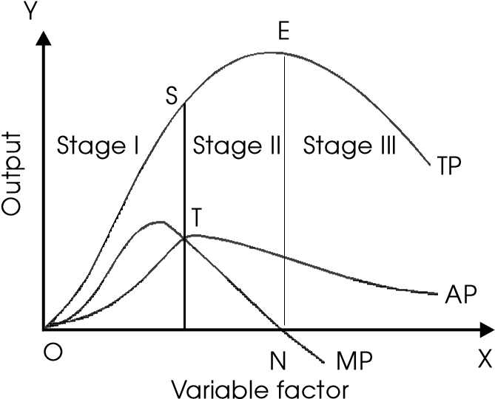

##### Fig. 6.1

In this figure, OX axis measures units of variable factor and OY axis measures output-total, marginal and average products. We observe three different stages of law of variable proportions as explained below:

1. The **first stage** goes from the origin to point where the average output is the maximum (point S). In this stage, marginal product increases. This stage is known as the stage of increasing returns. The reason for increasing returns is that when more and more units of the variable factor are added to the constant quantity of fixed factor, then fixed factor is more effectively and intensively used. This causes output to increase at a fast rate.
2. The **second stage** goes from the point where the average output is maximum to the point where marginal output is zero (point N). In this stage, marginal product starts falling. When the fixed factor is most efficiently used, then further increase in the variable factor causes marginal and average products to decline because the fixed factor now is scarce relative to the quantity of variable factor. Therefore, this stage is known as the stage of diminishing returns.
3. The **third stage** starts when the total product is maximum and marginal product is zero. In this stage, marginal product becomes negative. In this stage, the number of variable factors becomes too large relative to the fixed factor so that the total output falls and marginal output becomes negative. This is the reason why this stage is known as the stage of negative returns.

#### Returns to Scale

Scale of production relates to size of plant. Every entrepreneur has to decide about the size of his plant or business. The question is how large a business should be. Because up to a certain size of plant what is called ‘economies of scale’ take place. Economies refers to benefits arise due to the expansion of a business. Economies of scale can be broadly divided into two categoriesinternal and external. Internal economies are caused by some internal factors, which arise within the firm and are not shared by other firms. Use of better technology, purchase of raw materials at cheaper rates and selling the final goods at high price, easy availability of finance from financial institutions etc, are some examples of internal economies/benefits that a firm enjoys. External economies are those advantages which are available to all firms located in an area. Development of transportation, good and fast communication, good banking and insurance facilities, etc are the examples of external economies. Too big or too small size of plant or business is not viable in the economic sense. Optimum scale, which at least covers up cost per unit of output, is more desirable than too small or too large plant.

The study of changes in output as a result of changes (increase or decrease) in the scale is the subject matter of returns to scale. An increase/decrease in the scale refers to increase/ decrease in all inputs in the same proportion. Thus in returns to scale we study the effect of doubling or trebling and so on of all inputs on the total output. The law can be explained with the help of a table shown below :

|  |  |  |  |  |  |
| --- | --- | --- | --- | --- | --- |
| *Scale* | | *TP* | *MP* | *Stage I* | |
| 1. lab + 2 units of land 2. lab + 4 units of land 3. lab + 6 units of land 4. lab + 8 units of land 5. lab + 10 units of land 6. lab + 12 units of land | | 3  7  12  18 24  30 | 3  4 5  6  6  6 | I  II | |
| 1. lab + 14 units of land 2. lab + 16 units of land 3. lab + 18 units of land | 35  39  42 | | 5  4  3 |  | III |

Thus we find three phases of returns to scale explained as under. Up to 4th labour, marginal product or returns increases. Returns are constant over the 5th and 6th units of labour and thereafter, returns begin to decline.

**Stage I:** Output increases in a greater proportion than the increase in inputs. Thus if all inputs are increased by 10%, and as result output increases by 20%, then increasing returns to scale operates. This is also shown in the Fig. 6.2 below. In the beginning when the scale is increased, increased division of labour is possible and is undertaken, as result of which, output increases rapidly.

**Stage II:** If all inputs are increased in a given proportion and the output increases in the same proportion then returns to scale is constant. More clearly, if all inputs are increased by 10%, and as result output also increases by 10%, then constant returns to scale prevails. Up to a certain point division of labour is possible. After such a point, further increase in scale will make returns to remain constant.

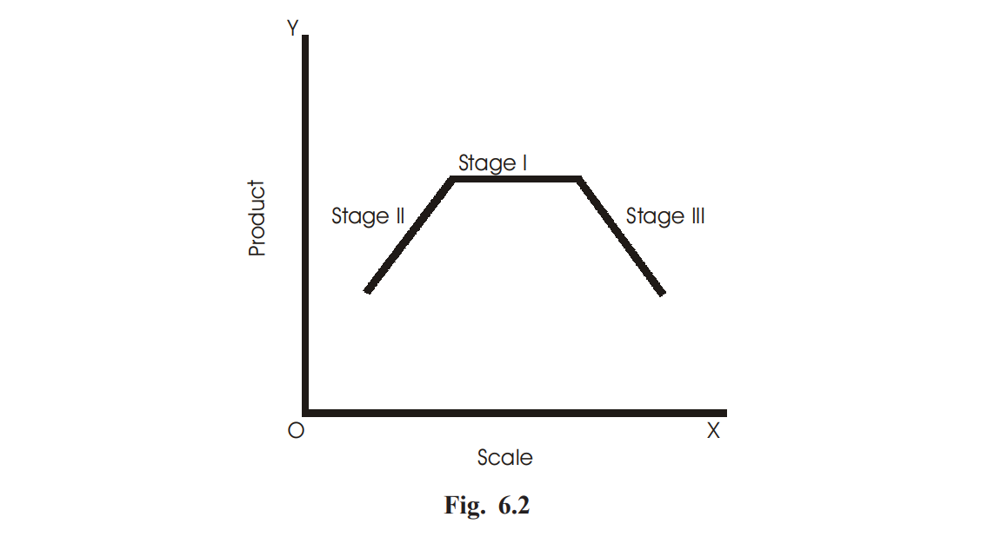

**Stage III:** If all inputs are increased in a given proportion and the output increases in less than that proportion then returns to scale is diminishing. That is, if all inputs are increased by 10%, and as result output also increases by 6%, then diminishing returns to scale prevails. When scale is increased to a point when division of labour is not possible, returns begins to decline.

#### Questions for Review

1. What are returns to scale?
2. Give two reasons for the operation of the law of increasing returns to scale.
3. Distinguish between ‘Returns to scale’ and ‘Returns to a variable factor.’
4. How can the scale of production be raised in the long run?
5. Define the following:
6. Production function
7. Returns to factor
8. Returns to scale
9. Marginal product
10. Explain. Draw an imaginary production schedule to depict the operation of this law. How can the law be kept in check?
11. Why do diminishing returns to a factor operate?
12. Complete the following table:

|  |  |  |  |
| --- | --- | --- | --- |
| *Units of* | *Total* | *Average* | *Marginal* |
| *capital* | *product* | *product* | *product* |
| 1 |  |  | 20 |
| 2 |  |  | 16 |
| 3 |  |  | 12 |
| 4 |  |  | 8 |
| 5 |  |  | 4 |
| 6 |  |  | 0 |
| 7 |  |  | –4 |

1. List any three inputs used in production.
2. What is meant by total physical product?
3. What is the general shape of the MPP?
4. What is meant by marginal physical product?
5. Give the meaning of increasing returns to scale.
6. Give the meaning of constant returns to scale.
7. Give the meaning of decreasing returns to scale.
8. What is meant by law of variable proportions?

**Chapter 7**

**THEORY OF THE FIRM**

A firm refers to a single business unit or enterprise under one ownership, management and contact. It is an independently administered business organisation that makes decision on how to use resources to produce goods and services in order to make profit.

**A plant**

A plant is a particular facility or building that is used to manufacture a product or produce a substance. Different firms have different plants.

An industry

An industry is made up of several firms that compete in the production of the same product or service. It can be made of a single firm, two firms or very many firms. For example, transport industry in Rwanda is made up of very many vehicles operators such as buses, matatus, airplanes and many others.

**Objectives of the firm**

**Remember!** The Industrial Revolution is one of the extraordinary jumps forward in the story of civilization.  
  
Different firms have different objectives depending on the size and location. All firms must make an appropriate choice when deciding on which good or service to produce in order to achieve its objectives. But in general, firms have the following objectives:

1. Profit maximization is one of the major objectives of firms.
2. Firms have an objective of increasing their share of the market. They have an objective of increasing their sales revenue. iv. They have an objective of limiting entry of new firms in the industry.
3. The objective of a firm is to improve the social and economic welfare of its employees.
4. Firms have an objective of long run survival in the market.

**Remember!**The heart and soul of the firm is creativity and innovation.

**Factors influencing long term decisions of the firm**

Every firm must put into consideration a number of factors when deciding on which good or service to produce for sale in order to make a maximum profit. This is because the resources available are scarce and every choice made has an opportunity cost. Some of the factors that should be considered include:

1. **The objective of the firm:**A firm will take decisions that are in line with its objectives such as profit maximization, sales maximization, long run survival among others.
2. **Government policies on business:**Policies like those on taxation, subsidization influence a firm’s decisions. For example, increased taxes on the firm’s products may influence a firm to increase prices or even reduce wages of employees in order to cut cost and remain profitable.
3. **The level of competition:** The level of competition will determine the decisions of the firm. For example, a firm operating under perfect or pure competition cannot take the same decisions as a monopolistic firm.
4. **Cost of production:**A firm has to consider the costs of production in taking its decisions. For example, a firm has to consider its average costs when taking decisions concerning determining price for its output.
5. **Location of the firm:** Firms that operate in urban areas will take decisions that are different from those of firms operating from rural areas as the nature of their business environment is different.
6. **Economic conditions:**The economic condition the firm is operating in influences its decisions. Such macro-economic conditions such as inflation, unemployment, business cycle will influence the decision taken by the firm.
7. **Business expectations:**What a firm expects in terms of return on its investment affects its decisions regarding planning, marketing and investment decisions among others.

Case study

One Saturday afternoon, five form four students of Tharaka Boys Highs School visited Marimanti Textiles, a large tailoring workshop in the market close to their school. This is the shop where their uniforms are bought. They were surprised by the number of customers that came in and out.

Questions

* Would you classify Marimanti Textiles as a firm or an industry? Explain your answer.
* The firm sells a wide variety of clothes. Explain the factors that the firm considers before settling on the production of particular clothes.

**LOCATION AND LOCALISATION OF FIRMS**

**Factors influencing location of a firm and an industry**

1. **Availability of raw materials:**A firm should be located in an area where raw materials are especially when the raw materials are heavy and it would be costly transport them from distant places.
2. **Availability of the market:**Firms should be located in areas where the market for its finished products is available as this reduces the firms expenditure to market its products and hence an increase in firm sales and profits.
3. **Government policy:**The policy of the government concerning industrialization influences location of firms. For example government may have the goal of regional balance in development and therefore my dictate where to locate certain firms in order to realize this goal.
4. **Transport and communication network:**Firms should be located in areas where the transport and communication infrastructure is developed. This eases transportation of the firm’s products to market and the raw materials to the firm as well as keeping in touch with its partners through efficient communication network.
5. **Availability of power:**Firms should be located in an area where power is available and less costly. This is because every firms need power in the production process and therefore its absence implies that the firm cannot undertake production.
6. **Availability of labour:**A firm should be located in an area where there is availability of abundant labour, with the required skills that the firm can employ to facility its production process.
7. **Availability of land:** Availability of enough land which the firm can acquire at a low cost and also where it can expand its scale of operations in future influences the location the firm.
8. **Political stability:**Firms should be located in an area where there is political stability since it will be sure of the security of its investments.
9. **Commercial institutions:**Presence of developed commercial institutions such as banks, insurance companies and advertising companies. They facilitate the firm to acquire credit and promote its products in case of advertising companies influence location of firms.

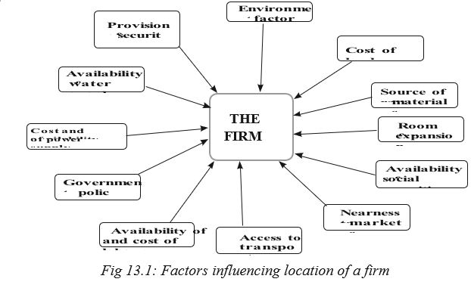

**Localization of firms**

In today’s economy, firms depend on one another. One firm’s waste material may be used by another firm as a raw material. Due to this interdependency among firms, most entrepreneurs decide to construct their firms near the ones that may provide raw materials. This helps in cutting down the transportation and disposal of waste costs for the firms.

**Merits of localization of firms**

1. **Creation of employment:**Localisation leads to creation of more employment opportunities to the population in the area as firms in the area will require workers with varying skills.
2. **Development of infrastructure:**Localisation results into improvement of infrastructure by the government such as roads and telecommunications to cater for the firm’s needs.
3. **Urbanisation:** Concentration of firms in a particular area results into urbanisation. With its advantages like improvement of cultures and attitudes, encouraging hard work hence promotion of economic development.
4. **Improved quality:**Concentration of firms in area results into production of high quality products due to competition among many firms.
5. **Improved reputation:** Localisation enables the area to gain reputation and the same will apply to the goods produced from that area which creates wider markets for its products.
6. **Supply of skilled labour:**Concentration of firms in an area attracts skilled labour to that area which in the long run promotes specialisation and division of labour in the production process with its associated advantages.
7. **External economies:**Concentration of firms in an area results into generation of various external economies like transport economies, marketing economies, labour economies, research economies and many others which reduce the production costs of the different firms.
8. **Industrial expansion:**Localisation of firms results into growth of subsidiary industries to supply raw materials, machine tools, component parts etc hence expansion of the industrial sector.

**Demerits of localization of firms**

1. **Regional imbalances:** As a result of localisation, some regions grow faster than others leading to regional imbalances in development. This can lead to friction, social conflicts and other political.
2. **Development of slums:**Localisation results into development of slums due to lack of adequate housing facilities to house the large number of people in the localised area
3. **Rural-urban migration:**Due to localisation, many people move to urban centers in search of employment. This results into high crime rates and other social problems in urban areas.
4. **Social problems:** Concentration of firms in an area results into social problems like congestion, overpopulation, traffic jams and accidents which reduce labour efficiency and industrial production.
5. **Over-straining infrastructure:** As a result of localisation, infrastructures like roads are excessively used which increases wear and tear, costs of replacement hence constraining the government budget.
6. **Diseconomies:**Due to concentration of many firms in an area, diseconomies of scale arise such as high cost of labour, transport problems, failure to secure credit, competition for raw materials resulting into high costs of production.
7. **Increased cost of living:**Concentration of firms in an area results into shortage of essential commodities in the area due to increased demand for those products, hence resulting into increased cost of living.
8. **Increased dependence:**Localisation results into overdependence on a particular area for a particular product which is dangerous in case of war, natural disasters or in an economic crisis.
9. **Exhaustion of resources:** Concentration of firms in an area leads of over exploitation of resources in the area resulting into exhaustion of the resources which deprives the future of access to those resources.

**Survival of small scale firms alongside large scale firms**

Activity

*In Gikongoro market, Josiane and Family Company have processed fruit juice for the last 10 years. The company has employed Nazou and Manasse only to help them run the business. They can manage to attend to as many clients as possible per day within the market.*

*In the same county, there is Inyange Industries that manufactures fruit juice. It employs many people from all over Rwanda. It produces over 10000 liters of juice per day. It has also opened up many branches in different cities in Rwanda.*

* *In your own opinion, identify the reasons why there is a big gap between the amounts of the output produced by the two firms.*
* *In a class discussion, explain the reasons why Josiane and Family Company continues to exist alongside large scale firms like Inyange Industries.*

***Remember!!****Small business are the backbone of our economy. I’m for big business, too. But small business are where the jobs are generated.*

Although large scale firms enjoy various advantages over small scale firms, small firms continue to established and exist alongside large scale firms. The following factors explain the continued existence and survival of small scale firms alongside large scale firms:

1. **Management:**Small scale firms are easier to manage. They make decisions very fast and efficiently since it is done by few people.
2. **Fear of rising costs:**Some small scale firms simply fear the rising costs associated with large scale production. When small scale firm expands, the owners may start experiencing an increase in cost. This may force them to retain the business as small scale.
3. **Market limitation:**Some firms remain small in the long run due to small size of the market for their products that cannot them to expand.
4. **Distance between producers:** When a firm is separated from its rivals by a long distance it may continue to exist despite its small size.
5. **Subsidiary industries:**Small firms may continue to exist alongside large ones if they act as subsidiaries of the large firms for example repairing machines, using by products and providing other services to the firm.
6. **Personal services:**Firms providing personal services where there is need for personal contact with customers usually remain small in the long run in order to maintain relations with customers such as medical firms, legal firms and many others.
7. **Desire for independence:**Where there is shortage of capital, individuals will continue with small firms where little capital is needed rather than integrating to form large ones due to desire for independence.
8. **Banding together:**Small firms continue to survive alongside large firms by working as a group while maintaining their independence which enables them to realise economies of large scale production.
9. **Sub-contracting:** Small firms may continue to survive alongside large firms by sub-contracting from the large ones which enables them to get access to markets e.g. construction firms.
10. **Government policy:**In some countries, the laws governing expansion of business are very strict. Small scale firms may fail to meet the conditions hence they remain small.

**Unit Summary**

* A firm was defined as the smallest unit of production under one control which employs factors of production to produce goods and services.
* Objectives of the firm were also discussed and they include, profit maximisation, sales maximisation, production of quality products, improvement of social economic welfare of employees among others.
* Factors influencing long term decisions of the firm were discussed such as cost of production, business expectations, objective of the firm, government policy, level of competition, planning period, economic conditions among others.
* Factors that influence location of a firm was discussed and they include among others; availability of raw materials, availability of market, government policy, transport and communication network, labour availability among others.
* Localisation was also discussed as the concentration of firms in an area.
* Advantages and disadvantages of localisation were also discussed. The advantages include; production of quality products, increased output, creation of employment opportunities, development of infrastructure, economies of scale etc.
* The disadvantages of localisation include; rural urban migration, development of slums, high cost of living, unemployment, social costs like high crime rates, prostitution, over dependence, diseconomies of scale, over straining infrastructure, exhaustion of resources, limits employment opportunities among others.
* Factors for survival of small scale firms alongside large ones were also discussed such as limited capital, limited market, long distance between producers, sub-contracting, fear of risks, subsidiary industries, case of personal services, desire for independence, banding together among others.

**Unit Assessment**

1. (a) Distinguish between a firm and an industry.

(b) Explain the factors that influence location of a firm.

1. (a) What is meant by localization of firms?

(b)Discuss the advantages and disadvantages of localization of

1. Discuss the factors that explain the survival of small scale firms alongside large scale firms.

**Chapter 8**

**SUPPLY AND ITS DETERMINANTS**

**MEANING OF SUPPLY**

Supply refers to the amount of good offered for sale in the market at a given price. Supply should be distinguished from stock. Stock is the amount of good which can be brought into the market for sale at a short notice. Thus supply is the quantity actually brought in the market but stock is a potential supply. Let us substantiate with an example. A farmer produces 1000 kg of rice and at a particular price he is willing to offer for sale about 500 kg in the market. Here, the quantity offered for sale i.e., 500 kg is the supply whereas 1000 kg is the stock.

### SUPPLY SCHEDULE

Supply schedule represents the relation between prices and the quantities of good supplied. It is a list of quantity supplied by producers at different prices. This is shown as under:

|  |  |
| --- | --- |
| *Price (in Ksh.)* | *Quantity supplied (in units)* |
| 1 | 10 |
| 2 | 15 |
| 3 | 18 |
| 4 | 24 |
| 5 | 28 |
| 6 | 35 |

It is seen that when price is Ksh 1/-, quantity supplied is 10 units and as price increases, supply also increases. This shows that supply and price of the commodity are directly related.

### SUPPLY CURVE

Supply curve is the graphical representation of the supply schedule. A supply curve is shown in the figure below.

In the Fig. 7.1, x-axis measures quantities of good supplied and y-axis measures price of the commodity. SS is the supply curve sloping upwards to the right, indicating that when price of the

commodity increases supply also increase. It should be noted here that if price of the product falls too much, producers refuse to supply any good. Thus the price below which the seller will refuse to sell is called the **reserve price**.

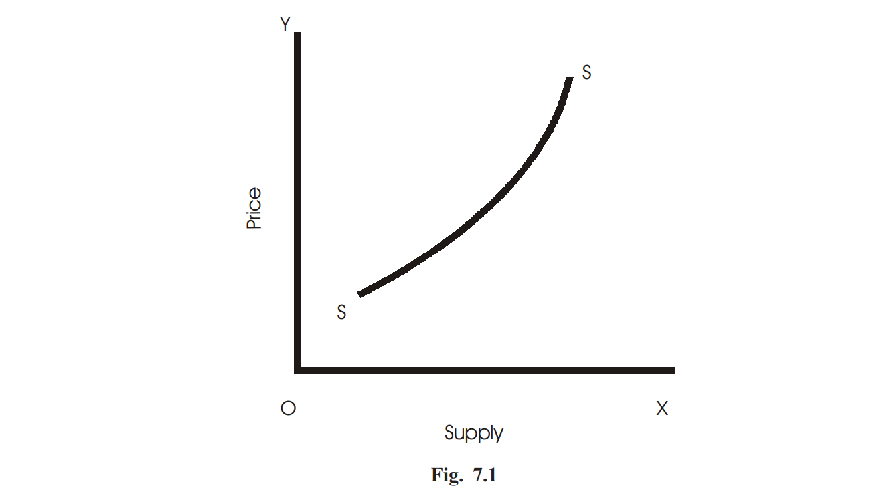

MARKET SUPPLY

The total amount of goods supplied at various prices by all producers/sellers in a market is called market supply. A market supply schedule is shown as under. Let us assume that there are three sellers—A, B and C. Their individual supply schedule is shown in 2nd, 3rd and 4th columns respectively. Market supply is the sum of A’s, B’s and C’s supply of a commodity. We find that the market supply schedule also behaves in the same way as an individual’s supply of a commodity. That is, at higher price, supply is greater and vice versa.

|  |  |  |  |  |
| --- | --- | --- | --- | --- |
| *Price (per unit)* | *A’s supply* | *B’s supply* | *C’s supply* | *Market supply*  *(A + B + C)* |
| 1 | 3 | 5 | 8 | 16 |
| 2 | 5 | 7 | 9 | 21 |
| 4 | 7 | 8 | 10 | 25 |
| 6 | 9 | 10 | 12 | 31 |
| 8 | 12 | 14 | 16 | 42 |
| 10 | 15 | 16 | 18 | 49 |

A market supply curve is the graphical representation of market supply and is derived by the lateral/horizontal summation of all individual sellers’ supply curve in the market as shown in the Fig. 7.2.

Market supply

Y

O 5 10 15 20 25 30 35 40 45 50 X

Pr

i

ce

9

8

7

6

5

1

2

3

4

10

Supply

**Fig. 7.2**

### LAW OF SUPPLY

The law of supply states that, other things remaining same, as the price of a commodity rises, its supply also rises and as the price falls, supply contracts. Thus supply and price of a commodity have direct/positive relationship, i.e., higher the price, larger will be the supply and vice versa. According to Marshall, “*As the prices rise, other things remaining same, the supply rises and as the price falls the supply decreases*”. The law of supply can be explained through a supply schedule as shown under:

|  |  |
| --- | --- |
| *Price of apples (in Ksh.)* | *Quantity supplied (in units)* |
| 1 | 5 |
| 2 | 10 |
| 3 | 15 |
| 4 | 20 |
| 5 | 25 |
| 6 | 30 |

It is seen in the table above that, as price of apples rise from Re. 1 to Ksh. 6, sellers increase supply of apples from 5 units to 30 units. Thus price and supply varies directly. Higher the price, more is the supply and vice versa, other factors remaining constant. These factors are money income of sellers and buyers, technology, costs of all factors of production, taxes and subsidies, prices of related goods etc. The Fig. 7.3 below shows the supply curve, which is derived from the schedule above.

SS is the supply curve sloping upwards to the right indicating direct relationship between price and supply of a product.

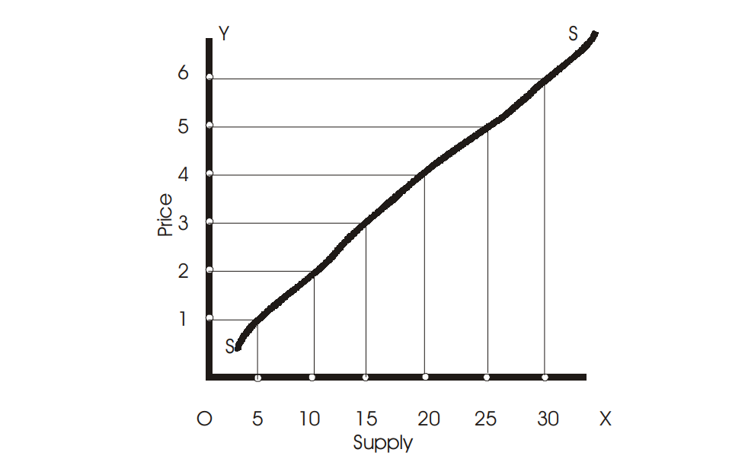

**Fig. 7.3**

### DETERMINANTS OF SUPPLY

Supply of a commodity depends upon a number of factors.The important determinants of supply can be grouped together in a supply function as follows:

SX = *f* (PX, PY, F, T, G)

**Supply function** describes the functional relationship between supply of a commodity (say X) and other determinants of supply, i.e., price of the commodity (PX), prices of related commodities (PY), price of the factors of production (F), technology (T) and goals (G) or general objectives of the producer.

Let us discuss the factors that determine supply of a product as under:

1. *Price of the product*: As already stated, price determines the supply of a product. When price is high, supply is more and vice versa. Producers are encouraged to produce more when price is high because of high profit margin.
2. *Technology:* The change in technology also affects supply of a product. It may reduce the cost of production and as a result supply will be more. Automatic and digital photocopier machines have increased the speed of photocopy per unit and hence large production.
3. *Price of factors:* Changes in prices of factors also cause a change in cost of production and thereby bring changes in the supply of the product. When costs of factors come down, it reduces the overall cost of production and as a result producers are induced to produce and supply more.
4. *Prices of other products:* Prices of substitutes and complements also affect the supply of a product. For example, if prices of tea rise, it will result in the reduction in the production and supply of coffee as the producers will withdraw resources from the production of coffee and devote these to the production of tea.
5. *Future price expectation:* If sellers expect the prices to rise in future, they would reduce supply of a product in the market and hoard the commodity to sell in the future.

This is specially done for earning high profits. For example, when traders expect that price of kerosene oil will rise further, they create artificial scarcity and stock so as to sell and reap high profits in future.

### MOVEMENT ALONG AND SHIFTS IN SUPPLY CURVE

A movement along the same curve simply indicates changes in quantities offered as a result of a change in the price. When supply changes not due to changes in the price of the product but due to other factors, such as change in technology, changes in the prices of related commodities, changes in price of inputs etc, it is said to be shifts in supply curve.

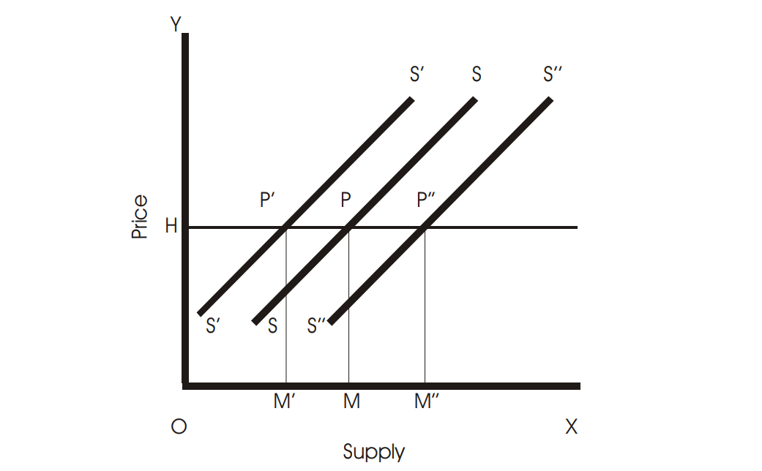

#### Fig. 7.4

Supply is said to increase (supply curve shifts to the right) when, price remaining same, more is offered for sale and decrease (supply curve shifts to the left) when, at the same price, less is offered for sale in the market. This is illustrated in the Fig. 7.4 above.

SS is the supply curve before the change. S*'*S*'* shows a decrease in supply because at the same price OM*'* (OM*'* < OM) is offered for sale. S*''*S*"* shows an increase in supply because at the same price OH, more is supplied (OM*"* > OM).

When there is a change in price (rise/fall), supply also changes (increases/decreases) and the phenomena is called extension and contraction in supply. In this case, equilibrium point moves along the same supply curve-either to left or right. In Fig. 7.5, SS is the supply curve and the equilibrium point is E at OP price. When price falls to OP*"*, supply gets reduced by N*"*N and supply increases to ON*'* when price rises to OP*'*. The equilibrium point E moves to E*'* when price falls and moves to E*'*, when price rises.

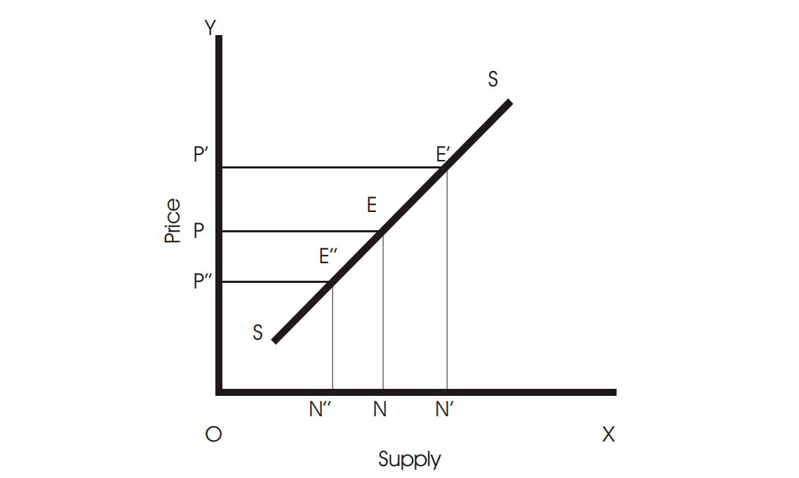

**Fig. 7.5**

**Price Elasticity of Supply**

**Definition of Price Elasticity of Supply**

The price elasticity of supply is the measure of the responsiveness in quantity supplied to a change in price for a specific good.

learning objectives

* Differentiate between the price elasticity of demand for elastic and inelastic goods

In economics, elasticity is a summary measure of how the supply or demand of a particular good is influenced by changes in price. Elasticity is defined as a proportionate change in one variable over the proportionate change in another variable:

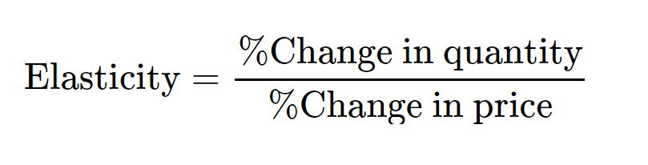

The price elasticity of supply (PES) is the measure of the responsiveness in quantity supplied (QS) to a change in price for a specific good (% Change QS / % Change in Price). There are numerous factors that directly impact the elasticity of supply for a good including stock, time period, availability of substitutes, and spare capacity. The state of these factors for a particular good will determine if the price elasticity of supply is elastic or inelastic in regards to a change in price.

The price elasticity of supply has a range of values:

* PES > 1: Supply is elastic.
* PES < 1: Supply is inelastic.
* PES = 0: The supply curve is vertical; there is no response of demand to prices. Supply is “perfectly inelastic.”
* PES = ∞∞ (i.e., infinity): The supply curve is horizontal; there is extreme change in demand in response to very small change in prices. Supply is “perfectly elastic.”

Inelastic goods are often described as necessities. A shift in price does not drastically impact consumer demand or the overall supply of the good because it is not something people are able or willing to go without. Examples of inelastic goods would be water, gasoline, housing, and food.

Elastic goods are usually viewed as luxury items. An increase in price for an elastic good has a noticeable impact on consumption. The good is viewed as something that individuals are willing to sacrifice in order to save money. An example of an elastic good is movie tickets, which are viewed as entertainment and not a necessity.

The price elasticity of supply is determined by:

* Number of producers: ease of entry into the market.
* Spare capacity: it is easy to increase production if there is a shift in demand.
* Ease of switching: if production of goods can be varied, supply is more elastic.
* Ease of storage: when goods can be stored easily, the elastic response increases demand.
* Length of production period: quick production responds to a price increase easier.
* Time period of training: when a firm invests in capital the supply is more elastic in its response to price increases.
* Factor mobility: when moving resources into the industry is easier, the supply curve in more elastic.
* Reaction of costs: if costs rise slowly it will stimulate an increase in quantity supplied. If cost rise rapidly the stimulus to production will be choked off quickly.

The result of calculating the elasticity of the supply and demand of a product according to price changes illustrates consumer preferences and needs. The elasticity of a good will be labelled as perfectly elastic, relatively elastic, unit elastic, relatively inelastic, or perfectly inelastic.

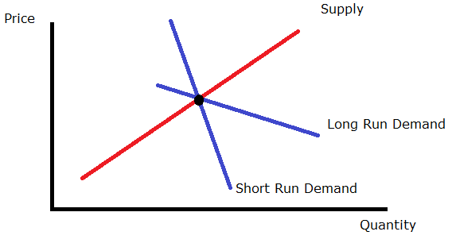

**Price elasticity over time**: This graph illustrates how the supply and demand of a product are measured over time to show the price elasticity.

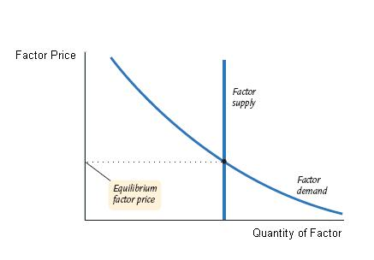

**Perfectly Inelastic Supply**: A graphical representation of perfectly inelastic supply.

**Measuring the Price Elasticity of Supply**

The price elasticity of supply is the measure of the responsiveness of the quantity supplied of a particular good to a change in price.

learning objectives

* Calculate elasticities and describe their meaning

The price elasticity of supply (PES) is the measure of the responsiveness of the quantity supplied of a particular good to a change in price (PES = % Change in QS / % Change in Price). The intent of determining the price elasticity of supply is to show how a change in price impacts the amount of a good that is supplied to consumers. The price elasticity of supply is directly related to consumer demand.

**Elasticity**

The elasticity of a good provides a measure of how sensitive one variable is to changes in another variable. In this case, the price elasticity of supply determines how sensitive the quantity supplied is to the price of the good.

**Calculating the PES**

When calculating the price elasticity of supply, economists determine whether the quantity supplied of a good is elastic or inelastic. The percentage of change in supply is divided by the percentage of change in price. The results are analyzed using the following range of values:

* PES > 1: Supply is elastic.
* PES < 1: Supply is inelastic.
* PES = 0: Supply is perfectly inelastic. There is no change in quantity if prices change.
* PES = infinity: Supply is perfectly elastic. An decrease in prices will lead to zero units produced.

**Factors that Influence the PES**

There are numerous factors that impact the price elasticity of supply including the number of producers, spare capacity, ease of switching, ease of storage, length of production period, time period of training, factor mobility, and how costs react.

The price elasticity of supply is calculated and can be graphed on a demand curve to illustrate the relationship between the supply and price of the good.

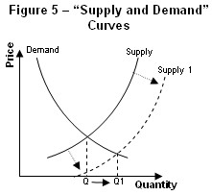

**Applications of Elasticities**

In economics, elasticity refers to how the supply and demand of a product changes in relation to a change in the price.

learning objectives

* Give examples of inelastic and elastic supply in the real world

In economics, elasticity refers to the responsiveness of the demand or supply of a product when the price changes.

The technical definition of elasticity is the proportionate change in one variable over the proportionate change in another variable. For example, to determine how a change in the supply or demand of a product is impacted by a change in the price, the following equation is used: Elasticity = % change in supply or demand / % change in price.

The price is a variable that can directly impact the supply and demand of a product. If a change in the price of a product significantly influences the supply and demand, it is considered “elastic.” Likewise, if a change in product price does not significantly change the supply and demand, it is considered “inelastic.”

For elastic demand, when the price of a product increases the demand goes down. When the price decreases the demand goes up. Elastic products are usually luxury items that individuals feel they can do without. An example would be forms of entertainment such as going to the movies or attending a sports event. A change in prices can have a significant impact on consumer trends as well as economic profits. For companies and businesses, an increase in demand will increase profit and revenue, while a decrease in demand will result in lower profit and revenue.

For inelastic demand, the overall supply and demand of a product is not substantially impacted by an increase in price. Products that are usually inelastic consist of necessities like food, water, housing, and gasoline. Whether or not a product is elastic or inelastic is directly related to consumer needs and preferences. If demand is perfectly inelastic, then the same amount of the product will be purchased regardless of the price.

Economists study elasticity and use demand curves in order to diagram and study consumer trends and preferences. An elastic demand curve shows that an increase in the supply or demand of a product is significantly impacted by a change in the price. An inelastic demand curve shows that an increase in the price of a product does not substantially change the supply or demand of the product.

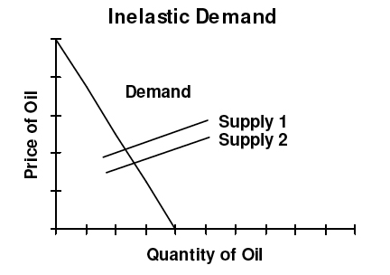

**Inelastic Demand**: For inelastic demand, when there is an outward shift in supply and prices fall, there is no substantial change in the quantity demanded.

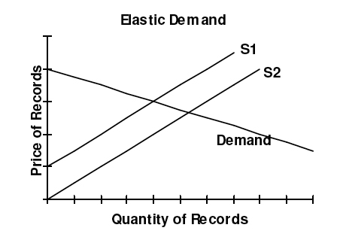

**Elastic Demand**: For elastic demand, when there is an outward shift in supply, prices fall which causes a large increase in quantity demanded.

**Key Points**

* Elasticity is defined as a proportionate change in one variable over the proportionate change in another variable:
* 
* The impact that a price change has on the elasticity of supply also directly impacts the elasticity of demand.
* Inelastic goods are often described as necessities, while elastic goods are considered luxury items.
* The elasticity of a good will be labelled as perfectly elastic, relatively elastic, unit elastic, relatively inelastic, or perfectly inelastic.
* The price elasticity of supply = % change in quantity supplied / % change in price.
* When calculating the price elasticity of supply, economists determine whether the quantity supplied of a good is elastic or inelastic.
* PES > 1: Supply is elastic. PES < 1: Supply is inelastic. PES = 0: if the supply curve is vertical, and there is no response to prices. PES = infinity: if the supply curve is horizontal.
* To determine the elasticity of a product, the proportionate change of one variable is placed over the proportionate change of another variable (Elasticity = % change of supply or demand / % change in price ).
* For elastic demand, a change in price significantly impacts the supply and demand of the product.
* For inelastic demand, a change in the price does not substantially impact the supply and demand of the product.
* Economists use demand curves in order to document and study elasticity.

**Key Terms**

* **luxury**: Something very pleasant but not really needed in life.
* **supply**: The amount of some product that producers are willing and able to sell at a given price, all other factors being held constant.
* **demand**: The desire to purchase goods and services.
* **mobility**: The ability for economic factors to move between actors or conditions.
* **capacity**: The maximum that can be produced on a machine or in a facility or group.
* **elastic**: Sensitive to changes in price.
* **demand**: The desire to purchase goods and services.
* **inelastic**: Not sensitive to changes in price.
* **supply**: The amount of some product that producers are willing and able to sell at a given price, all other factors being held constant.

#### Questions for Review

1. What is meant by shift of the supply curve?
2. What is the law of supply?
3. Explain briefly any three factors on which supply of a commodity depends.
4. What factors determine the supply of a commodity? Briefly explain.
5. What is meant by supply schedule?
6. Write short notes on :
   1. Market supply of a commodity
   2. Movement along and movement of the supply curve.
7. State the law of supply and illustrate it in the form of a curve with the following data:

|  |  |
| --- | --- |
| *Price (in Ksh.)* | *Quantity supplied (per period)* |
| 0 | 0 |
| 1 | 1000 |
| 2 | 2000 |
| 3 | 3000 |
| 4 | 4000 |
| 5 | 5000 |
| 6 | 6000 |

1. Distinguish between contraction/expansion in supply, and decrease/increase in supply. Illustrate with diagrams.
2. What are the factors on which the supply of a commodity depends? Discuss them briefly.
3. The supply schedule of a commodity as follows:

|  |  |  |
| --- | --- | --- |
| *Price per* | *Quantity* | *Quantity supplied* |
| *unit (Ksh.)* | *supplied initially* | *after change* |
| 1 | 20 | 0 |
| 2 | 40 | 20 |
| 3 | 60 | 40 |
| 4 | 80 | 60 |
| 5 | 100 | 80 |

1. Calculate elasticity of supply when price rises from Ksh. 2 to Ksh.3, both in case of A and B.
2. Why does supply elasticity differ in the two cases even though absolute change in quantity supplied is 20 units in both cases?
3. The coefficient of elasticity of supply of a commodity X is 2. How much quantity of the commodity will a seller supply at the price of Ksh. 5 per unit if he supplies 80 units of it at Ksh. 4 per unit?
4. The supply function of a commodity x is QSx = 20Px. The value of Px (in Ksh) is given as 6, 5, 4,3,2,1, and 0. Find out the producer’s supply schedule.
5. The market supply and demand schedules of a certain commodity at prices of Ksh.6,5,4,3,2,1, and

0 are given by the equation

* 1. Qdx = (12-2Px) 10000
  2. Qsx = (20 Px) 1000

Find out the equilibrium quantity and the equilibrium price.

1. Suppose that a freely determined price of kerosene oil is Ksh. 4.00 per litter. The government fixes its controlled price at Ksh. 3.00 per litter. At this price there is a shortfall of 2 million litters between the quantity and demand and supplied. What will be the consequence of this? Show with the help of a diagram.
2. What is meant by change in supply?
3. What effect does a cost saving technical progress have on the supply curve?
4. What effect does an increase in input price have on the supply curve?
5. What effect does an increase in excise tax rate have on the supply curve of the product?
6. Name three factors that can shift a supply curve.

**Chapter 9**

**CONCEPTS OF COST**

The concept of cost is of great significance in the micro economic theory. It is the cost of production which determines the production decision of an entrepreneur whose main aim is to maximize profit. Lower the cost of production, greater is the profit margin.

### COST OF PRODUCTION

The expenses incurred on all inputs of production–both factor inputs and non-factor inputs are known as the cost of production. Land, labour, capital and organization are the factors of production called factor inputs. Raw materials, fuel, equipments, tools etc are non factor inputs. Thus, cost is a function of various factors.Symbolically, cost function can be expressed as under, C = *f* (Q, T, P*f*)

Where C is the total cost of production, Q is output; T is technology, and Pf is the prices of factors of production.

Some important concepts of costs of production are explained as under.

#### Real Cost and Nominal Cost

Real costs refer to those payments, which are made to factors of production for the toil and efforts in rendering their services. Real cost is estimated in terms of the pain and sacrifices of labour. It is also the cost of waiting.

Nominal cost is the money cost (expenses) of production incurred on various inputs of production.

#### Explicit and Implicit Costs

Explicit costs are the paid out costs. These are the payments made for productive resources purchased or hired by the firm. These include wages paid to the labourers, rent paid for the premises, payments made for the raw materials, payments into depreciation accounts, premium paid towards insurance against fire, theft, etc. According to Leftwitch, “*Explicit costs are those cash payments which firms make to outsiders for their services and goods*.” These costs appear in the accounting records of the firm.

54

Implicit costs of production, on the other hand, are the costs of self-owned and self-employed resources. These costs are normally ignored while calculating the expenses of a producer. These include the rewards for the entrepreneur’s self-owned land, labour and capital. These costs do not appear in the accounting records of the firm.

The sum of explicit costs and implicit costs constitutes the total cost of production of a commodity.

#### Opportunity/Alternative/ Transfer Cost

The concept of opportunity cost is the most important concept in economic theory. In the simplest terms, opportunity cost of a decision may be defined as the cost of next best alternative sacrificed in order to take this decision. In short, the opportunity cost of using resources to produce a good is the value of the best alternative or opportunity forgone. Opportunity costs include both explicit and implicit costs. For example, if with a sum of Ksh. 2000, a producer can produce a bicycle or a radio set and decides to produce a radio set. In this case, opportunity cost of a radio set is equal to the cost of a bicycle that he has sacrificed.

#### Private, External and Social Costs

A cost that is not borne by the firm, but is incurred by others in society is called an external cost. The true cost to the society must include all costs regardless of who bears them. Private costs refer to the costs to a firm in producing a commodity. It is, in fact, the money costs of the firm. For example, the purchase price of a car reflects the private cost experienced by the manufacturer. The air pollution created in the production of the car however, is an external cost. Because the manufacturer does not pay for these costs, and does not include them in the price of the car, they are said to be external to the market pricing mechanism. The air pollution from driving the car is also an externality. The driver does not pay for the environmental damage caused by using the car.

Social cost is the total of all the costs associated with an economic activity. It includes both costs borne by the economic agent and also all costs borne by society at large. It includes the costs reflected in the organization’s production function (called private costs) and the costs external to the firm’s private costs (called external costs). Thus, it is the cost of producing a commodity to the society as a whole. Hence, the social cost is the sum of private and external cost.

That is,

Social Cost = Private Cost + External Cost

Or

External cost = social cost – private cost

If social costs are greater than private costs, then a negative externality is present. Environmental pollution is an example of a social cost that is seldom borne completely by the polluter thereby creating a negative externality. If private costs are greater than social costs, then a positive externality exists. An example is when a supplier of educational services indirectly benefits society as a whole but only received payment for the direct benefit received by the recipient of the education: the benefit to society of an educated populace is a positive externality.

In either case, economists refer to this as market failure because resources will be allocated inefficiently.

#### Economic Costs

Economic costs are the payments which must be received by resource owners in order to ensure that they will continue to supply them in the process of production. Economic cost includes normal profit.

#### Short Run Costs and Long Run Costs

Short run is a period of time within which the firm can change its output by changing only the amount of variable factors, such as labour and raw materials etc. In short period, fixed factors such as land, machinery etc, cannot be changed. Costs of production incurred in the short run i.e., on variable factors are called short run costs. The long run costs are the costs over a period in which all factors are changeable. Thus, costs of production on all factors (in the long run all factors become variable) are long run costs.

#### Fixed/Supplementary and Variable/Prime Costs

The expenses incurred on fixed factors are called fixed costs, whereas those incurred on the variable factors may be called variable costs.

The fixed costs include the costs of:

1. The salaries and other expenses of administrative staff;
2. The salaries of staff involved directly in the production, but on a fixed term basis;
3. The wear and tear of machinery (standard depreciation allowances);
4. The expenses for maintenance of buildings;
5. The expenses for the maintenance of the land on which the plant is installed and operates and
6. Normal profit, which is a lump sum including a percentage return on fixed capital and allowance for risk.

The variable costs include the cost of:

1. Direct labour, which varies with output.
2. Raw materials; and
3. Running expenses of machinery.

The sum of fixed and variable costs constitutes the total cost of production. Symbolically,

TC = TFC + TVC

#### Total Fixed Cost (TFC)

Total fixed cost is the sum of expenses incurred on those inputs that remain same at different levels of output. Total fixed cost is graphically shown in Fig. 8.1. It is a straight line parallel to output or x-axis. TFC is the total fixed cost curve parallel to x-axis indicating that it remains constant at all levels of output.

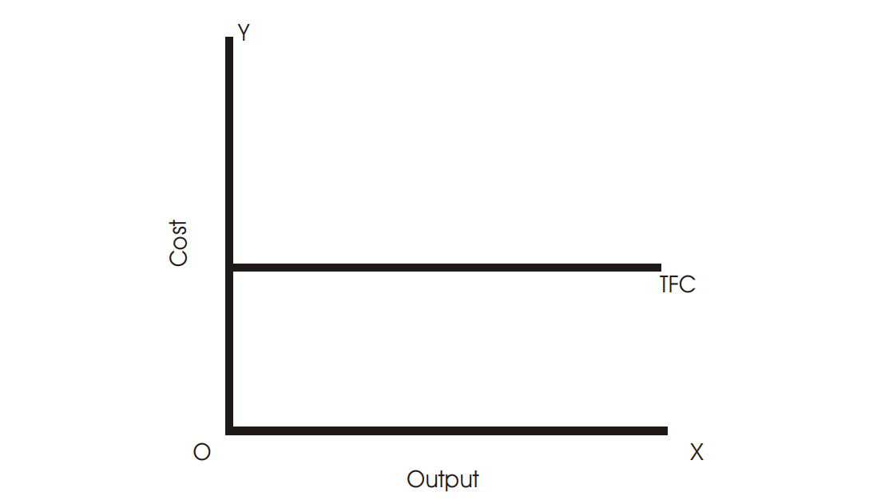

**Fig. 8.1**

#### Total Variable Cost (TVC)

Total variable cost is the sum of expenses incurred on those factor inputs whose quantity varies with a change in the level of output. Total variable cost curve TVC is shown in the Fig. 8.2. It has inverse-S shape. Total variable costs increase as the level of output increases.

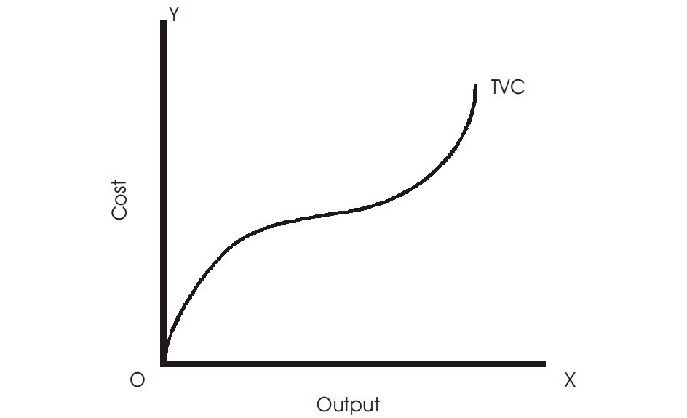

**Fig. 8.2**

#### Total Cost (TC)

Total cost to a producer for the various levels of output is the sum of total fixed costs and total variable costs, i.e.,

TC = TFC+TVC

The adjacent Fig. 8.3 shows total cost of production which is the sum of total variable cost and total fixed cost.

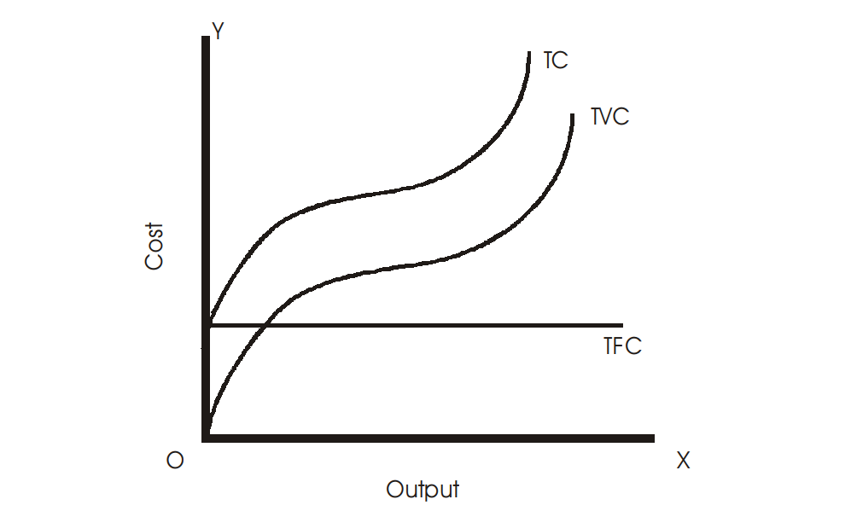

**Fig. 8.3**

#### Average Fixed Cost (AFC)

Average fixed cost is total fixed cost divided by total output. It is per unit cost on fixed factors.Symbolically,

TFC

AFC =

TQ

Where, TQ is the total output.

Average fixed cost is shown as under. AFC curve is a rectangular hyperbola, indicating same magnitude at all points as TFC remains constant throughout. This is shown in the Fig. 8.4 below:

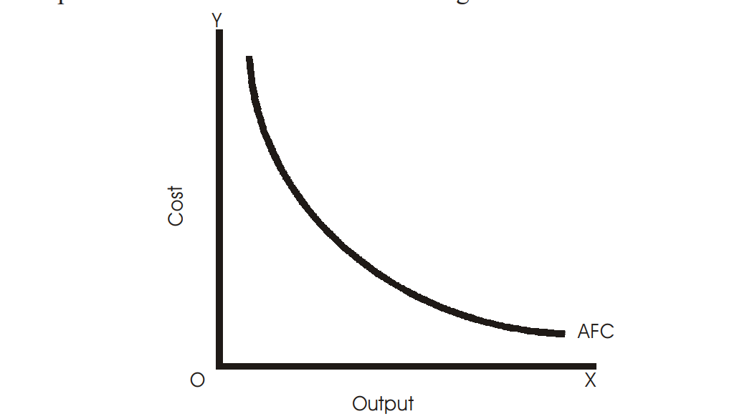

**Fig. 8.4**

#### Average Variable Cost (AVC)

The average variable cost is found by dividing the total variable costs by the total units of output, i.e., it is per unit cost of the variable inputs. Symbolically,

TVC

AVC = TQ

Average variable cost falls initially, reaches a minimum when the plant is operated optimally and rises after the point of normal capacity has been reached. This is shown graphically below in Fig. 8.5.

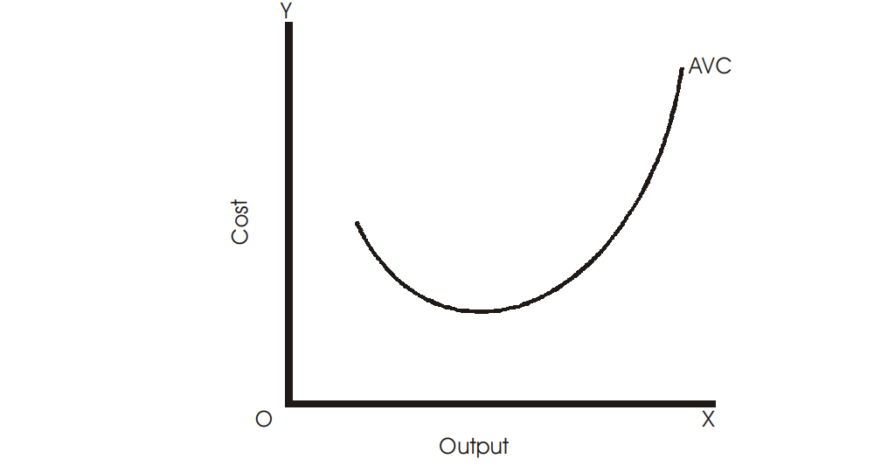

**Fig. 8.5**

#### Average Total Cost (ATC/AC)

ATC is the per unit cost of both fixed and variable inputs. Average total cost of production can be obtained by dividing total cost by the units of output, i.e.,

TC

AC =

TQ

TFC + TVC or =

TQ

or = AFC + AVC

Average total cost or ATC curve has the similar shape as that of AVC, that is, U-shaped.

The figure below shows AC curve.

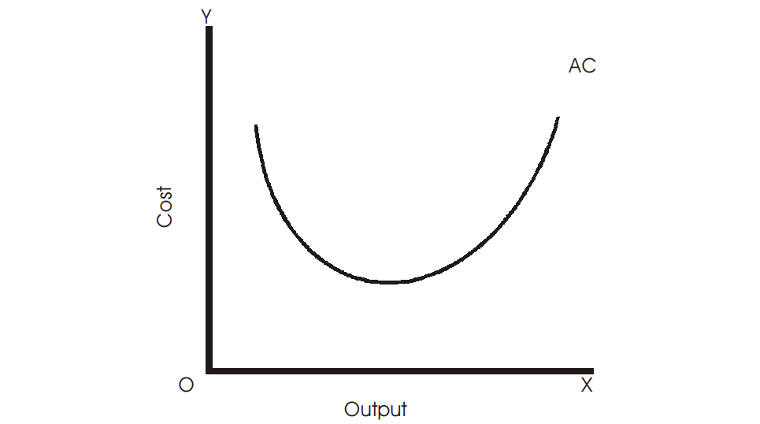

**Fig. 8.6**

#### Marginal Cost

Marginal cost is the addition to the total cost as a result of a unit (one unit) increase in the output. It is expressed as:

MCN = TCN – TCN–1

Where, N is the number of units of output. Alternatively, marginal cost can also be expressed as follows:

∆TC

MC =

∆TQ

Where, ∆TC stands for the change in total cost and ∆TQ for total output.

Graphically, MC curve is the slope of the TC curve, which is shown in Fig. 8.7. MC curve also has U-shaped. It first falls, goes to a minimum and then rises sharply.

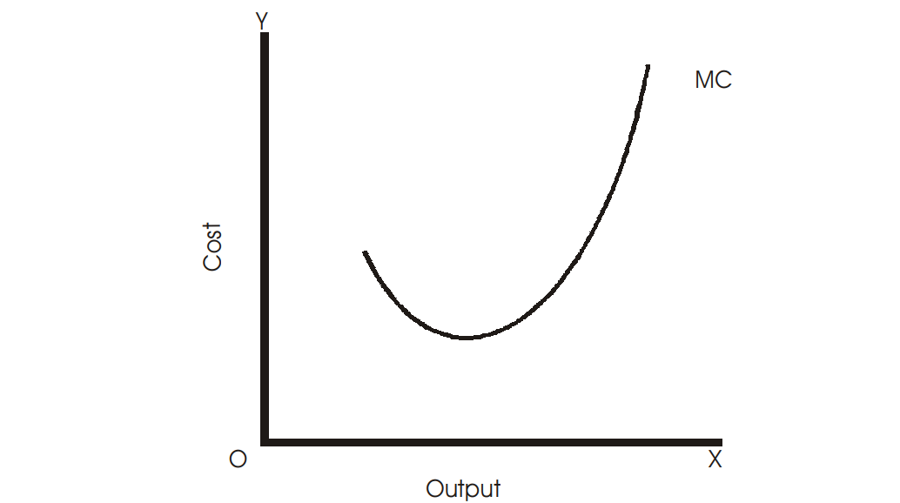

##### Fig. 8.7

The table below shows the relationship among fixed, variable costs, total, average and marginal costs.

|  |  |  |  |  |  |  |  |
| --- | --- | --- | --- | --- | --- | --- | --- |
| *Units of output* | *TFC* | *TVC* | *TC* | *AFC* | *AVC* | *AC* | *MC* |
| (1) | (2) | (3) | (4) | (5) | (6) | (7) | (8) |
| 0 | 10 | 0 | 10 | - | - | - | - |
| 1 | 10 | 4 | 14 | 10 | 4 | 14 | 4 |
| 2 | 10 | 7 | 17 | 5 | 3.5 | 8.5 | 3 |
| 3 | 10 | 9 | 19 | 3.3 | 3 | 6.3 | 2 |
| 4 | 10 | 11 | 21 | 2.5 | 2.7 | 5.2 | 2 |
| 5 | 10 | 14 | 24 | 2 | 2.8 | 4.8 | 3 |
| 6 | 10 | 19 | 29 | 1.6 | 3.1 | 4.7 | 5 |

Calculation is done in the following manner:

Column (4) = (2) + (3); (5) = (2) ÷ (1); (6) = (3) ÷ (1); (7) = (5) + (6); (8) = ∆ (4) ÷ ∆ (1)

### RELATIONSHIP BETWEEN AVERAGE COST AND MARGINAL COST

Average cost is obtained by dividing total costs by the units of output. Marginal cost is the change in total costs resulting from a unit increase in output. The relationships between the two are as follows:

1. When average cost falls with an increase in output, marginal cost is less than the average cost (before point P).
2. When average cost rises, marginal cost is greater than the average cost (after point P).
3. Marginal cost curve cuts the average cost curve at its minimum point (minimum point on the average cost curve is also the point of optimum capacity) i.e., at the point of optimum capacity, MC = AC (at point P).

With increase in average cost, marginal cost rises at a faster rate. This relationship between AC and MC is illustrated in the adjacent Fig. 8.8.

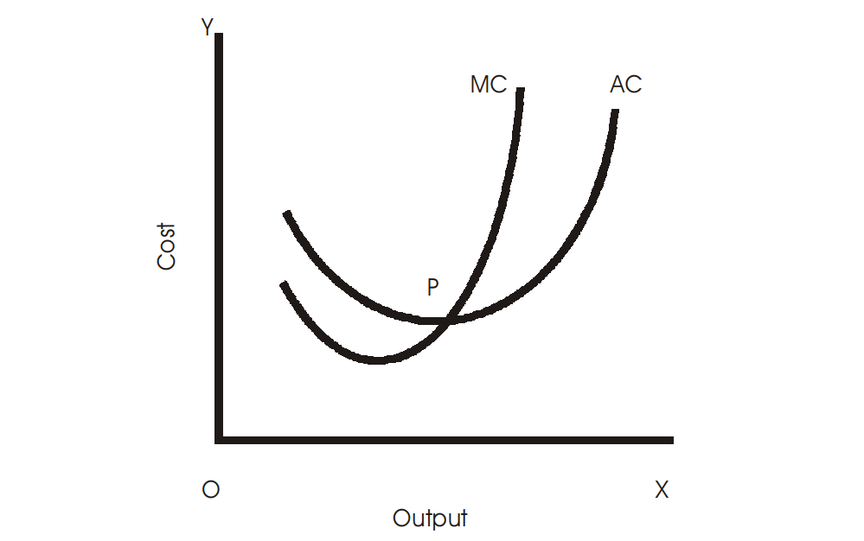

**Fig. 8.8**

#### Questions for Review

1. What is meant by opportunity cost?
2. Give two examples of implicit cost of a firm.
3. What is meant by supplementary costs?
4. Give two examples of fixed costs.
5. Give two examples of variable cost.
6. What are explicit costs?
7. Give two examples of implicit cost of a firm.
8. Distinguish between fixed and variable costs.
9. Distinguish between explicit and implicit cost.
10. Give two examples each of implicit and explicit costs in a tailoring shop.
11. With the help of an appropriate diagram state the relationship between Average cost and Marginal cost.
12. Give meaning of real costs, private costs, social cost.
13. Differentiate between money cost and real cost.
14. From the cost function of a firm given below, find:

|  |  |  |  |  |  |  |  |
| --- | --- | --- | --- | --- | --- | --- | --- |
| *Output (Units)* | *0* | *1* | *2* | *3* | *4* | *5* | *6* |
| TC (Ksh.) | 60 | 90 | 100 | 105 | 115 | 135 | 180 |
| TFC (Ksh.) | 60 | 60 | 60 | 60 | 60 | 60 | 60 |

1. TVC
2. AFC
3. AVC
4. ATC
5. MC
6. What is meant by money costs?
7. What is the significance of time element in determining costs of a firm?
8. How does total fixed cost change when output changes?
9. What is the general shape of the AFC curve?
10. What will happen to ATC when MC > ATC?
11. What are volume discounts?
12. Why is the MC curve in the short run U-shaped?
13. What is the condition of profit maximization for a competitive firm?
14. What is the general profit maximizing condition of a firm?

**Chapter 10**

**CONCEPTS OF REVENUE**

Revenue refers to the payments received by an entrepreneur from the sale of the goods produced.

If a producer can sell during a week 200 pens at the price of Ksh.5 each his total revenue during the week equals Ksh. 5 × 200 = Ksh. 1, 000.

#### Total Revenue

Total Revenue refers to the total amount of money that a firm receives from the sale of its products.

By selling 20 apples at the rate of Ksh. 2 each, the total revenue he gets is 20 × 5 = Ksh. 100. Thus,

TR = Q × P,

where Q is total quantity sold and P stands for price per unit.

#### Average Revenue

Average revenue is obtained by dividing total revenue earned by the total number of units sold by a producer. Average revenue curve of a firm is same thing as the demand curve of the consumer. Thus, it means price of the product. Symbolically,

TR

AR =

TQ

#### Marginal Revenue

Marginal revenue is the change in total revenue resulting from a unit (one unit) change in the output sold. In other words, it is the revenue, which would be earned by a producer by selling an additional unit of his product.

∆TR

MR =

∆TQ

Or, MR = TR*n* – TR*n*-1

Where, TRn is the current or selected value of total revenue and TRn-1 is the previous value of total revenue. For example, TR of selling first unit of a product is Ksh. 12 and TR of selling one more unit is Ksh. 20, then TRn and TRn-1 are 20 and 12 respectively. Thus, MR = 20 – 12 = 8. It means, by selling one more unit the seller gets additional revenue of Ksh. 8.

### RELATIONSHIP BETWEEN AVERAGE AND MARGINAL REVENUE

Let us explain the relationship between AR and MR with the help of a table below:

|  |  |  |  |
| --- | --- | --- | --- |
| *Units* | *Price or Average* | *Total* | *Marginal* |
|  | *Revenue* | *Revenue* | *Revenue* |
| 1 | 15 | 15 | 15 |
| 2 | 14 | 28 | 13 |
| 3 | 13 | 39 | 11 |
| 4 | 12 | 48 | 9 |
| 5 | 11 | 55 | 7 |
| 6 | 10 | 60 | 5 |
| 7 | 9 | 63 | 3 |
| 8 | 8 | 64 | 1 |

Total revenue column is derived by multiplying ‘units’ column with ‘AR or price’ column. Marginal revenue has been derived from the total revenue column as explained earlier. It is seen that when AR is falling, MR is less than AR. It should be noted that under perfect competition (meaning of perfect competition is dealt in a separate chapter) average and marginal revenue curves coincide, i.e., AR = MR. However, under imperfect competition, AR > MR as shown in the table above.

Under perfect competition, seller cannot influence price of the product. He has to sell at the ruling price prevailing in the industry. Thus, average revenue or price is same throughout. Marginal revenue curve coincides the average revenue curve because additional units are sold at the same price as before. This is shown in the table below:

|  |  |  |  |
| --- | --- | --- | --- |
| *Units (Q)* | *Price or Average* | *Total* | *Marginal* |
|  | *Revenue (P)* | *Revenue*  *(Q × P)* | *Revenue* |
| 1 | 10 | 10 | 10 |
| 2 | 10 | 20 | 10 |
| 3 | 10 | 30 | 10 |
| 4 | 10 | 40 | 10 |
| 5 | 10 | 50 | 10 |
| 6 | 10 | 60 | 10 |
| 7 | 10 | 70 | 10 |
| 8 | 10 | 80 | 10 |

The relationship between AR and MR under perfect competition is illustrated in the Fig. 9.1.

#### CONCEPTS OF REVENUE

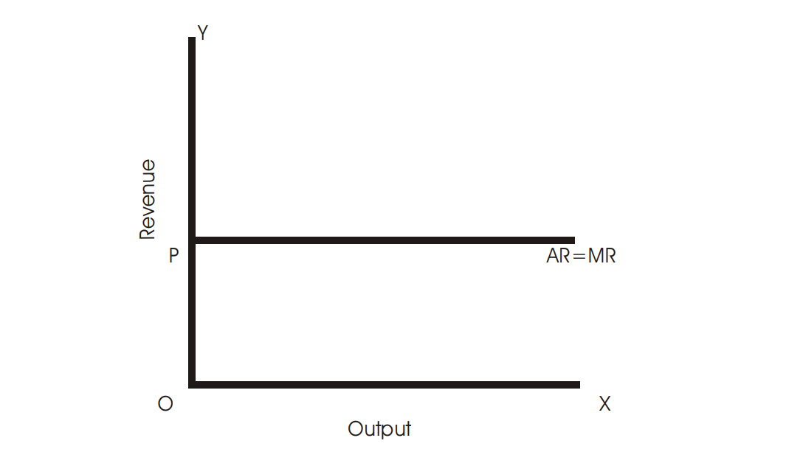

#### Fig. 9.1

The relationship between AR and MR under imperfect competition is illustrated in the Fig. 9.2 below. AR and MR are the average and marginal revenue curves. Along x-axis output is measured and along y-axis, revenue earned by the seller. It is seen that when AR is falling,

MR < AR.

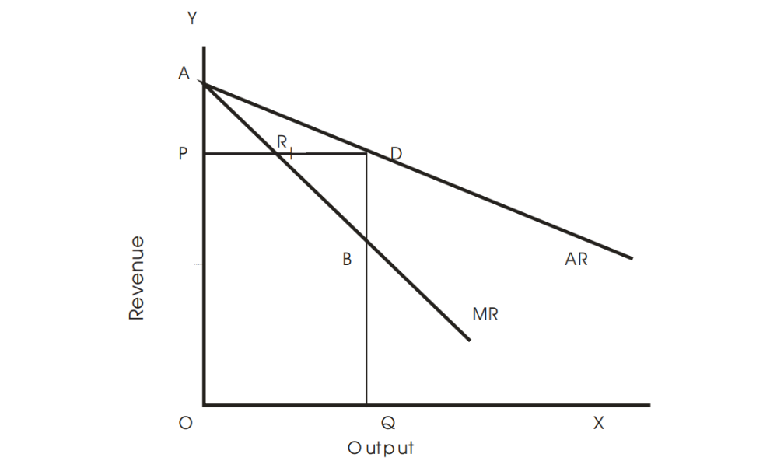

#### Fig. 9.2

A general relationship between AR and MR are as follows:

1. When AR is falling (sloping downwards), MR lies below AR (MR < AR).
2. If AR is constant, AR = MR (under perfect competition, Fig. 9.1).
3. When AR and MR curves are straight lines perpendicular drawn from any point of the AR curve to the y-axis will cut into equal parts by MR curve. PR =RD in the diagram shown in Fig. 9.2.
4. When AR and MR curves are not straight lines, but either is convex and concave to the origin, the marginal revenue curve will not lie halfway from the average revenue curve.

#### Questions for Review

1. What do you understand by the marginal revenue product?
2. What is meant by value of marginal product?
3. Explain the relationship between Average Revenue and the Marginal Revenue.
4. Explain the relationship between average revenue and the marginal revenue under monopoly.
5. What is the relationship between the total revenue, marginal revenue and average revenue?
6. Calculate TR, AR and MR from the following table:

|  |  |
| --- | --- |
| *Price per unit (Ksh.)* | *Demand (units)* |
| 1 | 100 |
| 2 | 90 |
| 3 | 70 |
| 4 | 60 |
| 5 | 50 |
| 6 | 40 |

1. What is the relationship between price and marginal revenue for a competitive firm?
2. Why is the total revenue curve facing a competitive firm a straight line passing through the origin?
3. Why is AR always equal to MR for a competitive firm?

## Chapter 11

## FORMS OF MARKET AND PRICE DETERMINATION

## MEANING OF MARKET

In general, the word ‘market’ refers to a place or an area where buyers and sellers generally meet so as to buy and sell a particular commodity. In Economics, we make use of the term ‘market’ in a different sense. It refers to a particular commodity that is sold and purchased rather than a place or an area. For example, cotton market, tea market etc. Any effective arrangement for bringing buyers and sellers into contact with one another is defined as a market in economics. The essentials of a market are the following:

1. Market does not confine to a particular place but the whole area wherein buyers and sellers of a commodity are spread over;
2. There must be buyers and sellers and for that physical presence is not necessary. In modern days, we sell goods through websites or electronic shopping markets or through telephonic media;
3. There must be a commodity which is bought and sold; and
4. There should be free interaction between buyers and sellers so that only one price is agreed upon for the commodity.

## FORMS OF MARKET

Economists have classified markets on the basis of:

1. the number of buyers and sellers of the commodity;
2. the nature of the commodity produced by the sellers;
3. degree of freedom in the movement of goods and factors; and
4. whether knowledge on the part of the buyers and sellers regarding prices in the market is perfect or imperfect.

On the basis of these criteria, economists have distinguished between four basic forms of the market:

1. Perfect competition
2. Monopoly
3. Monopolistic competition
4. Oligopoly

These market forms are discussed as under.

## PERFECT COMPETITION

A market is said to be perfect when there is a large number of buyers and sellers of the product and there is a complete absence of rivalry among the firms. The firms sell products which are homogeneous.

### Features of Perfect Competition

The important features of this type of market are summarized as follows:

1. **Large number of buyers and sellers.** The number of buyers and sellers is so large that no individual buyer or seller can influence the market price and output by his independent action. The reason for this is that every buyer and seller purchases or sells a very insignificant amount of the total output.
2. **Homogeneous products.** A firm produces a product which is accepted by customers as homogeneous or identical. There is no way in which a buyer can distinguish products sold by different sellers. The assumptions of large numbers of sellers and buyers and of product being homogeneous indicate that a single firm is a price-taker. Demand curve or average revenue curve is infinitely elastic, i.e., demand curve is horizontal straight line parallel to output axis. Therefore, a firm under perfect competition sells any amount of output at the prevailing market price.
3. **Free entry and exit of the firms.** Every firm is free to join or leave the industry. If the industry is making profits new firms can enter the market to share these profits. Similarly, if the industry suffers losses the individual firms can quit the market.
4. **No government regulation.** There is no government interference in the market in the form of taxes, subsidies, rationing of essential goods etc.
5. **Uniform price.** At a particular time, uniform price of a commodity prevails all over the market.

The above five conditions are related to pure competition. Perfect competition requires the following additional assumptions/conditions to be fulfilled.

1. **Perfect knowledge of market conditions.** Buyers and sellers have full knowledge of the price at which transactions take place in the market.
2. **Perfect mobility of the factors.** Factors of production can freely move from one firm to another in the industry. They can also move from one job to another and in this way there is a scope for learning newer skills.
3. **Absence of selling and transportation costs.** Selling and other promotional costs are not present in perfect market.

## PRICE AND OUTPUT DETERMINATION UNDER PERFECT COMPETITION

Equilibrium price under perfect competition is determined not by the seller/firm but by the industry (all firms together). The price determined by the industry is accepted by all firms. Thus, individual seller/firm is a price taker under perfect market. This is explained with the help of diagrams below:

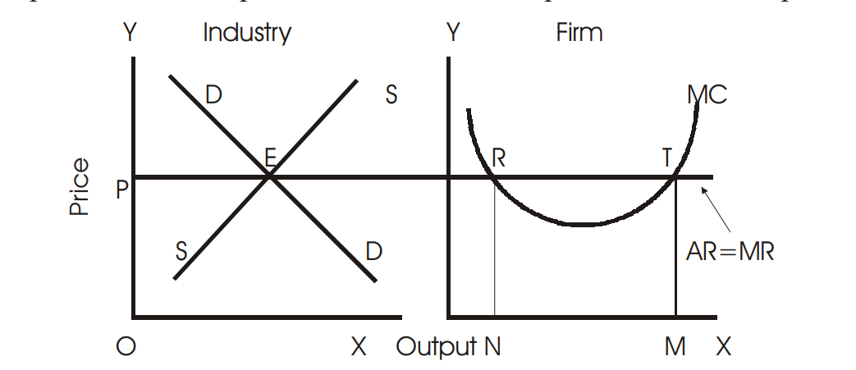

**Fig. 32**

In the diagram (Industry), DD and SS are the demand and supply curve respectively. The equality point of SS and DD is E, which is the equilibrium point. At this point, price OP is determined. OP price will be accepted by all firms in the perfect market and sell any amount of good at this price. Hence, average revenue curve faced by an individual firm is horizontal straight line parallel to the x-axis or perfectly elastic. Now, the firm’s task is to determine equilibrium output.

It is to be remembered that any seller will sell or produce that level of output where its profit is maximized. And profit is maximized where the following two conditions are satisfied:

1. MR = MC
2. MC curve cuts MR from below.

In the second diagram (Firm), it is seen that there are two equilibrium points-R and T, because at these points the first condition is met. However, point T satisfies both conditions. Hence the firm will be in equilibrium at point T and produce OM level of output at OP price. The firm will not stop producing at point R because beyond this point AR > MC and therefore, there is still enough scope to earn profits and maximize it. Similarly any output level greater than OM will bring losses to the firm as MC > AR (=MR) beyond point T.

In the short run, there are three possibilities for a firm. These are – (a) when a firm makes abnormal profits (AR > AC); (b) when it earns only normal profit (AR = AC); and (c) when it incurs losses, but does not shut down. Firms will operate till they are able to get variable costs. They will shut down their business when they cannot earn even average variable costs of production.

## MONOPOLY

The word ‘Monopoly’ has been derived from the two Greek words, ‘Monos’ which means single, and ‘polus’ which means a seller, Monopoly is a market situation where there is single seller of a product and he has full control over the supply of that commodity. He produces such a product which has no close substitutes.

Thus monopoly market has the following features:

1. There is a single seller of the product.
2. There are no close substitutes of the commodity produced by monopoly seller.
3. There is restriction on entry or exit of other firms.
4. There is no distinction between a firm and an industry under monopoly.
5. Seller is a price maker.
6. A monopoly firm earns abnormal profits both in short and long run.
7. Selling costs are negligible.
8. A monopolist is capable of following price discrimination, which means it can charge different prices for its products from different buyers.

Let us now see what the causes of monopoly are:

1. Monopoly can be the result of exclusive ownership of important raw materials or knowledge of production techniques;
2. Patent rights acquired by a firm for its product;
3. Foreign trade barriers imposed by the government, which prevents any foreign company to enter the industry.
4. A price policy adopted by the existing firms which prevents new firms to enter.

## MONOPOLISTIC COMPETITION

In a monopolistic competitive market the number of sellers is large but each seller has a product differentiated from those of his rivals. What one firm produces is not quite like what any other firm produces. In fact, each firm has a kind of limited monopoly of its own product and hence the name “monopolistic competition”. The following are the main features of the monopolistic competitive market:

1. **Large number of firms:** The number of firms which constitutes an industry is fairly large.
2. **Product Differentiation:** Under monopolistic competition each firm produces a differentiated product. The form or the quality of a product can be differentiated by using different kinds of raw materials, through workmanship, colour, packing, design, durability, etc. For example, different firms produce soft drinks like coca cola, limca, sprite, thums up etc. Though the ingredients are same, products carry a different brand name.
3. **Free Entry and Exit:** Firms under monopolistic competition are free to enter and leave the industry at any time.
4. **Individual Pricing by a Firm:** In this type of market, every individual producer has his own independent price policy.
5. **Selling Costs:** Every firm tries to promote its sales through expenditure on advertisement and on other promotional activities such as sales men’s incentives, gifts etc.
6. Under monopolistic competition, both price and non-price competition prevails.

## OLIGOPOLY

Oligopoly is a market structure where there are only a few producers/sellers of a commodity (but more than two producers) competing with one another. “Few” means enough number of firms that can keep watch on the actions of rivals and behave accordingly. A firm cannot take independent action without thinking of in what way its opponent firms will react. Precisely, few may mean three or four or twenty or thirty firms, including some major players while others small producers. Automobile companies making two-wheelers (Bajaj, Hero Honda, Kinetic, Yamaha etc) or four wheelers (Toyota, Mazda, Tata, Mahindra & Mahindra etc); TV manufacturers (Hisense, Bruhm, Onida, LG, Samsung, Sony etc) etc are the examples of oligopoly. Oligopoly is of two kinds:

### Pure Oligopoly

It is a market where the products are homogenous. There is mutual interdependence between firms. Any change in price by one firm has a substantial effect on the sales of other and cause them to change their price. Examples of pure oligopoly are found in such industries as cement, coal, gas, steel, etc.

### Differentiated Oligopoly

Under differentiated oligopoly, products are close substitutes for each other. Price change by one firm has less direct effect upon rival firms. Examples of differentiated oligopoly are refrigerators, television sets, air-conditioners, automobiles, scooters, motorbikes, instant coffee, etc.

### Characteristics of Oligopoly

Some of the important features of oligopoly are as follows:

1. **Interdependence:** Under oligopoly, a firm cannot take independent price and output decision. As the number of competing firms is limited, therefore, each firm has to take into account the reactions of the rival firms. Price and output decisions of one oligopoly firm has considerable effect on the price and output decision of the rival firms.
2. **Indeterminate Demand Curve:** An oligopoly firm can never predict sales correctly. It can never be certain about the nature and position of its demand curve. Any change in price or output by one firm leads to a series of reactions by the rival firms. As a result, the demand curve of the oligopoly firm remains indeterminate (indefinite and shifting). Thus, under oligopoly a price, once determined, continues to prevail for a long time. According to Paul M. Sweezy, an oligopolistic firm faces a kinked demand curve at the existing price as shown under in the figure. If a firm reduces prices of its products, other firms will also follow as demand curve is highly inelastic in its lower part EB. As a result, the firm which has lowered the price will not gain anything out of it act. Now, if it raises its price above the prevailing price OP, other firms will not follow this time as demand curve above the prevailing price (upper part) AE is more elastic.

Thus, the firm will lose due to his action. Therefore, price will remain more or less stable under oligopoly situation. The demand curve in the Fig. 10.1 is kinked (bent) at E.

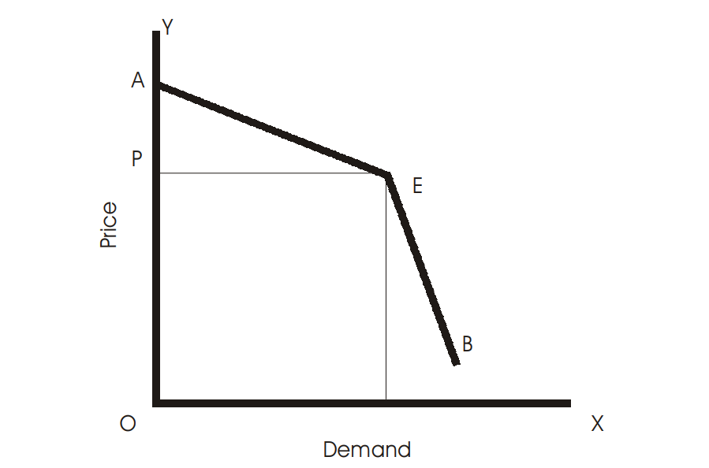

#### Fig. 10.1

1. **Role of selling costs:** Advertisement, publicity and other sales techniques play an important role in oligopoly pricing. Oligopoly firm employs various techniques of sales promotion to attract large number of buyers and maximize the profits. Selling cost has a direct bearing on the sales of the oligopoly firm.
2. **Price Rigidity:** Oligopoly firm generally sticks to a price, which is determined after a lot of planning and negotiations, with the competing firms. A firm will not resort to price cut, as it would lead to retaliatory actions by the rival firms resulting in price war. An oligopoly firm will also not raise the price because the rival may not follow suit and, as a result, the firm will lose many of its customers.
3. **Group Behaviour:** Price and output decisions of one oligopoly firm have direct effect on the competing firms. Interdependence of the firms compels them to think in terms of mutual co-operation. Firms try to maximize their profits through collusive action. Instead of independent price output strategy oligopoly firms prefer group decisions that will protect the interest of all the firms.

## DUOPOLY

Duopoly is a market situation where there are only two sellers. Duopoly can be with or without product differentiation. The important feature of duopoly is that the individual firm has to carefully consider the indirect effects of its own decision to change its price or output or both.

### Questions for Review

1. What is meant by market in economics?
2. What type of demand curve does a firm have under perfect competition?
3. Explain the characteristics of monopolistic competition. Compare demand curves under monopolistic competition and monopoly.
4. How is a seller under perfect competition a price taker? What is the relevance of the characteristic that there is large number of sellers in this context?
5. Define market.
6. Define monopoly?
7. What is perfect competition? State its main features.
8. What is oligopoly? Discuss its characteristic features.
9. Distinguish between perfect competition and monopoly.
10. State the main features of monopoly.
11. Define equilibrium price.
12. How does oligopoly differ from monopolistic competition?
13. What is Monopolistic Competition? How is it different from perfect competition?
14. State five necessary conditions for perfect competition to prevail in a market.
15. “Under perfect competition, the seller is a price-taker; under monopoly, he is the price-maker.” Expalin.
16. Write short notes on:
    1. Pure competition
    2. Differentiated product
    3. Demand curve of a seller under different market forms(*d*) Oligopoly.
17. How does an increase in the price of a substitute good in consumption affect the equilibrium price?
18. What does the FAD theory of famines say?
19. What is meant by economic viability of an industry?
20. Give one example of each of direct intervention and indirect intervention in the market mechanism.
21. What do you understand by (a) control price and (b) support price?
22. Name the three forms of imperfectly competitive markets.
23. What is the profit maximizing condition of a competitive firm in the long run?
24. What is meant by abnormal profit?
25. What is meant by abnormal loss?
26. What is break-even price?
27. How many firms are there in a monopoly market?
28. What is a cartel?
29. What is the profit maximizing condition for a monopoly firm?
30. What are anti-trust legislations?
31. Give two examples of monopolistically competitive market?
32. What are selling costs?
33. What are advertising costs?
34. What is persuasive advertising?

**CHAPTER 12**

**FACTOR PRICE DETERMINATION**

* A factor is a human or material agent which contributes something to production. A factor can be a worker, a machine, a building or a piece of land.
* Every factor has some sort of stored-up productive power which it exerts when used in production. This productive power or the actual contribution to the production is called services of a factor.
* Factor services are demanded by producers and supplied by factor owners. In economics, factors of production, which help in producing goods and services, are classified broadly into human and non-human factors.
* Labour, which is provided by a worker, is a human factor whereas buildings and machinery or capital is a non-human factor.
* When we say ‘Prices of factors’, it means the price a factor should get for providing its services.
* Labour gets wages and use of capital is rewarded with interest. Land, which is an important factor of production, earns rent and an entrepreneur who takes the risk of business in the environment of uncertainty earns profits – either positive or negative.

This chapter deals with the explanation of how prices of factors of production are determined by the forces of demand and supply. Prices of factor services are determined in the same manner as that of product pricing, the difference lies in the determinants of factor demand and supply.

### Demand for a Factor

* The price of a factor service is determined by the demand and supply of that factor.
* Producers demand various factor services for producing goods and services in the market.
* Every producer faces the problem of taking decision regarding the payment which it has to make to factors for the return of their services.
* This is one of the most crucial questions before a producer. In such situation, it is required to know the contribution made by a factor.
* How much extra a factor adds to the total output produced by a firm is required to be determined at such time.
* In economics, this extra contribution is called as marginal product of labour/factor. Thus, marginal product or marginal physical product (MPP) of labour/factor is the addition made to the total output by employing one more unit of labour/factor.
* For instance, if 5 workers together construct 20 meters of road length in a day and when one more worker joins them, the road length increases to 25 meters, then the 6th worker’s contribution to the total work is 5 meters. This is marginal physical productivity of 6th labour.
* The concept of MPP is primarily developed concerning labour, but it is equally applicable to other factors, such as land, capital, and organization. Thus, price of labour, i.e., wages depends upon the MPP of labour.
* A producer will equate its marginal cost of producing goods with the marginal productivity of labour so as to maximize his satisfaction/profits.
* Thus, MPP is of utmost importance in the theory of factor pricing. Marginal physical productivity of labour for a firm is shown in the table and Fig. 11.1 below.

|  |  |  |
| --- | --- | --- |
| *Units of labor* | *Total Physical Product* | *Marginal Physical Product* |
| 1 | 5 | 5 |
| 2 | 11 | 6 |
| 3 | 22 | 11 |
| 4 | 41 | 19 |
| 5 | 65 | 24 |
| 6 | 95 | 30 |
| 7 | 121 | 26 |
| 8 | 145 | 24 |
| 9 | 162 | 17 |
| 10 | 171 | 9 |

* Marginal physical productivity of labour increases as additional labourers are employed but after certain point it begins to decline continuously.
* Fall in the MPP after 6th unit of labour is not due to the decline in the efficiency level of labourers but due to the technical conditions which do not allow the continued increase in the units of labourers in relation to other factors.
* Total physical productivity (TPP) of labour increases, initially, at increasing rate and thereafter at diminishing rate as seen in the table above.

35

30

25

20

15

10

5

0

1

3

5

7

9

11

Marginal

Physical

Product

Marginal Physical Product

MPP

Labour units

#### Fig. 11.1

Every producer is interested in the revenue he will earn by employing a factor. In other words, a firm is interested in the money value of MPP of labour than in just productivity in physical terms. Money value of marginal physical product of a factor is estimated by multiplying MPP with price of the product. Thus,

VMP = MPP × Price of the product

A producer has to compare its marginal cost for employing an extra labour with what it adds to the total output, i.e, additional/marginal revenue. The additional revenue earned by using one more unit of a factor is called its marginal revenue product (MRP). MRP is more significant term than MPP. We can find MRP by multiplying MPP with the marginal revenue of the product being produced by the firm. Thus,

MRP = MPP × MR

The schedule below explains how MRP is calculated. Let us take Ksh. 5/- as the price per unit of the good in question. Further, it is assumed that there is perfect competition in the factor market, so that the price remains same at all levels of factor demanded and supplied. At constant price, MR is equal to the price. Therefore under perfect competition, MRP is equal to VMP. The demand curve of a firm for a single factor is its value of marginal product curve.

|  |  |  |
| --- | --- | --- |
| *Units of labour* | *Marginal Physical* | *Marginal Revenue Product* |
|  | *Product (in units)* | *(in Ksh.)* |
| 1 | 5 | 25 |
| 2 | 6 | 30 |
| 3 | 11 | 55 |
| 4 | 19 | 95 |
| 5 | 24 | 120 |
| 6 | 30 | 150 |
| 7 | 26 | 130 |
| 8 | 24 | 120 |
| 9 | 17 | 85 |
| 10 | 9 | 45 |

The MRP curve like the MPP curve has similar shape. It first rises and then falls continuously.

The determinants of the demand for a variable factor by an individual firm are the following:

1. The prices of the input. The higher the price of a factor, the smaller the demand for its services.
2. The marginal physical product of the factor.
3. The price of the commodity produced by the factor.
4. The amount of other factors which are combined with labour.
5. The prices of other factors.
6. The technological progress, which changes the MPP of all inputs and hence the demand.

The market demand for a factor is not the simple horizontal addition of the demand curves of individual factors. This is because as price the factor falls producers will employ more of this factor and expand their output. It will result in downward shift of supply of the commodity causing price of the commodity to fall. Since price is one of the components of the demand curves of the individual firms for a factor, these curves shift downward to the left. The market demand curve of labour is shown in Fig. 11.2. At W1 wage rate, firms demand ON level of factors and as wage rate falls to W2, demand also increases to OM.

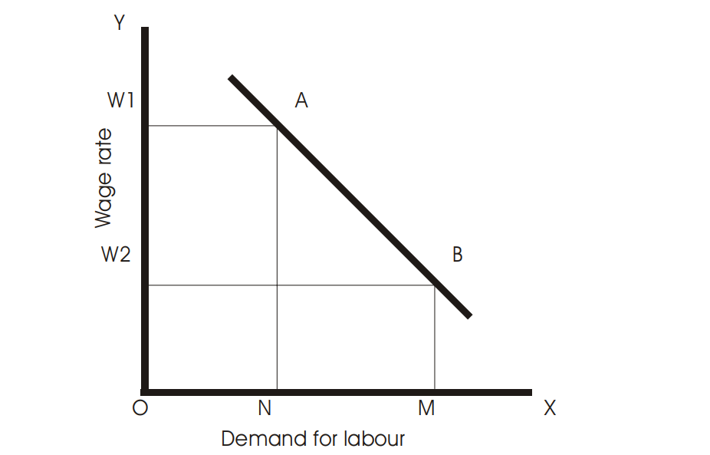

**Fig. 11.2**

### Supply of a Factor

To determine the supply of labour, we assume that labour is a homogenous factor, i.e., all labour units are identical to each other. The important factors which determine market supply of labour

are the following:

1. The price of labour, i.e., wage rate.
2. The tastes of consumers which affect their striking balance between leisure and work.
3. The size of population.
4. The labour force participation rate.
5. The occupational, educational and geographical distribution of labour.

The relationship between the supply of labour and the wage rate defines the supply curve. Therefore, other factors than wage rate are assumed to be constant, while determining the supply curve of labour. The market supply is the summation of the supply of labour by individuals. The supply curve of an individual labour is shown in Fig. 11.3.

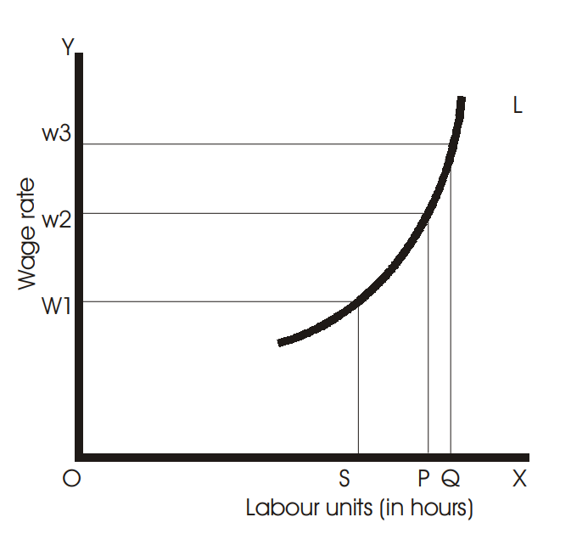

#### Fig. 11.3

When the wage rate is W1, the individual labour is in equilibrium by working OS hours and as wage rate increases to W2, labour hours also increases to OP. However, at some higher wage rate the labour hours may decline. This is depicted in the figure above, when wage rate rises to W3, the individual works for OQ hours. It is seen that the individual works less than at W2 wage rate, as evident from the fact that PQ < SP. When wage rate increases still further, the hours supplied for work declines even more. The behaviour of labourers at higher wage rates produces a backward bending supply curve for labour as shown in the Fig. 11.4.

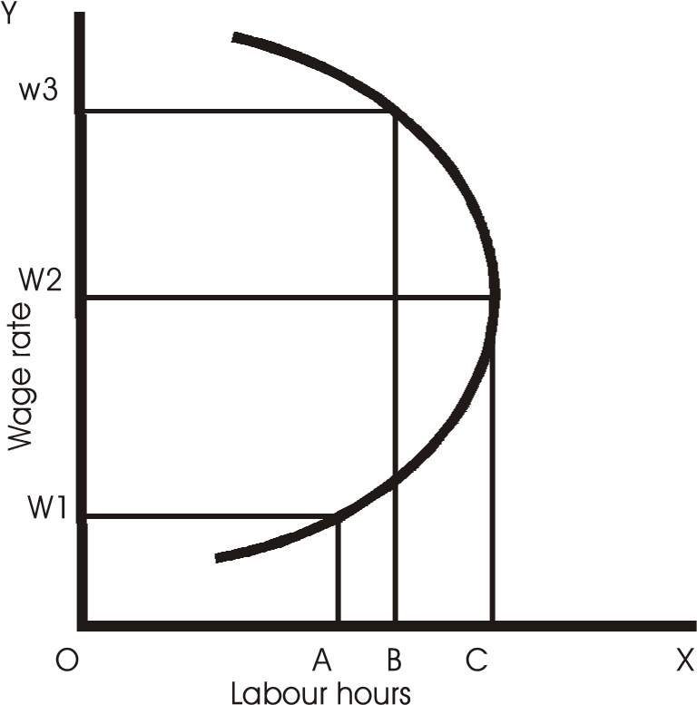

#### Fig. 11.4

When wage rate increases say up to a point, it gives incentive to the labourers for working or supplying more hours but when wage rates increase further, it creates disincentive for longer hours of work. The reason being longer hours of work means less leisure hours. As the wage rates rises, the individual’s income also rises, which enables him to have more leisure hours. Thus, beyond a certain level of the wage rate, the supply of labour declines as the worker prefers to use his increased income on more leisure activities. It means, as incomes reach the level required for a comfortable standard of living, workers like to have more vacations, fewer hours of work per day rather than go on working at higher wage rates.

However, aggregate supply curve of labour does not behave in this manner. Economists argue that in the short run such pattern may be evident but in the long run, the supply curve must have a positive slope. Higher wages may induce some people to work less hours, but will also attract new workers in the market in the long run.

### Determination of Price of a Factor under Perfect Competition

Thus, we can determine the factor price in perfect markets with the help of demand and supply curves of a factor. The Fig. 11.5 shows the price determination by the intersection of these two curves. In the figure, the equilibrium wage is OW and then employment level is OM. Thus, we find that the determination of wage rate is same as the determination of price of a commodity. But the determinants of demand and supply of a factor are different than that of goods. The demand for factors is a derived demand, i.e., their demand arises due to the demand for various commodities in whose production the factors are used. The supply of labour is not cost determined like the supply of commodities, but influenced by attitudes of workers toward work and leisure.

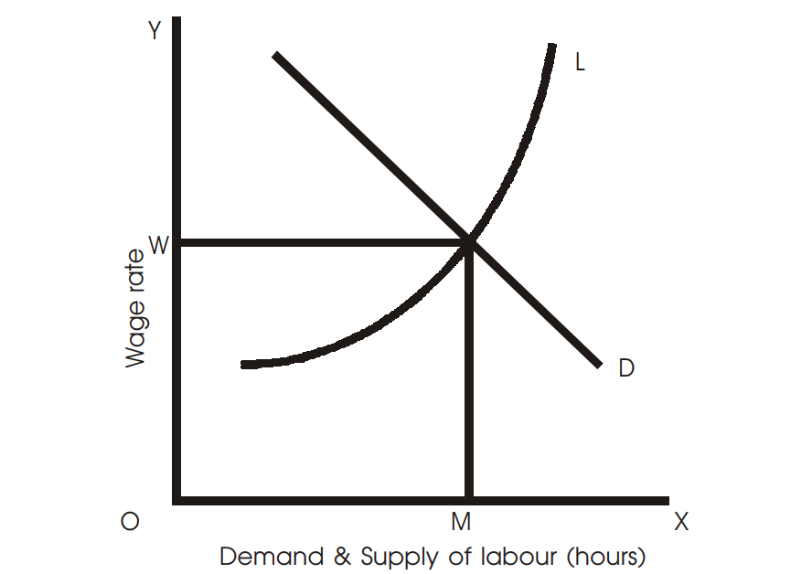

**Fig. 11.5**

## MARGINAL PRODUCTIVITY THEORY

**Marginal productivity theory** suggests that the amount paid to each factor in the production process is equal to the value of the extra output the factor of production produces.

|  |  |
| --- | --- |
| total production due to the addition of an extra employment of a unit of a factor. If the prevailing wage rate is less the marginal productivity, then | **C:\Users\HP\Downloads\2023-05-10 (19).png** |

Marginal productivity theory tries to explain how the services of factors are determined. As already stated, a firm works for profits and therefore he will not pay any factor more than its marginal productivity. Similarly, no factor will accept price less than its marginal productivity. Thus, marginal productivity determines the price of a factor. An entrepreneur will substitute one factor for another till the marginal productivities of all factors are equalized. At the margin of employment, the payment made to the factor concerned is just equal to the value of the addition made to themore labour will be employed. Competition among the firms will raise the wage rate to the level of marginal productivity. On the contrary, when marginal productivity is less than the wage, the firms will reduce the demand for labour. As a result wage will fall to the level of marginal productivity. In this manner, by competition, wage tends to equal the marginal productivity of labour. This is applicable to other factors of production. The Fig. 11.6 shows the above explanation. MRP is the marginal productivity curve for labour. It is the demand curve for the factor. At wage rate OW, OM quantity of labour is employed because at this level of employment, wage is equal to marginal productivity of labour.

### Shortcomings of Marginal Productivity Theory

Marginal productivity theory is criticized on the following grounds:

1. Assumption that all units of factors are homogenous is wrong. All labourers are not alike. Efficiency varies from labour to labour. Similarly, capital units are also of different types.
2. Different factors cannot always be substituted as assumed.
3. It is also assumed that factors are mobile as between various uses. Land lacks mobility. Labour and capital are also not perfectly mobile.

### Questions for Review

1. Who demand factors in the markets?
2. Who supply factors in the markets?
3. Define marginal physical productivity. How is it different from marginal revenue productivity?
4. Name two factors which shift the factor demand curve.
5. Explain backward bending supply curve of labour.
6. Demand for labour is derived demand. Explain.
7. What is the essence of marginal productivity theory of distribution?
8. How is price of a factor determined? Explain with the help of a diagram.
9. Describe marginal productivity theory of distribution.
10. What is derived demand?
11. What are the factors that determine market supply of labour?
12. Calculate from the following table-MPP and MRP, given that price per unit of the commodity is Ksh. 5/-.

|  |  |  |
| --- | --- | --- |
| *Units of labour* | *Total Physical Product* | *Marginal Physical Product* |
| 1 | 6 |  |
| 2 | 14 |  |
| 3 | 20 |  |
| 4 | 39 |  |
| 5 | 60 |  |
| 6 | 90 |  |
| 7 | 115 |  |
| 8 | 130 |  |
| 9 | 152 |  |
| 10 | 161 |  |

CHAPTER 13

FACTOR PRICES, AND INTERNATIONAL TRADE COMPARATIVE ADVANTAGE

A study of international trade necessarily explains why nations trade with other. The immediate cause of international trade is the presence of differences in the prices of goods and services between the countries. Price differences arise because of differences in supply and demand conditions. Supply conditions differ due to various reasons such as natural endowments of economic resources, the degree of efficiency with which factors are employed, the level of technology, labour skills, factor abundance etc. Differences in demand are mainly due to differences in income and taste pattern of people in different countries. The result of international trade will be equalization of product prices as well as factor prices. Before we analyze further, it would be imperative to have acquaint ourselves with some important terms used in the study of international trade.

## Internal and International Trade

Internal or inter-regional trade may be defined as exchange of goods and services among the residents of the same country. International trade is the exchange of goods and services between the residents of a given country and those of the rest of the world. The fundamental principles underlying trade between different countries and that within a country are the same. There is free mobility of factors of production within the nation whereas in the international setting, factor mobility is not free. In former case, there could not exist inter-regional differences in factor prices. The factors would always be attracted towards the regions where their prices are higher. As such they would move from the regions where their prices are low paid to the places where they would be rewarded at higher rates. This movement would continue till the factor price differences between the regions are completely removed. In the latter case, mobility is restrictive by immigration laws that prevent free mobility of labour from one country to another. The restrictions are not only limited to labour flow but also to flow of capital and investment across the countries. There are barriers as social, political and cultural that also restricts the flow of capital and labour.

As regards to movement of goods and services within a nation, it is free. The only barriers internally are the distance and cost of transportation. In case of international trade, such movement is not free because of various barriers like import and export duties and quotas, exchange controls non-tariff barriers etc.

Economic environment within the nations is more or less same in all regions. Economic environment such as legal framework, regulations regarding production and exchange of goods,

infrastructural facilities, etc are same within a country. But between nations, there are significant differences in economic environment.

The distinction between internal and international trade can be significantly seen in case of monetary units. There are currency differences between countries. Money and capital market within a country are the same for all regions governed by a single currency facilitating exchange of goods and services. But in the international setting this is not true. International monetary differences create complications in international transactions, which are not found in domestic trade.

## Absolute Factor Price Difference

It occurs when the price of a factor in one country is different, in absolute terms, from the price of that factor in another. For example, if a labour earns Ksh. 100 by working a day in Kenya and by providing same labour the worker gets Ksh. 500 in Japan, then there is absolute factor price difference between these two countries.

## Relative Factor Price Difference

It refers to the difference in factor price ratios across regions or countries. For example, in Japan a labour earns Ksh. 500 per day and capital earns Ksh. 2000 and in India earning of a labour is, say, Ksh. 100 and that of capital Ksh. 500, then relative factor price difference is,

|  |  |  |
| --- | --- | --- |
| C:\Users\HP\Downloads\2023-05-10 (20).png |  |  |

Thus, factor price ratio in India is lower than that in Japan.

## THE CLASSICAL THEORY OF INTERNATIONAL TRADE

### Theory of Absolute Advantage–Adam Smith

Adam Smith provided the base for the development of the classical theory of international trade. His theory is popularly known as the Theory of Absolute Advantage. According to Smith, if one country has absolute advantage over another in one line of production, and the other country has an absolute advantage over the first country in another line of production, then both the countries would gain by trading. He, thus, showed how all countries would gain from international trade through international division of labour. Let us explain Smith’s theory of international trade by taking an example.

Let us suppose that there are two countries in the world—Kenya and America. We also assume that there are two goods traded between these countries—rice and textiles. Assume further that both the countries can produce both the goods if they wish. Suppose America can produce 100 units of textiles or 50 units of rice using a given amount of factors of production or any other combination of two goods provided that the opportunity cost ratio remains 2:1. It would mean that if America wants to produce 1 more unit of rice, it will have to give up the opportunity of producing 2 units of textiles. In the same manner and with same amount of factors of production, Kenya can produce 50 units of textiles or 100 units of rice or any other combination in the opportunity ratio of 1:2. It means that Kenya has to give up 1 unit of textiles for the production of 2 units of rice. Thus, it is clear that America has an absolute advantage in the production of textiles and Kenya has absolute advantage in the production of rice. This means there is scope for Kenya to establish trade relations with America by specializing in production of that commodity where each has absolute advantage.

Thus, America will specialize in the production of textiles and Kenya in the production of rice, when they start trading each other. **Autarky** is a situation when a country is not having any trade relations with rest of the world. In such situation, two countries in question will produce and consume a combination of textiles and rice as shown in the following table:

|  |  |  |  |
| --- | --- | --- | --- |
| *Countries* | *Textiles (units)* | *Rice (units)* | *Total output/GNP (units)* |
| U.S.A. | 50 | 25 | 75 |
| Kenya | 25 | 50 | 75 |
| World | 75 | 75 | 150 |

America produces and consumes 50 units of textiles and 25 units of rice whereas Kenya produces and consumes 25 and 50 units of textiles and rice respectively. When the two countries open their economies to international trade, there take place changes in respect of production lines and GNP, as shown below in the table:

|  |  |  |  |
| --- | --- | --- | --- |
| *Countries* | *Textiles (units)* | *Rice (units)* | *Total output/GNP (units)* |
| U.S.A. | 100 | 0 | 100 |
| Kenya | 0 | 100 | 100 |
| World | 100 | 100 | 200 |

After the trade is established, America produces textiles only and Kenya produces rice. The two countries divert their resources in the production of that commodity in which they have absolute advantage. As a result of trade, GNP of both the countries has increased to 100 units. The world trade has also increased by 50 units. Both the countries have become better off, after trade, without making any country worse off. Thus, there have been production gains from international trade between two countries. As regards to consumption gains from trade, it depends on distribution of gains from production between two countries. In other words, consumption gains depend upon the terms of trade, i.e., number of units of textiles exchanged for one unit of rice between Kenya and America.

### Theory of Comparative Advantage–David Ricardo

Ricardo’s model on international trade is a further refinement of Smith’s model. He argued that even if the countries did not have absolute advantage in any line of production over the other countries, international trade would be gainful. Let us explain Ricardo’s model as under.

Let us again take the example of a world with only two countries—America and Kenya and two commodities—textiles and rice. Ricardo assumes that one country has the absolute advantage over the other country in both the lines of production. It means the other country has absolute disadvantage in both the lines of production. Further, in terms of relative or comparative advantage, he assumes that the first country has a greater comparative advantage in one line of production compared with the other and second country has a smaller comparative disadvantage in the second line of production compared with the first line of production. In short, one country’s comparative advantage is greater in one line of production, and the other country’s comparative disadvantage is smaller in the other line of production. If trade is established between these two countries, it would bring both production and consumption gains. The production possibilities of the two countries are shown in the following table:

|  |  |  |  |
| --- | --- | --- | --- |
| *Countries* | *Textiles (units)* | *Rice (units)* | *Opportunity cost ratios* |
| U.S.A. | 120 | 120 | 1:1 |
| Kenya | 40 | 80 | 1:2 |

America can produce 120 units of textiles or 120 units of rice, or any other combination of textile and rice at opportunity cost ratio of 1:1. It means America can produce 1 unit of textile (or rice) by sacrificing 1 unit of rice (textile). Here, America has absolute advantage in the production of both textiles and rice. Kenya, on the other hand, has absolute disadvantage in either line of production. She can produce either 40 units of textiles or 80 units of rice or any combination at opportunity ratio of 1:2. It would mean that Kenya has to give up 2 units of rice to produce 1 unit of textiles. Alternatively, ½ unit of textiles have to be given up to produce 1 unit of rice. It is to be noted here that the internal cost ratios for producing two commodities in the two countries are different, implying that there is potentiality of gains from international trade. The cost of producing any commodity in America is same, but in Kenya it is not so. In Kenya, to produce 1 units of rice, ½ units of textiles has to be given up and to produce 1 unit of textiles, 2 units of rice has to be given up. From the table above, we can see that America’s comparative advantage over Kenya is greater in the production of textiles (3:1) as compared to rice (1.5:1). Therefore, America would specialize in the production of textiles than rice. Now, Kenya’s comparative disadvantage, in relation to America, is lower in the production of rice (1:1.5) than textile (1:3). Thus, Kenya would specialize in the production of rice than textiles.

The theory suggests that a country should specialize in the production and export of those goods in which either its comparative advantages is more or its comparative disadvantage is less. Then only a country can maximize its production and increase economic welfare.

## THEORY OF OPPORTUNITY COST

Adam Smith’s and David Ricardo’s theories were based on the labour theory of value, which has been criticized on the ground that labour is not a homogenous factor and is not the only factor of production. Goods are produced by using all factors of production –land, labour, capital and organization and not labour alone. Thus Gottfried Heberler has developed a theory in terms of opportunity costs using labour and capital in 1936. Once comparative advantage is defined in terms of opportunity costs, it makes no difference whether goods are produced by labour alone or by all factors of production combined with labour. Let us explain the theory with an example. Suppose U.S. can produce either 100 units of wheat or 100 units of cloth when all factors are fully employed in the production of either wheat or cloth. However, the country will be interested in producing some combinations of two goods instead of one. The various combinations of wheat and cloth that U.S.A. can produce are shown by a production possibility curve (PP) in the Fig. 12.1 below, which is straight line, since constant returns to scale in the production has been assumed.

On the X-axis, we measure the units of cloth and along Y-axis, units of wheat. The country can produce both the goods at any point lying on the production possibility curve PP and not outside the curve. If it decides to produce at K, then it produces 50 units of each cloth and wheat. The production possibility curve is straight line implying that to produce a unit of wheat; same unit of cloth has to be forgone. Thus, opportunity cost in our example is 1:1. In the same fashion we can draw production possibility curve of another country, Kenya. Let us suppose that Kenya can produce either 100 units of cloth or 50 units of wheat. Thus the opportunity cost of producing cloth in terms of wheat is 1:1/2. Trade will benefit both the countries. Wheat is relatively cheaper in the U.S.A and cloth is relatively cheaper in Kenya. This is because to produce one unit of cloth, U.S.A has to sacrifice one unit of wheat whereas, to produce the same unit of cloth in Kenya, it has to sacrifice ½ unit of wheat. This clearly shows that U.S.A has comparative advantage of production in wheat and Kenya has a comparative advantage in the production of cloth. Thus, U.S.A will export wheat and import cloth and Kenya will export cloth and import wheat from U.S and in this way both the countries will gain from trade.

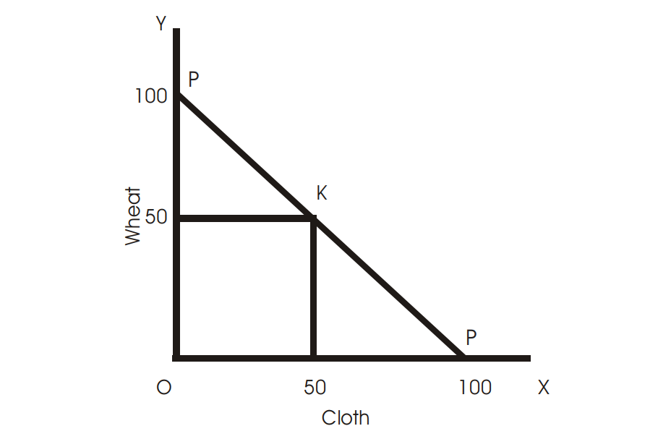

**Fig. 12.1**

## MODERN THEORY OF INTERNATIONAL TRADE—HECKSCHER AND OHLIN

The Modern theory of international trade was developed by Eli Heckscher and Bertil Ohlin. According to them, the immediate cause of international trade is the differences in the relative prices of commodities between the countries. These differences arise on account of the differences in the factor supplies in the two countries. The theory is based on the following assumptions:

1. There are only two factors-labour and capital.
2. There are only two countries and one country has abundant capital and another country has abundant labour.
3. There are only two commodities, the production of which uses both the factors.
4. There is perfect competition both in the product and factor markets.
5. There is full employment of resources.
6. There is no change in technology.

Heckscher and Ohlin predicted that the capital surplus country would specialize in the production and exports of capital intensive goods and the labour abundant country would specialize in labour intensive goods.

### Factor Abundance

Factor abundance can be defined in terms of factor prices. Accordingly, a country in which capital is relatively cheap and labour relatively more costly, is regarded as the capital abundant country, regardless of the physical quantities of capital and labour available in this country compared with the other country. Labour abundant country is one where labour is relatively cheaper than capital. Ohlin finds that the differences in factor prices are due to differences in factor supplies in the two countries.

Factor abundance can also be defined in physical terms. According to this criterion, a country is relatively capital abundant if it is endowed with a higher proportion of capital to labour than the other country. Similarly, labour abundant country is defined as the country in which labour is surplus than capital. Thus, a country ‘A’ would be capital abundant and country ‘B’ would be labour abundant if the following condition is met:

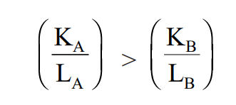

where KA and LA are the total amounts of capital and labour respectively in country A, and KB and LB are the capital and labour amounts in country B. Since, country A is capital abundant, it will produce capital intensive goods and country B will produce labour intensive goods. This is shown in the Fig. 12.2. The production possibility curve of country A is shown by the curve AB and that of country B by CD. Steel is capital intensive good while cloth is labour intensive good. If the two countries produce the goods in the same proportion along OR ray, then country A would produce at Q’ on its production possibility curve AB and country B at Q” on production possibility curve CD. It can be seen that the slope at Q’ is more steep than at Q”. In other words, the commodity price line shown by P’P’ is steeper than P”P”. This means that steel is cheaper in country A and cloth is cheaper in country B, provided that two countries produce at Q’ and Q” respectively. Thus, country A would produce more of steel than cloth and export to country B and country B would focus itself in the production of cloth and export it to country A. It is seen above that there is greater degree of specialization in the two countries in the production of those goods, in which they are abundant. But complete specialization is absent because of diminishing returns to scale conditions with respect to both the goods. It is to be noted here that, production and export of a country’s goods depend upon demand factors. If the tastes of the consumers in regard to goods are identical, then the theory is valid on the basis of physical definition of factor abundance.

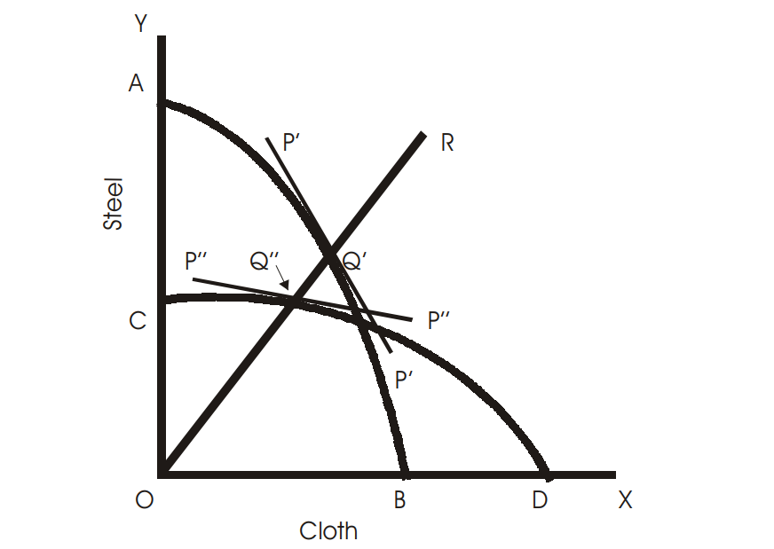

**Fig. 12.2**

## TERMS OF TRADE

Terms of trade is the rate at which a country exchanges its exports with its imports. Terms of trade are of immense use and significance. The gains from trade depend upon the terms of trade. There are many concepts of terms of trade. The most relevant concepts keeping in mind the scope of study are as explained below:

### Gross Barter Terms of Trade

The gross terms of trade is the ratio quantity of imports index to the quantity of exports index. Thus, if TG stands for gross terms of trade, M for imports and X for exports, then gross terms of trade is expressed as,

M

TG =

X

The higher the ratio of imports to exports, the better the terms of trade. The quantity index of imports and exports for the base year will always be equal to 100. Base year is used to measure changes in the gross terms of trade in any given year.

### Net Barter Terms of Trade

Net barter terms of trade is the ratio of price indices of exports to imports of a country. Symbolically,

X*p*

TN =

M*p*

where Xp and Mp are price index numbers of exports and imports respectively, TN stands for net barter terms of trade. Improvement in this terms of trade would mean increase in the economic welfare of the country.

### Income Terms of Trade

It is the ratio of the value of exports divided by the price index of imports. Income terms of trade helps in correcting movements in net barter terms of trade for changes in export volume. Symbolically,

### C:\Users\HP\Downloads\2023-05-10 (24).png

### Questions for Review

1. What do you mean by international trade?
2. What is meant by absolute and comparative advantage?
3. What is meant by relative factor price difference?
4. Explain absolute factor price difference.
5. Why does trade take place between two countries?
6. Explain the theory of comparative costs in international trade.
7. What is meant by terms of trade? How are they measured?
8. Examine the Hecksher-Ohlin’s theory of international trade.
9. Point out differences between internal and international trade.
10. What do you mean by gains from trade?
11. What is net terms of trade?