DOKUMENTASI C# TAKE HOME IT DIVISION

Nama: Vincent Hadinata

NIM: 2301850430

1. Menu Awal

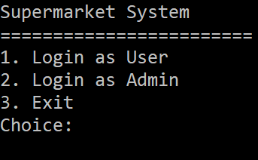

1. Menu User

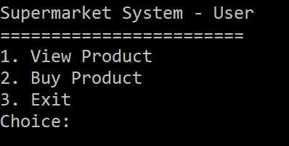

1. View Product

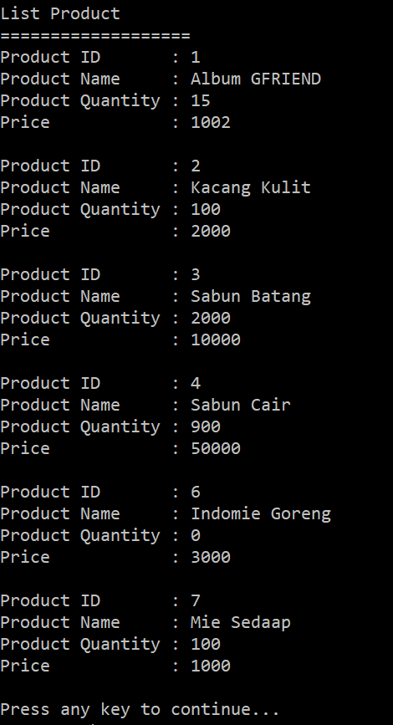

1. Buy Product

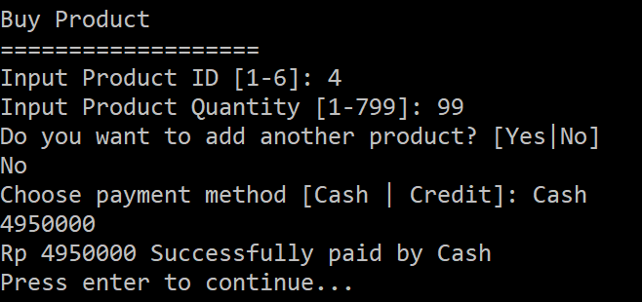



1. Menu Admin

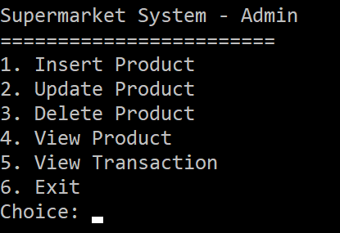

1. Insert Product

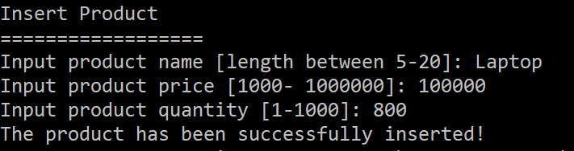

1. Update Product

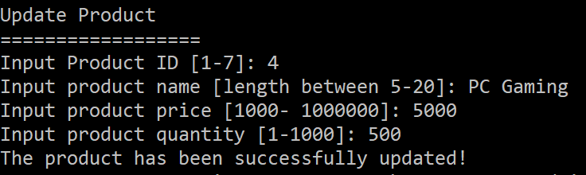

1. Delete Product

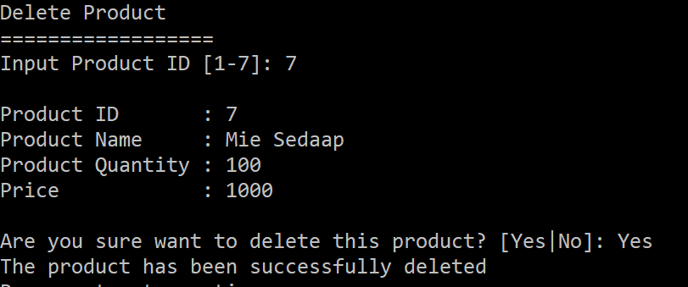

1. View Transaction

