TreeGUI Manual
TreeGUI Manual 1
Installation 1
Context Menus 1
Main Context Menu 1
Set this configuration as Default 1
User Guide 2
Indexing multiple profiles 2
FAQ 2
How to create multiple profiles? 2
How to Index multiple profiles? 3
How to open .tgc files? 3
Graphical User Interface 3
Options 3
Run as a Windows Service 3
Advanced 3
Uninstall McoreIndexer Service 3

Installation
TreeGUI does not copy any files to Windows directory. Therefore it is preferable to install TreeGUI in a folder that you will not lose after a reinstalling Windows. The setup will default to Documents\Applications folder. It’s your personal choice to install this in a folder other than the default location.

Context Menus

Main Context Menu

Set this configuration as Default
Click to make this profile the default TreeGUI profile. TreeGUI will use this profile when it loads next time.

User Guide

Indexing multiple profiles
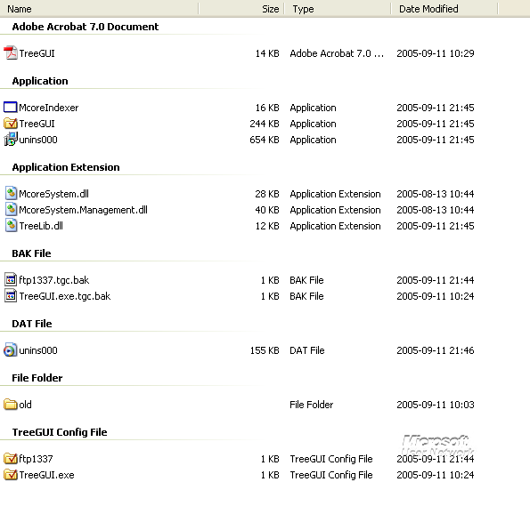
McoreIndexer can index all the TreeGUI Config files in the application folder. This feature is available for TreeGUI 1.6.0.0 and above.
To index multiple profiles simply create a new Config File in the application directory as shown above. See: How to create multiple profiles?

FAQ

How to create multiple profiles?
Keywords: Multiple; Create; Config; Profiles

Version 1.5 and above: To create another TreeGUI Config file simply create a copy of the current .tgc file. Rename it to give a descriptive name. Open it in TreeGUI. Right Click the Remove button and click Remove All. You can now add new folders you need. To make this configuration as default press Ctrl+S or right click TreeGUI and click set this configuration as default.

How to Index multiple profiles?
See: Indexing multiple profiles

How to open .tgc files?
To open .tgc files in Windows, go to advanced tab in TreeGUI and press Associate .tgc files with TreeGUI.

Graphical User Interface

Options

Run as a Windows Service
You can Start or Stop McoreIndexer using this checkbox. You need to run TreeGUI as an Administrator to perform this operation.

Advanced

Uninstall McoreIndexer Service
This uninstalls McoreIndexer from the System. You need to run TreeGUI as an Administrator to perform this operation.

