TreeGUI Manual

Windows 2000/XP/Server 2003/Vista

TreeGUI is an open source Directory Indexer for HTTP/FTP Servers. Index files can be created in XHTML or TEXT format. Windows Service is available to configure and forget. Other features are: Scheduling and option to automatically ZIP large index files.

# Getting Started

## Installing TreeGUI

TreeGUI does not copy any files to Windows directory, therefore a Limited User can perform an installation, provided that they install it to a folder other than Program Files. However to Administrative privileges are required to start the Windows Service.

## Upgrading TreeGUI

If you are installing TreeGUI over an existing installation, make sure you have stopped the McoreIndexer Windows Service to prevent ‘file already in use’ error while installing TreeGUI.

## Indexing your first folder

Once the installation is complete, load TreeGUI

* Press the Add button or Folders > Add folder to add a folder to index.
* Press Index Now.
* You now have your first index files created in the same folder.
* Double click the folder to load the index file.

## Options file

The TreeGUI options file can be located at the following directory: CommonApplicationData\TreeGUI\TreeGUI.xml

For instance at F:\Users\All Users\Application Data\TreeGUI\TreeGUI.xml

This location is not modifiable. TreeGUI will however look for a TreeGUI.xml in its start up folder. If there exists a file TreeGUI.xml in the start up folder then this file will have priority over the file that is in Common Application Data folder.

## Configuration files

You should save configuration files in the task folder location so that the indexer can use them to batch index. For this purpose, the initial directory for saving configuration files will be set to Task Folder path.

## Tasks folder

The tasks folder location is defaulted to TreeGUI start up folder.

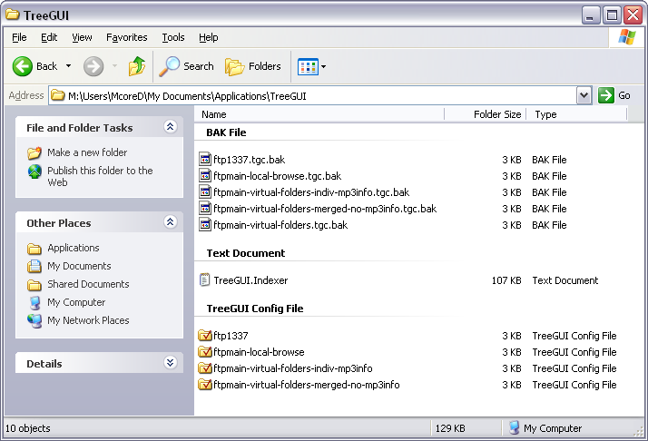

It is recommended to relocate the Task Folder path to another location which you will not lose after a Windows reinstallation.

# TreeGUI features

## Windows Service to index

TreeGUI incorporates a Windows Service to index folders. Once settings are configured using TreeGUI, the Windows Service could silently index all the folder locations in the Task Folder path.

To enable or disable Windows Service you have to run TreeGUI as an administrator.

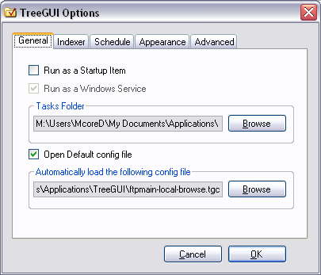

Windows Service can be enabled or disabled from Options.

## XHTML indexing

TreeGUI can index to valid XHTML 1.1 html files.

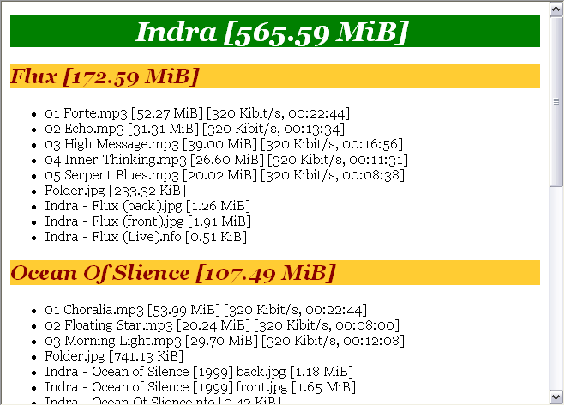

XHTML indexing is enabled by default.

## GUI to Tree command

TreeGUI provides a graphical user interface to the Tree Walk Utility found in Windows 2000/XP and Server 2003.

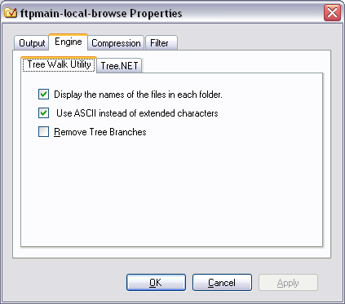

## Compress index files

TreeGUI can automatically compress index files using GZip compression.

Go to Tools > Config1 Properties or press Ctrl+D to load Configuration properties.

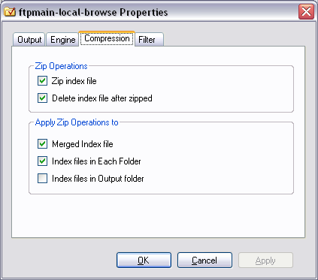

Configure zip operations accordingly.

## Virtual Folders

To configure virtual folders for the first time:

1. Select a folder from the list
2. Folders > Set Virtual Folder Name…
3. Config1 Properties > Engine > Tree.NET, XHTML Options > Show Folder Path on Status Bar
4. Config1 Properties > Engine > Tree.NET, XHTML Options > Show Virtual Folders
5. Save the config file

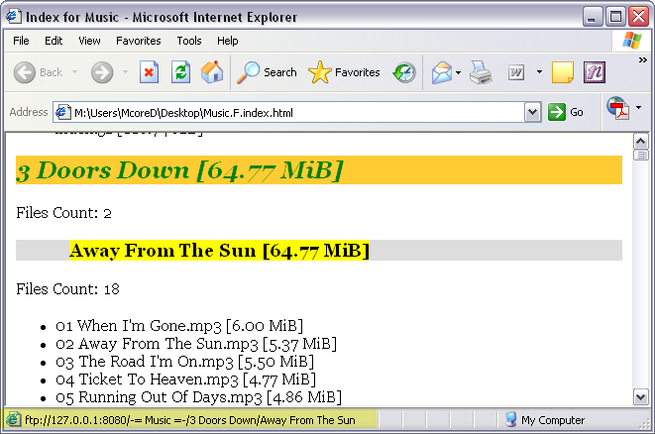

# Main Window

## Add…

Press Add to add a new folder to the folder list

## Remove

Removes a selected folder from the list

## Index Now

Press to start indexing the folders in the list

## Move Up / Move Down

Re-order folder list

# TreeGUI Options

Accessible by pressing F2

## General

### Run as Startup Item

Check to run TreeGUI in System Tray every time Windows starts

### Run as Windows Service

Check to install and run TreeGUI as a Windows Service

### Tasks folder

Change the Task folder location (preferably a location in Documents)

## Schedule

### Enable Scheduled Tasks in GUI Mode

If checked then TreeGUI will index folders according to schedule during normal execution

## Advanced

### Index using all config files in Tasks folder

Perform an indexing operation for all .tgc config files in the Tasks folder

### Associate .tgc files with TreeGUI

Will let you open .tgc files in Windows

# Configuration Properties

Accessible by pressing Ctrl + D

## Output

### Index file name

Specify the name of the index file here. Note that if you are creating a ZIP file then the ZIP file will also use this name.

### Index file extension

Here you select the file format it should be created in. By default .html output is selected for Tree.NET engine.

## Engines

### Tree Walk Utility

Refer to Tree Walk Utility settings

### Tree.NET

Refer to Tree.NET Engine settings

#### General

##### Scan Audio Tags

If checked then TreeGUI will scan for MP3, WMA and M4A files for their bit rates and length

#### XHTML

##### Cascading Style Sheet Document Path

Browse to use a customized version of CSS to be used in the XHTML index

##### Collapse Folders

Folders can be collapsed with a plus/minus to show/hide files in the XHTML file. By default TreeGUI adds plus.gif and minus.gif when you create a ZIP file to provide a much better visual experience. You can replace the gif files in the program directory to suit your needs.

### Compression

Refer to Compresion settings

# Main Menu

## File

### New

Click New or press Ctrl+N to creates a new TreeGUI Config file

### Open

Click Open or press Ctrl+O to open an existing TreeGUI Config file

### Save

Click Save or press Ctrl+S to save the current TreeGUI Config file

### Save As

Click Save As to save the TreeGUI Config file as a new file

### Exit

Exit TreeGUI

## Edit

### Undo

Undo previous folder add/remove operation

### Redo

Redo previous folder add/remove operation

## Folders

### Open Index File of this folder…

Opens the index file in the selected folder

### Show in Windows Explorer…

Shows the current folder in Windows Explorer

### Index checked folders

Indexes only the folders that are currently checked

### Set Virtual Folder Name…

Select a folder from the folder list and set a virtual folder name for that folder. The virtual folder will be the same name you use in your FTP Server program.

### Add Folder…

Browse to add a folder to index

### Add Folder and its subfolders…

Browse to add a folder and its subfolders to index

### Add Folder and its subfolders (recursive)…

Browse to add a folder, its subfolders, and their subfolders and so on to index

## Tools

### Options

Access TreeGUI Options

### Config1 Properties

Access the TreeGUI Configuration properties for the currently opened config file

### Always On Top

Keep TreeGUI Always on Top of other windows in case you need

# FAQ

## How TreeGUI is different from other indexers?

TreeGUI is a Directory Indexer for HTTP/FTP Servers. Index files can be created in XHTML or TEXT format. Unlike other indexers, TreeGUI includes a Windows Service to configure and forget. Other features are: Scheduling according to date/time or running at a given interval. TreeGUI’s other unique feature is the option ZIP large index files.

## How to enable HTML indexing

HTML indexing is enabled by default.

## How to Index multiple profiles?

You can either Index using all config files in Tasks folder or let Windows Service to index all the config files in the Tasks folder.

## How to open .tgc files?

See Advanced tab.

## How to configure Virtual Folders?

See Virtual Folders

## How to make folders in index files open in Windows Explorer on click?

Disable Virtual Folders.

## How to start/stop McoreIndexer Windows Service?

Using TreeGUI:

* Run TreeGUI as an Administrator.
* Press F2 or Go to Tools > Options
* Check/Uncheck Windows Service

Using Service Console:

* Control Panel > Administrative Tools > Services
* Locate McoreIndexer Windows Service
* Start/Stop Windows Service

# Technical Description

TreeGUI is a Directory Indexer for HTTP/FTP Servers. The purpose of indexing is to provide a list of files to the user that the Server is hosting. Indexing is important for both user and server owner. Users can find the files faster searching the index file. With the presence of an index file, users do not need to browse the whole server looking for a file; they can download the index file and perform a search locally. This reduces server traffic and thus benefits the Server owner.

Unlike other indexers, TreeGUI includes a Windows Service to configure and forget. Other features are: Scheduling according to date/time or running at a given time interval. TreeGUI’s other unique feature is the option ZIP large index files.

TreeGUI was designed as an alternative to Phuzz Indexer which seems to have ceased development.

## Config1.tgc files

### General settings

#### CreateIndividualFilesInOutputDir

Disabled and deselected by default, this setting enables or disables TreeGUI’s ability to create individual index files in the specified output folder.

Config1 Properties, Locations >Create Individual index files

#### FolderList

Contains the folder list that is ready to index

#### IndexFileName

The name of index file

Config1 Properties > Output, Name

#### IndexFileExtension

The type of index file, if set to .html, TreeGUI creates XHTML index files. If set to .txt, TreeGUI creates index files in plaintext. Plaintext file type is a must for indexing using the Tree Walk Utility.

Config1 Properties > Output, Name

#### isIndexFileInSameDir

Config1 Properties > Output, Locations > Create index in the same directory

#### isIndexFileInOneDir

Config1 Properties > Output, Locations > Create index in the following directory

#### isMergeFiles

Config1 Properties > Output, Locations > Merge all index files to a single file

#### OutputDir

Path of the directory of the output apart from the folder path of the indexing folder.

### Tree Walk Utility settings

#### isRemoveTreeBranches

If set to true, removes branches created by the Tree Walk Utility

Config1 Properties > Engines > Tree Walk Utility > Remove Tree Branches

#### isAscii

Set to true by default, uses ASCII instead of extended characters to increase readability.

Config1 Properties > Engines > Tree Walk Utility > Use ASCII instead of extended characters

#### isAddFiles

Set to true by default, includes file names while indexing.

Config1 Properties > Engines > Tree Walk Utility > Display the names of the files in each folder

#### FolderHeadingStyle

Folder heading style used by Tree.NET for indexing to plaintext.

### Tree.NET Engine settings

#### ShowFilesTreeNet

Enabled by default, option to show/hide files.

Config1 Properties > Engine > Tree.NET > Display files in each folder

#### ShowFileSize

Enabled by default, option to show/hide file size.

Config1 Properties > Engine > Tree.NET > Show File Size

#### ShowDirSize

Enabled by default, option to show/hide directory size.

Config1 Properties > Engine > Tree.NET, XHTML Options > Show Directory Size

#### ShowFilePath

Disabled by default.

Config1 Properties > Engine > Tree.NET, XHTML Options > Show File Path instead of File Name

#### ShowFolderPath

Disabled by default.

Config1 Properties > Engine > Tree.NET, XHTML Options > Show Folder Path instead of Folder Name

#### HideExtension

Disabled by default, option to show/hide file extension

Config1 Properties > Engine > Tree.NET, XHTML Options > Hide File Extension

#### ShowFolderPathOnStatusBar

Config1 Properties > Engine > Tree.NET, XHTML Options > Show Folder Path on Status Bar

#### ShowVirtualFolders

Disabled by default, option to show/hide virtual folders. For this to work, ShowFolderPathOnStatusBar needs to be true.

Config1 Properties > Engine > Tree.NET, XHTML Options > Use Virtual Folders

#### CssFilePath

Path of the CSS file for TreeGUI to embed into the XHTML file.

Config1 Properties > Engine > Tree.NET > Cascading Style Sheet Document Path

#### RevereFileOrder

Disabled by default, reverse file listing if set to true.

Config1 Properties > Engine > Tree.NET, XHTML Options > Sort files in Reverse Alphabetical order

#### ShowFileCount

Disabled by default, shows the total file count if set to true.

Config1 Properties > Engine > Tree.NET, XHTML Options > Show File Count

#### VirtualFolderList

Contains the alias names for each folder that is ready to index.

#### ListType

Set to Bullets by default.

Config1 Properties > Engine > Tree.NET > Number Files instead of using Bullet Points

#### ServerInfo

Stores server information i.e. domain name and port number e.g. <ftp://127.0.0.1:21> that is useful for Virtual Folders.

Config1 Properties > Engines > Tree.NET > Server Information

#### AudioInfo

Disabled by default, if set to true, then TreeGUI will scan for MP3 ID3v2 tags. It takes roughly 1 minute to scan 1000 MP3s with AudioQuickScan set to true.

#### AudioQuickScan

Enabled by default, if set to true, TreeGUI only scans for the header of each MP3 file. Otherwise TreeGUI will scan for the whole MP3 file to accurately determine average MP3 bit rate.

### Compresion settings

#### ZipAfterIndexed

Config1 > Compression, Zip Operations > Zip Index file

#### ZipAndDeleteFile

Config1 > Compression, Zip Operations > Delete index file after zipped

#### ZipMergedFile

Config1 > Compression, Apply Zip Operations to > Merged index file

#### ZipFilesInEachDir

Config1 > Compression, Apply Zip Operations to > Index files in each folder

#### ZipFilesInOutputDir

Config1 > Compression, Apply Zip Operations to > Index files in output folder

### Filter settings

#### IgnoreHiddenFiles

Config1 > Filter, Files > Ignore Hidden Files

#### IgnoreSystemFiles

Config1 > Filter, Files > Ignore System Files

#### IgnoreFollowingFiles

Config1 > Filter, Files > Ignore the following files while indexing

#### IgnoreFilesList

Appropriate usage is **.DS_Store|*.db|index.html** etc.

#### IgnoreHiddenFolders

Config1 > Filter, Folders > Ignore Hidden Folders

#### IgnoreSystemFolders

Config1 > Filter, Folders > Ignore System Folders

### XML only Settings

#### MergedHtmlTitle

Title of the merged html file. Default is set to “Site Index”.

## TreeGUI.xml file

### General settings

#### StartupItem

TreeGUI will load with Windows if set to true.

#### OpenDefaultConfig

TreeGUI will open selected configuration file upon load if set to true.

#### DefaultConfigFilePath

Path of the configuration file that will be opened upon TreeGUI load. Needs OpenDefaultConfig set to true.

#### TasksFolderPath

Specifies the Task Folder path

Tools > Options > General, Task Folder

### Indexer settings

#### IndexingEngineID

Specifies indexing ID of Indexing Engines to be used by TreeGUI.

* Tree Walk Utility = 0
* Tree.NET = 1

#### ProcessPriority

Sets the priority of indexing process.

Tools > Options > Indexer, Process Priority

#### EnabledFiltering

Tools > Options > Indexer, File and Folder Filtering > Enable Files and Folder Filtering for Configurations

#### HideProtectedOperatingSystemFilesFolders

Tools > Options > Indexer, File and Folder Filtering > Hide Protected Operating System Files and Folders

### Schedule settings

#### IsIndexAccordingToTime

If set to true, TreeGUI will index according to date and time specified.

#### IsIndexingIntervalEnabled

If set to true, TreeGUI will index at a regular interval specified.

#### IndexingInterval

Indexing interval specified for TreeGUI to index regularly.

#### RunTasksInGUI

If set to true, TreeGUI will run schedule in GUI mode. This is useful if the user decides not to user Windows Service. Default setting is false.

#### OnMonday

If set to true, will index on Monday

#### OnTuesday

If set to true, will index on Tuesday

#### OnWednesday

If set to true, will index on Wednesday

#### OnThursday

If set to true, will index on Thursday

#### OnFriday

If set to true, will index on Friday

#### OnSaturday

If set to true, will index on Saturday

#### OnSunday

If set to true, will index on Sunday

#### ScheduleTime

Time for Date & Time based indexing

### Appearance settings

#### TrayIconIsEnabled

Tools > Options > Appearance > Enable TreeGUI System Tray Icon

#### TrayOnLoad

If set to true, TreeGUI load in tray.

Tools > Options > Appearance > Do not show TreeGUI on load

#### CloseToTray

Tools > Options > Appearance > Close to System Tray

#### MinimizeToTray

Tools > Options > Appearance > Minimize to System Tray

### XML only Settings

#### EmptyFolderMessage

String that appears in index files if folder is empty. By default, set to “Folder is Empty.”

#### IndividualIndexFileWordSeperator

The separator used for file names of individual index files saved in the output directory. E.g. Downloads.E.index.html.

#### ForceSave

Determines if user is prompted to save the configuration file.

#### IndexedTimeInUTC

Defaulted to true, determines if time of indexing is shown in UTC or local time.

#### AlwaysOnTop

Setting to determine if TreeGUI should be on top of other windows or not. Default is set to false.

#### MaximizedWindow

Defaulted to true from version 2.3.3.0, determines if TreeGUI should be loaded Maximized or not.

This manual was last updated on 2007-12-17 19:16:21 for TreeGUI v2.9.7.