Documentation of the File Browser Detail implementation

File Browser Detail is a special window, which was implemented based on this feature request. It should help users with searching of album arts based on ID3 tag values.

File Browser Details Window is on the picture bellow:

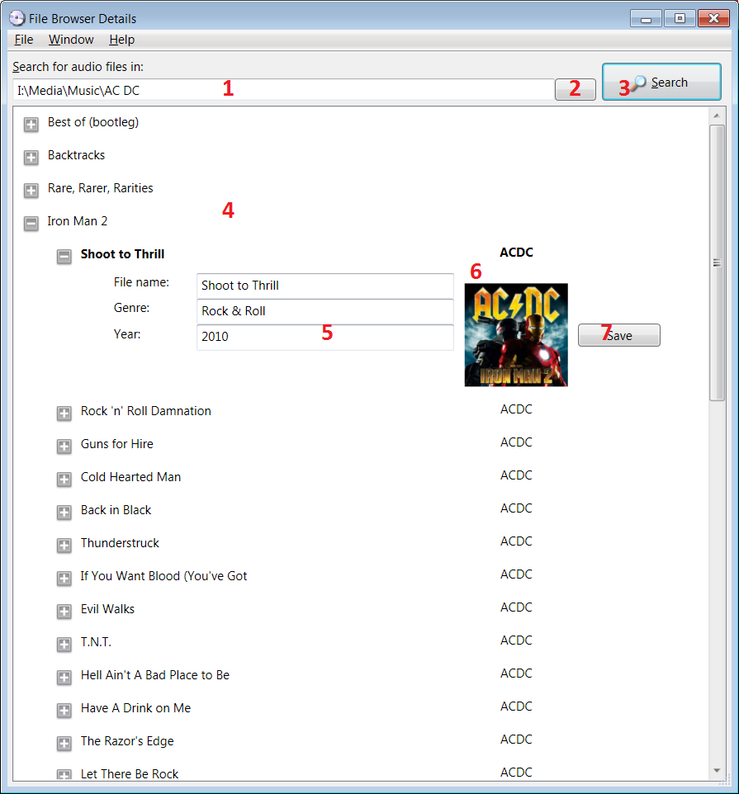

File Browser Detail window contains following navigation controls:

[1] Search Directory Text Box
[2] Open File Explorer Button
[3] Search Button
[4] Tree View Component Area
[5] One Track ID3 Tag Information
[6] Album Art File Information
[7] Save Button

Type path directly into the [1] or click on the [2] to display standard File Explorer, where directory which will be used for album search, could be selected.

Click on the [3] to start album search.

In the [4] found albums will be displayed in expandable hieararchical structure. On the first level is album, on the second level is single track and on the third level there are ID3 tags for this track.

To update ID3 tags for given file edit appropriate text boxes in the [5] and after every necessary changes are done, click on the [7] to write all changes back into file.

[6] contains album art cover which is stored in ID3 tag information of the track. If there is no cover, this area is empty.

