Car Rental App

Use-Case Model

Version <1.0>

Revision History

|  |  |  |  |
| --- | --- | --- | --- |
| **Date** | **Version** | **Description** | **Author** |
| 22.03.2023 | 1.0 | Sketching initial use-cases and detailing a few of them | Cornea Mihai |
|  |  |  |  |
|  |  |  |  |
|  |  |  |  |

Table of Contents

1. Use-Cases Identification 4

2. UML Use-Case Diagrams 4

# Use-Cases Identification

[Identify actors, scenarios and use cases. Describe the three most important use-cases according to the following format

Use case: Rent a car

Level: User-goal level

Primary actor: Customer

Main success scenario:

Customer opens the car rental app and searches for available cars based on location and date/time.

App presents a list of available cars with details such as make, model, price, and features.

Customer selects a car and chooses the rental period.

App prompts customer to provide their driver's license information and payment details.

Customer inputs their information and confirms the rental.

App confirms the rental details, including pickup/drop-off location and time, and provides a reservation number.

Customer picks up the car at the designated location and presents their driver's license and reservation number to the rental agent.

Rental agent verifies the customer's information, checks the car for any damages, and hands over the keys.

Customer drives the car during the rental period.

Customer returns the car to the designated location at the specified time and hands over the keys to the rental agent.

Rental agent checks the car for any damages and confirms the return with the customer.

Extensions:

If no cars are available, the app informs the customer and suggests alternative options.

If the customer enters invalid or incomplete information, the app prompts them to correct it.

If the customer fails to pick up the car at the designated time and location, the app cancels the reservation and charges a fee.

If the customer returns the car with damages, the rental agent assesses the damage and charges the customer accordingly.

Use case: Modify car details

Level: Sub-function level

Primary actor: Admin

Main success scenario:

The admin logs into the car rental app.

The admin navigates to the "Car Management" section of the app.

The admin selects the car they want to modify.

The app displays the current details of the selected car, such as its make, model, year, and price.

The admin modifies the details of the car as needed, such as updating the price or adding a new feature.

The admin saves the changes.

The app updates the car's details in its database and confirms the changes have been made.

The admin logs out of the app.

Extensions:

If the admin enters invalid data when modifying the car details, such as a non-numeric price or an invalid model year, the app displays an error message and prevents the changes from being saved.

If the admin selects a car that is currently rented out, the app displays a message informing the admin that the car cannot be modified at this time.

# UML Use-Case Diagrams

Use-case diagram for the user

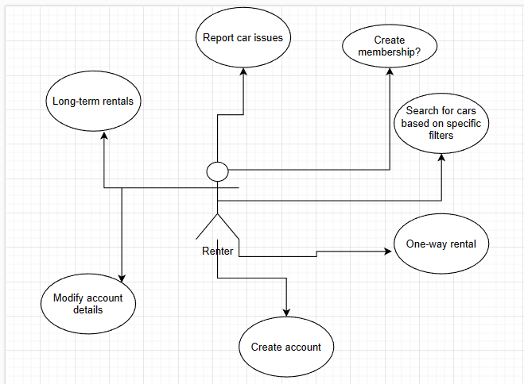

Use-case diagram for the administrator:

