Documentation - PairDO

**The Layout**

The overall layout of the page was inspired by the Featured graphic found on designshack[1]. Over time though the location of some of the elements changed from that original design for example positioning the navigation bar to a similar space as the design lead to the links being difficult to use on a mobile device. After attempting several different ways to style the navigation bar I thought it would be best to separate it from the main content of the page. The HTML for the navigation bar is similar to the horizontal navigation bar taught on w3schools [2] but the width is set to just below a fifth of the page width to make it resize for mobile devices. The text glow that occurs when the text is hovered over is three text-shadow styles with zero offset stacked up behind each other (example is shown in Screenshot below).



The layout of the main content of each page differs from page to page but to display static content I used halfblock and quarterblock divs which allowed me to position content easily on the page. By the time I had put all the content in the Home page and the attractions page used this way of positioning the text. If someone wanted to drastically change the layout of the content this way of formatting would probably need to be changed as while it suited the current sites layout it is not very flexible.

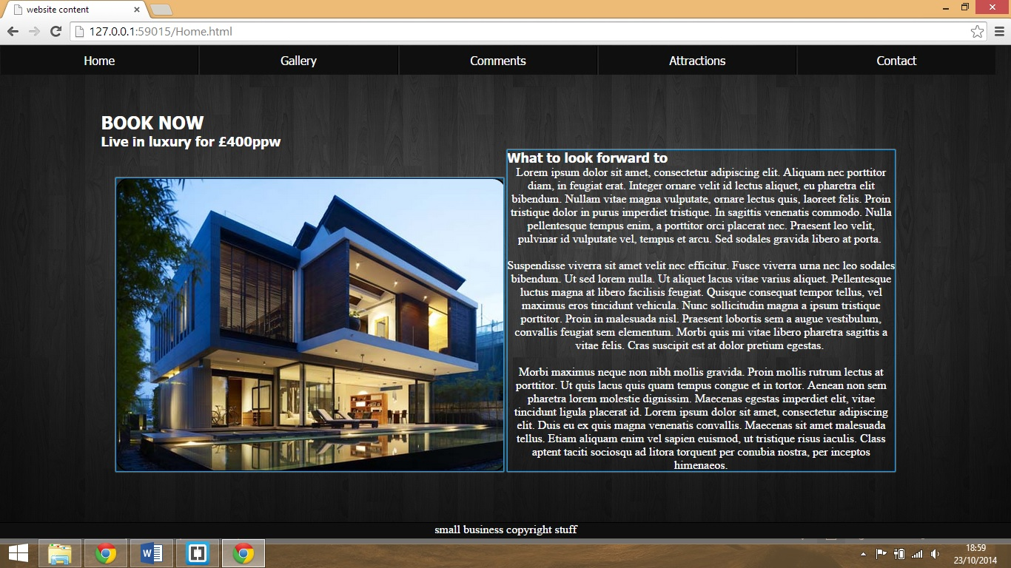

The blue squares represent the quarter blocks that are used in the site. They are designed to fit 4 into the viewport but will stretch to fit the contents height.

**Gallery**

The gallery page is formatted using a list and each item in the list consists of an image and a caption. Each list item is given a large negative right margin and the list word-space property is set to no wrap, these two things together mean that the browser will present the images in one line even if it goes off the screen. By setting the galleries overflow property to scroll we can use this to make a scrollable gallery with images and captions.

The gallery style sheet also contains formatting for the lightbox that the gallery uses. The lightbox uses the onclick attribute attached to an image so that the image can call a JavaScript function and pass itself through to the JavaScript as an image object. The JavaScript then takes the source from the image and inserts into a small section of html which is appended to the end of the body of the webpage. A lightbox image is absolutely positioned in the center of the webpage which places it above the rest of webpage, a semitransparent background is set to make the rest of the webpage appeared dimmed. The JavaScript also checks to see if the html has already been appended and if it has all the JavaScript does is change the img tag inside the inserted html. Once the lightbox is being displayed the entire webpage has an onclick function to hide any output resulting from the lightbox html.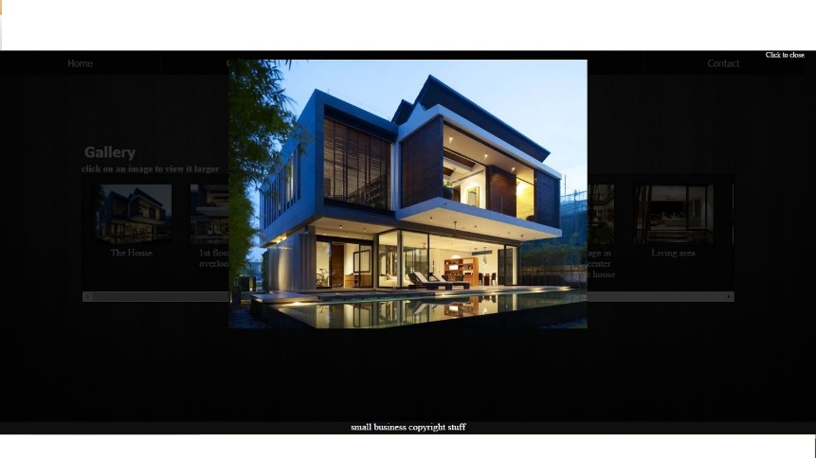

**Attractions page**

The attractions pages uses the same half and quarter block model as the home page to layout each Attraction. At the top of the page there is a google map that is inserted using an iframe and the google embed maps API [3]. The source for the iframe is a link to the google embed website that sets the map mode to search and then searches for attractions round the postcode of the holiday home. If given more time to learn and implement the JavaScript the map could be implemented in JavaScript. This would add a lot more flexibility to the map such as having dynamic directions from the viewer’s location and having these directions as well as the surrounding attractions from the home. The iframe also doesn’t function very well on old versions of internet explorer. The map cannot be dragged and clicking on it takes the user off the website and straight to the google maps page.

**Mobile**

On mobile the website retains most of its formatting as it is on PC as most sizes are don’t in percentages. The navigation bar requires the user to zoom in on a mobile but as the links in the navigation bar cover the entire block the text is in it is still possible to use navigation without having to zoom in too far. There are two formatting issues that may frustrate mobile users, the first will annoy users on very small screens and is the fact that the image in lightbox resizes to fit the phone whenever the user zooms in, this meant that they cannot zoom in on the image to view certain areas of it.

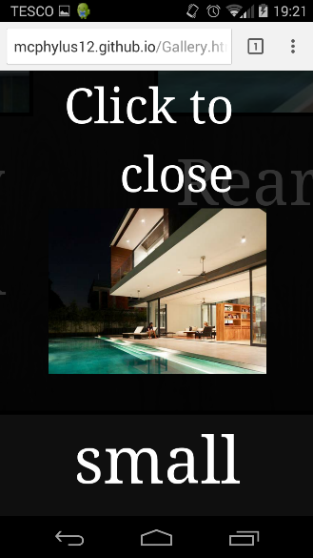   
As you can see from the image the text is large as the user has zoomed in but the image has still scaled to fit the phone.

I do not know exactly why this is happens but I assume it’s because the image is positioned absolutely within the browser. The second issue is that on the homepage the picture of the house sticks to the bottom of its quarterblock, this causes the image to appear at the bottom of the page and on tablets and mobiles orientated landscape it is not visible unless the user scrolls down.

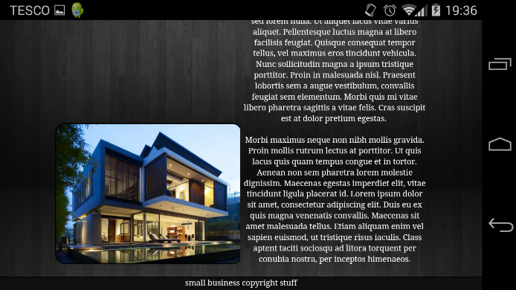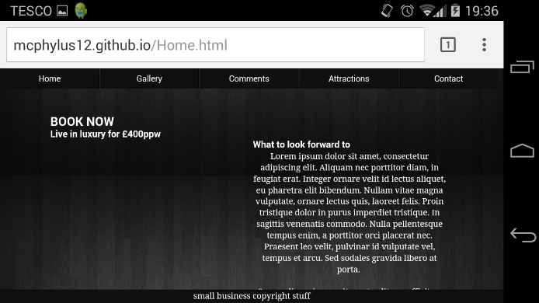

As you can see the image is level with the bottom of the text and so it is not visible on the other screen.

This is what greets a user using a landscape orientation

**Comments**

The Comments page is the least functional on the website. The page consists of a small form and an empty comment block. The user can enter their name or an alias as well as a comment and submit them to the website. As the comments page uses JavaScript to submit comments the comments the user submits are only viewable on their own machine. This makes the comments practically useless as the user will know their own comments and will be viewing the webpage to view other comments. With more time and knowledge the first priority for updating the website will be adding an action page and making use of a server side scripting language to move the storage of comments to the server. This would mean that all users could view each other’s comments and the comments page would be worth viewing.

An issue that I have not been able to solve is the text that appears and the bottom of comments once one comment has been submitted. The text says null and is probably the result of accessing an empty localstorage object but even with checks in place the text still appears.

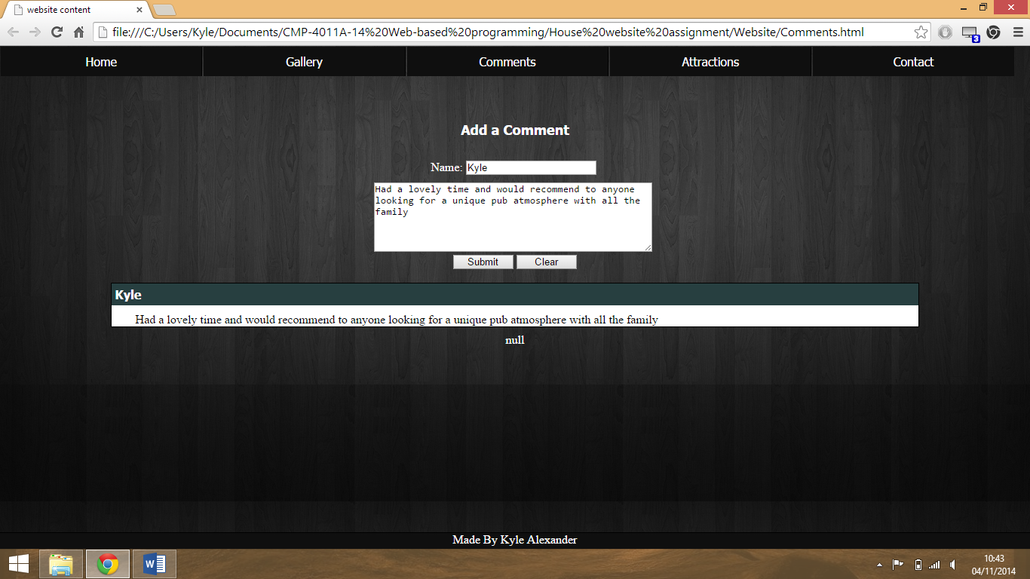

The null that appears whenever a comment is present

**Limitations**

The overall website has a few drawbacks for both PC and mobiles. The most noticeable one will affect anyone on a slow connection and is that the background image is large. This will mean that on slow connections the user will be able to see the image load in top to bottom and on the larger webpage they can see the vertically repeated tiles load in separately. This is only an issue for someone loading the page initially and as the image is loaded in from a style sheet and persists as long as they are on the website.

Another issue is that the google map on the attractions page doesn’t function on older browsers. The problem with this is that when first going on to the page the map looks fully functional but if the user tries to drag or click on something instead of doing what the user would expect it just takes from the website to the google maps website. This will annoy users as the google maps page offers no way to get back to the website and the user will have to use the back.

Several features on the website rely on JavaScript and the website will not nearly be effective. If the user enters the site using the root directory a webserver would send them to index.html. On this site index.html uses JavaScript to automatically redirect the user to home.html. This means that if the user does not have JavaScript enabled they will not be redirected anywhere. To inform the user of the fact they have JavaScript turned off there is a message on index.html informing as well as a manual link so they can view the webpage anyway.

**Inspirations**

Several styles that can be found on the website take inspiration from similar ones found on the internet. A good example is the navigation bar’s positioning which was inspired by the bootstrap navigation bar [4]. There is also the main page which takes the idea of having a single large image on the homepage to immediately show the user what the websites product is [1]. The website was initially designed to steer away from conventional 3-column and 2-column designs and make use of the width of the page. This means that on mobile the website functions better when orientated landscape but there are styles in place to style the website to fit a portrait display. The initial design was laid out with the assumption that the webpages content could be kept on a single pane and no scrolling would be needed. This fit better with the single large background but as the comments and attractions pages grew larger resulting in scrolling this meant the large background didn’t look as good as it otherwise would have.

References

[1] <http://designshack.net/articles/layouts/10-rock-solid-website-layout-examples>

[2] <http://www.w3schools.com/css/css_navbar.asp>

[3] <https://developers.google.com/maps/documentation/embed/guide>

[4] <http://getbootstrap.com/examples/navbar-static-top>