|  |  |  |  |  |  |  |
| --- | --- | --- | --- | --- | --- | --- |
| **Algorithm** | **Open / Closed List Type** | **Heuristic** | **Opened Nodes** | **Explored Nodes** | **Fill** | **Time (s)** |
| A* | Simple Unordered List | Zero | 166 | 145 | 155 | 2.968 048 |
| Euclidean | 70 | 34 | 59 | 0.768 713 |
| Gateway | 52 | 27 | 41 | 0.625 854 5 |
| A* | Node Record Array | Zero | 166 | 145 | 155 | 3.012 6 |
| Euclidean | 36 | 12 | 25 | 0.288 713 5 |
| Gateway | 40 | 13 | 28 | 0.358 543 4 |
| Node Array A* | Node Record Array | Zero | 166 | 145 | 155 | 2.986 528 |
| Euclidean | 36 | 12 | 25 | 0.364 927 3 |
| Gateway | 40 | 13 | 28 | 0.311 508 2 |

Using A* with Simple Unordered List and Zero Heuristic:

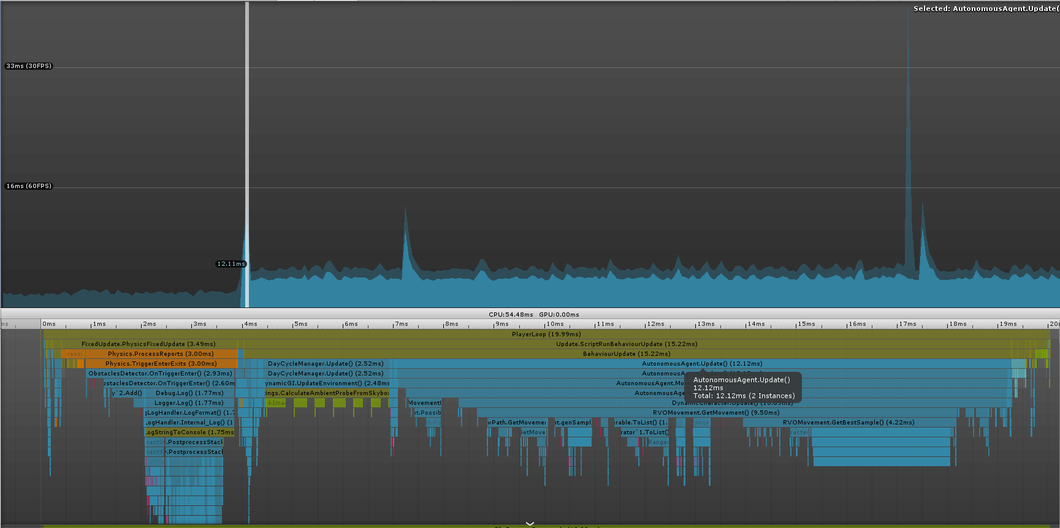

Using Node Array A* with Node Record Array and Gateway heuristic:

