PROJECT TITLE
On: 2026-09-09

Smart Plant Watering System Using ESP32 and Blynk IoT
Project Report
CSE 342: IoT based Project Development
School of Science, Engineering and Technology,
East Delta University
Submitted By:
Md.Abrar Hossain (232006512)
Hrishika Dhar Tisha(232008312)
Saiada Tun Nesa(232008612)

Abstract
Smart Plant Watering System Using ESP32 and Blynk
This project showcases the structural design and implementation of a smart plant watering system using ESP32 with Wi-Fi micro-controller using Blynk internet of things (IoT) web platform which can achive remote control and automated controlled irrigation. The project’s primary goal is to build an energy-effective system which is also a cost-effective solution for changing a normal garden into a self regulating and smart echo-system. The system’s design is built with a soil moisture sensor for obtaining uninterrupted data, then utilizing a water pump, a relay module supplies water to the plant. Main procedure involves programming the ESP32 to perform an algorithm, which is closed-loop controlled algorithm, it will read the soil moisture data, to make real-time decision for pumping water while communicating this information wirelessly. The Blynk IoT Cloud, which provides a cohesive user experience via the web dashboard and mobile application which is essential to the design. This allows users to check real-time humidity and moisture percentage. This hybrid control system encourage the saving of water while guaranteeing the best possible plant health. The finished system demonstrates a dependable and reliable prototype. Showcasing an effective and useful use of IoT concepts in environmental management and Home Automation.

1 Introduction

1.1 Problem Statement
The main problem addressed by this project is the inefficiency and the inconsistency of manual plant watering practices which is resulting into a negative outcome on plant health and water utilization. Current methods like the accuracy required to pump water only when the moisture level detects it. This highlights the lack of independent data driven system. Therefore, this project intends to develop a solution that consistently monitors the soil moisture, intelligently controls a water pump and provides instant feedback with remote control capabilities via a unified IoT Platform.

1.2 Scope
This project is concentrated, therefore, on designing, building, and functionally testing a prototype smart plant watering system. It uses an ESP32 for processing and also for Wi-Fi connectivity. It is then connected to one soil moisture sensor for input and a relay operated mini water pump for watering. Blynk IoT platform handles the control and remote monitoring of the plants. This project does not include critical features like controlling multiple plant zones, combining weather APIs, or performing compound self diagnostic’s beyond simple error handling.

1.3 Outcomes/Objectives
This project’s primary goal is to develop a smart plant watering system that can either operate autonomously by using real-time sensor data to determine when to water the plant or allow the user to observe the data and perform the task manually. The goal is to ensure the system easily connects to a local Wi-Fi connection. This would let the user control the water pump remotely and check its status with a certain smartphone application known as Blynk.

2 Analysis and Design

2.1 Analysis
This project concentrates on automating the monitoring and watering process of plants using IoT technology. The system will accumulate some decisive parameters like as soil moisture, temperature, and humidity and mechanically control a water pump based on these data. In addition, users will be notified via a mobile interface whenever the plant needs water or when the watering is complete.
The analysis focuses on three main features:
Sensor Data Collection: Using DHT11 and Soil Moisture Sensor to measure atmospheric conditions.
Automation Control: Using ESP32 and a relay module which controls the water pump.
User Interaction: Allowng manual pump control and viewing of plant data through a web or mobile dashboard.
This system reduces human dependency on plant care and ensures an optimal watering environment for plant growth.

2.2 Problem Statement
Over-watering or under-watering of plants is a common incident in the case of watering them manually, especially when the owners are away from home. Sometimes, people even have to give their house keys to neighbors to water the plants in their absence. This is where the need for an automated system arises, one that can monitor the state of the plant’s soil and water it accordingly, while also updating the user with real-time status and manual control options.

2.3 Requirement Analysis
Requirement Analysis for Smart Plant Monitoring System
Type | Requirement | Description
Hardware | ESP32 DevKit V1 | Main microcontroller to process sensor data and control the pump
Hardware | Soil Moisture Sensor | Detects soil water level
Hardware | DHT11 Sensor | Monitors temperature and humidity
Hardware | Relay Module | Switches water pump ON/OFF
Hardware | Mini Water Pump | Provides water to the plant automatically
Hardware | Breadboard + Jumper Wires | For circuit prototyping and sensor connections
Software | Arduino IDE | To code and upload program to ESP32
Software | Blynk / Web Dashboard | For user notifications and manual pump control
Functional | Automatic Watering | Pump turns ON/OFF based on soil moisture level
Functional | Manual Control | User can override pump through app
Functional | Notification System | Sends alerts when water is needed or watering is done
Functional | Data Monitoring | Displays real-time temperature, humidity, and soil moisture

2.3.1 Use case
Use Cases for Smart Plant Monitoring System
Use Case ID | Actor | Description | Expected Outcome
UC-01 | System | Reads level of soil moisture | Gets current soil condition
UC-02 | System | Checks if moisture is greater than the threshold | Decides if watering is needed
UC-03 | System | Turns water pump ON | Starts watering
UC-04 | System | Stops pump when moisture is less than threshold | Prevents overwatering
UC-05 | User | Views expected data | Monitors temperature, humidity, and soil status
UC-06 | User | Manually controls pump | Overrides system decision
UC-07 | System | Sends notifications | Informs user of plant status

2.4 Hardware Description
ESP-32 Model (Dev-kit V1): The ESP-32 Dev-kit V1 is a microcontroller board which features built-in connection of Wi-Fi and Bluetooth. It is consisted of dual-core processing and GPIO pins, which makes it perfect for IoT projects that needs wireless communication and real-time data processing.
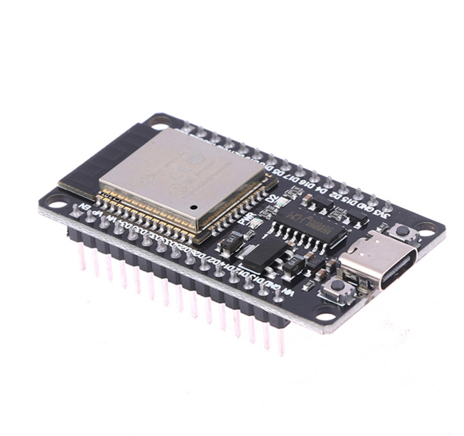
ESP-32 Model(Dev-kit V1)
ESP-32 Adapter: The ESP-32 adapter features an easy way to connect the ESP-32 board to external devices. It works with powering the module, control voltage, and makes sure that connections are reliable during sensor interfacing.
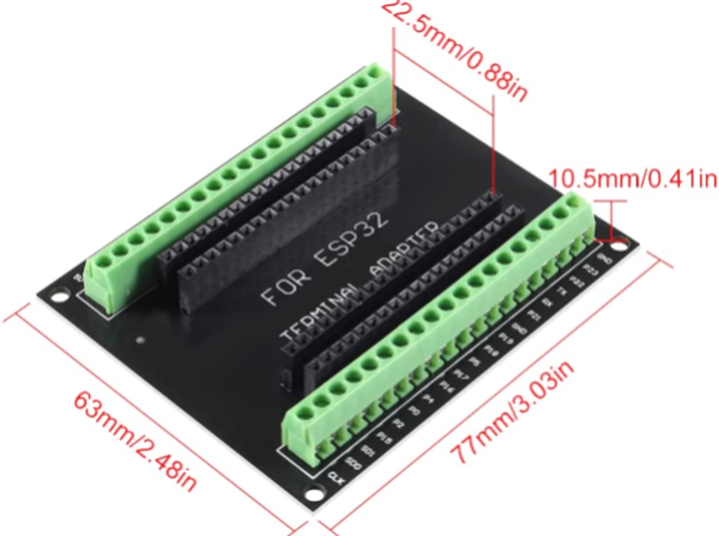
ESP 32 Adapter
Soil Moisture Sensor: The soil moisture sensor measures the amount of water present in the soil. It determines whether the soil is dry or wet by configuring the electrical resistance between its nodes, allowing the system to automatically water the plant based on the conditions of the soil.
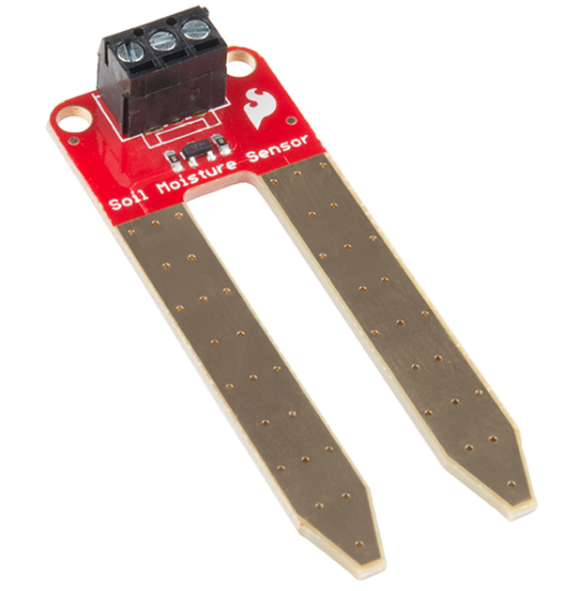
Soil moisture sensor
DHT11 Sensor: The DHT11 is a temperature and humidity sensor that provides adjusted digital result. It is used to compute the environment’s air’s humidity and temperature and sends the information to the ESP-32 for processing and control in monitoring projects.
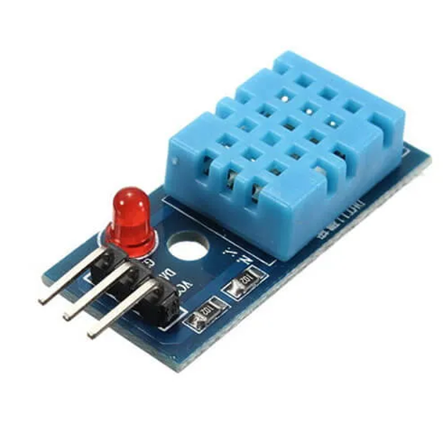
DHT11 sensor
LCD 12C Monitor (12C LCD Display): The 12C LCD display is a 16x2 character screen that works by the I2C communication protocol, which requires two data lines only (SDA and SCL). It will be used to show sensor data like temperature, humidity, or soil moisture in real time.
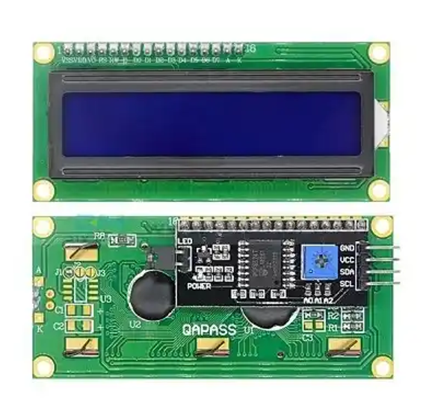
LCD 12C Monitor
Breadboard: The breadboard is a reusable board that is used for building and testing electronic circuits without brazing. It lets the components and jumper wires to be carefully connected, modified, or removed during the prototyping phase.
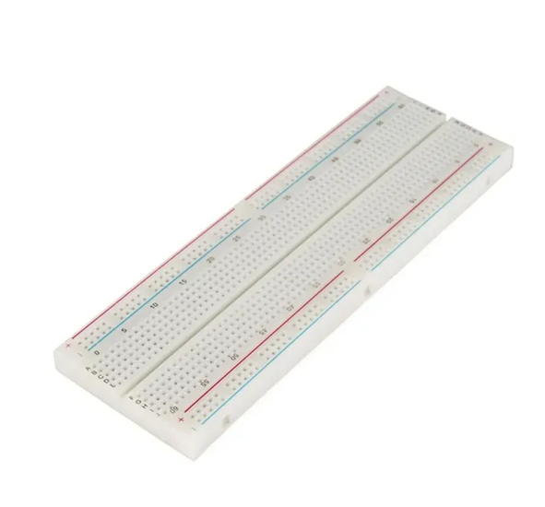
Breadbord
Water Pump: The water pump can be used for controlling the water flow in the irrigation system. It can be turned on automatically by the ESP-32 if the moisture level of soil falls down a certain threshold, making sure of proper watering of the plants.
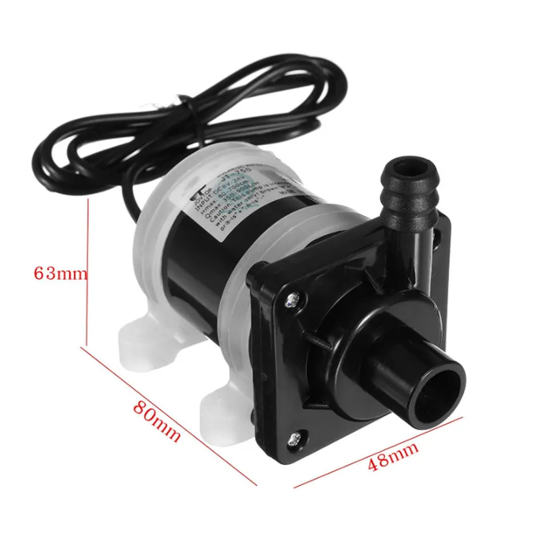
Water pump
USB Cable: The USB cable connects the ESP-32 board to a power source, in this case,which may be a computer. It is used for programming the ESP-32. It also supplies power to the circuit during testing and operation of the program.
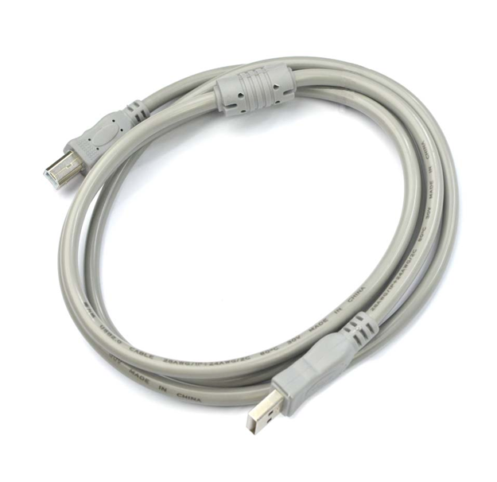
Usb Cable

3 Implementation

3.1 Requirements
An ESP32 is required in the system as the central controller. A soil moisture and temperature-humidity sensor (DHT11) provides environmental data, while a mini water pump is controlled by a relay module for automated watering. On the software side, for uploading the firmware, and coding, the Arduino IDE is used. Lastly, the Blynk app enables real-time monitoring and controlling from a mobile device.
All components are powered through a 5V DC supply.

3.2 Data Details
The system constantly gathers and interchanges sensor data to make valid decisions. The soil moisture sensor generates analog measurements from 0 to 1023, which represents the dryness or wetness of the soil. The DHT11 sensor gives temperature (°C) and humidity (%) readings, which helps us to decide environmental conditions that can affect soil moisture.
All sensor data is processed and oraganaized by the ESP32 and transmitted to the Blynk IoT Cloud. If the moisture level drops below 30%, the system sends a notification to the mobile, saying “The plant needs water” and automatically turns on the water pump. When the percentage of humidity hits 70%, a "Watering Finished" message is displayed and the pump is shut down automatically. The Blynk app allows the users to control the pump manually also, providing additional functionality.

3.3 Method
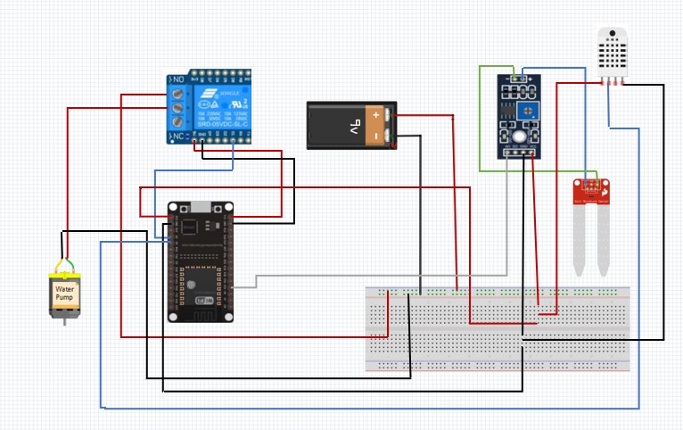
Circuit Diagram
The process of implementation of this project involves hardware installation, software coding, and cloud interfacing.
Hardware Setup: The ESP32 is interfaced with the Soil Moisture Sensor and DHT11 Sensor to collect environmental data (humidity, temperature, etc.).
Programming: The Arduino IDE is used to program the ESP32. Threshold values for soil moisture and temperature are defined in the code, and Wi-Fi credentials are to be configured for cloud communication.
Integration with Blynk IoT: The Blynk platform is set up with a dashboard containing widgets to show soil moisture, temperature, and humidity values. Control buttons are added to manually control the water pump.
Testing: It involves implementing various tests on a system to establish thresholds for soil moisture.
Deployment: This equipment will be installed alongside the plant, with a connection of the water level. Once it has been turned on, it automatically monitors, notify, and regulates the water supply.

3.4 Evaluation Measures
The Smart Plant Watering System is tested based on the following criteria:
Sensor Accuracy: To ensure sensor accuracy, compare soil moisture, humidity, and temperature values with manual measurements.
Reliability of Automation: Monitoring the time and consistency of pump activations and deactivation using sensor inputs.
Network Responsiveness: Delay between cloud updates and physical actions (like activating the pump) prompted by the Blynk mobile app.
User Control Efficiency: Optimizing user control efficiency by ensuring manual control override over automation where relevant.
Power and Component Stability: Monitor system stability over time to ensure sensors and pumps are operating properly.
Effective implementation leads to a system that optimizes soil moisture, minimizes water waste, and provides real-time monitoring and control.

4 Conclusions
A smart plant watering system checks temperature, humidity, and soil moisture to support plants healthy growth. When the soil is dry, the system automatically irrigates the plant and can be remote controlled using the Blynk app. Its most impressive feat is bringing automated irrigation, real-time environmental monitoring, and mobile Wi-Fi based control into a single device. Because of these, it is an effective and modern way of taking care of plants indoors and outdoors. With further development, this technology can be the ideal smart gardening practice that is able to sustain a high number of plants using sophisticated data analysis and irrigation.

4.1 Achievements
This project achieves complete realization of sensor and automation integration in maintaining plant health with low human intervention. One of the greatest achievements is the use of the ESP32 in real-time communication and management using the Blynk IoT platform. This system collects atmospheric data using the Soil Moisture Sensor and DHT11 Sensor and activates the Mini Water Pump when soil moisture falls below a predetermined level. The system gives alertness to the phone of the user, enabling them to remotely monitor and control. This technology offers an efficient and cost-effective solution for smart plant medicine. These results demonstrate that a straightforward, low-budget setup can accomplish genuine automation with no necessity of advanced machinery or heavy cost.

4.2 Recommendations
Though the Smart Plant Watering System achieves its primary goals, it can be further improved. The addition of more precise sensors, such as capacitive moisture and light sensors in the soil, can enhance the integrity of the data. Integrating AI and machine learning technology will enable the system to change its watering regimes based on atmospheric conditions as well as plant species. Integration with solar power can enhance the environmental sustainability and performance of the design in outdoor environments.
SriTu Hobby. “How to Make a Plant Watering System with ESP32 Board and Blynk App.” SriTu Hobby. Accessed [17th Octobar, 2023]. https://srituhobby.com/how-to-make-a-plant-watering-system-with-esp32-board-and-blynk-app/

