**CUSTOMER RELATIONSHIP MANAGEMENT**

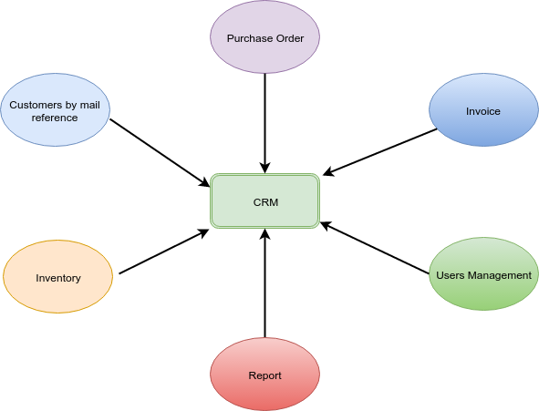

Customer relationship management (CRM) is use to manage and analyze customer interactions and data throughout the Customer life-cycle with the goal of improving customer service relationships.

**CRM Process Flow**

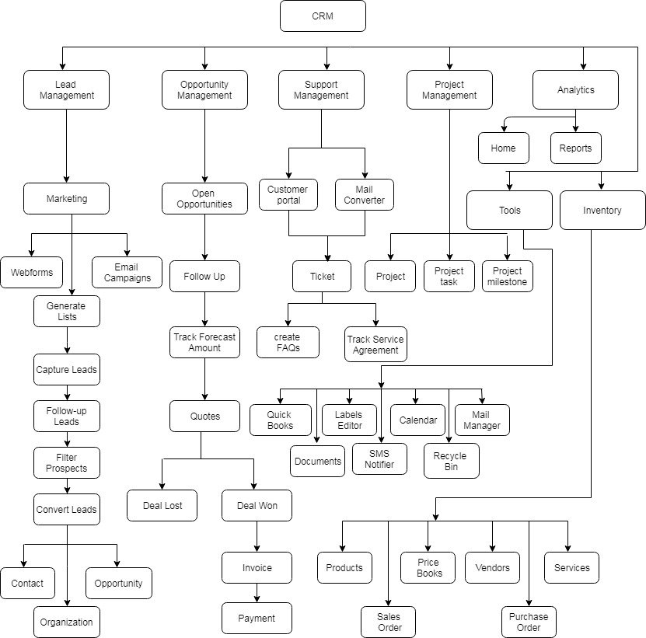

**Leads:**

Leads are the details gathered about an individual or representatives of an organization. They play a very important role in an organization’s Sales & Marketing department and useful in identifying potential customers. A Lead record maintains information of a person, and the company he is associated with.

You might generate Leads from trade shows, purchase lists, advertisements, websites, business cards, or through a referral.

In CRM, lead details contain a combination of company (account), person (contact), and business opportunity (potential), depending on your CRM requirement – for managing Business to Business (B2B) industry or Business to Consumer (B2C) industry.

**Leads Process Flow:**

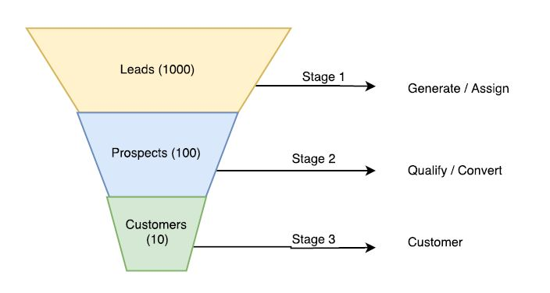

**Contacts:**

Contact can be represented as a qualified sales lead. Contacts differentiate qualified customers from the huge list of unqualified customers. Contacts also represent the people that are conducting business with you. In Business-to-Consumer (B2C) scenarios, contact is the most important information for acquiring customers, whereas in Business-to-Business (B2B) it is a part of the organization details with which you are doing business.

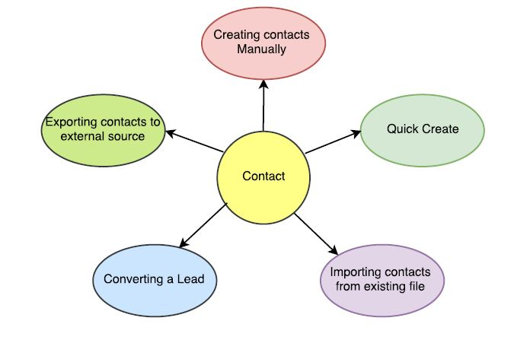

**Organization:**

Organization represents a company or an institution that has multiple employees associated with it. Contacts, as in employees, can be directly related to an Organization record. Organization need not always be a existing customer.  You will track the business deal through Opportunities. In a typical B2B organization all deals have to undergo a complete sales cycle, which starts with identifying the hot prospect and ends with prospects being won or lost.

**Opportunity:**

Opportunity represents prospect with plentiful chances of generating revenues. Opportunities provide strategy to follow up prospective customers who are likely to successfully finish the sale. It helps you track the potential of prospects through the sales cycle. Customers who are very likely to purchase your product can be termed as Opportunities. The journey of sales process may begin at different stages

* Creating Opportunity for a Lead
* Creating Opportunity for an existing Contact / Organization
* Creating Opportunity for a New Customer.

**Invoice:**

An invoice, or a bill, is a non negotiable itemized statement issued for the Products and Services rendered to the customer. It contains

* Products or Service details
* Prices and Taxes
* Dates
* Parties involved
* Address information
* Terms and Discounts
* Payment methods

**Quotation:**

A Quotation is a formal statement issued by a seller to the prospective buyer; basically, upon inquiry or request for a quotation.

**Inventory Management:**

**Price Book:**

Price Books gives you the ability to attribute different prices for products. As it gives control over the pricing, you can vary prices at any time; As a result, you can always offer best price to delight your customers.

**Vendors:**

Vendor is a person or organization that supplies Products or Services to your company. Vendor can also be a manufacturer or a re-seller.

**Sales Orders:**

Sales Order is an internal document generated within the company after the Purchase Order is received. It helps your sales team track all the Products or Services that should be manufactured, shipped etc according to the agreed prices and dates. It contains

* Sales Order Number
* Purchase Order
* Recurring invoice
* Billing and Shipping Address
* Products or Services
* Prices and Taxes

**Purchase Order:**

A purchase order is a legal document handled over to a vendor to purchase Products or Services. It contains

* Purchase order number
* Vendor details
* Product or Service details
* Terms and Conditions
* Prices

**Products:**

Products represent stock of goods in your Inventory. Products can be either procured from your suppliers or rendered to your customers depending upon nature of your Organization.

**Customers:**

The companies use to manage and analyze customer interactions and data throughout the customer lifecycle, with the goal of improving business relationships with customers, assisting in customer retention and driving sales growth. CRM systems can also give customer-facing staff detailed information on customers' personal information, purchase history, buying preferences and concerns.

**Services:**

Services refer to the free or paid assistance you would offer to benefit your customers. In general, services are non-stock items rendered to your customers. Services do not have bundles.

**Receiving:**

Receiving and processing customer orders efficiently and thoroughly is essential to any business operation – indeed it’s the core of your revenue stream. Yet processing sales orders is traditionally one of the biggest bottlenecks in an organization, often with little communication between the home office where the orders are received and the warehouse where the orders are fulfilled. Even the data entry associated with orders can be a cumbersome and time consuming process.

**Analytics:**

**Home:**

Home page widgets will provide graphical representation of current status and key performance indicators. As complete analysis of data is displayed on one single screen, decisions and conclusions can be monitored at a glance.

**Reports:**

Reports provide your sales team the ability to extract only data relevant to them from thousands of records. You may use these report features to get an overview of customer related activities and to draw conclusions on how to improve your sales process.

**Campaigns:**

Campaigns offer your marketing team the ability to schedule and execute mass marketing campaigns.

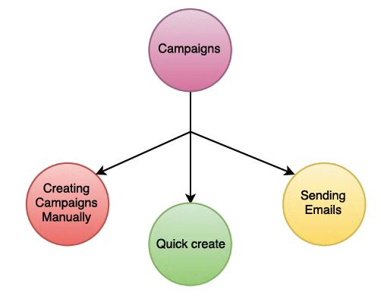

**Project:**

Project is a planned work that involves specific goals, start date and target end date, budgets, progress etc. Comments will help you to collaborate among users.

**Ticket:**

Tickets, also called as Cases, are post-sales support requests generated by your customers. It offers your sales team the flexibility to create, communicate, edit, and close the case after the right solution is delivered to your customers.

**FAQ:**

FAQ acts as a repository for all questions frequently asked by your customers as well as internal team members It will be a hassle for your support team to provide same solution repeatedly. You can either convert Tickets into FAQs or create new FAQs and share with your customers and internal team as well.

**Asset:**

Assets are tangible or intangible resources that are rendered to your customers. When products are shipped to customers, information of individual product item like: Product Number, Serial Number, Date Sold, Customer Name etc are stored in CRM as Asset records. With Assets, it becomes easy for your support center to audit individual product items, and cases resolved upon them.

**Service contracts:**

Service Contract is a negotiated agreement for the products rendered to your customers. As per the agreed contracts, your support center is supposed to offer service for the product for agreed period of time. It boosts level of customer satisfaction and builds healthy trading relationships.

**Tools:**

**Mail Manager:**

Mail Manager is an integrated email client that allows users to perform CRM related actions on incoming email. It helps you create Leads, Contacts, Organizations, Tickets and To Dos from the emails that you receive in your inbox. Should sender's email id match with a record in CRM, you can perform more actions like, attaching email, adding to do, Comment and Ticket. Additionally, you can manage composing, replying, forwarding emails etc.

**Calendar:**

A typical day of a sales person includes managing, tracking and following up activities that are scheduled to be done on present day. You can do all that with one single Calendar application in CRM.

**Documents:**

Documents are the files you save in CRM. You can either upload files directly or provide an external link to download the file again. Files can be classified by grouping them under different folders.

**SMS notifier:**

This feature gives you the flexibility to send text messages to your customers. You can send text messages to multiple records in one shot. In addition to manually sending out messages, you can also forward automatic notifications triggered by workflows in CRM.

**Module Builder:**

CRM gives you the flexibility to create your own basic module as per your business requirement using Module Builder. You can create a custom module, add custom blocks & fields to it and create relationships with other modules.

**Email Campaigns:**

The email Campaigns feature helps you to create email campaigns and send beautiful email templates to the selected list of subscribers. Additionally, the email results — clicks, opens, unsubscribe, bounces — are tracked and measured on an engagement scale to help you identify your customers' areas of interest. CRM application with email campaigning abilities helps you close more deals in less time.

**Social Module:**  Tracks social media activity of your audience, such as, likes and dislikes comments, mentions, and shares. It can also be a part of campaign management or sold separately.

**Customer Link:**

<https://tgsolutions.com.sg/cmslogin/>

<http://inoble.in/ino_crm>