
American International University- Bangladesh (AIUB) Faculty of Engineering (EEE)

Course Name: |  | Microprocessor and Embedded System | Course Code: | EEE 4103
Semester: |  | Spring 2022-2023 | Sec: | I
Faculty: |  | Ali Noor
Capstone Project Title: |  | Human Following Robot
Project Group No. |  | 04
 | Student ID: |  | Student Name:
1. | 20-41898-1 |  | Md.Asifur Rahman
2.
3.
4.
5.
6.
7.
8.

Assessment Materials and Marks Allocation:
Cos |  |  | Assessment Materials | POIs | Mark s
CO4 | Project report |  |  | P.d.1.C5 | 5

COs-  POIs | Excellent [5] | Proficient [4] | Good  [3] | Acceptable [2] | Unacceptable [1] | No Resp  onse  [0] | Secure d  Marks
CO4  P.d.1.C5 | The outcome of project perfectly investigates the design of experiments for  complex engineering problem through appropriate research. | The outcome of project displays impressive  familiarity with good range  of appropriate literature research. | The outcome of project displays familiarity with reasonably full range of literature; demonstrates an appropriate grounding and engagement  with the  literature | The outcome of project does not indicate familiarity with literature; has large gaps and shows little grounding of the capstone in the literature. No  substantive engagement. | The outcome of project does Minimally address research questions and fail to demonstrate its claims persuasively.  structure reflects a lack of organization. | No Resp onse
Comme nts |  |  |  |  |  | Total mark s (5)

Human Following Robot Using Arduino
Ashikur Rahaman Joy¹, Syed Fahim Shahriar², Shakil Barua³, Md. Musfiqul Hasan Miah⁴, Fahim Ahmmed Mojumder⁵, Sayada Tasfiha Rahman⁶, Ishika Ahmed Moon⁷

Abstract— For a robot that performs autonomously, the communication between the person and the robot is the most important factor. A significant awareness has been observed regarding the usage of such a technology. Human following robot is very common in this technology era. Human following is a technique used by robot and autonomous vehicles to follow a human within a specific range. In this case, communication between the human and the robot is the most significant factor where sensor is needed to ensure its successfulness. This paper discussed a human following robot system that utilized ultrasonic sensor. Ultrasonic sensor is preferred for human following robot due to its wide detection area, less light dependency, the ability to detect glass and shining wall, smaller in size, lightweight, use a very low memory, cheaper than Laser Range Finder (LRF) or camera and lower power consumption. detect the human’s leg, and the data collected from the sensors were used upon the design of sensor platform. In order to detect human’s leg, the sensor platform was tested repeatedly to obtain optimum data. The data which have been interfaced with Arduino software. Thus, this paper outlines a set of benchmarks for human following and briefly evaluates its performances. The human following robot was tested in a real laboratory environment. The results were good, where the implementation of this algorithm is able to produce an accurate decision.

Index Terms—Human following, Robot, Sensor, Arduino, Motor, Object detect, Infrared Sensor, Ultrasonic sensor.

I. INTRODUCTION

1.1 Background of Study and Motivations:

Robotic technology has increased appreciably in past couple of years. Such innovations were only a dream for some people a couple of years back. But in this rapid moving world, now there is a need of robot such as “A Human Following Robot” that can interact and co-exist with them. The human following robot is an automotive system that can detect obstacles, move, and modify the robot's position toward the subject in the most efficient manner to stay on track. To accomplish its purpose, this project makes use of an Arduino, motors, and several sensors. To perform this task accurately, robot needs a mechanism that enables it to visualize the person and act accordingly. The robot must be intelligent enough to follow a person in the crowded areas, vivid environment and in indoors and outdoors places.

1.2 Project Objective:

The human following robot is an automobile system that has ability to recognize obstacle, move and change the robot's position toward the subject in the best way to remain on its track. This project uses Arduino, motors different types of sensors to achieve its goal.

1.3 Brief Outline of the Report:

In this project report, we will discuss about the methods and model we followed where process of work, implementation, experiment setup, cost analysis is included. In addition, the results we will be getting from different scenarios where project analysis will have a big contribution.

II. LITERATURE REVIEW
Robotics is an interdisciplinary branch of computer science and engineering. Robotics involves design, construction, operation, and use of robots. The goal of robotics is to design machines that can help and assist humans. Robotics develops machines that can substitute for humans and replicate human actions. Robots can be used in many situations for many purposes, but today many are used in dangerous environments manufacturing processes, or where humans cannot survive. Human following robots is very common in this technological era. Human following is a technique used by robots and autonomous vehicles to follow a human within a specific range. In this case, communication between the human and the robot is the most significant factor where sensor is needed to ensure its success. This paper discussed a human following robot system that utilized ultrasonic sensor. Ultrasonic sensor is preferred for human following robot due to its wide detection area, less light dependency, the ability to detect glass and shining wall, smaller in size, lightweight, use a very low memory, cheaper than Laser Range Finder (LRF) or camera and lower power consumption. However, being a specular type of sensor and not narrowly focused, this can cause wrong estimation and recognition of humans, especially at the legs. Therefore, necessary accompanying algorithms should be developed to encounter this issue. Here, three pieces of 40 kHz ultrasonic sensors are mounted on the four-wheeled mobile robot platform. Ultrasonic sensors are used to detect the human's leg, and the data collected from the sensors were used upon the design of sensor platform. In order to detect the human leg, the sensor platform was tested repeatedly to obtain optimum data. The data which has been collected from the ultrasonic sensor will then be interfaced with Arduino software. Thus, this paper outlines a set of benchmarks for human following and briefly evaluates its performance. The human following robot was tested in a real laboratory environment. The results were good, where the implementation of this algorithm is able to produce an accurate decision.

III. METHODOLOGY AND MODELING

3.1 Introduction

Our project can mainly be divided into two parts- detecting an object and following it. To implement this project, we have followed some specific process and principle. In the Methodology and Modelling part, we are going to elaborate this procedure. How and what strategies were followed and how to get the best result from our project will be illustrated here.

3.2 Working principle of the proposed project

This project was conducted by using some components Arduino Uno R3, Ultrasonic Sensor, Infrared Sensor, Motor Driver Shield L293D, Servo Motor, Bread Board. TT Gear Motor, Arduino UNO - the microcontroller was used to implement this project as it is comparatively cheaper and easy to use. Here, the basic principle was collecting data from the surface using a sensor and following people by ultrasonic sensor.

3.3 Description of the important component

- Arduino Uno R3:

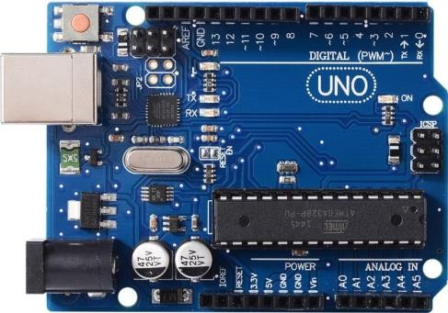
The Arduino Uno R3 is a microcontroller board based on a removable, dual-inline-package (DIP) ATmega328 AVR microcontroller. It has 20 digital input/output pins (of which 6 can be used as PWM outputs and 6 can be used as analog inputs). Programs can be loaded on to it from the easy-to-use Arduino computer program. The Arduino has an extensive support community, which makes it a very easy way to get started working with embedded electronics. The R3 is the third, and latest, revision of the Arduino Uno.

- Ultrasonic Sensor:

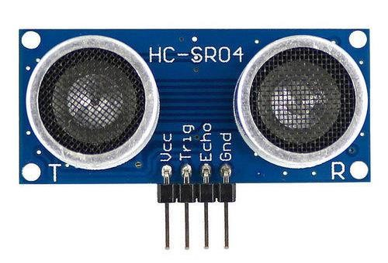

An ultrasonic sensor makes sounds, even when you can't hear it. An ultrasonic sensor makes a sound that humans cannot hear. Humans can hear from 20 Hz to 20 kHz, and the ultrasonic sensor makes a sound beyond our range. Ultrasonic sensors send out a signal (a sound) and then waits for a signal to bounce back. It works just like a bat's ears. The only flaw of the ultrasonic sensor is that if you want an ultrasonic sensor to detect an object that is soft and absorbs, or if it is positioned at a different angle, you may not receive a signal back. Ultrasonic sensors are used on cars, so you don't hit something while parking or driving. For example, when you are too close to another car, you might hear an alarm. That means your ultrasonic sensor senses that a car is too close and is telling to be a bit far away.

- Infrared Sensor:

because of their higher current and power ratings, so motor shields or driver ICs are used instead. These shields or ICs isolate a motor’s power supply and use control logic from the microcontroller circuitry. One of the most popular motor driver shields used with Arduino is the L293D. The full-featured L293D motor driver shield can control up to four bi-directional DC motors with 8-bit speed selection, two stepper motors, and two servo motors.

  - Servo Motor:
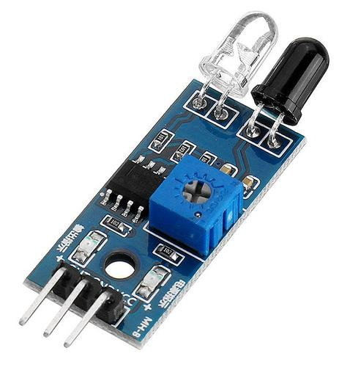
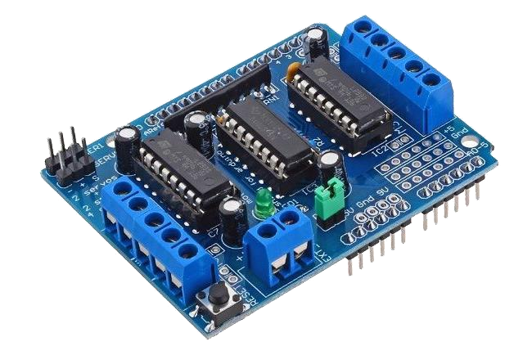
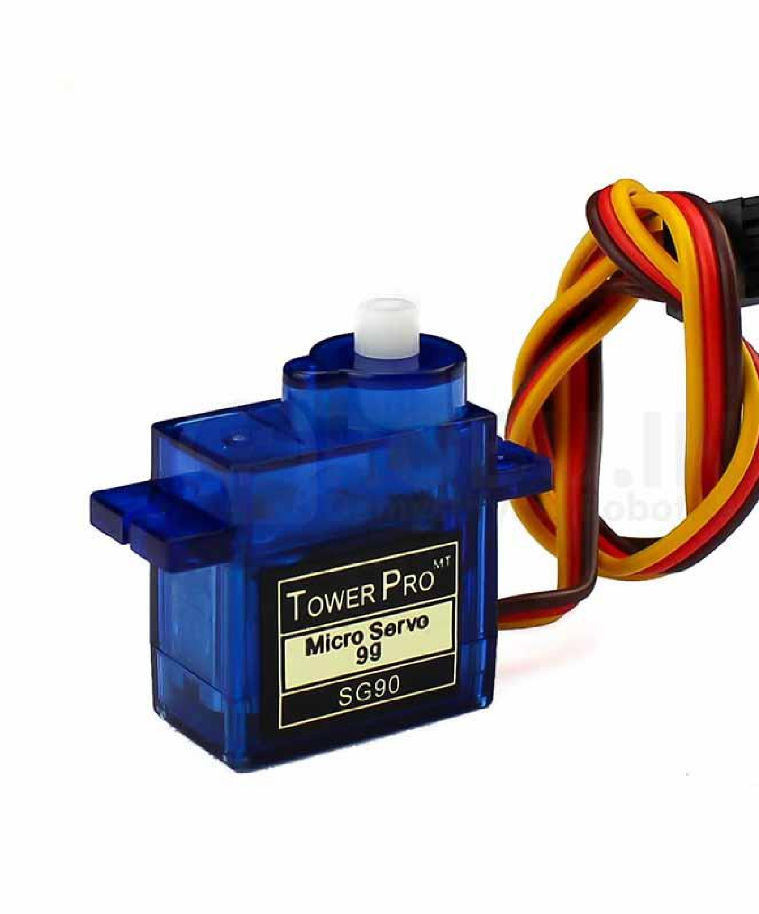

An infrared sensor is an electronic device, that emits in order to
sense some aspects of the surroundings. An IR
sensor can
measure the heat of an object as well as detects the motion.
These types of sensors measure only infrared radiation, rather
than emitting it that is called a passive IR sensor. Usually, in the
infrared spectrum, all the objects radiate some form

of thermal
radiation.

These types of radiations are invisible to our eyes, which can be
detected by an infrared sensor. The emitter is simply an IR LED
(
Light Emitting Diode) and the detector is simply an IR
photodiode that is sensitive to IR light of the

same wavelength
as that emitted by the IR LED. When IR light falls on the
photodiode, the resistances and the output voltages will change
in proportion to the magnitude of the IR light received.

D.
Motor Driver

Shield L293D

A servo motor i
s a type of motor that can rotate with great
precision. Normally this type of motor consists of a control
circuit that provides feedback on the current position of the
motor shaft, this feedback allows the servo motors to rotate with
great precision. If yo
u want to rotate an object at some specific
angles or distance, then you use a servo motor. It is just made
up of a simple motor which runs through a servo mechanism. If
a motor is powered by a DC power supply, then it is called DC
servo motor, and if it i
s AC
-
powered motor then it is called AC
servo motor. For this tutorial, we will be discussing only about
the DC servo motor working. Apart from these major
classifications, there are many other types of servo motors
based on the type of gear arrangement an
d operating
characteristics. A servo motor usually comes with a gear
arrangement that allows us to get a very high torque servo motor
in small and lightweight packages. Due to these features, they

The Arduino L293D motor driver shield guide is a robobtics project that involves driving various types of motors. The most common types used for robotic applications include DC, servo, and stepper motors. However, these motors typically cannot be driven directly by Arduino or another microcontroller. This is

are being used in many applications like toy car, RC helicopters and planes, Robotics, etc.

  - Bread Board:

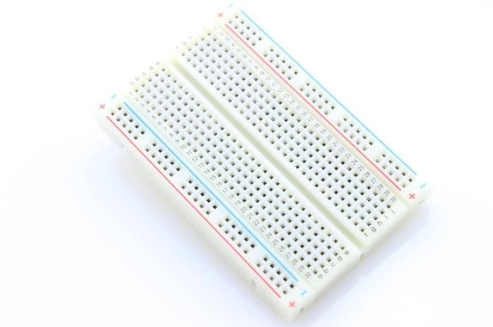

A breadboard is a rectangular plastic board with a bunch of tiny holes in it. These holes let you easily insert electronic components to prototype (meaning to build and test an early version of) an electronic circuit, like this one with a battery, switch, resistor, and an LED (light-emitting diode).

G. TT Gear Motor:

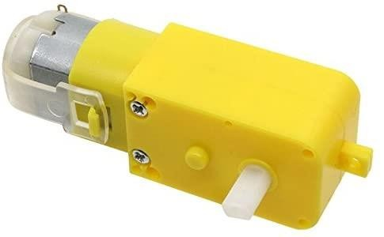

These inexpensive and reliable TT Gear Motors are an easy, low-cost way to get your projects moving. These gear motors require a voltage of 3-6VDC with a no-load current of less than 150mA at 3V and possess a stall torque of 0.8kg.cm at 6V, a gearbox ratio of 48:1, and it comes with 2 x 200mm wires with breadboard-friendly 0.1" male connectors. Perfect for plugging into a breadboard or terminal blocks.

3.4 Implementation:

Our system consists of a four wheels robotic vehicle mounted with a separate microprocessor and control unit along with different sensors and modules i.e., ultrasonic sensor, infrared sensors which helps them to move with respect to people and objects in their surroundings. The above sensors work in unison with each other and helps the robot in its operation and to navigate its path by avoiding the obstacles and maintaining a specific distance from the object. We used ultrasonic sensor for obstacle avoidance and to maintain a specific distance for the object. The ultrasonic sensor works accurately works accurately within a range of 4 meters. This ultrasonic sensor is placed at the top of robot and pair of IR sensors are attached on either side of the ultrasonic sensor. We used ultrasonic sensor for obstacle avoidance and to maintain a specific distance for the object. The ultrasonic sensor works accurately works accurately within a range of 4 meters. Ultrasonic sensors operate by calculating the time differences. Infrared sensors detect the object’s distance with infrared radiations when the beam from transmitter detects an object it returns to the receiver with an angle after reflection also known as method of triangulation this also helps in calculation of distance travelled by robot and eliminate any further error in the robotic movement due to displacement.IR sensor controls the movement of motors and ultrasonic sensor detects the obstacle and stops the motors.

3.5 Test/Experimental setup:

In our system, we used four TT gear motors that are connected with Arduino motor driver shield. A servo motor, Ultrasonic sensor, two infrared sensors also connect with the Arduino motor driver. When the system detects an object on the right side then the wheels will move forward. On the other hand, when an object detects on the left side then the wheels will move backward.
We’ve tested this project three times.

3.6 Cost analysis

We have tried to come up with the total cost to implement this system. There might be some differences in the local market.

Components | Quantity | Cost (TAKA)
Arduino Uno R3 | 1 | 800
Ultrasonic Sensor | 1 | 80
Infrared Sensor | 2 | 70
Motor Driver Shield L293D | 1 | 140
Servo Motor | 1 | 130
Bread Board | 1 | 100
TT Gear Motor | 4 | 400

Wheel | 4 | 50
Car Chassis | 1 | 100
Jumper Wire | 1 | 60
2 Slot Battery  Case | 1 | 30
18650 Battery-2 | 1 | 160
 |  | Total = 2120 Taka
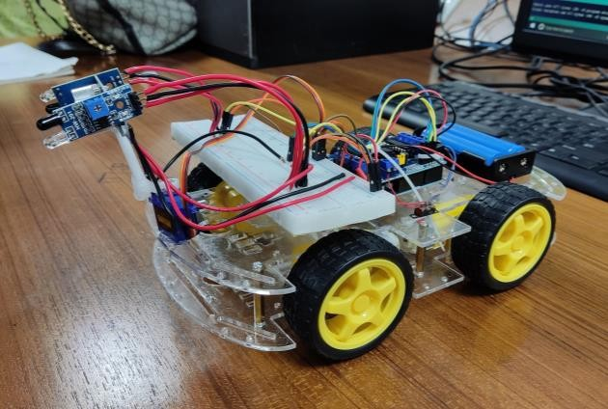
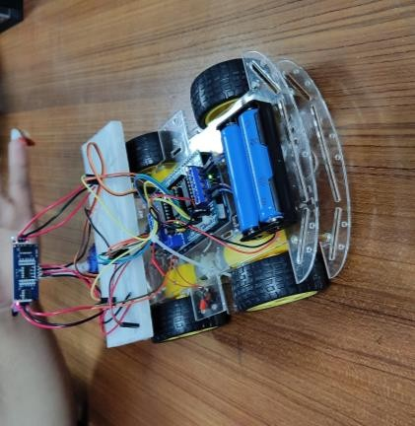
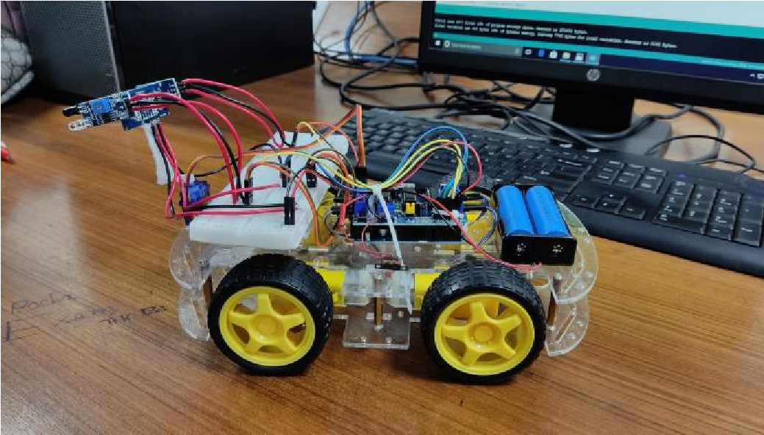
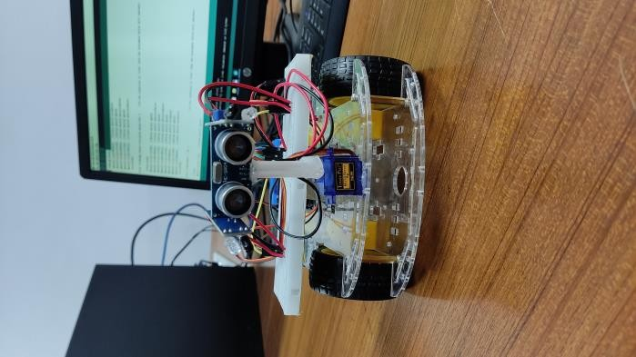
IV. RESULT AND DISCUSSION

4.1. Simulation/Numerical analysis

4.2. Measured response/Experimental results

Different experiments were conducted and the performance of the human following robot was tested. Each experiment that was performed took about 10 to 15 minutes. On the basis of results obtained from these tests and experiments, we made the necessary changes in the processing and control algorithm. The test was performed on the ultrasonic sensor. It was noted that sensor was working accurately with in a range of 4 meters. Then we performed the test to check that weather the robot maintains a specific distance with target object. Initially the we set the stopping of robot to 8 inches. It was observed that robot collided with the object as the distance between robot and target object approaches to 8 inches. This problem behind this was that the stopping distance was small enough and robot was not stopping quickly because of its load on board. So, we increased the distance to 12 inches. Then we again verified the routine. Hence the objective of implementing a good Human-Robot interaction was achieved by fast processing of the visual input combined with the proper handling of the information from the sensors.

4.3. Comparison between numerical and experimental results

We have done this project using Arduino Uno R3, Ultrasonic Sensor, Infrared Sensor, Motor Driver Shield, Servo Motor, Bread Board, TT Gear Motor, Wheel - 4, Car Chassis, Jumper Wire, 2 slot Battery Case, 2 Batteries (18650). We have gone through some difficulties while run Human Following Robot. Motor 2 and Motor 4 was running reverse for connection problem, but later we have successfully accomplished our goal to run all the motor in forward. Whenever, our system can detect an object using Ultrasonic Sensor and Infrared Sensor it moves forward or backward. If right infrared detect object the robot will go forward. If left infrared detect object the robot will go backward. When the left and right infrared sensor detect an object at a time, then the robot will be stop.

V. CONCLUSION
A successful implementation of a person follower robot is illustrated in this research. This robot does not only have the detection capability but also the tracking and following ability as well. The tracking is basically performed on the object and the human is followed on the basis of that detection. It was also kept in mind that the „following‟ capability of the robot should be as efficient as possible. The tests were performed on the different conditions to pin point the mistakes in the algorithm and correct them. The different sensors that were integrated with the robot added an additional advantage.

REFERENCES
- N. Bellotto and H. Hu, “People tracking and identification with a mobile robot,” in Mechatronics and Automation, 2007. ICMA 2007. International Conference on, 2007, pp. 3565–3570.
- Morioka K, Lee J H and Hashimoto H 2004 Human Following Mobile Robot in a Distributed Intelligent Sensor Network IEEE Trans. Ind. Electron 51(1) 229-237
- M. Kristou, A. Ohya, and S. Yuta, “Target person identification and following based on omnidirectional camera and LRF data fusion,” in ROMAN, 2011 IEEE, 2011, pp. 419–424.
- M. Lindstrom and J. O. Eklundh, “Detecting and tracking moving objects from a mobile platform using a laser range scanner,” in 2001 IEEE/RSJ International Conference on Intelligent Robots and Systems, 2001. Proceedings, 2001, vol. 3, pp. 1364–1369 vol.3.
- N.-Y. Ko, D.-J. Seo, and Y.-S. Moon, “A Method for Real Time Target Following of a Mobile Robot Using Heading and Distance Information,” J. Korean Inst. Intell. Syst., vol. 18, no. 5, pp. 624–631, Oct. 2008.
- N. Bellotto and H. Hu, “Multisensor integration for human-robot interaction,” IEEE J. Intell. Cybern. Syst., vol. 1, no. 1, p.

