***Using AR Technology in Bangladesh Map to Represent Bangladesh’s Historical Places***

|  |  |  |
| --- | --- | --- |
| Dr. Md. Abdullah-Al-Jubair  Department of Computer Science  American International University –Bangladesh  Dhaka, Bangladesh  Md. Dipu Hasan  Department of Computer Science  American International University –Bangladesh  Dhaka, Bangladesh | Shanzida Afroza Shatu  Department of Computer Science  American International University –Bangladesh  Dhaka, Bangladesh  Md. Atik Hasan  Department of Computer Science  American International University –Bangladesh  Dhaka, Bangladesh | Jannatul Ferdoush  Department of Computer Science  American International University –Bangladesh  Dhaka, Bangladesh |

**Abstract- Augmented Reality (AR) is the integration of real-world objects with real-time use of information in the form of text, graphics, audio and other virtual enhancement. Tourism sector is a booming sector in Bangladesh. To boost up the tourism sector of our country, mobile augmented system can bring a revolutionary change. When tourists want to know the details of the historical place of Bangladesh, it will show the desired video and 3D model on their mobile screen. As a result, tourists will be encouraged to visit these places. An Augmented Reality based map was developed in this study to enhance the tourism sector and to know the usefulness of mobile AR system. Mobile Augmented Reality for Android Smartphone’s will encourage and enlighten tourists around the world about the Bangladeshi cultural heritage and rich history. We have used Vuforia as tracking library and Unity Game Engine to integrate the system. For developing the application, we have used the Software Development Life Cycle (SDLC) model. For the testing, a questionnaire was used to evaluate the user’s satisfaction by throwing two questions on Google form. From the evaluation report, we acknowledged that the application meets its expectations, and user’s feedback was satisfactory. To sum up, the mobile AR system was implemented successfully and could be upgraded with new features and should keep on maintenance.**

***Index Terms- Augmented Reality,Target Image, Integration, Vuforia, Unity, Effectiveness.***

**INTRODUCTION**

The advancement of Augmented Reality (AR) technology provides a latest way to guide students by enhancing the quality of instructing and learning experiences (Nincarean, Ali, Halim & Rahman, 2013). Maps represent information about the world in a simple and easy way. It provides us information to identify places and locations in a region that helps to find from one place to another. Here’s how map reading helps us while travelling to and within a brand new place such as avoids confusion, saves time, better safety etc. An interactive map will help the users to navigate safely. People find it difficult to calculate country’s local time with regard to Greenwich Meantime (GMT). As we find something such as historical place, specific road or any significant object from a well designed soft copy or printed copy map, sometimes it is difficult to interpret from the image and also it can be uninformative. So, the problem is encountered of how to extract relevant correct information from an image as the investigator may not feel that much of interest and may not find that much of content unless the identification of the position. In that case a 3D map can completely change the seeker’s mind via its Augmented Reality representation. Proper informative 3D map will reduce the wastage of time while visiting an unknown place. The main goal of this study is to find out the effectiveness of AR based Bangladesh Map by conducting a survey to know about Bangladesh properly.

**BACKGROUND AND RELATED WORK**

Augmented reality is a new technology and AR is on the verge of becoming a part of life. The perception of the user, better acknowledgement about the surroundings and the interaction with the surroundings can be improved by Augmented Reality (Iftene&Trandabat, 2018). Augmented Reality permits the user to observe the actual world with virtual surroundings overlaid on it (Azuma, 1997). AR can simplify the user’s life by introducing virtual information from the actual world (Carmigniani&Furhut, 2011). AR technology has the following three characteristics-

* Combination of Real & Virtual environment
* Interactive in real-time
* Registered in 3D (Azuma, 1997)

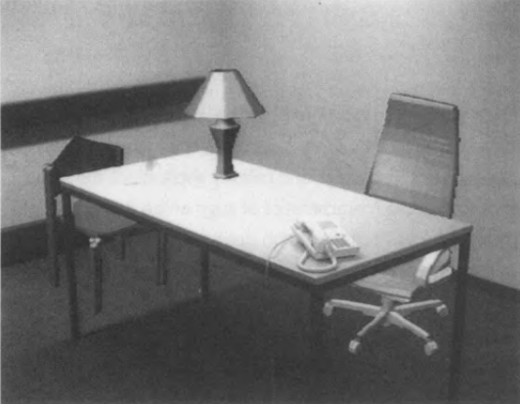

**Figure 1: Real desk with virtual lamp & two virtual chairs**

Computer vision is the advancement of augmentation that happens in actual time which determines that users are conscious of being in the actual world (Azuma, 1997). To solve the difficulties arises from the real world or complex conceptual visualization can be eliminated by affordance that helps students to locate an unknown location easily (Nincareana et al., 2013). Now-a-days, the combination of AR with the surgical navigation system aims to improve the safety and reliability of surgery by implementing an optical see-through HMD (Head-Mounted Display) (Chen et al., 2015). Over the last decade, the evaluation of mobile augmented reality has progressed rapidly between 1968 and 2014 (Arth et al., 2015). Mobile Augmented Reality is perhaps the most unstable development region for AR applications right now (Criag, 2013). For the advancement of emerging technological fields, usable AR applications such as authoring tools, tracking mechanism, display systems and input devices can be created to solve many technological issues (Billinghurst, 2002).

**METHODOLOGY**

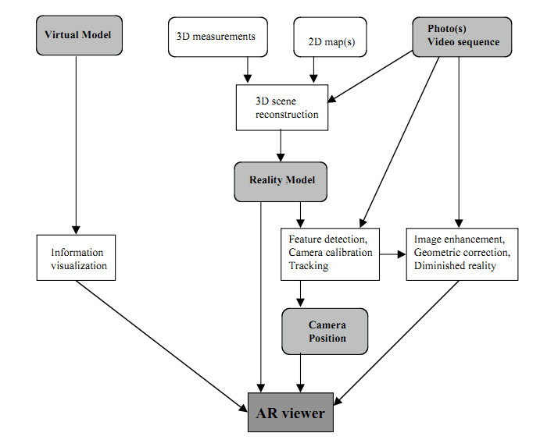

**Figure 2: Conceptual Framework of an AR System**

Klinker et al., (2001) described the conceptual framework for augmenting images of the real world with virtual objects. In virtual model, information visualization tasks can be integrated by OpenGL which can show video output in AR viewer. 3D scene or 2D map can detect features, track camera calibration in reality model through image enhancement, geometric correction and diminished reality that can be viewed in AR viewer (Klinker et al., 2001).

Without the execution of a proper life cycle model, the development of a system would not be a success (javaTpoint, 2021). In this study, we have chosen SDLC (System Development Life Cycle). The minimization of risk and the highest quality of the product is ensured by SDLC (Rather and Bhatnagar, 2015). The SDLC defines the framework that includes different activities and tasks to be carried out during the software development process (Rather &Bhatnagar, 2015). SDLC is a methodology for designing, building and maintaining information and industrial system. Using the SDLC phases the user can develop the software according to their requirement (Navita, 2017).

We have chosen SDLC because it is the best suited model for small project in compared to other software development model

(Amlani, 2012). Many researches have been conducted before by using SDLC because the researchers got satisfactory result from this model.

There are five stages in the development methodology-

1. Planning
2. Requirement Gathering & Analysis
3. Development & Implementation
4. Testing
5. Deployment

**i) Planning:**

Without a perfect plan, the development of any system is meaningless. This is the most essential aspect of the SDLC. Planning for the standard assurance necessities and identification of the risks related to the project is additionally drained the design stage. A group discussion will help to plan and identify the requirements properly. The work will be distributed to the group members.

**ii) Requirement Gathering & Analysis:**

The requirement gathering & analysis for the project are the most important part of the SDLC. At this phase, the resources will be gathered and analyzed. Primary data will be collected for the map from Bangladesh Map through android Smartphone’s. Secondary data will be collected from online resources. Android is considered as the platform for the implementation of handheld AR technology. Unity game engine and Vuforia SDK is used for this study.

**iii) Development & Implementation**

In this phase, actual development of the project starts according to the designed architecture. If designing is done successfully then this phase is not much difficult. The collected resources will be manipulated later based on the requirements of the system. Vuforia SDK will be installed from Vuforia developer portal and can be accessed through the Unity Package Manager by adding Vuforia's package repository.

**iv) Testing**

Product defects are reported, analyzed and corrected in this phase until the product meets the quality standard. Debugging has to continue to correct the bugs and issues that will be found in the product.

**v) Deployment**

After successful testing and correction of the system, the system will be declared ready to use with the Bangladesh Map.

**IMPLEMENTATION**

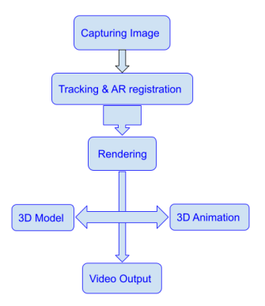

**Figure: Flow chart of Architecture of the system**

Now-a-days, Vuforia Engine is one of the most widely utilized platforms for AR development, with support for leading phones, tablets, and eyewear (Vuforia, 2021). Vuforia Engine is a software development kit (SDK) for implementing Augmented Reality apps (Vuforia, 2021). We have used Vuforia as tracking library to develop our augmented reality system. Advanced computer vision functionality permits the developer to identify the objects from the actual world (Vuforia, 2021). Vuforia Engine also offers a variety of trackable targets and capabilities that can be categorized as Images, Objects, and Environments (Vuforia, 2021).

Unity game engine was also used to create 2D and 3D multimedia generations. Unity is equally suited to making each 2D and 3D graphics. It permits Vuforia SDK extension modules to distinguish and makes AR applications and games.

We have uploaded the target images in Vuforia database and the target images must be augmented by few stars. The 3D video of different division was configured with Unity and CodeBlocks. Users can see the 3D view of different division by holding the camera on a specific division’s image of Bangladesh map. We have captured some images by an android phone camera from the video. When the AR application recognized the marker by scanning the target image, it displayed the specific video on the mobile screen with audio. We have also added some audio to the specific division’s video by taking it from different online sources. The video would also disappear and scan for marker again when target image was vanished.

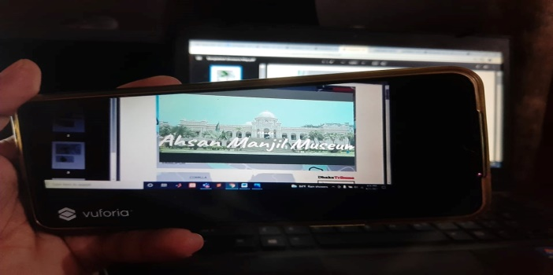

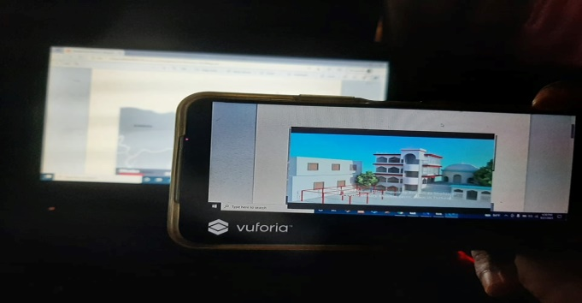

**Figure: Sample pictures of 2D and 3D video capturing**

**EVALUATION**

We have implemented the user evaluation part by conducting a survey. The main goal of this study is to know that how much the mobile AR system is effective in Bangladesh Map. To find out the effectiveness, 55 participants have participated in the survey by providing their feedback after using our system.

The evaluation represents the graphical expression of the data which was evaluated among almost 55 participants in numerous professions to know the efficiency of augmented reality map. 85% of participants were selected from fresh undergraduate in discipline institution and rest of them was service holder, contributors also provided efficient and precise judgment. Most of the participants did not familiar with the mobile AR technology.

In this study, a questionnaire was used as a method for collecting data to get the results for users. All respondents were anonymous when research material was collected, stored and published. This survey was created in online by making a Google form and stored on a secure Google Drive account for data collection and analysis. Online (web URL) version was distributed to the users for data collection. We have conducted and analyzed two questions to find out the effectiveness for evaluation part. Help from individuals and social networking platforms (Facebook, WhatsApp) were taken to reach the students. Students were cordially requested to circulate the survey (web-link) to their course mates, friends, senior and junior.

**RESULT**

Respondent’s response to the general performance questionnaire which is outlined below-

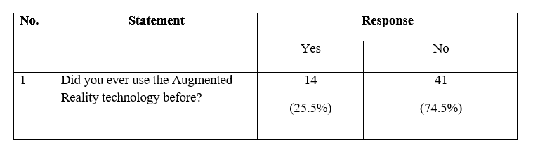

As we can see from the table that 25.5% participants have used augmented reality technology before & the rest of the 74.5% participants didn’t ever use the technology before which is a surprising fact.

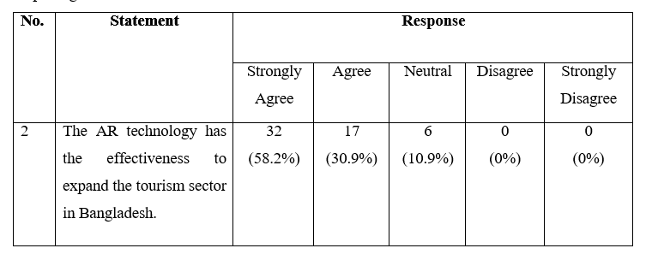

The above table shows that most of the participants (89.1%) are acknowledged with the fact that augmented reality technology can be effective to expand the tourism sector in Bangladesh which is quite satisfactory and 10.9% contributors are neutral in their decision may be they are confused about their opinion.

**FINDINGS**

55 participants were participated in the survey by providing their valuable opinions. The survey was targeted to the participants who have minimal education with computer literacy as the objective of this study is to find out the effectiveness of Augmented Reality map. Among them, 38 participants are male and 12 participants are female and their age range is from 22 to 28. A total of 2 questionnaires (online versions) were collected and analyzed to find out results. From the survey results, it can be clearly concluded that 89.1% participants strongly agreed to the fact that the augmented reality technology can be effective to expand the tourism sector in Bangladesh and 10.9% gave a neutral response. The significance of this Augmented Reality map is that it can captivate the tourists by enhancing the attractiveness of a map using Handheld Augmented Reality. It allows the 3D map to become a dynamic source of information. This augmented reality map also helps to boost up our tourism sector which can contribute a significance change in our economical development. Thus, this AR map is effective in terms of user satisfaction. Our system will easily identify which place is better to go easily. Basically this system will be created for foreigner tourist people because they do not know about the tourist spots in our country. Tourist spots can be easily found through Augmented Reality maps. Representation of our country in front of other nations will be easier.

**LIMITATION & FUTURE WORK**

Some limitations were pointed out while performing the thesis work. In our system, it cannot be possible to include more locations of the tourist places due to the large file size of database. Another finding was when the picture quality is not good enough in that case the image cannot be detected properly and for this reason 3D visualization of the system will be paused at any moment. The third limitation is with the android device when the camera angle of android device is not suitable then the image of map cannot be detected so that it cannot correlate with the system. Also, the ability to detect markers in poor lighting condition was an issue. Moreover, user cannot manipulate the 3D audio-visuals with their physical interaction.

Several proposals for future research and work in terms of this exploration are:

* Suggestion to improve the camera app quality, which is implemented by using AI technology
* Suggestion to include large number of input data without changing application size by switching of algorithm and also the programming language
* Suggestion to import the precise tracking library to detect the image in any lighting conditions
* Suggestion to provide audio instructions for visually impaired people to navigate in complex places
* Suggestion to add multiple buttons in the system
* Suggestion to add exit button

**CONCLUSION**

A mobile AR system was developed to extract relevant information for the tourists while visiting our country. System Development Life Cycle (SDLC) was used as system development methodology to develop 3D visualization in this mobile AR system. 55 participants gave their feedback to evaluate the system. By using pie-chart, data findings tasks were done which was used in analysis plans and to examine results in this study. The evaluation result showed that the integration of AR system was successfully implemented. In conclusion we can say that the mobile AR system for Bangladesh Map fulfilled the expected outcome of research objectives to expand the tourism sector. Moreover, some new features can be added in the existing system for future work.

**ACKNOWLEDGEMENTS**

We would like to thank our project leader to guide us properly and also like to thank our University to give us the opportunity to do research in this field.

**REFERENCES**

1. Azuma, R. T. (1997). A survey of augmented reality. *Presence: Teleoperators and Virtual Environments 6,* 4 (August 1997), 355–385. Cambridge, MA: The MIT Press.

2. Amlani, R. D. (2012). Advantages and Limitations of ifferent SDLC Models. *International Journal of Computer Applications and Information Technology, Vol. 1, Issue. 3.*

3. Arth, C., Gruber, L., Grasset, R., Langlotz, T., Mulloni, A., Schmalstieg, D. & Wagner, D. (2015). The History of Mobile Augmented Reality. *Inst. for Computer Graphics andVision*, Graz University of Technology, Austria.

4. Billinghurst, M. (2002). Augmented reality in education. *New Horizons for Learning.* Retrieved from <http://www.newhorizons.org/strategies/technology/billinghurst.htm>

5. Billinghurst, M.,Clark, A. & Lee, G. A. (2015). *A Survey of Augmented Reality*. [Foundations and Trends® in Human-Computer Interaction](https://www.researchgate.net/journal/Foundations-and-TrendsR-in-Human-Computer-Interaction-1551-3963) vol. 8, no. (2-3), (pp. 73-272). DOI:[10.1561/1100000049](http://dx.doi.org/10.1561/1100000049). Retrieved from <https://www.researchgate.net/publication/277637661_A_Survey_of_Augmented_Reality>

6. Carmigniani, J. &Furht, B. (2011). Augmented Reality: An Overview. Retrieved from <https://www.researchgate.net/publication/227164365_Augmented_Reality_An_Overview>

7. Chen, X., Xu, L., Wang, Y., Wang, H., Wang, F., Zeng, X., Wang, Q. & Egger, J. (2015). Development of a surgical navigation system based on augmented reality using an optical see-through head-mounted display. *Journal of Biomedical Informatics*, 55, 124-131. <http://dx.doi.org/10.1016/j.jbi.2015.04.003>.

8. Craig, A.B. (2013). Mobile Augmented Reality. *Understanding Augmented Reality* (pp.1-12). Retrieved from <https://www.elsevier.com/books/understanding-augmented-reality/craig/978-0-240-82408-6>.

9. Iftene, A. &Trandabat, D. (2018). Enhancing the Attractiveness of Learning through Augmented Reality. *International Conference on Knowledge Based and Intelligent Information and Engineering Systems*, 166-175.

10. Klinker, G., Stricker, D., Reiners, D. (2003). Augmented Reality for Exterior Construction Applications. Retrieved from <https://www.researchgate.net/publication/2869760_Augmented_Reality_for_Exterior_Construction_Applications>

11. Navita. (2017). A Study on Software Life Cycle & its Model. *International Journal of Engineering Research in Computer Science and Engineering, Vol. 4, Issue. 9.*

12. Nincarean, D., Ali, M. B., Halim, N. D. A. & Rahman, M. H. A. (2013). Mobile Augmented Reality: the potential for education. *13th International Educational Technology Conference*, 103, 657-664. Available on <http://www.sciencedirect.com>

13. Software Development Life Cycle (SDLC) 2021. Available on <https://www.javatpoint.com/software-engineering-software-development-life-cycle>

14. Vuforia Developer Library (2021). Available on https://library.vuforia.com/