ERDs -> Entity Relationship Diagrams

Entitys - Attribute
- Relationship
- Cardinality

Database: A collection of information that’s organized for easy
. storage . management . updates . retrival

Theres lot of information moving in database. Understanding how each of these elements interacts with one another is difficult to grasp. ERDs provide engineers a visual way how the information is related and how it works together.

Components of ERDs:

- Entity : An odject(person, place, thing) that tracked in the database. Each entity represents a table in database.
Example: Customer, order, product.
- Attributes: Propertis or traits of Entity. Example: Customer_id, first_name, Last_name, Zip, phone.
- Relationship: describes how entities interact with each other.
. Cardinality help defines relationship in numerical context.
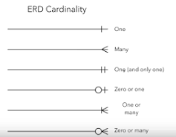
Relationship and cardinality between customer and order:

Customer -> order: Zero or many
Order -> customer: one and only one

Primary key: An field or attribute that can uniqely identifies each record in a certain table. Example: In cutomer table ‘customer_id’ is primary key.
- has to be unique and identify only one record in our table.
- needs to be never changing.
- needs to be never null.

Foreign key: same as primary key , just located on foreign place. Example: customer_id in order table.
- can be repeated.
- there can be multiple foreign key in one entity.

Composite Primary key: Two or more atributes are necessary to uniquely identify every record in a table.
- use the fewest number of attributes as key as possible.
- don’t use attributes that’s are apt to change.

