Lab 4

Due: September 11 (Wednesday)

Revised on 10/9/2013

**Part 1 Mash-Up Application**

**Summary:**

The mash up page contains of Map and Ven-Graph. Using this mash, a user can look at road condition of a particular area. Also the ven-graph will show the comparison between the numbers of accident happened around that place and the state.

**API uses:**

* MapQuest API for rendering traffic condition map and geographic map.
* Google Search API to get search results on “traffic accidents” around the input area.
* Google Chart API to render Ven-Graph.

**Important UI elements:**

* Search box: To search traffic condition of a particular area
* Show JSON: Contains the returned JSON data.
* Show Chart: Contains the comparison chart.
* Traffic map: illustrates traffic condition of the input location
* Geo Map: render the geo map of same location

**Two files containing the source codes:**

* MashUp(new): Contains the mash up with JQuery Mobile styles.
* MashUp (bare): Bare page with all functionalities.

Screen shots from Mash-up(new):

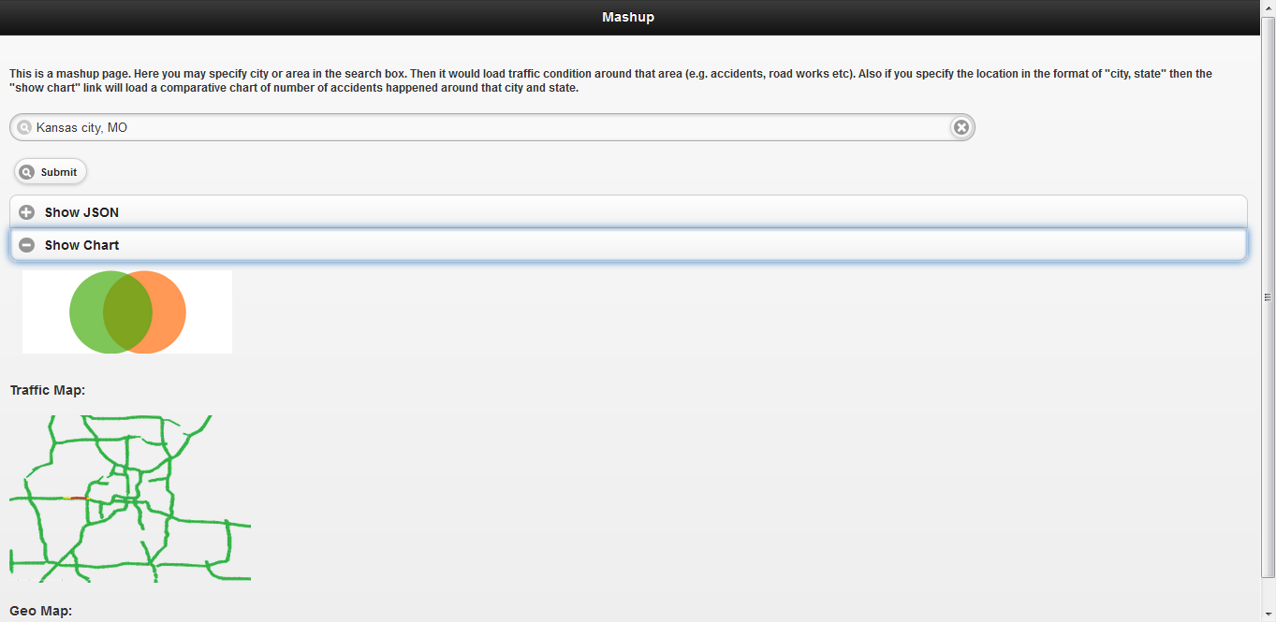

***Note***: At first, I tried to create a bare html page will all the functionality. It worked well. However, when I used JQuery Mobile styles, the “Geo Map” was not rendered. My guess is, the JQuery CSS is conflicting with returned data from Map API.

**Part 2 Install IIS Server on BM Cloud instance**

IBM Cloud Instance:

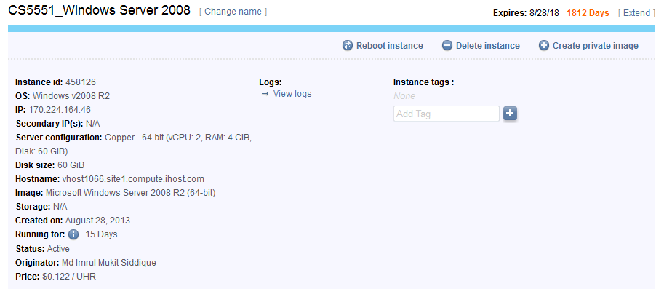

Installed IIS Server in cloud machine:

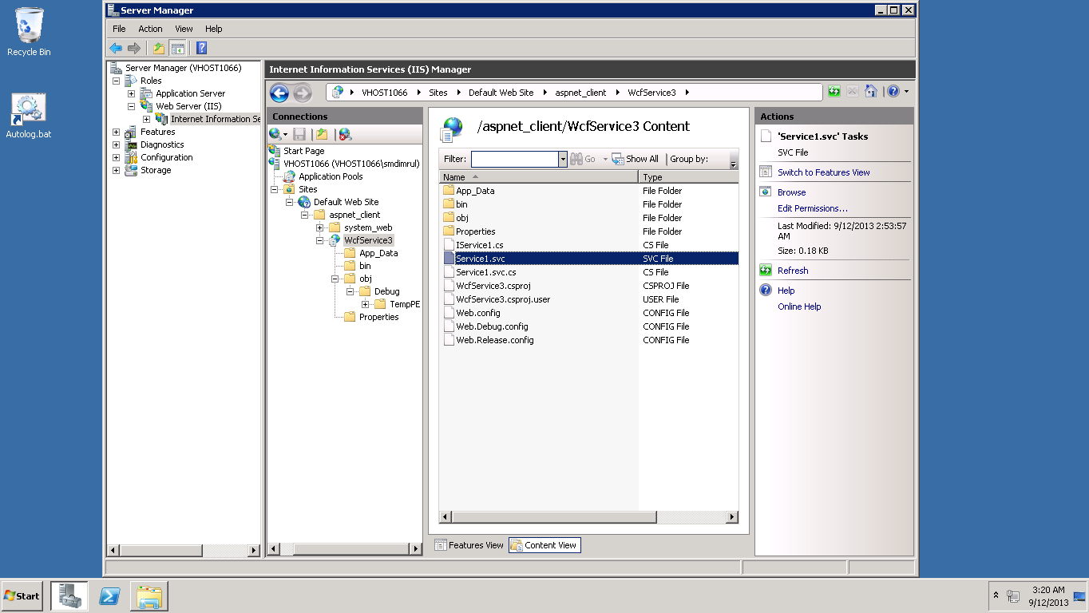

**REST Web Service**

The project is named “WcfService3” which contains a service “Add” that adds two numbers. The returned data is in JSON format.

**URL of the service**

http://vhost1066.site1.compute.ihost.com/aspnet_client/WcfService3/Service1.svc/add?x=1&y=1

Accessing the deployed Web service from browser:

