Requirements:

1. Landing page
   1. Home
   2. Services
   3. FAQ’s
   4. Contact
   5. About us
2. Authentication page
   1. Sign up
   2. Login
   3. Logout
   4. Forget password
   5. Reset password
   6. Social authentication
3. Multi keyword searching
4. Job Section
   1. Post for a job
      1. Offline job
      2. Remote job
   2. Apply for a job
      1. Offline job
      2. Remote job
5. Create Resume
   1. Video resume
6. Project Section
   1. Apply for project
   2. Post a project
7. Checkout
8. Payment Gateway
   1. SSL Commerz
9. Message integration
10. Rating and review system
11. Comment
12. Blog
13. Special Offer system on special day**(If possible)
14. Profile/Dashboard
15. Job list
16. Freelancer’s list
17. Approval(admin)

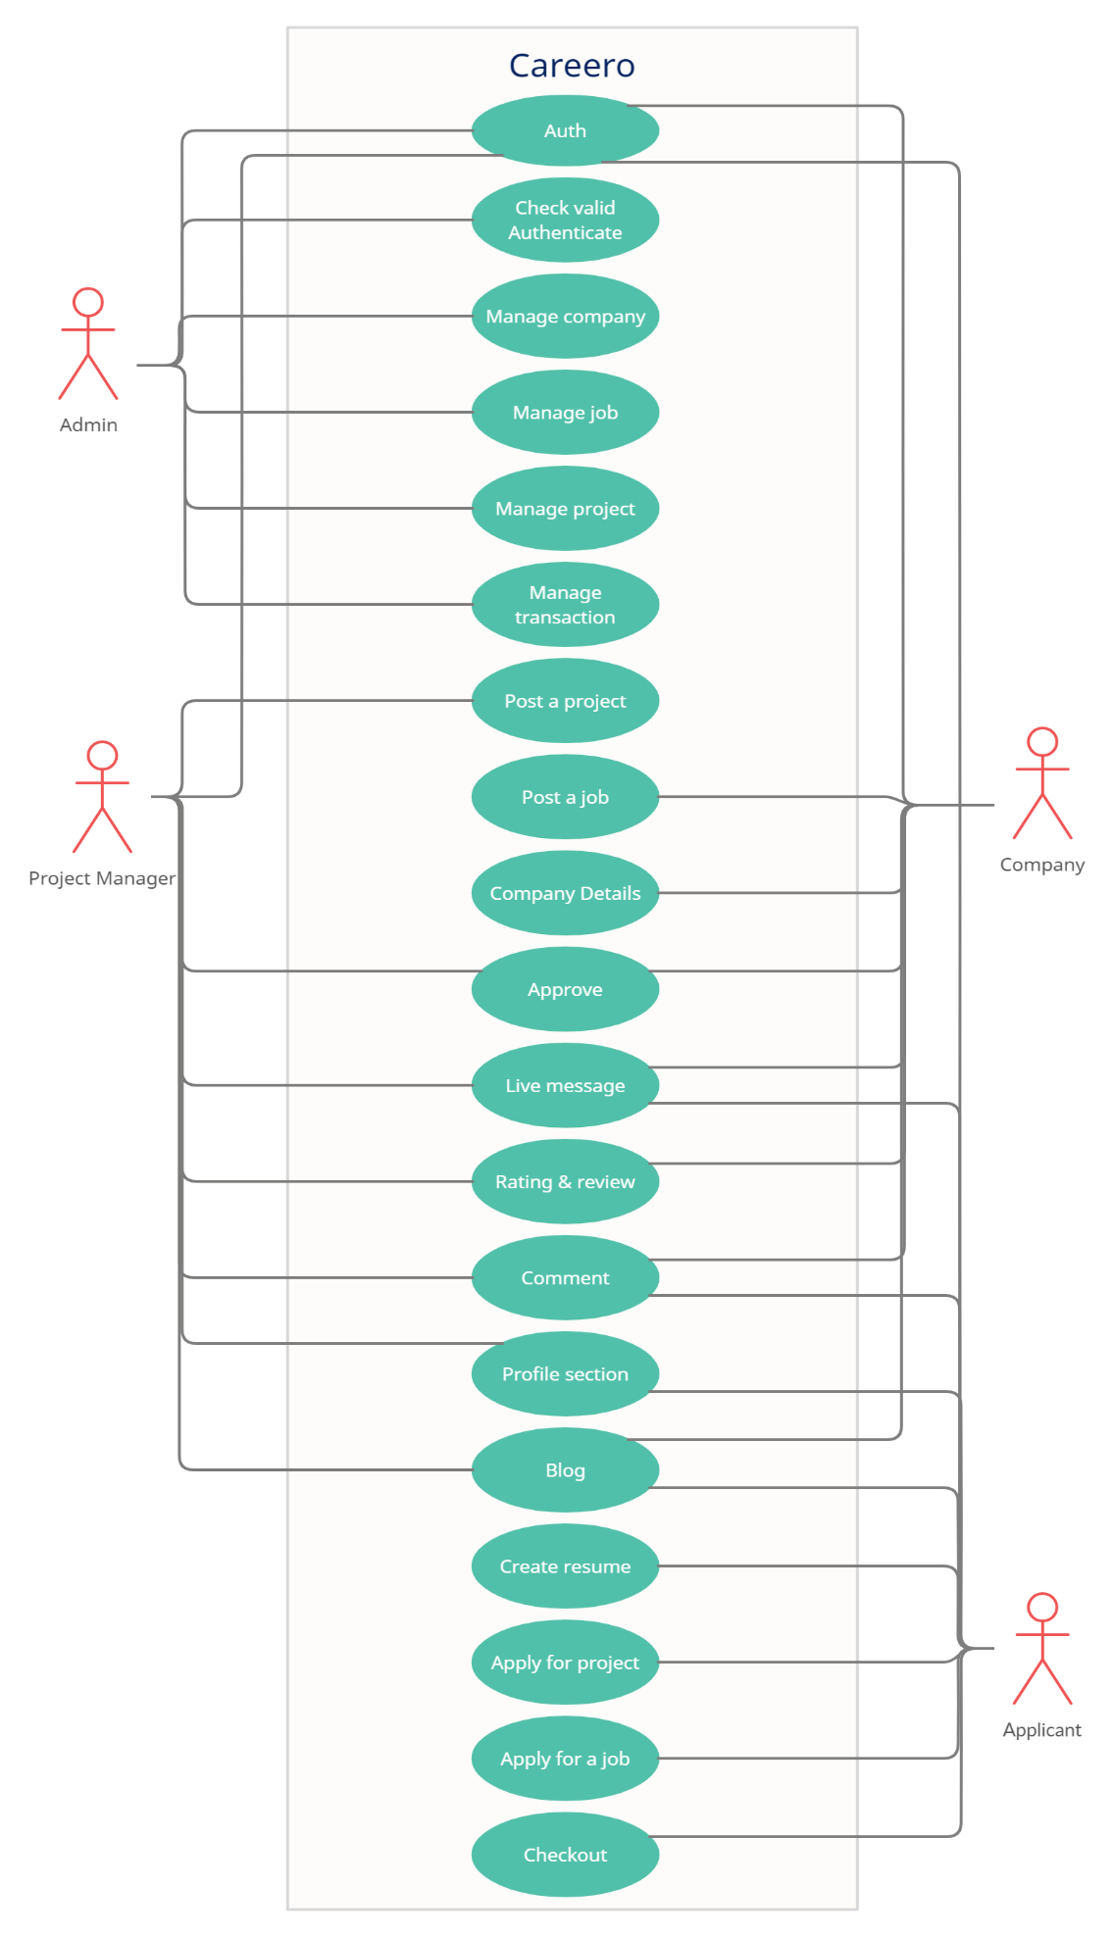[Use case](https://app.creately.com/diagram/cbpQevcGRyr/):

[**Database Demo**](https://docs.google.com/spreadsheets/d/1gh0nhdyS9ymHzCKitfYMbnJmXgmUulPa27Uv7dCuWvU/edit?usp=sharing)