



Ch3 - Packet Tracer Skills Integration Challenge

**Topology Diagram**

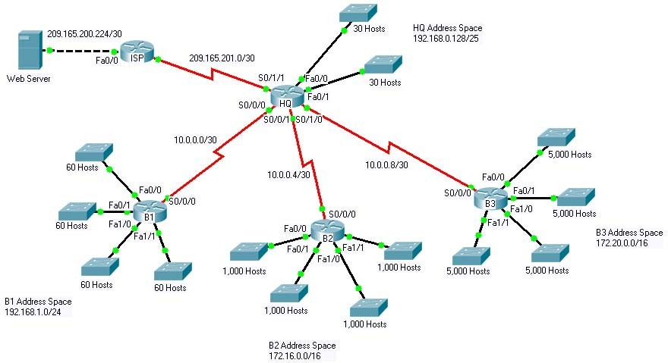

**Introduction:**

This activity focuses on subnetting skills, basic device configurations and static routing. Once you have configured all devices, you will test for end to end connectivity and examine your configuration.

**Addressing Table**

|  |  |  |  |
| --- | --- | --- | --- |
| **Device** | **Interface** | **IP Address** | **Subnet Mask** |
| **HQ** | **Fa0/0** | 192.168.0.129/27 | 255.255.255.224 |
| **Fa0/1** | 192.168.0.161/27 | 255.255.255.224 |
| **S0/0/0** | 10.0.0.1 | 255.255.255.252 |
| **S0/0/1** | 10.0.0.5 | 255.255.255.252 |
| **S0/1/0** | 10.0.0.9 | 255.255.255.252 |
| **S0/1/1** | 209.165.201.2 | 255.255.255.252 |
| **B1** | **Fa0/0** | 192.168.1.1/26 | 255.255.255.192 |
| **Fa0/1** | 192.168.1.65/26 | 255.255.255.192 |
| **Fa1/0** | 192.168.1.129/26 | 255.255.255.192 |
| **Fa1/1** | 192.168.1.193/26 | 255.255.255.192 |
| **S0/0/0** | 10.0.0.2 | 255.255.255.252 |
| **B2** | **Fa0/0** | 172.16.0.1/22 | 255.255.252.0 |
| **Fa0/1** | 172.16.4.1/22 | 255.255.252.0 |
| **Fa1/0** | 172.16.8.1/22 | 255.255.252.0 |
| **Fa1/1** | 172.16.12.1/22 | 255.255.252.0 |
| **S0/0/0** | 10.0.0.6 | 255.255.255.252 |
| **B3** | **Fa0/0** | 172.20.0.1/19 | 255.255.224.0 |
| **Fa0/1** | 172.20.32.1/19 | 255.255.224.0 |
| **Fa1/0** | 172.20.64.1/19 | 255.255.224.0 |
| **Fa1/1** | 172.20.96.1/19 | 255.255.224.0 |
| **S0/0/0** | 10.0.0.10 | 255.255.255.252 |
| **ISP** | **S0/0/0** | 209.165.201.1 | 255.255.255.252 |
| **Fa0/0** | 209.165.200.225 | 255.255.255.252 |
| **Web Server** | **NIC** | 209.165.200.226 | 255.255.255.252 |

**Objectives**

* Design and document an addressing scheme based on requirements.
* Select appropriate equipment and cable the devices.
* Apply a basic configuration to the devices.
* Configure static and default routing.
* Verify full connectivity between all devices in the topology.

# Task 1: Design and document an addressing scheme.

## Step 1: Design an addressing scheme.

Based on the network requirements shown in the topology, design an appropriate addressing scheme.

* The HQ, B1, B2, and B3 routers each have an address space. Subnet the address space based on the host requirements.
* For each address space, assign subnet zero to the Fa0/0 LAN, subnet 1 to the Fa0/1, and so on.

## Step 2: Document the addressing scheme.

* Document the IP addresses and subnet masks. Assign the first IP address to the router interface.
* For the WAN links, assign the first IP address to HQ.

# Task 2: Apply a basic configuration.

Using your documentation, configure the routers with basic configurations including addressing and hostnames. Use **cisco** as the line passwords and **class** as the secret password. Use 64000 as the clock rate. ISP is the DCE in its WAN link to HQ. HQ is the DCE for all other WAN links.

# Task 3: Configure static and default routing

Configure static and default routing using the exit interface argument.

* HQ should have three static routes and one default route.
* B1, B2, and B3 should have one default route.
* ISP should have seven static routes. This will include the three WAN links between HQ and the branch routers B1, B2, and B3.

# Task 5: Test connectivity and examine the configuration.

## Step 1: Test connectivity.

* You should now have end-to-end connectivity. Use ping to test connectivity across the network. Each router should be able to ping all other router interfaces and the Web Server.
* Use extended ping to test LAN connectivity to the Web Server. For example, the test the Fa0/0 interface on B1, you would do the following:

B1#**ping** Protocol [ip]:

Target IP address: **209.165.200.226**

Repeat count [5]:

Datagram size [100]:

Timeout in seconds [2]:

Extended commands [n]: **yes**

Source address or interface: **192.168.1.1**

Type of service [0]:

Set DF bit in IP header? [no]:

Validate reply data? [no]:

Data pattern [0xABCD]:

Loose, Strict, Record, Timestamp, Verbose[none]:

Sweep range of sizes [n]:

Type escape sequence to abort.

Sending 5, 100-byte ICMP Echos to 209.165.200.226, timeout is 2 seconds: Packet sent with a source address of 192.168.1.1

!!!!!

Success rate is 100 percent (5/5), round-trip min/avg/max = 67/118/138 ms

* Troubleshoot until pings are successful.

## Step 2: Examine the configuration.

Use verification commands to make sure your configurations are complete.